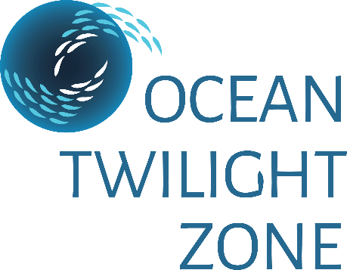

OTZ Postdoctoral Scholar Fellowship for 2021-2022

The Ocean Twilight Zone (OTZ) project will award a fellowship for research on twilight zone (100-1000 m) ecosystems and processes, including biomass, biodiversity, life histories and behavior, trophic interactions, links to the global carbon cycle, and ways to engage scientists with stakeholders. Award recipients may be advised by scientific staff within the five Departments as well as the Marine Policy Center and are encouraged to contact OTZ team members for more information on current activities: https://twilightzone.whoi.edu/our-bold-ideas/.

PROGRAM Researchers at Woods Hole Oceanographic Institution (WHOI) are undertaking a large-scale, comprehensive exploration of the twilight zone designed to develop a new understanding of this important ecosystem, laying the groundwork for long-term sustainability of human activities that may affect it. You are invited to apply for an OTZ Postdoctoral Scholar Fellowship for any project related to the themes of this program. These include: 1) quantifying and understanding the distribution of twilight zone biomass and biodiversity; 2) uncovering food web linkages within the twilight zone and between the twilight zone and other ocean realms; 3) determining the life histories and behaviors of twilight zone animals; and 4) understanding the role of the twilight zone and its inhabitants in the global carbon cycle. Interweaved through these science themes, we will apply state-of-the-art and emerging technologies. Further, we will engage scientists with stakeholders ranging from the general public to global decision-makers. A successful candidate may choose a research project with faculty in any of WHOI’s five science and engineering departments and the Marine Policy Center or any combination thereof.

ELIGIBILITY New or recent recipients of a doctoral degree with interests in the oceanographic sciences or engineering are eligible. Usually, scientists with more than three to four years of postdoctoral experience are not considered eligible for these awards.

STIPEND Scholarships are awarded for 18-month appointments. Successful applicants will receive a stipend of $62,250 per year, relocation and health and welfare allowances, as well as a modest research budget.

APPLICATION Completed applications will be accepted up to October 15, 2020 for consideration for Postdoctoral Scholar Awards for 2021-2022. In addition to the application form, the following are required: a current CV or resume; a minimum of three non-WHOI recommendations; a concise statement describing research interests, in particular those that the applicant would like to pursue at the Woods Hole Oceanographic Institution, as well as more general career plans; and a brief synopsis of their doctoral dissertation. Announcement of awards will be made in December.

TENURE Recipients of awards can initiate their study and research period at the Institution any time after January 1, 2021 and before December 1, 2021.

Further information and application forms may be obtained through the Academic Programs section of the WHOI web pages at www.whoi.edu/postdoctoral, or by contacting:

The WHOI Postdoctoral Coordinator

Telephone: (508) 289-2950 ٠ E-mail: postdoc@whoi.edu

The Woods Hole Oceanographic Institution is an Equal Employment Opportunity/Affirmative Action Organization

