Iridium

The advantages...

- Small antennas
- Low power
- Global (nearly) coverage
- Two-way
- Always available
- Useful bandwidth
- Channel multiplexing
- No latency
- Lower cost equipment
- Low traffic cost per kbyte
- A single protocol/procedure globally

Iridium

Cost factors...

- Monthly terminal charge
- Airtime
- Minimum charge per session
- Billing increment

Iridium

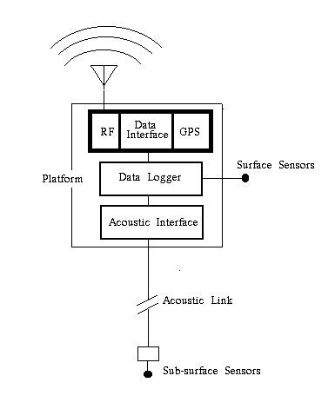

Iridium

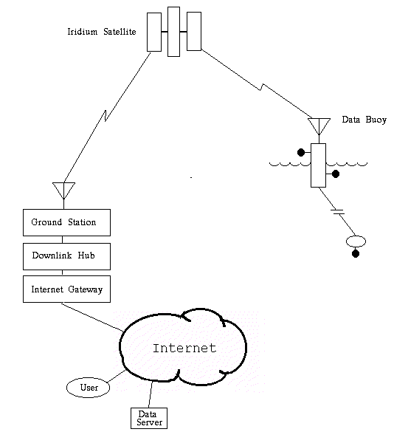
Iridium

Two-way data connections...

- Interactive
- Batch

Iridium

A full system...

- RF package
- Airtime
- Dedicated ground station (?)
- Download/distribution hub
- Internet gateway
- Accounting and billing
- Carrier quality monitoring
- Two-way connections
- Support

