Report on the Universal Undersea Navigation/Communication

Gateway Platforms Workshop

held at Woods Hole, MA on January 17/18, 2001



Sponsored by the Office of Naval Research

March 15, 2001

Preface
The Universal Undersea Navigation/Communication Gateway Platforms Workshop was held at the Woods Hole Oceanographic Institution (WHOI) in Woods Hole, MA on January 17 and 18, 2001. The Office of Naval Research (ONR) sponsored the workshop whose purpose was to develop a conceptual approach to gateway platforms that would promote their use by the existing fleet infrastructure. We hoped to establish a general specification for each of the gateway elements and determine which of these elements are available in the present commercial or research environment and which will require substantial development. One anticipated result of the workshop will be better-coordinated research and development on gateway systems to ensure that they conform to standard protocols and have plug and play modularity.
To address the goals of the workshop, ONR developed a list of invitees that included individuals from NUWC, CSS, SPAWAR, NRL-DC, ARL-UT, JHU-ARL, WHOI, FAU, and a number of operational Navy groups and commercial companies. A total of 49 people attended the workshop (see workshop website at http://www.whoi.edu/science/AOPE/ael/webonrwk/workshop_home.htm [1]); about 50 % were from Navy labs or operational groups, about 20 % were from academia and about 30 % were from a total of 11 commercial firms. ONR's objective was to bring together a small group of gateway developers, gateway users and manufacturers to focus on a unified concept and approach to gateway systems.
Three working groups were organized around the themes of Acoustic Communications, RF Communications, and Platforms and Sensors. The working groups operated individually and reported back to the main body several times per day. The reports from the working groups were collected and edited to produce this document.

Acknowledgements
Tom Curtin and Tom Swean of ONR provided the motivation and guidelines for the workshop. Kevin Comer, also from ONR, provided support in organizing the event and developing the list of invitees and speakers.
Jason Gobat and Dan Frye were the facilitators for the Platforms and Sensors group, Lee Freitag and Dan Nagel facilitated the Acoustic Communications working group, and Bob Heinmiller and Keith von der Heydt ran the RF Communications group.
In addition, Dolores Chausse developed and is maintaining the workshop website and helped to host the function with Gloria Franklin.

Executive Summary
A gateway platform is a modular telemetry system that connects underwater sensors or data gatherers to manned platforms located at some distance. It combines an RF communications module and an acoustic communications module and provides two-way connectivity. Acoustic and GPS navigation capabilities are inherent in the gateway architecture. Ideal gateways operate autonomously for days to weeks and can be delivered and deployed to hostile environments in clandestine ways. Gateways may be expendable or reusable and may be mobile (self-powered or drifting) or fixed (moored). Groups of gateways should operate as a network.
The workshop attempted to identify the general missions for gateway platforms and the data rates, ranges and durations that were implicit in these missions using the present state of the art in the respective technical areas. Specific criteria were developed including delivery methods, clandestine requirements, power limitations and size and weight requirements. The important missions identified by the group were:

- Intelligence, Surveillance and Reconnaissance (ISR)
- Explosive Ordinance Disposal/Mine Countermeasures (EOD/MCM)
- Tactical Surveys (hydrographic, bathymetric and meteorological)
- Distributed Large Area Network Surveillance
- Submarine Wireless Communications

Most of these missions share a need for gateways that are difficult to detect and remove and can be installed without using a surface vessel. These requirements make most of the gateways that have been used to date, which typically have been moored surface buoys deployed from ships, less than ideal.
The optimal gateway platform designs are gliders, AUVs, and pop-up moored systems that remain submerged except when sending data via the RF channel. They are deployed by subsurface means (i.e., submarine, AUV or diver/diver vehicle) and operate over periods from a few hours to about 1 month. They collect data from remote, acoustically linked sensors and telemeter that data over the horizon (OTH) during their relatively infrequent visits to the surface. They may surface as few as 10 times or as many as 100 times during a deployment, depending on the mission requirements.
Gateway RF communication modules include line of sight (LOS), over the horizon (OTH), and satellite systems. The LOS option is available COTS and can provide adequate burst data rates (56 Kbps) for most missions. The OTH option can be met with an aircraft relayed LOS link or with an HF system operated in ground wave mode. The HF system can, in theory, provide throughput similar to the LOS link at reasonable power, though these HF systems are not in widespread use. Concerns about HF antenna size, hardware size and weight, and the reliability of the communications channel need to be addressed. Satellite links are also potentially useful in gateways, if reluctance by the users can be overcome. Users have expressed concerns about latency, throughput and timely access to the satellite bandwidth.
The horizontal range of existing acoustic modems operating in the 10-20 kHz band varies from about 0.5 to 6 miles depending on the water depth, noise levels, propagation channel, output power, data rate and specific site conditions. Data rates vary between about 50 and 10,000 bits/sec, depending on the variables above as well as the transducer bandwidth, modulation technique and receiver array configuration. One approach to addressing the range of these values in a single gateway design is to develop an adaptive acoustic modem that automatically chooses between several clear choices in data rate and power to meet the needs of the user. As an example, an acoustic modem operating in the 10-20 kHz range, might be configured to negotiate between 100, 1000 and 10,000 bps using 15 Watts of transmit power. This approach would cover most of the operational scenarios.
Thus, the conceptual gateway design consists of a variety of potential platforms that each contain identical RF, acoustic and control modules with a battery pack designed for the mission duration and operating cycle. The gateway provides reliable underwater connectivity at ranges typically between 0.5 and 3 miles with a minimum reliable acoustic data rate of a few 100 bps. It has an RF range of order 6 to 12 miles (LOS) or 120 miles OTH and a burst data rate of the order of 50 to 100 kb/s.

TABLE OF CONTENTS

Preface……………………………………………………………………………………….2
Acknowledgements………………………………………………………………………….2
Executive Summary…………………………………………………………………………3
- Background………………………………………………………………………......6
- Missions…………………………………………………………………………...….7
- Gateway Platforms…………………………………………………………………10
- RF Communications Module………………………………………………………16
- Acoustic Communication Module…………………………………………………19
- Test Plans……………………………………………………………………………21
- Conclusions……………………………………………………………………….....22
- References………………………………………………………………………...…23

1. Background
Six presentations (listed below) were made during the workshop to provide background information to the workshop participants. The working groups used this information to help define the state of the art in RF and acoustic communications and to gain insight into operational issues associated with gateway delivery options available in the fleet. The graphics material presented can be viewed at the workshop website [1].
1. Overview of Acoustic Communications by Lee Freitag
2. Overview of RF Communications by Ken Gamache
3. A General View of Gateway Platforms by Dan Frye
4. Deployment Options by Mike Wood
5. Submarine Launcher Systems by Nick Venier
6. A LEO-based Data Delivery and Platform Positioning System by Bob Heinmiller
and Ngoc Hoang

2. Missions
The primary mission for the gateway concept is the transfer of data from inshore sensors or other data gatherers, typically in very shallow water and from congested sites such as harbors, to manned platforms (ships, submarines, aircraft, shore sites) located up to 120 miles away (see Figure 1). To accomplish this task in a clandestine manner usually requires a short range acoustic link from the data source to an RF equipped platform that forwards the data over a longer range to the manned platform. In some cases a moving sensor platform (AUV or glider) incorporates an RF link and an ability to surface, which makes the sensor platform also a gateway platform. In either case, an ability to act as a node in a larger network is required. The network topology that is required for the gateway concept consists of a hub and spoke arrangement where the manned platform is the hub (which can then forward data to all other users) and the gateway is a node at the end of a spoke. Each gateway is also a data aggregation point for distributed sensors in the local area that are equipped with acoustic links. The network is two-way, but is optimized for data flowing from the sensors to the manned platform, i.e. from the sensors to the gateways (nodes) to the hub.
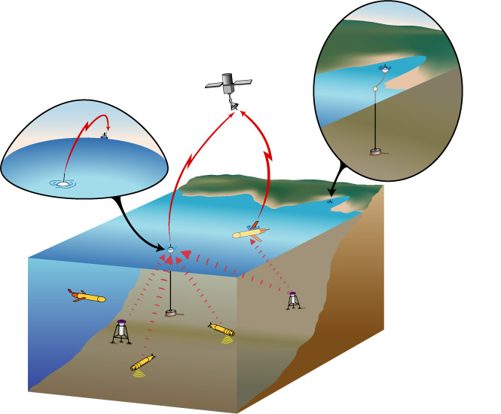
Figure 1. Conceptual view of a coastal region instrumented with sensors, gateways and vehicles.
Mission requirements vary considerably in terms of data rates, durations and the specifics of the assets being utilized, but most missions would utilize high data rates and long-range data links, if they were available. Given the constraints of the existing acoustic and RF telemetry capabilities, it is instructive to examine missions that can use gateway capabilities as they presently exist. With this philosophy in mind, five missions that would benefit from a general-purpose gateway platform were identified. In addition to these missions, several others were discussed in the working group, but they were either considered less important or broadly similar to those listed below. The primary missions that were examined in detail are:
- Intelligence, Surveillance and Reconnaissance (ISR)
- Explosive Ordinance Disposal/Mine Countermeasures (EOD/MCM)
- Tactical Surveys (hydrographic, bathymetric and meteorological)
- Distributed Large Area Network Surveillance
- Submarine Wireless Communications

Table 1 shows the requirements that were identified for each of these missions.
The RF surface links applicable to these mission scenarios include:
- Gateway to manned surface platform (ship, submarine at periscope depth, or shore facility)
- Gateway to aircraft
- Gateway to gateway
- Gateway to satellite
The subsurface acoustic links applicable to these mission scenarios include:
- Gateway to submerged instrument, sensor or navigation node
- Gateway to AUV or glider
- Gateway to submarine
Table 1. Mission Requirements Summary
 | ISR | EOD/MCM | Tactical Surveys | Large Area Surveillance | Submarine Gateway
Duration | Days to months | Hours to days | Hours to days | Up to 40 days | Hours
Delivery | Subsurface  Aircraft | Subsurface  Small boat  Aircraft | Subsurface  Surface | Subsurface  Surface  Aircraft | Submarine  Aircraft
Acomms Rate* | Low to moderate | Low to moderate | Low to moderate | Low | High
Acomms Range | 1-3 miles | 2-12 miles | Up to 12 miles | 2-5 miles | 1-6 miles
RF Rate | 1-10 kbps | 64 kbps | 64 kbps burst | 64 kbps burst | 2-20 kbps
RF Range | 20+ miles | LOS  OTH | LOS  OTH | OTH | LOS  OTH  Satellite
Latency Requirement** | Low | Moderate | Moderate | Low | Very low
Detectability | Clandestine | Clandestine or  Low visibility | Clandestine or  Low visibility | Clandestine or  Low visibility | Low visibility
Platform Options | Glider  AUV  Pop-up mooring | Glider  AUV  Pop-up mooring  Surface mooring | Glider  AUV  Pop-up mooring  Surface mooring | Glider  AUV  Pop-up mooring  Surface mooring | Surface drifter  Surface mooring
RF Contacts | 10-100 | 10 (long) | 10 | 10 (long) | 1 or several
Gateway Location | Harbors  10-300 ft | 10-300 ft | 10-300 ft | 150-1500 ft | >600 ft  Littoral
Network | Yes | Yes | Yes | Yes (100s) | No

* Low~ 100 bps; Low to moderate~ 100-1000 bps; High~ 2-20 kbps
** Very low~ Seconds; Low~ Few minutes; Moderate~ Tens of minutes

3. Gateway Platforms
The most difficult design issue for a general-purpose gateway platform is centered on its physical configuration and the methods used to deliver it to the operational area. Based on the workshop discussions, all of the operational scenarios had at least some requirements for clandestine deployment and operation, and this creates significant restrictions on the design. Most missions have some requirements for aircraft or small-boat delivery also. Potential gateway platform configurations include:
- Mobile powered or gliding autonomous vehicles
- Moored gateways with constant or intermittent surface presence
- Free-drifting surface buoys
The optimum choice of platform for each mission is determined by a number of factors besides those shown in the mission descriptions. These additional factors include issues such as cost, complexity, reliability and delivery methods.

3.1 Mobile Gateways
One promising approach to both collecting and telemetering data is the mobile gateway. These mobile platforms are capable of driving themselves into position from considerable distances, of staying submerged unless an RF contact is needed and collecting sensor data over a wide area. The mobile gateway may take the place of several fixed gateways, thus providing a cost advantage. The mobile gateway can also improve the range or reliability of the acoustic link by positioning itself at an optimal depth or moving to a more advantageous position for acoustic propagation.
Issues of control, reliability, deliverability and antenna placement are all of concern with the mobile gateway. Unit cost is also a serious issue, particularly in scenarios requiring large numbers of gateways.
Powered Vehicles [2] [3] [4]
AUVs are most suitable for use as mobile gateways when precision maneuvering is required. However, the endurance of small vehicles is typically between a few hours (at speed) and one day so they will normally be used for short missions. Existing small AUVs include, among others, the EMATT (Figure 2) and SUBMATT vehicles made by Sippican and REMUS (Figure 3), which as been developed at WHOI. The EMATT vehicle is A-size and REMUS is small enough to be deployed from many host platforms. Both have payload capability consistent with the gateway electronics modules, though the smallest vehicles will present challenges in antenna and acoustic transducer integration and battery packaging.

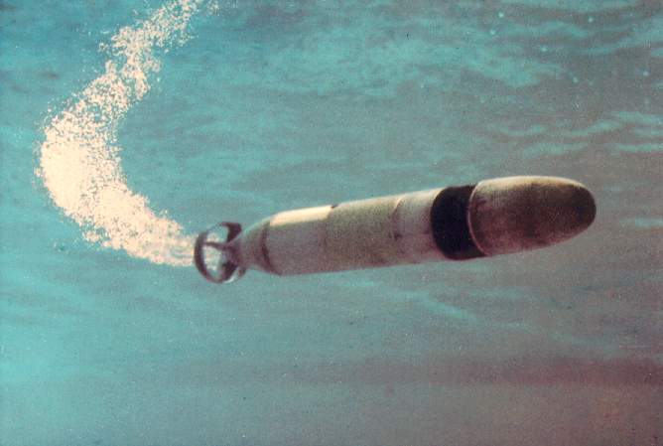

Figure 2. Sippican’s EMATT AUV

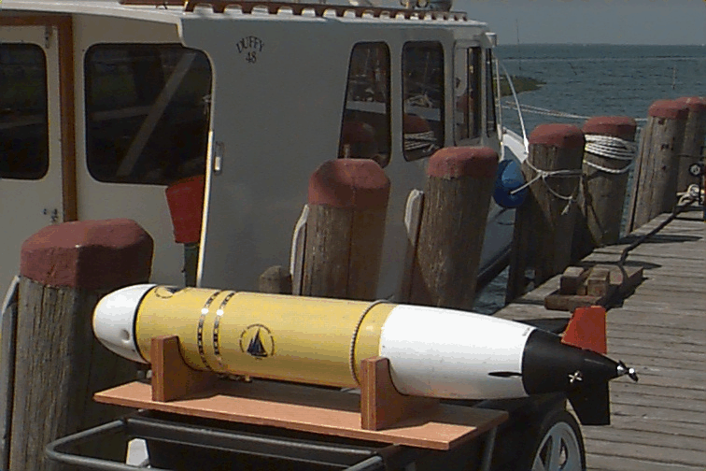
Figure 3. WHOI's REMUS docking vehicle

Gilding Vehicles [5][6]
Due to their endurance, gliders have optimal performance characteristics in deep water and for long duration operations where speed and precise maneuvering are not important (see Figures 4 and 5). Gliders are a very recent development in oceanographic research and they present more development issues than the other mobile platform options. While they appear to have suitable specifications for some missions, their ability to remain on location in high current, shallow water environments is limited. They may also be unsuitable for maneuvering in shallow, congested areas and may not be capable of remaining on station in confined locations.

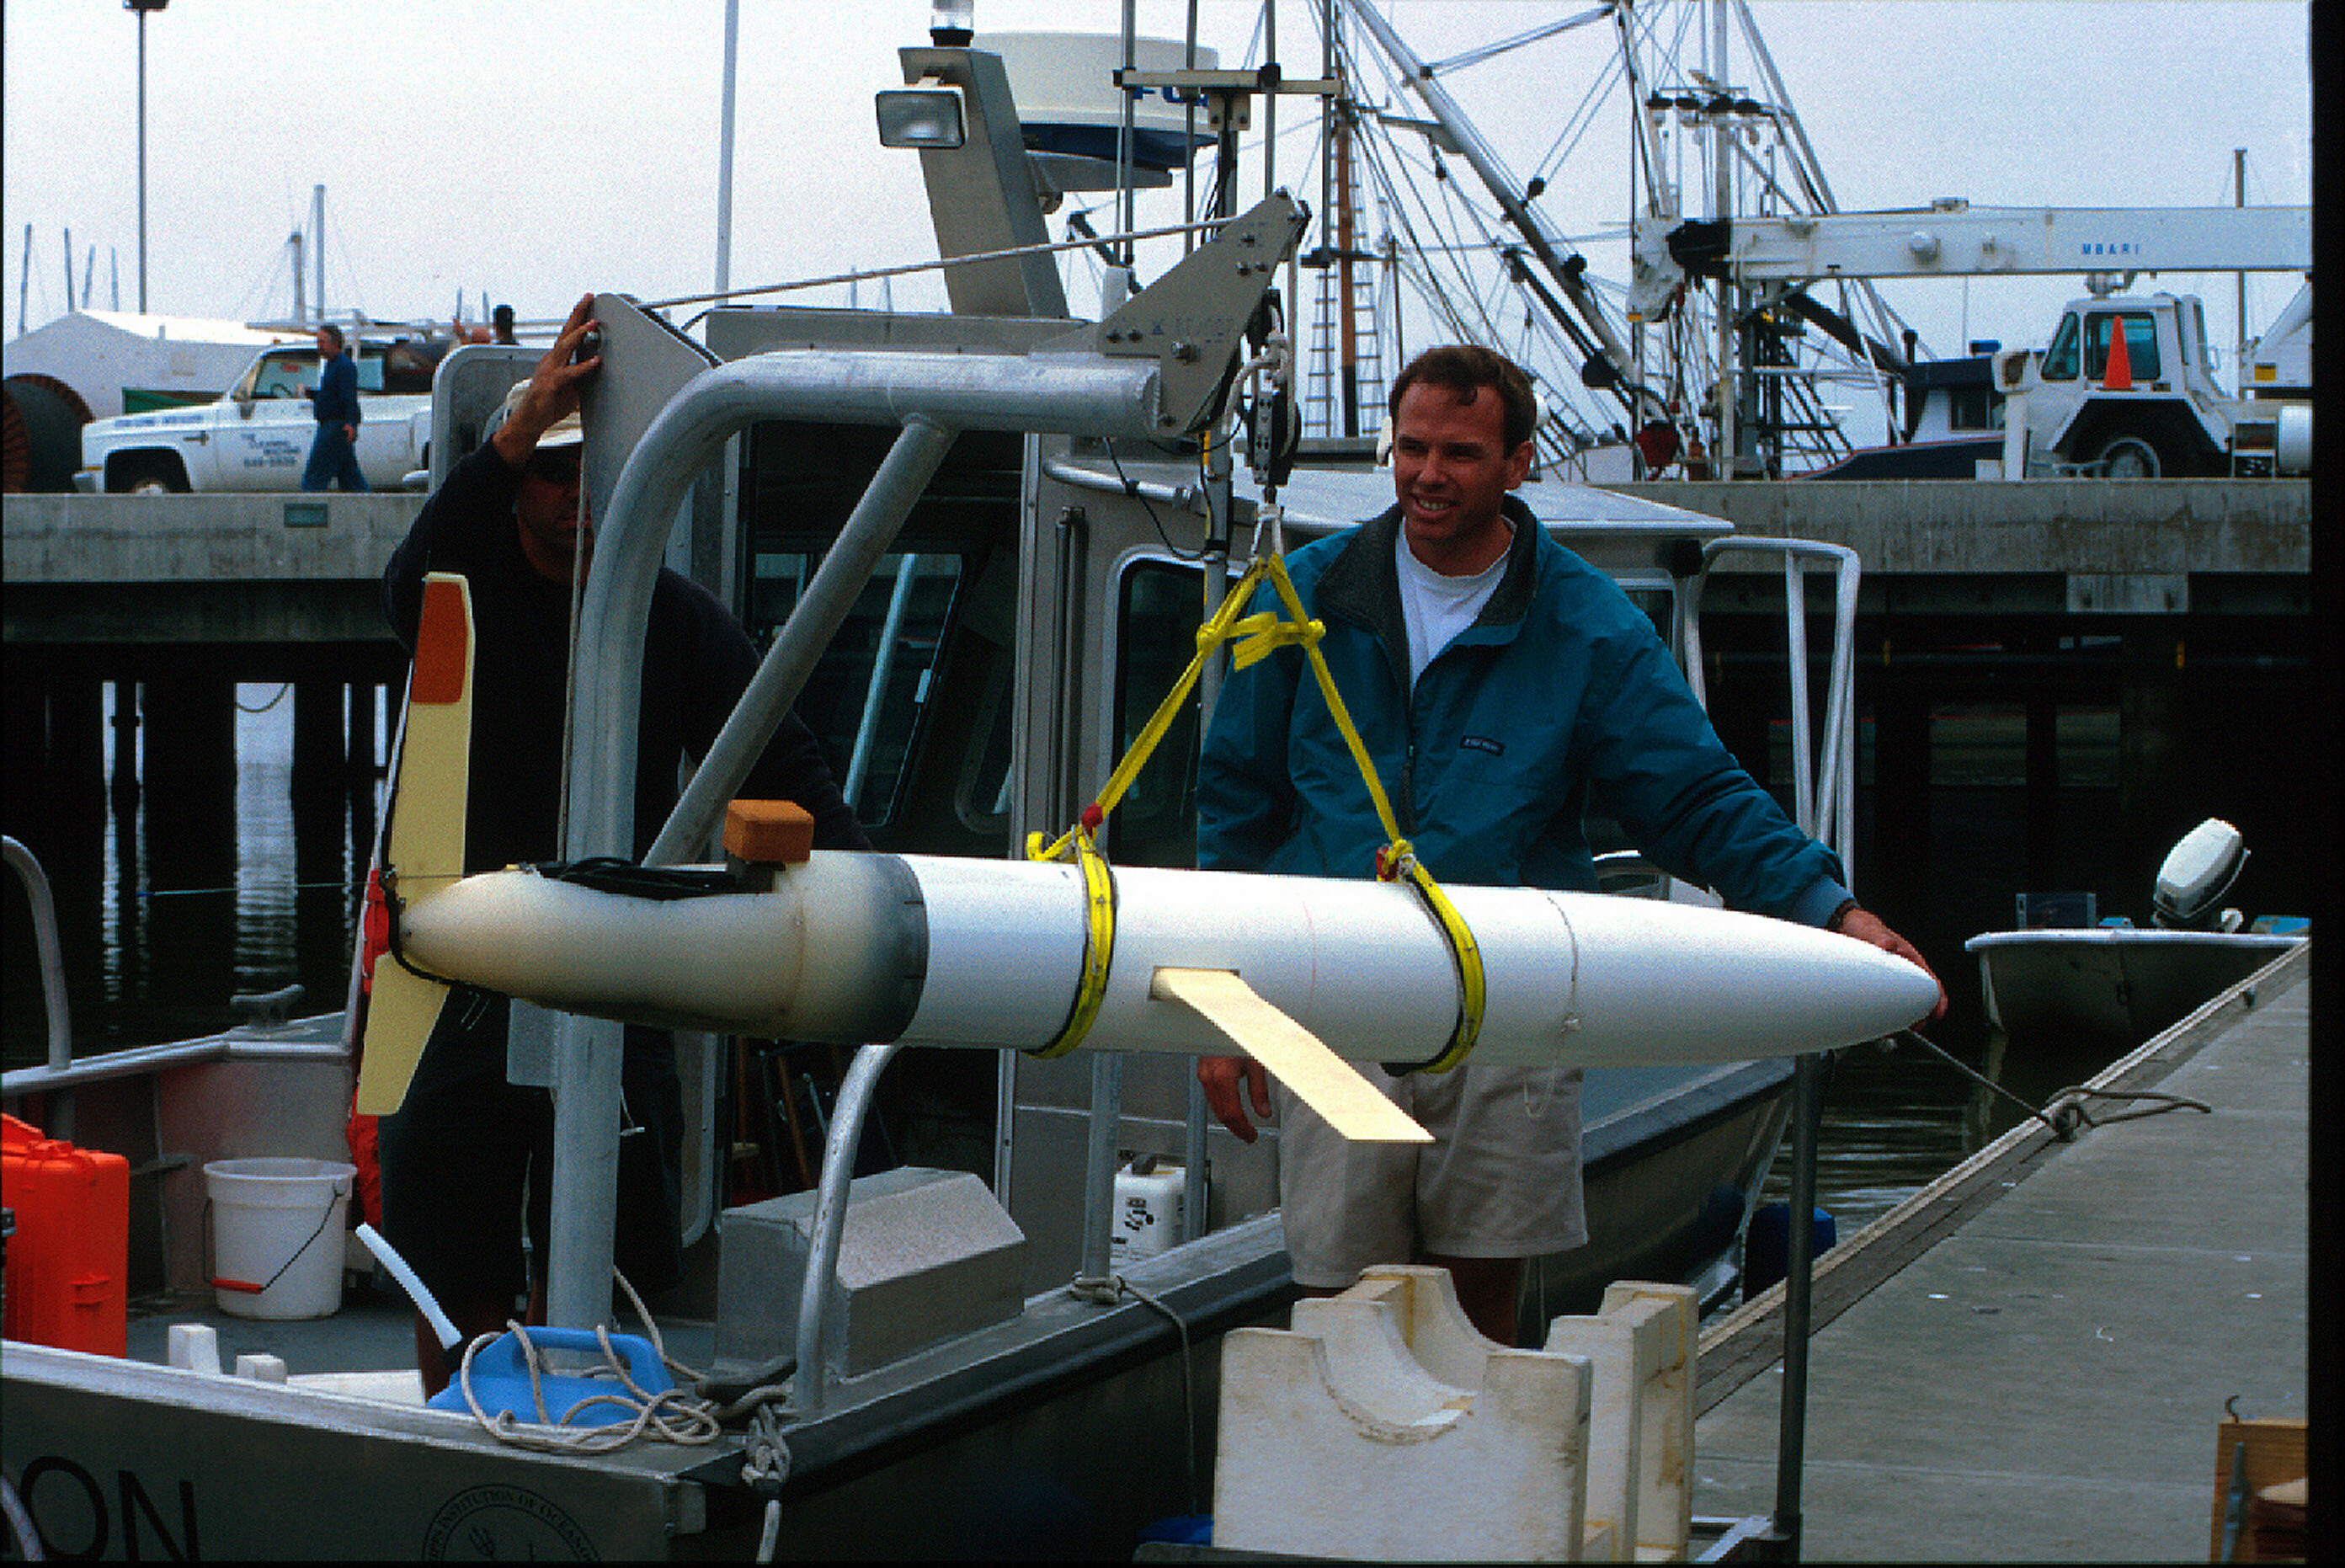
Figure 4. SIO/WHOI battery powered glider

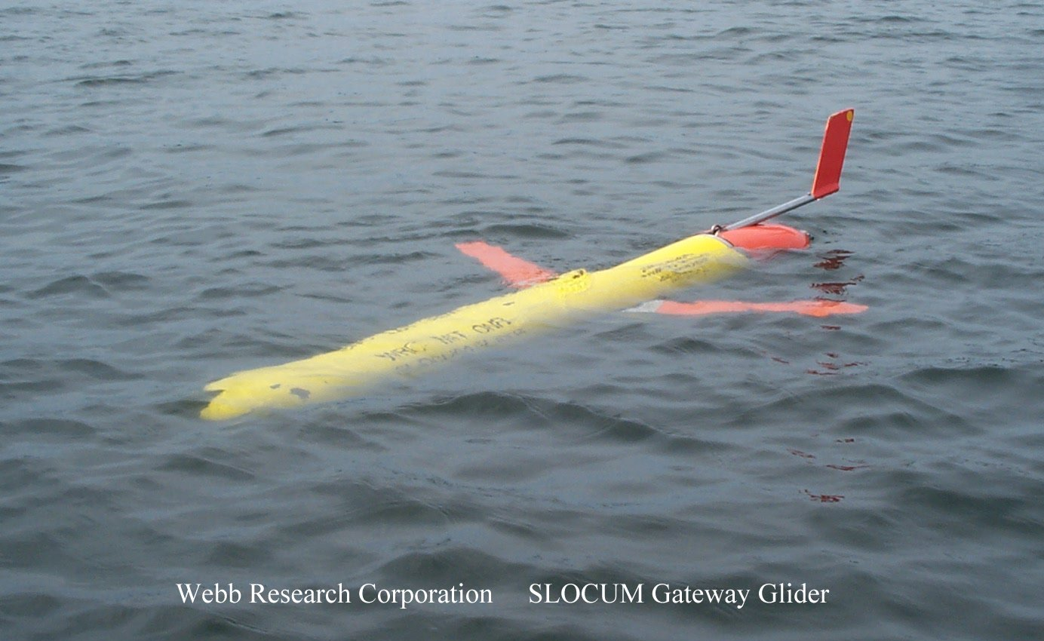
Figure 5. Webb Research environmentally powered glider

3.2 Moored Gateways
For missions where a fixed gateway is desirable, or where the cost and complexity of a mobile platform is unwarranted, a moored approach may be more appropriate. There are two gateway mooring options; conventional surface moorings and pop-up moorings that have intermittent surface expressions. With both approaches there are concerns about the mooring’s survivability in areas with heavy fishing pressure or concerted enemy removal efforts. High currents can also be a factor for very lightweight moorings.

Surface Moorings [7], [8], [9]
The surface mooring is the conventional solution for gateway platforms and has been used for many years in this capacity (Figure 6). Surface moorings are normally deployed using surface vessels, but they have also been deployed by aircraft in a few instances. The suitability for any given mission depends upon the mooring's design (water depth and life), and this in turn influences the weight and volume of the total system. Large buoys have the capability to be moored in deep water (>3000 ft), but are difficult to deploy by air. Small surface buoys such as the one shown in Figure 6b can be deployed by small boats and may operate in up to 3000 ft of water. They have been used as gateways for several science programs.

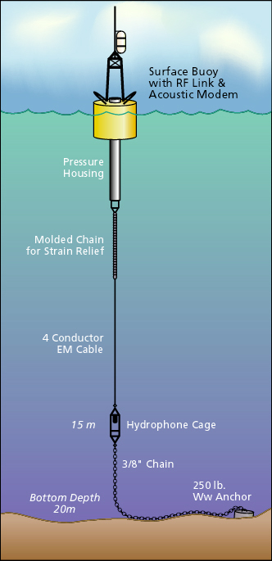 | 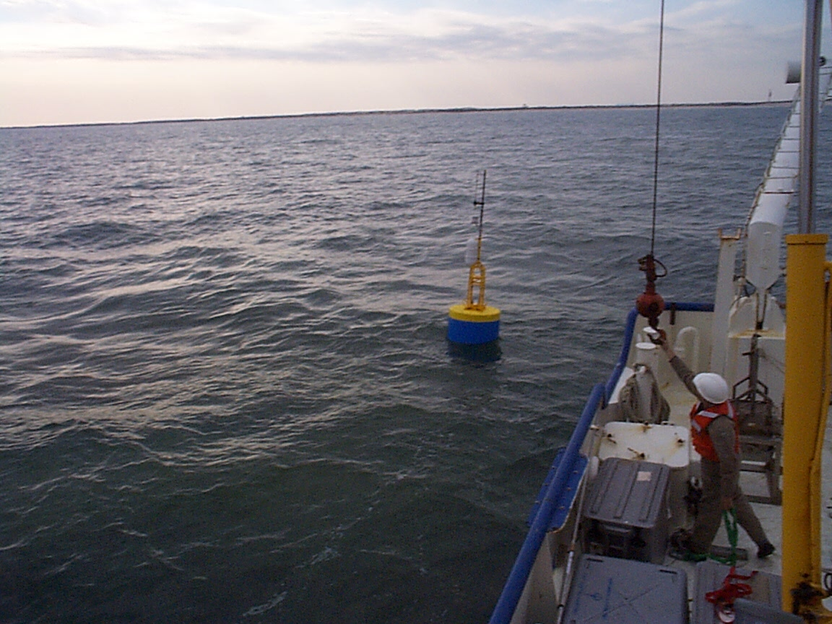
Figure 6a. Schematic of a small surface mooring that functions as a gateway. | Figure 6b. A surface mooring very similar to the drawing in 6a deployed as a gateway in the Gulf of Mexico.

Air deployable surface moorings (for shallow water) are available from at least one sonobuoy vendor in an A-size form-factor [10], which suggests that such a gateway may be feasible. A somewhat larger (B-size), longer-life (3 month), self-deploying surface mooring was also developed at WHOI [11], but was never packaged for air deployment (Figure 7). It is clear that a wide range of surface moorings can be developed to meet the mission requirements in Table 1, and that their performance depends primarily on the allowable size and weight of the overall package. The A-size, air-deployed mooring with a small inflatable buoy would probably see wide usage, if it were available and capable of operating in shallow water for a few days to a few weeks. Figure 8 shows an A-size sonobuoy with its major components identified.

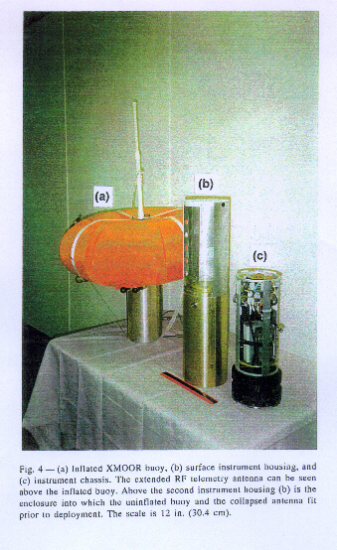
Figure 7. The XMOOR expendable surface mooring developed at WHOI.
Figure 8. An A-size sonobuoy from Undersea-Sensors.

Pop-Up Mooring [12] [13] [14] [15]

There are two clear advantages to pop-up moorings over conventional surface moorings. One, pop-up moorings are clandestine when submerged (which may be most of the time), and two, they stay out of the most serious wave action most of the time, which means that they can be designed for fewer load cycles. Pop-up moorings of several types have been designed and built, however, to date none have combined ease of delivery and small size with reliable operation in the coastal environment. The primary design issues with the pop-up concept are the number of up/down cycles required (an energy issue) and the need to self-deploy from a small package that can be delivered in a number of ways. The size issue is particularly driven by water depth requirements, mission durations and time varying currents. The more benign the environment, the smaller a pop-up design can be and still be effective.

3.3 Drifting Gateways
A sonobuoy equipped with an acoustic modem and suitable RF module is an air-launched drifting gateway. This system may be useful for short-lived applications where it is necessary to retrieve data from underwater systems without surface expressions, such as large-area surveillance arrays or submarines. A version suitable for submarine deployment via the 3-inch launcher or trash disposal unit (TDU) would float at the surface for a few hours and provide combined acoustic and RF telemetry. This design is both feasible and potentially very useful, and would be similar to the so called Slot Buoy that is preloaded with data on a submarine and then sent to the surface where it transmits via UHF to satellite.

3.4 Gateway Power
Power for both acoustic and RF transmission in a gateway platform is typicallyof the order of 10-15 Watts while power for reception is about an order of magnitude less. Standby power is typically another order of magnitude down. The hardware, including a special purpose controller that links the existing acoustic and RF modems, can probably be designed to fit in a 4.25-in ID tube that is 12 to 18-in long. Antennas and transducers can probably be made to fit in a similar volume. Battery volume depends on the duration of the system operation, the duty cycle of the transceivers and the battery chemistry. As an example, 7 lithium D cells fit in about 2.5- in of a 4.25 in diameter housing and contain about 350 watt-hours of energy. For an operation where the transceivers are operating in receive mode for 10% of the time, in transmit mode for 5% of the time and in sleep mode the rest of the time, a gateway with 7 lithium D cells would last a week or two. Most of the mission durations discussed during the workshop would fit within this window. The longest mission duration identified was 40 days of low data rate operation, which might require 2 or 3 times this power (for telemetry).
Power to cycle a pop-up buoy to the surface depends on the cycle depth, the buoyancy change needed to surface in the face of horizontal current drag forces, and the efficiency of the system. As an example, if a buoyancy change of 30 pounds is required to operate over a depth of 30 feet, a total energy expenditure of 900 foot pounds is required. If one assumes an overall efficiency of 25% including the re-submergence energy needed, then 10 cycles requires 36,000 foot pounds of energy, or about 14 watt-hours, and 100 cycles require about 140 watt-hours, or about the energy equivalent of 3 lithium D cells. Given the short duration of most of the missions, the mooring components themselves can be very lightweight and can probably be packaged in a small volume. An air-deployed version of the pop-up mooring would be useful in a variety of operational scenarios. However, it will be a challenge to design a reliable pop-up mooring with gateway electronics and 10 to 100 cycle capability in an A-size package for any but the most benign environments.

4. RF Communications Module

Assumptions
The RF Communications working group proceeded on the assumption that the need for data telemetry was primarily in coastal operations (out to 120 miles), not in the open ocean. Range, power, equipment and operating costs, and size and weight were considered to be significant factors. Other, hard to quantify considerations were reliability, robustness, and adaptability to clandestine operations.
A wireless LAN, using TCP/IP protocols, with every gateway platform, vehicle, and shore facility acting as a node on the network is the network structure that was envisioned. (In other words, a wireless Internet.) However, for the workshop discussions the focus was placed on point-to-point links.

Capabilities
The Capabilities Matrix (see Table 2) summarizes the characteristics of five options that were identified for RF data communications within the coastal zone. The options considered were:
- High Frequency ground wave (HFGW)
- Line-of-sight UHF (LOS)
- Line-of-sight UHF with aircraft destination/reply (LOS w/ relay)
- L- and C-band satellite
- UHF military satcom
Only one of these options, LOS, is limited to short range (6 to 12 miles), depending on antenna heights. LOS w/ relay and HFGW have ranges up to 120 miles, and the two satellite options (L/C band and UHF satcom) are, of course, very long range. Another option that was not discussed by the panel, but was suggested by K. von der Heydt is spread spectrum (SS) VHF. Oddly enough, with all the emphasis on SS in the ISM (Instrumentation, Scientific and Medical) and cell phone bands (UHF), the VHF band may be underutilized. The necessary VHF hardware exists in the fleet infrastructure for ASW purposes. As an example, P3 antennas could be adapted for bi-directional operations in the sonobuoy band. If the data rate of VHF SS is scaled from typical UHF SS systems such as the Freewave [16], which operates in the 26-915 MHz band, then the VHF band (~ 4.5 -160 MHz) might well support a 4 kb/s SS link, allowing multiple channel use similar to the Freewave-like systems. In comparison, when scaled to a standard 375 kHz bandwidth sonobuoy channel, the estimated data rate would be about 1200 bps versus a 56 kbps Freewave link.
Given all factors, and aiming at the greatest flexibility, the preferred gateway options are the HFGW and the LOS w/ relay. In terms of development, both of these options represent moderate risk.
Table 2. RF Capabilities Matrix
 |  | HF Ground Wave | Line-of-Sight UHF | Line-of- Sight to aircraft | L/C band satellite | UHF Satcom*
Range |  | 120 miles | 12 miles | 120 miles | Global | Global
Frequency |  | 50-100 MHz | 915 MHz, 2.4GHz | 915 MHz, 2.4GHz | L-band 1.6 GHz C-Band 4-6 GHz | 240-270MHz downlink 290-320 MHz-uplink
Power: Joule/bit |  | 2 | 0.6 | 10 | 100 | 20-40
Peak |  | 20 W | 6 W | 30 W | 20 W-100 W | 20 W
Two-way |  | Yes | Yes | Yes | Yes | Yes
Covert option |  | Yes | Yes | Potentially | Unlikely | Unlikely
Weight/size |  | 5 lb., 50 cu. in. | 1 lb., 13 cu in. | 1 lb., 13 cu in | 2 lb., 30 cu in.
Latency |  | 0 | 0 | 0 | L-band – a few min C-band – ~0 | 0
Antenna |  | Package for launch ~50 cu in deployed | Omni – 1.5' on 6' mast | Omni – 1.5' on 6' mast | L-band small (preferred) | 6-inch tube
Risk |  | Antenna – Low-Mod Propagation – Low-Mod Tested but unproven | Very low | Aircraft antenna – Mod | C-band not yet COTS | Can’t get channels
Availability |  | In development – not COTS | COTS | Aircraft antenna? Power amp? Transceivers are COTS | C-band not COTS | COTS
Data rate:Burst |  | 100 kb/s | 56 kb/s | 56 kb/s | 100-100 kbyte/day | 2.4 Kb/s
Coverage |  | Local | Local | Local | Global - non-polar | Global - non-polar
*Comments: Military UHF systems may be useful if dedicated channel assignment is possible for gateway use, which is the only way that Demand Assignment Multiple Access problems could be avoided.

Development Issues
The main development issues for the preferred RF options are:
- Collapsible HF antennas and system integration for HFGW transceivers.
- LOS aircraft relay system integration and antenna installation.
In both cases, if deployment from a submarine is required, then the deployment packaging and certification is also an issue. Packaging here assumes that the system can be launched through either the 3-inch tube or the trash disposal unit (TDU) on a submarine. If a system is airdropped or deployed from a surface craft, packaging is less of an issue. The HF antennas are probably the most difficult item in terms of packaging, but this problem seems addressable in the near term. Apart from the preferred options, there are development and integration issues with both potential L-Band and C-Band satellite systems, as noted in the Capabilities Matrix.
There are two development issues that are independent of the wireless option chosen.
- Standards - Intra-platform communications, which addresses the desire for plug and play modularity.
The working group assumed that a gateway platform could be viewed as being made up of a command/control module, an acoustic communications module and a wireless communications module. The intra-platform communications should be standardized and the modules should be plug and play to the extent possible. That is, it should be possible to make a choice of a wireless mode based on the location, data rate, etc. and plug in the appropriate module, without having to go through an elaborate configuration process each time. Many on the panel saw RS-232 as a simple standard for intra-module communications. However, a platform-local Ethernet may be a more promising approach and it may work more seamlessly with the inter-platform networking discussed in the next item.
- Multiple-node platform and vehicle networking
Although, as noted above, point-to-point wireless communications was the focus of the discussions during the working group sessions, there was general agreement that it is important to develop true multi-node, routed networking among gateways, autonomous vehicles, surface vessels, submarines, aircraft, and shore-based installations. This is essential in the future utilization of gateway platforms in a network-centric battlespace. In other words, a local Internet (with or without a gateway to a wider area Internet) was envisioned using standard or modified TCP/IP protocols. An important point here is that any extra-platform communications protocols should not be designed with simple point-to-point applications in mind so that obstacles for future multiple-node networking can be avoided. The Navy is developing policies and standards for wireless radio-LANs. People involved in that effort should be contacted to avoid duplication of effort and to insure interoperability. A good point of contact in this arena is Rex Buddenberg at the Naval Postgraduate School in Monterey, California (budden@nps.navy.mil - 831-656-3576).

5. Acoustic Communication Module

Assumptions
It was assumed in the Acoustic Communications working group that gateway platforms would by necessity be relatively small. The acoustic modem module sizes that were considered included:
- A-size sonobuoy package (4 7/8-in OD by 36-in long)
- Submarine Trash Disposal Unit (TDU) size
- Submarine 3-in launcher size (3-in OD by up to 38-in long)
Based on these constraints and the size of existing electronics used for several commercial and research acoustic modems [17], [18] and [19], the following size specifications were suggested as reasonable:
- A-size: about 4-in maximum width
- 3-in launcher: about 2.5-in maximum width
- Length (typical): about 5 inch (1 channel)
- Length (max): about 10 inch (8 channels)
Assuming the use of standard, inexpensive ceramic, the following notes may be made about the projector:
- A-size: 4.5-in ceramic yields 8 kHz resonance.
- 3-in launcher: 2.75-in ceramic yields 13 kHz resonance.
- Higher frequencies are easily supported; lower frequencies require plot-cylinder transducers or other designs.
It should be noted that there are other options available for acoustic sources, in particular composite technologies. However, the cost of these technologies may be considerably higher than conventional ceramics.
The receive sensor used for the gateway acoustic modem in the proposed platforms might be:
- Same ceramic as the projector in minimum-sized package.
- Several omni-directional hydrophones mounted on a vehicle.
- Multi-element vertical array for a moored buoy. (Note: an 8-element, 25-ft array is packaged in less than 12 inches within an A-size sonobuoy tube.)
Based upon discussions of existing systems and with some extrapolation to what might fit into the proposed platforms, the power required by the acoustic modem falls into these ranges:
- Power (peak/transmit): 10-100 W RMS for packet length of 1-10 seconds
- Power (receiver): 0.2-5 W. Power scales with capability and thus is application-dependent.
- Power (standby mode): several mW or less.
The proposed data interface is RS-232.

Capabilities
The performance of the acoustic link depends upon many factors, including source level, receive array aperture, propagation conditions, Doppler shift and spread, background noise, etc. However, in order to assist in developing applications, the following rules of thumb were agreed upon for primarily horizontal links in the 7-20 kHz frequency band. The link metric used was 90% or higher packet success, meaning that 90% or more of the packets are received error-free, after error correction.
- VSW (10-40 ft) maximum range may be about 3 miles.
- SW (40-600 ft) maximum range may be about 6 miles.
However, it should be noted that maximum ranges of 0.5 miles (or less) have been observed in shallow water or very shallow water under difficult propagation conditions.
Increasing the range of a point-to-point link requires lowering the frequency. It has been shown that ranges of 10-20 miles are possible under ducted conditions at 3-5 kHz. However, signals in the 3-5 kHz band are also detectable at long ranges. Links of 12 miles using the 7-20 kHz band require multiple-hops. If the closest node is 1 mile offshore, 4 hops of about 3 miles each are required for a 12-mile link. It should be noted that an LPI requirement might reduce the maximum range and rate, as well.
Achievable burst rates are very difficult to estimate. However, a rough guide is:
- 50-150 bps at the maximum ranges noted above, or in difficult channels, with a single receiver.
- 150-1000 bps at close range, or in an easy channel, with a single receiver.
- 1000-10,000 bps may be possible using a multi-element vertical receiver array under favorable conditions.
The energy efficiency of the link is estimated to lie in the following range.
- 1 bit/Joule at maximum range or in a difficult channel.
- 100 bits/Joule at close range or in an easy channel.

Navigation
During the navigation discussions, the following points were made:
- An LBL beacon capability should be an integral part of an acoustic modem.
- The modem should also be capable of operating as an USBL homing beacon.
- Synchronous acoustic navigation is an option, if needed, though it will require accurate clocks or a surface expression to collect GPS timing signals.

Networking
The physical layer (modem hardware/firmware) must support the data layer and the network layer. In addition, the hardware (transducer and DSP) is presumed to be able to handle the required network software and protocols.

Transducer Positioning
The location of the transducers in the water column is very important in determining acoustic communication performance. Modems on AUVs or pop-up moorings can operate at the depth that maximizes range. Moored modems may need to span a large fraction of the water column for optimal results. It should also be noted that AUVs might be able to close range to increase data rate in some scenarios.

6. Test Plans

6.1 Gateway Development
The Platform working group briefly addressed the structure of a test or demonstration plan for newly developed gateways. The concept of the proposed test plan was to simulate the operational use of gateways in a 2-phased approach. In phase 1 the functionality of a single gateway would be tested in a realistic environment. For example, a gateway might be deployed from a small boat in the coastal environment for a duration equal to the operating scenario. It would be required to operate in a realistic way, for example, forward acoustic messages from a number of deployed sensors to an OTH ship. If surfacing was one of its functions, it might have to surface on demand 10 times over the course of the demonstration. A phase 2 test would be aimed at two more complex aspects of the gateway design, which are delivery methods and networking. As an example, a phase two test might include half a dozen gateways that are fully networked and deployed via subsurface and air-launched means. They would be expected to self-navigate to their specified locations and autonomously begin to transfer data. Adaptive behavior, such as adjusting the acoustic telemetry rate or moving closer in the case of an AUV to improve communications, would be part of the phase 2 demonstration.

7. Conclusions
The workshop participants and facilitators came to the following conclusions during the meeting and during subsequent discussions concerning how gateway platforms should be conceptualized and how development should be prioritized.
First, existing acoustic modems, such as those in use at WHOI and those produced by Benthos, have the capabilities needed by first generation gateway platforms. Development of adaptive versions of these modems should be pursued along with packaging for use with gliders, AUVs, and small moored systems.
Second, present COTS LOS UHF radio links, such as Freewave modems, can be used for LOS or OTH (with aircraft relay) applications. Implementations with special purpose controllers and special antenna configurations need to be developed. Ground wave HF transceivers and L/C band satellite transceivers that are optimized for low power and small antennas need to be investigated more fully to determine the best approach for OTH situations where aircraft relays are impractical or too costly. The major issues here are packaging, power, antenna size, and data reliability.
Third, existing glider and AUV designs need to be configured with gateway electronics and acoustics to test how they work in operational scenarios. Pop-up moorings that self-deploy need to be developed for use in VSW. These moorings need to be packaged for diver and aircraft deployment. The aircraft version would also be useful in deeper water. An aircraft version (A-size) of a low-cost surface moored gateway should be developed for applications requiring widely spaced gateways that are not too sensitive to detection issues.
Fourth, a network topology needs to be defined that will allow gateways and sensors of all types to operate in various configurations with a variety of data rates and duty cycles. The Freewave RF modems may provide a reasonable model for this network definition. An internet-based TCP/IP protocol is recommended for the network with a simpler, but well-defined interoperability standard(s) for the acoustic communication subnet. A first generation acoustic interoperability standard is in place and has been implemented on the WHOI and Benthos acoustic modems.

8. References

[1] http://www.whoi.edu/science/AOPE/ael/webonrwk/workshop_home.htm

[2 ] Purcell, M., C. von Alt, B. Allen, T. Austin, N. Forrester, R. Goldsborough and R.
Stokey, New capabilities of the REMUS autonomous underwater vehicle, Proc. Oceans'
2000, pp. 147-151.

[3] http://www.sippican.com/underwater_vehicles.html

[4] http://auvserv.mit.edu/OdysseyIIb.html

[5] http://www.webbresearch.com/slocum.htm

[6] http://www.ocean.washington.edu/research/glider/project.html

[7] http://woodshole.er.usgs.gov/operations/coastobs/

[8] http://nopp.uconn.edu/Proposal/index.html
river
[9] Austin, T. C., R. P. Stokey and K. M. Sharp, PARADIGM: a buoy-based system for
AUV navigation and tracking, Proc. Oceans' 2000, pp. 935-938.

[10] http://www.sparton.com/sparton.htm

[11] Frye, D. and J. Boyd, Expendable oceanographic mooring-XMOOR, Sea Technology,
Aug. 1996, pp. 61-65.

[12] Ware, J., D. Frye and K. Doherty, An active oceanographic mooring, abstract in EOS
Transactions- Ocean Sciences Meeting- Jan. 24-28, 2000, p. 74.

[13] Tyce, R. F. de Strobel, V. Grandi and L. Gualdesi, Trawl-safe profiler development at
Saclant Centre for shallow water environmental assessment and real time modeling, Proc.
Oceans' 2000, pp. 99-104.

[14] Bocconcelli, A., ed., Real Time Environmental Arctic Monitoring (RTEAM), Woods
Hole Oceanographic Institution Tech. Rpt. WHOI-87-50, 1987.

[15] Dahlen, J. and R. Araujo, Pop Up Buoy, CSDL Proposal No. 6-329, Charles Stark
Draper Laboratories, Inc., 1986.

[16] http://www.freewave.com

[17] Freitag, L., M. Grund, S. Singh and M. Johnson, Acoustic communication in very
shallow water: results from the 1999 AUV Fest, Proc. Oceans' 2000, pp. 2155-2160.

[18] http://www.benthos.com/

[19] LeBlanc, L. R., M. Singer, P. Beaujean, C. Boubli and J. R. Alleyne, Improved chirp
FSK modem for high reliability communications in shallow water, Proc. Oceans' 2000, pp.
601-603.

