Draft Science Plan

Quantifying, Predicting, and Exploiting Uncertainty (QPE)

Office of Naval Research, Directed Research Initiative (DRI)

I. Goals and Objectives

The assessment of uncertainty in observations and predictions of the propagation of sound in littoral regions is a complicated problem. The issues are inherently multi-scale and multi-disciplinary, involving acoustics, geoacoustics and ocean bottom properties, and physical oceanographic processes. Despite the challenges, a number of new techniques developed during the recent ONR Capturing Uncertainty in the Tactical Environment DRI offer attractive possibilities for quantifying and predicting uncertainty. The intent of this program is to use combined modeling and field observations over the continental shelf and slope northeast of Taiwan in order to apply these new techniques. We will concentrate on low-frequency passive acoustics - in particular, propagation (transmission loss), ambient noise, and temporal-spatial coherence.

Among the new techniques developed for quantifying and predicting uncertainty are Predictive Probability of Detection (PPD), adjoint ocean modeling, coupled acoustic-oceanographic data assimilation, and custom climatologies. This program will use numerical models to assess the likely impact of various ocean and geological processes (seabed variability) on passive acoustics. Field observations will be used to directly assess the uncertainty relative to model predictions. We will place quantitative bounds on the uncertainty of the ocean and seabed environment in the chosen region as well as its impact on low frequency transmission loss, ambient noise, and coherence. We will evaluate predictions of uncertainty from oceanographic and acoustic models. Finally, we will exploit knowledge of the oceanographic and seabed uncertainty to enhance acoustic performance for passive sonars in the frequency range of about 100-1000 Hz.

This program will be done in close cooperation with scientific colleagues from Taiwan. We note that Taiwanese scientists have worked in this geographical region for some time and are generously sharing their insights in planning this program.

II. Science Questions
- How large are uncertainties in transmission loss over the continental shelf and slope? While there are a wide variety of oceanographic and seabed processes in the region, a fundamental question is how large are the spatial and temporal uncertainties in transmission loss. The region encompasses a variety of settings, including shelf and slope environments, a branched canyon and a single-channel canyon, and a range of bottom types (described below). A careful set of experiments using both fixed and mobile source-receiver geometries will be necessary to evaluate the uncertainty in the full range of settings in this area. Chen et al. (1985) have already shown that cold-core eddies in this region have a large impact on transmission loss.
- What are the ambient noise levels and directionalities in this region? This region contains active fishing fleets, which are expected to be an important source of ambient noise in this area. An important issue is the degree to which water column variability influences the spatial and temporal characteristics of ambient noise (e.g. the noise notch).
- What are the dominant mechanisms and relative contributions of environmental uncertainty to transmission loss and ambient noise? In addition to quantifying the uncertainty in transmission loss, it is important to determine which aspects of acoustic propagation contribute the most to uncertainty. This includes bottom reflection/scattering, ambient noise, range-dependent effects associated with fronts and eddies, and scattering from internal waves and tides. Abbot et al. (2006) have analyzed the relative contributions to uncertainty in other regions of the East China Sea.
- What is the structure and variability of the Cold Dome over the outer continental shelf northeast of Taiwan? The Cold Dome (Figures 2, 3) is a relatively cool region northeast of Taiwan. As such it is the ambient water mass over the outer continental shelf. It appears that canyons may serve as conduits for deep, cool water beneath the Kuroshio to be carried onto the continental shelf (Tang et al., 2003). Because of the difficulty of keeping moorings out over the continental shelf due to intense fishing activity, there are gaps in our understanding of the variability and structure of the Cold Dome and its impact on acoustic propagation over the outer continental shelf.
- How predictable are Kuroshio excursions onto the continental shelf in this region? Thermal imagery suggests that Kuroshio flows extend over the continental shelf in this region. Near-surface drifter tracks (P. Niiler) show direct pathways from the Kuroshio to the outer continental shelf. Preliminary modeling work (B. Cornuelle, J. McClean) suggests that maximum correlations with onshore Kuroshio excursions onto the shelf occur for sea surface height gradients east of Taiwan near the southern end of Taiwan. This implies that there may be predictability of onshelf motions of the Kuroshio if proper observations are made upstream in the Kuroshio.
- How predictable are internal tides and internal waves in this region? Both baroclinic and barotropic tides are strong over the continental shelf northeast of Taiwan. Hsu and Liu (2000) note that there appear to be a variety of source regions for internal wave packets viewed from Synthetic Aperture Radar (SAR) in this region. There is not much information on typical internal wave amplitudes or directionality in this region. Similarly, the large variations in stratification associated with the Kuroshio suggest that there may be trapping of baroclinic tidal energy shoreward of the Kuroshio, analogous to observations further to the northeast (Rainville and Pinkel, 2004). Model results suggest that there are large spatial variations in the baroclinic tidal energy fluxes in this region (Jan Sen).
- What are the uncertainties in bottom geoacoustic properties over the outer shelf and continental slope northeast of Taiwan? The outer shelf and upper slope northeast of Taiwan contain a variety of bottom types. Near northern Taiwan and Taiwan Strait, there are large sand waves and large sediment deposition rates from rivers flowing into Taiwan Strait. Over the continental slope, there are fine-grained sediments carried by the Kuroshio. The transition zone between the sandy sediments of the continental shelf and the muds of the continental slope is expected to be complex due to the glacial history of the shelf as well as the many canyons in the region. A further complication is the possible presence of gas deposits, which have a large anomaly in soundspeed beneath the seabed. Characterization of the spatial distribution of bottom types and geoacoustic properties is necessary along with associated uncertainties.
- How do uncertainties in bottom geoacoustic properties and morphology affect uncertainty in acoustic performance prediction? In bottom limited regions, uncertainties associated with the geoacoustic properties can lead to large uncertainties in acoustic performance prediction. An important question is how to represent three-dimensional geoacoustic uncertainties in a general range-dependent framework and how to obtain the requisite data to quantify the geoacoustic uncertainties. Uncertainties in seabed shape (bathymetry) typically have a minor effect on acoustic uncertainties on the shelf, but can have a large impact on acoustic uncertainty in the slope and canyon areas.
- How do oceanographic processes over the outer shelf and upper slope in the East China Sea affect uncertainty in acoustic performance prediction? We anticipate that a number of oceanographic processes on a wide variety of space and time scales will affect uncertainty in acoustic performance prediction. On larger scales, the structure and spatial extent of the Cold Dome creates frontal structures and lateral gradients in soundspeed that creates uncertainty in acoustic performance prediction. Similarly, intrusions of Kuroshio water onto the continental shelf also imposes gradients in the vertical position and gradients within the thermocline that affect acoustic propagation. For high frequencies, observations in a number of other regions including the South China Sea show that the timing and amplitude of internal wave packets and internal tides contribute to uncertainty in acoustic performance prediction. Using real-time data from thermistor chains or drifting buoys allows the possibility of predicting the arrival of non-linear internal wave packets. The effects of wave packets may increase acoustic uncertainty and there may be focusing effects which depend strongly on knowledge of the propagation direction for the internal waves.
- How can knowledge of the spatial structure or temporal shifts in uncertainty of acoustic performance prediction be exploited to improve passive acoustics signal–to-noise ratios? This is a general question, but in each of the cases above it is important to determine how timing or geometry of different processes can be used to enhance the signal-to-noise ratio in acoustic propagation. More specifically, we wish to determine how estimates of environmental variables which include the error fields as well as statistical knowledge of spatial and temporal variability and the corresponding uncertainty in the signal-to-noise ratio can be used to increase detection ranges for passive acoustics.

III. Research Themes

The oceanographic and geological processes in this region are complex and not fully explored. The Kuroshio is the source of strong currents over the continental slope that extend onto the continental shelf, along with associated eddy formation and meandering. The Kuroshio turns from a generally northward to a northeastward orientation as the topography changes orientation. A complicating factor is the presence of a number of canyons in the region (Figure 1). Keelung Canyon is narrow and very close to the northern coast of Taiwan. Mien-Hua Canyon is further offshore and consists of one major channel extending onto the shelf. North Mien-Hua Canyon is the most complicated, with four separate branches over the continental shelf merging into one channel over the continental slope. In order to address the uncertainties associated with processes affecting acoustic propagation, four major research themes are required.

III.1. Shelf/Slope Processes and Kuroshio Interactions

Expected contributors to the ocean environment uncertainty fields are the oceanographic processes over the outer continental shelf and upper slope (Figure 2). These include possible up-canyon flows that may supply the Cold Dome (Figures 2, 3) and drive local circulation over the shelf, excursions of the Kuroshio onto the shelf, and internal tide and internal wave generation. Each of these processes is expected to modify the local sound velocity profile and introduce range-dependent effects. Because of the large advective influence of the Kuroshio, the local stratification may vary over relatively short time scales, which in turn impacts the structure of the internal tides and internal waves as well as modulating the bottom attenuation of acoustic energy. An interesting possibility is that the Kuroshio may serve as a barrier for offshore propagation of internal tidal energy, so that there may be areas in which the energy is trapped and large amplitude waves may result.

III.2. Geoacoustic Properties and Seabed Characterization

The area of interest encompasses a variety of geological environments. Processes affecting the seabed include riverine inputs, erosion enhanced by seismicity, and sediment transport across the East China Sea shelf from the Yangtze and Yellow Rivers. Biogenic material is abundant at the shelfbreak and upper slope, and muddy sediments associated with upwelling contain planktonic forminifera and pteropod shells. The East China Sea shelf is strongly shaped by glacio-eustasy, with alternating continental and marine sediments. The layering of sediments is important to acoustic propagation at low frequencies.

Other features which may be important to acoustic propagation and require consideration include sand ridges, which may be up to 25 m high near Taiwan (Liu et al., 2000) and mud volcanoes and pock marks which are believed to be common near the shelfbreak in the western upper slope of the Okinawa Trough (Yin et al., 2003). The mud volcanoes may be 5-40 m in height with radii of 20 to 600 m. They may also vent methane or oil into the ocean.

There is a wide range of seabed physical properties in this area, with sound speeds from relict sands roughly 1600-1700 m/s, sediments with interstitial gas 200-1500 m/s, 2000-4000 m/s in carbonate pavements, and 1450-1500 m/s in clays and muds. Determining the spatial characteristics of the geoacoustic properties is an important part of quantifying uncertainty in acoustic propagation.

III.3. Modeling of Uncertainty of Ocean Processes

Uncertainties in model predictions arise from three major sources: initialization and boundary condition errors, model errors, and integration of errors with model dynamics. For the continental shelf and slope northeast of Taiwan, important issues regarding regional modeling include proper upstream boundary conditions, including northward flow through Taiwan Strait, proper initialization over a large spatial area, uncertainty of bathymetry over steeply sloping topography, and proper boundary conditions for barotropic and baroclinic tides.

Two important tools for this program are adjoint methods, which account for all uncertainties and calculate fields backwards in time, and ensemble methods, which only account for dominant uncertainties, and can also compute fields backwards in time. The adjoint methods are particularly suitable for determining where observational resources may be placed to maximize influence at a specific location or area, while the ensemble methods are useful in directly calculating the four-dimensional fields of uncertainty, evolving in both time and space.

A key aspect of the modeling is in planning where observations may be placed to reduce uncertainty of environmental keys as well as enhancing detection ranges. Use of models for adaptive sampling, including heuristic estimation of future states, non-linear predictions of the impact of future observations (Error Subspace Statistical Estimation), path planning via mixed integer programming (Patrikalakis et al., 2007) or genetic algorithms (Heaney and Duda, 2006) offer means of direct observational sampling in order to obtain optimal states (assuming perfect models).

III.4. Observations and Modeling of Acoustic Processes

We will concentrate on understanding acoustic propagation over the outer shelf and upper slope in the frequency band 100-1000 Hz. Taiwanese acousticians are interested in slightly higher frequencies (1000-4000 Hz). The key challenge for this program is to make predictions about important measures (transmission loss, ambient noise including directionality, coherence) and to compare actual field observations with the predictions. It is desirable to contrast outer shelf with upper slope, sandy shelf versus canyon, and various phases of the internal tide to determine the broadest range of uncertainty in this area.

A particularly interesting tool to apply is the Predictive Probability of Detection (PPD; Figure 4). Using mobile acoustic sources with one second pings, it is possible to obtain robust statistics on the probability of detection as a function of range. A key challenge is to use the information of spatial distribution of seabed characteristics and knowledge of space and time scales of oceanographic processes (e.g. Kuroshio excursions, non-linear internal waves) to gain fundamental insights into uncertainties affecting acoustic performance prediction.

Propagation modeling using existing levels of information about seabed characteristics and soundspeed structure over the outer shelf and upper slope is important in defining sets of experiments that address both spatial and temporal aspects of uncertainty. Model results will be useful in shaping specific local areas to direct mobile acoustic sources (e.g. sandy outer shelf versus canyon) as well as considering locations for fixed source-receiver pairs. The fixed geometries are necessary to examine effects of high-frequency and tidal processes. Data assimilation in coupled ocean-acoustic models will be an important tool to quantify uncertainty after field data is collected.

IV. An Integrated Plan

IV.1 Experiments
The measurements and modeling are focused on assessing the uncertainty of predictions of acoustic transmission loss, ambient noise, and coherence over the continental shelf and upper slope east of Taiwan. In order to achieve these goals, there are three major aspects of the program: an intensive field program with acoustic observations over a limited geographical area (50 by 50 km), larger scale measurements necessary to improve predictability on a larger scale (500 km), which includes the upstream conditions in the Kuroshio, and numerical modeling of oceanographic and acoustic processes. A list of major measurements appears in Table 1.

Table 1. Measurement and modeling tools.

The study region (Figure 5) contains steep topography and is indented by several canyons. There are uncertainties in both bathymetry and bottom type in the region. This necessitates an initial effort to map the potential intensive study area with a multi-beam survey to make informed choices. In addition, efforts to obtain additional information on maps of bottom type from both Taiwanese and U.S. sources will be undertaken. A related Taiwanese program will be measuring geoacoustic properties in this region in June, 2008 (Chi-Fang Chen, NTU) and the results from this cruise will be important in defining the spatial variability of the geoacoustic properties. A multi-beam survey from the R/V Melville will also occur in June, 2008, with the primary objective being surficial mapping of the outer shelf and upper slope. Key objectives of this survey are defining the spatial extent of sand ridges and mud volcanoes as well as defining some of the complex channel systems near North Mien-Hua Canyon.

The intensive field program will consist of both acoustic measurements in the range of 100-4000 Hz, with U.S. investigators concentrating on 100-1000 Hz and Taiwanese investigators concentrating on 1000-4000 Hz, and high-resolution oceanographic observations. The acoustic measurements will be a mix of relatively simple fixed receivers and sources along with mobile acoustic and towed sources deployed from ships. The area for the intensive field program contains high levels of fishing activity and this should be taken into account when considering the types and numbers of fixed equipment such as moorings or buoys. Sampling will be directed toward resolving a number of bottom types as well as water masses in the depth range of 100-500 m.

Oceanographic sampling will include a mooring array as well as shipboard and autonomous sampling. Over the outer shelf, a mooring array consisting of several bottom-mounted ADCPs along with thermistor chains will be used to measure the tides and internal waves. The use of a number of low-cost moorings is preferred because of the intense fishing activity. An optional measurement would be including several telemetered moorings that could give real-time information on internal waves and tides. This could be used to help guide the timing of sampling from mobile acoustic sources. Major features of interest include the Cold Dome as well as Kuroshio Intrusions onto the shelf. Both high-resolution shipboard surveys of the outer shelf and slope as well as the use of gliders and/or profiling floats to resolve Kuroshio flows over the upper slope will be employed.

The presence of the Kuroshio necessitates upstream measurements a large distance (300-500 km) south of the intensive study area east of Taiwan. The Kuroshio processes such as meandering and eddy translation occur on time scales of days to several months. As a result, sampling of the Kuroshio needs to be over longer time scales than that of the intensive field program. Drifter deployments east of Taiwan over a time scale of several months will be used to define upstream boundary conditions for the models and relate the Kuroshio variability upstream to Kuroshio excursions onto the shelf. An optional measurement is a deployment of a Pressure/Inverted Echo Sounder (PIES) array just north of the Ilan Ridge. This would provide detailed structure immediately upstream of the major canyons and shelfbreak regions.

IV.2 Modeling

The modeling will encompass a range of activities. Initially, models will be used to learn more about the processes affecting variability over the continental shelf and slope in this region, which will assist in planning the field measurements. Modeling of the tides, Cold Dome and shelf stratification, and Kuroshio excursions onto the shelf are all important in gaining insight into the dynamics of processes affecting temporal and spatial shifts of stratification over the outer shelf and upper slope. Assessment of the predictability in the intensive study region based on upstream conditions is also important. Propagation modeling using historical data of both hydrographic and geoacoustic parameters is important to get a sense of the sensitivity of the transmission loss to variation in these parameters.

Regional modeling is necessary to resolve the oceanographic processes in the region. Upstream boundary conditions from the combination of drifter and glider data can be used along with initializations provided by the high-resolution hydrographic sampling. A variety of techniques will be employed, including data assimilation, adjoint methods to assess sensitivity to upstream conditions, and coupled acoustic-oceanographic data assimilation.

Methods to directly address uncertainty include Monte Carlo methods, ensemble forecasts, and direct comparison with observations. The quantification of uncertainty will include oceanographic, geoacoustic, and acoustic variables.

IV.3 Experiment Location and Timing

The focus of the experiment is on the outer shelf and upper slope northeast of Taiwan. The area for intensive field studies is near Mien-Hua and North Mien-Hua Canyons (Figure 5). There is a relatively flat shelf region between these two canyons which will furnish the primary area for the mooring array. There are complex channel systems feeding the North Mien-Hua Canyon and it will be necessary to consider results from a bathymetric survey before final choices of exact locations are made.

For the upstream measurements, the region east of Taiwan potentially extending as far south as the southern tip of Taiwan is appropriate. Assessment of model results will continue to refine the timing and exact location of upstream drifter deployments to enhance predictability. A major factor in the choice of experiment timing is the typhoon frequency. In this region, July and August historically exhibit the highest frequency of typhoon passage. Thus, late September and early October will be the time of the intensive field studies. Upstream measurements will begin several months before this.

A pilot program will address issues relating to seabed characterization in June, 2008. The R/V Melville will perform a multi-beam survey in the projected intensive study area. As described earlier, Dr. Chi-Fang Chen will be doing geoacoustic measurements in this area in May, 2008 so there will be coordination between these two cruises. An additional pilot cruise will occur in late September-early October of 2008. The objective will be to obtain limited oceanographic and acoustic measurements (primarily with mobile acoustic sources) to identify important processes and assess baseline conditions for thorough planning of the major field effort. A summary of the field work and planning meetings appears in Table 2.

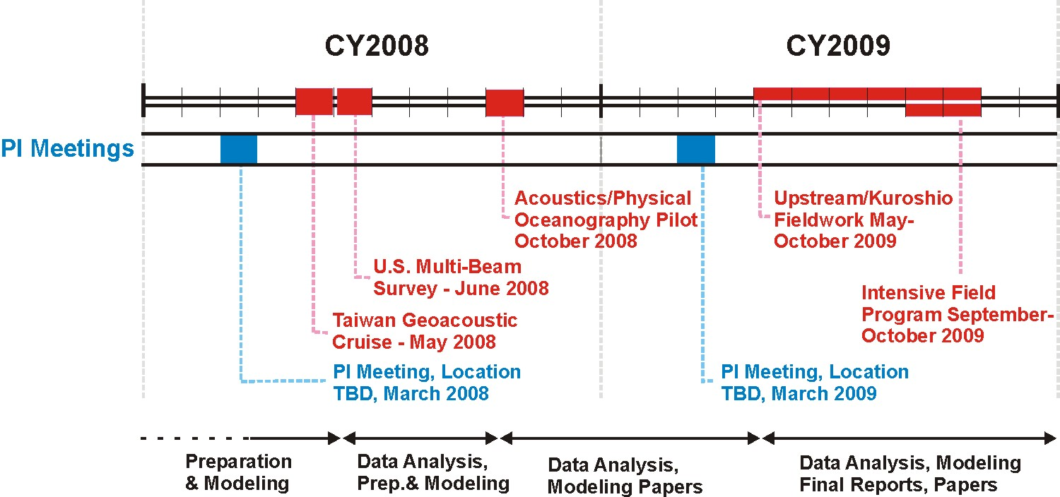

Table 2. Timeline for field work and planning meetings.

We project that a number of ships will be necessary for the intensive field program, including the R/Vs Revelle and Melville along with the Taiwanese ships Ocean Researcher 1 and Ocean Researcher 3. Further planning is necessary to coordinate the logistics.

V. Data Policy

The success of the program will depend on an open data policy that respects the rights of
those making measurements and producing model output, while recognizing that no
individual PI is capable of collecting all the “supporting” data they need to interpret their
core measurements.

ONR expects the following principles to be respected:

- Data should be made available to everyone in the program as rapidly as possible with
appropriate warnings regarding data quality.
- Data should be updated when improved.
- The use of other people’s data for publication before it is published by them requires
appropriate discussions and agreement on co-authorship.
- Clear consideration should be given to avoid pre-empting dissertation research
- Data should be available and archived in the public domain at the end of the
program.

In this context, “data” includes experimental data and model results.

A public program web site and a private data archive for program participants will be
established at Woods Hole Oceanographic Institution for the program. At the end of the
program the data archive will be made public in accordance with the data sharing
principles described above.

VI. References

Abbot, P., I. Dyer and C. Emerson, Acoustic propagation uncertainty in the shallow East China Sea, IEEE Journal of Ocean Engineering, 31, 368-383, 2006.

Chen, C.-F., J.-J. Lin, and T. Lee, Acoustic transmission of Taiwan’s Northeast Sea, Acta Oceanographica Taiwanica, 34, 39-51, 1995.

Heaney, K.D., and T.F. Duda, Non-linear optimization of multi-vehicle ocean sampling networks for cost-effective ocean prediction systems, IEEE OCEANS 2006 Asia Pacific Conference, May 16-19, 2006, Singapore.

Hsu, M.K., A.K. Liu and C. Liu, A study of internal waves in the China Seas and Yellow Sea using SAR, Continental Shelf Research, 20, 389-410, 2000.

Liu, Z.-X., S. Berne, Y. Saito, G. Lericolais, T. Marsett, Quaternary seismic stratigraphy and paleoenvironments on the continental shelf of the East China Sea, Journal of Asian Earth Sciences, 18, 441-452, 2000.

Rainville, L. and R. Pinkel, Observations of Energetic high-wavenumber internal waves in the Kuroshio, Journal of Physical Oceanography, 34, 1495-1505, 2004.

Tang, T.Y., H.Y. Tai and Y.J. Yang, The flow pattern north of Taiwan and the migration of the Kuroshio, Continental Shelf Research, 20, 349-371, 2003.
Yin, P., S. Berne, P. Vagner, B. Lobrieu, Z. Liu, Mud volcanoes at the shelf margin of the East China Sea, Marine Geology, 194, 135-149, 2003.

Figure 1: Overview of study area, including relevant geographic features.

Figure 2: General circulation and oceanographic characteristics.
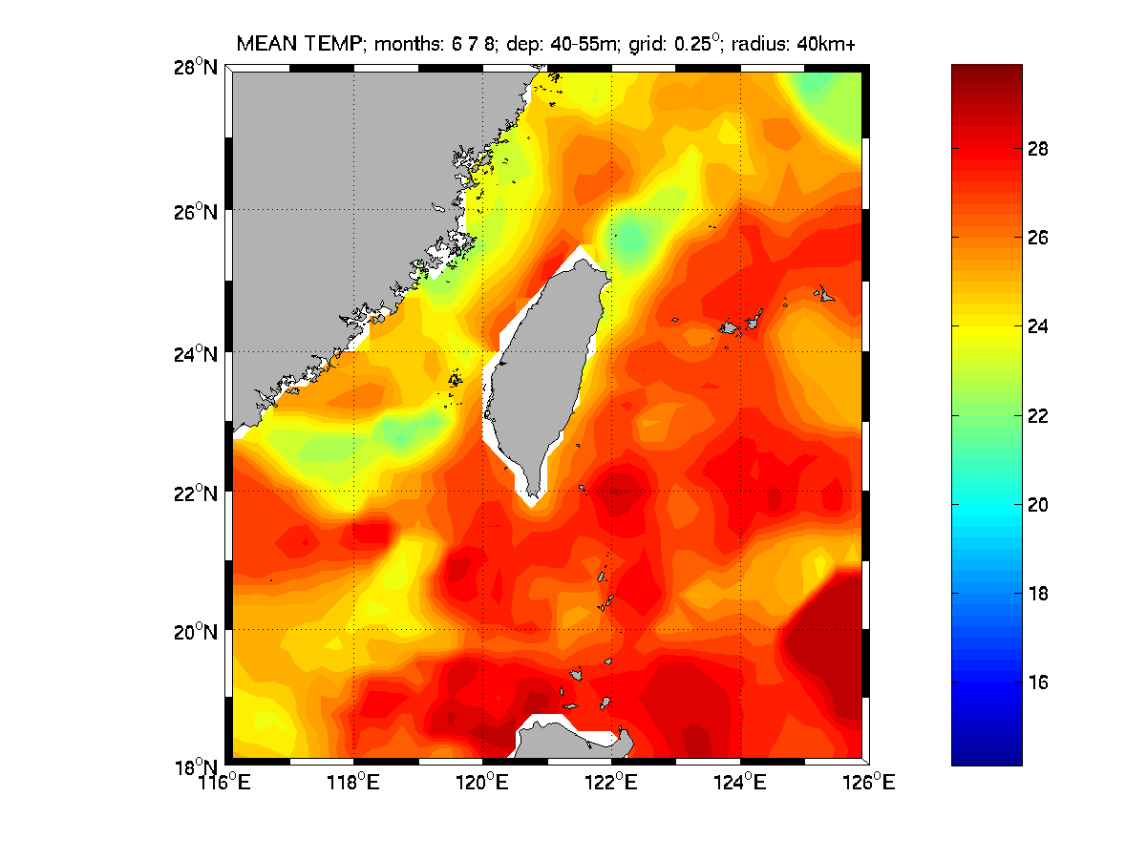
Figure 3a: Temperature Mean Field for Summer (40-50 m). Kuroshio runs along
Continental slope NE of Taiwan Cold Dome over shelf.

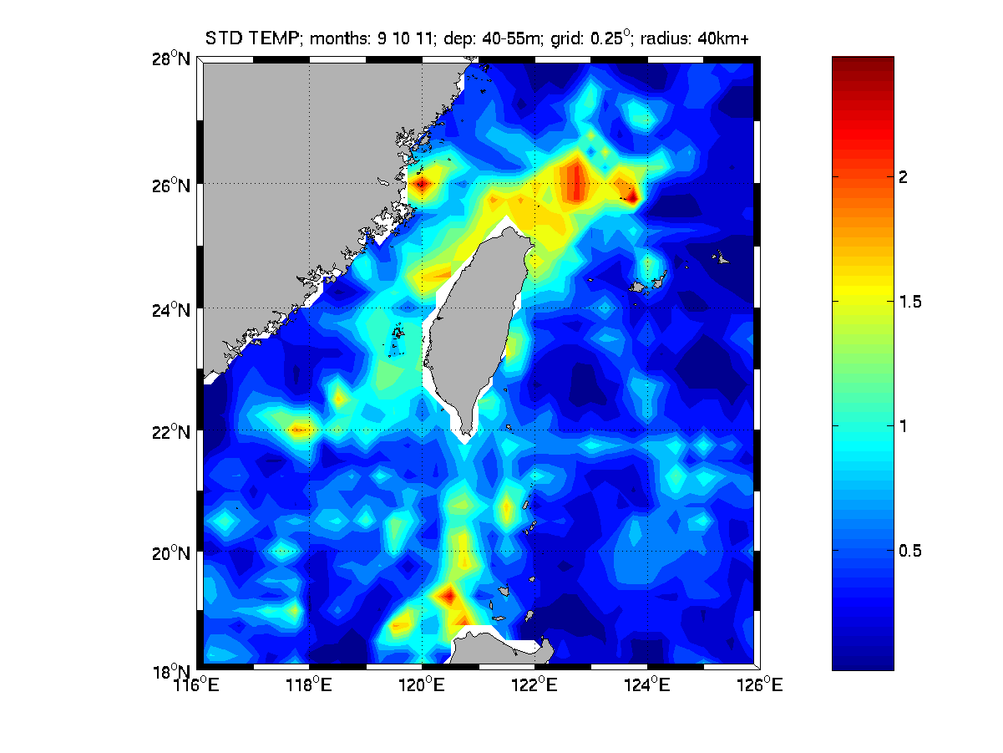
Figure 3b: Temperature Standard Deviation Field for Summer (40-50 m). Variability is greatest NE of Cold Dome and along Axis of Kuroshio.

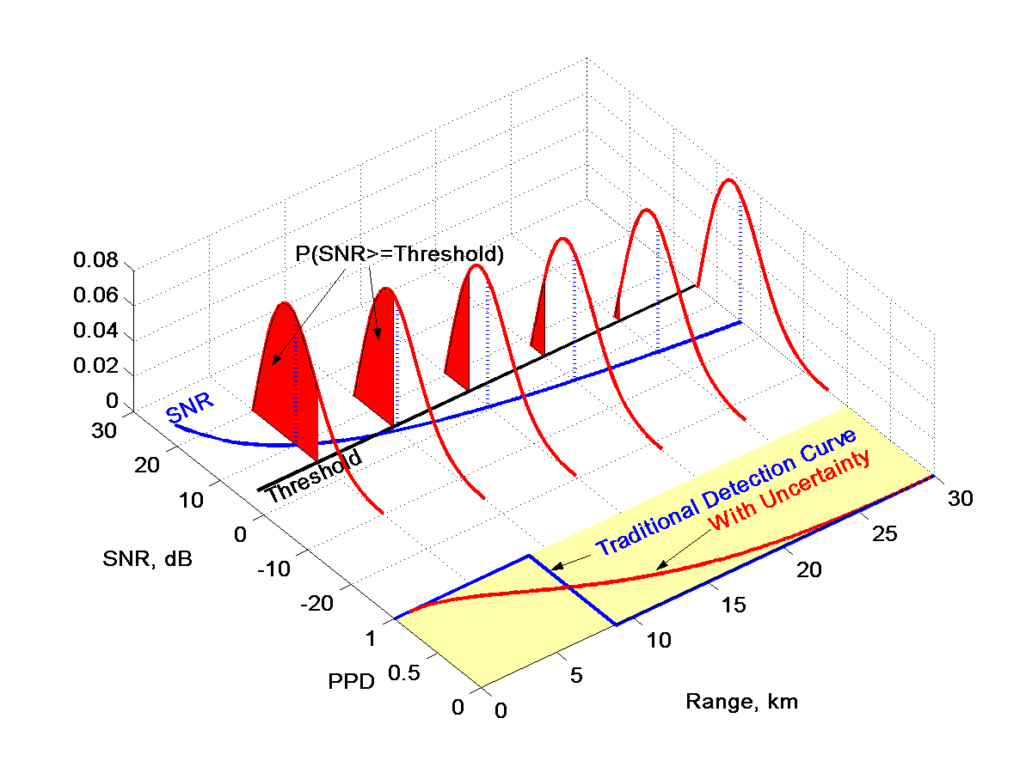
Systems-based PDF (convolution of all PDFs, incorporates environmental and system uncertainty)
μ: mean terms in sonar equation
σ: set by fluctuations of each term
n: local slope of the TL~ R^{n}
Figure 4a: Predictive Probability of Detection method.

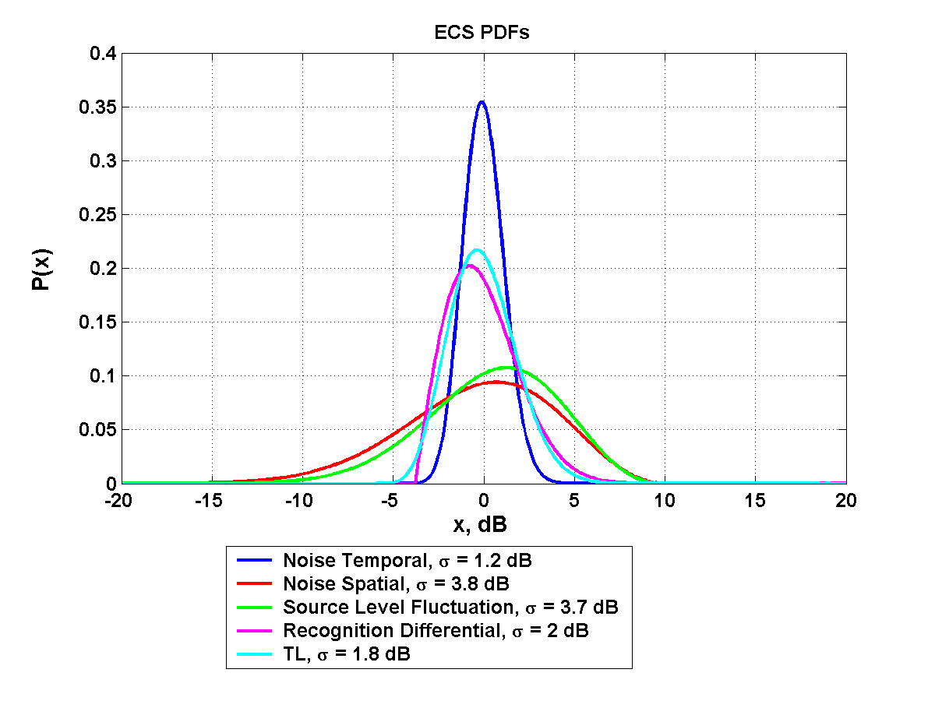
N, temporal
RD
TL
SL
N, spatial
In some environments, acoustics
uncertainty may be noise-dominated
(e.g. ECS/summer) and, in others,
TL-dominated (e.g. SOJ/summer)
Figure 4b: East China Sea Example (Before convolution)

Figure 5: Intensive study area (red box), with US (red) and Taiwan (green) ADCP locations and island-avoidance circles shown.

