Assessment of environmental correlates with the distribution of fish stocks using a spatially explicit model

MILES A. SUNDERMEYER^{1,*}, BRIAN J. ROTHSCHILD, AND ALLAN R. ROBINSON²

¹School of Marine Science and Technology
University of Massachusetts Dartmouth
New Bedford, Massachusetts

²Department of Earth and Planetary Sciences

Harvard University
Cambridge, Massachusetts

*Correspondence:
e-mail: msundermeyer@umassd.edu
phone: (508) 999-8812
fax: (508) 910-6371

Running title: Assessing environmental correlates using a spatially explicit model

ABSTRACT

In this paper, we present a method for assessing the explanatory skill of environmental correlates with the distributions of commercial fish stocks using a simple analytical/numerical, spatially explicit model. We examined three environmental variables, temperature, bottom sediment type, and bottom depth, which have been shown by previous investigators to be environmental correlates of two species of groundfish, Atlantic cod (Gadus morhua) and haddock (Melanogrammus aeglefinus), over Georges Bank. Comparisons between modeled and observed distributions showed that bottom temperature alone accounts for between 0% – 35% of the spatial variance in monthly averaged distributions of both species. A smaller amount of the observed variance, 0% – 20%, is explained by bottom sediment type and bottom depth. As a benchmark, smoothed monthly maps computed by optimal interpolation (OI) of the data explained 15% – 75% of the observed variance. The model also showed that these same variables account for a smaller percent of the monthly catch variance observed in individual years. This suggests that while the environmental correlates examined can explain some of the variance in the observed distributions, historical monthly distributions are a better predictor of mean monthly distributions as well as monthly distributions within a given year.

Key words: environmental correlates, numerical model, spatially explicit, cod, Gadus morhua, haddock, Melanogrammus aeglefinus, temperature, sediment type, depth.

INTRODUCTION

We present here a method for assessing the explanatory skill of environmental correlates of the distribution of commercial fish stocks in the ocean. In a previous paper (Sundermeyer et al., 2005; henceforth, SRR), commercial landings data were used in conjunction with historical CTD (conductivity, temperature, depth) data to investigate empirically how the distributions of commercial fish stocks relate to environmental conditions such as temperature, salinity, density, stratification, bottom type, and water depth. Most notably, it was shown that catch-weighted mean bottom temperatures for both cod and haddock over Georges Bank differed from un-weighted mean temperatures over the same region. This result suggested that the distributions of cod and haddock on the Bank are not random with respect to bottom temperature, but rather that both species tended to be found preferentially at certain values of bottom temperature. It was further found that catch-weighted mean bottom temperatures varied seasonally, from approximately 5 ºC in spring up to 10 – 11 ºC by late fall, suggesting that the value of their preferred bottom temperature varied seasonally. Similar environmental associations were found between the monthly distributions of cod and haddock and bottom sediment type and overall water depth. The catch-weighted mean values of these latter variables also varied seasonally.
A major conclusion of SRR was that statistics derived from commercial landings data were consistent with results of previous investigators using data from winter/spring and summer bottom trawl surveys conducted by the National Marine Fisheries Service (NMFS; e.g., Fogarty and Murawski, 1998; Begg, 1998; O'Brien and Munroe, 2000; Brown and Munroe, 2000). While this does not address the question of how the commercial data and survey data compare in detail, it suggests that irrespective of the many biases and uncertainties in the commercial landings data, similar conclusions can be drawn from the two data sets. The advantage of using the landings data to assess environmental correlates is that they complement the survey data by providing information throughout the year rather than only during winter/spring and fall.
In light of the above results, we now seek to determine the explanatory power of such associations. Specifically, how well can the spatial distributions of the species of interest be accounted for by the above environmental correlates? To answer this question, we use a spatially explicit model that directly parameterizes fishes’ preferences for these variables. While it is hoped that this model may eventually be useful as a predictive (e.g., forecast) model, at this stage, we do not pose it as such. Rather, we first address the intermediate but important question of how much of the observed variance can the model, and hence the environmental correlates explain? The latter is a question not only of the skill of the model, but also more generally of our level of understanding of the dynamics governing fish populations.
This paper is organized as follows. We begin with a brief description of the fish catch and environmental data sets used in the empirical analysis of SRR and in the present study. We then present a spatially explicit environmental preference model, which can be used to assess the explanatory power of the environmental correlates. The model is first used to examine the skill of a single environmental variable, e.g., bottom temperature, at describing the mean monthly distributions of cod and haddock over Georges Bank. An expanded model is then used to examine the skill of multiple variables in combination (bottom type and overall water depth). Finally, the same multi-preference model is used to examine the skill of these same environmental variables at describing inter-annual variations in the distributions of cod and haddock over the Bank. We then discuss the limitations of this approach, and how it may be extended to incorporate any number of physical, biological, and/or chemical correlates.

MATERIALS AND METHODS

The historical data used in the present study were described in detail in SRR, and will only briefly be described here. Readers familiar with SRR may skip the following subsections and continue with the Spatially explicit model subsection.

Commercial landings data
Catch distributions of commercial fish stocks (which we use to infer relative abundance) were derived from historical landings compiled by the U.S. NMFS. The data used here spanned the 11-yr period, 1982 – 1992, and were in the form of pounds of fish landed and total fishing time per sub-trip (i.e., region fished), from which we computed catch per unit of fishing effort (CPUE) in units of kg/day. All landings data included the year, month, nominal day, and latitude and longitude (to the nearest 10 minutes) at which the fish were caught. In addition, the depth zone where the fish were caught was provided in the following ranges: 0 – 30 fathoms (0 – 55 m), 31 – 60 fathoms (56 – 110 m), 61 – 100 fathoms (111 – 184 m), 101 – 150 fathoms (185 – 275 m), 151 – 200 fathoms (276 – 366 m), 201 – 300 fathoms (367 – 549 m), greater than 300 fathoms (549 m), or mixed depths (3 or more depth zones).
To minimize sampling variability within the data, and to avoid the problem of standardizing catch rates across different vessel sizes and gear types (e.g., Gavaris, 1980; Ortega-Garcia and Gomez-Munoz, 1992), we limited our analysis to data collected by vessels 70 – 79 ft (21.3 – 24.1 m) in length, and that fished along the bottom using otter trawls (i.e., from the raw data, length code = 07 and gear code = 050). As the present analysis focuses on near-bottom dwelling species, we further selected data whose reported depth zone encompassed the bottom. The resulting database consisted of a total of 3,591 and 2,904 usable CPUE records for cod and haddock, respectively, within the region bounded by 69.5 ºW, 65.0 ºW, and 39.5 ºN, 43.0 ºN. Of these, 2,062 cod and 1,558 haddock records were located over the crest of Georges Bank within the 110 m isobath. Resulting spatial distributions of monthly CPUE for cod and haddock are plotted in SRR, and are not reproduced here.
In addition to the above “raw” format, the data were used to create smoothed monthly maps of CPUE across the Bank, averaging over all years. These smoothed maps were used as a baseline for computing CPUE anomalies, which could then be compared with research survey data from previous studies. Smoothing was done by the method of optimal interpolation (OI) described by Bretherton et al. (1976). As part of this analysis, spatial correlation functions of both cod and haddock CPUE were first computed for each month. These correlation functions indicated decorrelation scales ranging from 50 – 150 km for both species. To balance the trade-off between retaining synoptic features versus smoothing over sparse data in both space and time, we used an isotropic Gaussian correlation function with a decorrelation scale of 60 km in our OI.

Hydrographic data
Historical CTD data were compiled from a variety of sources including the National Oceanographic Data Center (NODC); the Atlantic Fisheries Adjustment Program (AFAP); the Marine Resources Monitoring, Assessment and Prediction Program (MARMAP); the Global Ocean Ecosystems program (GLOBEC); and a number of other smaller field programs. Only those casts that extended over the full water column (i.e., from within 5 m of the surface to more than 85% of the total water depth) were used. After this initial screening of the data, a total of 15,632 CTD profiles were retained for the region bounded by 69.5 ºW, 65.0 ºW, and 39.5 ºN, 43.0 ºN, and spanning the period from July 11, 1913 to October 6, 1999. Of these, 10,063 profiles were within the region bounded by the 110 m isobath. To coincide with the time span of the historical commercial landings data, only CTD data from 1982 to 1992 were used to assess associations between CPUE and environmental variables. The full CTD data set was used as a reference for computing monthly anomalies.
Profiles that met the above criteria but did not extend to the surface or bottom were extrapolated to these levels. Specifically, casts that extended to within 5 m of the surface were extrapolated to the surface using the shallowest observation as the surface value, while casts that extended deeper than 85% of the overall water depth were extrapolated to the bottom by using the deepest observation as the bottom value.
The CTD data were binned by month and used to create smoothed maps of surface and bottom temperature, again using the method of OI. As with CPUE, spatial correlation functions were computed for each month for each of variables of interest. Again these indicated decorrelation scales of 50 – 150 km. In light of this, and to balance the trade-off between retaining synoptic features (such as the shelf-slope front and the tidal mixing front), and smoothing over sparse data in both space and time (which could lead to artificially large spatial gradients in the property fields), we again used an isotropic Gaussian correlation function with a decorrelation scale of 60 km.

Bottom type and depth
Information about bottom type (i.e., sediment grain size) over Georges Bank was obtained from published data by Twichell et al. (1987; republished from Schlee, 1973). They classified sediments in terms of four categories of grain sizes: < 1/16 mm (silt and clay), 1/16 – 1/4 mm (fine sand), 1/4 – 1 mm (medium-to-coarse sand), and > 1 mm (gravel). This classification scheme coarsely follows Wentworth (1922).
The discretely classified sediment sizes were further interpolated to form a continuous distribution of sediment types over a regular grid. This was done to assess to what extent our analysis is affected by the discretization of continuous sediment sizes. The interpolation was done by assigning an integer value to each of the sediment classes (i.e., silt and clay = 1, fine sand = 2, medium-to-coarse sand = 3, and gravel = 4). The values of the sediment type were then interpolated between contours using quadratic interpolation.
Bathymetry data used in the present study were obtained from the U.S. Geological Survey. The 15-s resolution data used here are a subset of a larger database that covers the Gulf of Maine, Georges Bank, and the New England continental shelf.

Spatially explicit model
We used a spatially explicit model to evaluate the explanatory skill of the above environmental variables on selected commercial fish stocks. Specifically, we examined associations between cod and haddock, and bottom temperature, sediment type and bottom depth. The model represents the concentration of fish at a given location by a continuous tracer and uses an advection/diffusion parameterization to describe the tactic searching behavior of fish towards preferred environmental variables (e.g., Grunbaum, 1999). Similar models have been used by Sibert et al. (1999) to describe the distributions of skipjack tuna in the equatorial Pacific, and by Mullen (1989) for yellowfin tuna, except that Mullen (1989) used a variable diffusivity instead of advection to characterize fish aggregation.
Because the problem of evaluating environmental correlates of fish stocks is complex, rather than immediately advancing a complete multi-preference model, we first examined a single environmental variable, bottom temperature. We then proceeded with other variables of interest in turn, namely sediment type and bottom depth. Once we characterized the dynamics associated with each of these individual environmental correlates, we then combined them into a single multi-preference model who’s results could be directly compared to both the total annual and interannual variability in the fishes’ distributions.
The model formulation was based on the results of SRR, as well as those of previous investigators (e.g., Mountain and Murawski, 1982; O'Brien and Rago, 1996; and O'Brien, 1997), which suggest that over the crest of Georges Bank, both cod and haddock exhibit a preference toward certain values of bottom temperature. Specifically, based on commercial landings data, SRR showed that the value of the catch-weighted temperature for both cod and haddock varied seasonally (see their Fig. 8a) from approximately 5 ºC in winter/spring up to 10 – 11 ºC during late fall. To assess how well such preferences describe the spatial distributions of cod and haddock on the Bank, we used the following advection/diffusion model to describe how fish respond to bottom temperature:

$\frac{∂C}{∂t}+\frac{∂}{∂x}(f_{x}C)+\frac{∂}{∂y}(f_{y}C)=κ\frac{∂^{2}C}{∂x^{2}}+κ\frac{∂^{2}C}{∂y^{2}}$, (1)

where C = C(x,y,t) represents the concentration of fish at a given time and location in the horizontal, κ is an effective horizontal diffusivity, and f_{x} , f_{y} are spatially varying advection coefficients given by

$f_{x}(x,y)=−S\frac{∂}{∂x}\frac{Θ^{2}}{2}$ (2)

$f_{y}(x,y)=−S\frac{∂}{∂y}\frac{Θ^{2}}{2}$ (3)

$Θ^{2}=(T−T_{c})^{2}$, (4)

where T = T(x,y) represents bottom temperature, T_{c} is a preferred bottom temperature, which varies by month or season, but is fixed within a given month; and S is a constant coefficient whose magnitude is to be determined.
Equations (1) – (4) model the relationship between cod and haddock and bottom temperature as an affinity by the fish towards a preferred value of bottom temperature (or in general, any variable for which they have an affinity; Grunbaum, 1999), which may vary seasonally. Here f_{x}(x,y) and f_{y}(x,y) can be thought of fish swimming velocities such that the further the fish are from their preferred temperature, the faster they swim towards it; and the larger the temperature gradient, the faster they swim. (Note that this assumes the fish can detect these gradients.) The parameter, S, sets the overall strength of this affinity; a larger value of S implies a greater swimming speed. Meanwhile, the horizontal diffusion term in equation (1) can be thought of as a parameterization of random searching behavior, and of the tendency of the fish to avoid aggregating to arbitrarily high concentrations at any given location. This approach of characterizing directed swimming behavior is similar to the “habitat index” or “carrying capacity” approach (e.g., Mullen, 1989); in that case, fish are attracted to “good” habitat or regions of high carrying capacity.
The above model can be used to represent the vertically integrated abundance of cod or haddock, i.e., number of fish per unit area; or alternatively the number of individuals per unit volume near the bottom. While the precise relationship between CPUE and abundance is a widely debated topic, for the purpose of the present study we assume that CPUE is proportional to abundance. As discussed in SRR, statistics obtained from a stock size-CPUE regression analysis based on published data by O'Brien and Munroe (2000) support this assumption. Specifically, regression analysis applied to their values of landings per unit effort (LPUE) vs. catch per tow from spring and fall survey data for the period 1978-1999 give slopes of 6.6 (9.2, 4.0) (at 95% confidence) and 4.9 (7.1,2.7) for winter/spring and fall, respectively, with r² values of 0.58 and 0.53. The latter suggests that on the whole, CPUE derived from landings data are correlated with stock size estimates from survey data. In this study, we thus use CPUE as a proxy for fish abundance (to within a constant of proportionality) both in equations (1) – (4) and in our discussion.

Annual cycle
To determine the amount of spatial variance in the annual cycle of cod and haddock distributions accounted for by equations (1) – (4), the model was integrated numerically for each month using appropriate monthly averaged bottom temperatures, bottom type and bottom depth. In all cases, integration was performed on a 3 km by 3 km grid, which spanned the Bank (Fig. 1). In each run, initial fish distributions were uniform across the domain, while bottom temperature was set to the corresponding OI monthly field (Fig. 2). The model was then integrated in time until an approximately steady state was reached.
In all runs, the diffusion parameter on the rhs of equation (1) was set to κ = 100 m² s⁻¹. This value was chosen based on a combination of physical, biological and numerical reasons. First, it corresponds roughly to the diffusivities observed in drifter studies by Drinkwater & Loder (2001) of 10 m² s⁻¹ up to 200-400 m² s⁻¹. As we are aware of no studies that compute “diffusivities” explicitly for fish, i.e., including behavior, we consider 100 m² s⁻¹ a sensible first guess inasmuch as it theoretically represents the diffusivity of fish in the absence of behavior, i.e., as passive drifters. Second, this value is large enough to “level” the tracer field (i.e. smooth out any initial gradients) in the absence of advective effects over the course of our runs. This effectively guarantees the importance of the diffusive term in runs where advection is included. It is important to note here, however, that the relevant quantity is actually the ratio of the swimming velocity to the diffusion parameter (i.e., the ratio of the advective term to the diffusive term), and not either term independently. This is because the model is run to equilibrium, which is equivalent to assuming that environmental conditions change slowly enough that fish have time to “find” their preferred environments. The value of κ, which we have set at 100 m² s⁻¹ throughout this study, is therefore in some respects arbitrary; more important is the ratio of κ to S. The method of determining S is described below.

Bottom temperature
In the first set of simulations, the model was run for each month for both cod and haddock to assess the degree to which temperature associations account for their distributions over Georges Bank. Preferred temperature, T_{c}, was set by one of two methods. In one case, T_{c} values were chosen based on the monthly catch-weighted temperatures estimated by SRR (see their Fig. 6a). In the other case, both T_{c} and S were selected based on the least-squares “best fit” between monthly modeled and observed CPUE distribution over the Bank. The latter approach is similar to that used by Sibert et al. (1999). Monthly values of T_{c} from SRR as well as values of T_{c} and S for cod and haddock determined using these two criteria are listed in Table 1.

Bottom type and depth
The model described in equations (1) – (4) can readily be adapted to other environmental variables, or to include multiple environmental variables in parallel. In the present context, the simplest extension to equations (1) – (4) is where bottom temperature, Τ, and the preferred temperature, T_{c}, are replaced with their bottom type or depth analogs. An important difference between temperature and bottom type or depth, however, is that while temperature changes seasonally, bottom type and depth are relatively constant. Nevertheless, for preferred sediment type, T_{B}, and preferred bottom depth, T_{D}, simulations were conducted following the same approach as for bottom temperature. Specifically, the preferred values of these variables were set based on either the monthly weighted values computed in SRR, or based on a least-squares “best fit” between monthly modeled and observed CPUE distribution over the bank.

Combined bottom temperature, bottom type and depth
Having examined bottom temperature, bottom sediment type and bottom depth associations individually, we next examined these three environmental factors in combination. The question we posed was whether these three environmental variables together could explain more of the observed variance than any of the individual components alone.
Equations (1) – (4) were revised to include three independent environmental preferences:

$\frac{∂C}{∂t}+\frac{∂}{∂x}([f_{x_{T}}+f_{x_{B}}+f_{x_{D}}]C)+\frac{∂}{∂y}([f_{y_{T}}+f_{y_{B}}+f_{y_{D}}]C)=κ\frac{∂^{2}C}{∂x^{2}}+κ\frac{∂^{2}C}{∂y^{2}}$, (5)

$f_{x_{[T,B,D]}}(x,y)=−S_{[T,B,D]}\frac{1}{2}\frac{∂}{∂x}Θ_{[T,B,D]}^{2}$ (6)

$f_{y_{[T,B,D]}}(x,y)=−S_{[T,B,D]}\frac{1}{2}\frac{∂}{∂y}Θ_{[T,B,D]}^{2}$ (7)

$Θ_{T}^{2}=(T−T_{c})^{2}$, (8)

$Θ_{B}^{2}=(B−B_{c})^{2}$, (9)

$Θ_{D}^{2}=(D−D_{c})^{2}$. (10)

Here C(x,y,t) again represents the concentration of fish, T(x,y) is bottom temperature, T_{c} is the preferred temperature; B(x,y) is the bottom sediment type, B_{c} is the preferred sediment type, D(x,y) is bottom depth, D_{c} is the preferred bottom depth, and the constants S_{[T,B,D]} determine the relative strength of each of the preferences.
As for a single environmental preference, the multi-preference model given by equations (5) – (10) expresses the tendency of fish towards a preferred environment as an up-gradient swimming behavior superimposed on a background diffusivity representing their searching behavior. The additive relationship between the different variable’s swimming terms in equation (5) can be interpreted as a non-exclusive swimming behavior towards the different environmental variables. For example, if the fish encounter an environment in which the local gradient towards their preferred temperature and bottom type are the same, the swimming behavior towards these preferred environments will be equal to the sum of the swimming speeds of the two environmental preferences. Conversely, if the preferred environmental gradients are in opposing directions, the resulting swimming behavior will be the difference between the two. In the occasional (but real) case of equal but directionally opposed preferences, the sum will equal zero, i.e., equation (5) indicates that the fish will have no net swimming motion, only a diffusive tendency.
The rationale behind this formulation is best illustrated by example. Consider a case in which two preferred environmental variables, bottom temperature and bottom type, are exactly complementary: where the fish find their most preferred temperature they find their least preferred bottom type, and vice versa. Suppose also that preferences toward each of these environmental variables is equal. In this case, we might expect the fish to effectively compromise and settle somewhere between the two extremes. Indeed, this is precisely the behavior represented by equation (5). For unequal preferences between different environmental variables, the stronger the preference towards a particular variable, the stronger the swimming tendency for that variable. These relative strengths are represented in equation (5) by the relative sizes of the swimming coefficients f_{x[T,B,D]} and f_{y[T,B,D]} among the different variables.
To test whether equation (5) – (10) can explain more of the observed variance than any of the individual components alone, the model was run as in the previous subsections, except this time starting with bottom temperature and incrementally adding the different environmental variables. The model was first re-run for the case of bottom temperature and bottom type combined. For temperature, we used the best-fit parameters determined in the previous subsections, while for bottom type we repeated the approach outlined above for finding best-fit parameters. The motivation for recomputing best-fit parameters in this way was to account to lowest order for the dynamics of competing preferences among different environmental variables while limiting the amount of parameter space that must be explored to tune the model. This greatly simplified the analysis for multiple variables, since the addition of each new environmental variable in equations (5) – (10) nominally adds two new model parameters, the new variable's preferred value, and the relative strength of the preference toward the new variable relative to those of existing variables. While we present here only a single permutation of the order in which the three environmental variables were considered, our results did not change appreciably when we changed the ordering in which we tuned the three variables.

Interannual variability
Our analysis thus far has focused on assessing the spatial variance explained for each calendar month, and then assessing how that variance changed through the course of the year. In other words, we have examined the extent to which the environmental associations modeled by equations (5) – (10) describe the annual cycle of cod and haddock distributions on the Bank. The next and final measure of the explanatory skill of the environmental correlates in question was to determine how much variance they could explain on interannual time scales. This was done for monthly distributions in the full eleven-year time series in an analogous manner to the mean monthly distributions using the best-fit combined bottom temperature, sediment type, and bottom depth model, with one additional modification. Rather than simply using the monthly OI bottom temperature fields as the attractant, we adjusted each month’s temperature by an amount equal to the mean temperature anomaly of that month of that year. For example, when the observed temperatures for January of a given year were on average 1 ºC cooler than the mean January values, the temperature field used in the model for January of that year was the January OI temperature field minus 1 ºC across the entire domain. While there are some obvious shortcomings in this approach (see Discussion), given the limited spatial coverage afforded by the data in any given month of any given year, it was the most practical means of obtaining a nearly complete time series.

Measures of explanatory skill
In all of the above analyses, environmental correlates were evaluated in terms of how much of the total observed variance they explained. Throughout this study, we report this as the percent variance explained by the environmental preference model,

Percent variance explained = 100* {1 – [var(x_{obsv} – x_{modeled}) / var(x_{obsv})]},
(11)

where x_{obsv} and x_{modeled} are the observed and modeled ln(CPUE) values, respectively. As a matter of clarification, we note that if the modeled and observed values were equal, the variance explained would be 100%; if the modeled values were constant, the variance explained would be 0%; and if the model had a large variance but was uncorrelated with the observations, the variance explained may be negative. Note that the latter could occur even if var(x_{obsv}) = var(x_{modeled}); for example if the model had the same variance as the observations, but the peaks and troughs in model were displaced compared to the observations. A negative variance would thus mean that the model mis-predicted the observations. As will be seen in the results on interannual variability, this sometimes occurred.
Lastly, as a benchmark for assessing the explanatory power of the above environmental correlates, the percent variance explained by the monthly OI fields was also computed. The OI fields are an appropriate benchmark because in principle (assuming perfect correlation statistics) they represent the best possible spatial description of the monthly averaged observations for a given decorrelation scale. In other words, a perfect OI map would contain 100% of the spatial variance in the observed monthly CPUE distributions, with any remaining variance being due to temporal variations (e.g., sub-monthly or interannual) in the observations. The distinction between spatial and temporal variance is important because it means that if a particular environmental correlate accounts for, say, half as much of the variance in the observed monthly averaged distributions as does the OI, then that environmental correlate accounts for half the spatial variance in the observations, regardless of the percent of the total variance that it explained. For reference, the monthly OI maps for each species are plotted in Figs 3 and 4.

RESULTS

Annual cycle

We begin with the variance explained in the monthly averaged cod and haddock distributions.

Bottom temperature
The values of T_{c} determined from monthly catch-weighted temperatures, and by our least-squares best-fit approach, are listed in Table 1. The percent of the observed spatial variances explained by the bottom temperature preference model for each month are plotted in Fig. 5. For reference, the percent variances explained by monthly OI are also plotted in Fig. 5.
Comparison between the monthly best-fit modeled and the monthly observed ln(CPUE) fields shows that temperature associations accounted for between 0% – 35%, and 0% – 15%, of the total variance in the observed distributions of cod and haddock, respectively (Fig. 5). By comparison, the monthly OI fields accounted for, between 15% – 75%, and 15% – 50%, respectively. The wide range in the percent variance explained by the temperature preference model for different months suggests that temperature associations of both cod and haddock may vary considerably on monthly time scales. Specifically, the fact that the variance explained was nearly zero during certain months suggests that during those months, the effects of temperature associations on the spatial distributions were small. Conversely, assuming that the OI maps are a reasonable measure of how much of the total variance can be explained by spatial variability, and that any remaining variance is therefore due to temporal (e.g., interannual) variability, during other months, nearly half of the observed spatial variance (e.g., 35% out of the 75% described by the OI results) was explained by bottom temperature associations.
The differences in our findings for cod versus haddock, namely that bottom temperature associations account for more of the monthly spatial variance in distributions of cod than haddock, suggest that there may be behavioral differences in how cod and haddock respond to changes in temperature across the Bank. Nevertheless, the temperature preference model appeared to capture the essence of the annual cycle of both cod and haddock distributions over the Bank, with peak abundances occurring over the crest of the Bank in winter/spring, and lowest abundances over the Bank in summer/fall. With regard to the details of the distributions, the model reproduced a number of more localized features such as the local maxima over the northeast peak of the bank in late winter/early spring, and the high values along the major axis of the bank in May-June (not shown, however, see Figs 11 and 12 for combined bottom temperature, bottom type and depth model results).
Noteworthy in Table 1 is that values of T_{c} determined from catch-weighted temperatures versus those computed by the least-squares best-fit approach differed, particularly during the summer/fall months. This suggests that although both cod and haddock were generally found at warmer temperatures during the summer and fall (up to 10 – 11 ºC) compared to winter and spring (as low as 4.6 ºC), nevertheless, in the context of the temperature preference model defined by equations (1) – (4), their behavior was better modeled by (i.e., it was dynamically more consistent with) a preference towards much cooler temperatures of 2 – 5 ºC. In other words, although both cod and haddock can be found on the Bank during summer and fall, their behavior suggests that they prefer much cooler waters during these times of year. Note also, however, that these conclusions must be tempered in consideration of the amount of variance explained by the model during these months. For example, during July and August, only between 0% – 5% of the observed variance in either species was accounted for by the temperature preference model, while during September and October, approximately 35% and 15% of the variance in the observed distributions, or about half that expected based on the OI results, was explained for cod and haddock, respectively. Considering that the July-August catch-weighted bottom temperature estimated in SRR (see their Fig. 8a) was approximately 4.5 ºC cooler than the mean bottom temperature, however, it is unclear why the spatially explicit model explained so little variance during these months. It may have been because of the scarcity of temperature data over the bank during the period examined.

Bottom type and depth
The values of B_{c} determined from monthly catch-weighted bottom types, and the least-squares best-fit values based on equations (1) – (4) are listed in Table 2. The percent of the observed spatial variances explained by the bottom type preference model for each month are plotted in Fig. 6. The results indicate that bottom type accounts for between 0% – 10%, and 0% – 15% of the variance in the observed monthly distributions of cod and haddock, respectively. As with temperature, the values of B_{c} computed empirically differed somewhat from those determined from the model best fit. Specifically, the best-fit values of B_{c} were generally higher (with the exception of a few months) than those determined empirically. Once again this suggests that while the data showed a tendency of both species toward larger grain-size sediments, this tendency was better modeled as an even stronger preference towards coarser sediments.
Analogous results for bottom depth are listed in Table 3 and plotted in Fig. 7. The results were similar to those for bottom type, indicating that over most of the year, bottom depth preference accounted for between 0% – 20% of the observed variance in the observed monthly distributions of either species. An exception to this occurred in late summer / early fall, when the percent variance accounted for in cod distributions increased to nearly 60%. A smaller seasonal increase was seen in the results for haddock. These variations suggest that bottom depth associations were particularly important in determining cod and haddock distributions during summer and fall. This variation is likely related to similar trends in the temperature preference model. Also, as with temperature, the different strengths of this tendency between the two species further suggests that there may be differences in the bottom depth preferences of cod and haddock, particularly in summer and fall.
Regarding monthly values of D_{c}, the best-fit values of preferred bottom depth were either somewhat higher or lower (depending on the season) than the catch-weighted bottom depths estimated in SRR. Our interpretation of this result is similar to that for temperature. That is, while both cod and haddock tended towards deeper waters in summer than in spring, their distributions were dynamically more consistent with a preference towards even deeper or shallower waters, respectively.

Combined bottom temperature, bottom type and depth
The percent variances accounted for by the combined bottom temperature and bottom type preference model for cod and haddock are shown in Fig. 8. The results indicate that the multi-preference model generally accounted for the same or slightly more variance in both cod and haddock observations than did bottom temperature or bottom type preference alone.
A similar result was found when we combined only bottom temperature and bottom depth (Fig. 9). The model again showed that the variances accounted for in both cod and haddock monthly data were comparable or slightly greater than the cases of either bottom temperature or bottom depth alone.
Finally, running the model for bottom temperature, bottom type, and bottom depth combined, again only tuning the parameters for the newest variable, we found that in general the variances accounted for in both cod and haddock were about the same or slightly greater than the runs with single preferences (Fig. 10). It thus appears that using all three preferences effectively took the best of each of the individual simulations. For example, the combined model approximately matched the winter/spring result in which cod temperature preference was found to account for 20% – 30% of the observed variance. Conversely, the combined model also approximately matched the late summer result in which bottom depth was found to account for nearly 60% of the observed variance. In other words, while at any particular time of year the individual contributions of bottom temperature, bottom type and bottom depth preferences varied, the sum contribution of these preferences explained more variance than that of any of the individual components. The monthly spatial distributions of cod and haddock based on the combined bottom temperature, bottom type and depth model are shown in Figs. 11 and 12, respectively. These can be compared directly to the OI maps plotted in Figs. 3 and 4.
While results are informative, it is important to note that the multi-factor model would be expected to perform at least as well as the best single factor model, which it does. A more relevant question, however, is whether additional environmental associations actually improve the model? The results plotted in Fig. 10 suggest that for certain months (e.g., October cod distributions), the multi-factor models shows little improvement over the best single factor model, i.e., the answer is “not always.” However, the fact that the multi-factor model effectively takes the “best of” the single factor results for each month means that over a 12 month cycle, it does perform better over all than any one single factor model.
Also, recall that the benchmark for the monthly model prediction is the variance explained by the monthly OI maps, and not 100%. Thus, for example, the January – March results for cod indicated that the multi-factor model explained about 35% of the variance out of an expected maximum (according to the OI results) of 50%-70%, or about half of the expected maximum possible variance. That this 35% was approximately the sum of the variances explained by each of the single-factor models means that each of the individual factors contributed to the total variance explained by the multi-preference model during these months. The same was true to varying degrees at other times of year.

Interannual variability
The percent variances accounted for in individual monthly cod and haddock distributions for the full eleven-year time series by bottom temperature, bottom type and depth associations are plotted in Fig. 13. The time series for both species indicate that the percent variance accounted for by the model ranged from less than zero (i.e., the model-observation residual contained more variance than the observed CPUE fields) to as much as 60%. In these simulations, temperature and CPUE data were available for approximately half of the 132 month period examined. Of these months, more than 50% accounted for at least some portion of the observed variance in the cod and haddock CPUE distributions.
As a benchmark for comparing the model’s explanatory skill for the full time series, we again used the monthly OI maps. Repeating the above variance calculations for the eleven-year time series, but this time using the OI maps, the results were somewhat similar to those obtained for seasonal time scales in the previous section. Namely, a considerable portion of the spatial variance observed in the eleven-year time series for both cod and haddock was typically accounted for by the monthly OI maps (Fig. 14). On average about 50% and 35% of the observed variance was accounted for by the monthly OI maps for cod and haddock, respectively. Thus even though the monthly OI maps did not explicitly take into account interannual variability, they were still reasonably good at describing the monthly distributions of cod and haddock over the bank. In other words, “climatology” (or, to borrow the term used in weather forecasting, “persistence”) based on monthly mean spatial distributions was a reasonably good estimate of the relative distributions of these species on Georges Bank.
Comparing the combined bottom temperature, bottom type and depth model results to those using the OI, we found that the amount of variance accounted for by the model was generally considerably less than was accounted for by the monthly OI maps. Thus while the temperature, bottom type and depth preference model explained some of the seasonal and interannual variations in cod and haddock distributions, it was far from complete. Whether future improvements should include refinements in the parameterizations of the environmental preferences examined here, and/or additional environmental, biological, or chemical correlates is the subject of ongoing investigation.

DISCUSSION

The above results suggest that during certain times of year bottom temperature, sediment type and bottom depth are all associated with the distributions of cod and haddock on Georges Bank, but that the strength of their associations varies seasonally (see Fig. 10). The fact that bottom temperature preference generally accounted for more of the variance in the observations than did bottom type and bottom depth may indicate that bottom temperature plays a larger role in determining the distributions of these species over the Bank. However, fluctuations in the variance accounted for by each of these variables also suggest that the dominance of the temperature association may vary seasonally. Most notably, our results indicate that bottom depth may be more important than bottom temperature during summer and fall. To what extent this finding is related to a correlation between depth and temperature has not been quantified. However, the known correlation between bottom temperature and depth suggests that there is likely some overlap between these two variables. Furthermore, the fact that both these variables independently explain between 20% - 50% of the observed variance during this time of year, but that the combined multi-preference model explains little more than either of them independently, supports this conclusion.
The low percent variance explained by these models during other times of year, suggests that the above environmental correlates may not be important at all times. For example, the low variances explained for haddock for the months of December and January suggest that bottom temperature associations are not important during those months. That both the Nov-Dec and Jan-Feb CPUE-weighted vs. mean bottom temperatures reported in SRR were approximately equal (see their Fig 8a) supports this conclusion, and suggests that haddock may instead have been randomly distributed with respect to temperature during these months. These two results combined, the model result of nearly zero variance explained, and the equal CPUE-weighted and un-weighted means illustrate the utility of our combined empirical/numerical approach in assessing how well fish distributions can be explained by environmental preferences.
In all of the above, we emphasize again the importance of using the OI analysis as a benchmark for the amount of spatial variance explained. In principle, since we use the same smoothing scale in the hydrographic data as the CPUE data, the OI represents the maximum amount of variance that could be explained by our spatially explicit model. That the OI explained on average about half of the total variance in the monthly observations of cod and haddock implies that the remainder of the observed variance was due either to temporal variability (e.g., sub-monthly or interannual variability) or to spatial variability on scales smaller than those resolved by the OI.
In contrast to such measures of spatial variance, as discussed in SRR, a different measure of skill based on the empirical results alone was an r² statistic applied to, for example, the relationship between CPUE-weighted bottom temperature and mean bottom temperature across the Bank. There the r² value represented the percent of the seasonal and interannual variance in the monthly averaged data explained by a linear fit. While this statistic was useful, however, it is limited in that it represents the temporal variance of spatially averaged quantities, and says nothing about the spatial variance itself; hence our motivation in the present study for using a spatially explicit model to address the question of spatial variance. We also note that such regression statistics applied to the empirical data must be interpreted with care. For example, in the analysis of SRR, a slope of 1 with a high r² value would be consistent with a random distribution of fish with respect to bottom temperature. However, a slope different from 1 with a high r² value would indicate a preference toward particular values of bottom temperature. The key point is that in that analysis, the slope is what indicated whether fish are distributed randomly or non-randomly with respect to the environmental variable. The r² value simply provided a measure of how well the data fit the model of a straight line representing that tendency.
Extending the analogy of linear regression analysis, we note that the present study fundamentally uses the same approach, only here we do so in the context of a spatially explicit model. Consider linear regression analysis applied to two variables, which we assume are correlated in some manner. We can think of linear regression as a model of the data – the model is a straight line, which is fit to the data using least squares. Formally, the system is over-determined if we have more than two data pairs, since a linear regression represents a fit to two unknowns, a slope and an intercept. Upon fitting the straight line, conventional practice is to cite uncertainties of the fitted parameters as, for example, 95% confidence limits. An r² value is also typically cited, which gives a measure of the variance explained by the model, the straight line.
The same approach was used in the present study, except that our model was given by equations (1) – (4), and (5) – (10), and our data are in two dimensions rather than one. Our system was formally over-determined since we had hundreds of observations, but only two unknowns, T_{c} and S, (or six in the case of the multi-preference model). The values of these unknowns were found using a least-squares approach. The variance explained by the model was then given by the variance of the residual between the model and observations.
As an additional point, recall that throughout this study, our model was run to equilibrium. In doing so, we have implicitly assumed that fish distributions are always in equilibrium with respect to their preferred environments. One consequence of this is that there are time constants which are implicitly also incorporated into model, such as, for example, the (monthly) time evolution of bottom temperature. To illustrate this point, consider that if we had had very large amounts of data, we could in principal have run our steady state model using weekly, or even daily bottom temperature fields. This would have given us a daily prediction of fish distributions; but as equilibrium solutions, these would still have been constrained to vary on the same time scales as bottom temperature. Thus there is a time constant set by our choice of monthly averaging, as oppose to weekly or daily averaging of the temperature fields, and by the natural time variability of the temperature field itself. To relate this point to what we would have gotten if we had not run the model to steady state, but rather had run it in a time dependent mode, we note that adding time dependence to our integration would have added another free parameter to our model, a time constant for how long it takes fish to “find” their preferred environment. Since we have no basis a priori for what value to use for such a time constant, we have chosen here not to add such a parameter to our model at this point.
Lastly, we emphasize that although time dependence is not included in the model in the above sense, there are important dynamics associated with the advective / diffusive balance. The advective (swimming tendency) terms make the fish distributions more peaked, while the diffusive term makes them more uniform. Meanwhile, the particular values of the preferred environmental variables (T_{c}, etc.) determine the locations of the fish’s aggregations. Put another way, a purely diffusive fish model would represent a random fish distribution, while the inclusion of advection (swimming) toward preferred environments indicates the degree of non-randomness of the distributions relative to the environmental variables in question. Our model thus examines the nature of this balance, randomness vs. non-randomness, with respect to environmental variables. This is an important question in fisheries that is not well understood.

CONCLUSIONS

In this paper we used a spatially explicit model to assess the explanatory skill of empirical environmental correlates at describing the spatial distributions of commercial fish stocks in the ocean on annual and inter-annual time scales. Specifically, we examined two species: Atlantic cod and haddock, and three environmental correlates: bottom temperature, bottom type, and overall water depth.
The spatially explicit model used here parameterized the fish’s tendency toward specific environmental preferences as a searching tactic towards those environments. A major result of this study was that in the context of such a model, bottom temperature associations alone accounted for between 0% – 35% of the spatial variance in the observed monthly ln(CPUE) fields of either cod or haddock over Georges Bank. Bottom sediment type and bottom depth associations generally accounted for a smaller amount of the observed variance, between 0% – 15%, and 0% – 20%, respectively, of the observed variance in either of the species examined.
The above analysis provides a framework for evaluating environmental correlates and their relation to commercial fish stocks. However, there were also limitations to our approach. First, the model evaluation used smoothed bottom temperatures obtained from monthly OI analysis rather than synoptic temperature fields to drive the fish advection/diffusion model. The resulting fish distributions were thus smoothed not only by the model dynamics themselves, but also artificially through the smoothing in the input temperature fields. While this was certainly sensible in our analysis of monthly/seasonal time scales, it was only a coarse approximation in our eleven-year monthly simulations. Nevertheless, for lack of eleven years of synoptic data, it was necessary to evaluate the association model’s explanatory skill in this capacity. Whether these environmental correlates can be further tested and improved by using more synoptic but seasonal surveys such as those conducted by NMFS is a subject for future study.
While the present study examined only physical environmental correlates, the above approach can also readily be extended to include chemical and/or biological correlates. Possible extensions include predator/prey tendencies/preferences, and/or other multi-species interactions. For example, it is known that several species of groundfish, including cod, prey extensively on herring and mackerel (e.g., Grosslein et al., 1980; Bowman et al., 1998; Fogarty and Murawski, 1998). Incorporating such relationships into the spatially explicit models described here is the subject of ongoing research.
Lastly, as noted above, the model presented here could also be run in a time evolution manner, e.g., using and initial distribution from March, and running through April, May and June. In this case, however, an additional model parameter would have to be included, a time constant representing how long it takes fish to “find” their preferred environment. In that case, much higher resolution observations, both temporally and spatially, would also be needed to evaluate the model. While such extensions are beyond the scope of the present study, we believe they would be of great utility in terms of predicting the distributions of commercial fish stocks.
ACKNOWLEDGEMENTS

Funding for this work was provided by the National Aeronautics and Space Administration, under grant number NAG13-48. The cooperation of the National Marine Fisheries Service in collecting and making available the commercial landings data used in this study is gratefully acknowledged. The authors also thank Dr. Lyon Lanerolle for insightful discussions on the numerical modeling.
REFERENCES

Begg, G. A. (1998) A review of stock identification of haddock, Melanogrammus aeglefinus, in the Northwest Atlantic Ocean. Mar. Fish. Rev, 60 (4):1–15.

Bowman, R. E., Stillwell, C. Michaels, W. L., and Grosslein, M. D. (1998) Food of Northwest Atlantic fishes and common squids. National Oceanic and Atmospheric Administration Technical Memorandum.

Bretherton, F. P., Davis, R. E., and Fandry, C. B. (1976) A technique for objective analysis and design of oceanographic experiments applied to MODE-73. Deep Sea Res., 23:559–582.

Brown, R. W. and Munroe, N. J. (2000) Stock assessment of Georges Bank haddock, 1931 – 1999, Northeast Fisheries Science Center Reference Document 00-12.

Drinkwater, K. F. and Loder, J. W. (2001) Near-surface horizontal convergence and dispersion near the tidal-mixing front on northeastern Georges Bank. Deep Sea Res. II, 48: 311–339.

Fogarty, M. J. and Murawski, S. A. (1998) Large-scale disturbance and the structure of marine systems: fishery impacts on Georges Bank. Ecological Applications, 8 (1):S6–S22.

Gavaris, S. (1980) Use of a multiplicative model to estimate catch rate and effort from commercial data. Can. J. Fish. Aquat. Sci., 37:2272–2275.

Grosslein, M. D., Langton, D. R., and Sissenwine, M. P. (1980) Recent fluctuations in pelagic fish stocks in the Northwest Atlantic, Georges Bank region in relation to species interactions. Rapports et Proces-verbaux des Reunion de Conseil International de Exploration de la Mer, 177:374–405.

Grunbaum, D. (1999) Advection-diffusion equations for generalized tactic searching behavior. J. Math. Biol., 38:169–194.

Mullen, A. J. (1989) Aggregation of fish through variable diffusivity. Fishery Bulletin, U.S., 87:353–362.

O’Brien, L. (1997) Preliminary results of a spatial and temporal analysis of haddock distribution applying a generalize additive model. Northeast Fisheries Science Center Reference Document 97-01.

O’Brien, L. and Munroe, N. J. (2000) Assessment of the Georges Bank Atlantic cod stock for 2000. Northeast Fisheries Science Center Reference Document 00-17.

O’Brien, L. and Rago, R. (1996) An application of the generalized additive model to groundfish survey data with Atlantic cod off the Northeast coast of the United States as an example. NAFO Sci. Coun. Studies 28:79–95.

Ortega-Garcia, S., and Gomez-Munoz, V. M. (1992) Standardization of fishing effort using principal component analysis of vessel characteristics: the Mexican tuna purse-seiners. Sci. Mar., 56 (1):17–20.

Sibert, J. R., Hampton, J., Fournier, D. A., and Bills, P. J. (1999) An advection-diffusion-reaction model for the estimation of fish movement parameters from tagging data, with application to skipjack tuna (Katwuwonus plamis). Can. J. Fish. Aquat. Sci., 56:925–938.

Sundermeyer, M. A., Rothschild, B. J., and Robinson, A. R. (2005) Using commercial landings data to identify environmental correlates with distributions of fish stocks. Fish. Oceanogr., 14 (1):47–63.

 |  | Jan | Feb | Mar | Apr | May | Jun | Jul | Aug | Sep | Oct | Nov | Dec
Cod | CPUE wt. T_{c} | 6.4 | 5.1 | 4.6 | 5.1 | 7.0 | 6.9 | -- | 5.5 | 6.6 | 8.1 | 13.6 | 7.8
 | Best-fit T_{c} | 6 | 2 | 2 | 3 | 5 | 2 | 2 | 2 | 2 | 2 | 2 | 2
 | Best-fit S | 1e-1 | 3e-1 | 3e-2 | 1e-2 | 1e-1 | 1e-2 | 1e-2 | 1e-2 | 3e-2 | 3e-2 | 1e-2 | 1e-1
Haddock | CPUE wt. T_{c} | 6.2 | 5.2 | 4.7 | 5.1 | 6.9 | 6.9 | -- | 8.6 | 6.1 | 7.3 | 11.7 | 8.4
 | Best-fit T_{c} | 7 | 8 | 6 | 2 | 8 | 8 | 2 | 2 | 5 | 4 | 2 | 2
 | Best-fit S | 1e-1 | 3e-2 | 3e-2 | 3e-3 | 3e-2 | 3e-2 | 1e-3 | 1e-2 | 3e-1 | 3e-2 | 1e-2 | 1e-3

Table 1. Monthly empirical and best-fit values of bottom temperature, T_{c} (units ºC), and best-fit values of S (units m²s⁻¹ ºC⁻²), used in the temperature affinity model for cod and haddock over Georges Bank.

 |  | Jan | Feb | Mar | Apr | May | Jun | Jul | Aug | Sep | Oct | Nov | Dec
Cod | CPUE wt. B_{c} | 3.7 | 3.6 | 3.6 | 3.4 | 3.4 | 3.5 | 3.4 | 3.3 | 3.2 | 3.5 | 3.7 | 3.8
 | Best-fit B_{c} | 5 | 4.5 | 4.5 | 3.5 | 2 | 4 | 5 | 5 | 4.5 | 4.5 | 5 | 5
 | Best-fit S_{B} | 1e-4 | 1e-1 | 1e-1 | 3e-2 | 1e-4 | 1e-4 | 1e-4 | 3e-2 | 1e-4 | 3e-2 | 1e-1 | 1e-1
Haddock | CPUE wt. B_{c} | 3.7 | 3.7 | 3.6 | 3.4 | 3.4 | 3.6 | 3.4 | 3.3 | 3.4 | 3.7 | 37 | 3.7
 | Best-fit B_{c} | 3.5 | 4.5 | 5 | 5 | 5 | 4.5 | 4.5 | 2 | 5 | 5 | 5 | 2
 | Best-fit S_{B} | 1e-1 | 3e-1 | 3e-1 | 1e-1 | 1e-1 | 1e-1 | 1e-1 | 1e-4 | 1e-1 | 3e-2 | 1e-1 | 1e-1

Table 2. Monthly empirical and best-fit values of preferred bottom type, B_{c}, and best-fit values of S_{B} (see text for units/scales), used in the bottom type affinity model for cod and haddock over Georges Bank.

 |  | Jan | Feb | Mar | Apr | May | Jun | Jul | Aug | Sep | Oct | Nov | Dec
Cod | CPUE wt. D_{c} | 61 | 62 | 60 | 63 | 63 | 67 | 67 | 69 | 71 | 74 | 62 | 62
 | Best-fit D_{c} | 30 | 30 | 30 | 30 | 30 | 80 | 30 | 80 | 70 | 60 | 110 | 30
 | Best-fit S_{D} | 1e-4 | 3e-2 | 1e-1 | 3e-2 | 1e-4 | 1e-4 | 1e-4 | 1e-4 | 1e-4 | 1e-1 | 1e-4 | 1e-4
Haddock | CPUE wt. D_{c} | 63 | 63 | 61 | 62 | 61 | 68 | 67 | 68 | 73 | 75 | 66 | 64
 | Best-fit D_{c} | 40 | 80 | 30 | 30 | 30 | 40 | 30 | 110 | 70 | 80 | 110 | 110
 | Best-fit S_{D} | 1e-1 | 3e-1 | 3e-1 | 1e-1 | 1e-1 | 1e-1 | 1e-4 | 1e-4 | 1e-4 | 3e-2 | 1e-4 | 1e-4

Table 3. Monthly empirical and best-fit values of preferred bottom depth, D_{c} (units meters), and best-fit values of S_{D} (units s⁻¹) used in the bottom depth affinity model for cod and haddock over Georges Bank.
Figure 1. 2-D model grid used in solving equations (1) – (4) and (5) – (10). Grid resolution is approximately 3 km, which is twice that depicted here.

Figure 2. Smoothed monthly bottom temperature fields (ºC) over Georges Bank based on optimal interpolation of historical CTD data for the period 1982-1992. The 50 m, 110 m, and 500 m isobaths are also shown.

Figure 3. Monthly distributions of ln(CPUE (kg/day)) for cod over Georges Bank based on optimal interpolation of commercial landings data for the period 1982-1992. The 50 m, 110 m, and 500 m isobaths are also shown.

Figure 4. Monthly distributions of ln(CPUE (kg/day)) for haddock over Georges Bank based on optimal interpolation of commercial landings data for the period 1982-1992. The 50 m, 110 m, and 500 m isobaths are also shown.

Figure 5. Percent variance accounted for in (a) cod and (b) haddock distributions over Georges Bank by numerical integration of equations (1) – (4) for bottom temperature alone. Dashed lines indicate the percent variance explained by monthly CPUE OI maps.

Figure 6. Percent variance accounted for in (a) code and (b) haddock distributions over Georges Bank by numerical integration of equations (1) – (4) for bottom type alone. Dashed lines indicate the percent variance explained by monthly CPUE OI maps.

Figure 7. Percent variance accounted for in (a) cod and (b) haddock distributions over Georges Bank by numerical integration of equations (1) – (4) for bottom depth alone. Dashed lines indicate the percent variance explained by monthly CPUE OI maps.

Figure 8. Percent variance accounted for in (a) cod and (b) haddock distributions over Georges Bank by numerical integration of equations (5) – (10) for bottom temperature and bottom type combined (solid lines). Thick dashed lines indicate the percent variance explained by the monthly CPUE OI maps, while thin dashed lines are the model results using bottom temperature and bottom sediment type alone (see Figs. 5 and 6).

Figure 9. Percent variance accounted for in (a) cod and (b) haddock distributions over Georges Bank by numerical integration of equations (5) – (10) for bottom temperature and bottom depth combined (solid lines). Thick dashed lines indicate the percent variance explained by the monthly CPUE OI maps, while thin dashed lines are the model results using bottom temperature and bottom depth alone (see Figs. 5 and 7).

Figure 10. Percent variance accounted for in (a) cod and (b) haddock distributions over Georges Bank by numerical integration of equations (5) – (10) for bottom temperature, bottom sediment type, and bottom depth combined (solid lines). Thick dashed lines indicate the percent variance explained by the monthly CPUE OI maps, while thin dashed lines are the model results using bottom temperature, bottom sediment type and bottom depth alone (see Figs. 5 – 7).

Figure 11. Monthly distributions of CPUE (kg/day) for cod over Georges Bank based on numerical integration of equations (5) – (10) using best-fit parameters for bottom temperature, sediment type and depth (see also Fig. 3).

Figure 12. Monthly distributions of CPUE (kg/day) for haddock over Georges Bank based on numerical integration of equations (5) – (10) using best-fit parameters for bottom temperature, sediment type and depth (see also Fig. 4).

Figure 13. Time series of percent variance accounted for in (a) cod and (b) haddock distributions over Georges Bank by numerical integration of equations (5) – (10) using bottom temperature, bottom sediment type, and bottom depth combined.

Figure 14. Time series of percent variance accounted for in (a) cod and (b) haddock distributions over Georges Bank by monthly CPUE OI maps.
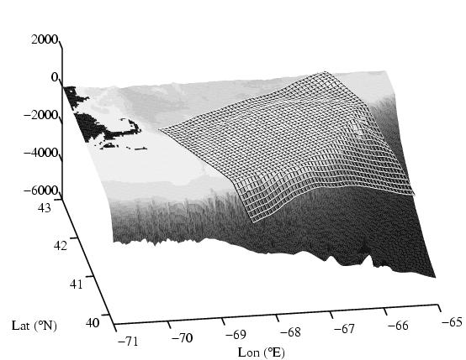
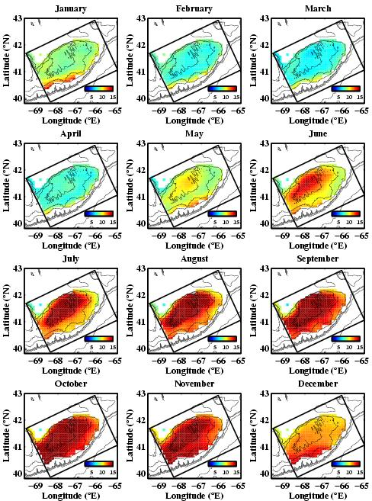
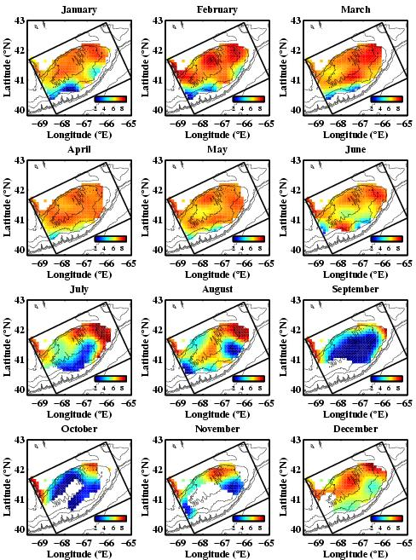
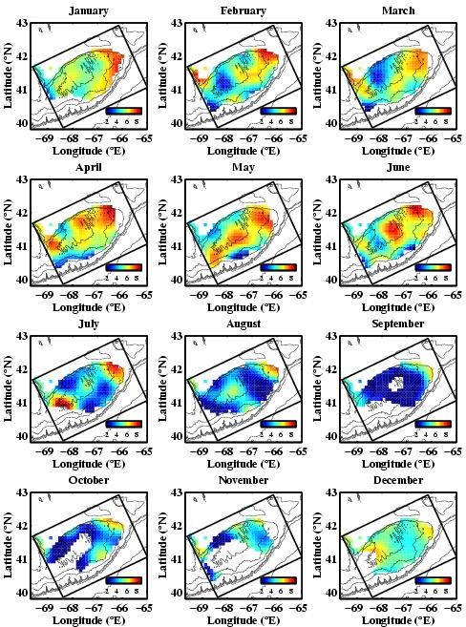

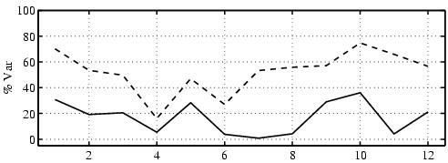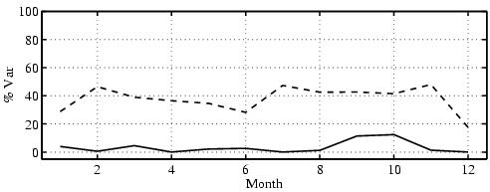

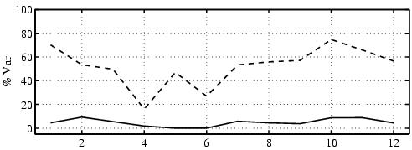
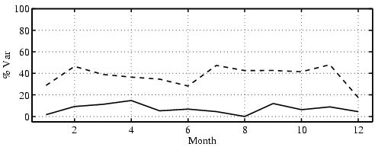

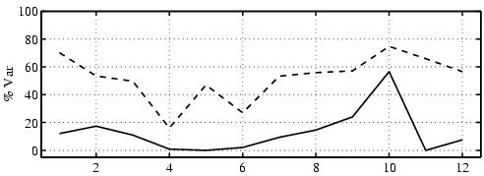
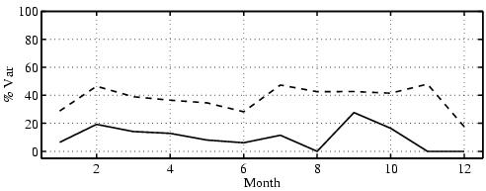

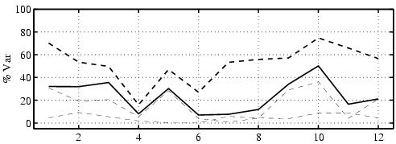
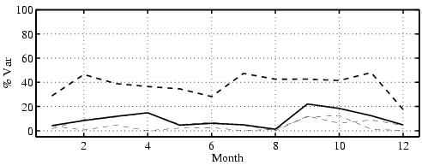

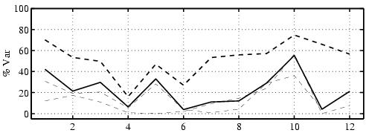
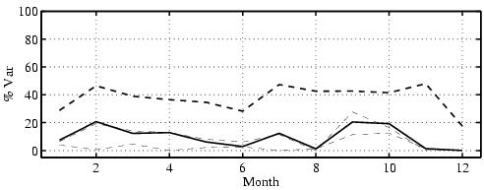

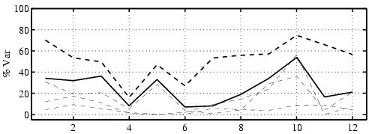
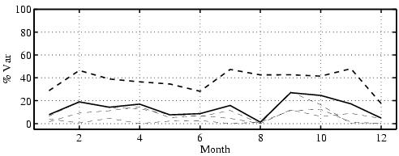
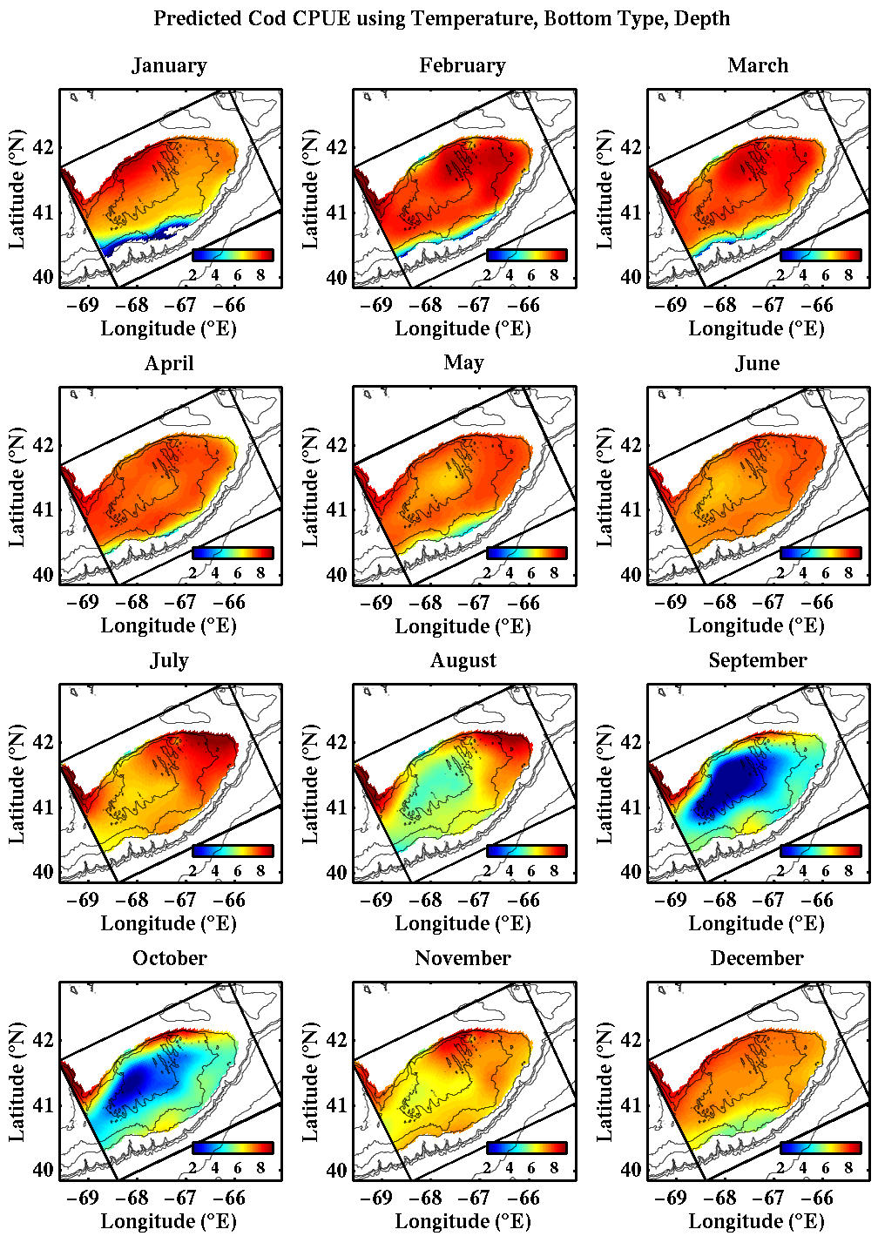
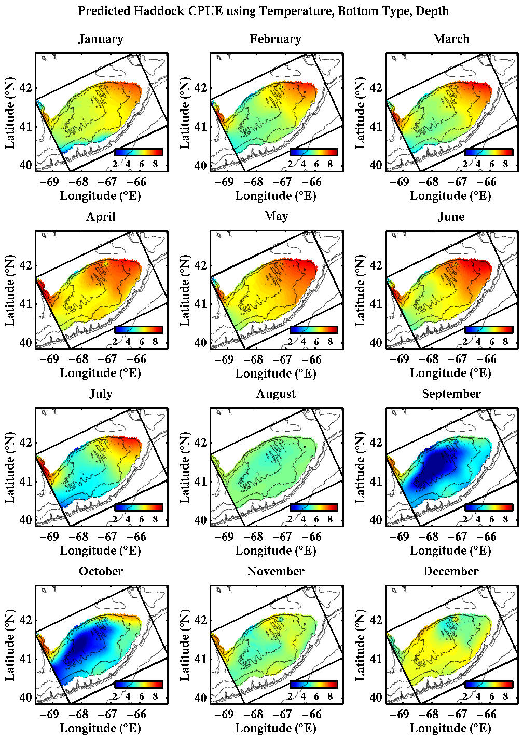

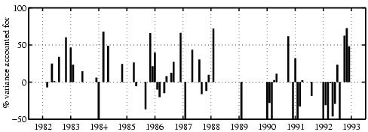
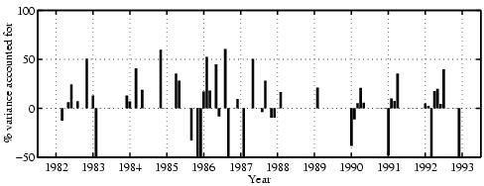

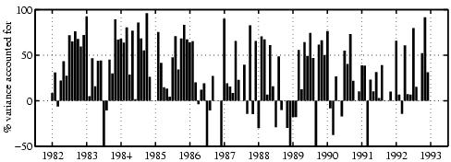
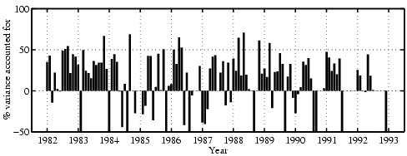

An analogous multiplicative model representing mutually exclusive environmental variables has also been formulated (e.g., discrete gradations of sediment type such as silt and clay versus gravel). However, the applicability and detailed dynamics associated with this model are still under investigation and hence will not be discussed here.

