Chapter 9 The Charney model of baroclinic instability

9.1 Introduction

Eady’s model of baroclinic instability is particularly simple mathematically because the basic state potential vorticity gradient is zero. This in turn implies that the perturbation potential vorticity is also zero for the normal modes, This, in turn, allows a very simple ordinary differential equation to determine the vertical structure of the modes. In order for such a simple model to support baroclinic instability it was necessary to have two horizontal boundaries sufficiently close together so that they could interact. As (5.2.7) shows for a given mode it is necessary for the two boundary terms to cancel in the absence of an interior pv gradient. The perturbation must “reach” both boundaries. Indeed, if one of the boundaries were removed the flow would be stable to normal mode perturbations in spite of the presence of vertical shear in the basic state.
The presence of two such boundaries is rather artificial. In the atmospheric case it is hard to justify an upper boundary and for the oceanic case, while an upper boundary is realistic, the small shears of currents at depth makes the contribution of the lower boundary to the required balance problematic. To move beyond that model we need to consider the potential vorticity gradient in the interior of the fluid. This is the principal feature of the Charney model and we shall see that when $¶q_{o}/¶y$ is not zero the problem changes in a striking way. Charney formulated his model without knowledge of Eady’s work and his interest in including a nonzero $¶q_{o}/¶y$ was connected to the work of Rossby who had, not long before, described the basic dynamics of what we now call the Rossby wave. It is hard to exaggerate the important effect of the Rossby wave on the meteorological community at that time and the importance of the beta effect was considered self-evident by the time of Charney’s thesis work (1946) especially among the group of Scandinavian meteorologists at UCLA where Charney did his work. At the same time, through kinematic and heuristic arguments there was an understanding of the need of the phase shift of the baroclinic wave with height to produce amplification (the word used then was “deepening”) of the wave. The notion of the importance of the “upper air wave” and the beta effect were probably key in forming the ingredients of Charney’s approach. In his first notes on the problem of baroclinic instability (“development” as it was called), Charney intended to do a sort of initial value problem and show how the phase tilt with height was quantitatively required to produce growth. His alteration of the problem to a normal mode problem has an unclear history but it may be related to conversations he had with C.C. Lin who was then visiting Cal. Tech, on the traditional shear flow instability problem. ♦
Charney’s model included the β effect, a finite density scale height and, in its final form, a current with a constant vertical shear which extended to infinite height. He reasoned that the modes of interest would decay with height and that the particular nature of the shear at very large z would be irrelevant to the problem. In this way he removed the upper lid from the Eady model and, with (5.2.7) in mind, we can see that this allows the interior pv gradient to balance the lower boundary term when the upper boundary term is removed. If the beta effect is positive and the shear is positive we will shortly see that $¶q_{o}/¶y$ > 0. In that case the necessary condition for instability will be satisfied if the vertical shear at the lower boundary (it is flat in Charney’s model) is also positive. Since $¶q_{o}/¶y$ is present for all z, any perturbation, no matter how shallow in z might balance the interior integral in (5.2.7) against the lower boundary term. We can anticipate therefore that the short wave cut-off of Eady’s model, which is due to the requirement that the upper boundary perturbation reach the lower boundary will no longer be constraining for the instability. This has profound implications for the stability problem. Again thinking of the balance in (5.2.7) it follows that a positive beta term, balancing the lower boundary term is essential in allowing instability. This further implies in a counter-intuitive way that the beta effect might have a destabilizing effect on the flow although we associate the beta term with providing a restoring mechanism allowing the oscillations of the pure Rossby wave. The fact that the absence of $¶q_{o}/¶y$ yields stability when there is a single horizontal boundary even with the available potential energy represented by the vertical shear and the possibly destabilizing effect of the beta term emphasizes that the instability is strongly governed by potential vorticity dynamics.
The oceanographers among us should realize that if we turn Charney’s model around and put the boundary at the upper level, positive vertical shear and positive $¶q_{o}/¶y$ will lead to stable solutions. The oceanographic instability problem, for eastward currents will thus require that $¶q_{o}/¶y$ somewhere change sign with depth.

9.2 Formulation of Charney’ s problem.
In Charney’s model the basic current is a linear function of z, the buoyancy frequency is constant and the density scale height of the background is also a constant, i.e.

$\begin{aligned}U_{o}(z)=U_{o_{z}}z, \\ \\ −\frac{1}{ρ_{s}}\frac{{dρ}_{s}}{\text{dz}}=\frac{1}{H}=\text{const}\text{.}\end{aligned}$ (9.2.1)

Under these conditions the normal mode stability equation is

$\begin{aligned}\left(U_{o_{z}}z−c\right)\left[\frac{f_{o^{2}}}{N^{2}}(F_{\text{zz}}−\frac{1}{H}F_{z})+F_{\text{yy}}−k^{2}F\right]+\left[β+\frac{f_{o^{2}}}{N^{2}}\frac{U_{o_{z}}}{H}\right]F=0, \\ \\ −{cF}_{z}−U_{o_{z}}F=0,z=0\text{.}\end{aligned}$ (9.2.2 a,b)

Charney looked for solutions independent of y but since the basic state is independent of y we can find solutions satisfying homogeneous boundary conditions on y = 0 and y=L in the form,

$F(z,y)=A(z)\text{sin}(\text{ly}),l={mp}/L$ (9.2.3)
so that (9.2.2) becomes,

$\begin{aligned}\left(U_{o_{z}}z−c\right)\left[\frac{f_{o^{2}}}{N^{2}}(A_{\text{zz}}−\frac{1}{H}A_{z})−K^{2}A\right]+\left[β+\frac{f_{o^{2}}}{N^{2}}\frac{U_{o_{z}}}{H}\right]A=0, \\ \\ −{\text{cA}}_{z}−U_{o_{z}}A=0,z=0\text{.} \\ \\ K^{2}=k^{2}+l^{2}\end{aligned}$ (9.2.4 a,b)

Note that an upper boundary condition is required. For all unstable modes it will be enough to insist on finiteness of the perturbation for z going to infinity.
Before beginning an analysis of the mathematical problem let’s examine a few of its general features. Since $¶q_{o}/¶y$ is not zero, the equation is singular at all those points for which $z=c/U_{o_{z}}$. If c is complex the singularity will lie in the complex z plane while if c is real the singularity will lie on the real line and if c is real and positive it will lie within the domain of the problem $z³0$. Such points are called critical levels. This singularity renders the problem both difficult and physically interesting.
In addition, no matter what the parameter values of the problem, the structure of the solution must be such to retain a balance between the second derivative of A and the term involving $¶q_{o}/¶y$. The absence of the second derivative would not allow us to satisfy the boundary conditions while the effect of the $¶q_{o}/¶y$ is required, as we have seen, for the mode to be unstable. We can use these considerations to get an a priori estimate of the depth scale of the perturbation, its wavelength and the accompanying growth rate. Keep in mind these are scaling estimates and not solutions of the problem.
Suppose the depth scale of the disturbance is d. Balancing the second derivative term with the pv gradient leads to the scaling relation,

$U_{o_{z}}d∗\frac{f_{o^{2}}}{N^{2}d^{2}}A»\left[β+\frac{f_{o^{2}}}{N^{2}}\frac{U_{o_{z}}}{H}\right]A$ (9.2.5)

If the β term dominates on the right hand side, this leads to an estimate for d,

$d=d_{β}=\frac{f_{o^{2}}}{N^{2}}\frac{U_{o_{z}}}{β}$ (9.2.6a)

Note that with this estimate the larger is beta or the smaller the vertical shear, the smaller the vertical scale predicted for the perturbation. Since the perturbation must be in contact with the lower boundary for instability this implies that the perturbation becomes surface intensified as β increases ( in a nondimensional sense). No longer is the scale controlled by a geometric scale as in Eady’s problem. The scale is now internally determined. If we anticipate that baroclinic energy release will require horizontal scales of the order of the deformation radius based on the vertical scale of the motion, this yields an estimate of the horizontal scale in x , L, (not to be confused with the channel width)

${LºL}_{β}=\frac{{\text{Nd}}_{β}}{f_{o}}=\frac{f_{o}}{N}\frac{U_{o_{z}}}{β}$ (9.2.6b)

Thus as the vertical scale shrinks, say for weak shear or strong beta, the horizontal scale also shrinks accordingly. We anticipate no short wave cut-off in Charney’s model.
Similarly, we can now make an estimate of the growth rate to be expected. From the semi-circle theorem we can anticipate that the imaginary part of c will be of the order of the variation of U_{o} over the scale of the perturbation or,

$c_{i}»U_{o_{z}}d$
At the same time the growth rate will be of the order of ${\text{kc}}_{i}$ where k =O(1/deformation radius) or

$s={\text{kc}}_{i}»U_{o_{z}}d\frac{f_{o}}{\text{Nd}}=\frac{f_{o}}{N}U_{o_{z}}$ (9.2.6c)

Note that the growth rate is independent of our estimate of d and only depends on the assumption that the horizontal scale is of the order of the deformation radius based in turn on the depth of the motion.
These estimates have been based on the assumption that the density scale height H is large, or more precisely that,

$H>\frac{f_{o^{2}}U_{o_{z}}}{N^{2}β}=d_{β}$ (9.2.7)
so that the beta term in $¶q_{o}/¶y$ dominates the shear term. If the inequality in (9.3) is reversed our estimate for d from (9.2.5) would be simply,

$d=H$ (9.2.8.a)
from which it would follow that ,

$L=\frac{\text{NH}}{f_{o}}$ (9.2.8.b)

while the growth rate, of course, would still be given by (9.2.6c) since it is independent of d.

Which vertical scale is pertinent in any particular problem? Clearly, is it the smaller of the two scales. If $d_{β}<H$ the scale is given by (9.2.6a). If the inequality is reversed the vertical scale is given by (9.2.8a). It is the smaller scale that determines the dominant term in the potential vorticity gradient. Similar scale estimates arise if we insist on a balance between the interior integral and the boundary term in (5.2.7).
Another way to look at the same result focuses on the condition that, regardless of scale, there be significant motion within the wedge of instability. This suggests that,

$\frac{w}{v}=O\left(\frac{J_{o_{y}}}{J_{s_{z}}}\right)=\frac{f_{o}U_{o_{z}}}{N^{2}}$ (9.2.9)
while for large β the vorticity equation reduces to
$βv=O\left(f_{o}w_{o_{z}}\right)⇒w/v=dβ/f_{o}$ (9.2.10)

Combining (9.2.9) and (9.2.10) leads again to the estimate (9.2.6a). So, even for very large β where we would expect stability the perturbation can still arrange to have perturbation trajectories within the wedge of instability with the consequent release of energy, i.e. instability.

9.3 The critical level

Before discussing Charney’s normal mode problem ,(9.2.4), in detail it is useful to deal with some general considerations of the normal mode equation in cases for which the potential vorticity gradient does not vanish but where for some z = z_{C}

$U_{o}(z_{c})−c=0$ (9.3.1)

Points where (9.3.1) is satisfied are called critical points or critical levels of the problem and we see that the governing differential equation is singular there unless $q_{o_{y}}$ happens also to vanish at that point. Of course for the Charney model $q_{o_{y}}$ is a constant so it is never zero. To understand the effect that has on the problem let’s consider the nature of the solution in the vicinity of the critical point. We will use the method of Frobenius and you may want to review that method which can be found in any book that discusses series solutions of ordinary differential equations.
In the vicinity of the critical point we can write,

$U_{o}−c=\overset{=0}{\overbrace{U_{o}(z_{c})−c}}+U'_{o}(z_{c})(z−z_{c})+U_{o^{\text{''}}}(z_{c})(z−z_{c}{)^{2}}/2+\text{.}\text{.}\text{.}$(9.3.2)

It is convenient to introduce the variable,

$Z=z−z_{c}$ (9.3.3)

so that in the vicinity of the critical level we can write (9.2.4) as

$\left(Z+\frac{U_{o^{\text{''}}}}{2U_{o^{'}}}Z^{2}+\text{.}\text{.}\text{.}\right)\left(A_{\text{zz}}+A_{z}\frac{d}{\text{dz}}\text{log}\left[\frac{ρ_{s}f_{o^{2}}}{N^{2}}\right]−K^{2}\frac{N^{2}}{f_{o^{2}}}\right)+\frac{¶q_{o}}{¶y}\frac{N^{2}}{U_{o^{'}}f_{o^{2}}}A=0$(9.3.4)

Here, once again, for a basic flow dependent only on z, we have used for the solution the form $F=A(z)\text{sin}\text{ly}$. The terms in (9.3.3) involving the basic state velocity and its derivatives are understood to be evaluated at the critical level. The same is true for the potential vorticity gradient. These are the only terms required to reveal the solution structure in the vicinity of Z =0.
The method of Frobenius searches for solutions of ordinary differential equations with regular singular points by employing the following series in the vicinity of that point,

$A(Z)=Z^{p}\sum_{k=0}^{¥}{a_{k}Z^{k}}$ (9.3.5)
If (9.3.5) is inserted into (9.3.4) and like powers of Z are equated, the index p is determined and a recursion relation for a given p then follows relating the a_{k} to the arbitrary values of a_{O} and a₁. The equation for the index p follows from isolating the most singular term in the resulting series and leads to the requirement for an equation like (9.3.4),

$p(p−1)=0$ (9.3.6)

As is well known when the two indices differ by an integer the form (9.3.5) does not lead to two independent solutions when the series for each p is worked out. Only the series for the larger p , in this case p=1 is valid. Its solution can be written in the form,

$A_{1}(Z)=Z(1+a_{1}Z+a_{2}Z^{2}+\text{.}\text{.}\text{.})$ (9.3.7 a)
In the limit when $c_{i}$→0, it is important to note that the recursion relation for the a_{k} in (9.3.7a) will be real so that in that limit, which will be of particular interest to us, we can consider the solution in (9.3.7a) strictly real. The standard Frobenius theory tells us that the second solution consists of a series using the smaller value of p, here p=0, plus a logarithmic term multiplying the first solution. That is,

$A_{2}(Z)\text{=-}(1+d_{1}Z+d_{2}Z^{2}+\text{.}\text{.}\text{.})+\left[\frac{q_{o_{y}}}{U_{o^{'}}}\frac{N^{2}}{f_{o^{2}}}\text{log}Z\right]A_{1}(Z)$ (9.3.7b)

and it again important to note that in the limit where $c_{i}$→0 the recursion relation will yield values for the d_{k} which are real.
If $q_{o_{y}}$ is different from zero at the critical level the second solution will contain a logarithmic singularity. For small values of $c_{i}$ we can find its position by solving (9.3.1) for z_{C},

$$\begin{aligned}z_{c}=z_{c_{r}}+{\text{iz}}_{c_{i}}, \\ \\ U_{o}(z_{c_{r}})»c_{r,} \\ U_{o^{'}}z_{c_{i}}=c_{i,}⇒z_{c_{i}}=c_{i}U_{o^{'}}\end{aligned}$$
and its position is shown in the figure below.
Z

z_{C}
α

*
$${c_{i}}/{U_{o^{'}}}$$

z

Figure 9.3.1 The position of the critical point in the (complex) z plane. It is displaced from the real line by a small amount if c_{i} is small. The dashed line is the branch cut required to make the logarithmic term single valued.

For cases like the Charney model for which the unstable waves have ${c_{i}}/{U_{o^{'}}}>0$ so that the singularity is in the upper half of the complex z plane, we note that since
$$z−z_{c}=\left|z−z_{c}\right|e^{iα}$$

it follows that,

$\text{log}Z=\text{log}\left|z−z_{c}\right|+iα$ (9.3.8)

and,
$\begin{aligned}z>z_{c}α»0, \\ \\ z<z_{c}α\text{»-}p\end{aligned}$ (9.3.9 a,b)
so that the logarithmic term in the second solution has a sharp change in phase with z as we pass through the critical level when c_{i} is small. We know that it is the phase shift of the solution with height that leads to a nonzero buoyancy flux and an energy release required for instability and we can anticipate that the presence of a critical level will give rise to such a phase shift even in the limit as $c_{i}→0$ if the potential vorticity gradient is non zero at that value of z. Let’s calculate the buoyancy flux in the vicinity of the critical level.

$\begin{aligned}\overline{v'b'}=\frac{{\text{ikf}}_{o}}{4}\overline{\left[{\text{Ae}}^{iq}−A^{}e^{−{iq}^{}}\right]\left[A_{z}e^{iq}+A_{z^{}}e^{−{iq}^{}}\right]}{\text{sin}}^{2}\text{ly} \\ \\ =\frac{{\text{ikf}}_{o}}{4}\left[{\text{AA}}_{z^{}}−A^{}A_{z}\right]{\text{sin}}^{2}\text{ly}e^{2{\text{kc}}_{i}t}\end{aligned}$ (9.3.10)

where we again have used the notation, $q=k(x−ct)$. Note that the bracket in the second form in (9.3.10) has been seen before in the Eady problem where it was shown to be a constant. There was no critical level in that problem (the potential vorticity gradient vanished everywhere , and in particular where $U_{o}=c$). In the present case where the pv gradient is not zero and writing,

$A=A_{1}(Z)+{\text{RA}}_{2}(Z)$ (9.3.11)

where R is an arbitrary constant we can easily evaluate the right hand side of (9.3.10) in the limit where $c_{i}→0$. In that limit every term in the solutions will be strictly real except the contribution from the logarithm. A brief calculation then shows that,

$\overline{v'b'}\text{=-}\frac{{\text{kf}}_{o}}{2}{\left|R\right|}^{2}α\frac{N^{2}}{f_{o^{2}}}\frac{q_{o_{y}}}{U_{o^{'}}}{\text{sin}}^{2}\text{ly}e^{2{\text{kc}}_{i}t}$ (9.3.12)

There is thus an abrupt change of the buoyancy flux across the critical level as α changes by 180º by (9.3.9). Note too, that as $c_{i}→0$ the buoyancy flux at the critical level does not go to zero!
An important consequence of this fact follows directly from the necessary condition for instability (5.2.7) which relates the integrated potential vorticity flux the to buoyancy fluxes on the boundary. Using (9.2.3) and restricting attention to flows independent of y, we can rewrite (5.2.7) in the case where the upper boundary is moved to infinity as, [for a flat bottom]

${\text{kc}}_{i}\int_{0}^{¥}{ρ_{s}\frac{{\left|A\right|}^{2}q_{o_{y}}}{{\left|U_{o}−c\right|}^{2}}\text{dz}}={\text{kc}}_{i}{\left.\frac{{\left|A\right|}^{2}}{{\left|U_{o}−c\right|}^{2}}\frac{f_{o^{2}}}{N^{2}}\right\}}_{z=0}$ (9.3.13)
The integral on the left hand side can be written as,

${\text{kc}}_{i}\int_{0}^{¥}{ρ_{s}\frac{{\left|A\right|}^{2}q_{o_{y}}}{\left[(U_{o}−c_{r})^{2}+c_{i^{2}}\right]}\text{dz}}=\text{Im}\left\{\int_{0}^{¥}{ρ_{s}k\frac{{\left|A\right|}^{2}q_{o_{y}}}{\left[U_{o}−c\right]}\text{dz}}\right\}$ (9.3.14)

In the limit $c_{i}→0$ the left hand side of (9.3.13) will go to zero except for the contribution from the pole singularity at the critical level. As $c_{i}→0$ that pole move to the real z line and the contour must be indented to pass underneath it in the limit as shown in the figure,

Integration contour
z
*

Figure 9.3.2 the integration contour for (9.3.14) showing the indentation in the contour to pass under the singularity as $c_{i}→0$.

In passing under the pole we pick up the only contribution to the imaginary part of the integral and this is exactly 1/2 the value of the residue of the pole at the critical level. Thus, the left hand side of (9.3.13) becomes,

$p\frac{{\text{kf}}_{o}}{U_{o^{'}}}ρ_{s}(z_{c}){\left|A(z_{c})\right|}^{2}q_{o_{y}}(z_{c})={\text{kc}}_{i}{\left.\frac{{\left|A\right|}^{2}}{{\left|U_{o}−c\right|}^{2}}\frac{f_{o^{2}}}{N^{2}}\right\}}_{z=0}$ (9.3.15)

As $c_{i}→0$ the right hand side vanishes but the left hand side remains as long as $q_{o_{y}}¹0$ at the critical level. There is therefore a contradiction unless $q_{o_{y}}$ =0 there or if the critical level should move to the boundary, z=0. When that happens the pole in figure 9.3.2 no longer occurs within the domain. Note that when β is nonzero the semi-circle theorem allows unstable modes with c outside the range of U_{O} . However, even with β =0, the potential vorticity gradient will be positive for positive shears due to the finite density scale height. In that case c must lie in the range of the basic velocity for instability to occur. Thus, we anticipate, in Charney’s model, that the parameter values for which the flow is just unstable, the so-called marginally unstable modes, must correspond to phase speeds near the lower boundary velocity that in Charney’s model is zero. As the growth rate increases from zero we can expect the position of the critical level to move into the fluid although for $c_{i}$ not equal to zero the singularity will not occur for real z. Another way of stating our result is that the presence of a critical level within the fluid guarantees that such a mode, if it exists, must be unstable. As we shall see this has important consequences for Charney’s model.

9.4 The Charney eigenvalue problem.
To analyze the eigenvalue problem (9.2.4) for the Charney model of baroclinic instability it is useful to introduce a vertical coordinate scaled with the characteristic scale $d_{β}=\frac{{}_{{f_{o}}^{2}}}{{}^{N^{2}}}\frac{U_{o_{z}}}{β}$. Let
$z'=z/{d_{β}}$ (9.4.1)

so then (9.2.4) becomes
$(z'−c')(A_{z'z'}−{dA}_{z'}−m^{2}A)+\left[1+d\right]A=0$ (9.4.2)

where
$\begin{aligned}c=U_{o_{z}}d_{β}c\text{',} \\ \\ m={\text{KL}}_{β}={{\text{KNd}}_{β}}/{f_{o}} \\ \\ d={d_{β}}/H\end{aligned}$ (9.4.3 a,b,c)

The wavenumber is scaled with the deformation radius based on the vertical scale $d_{β}$ and the parameter δ is the ratio of $d_{β}$ to the density scale height H. For a fluid that is Boussinesq in density, e.g. the ocean, whose density scale height is much larger than the vertical scale of the motion, the parameter δ →0. The nondimensional complex phase speed has been scaled with the characteristic velocity variation experienced by the perturbation over its vertical extent, leading to a growth rate that will scale as (9.2.6c). Finally, to put the equation in standard mathematical form the following transformations are useful. Since the region in z’ is infinite, for large z’ the dominant term is the bracket multiplied by the factor (z’-c’). That suggests that for large z’ there will be an exponential decay of the solution, of the form,
$e^{νz'},ν=\frac{d}{2}−{\left[m^{2}+d^{2}/4\right]}^{1/2}$ (9.4.4)
Note that ν is always negative. In fact, if δ is very small, the decay is just proportional to μ exactly like the Eady model. We also note that if c=0, the eigenfunction, by (9.2.4) must vanish at z=z’=0. This suggests looking for solutions in the form,

$A(z')=e^{νz'}(z'−c')F(z')$ (9.4.5)

where, of course, this form can be multiplied by an arbitrary constant. The final step is less intuitive but anticipating the simplicity that results we introduce a slightly rescaled vertical coordinate,

$Z=(z'−c')\sqrt{4m^{2}+d^{2}}$ (9.4.6)

Inserting the form (9.4.5) and the transformation (9.4.6) into (9.4.2) results in the final equation for the function F(Z),

${ZF}_{\text{ZZ}}+(2−Z)F_{Z}−F(1−r)=0,$ (9.4.7)

where the parameter r is defined by

$r=\frac{(1+d)}{{\left\{4m^{2}+d^{2}\right\}}^{1/2}}$ (9.4.8)

The boundary condition at z’=0, becomes,

$Z_{o^{2}}\left[F_{Z}+\frac{ν}{\sqrt{4m^{2}+d^{2}}}F\right]=0,Z_{o}\text{º-}c'\sqrt{4m^{2}+d^{2}}$ (9.4.9)

The factor $\frac{ν}{\sqrt{4m^{2}+d^{2}}}\text{=-}1/2+\frac{d}{\sqrt{4m^{2}+d^{2}}}$ so that in the Boussinesq limit δ→ 0 and that coefficient in (9.4.9) becomes –1/2 and independent of the parameters of the problem. In the same limit the parameter r → $1/(2m)$ so that in the Boussinesq (density) limit the only remaining parameter in the problem is the scaled wavenumber. That being the case we see that, in common with the Eady model there can not be a critical shear required for instability, only perhaps a critical wavenumber. That wavenumber may depend on the shear but, again, in the limit δ → 0, any shear will be unstable if the problem is unstable for some value of the shear. This is rather surprising because it indicates the inability of the β effect to stabilize the flow. (Indeed, we argued that because of the critical level effect β could destabilize the flow).
The final equation, (9.4.7) is the confluent hypergeometric equation. It’s properties are well known although the functions are rather complex. The resulting eigenvalue problem is a complex and delicate one requiring considerable mathematical analyis. The details of the problem can be found in Chapter 7 of GFD. Here we will only deal with the results of the main points of the analysis.
The solutions of (9.4.7) have a different character depending whether the parameter r is an integer or not. This follows from considering the solution of the equation obtained by the method of Frobenius. According the theory of ordinary differential equations there will be a regular singular point at Z =0 and an irregular singular point at infinity. Of the two independent solutions of the equation, one will be regular at Z=0, and that solution is defined as

$\begin{aligned}M(a,2,Z)=1+\frac{\text{aZ}}{2}+\frac{a(a+1)Z^{2}}{2⋅3⋅2!}+\frac{a(a+1)(a+2)Z^{3}}{2⋅3⋅4⋅3!}+\text{.}\text{.}\text{.} \\ \\ +\frac{(a)_{n}}{(2)_{n}}\frac{Z^{n}}{n!}+\text{.}\text{.}\text{.}, \\ \\ \end{aligned}$ (9.4.10)

where we have used the notation,

$\begin{aligned}a=(1−r), \\ \\ (s)_{n}ºs(s+1)(s+2)\text{.}\text{.}\text{.}(s+n−1), \\ \text{note}, \\ \\ (2)_{n}=(n+1)!\end{aligned}$ (9.4.11 a,b,c)

When r is a positive integer, i.e. r = n, the solution (9.4.10) will terminate (since a will be zero or a negative integer) and the solution will be an n-1st polynomial. This is a solution which, when the exponential factor in (9.4.5) is considered, will satisfy the finiteness condition at infinity; indeed, it will exponentially decay. The second solution for integer r can be shown to be singular for large Z and even with the exponential factor of (9.4.5) is singular at infinity. (This must be the case because the original equation for A is singular for large z). The for integer r the solution is a simple polynomial.
On the other hand when r is not a positive integer one can show that the solution (9.4.10) leads to asymptotically unbounded solutions for large Z and the solution instead is given by a rather complicated function whose standard name is $U(a,2,Z)$. Its definition can be found Abramowitz and Stegun” Handbook of Mathematical functions, (Nat’l Bureau of Standards) and is also described in GFD. The key feature of this function is that it contains a logarithmic singularity at Z=0 as we would expect from the discussion of the previous section.
Consider first the solutions corresponding to integer r. We will find that for such values of r=n the polynomial solutions correspond to marginally stable solutions. That is, they define lines in the (δ, μ) plane on which the imaginary part of c’ vanishes. We would normally associate such curves with stability thresholds but as we shall see, and have already anticipated, the problem is much more complex. If we use the condition r=n, we obtain the following equation for δ,

$d(K,n)=\frac{f_{o^{2}}}{N^{2}}\frac{U_{o_{z}}}{βH}={\left\{n{\left[1+4K^{2}N^{2}{H^{2}}/{f_{o^{2}}}\right]}^{1/2}−1\right\}}^{−1}$ (9.4.12)
The condition for the curves relates the vertical shear to the wavenumber, In (9.4.12) the wavenumber is scaled by the deformation radius defined in terms of the density scale height for the depth. If, instead, we were to consider the case where that scale height was large compared to the motion scale $d_{β}$, the condition that r =n would reduce to,

$\frac{f_{o}U_{o_{z}}}{Nβ}K=1/(2n),\text{for}d→0$ (9.4.13)

Figure 9.4.1 shows the first four critical curves for the Charney model. Higher values of n give curves that lie closer to the zero shear axis. Note that the n=1 curve asymptotes to infinity as K→ 0 while the other curves asymptote to $d→(n−1)^{−1}$.

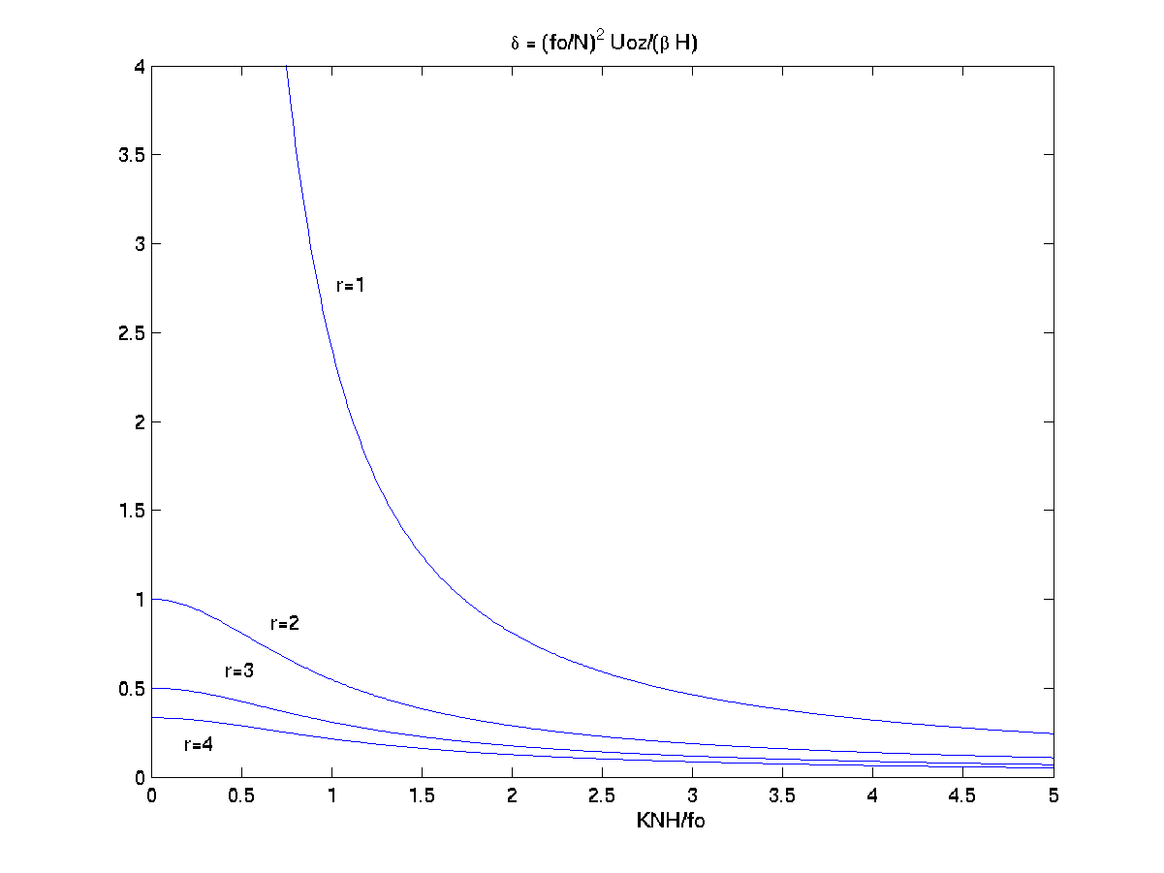

Figure 9.4.1 The first four Charney critical curves.

It has been traditional to present these same curves plotted against wavelength i.e. $2p/K$. That figure is shown below,

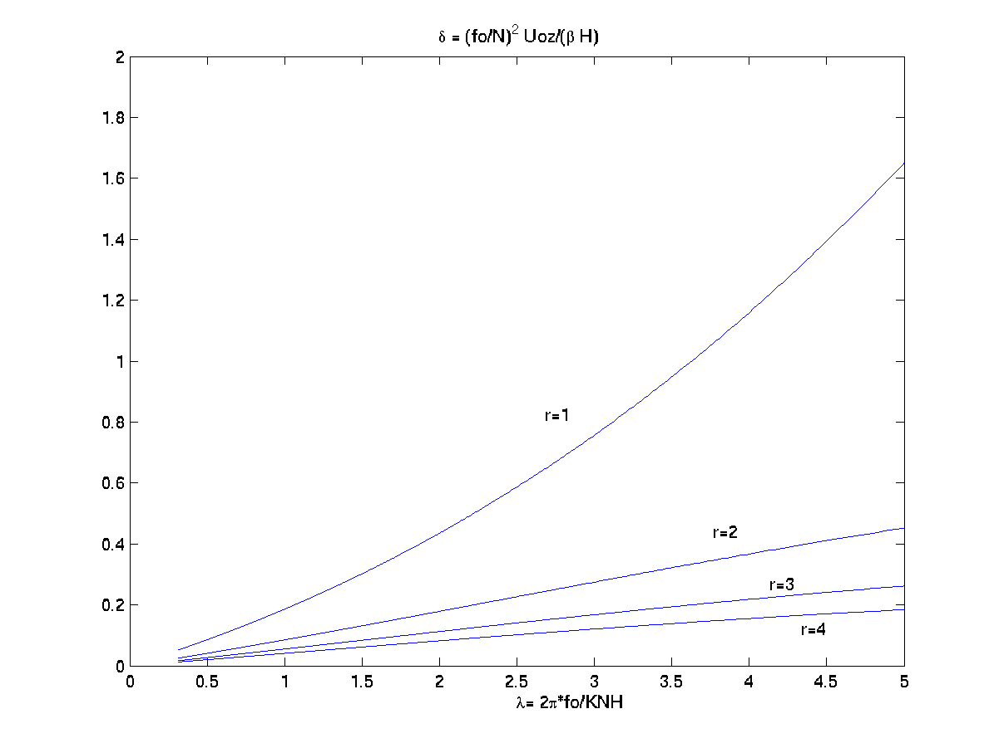

Figure 9.4.2. The shear parameter δ plotted against the scaled wavelength $λ=\frac{2{pf}_{o}}{\text{KNH}}$.

A historical note: When in 1946-47 Chaney was working on this problem he was simultaneously trying to solve the instability problem and formulate the quasi-geostrophic equations for the problem (not a bad Ph.D. thesis). In his formulation of the quasi-geostrophic model he made a single slip and apparently did not notice that he had retained a term in the boundary condition at the ground that was of the order of the ratio of the internal deformation radius to the external deformation radius, a term that for consistency should be neglected if we ignore the time derivative of the density in the continuity equation. That slip led to an unnecessary complexity in which the critical curves were no longer simply the curves r = integer. Charney was therefore forced to laboriously hand calculate (this is the era before computers, before Matlab, etc.) the roots of the dispersion relation involving the confluent hypergeometric functions on a mechanical Marchand calculator. He worked for months to obtain the curve corresponding roughly to the curve r= 1 in figure 9.4.2. He then slightly perturbed that solution to consider slightly larger shears and found that the region above the curve was bounded by unstable solutions. Exhausted, he assumed that the region below the curve was stable. After all, it seemed sensible that if there were a critical curve on which the flow was stable, it would certainly be stable for smaller shears. He and all subsequent readers believed that the curve r =1 then divided the plane into a stable and unstable region, the stable zone produced by the effect of β. It was unclear why short waves in his model were unstable, since for short waves the β effect should be negligible but the stabilization at large wavelengths seemed sensible. There was considerable surprise when Burger proposed in the early 6o’s that the Charney model was unstable everywhere in the δ,K plane except on the lines of integer r . Burger’s proof (J. Atmos. Sci. 1962,19,31-38) is elegant but rather abstract, proving the flow must be unstable for all parameter values except integral r but there were few people who could follow the argument. Fundamentally, the argument hinges on the existence of the logarithmic term in the solution that enters for non-integer r, or from a physical point of view, from the critical level behavior we described in section 9.3. Finally, Miles in a series of papers in 1964 (which are referenced in GFD) described a series of perturbation approaches to the problem near the r =n curves that clarified the behavior of the solutions. We will not go into that detail. As mentioned earlier, those details are presented in Chapter 7 of GFD. Here I will quote only the results. We will also discuss some numerical investigations of the problem. However, those investigation are of necessity dependent on certain analytic preliminary results which I will only outline.
A useful starting point is to examine the nature of the eigenfunction on what is now called the Charney critical curve r =1. If r =1 the parameter a =0 and the polynomial series terminates after the constant term, i.e. F=1. Furthermore for r=1,

$$\sqrt{4m^{2}+d^{2}}=1+d$$

from the definition of r (9.4.8). This in turn yields, $ν\text{=-}1/2$ for all wavenumbers. Hence along the Charney curve r =1,

$A(z)=(z'−c')e^{{−z}/{d_{β}}}$ (9.4.14).

When F=1 is used to satisfy the boundary condition we obtain the condition,

$Z_{o^{2}}\left\{−\frac{1}{2(d+1)}\right\}=0$ (9.4.15)

Hence the only way to satisfy this condition is if $Z_{o^{2}}=c'^{2}=0$. As expected for this marginally stable solution the phase speed is equal to the basic flow velocity on the boundary eliminating any critical level within the fluid. Note also that this corresponds to a double root for the phase speed and we saw in the Eady problem that this coalescence of roots for the inviscid stability problem is a sign of contiguous unstable solutions.
At higher values of integral r the situation is more complex. The boundary condition can be rewritten in terms of δ and r as,

$Z_{o^{2}}\left[F_{Z}−\frac{1}{2}\frac{(1+d(1−r))}{(1+d)}F\right]=0,$ (9.4.16)

Consider the case r=2 (a=-1). The solution for F is,

$\begin{aligned}F=1−Z/2, \\ \\ A=(1−Z/2)Z\text{exp}(−z(1−d)/4d_{β})\end{aligned}$ (9.4.17 a,b)

Since δ <1 on the curve r=2 the exponential factor in (9.4.17b) ensures exponential decay. Inserting (9.4.17a) into the boundary condition (9.4.16) yields either a) again the double root at c’=0 or the condition (from the terms in the square bracket in (9.4.16),

$Z_{o}\text{=-}c'=\frac{4}{1−d}$ (9.4.18)

Thus since δ <1 the phase speed of the third solution is always retrograde with respect to the basic flow. Consider the two roots corresponding to zero phase speed. For those roots

$Z=\left(\frac{z}{d_{β}}\right)\frac{(1+d)}{r}$ (9.4.18)

so the solution for the perturbation amplitude, (9.4.17b) has a node at the position

$z/d_{β}=\frac{4}{1+d}$ (9.4.18)

This pattern holds for all the higher modes that exist for larger integer r. (These higher modes with internal nodes are called Green nodes in honor of John Green who first suggested their presence. [reference in GFD]) On each curve the eigenfunction, corresponding to the coalescence of two real roots at zero phase speed, has r-1 nodes. At those curves there also exist r-1 retrograde, neutral Rossby-type modes. Note that if one fixes the shear and increases the wave number one crosses (for finite H) a finite number of such critical curves. At the crossing of each curve the phase speeds are real and represent a coalescence of two roots in the same way as in the Eady problem the critical wave number identified a point where the phase speeds coalesced.
If we move off the critical curves so that r is no longer an integer, the solution is no longer given by our simple polynomial solution and the solution referred to as U(2,a,Z) must be used to satisfy the boundary condition. This leads to a considerable analytical difficulty. This is the problem that Miles has unraveled so neatly in the series of papers referred to above. I will just outline the principal result. Imagine keeping the shear constant and crossing a particular curve r =n. As the wave number is decreased we move to higher values of r (see fig. 9.4.1) What Miles showed was that on the short wave side of the curve the imaginary part of the phase speed, $c_{i}$, increased like $(n−r)^{1/2}$,i.e. rapidly, in much the same manner as the increase in $c_{i}$, as one crosses the marginal curve in the Eady problem. However, rather than the other side of the curve corresponding to stability, he was able to show directly that $c_{i}$, behaved like $(r−n)^{3/2}$so that there was, weak growth in the vicinity of the critical curve. For example, this would yield weak growth below the Charney critical curve. The situation at each integral value of r is illustrated schematically below.
c_{i}

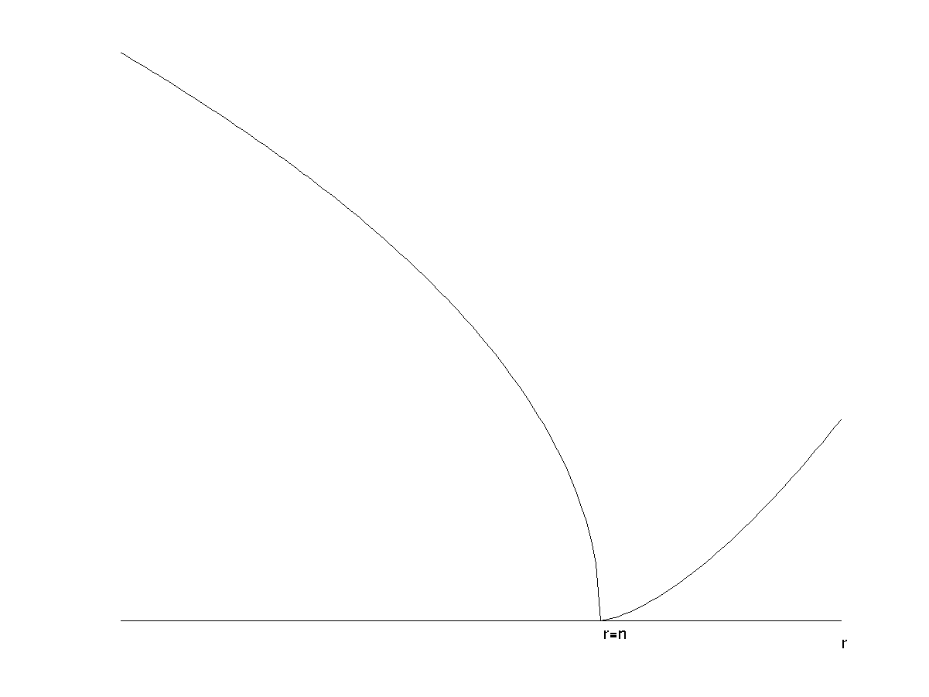
Figure 9.4.3. The behavior of $c_{i}$, as the integral curve r=n is crossed.
As one moves to the next smaller integral value of r the left hand curve reaches a maximum and approaches the $c_{i}$,=0 axis with the square root singularity and the pattern is repeated for each higher r=n (see figure 9.5.1). Note that for finite H there are only a finite number of such crossings for each value of the shear. To go beyond this local analysis near each critical curve numerical investigation is necessary. Either a numerical evaluation of the dispersion relation obtained by explicitly evaluating the boundary conditions in terms of the hypergeometric functions or a direct numerical treatment of the original eigenvalue equation (9.4.2) is required. It should be evident that numerical methods will be especially tricky near the points where $c_{i}$, vanishes because of the singularity in the equations, or if done by marching a time dependent approach because of the very weak growth rates. It is therefore essential to have both the analytical results near the integral r curves as well as the numerical approach to discuss the solution when the growth rate is O(1).

9.5 Numerical results for Charney’s model.

Kuo (J. Atmos, Sci, 1979, 36,2360-2378) examined the Charney problem following the analysis we have presented and ended up, by applying the boundary conditions, with a transcendental dispersion relation that he solved numerically. He also considered other profiles for the basic flow but here we will discuss only his results for the classical problem of Charney. Although his notation is somewhat different than ours he introduces a parameter r which is the same as what we have used. His independent variable is $h$ and it is precisely our Z and the its value on z=0, which we call Z_{O} is called $h_{b}$. In either case it is minus the nondimensional phase speed. Thus its imaginary part yields $c_{i}$ and its real part is $c_{r}$. Kuo chose a finite scale height of about 9 km and otherwise standard values for the Coriolis parameter (10⁻⁴ sec⁻¹) and buoyancy frequency, N, (1.2 10⁻² sec⁻¹) although he considered somewhat different values also for N. Figure (9.5.1) shows his calculation for the case where there are three crossings of the neutral curves for a particular value of shear. It is important to note that the y-axis in these figures runs over negative values.

Figure (9.5.1) The behavior of $Z_{o}$ as a function of r from Kuo (1979).

The neutral points where $h_{b_{i}}$ =0 occur at r =1,2, and 3. Note that approaching the integral values the curves for $h_{b_{i}}$ behave locally like (9.4.3), that is on the short wave side ( r just less than an integer) the curves are steep reflecting the square root behavior while on the other side there is a slower increase in $h_{b_{i}}$ moving away from the integral value of r. Note too, the behavior of the real part of $h_{b}$, in particular that it vanishes as the each critical line is approached. The largest value of $c_{i}$ occurs to the left of the smallest value of r i.e. in the domain of the Charney mode while the higher Green modes have smaller values. Note that the growth rate, as opposed to $c_{i}$ involves multiplication by the wavenumber. The wavenumber is larger in the domain of the Charney mode and this accentuates the dominance of that mode as far as the growth rates are concerned.
In figure (9.5.2) we show the eigenfunctions corresponding to non integral values of r i.e. corresponding to unstable modes.

Figure 9.5.2 The eigenfunctions calculated by Kuo for a) r=0.5, b) r=1.3, c) r =1.7.

Panel a shows a value r=0.5 right in the middle of the Charney mode domain and near to the most unstable wave. The absolute value of the perturbation is labeled $\left|y\right|$ in the figure and the dashed phase line ( for some reason Kuo defined the phase as the negative of the standard phase definition of a complex function so the apparent decrease of phase is really an increase). Also shown (the dot-dash curve) is the temperature perturbation. Note that the perturbation, much like the neutral mode on the r =1 curve, is surface trapped. Moreover, the region where the phase is changing with height is also restricted to the lower surface (there is an artificial phase shift at great height is irrelevant since the perturbation is essentially zero there). This implies that the energy conversion due to the buoyancy flux is strongly limited to the lower boundary. This is contrasted to the panels to the right of the first panel. The second and third panels are for the cases r =1.3 and 1.7 both in the range between the first and second critical curves. Note that for these values of r the eigen function has it principal maximum at greater heights, nearly at 20 or 25 km with the maximum increasing with height for the longer waves at larger r. Note that the phase shift is much larger, nearly 220º so that the solution has the structure, qualitatively, of a second mode in the vertical. Note too, that the phase shift is limited mainly to the lower part of the fluid, well below the amplitude maximum. These modes are much less efficient at releasing energy, Indeed, one might interpret the mode as a response to lower level forcing and the upward propagation of a neutral wave until it reaches an elevation where $U_{o}−c$ becomes so large that the amplitude must decay as foretold by the theory of Charney and Drazin on the vertical propagation of Rossby waves. (J.G.R., 1961, vo.66, 83-109).
There is only one unstable wave for each x-wavenumber. Geisler and Garcia (J.Atmos. Sci. 1977, 34, 311-321) took advantage of this fact by finding the unstable modes by an time integration of the linear quasi-geostrophic potential vorticity equation forced at the ground by an imposed vertical velocity with a wave-number, k, and they chose a real frequency of the forcing close to what one would expect from the analytic problem. The problem is not sensitive to that choice since for a given k the linear solution, after sufficient time, will be dominated by the unstable mode at that k with the complex phase speed of the normal mode. This is a very straight forward way of finding unstable modes. It clearly has its weakness exposed for those values of k for which the growth rates are small for then one has to wait too long to see the dominance of the unstable mode.
Figure 9.5.3 shows the e-folding times (inverse growth rates) for the Charney model. Note that the e-folding time has a minimum at zonal wave numbers around 6 (six waves around the earth at mid-latitudes ,45^{O},) corresponding to the interval of the first Charney mode. The peaks in the e-folding times correspond to the neutral, integral r curves.

Figure 9.5.3 The e-folding times versus k for the Charney model from Geisler and Garcia (1977).

a)

b)
Figure 9.5.4 aThe amplitude and phase of the Charney mode. b) The Green mode. (Geisler and Garcia, 1977)

Figure 9.5.4a shows the amplitude and phase of the Charney mode for wave number 9, a typical Charney mode. Figure 9.5.4 b shows a Green mode at longer wavelength (wavenumber 2), while figure 9.5.5 shows as collection of wave amplitudes vs. height for a variety of different modes. The Green modes appear at larger x-wavelengths, penetrate further in to the atmosphere and have lower growth rates.

Figure 9.5.5 Amplitude vs. height of unstable Green and Charney modes. (Geisler and Garcia, 1977)

The increase of the phase with height has an important kinematic consequence. If we write the wave as,

$y'=\left|A(z)\right|e^{i(\text{kx}−{kc}_{r}t+α(z))}\text{sin}\text{ly}$ (9.5.1)

the tilt of the wave in the x,z plane is given by,

$\frac{¶z}{¶x})_{\text{phase}}=\frac{−k}{¶α/¶z}<0$ (9.5.2)
displaying the expected westward tilt with height of the lines of constant phase. If we calculate the vertical phase velocity,

$\frac{¶z}{¶t})_{\text{phase}}=\frac{{\text{kc}}_{r}}{¶α/¶z}>0$ (9.5.3)

In the regions where energy is being release the phase speed is upward. Note that this is the opposite of what we would expect of a stable Rossby wave whose energy source is at low levels in z. The vertical propagation of energy in a Rossby wave must be associated with a downward propagation of phase.

There is an additional interesting reference of Lindzen and Rosenthal (J.Atmos.Sci, 1981, vol 38, 619-629. in which they describe a WKB approach to the stability equation. Those calculations are compared with direct numerical calculations of the stability equation and they show an interesting dependence of the wave structure and the growth rate vs.k behavior that one could anticipate from our earlier results. (Note that their parameter r is actually our 1/δ.). Of particular interest is their suggestion to examine the equation for the wave amplitude recast in terms of the function G(z), by removing the density scale height term, i.e. write

$\begin{aligned}A=e^{z/2H}G(m[z'−c']) \\ z'=z/{d_{β}}, \\ \end{aligned}$ (9.5.4)

which results in the following equation for G,
$$\begin{aligned}Z=z'−c\text{',} \\ m={\left(d^{2}+4m^{2}\right)}^{1/2}\end{aligned}$$

$G\text{''}+\left[\frac{r}{Z}−1/4\right]G=0\text{.}$ (9.5.5)

The point to be made is that for $0<Z<4r$, the solution will be oscillatory. For larger Z it will decay and for smaller z’, such that the interval lies between the ground Z_{O} and the critical level at Z=0, the solution will be exponential rather than oscillatory.

◻ A fascinating review of the relevant history can be found in: “The atmosphere—A challenge. The science of Jule Gregory Charney”, A.M.S. Monograph Series. 1990. Eds. Lindzen, Lorenz and Platzman

