Deepwater Horizon Experiences and Advice

My name is Bob Nelson, I have been employed at WHOI since 1987, I am a Research Specialist at WHOI in the Dept. of Marine Chemistry & Geochemistry and I have just returned from cruise GU 10-02 aboard the NOAA vessel Gordon Gunter. The Gordon Gunter spent ~8 days at sea at the 20-mile exclusion zone, the 5-mile exclusion zone and the 3-mile exclusion zone of the Deepwater Horizon site. This white paper is divided into two sections. The first pertaining to “over-the-side” CTD and AUV operations and the second is advice for working in this difficult environment based on my experiences.

When working with potentially hazardous substances, the best practice is to define a “hot” zone where potentially contaminated equipment is located. We outlined these areas with yellow caution tape on the deck area and we restricted access to these locations so that there was only one path of egress from these zones. This helped keep the number of people working in potentially contaminated areas to a minimum. In addition, it also helped the people working with potentially contaminated samples and equipment in defined areas with pre-determined protocols for waste disposal etc… which really helped keep the ship clean. If you would like to contact me my contact information is: email rnelson@whoi.edu phone 508.289.3452. The CO of the Gordon Gunter is Captain David Score email "co.gordon.gunter" <CO.Gordon.Gunter@noaa.gov> and the XO of the Gunter is C/M Don Pratt and can be reached at "xo.gordon.gunter" <XO.Gordon.Gunter@noaa.gov>

CTD and AUV Operations In and Near the Deepwater Horizon Oil Spill

The major concern regarding any over the side operations in the Gulf of Mexico is oil contamination coming aboard and being spread throughout the ship. We developed a procedure with our onboard Coast Guard Hazmat Strike Force observer that included the following safe guards.

- We treated the CTD station and the area around the MBARI Gulper AUV deck station as hazmat “hot” zones. This means that there is only one entry and exit path from the rest of the ship to the hot zone. We kept our working gear including tools, rubber boots, gloves and eye protection in the warm zone right at the entrance to the hot zone. We had a disposal bin for “oiled” pads, paper towels, and Tyvek in the warm zone. We also had a boot washing station with scrub brush that we stepped through when transiting from hot to warm zone. We removed our boots and gloves in the warm zone and stored them there. The egress route from the warm zone to the rest of the ship was our green or cool zone. After our first few CTD and AUV deployments, our over the side equipment came back fairly clean (we did have a weathered tar ball come aboard with the MBARI Gulper AUV on one occasion), so we decided that we could dispense with the use of tyvek suits and just wear eye protection, gloves and rubber boots in the hot zones.
- We washed our equipment with a dilute solution of Dawn soap including our GO Flow bottles on a couple of occasions. Especially if we were in areas that were heavily slicked over. We rinsed the bottles with fresh water (as much as we could spare) and then filled them with fresh water and left them full and soaking on the inside until our next CTD station. We did have an oxygen sensor on the pumped portion of our CTD and we cleaned out the tubing and oxygen sensor with a dilute solution of Triton X-100, rinsed it out with fresh water, capped it and then filled it with fresh water and left it soaking in fresh water until our next CTD station as well.
- In order to deploy and recover our CTD and AUV, we sprayed a salt water fire hose at the area that we were trying to drop the CTD or AUV into. While spraying, we dripped Dawn detergent into the stream (you don’t need that much, only a few drops once in a while is plenty) of the hose in order to break up the surface sheen and slicks. When we had an area cleared, we dropped our equipment in (or pulled our equipment out) through the clean space at the surface. This minimized us either bringing oil down into the water column with our equipment or back onboard when we retrieved our equipment.
- We made a conscious effort to stick to these “best clean practices” and we were able to deploy and recover our CTD and AUV over 30 times without ever contaminating the rest of the ship.

Advice

After having been at the site, I have some advice for others heading in for the first time. We brought extra cases of bottled water – every state room was given a case of bottled water to drink during the cruise. Stay hydrated at all times. The weather at the site was hot and humid. It is important to drink fluids constantly in this environment. We set the all time low water usage record on the Gordon Gunter. We took navy showers every other day and the laundry room was closed for the first 5 or 6 days at sea. The best way to stay clean and fresh is to bring baby wipes to wash up with. I used “antibacterial Wet Ones.” Bring lots of extra tee shirts, socks, etc… We shut down the flow through water system in the wet lab because we did not want to inadvertently suck a tar ball into the flow through system. We were safe and when we felt that the air quality was beginning to get bad, we moved the ship to a better location – we did skip a CTD station at one point because the air quality was very poor. At that point, the commanding officer of the Gordon Gunter advised us to put on our respirators and we exited the area.

Images of Operations, Oil Slicks, Sheen, and the Site

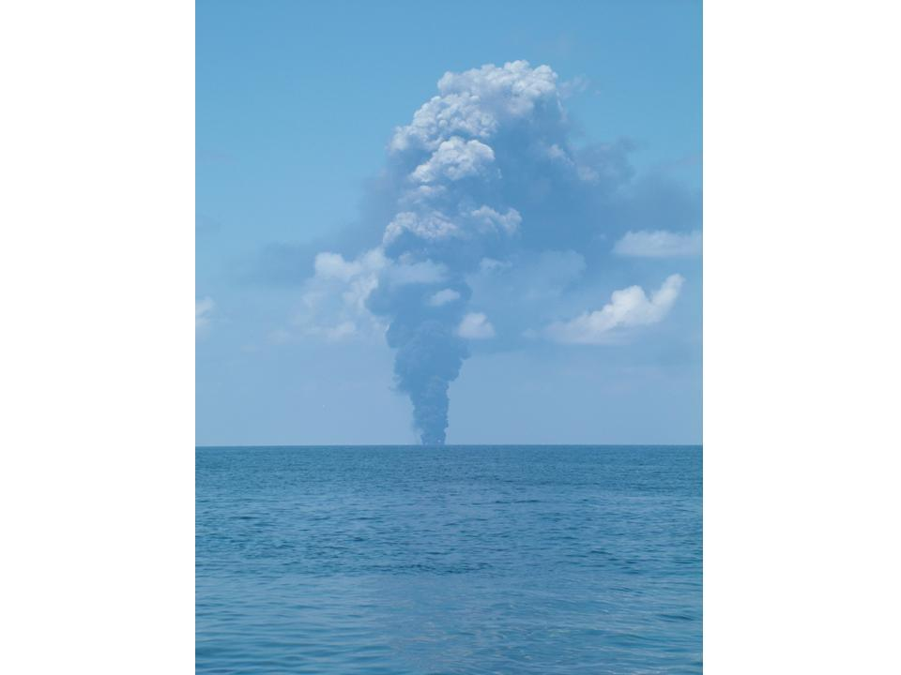 surface burn
Deepwater Horizon Site
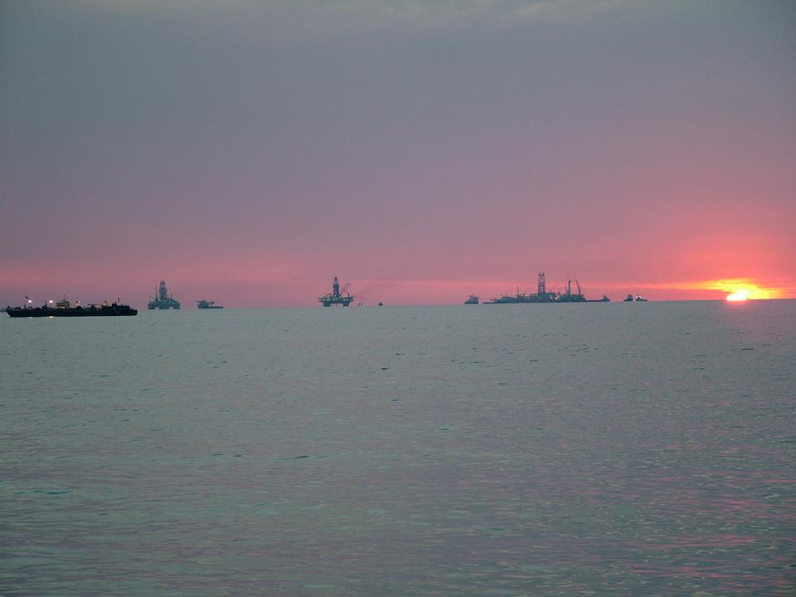

Using Dawn Detergent and a Firehose to create a clean patch to pull the CTD out of the water through.
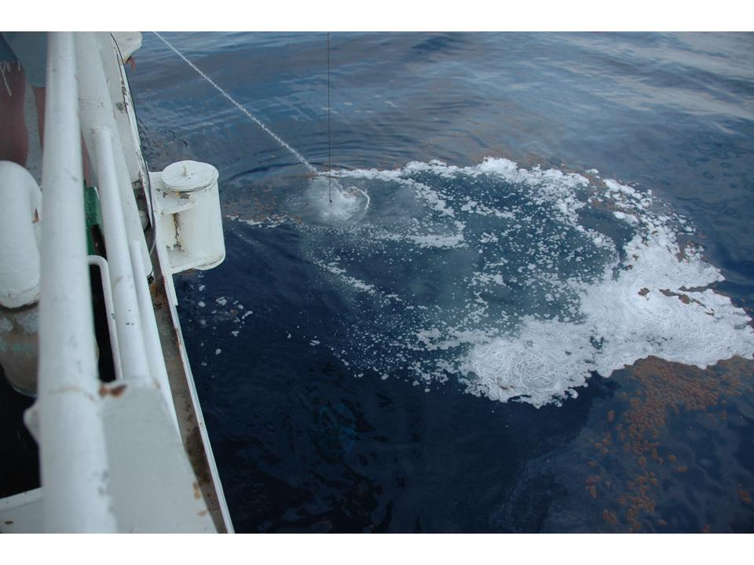
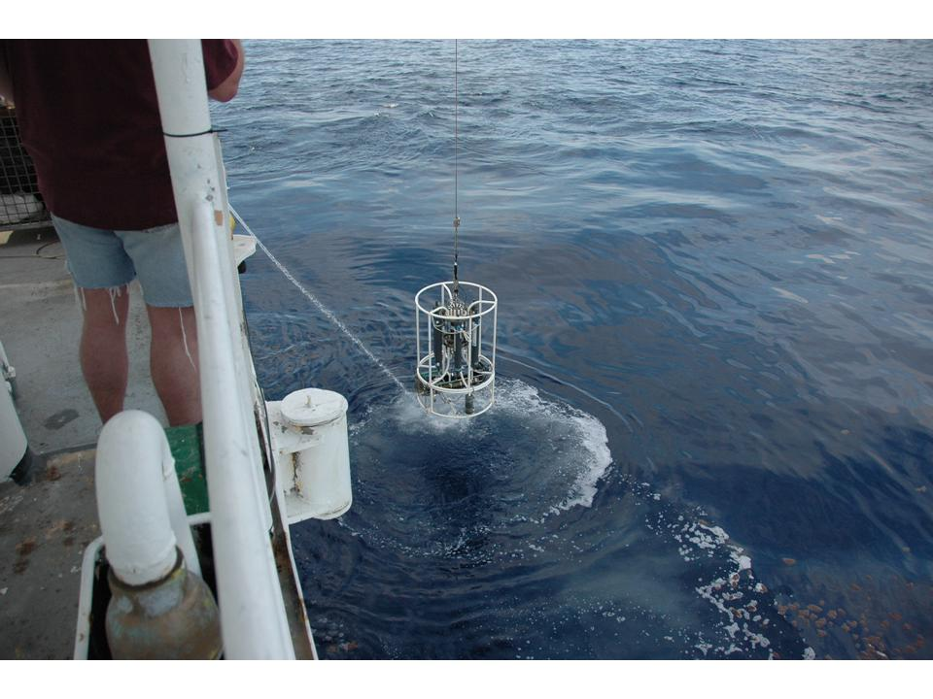

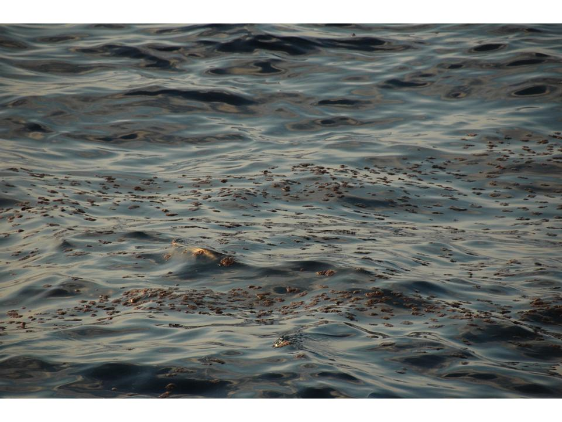weathered crude

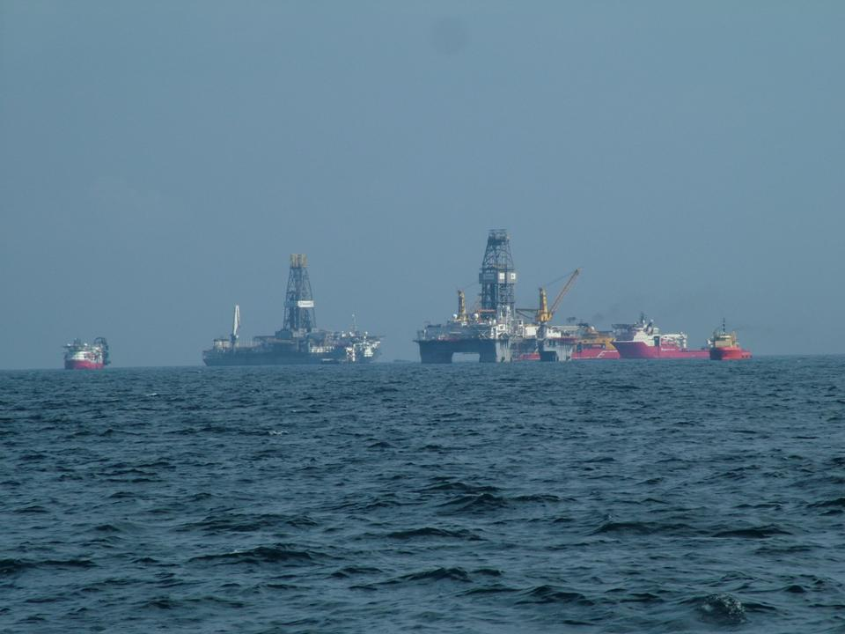

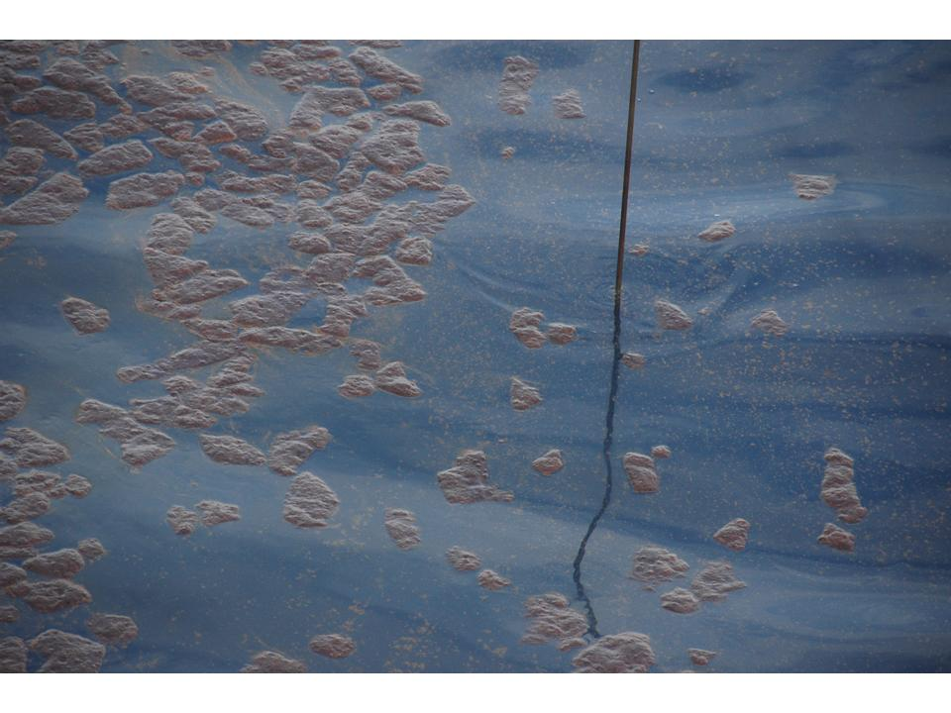
Oil around Hydrocast wire

rkn

