Chapter 10
Bernoulli Theorems and Applications
10.1 The energy equation and the Bernoulli theorem
There is a second class of conservation theorems, closely related to the conservation of energy discussed in Chapter 6. These conservation theorems are collectively called Bernoulli Theorems since the scientist who first contributed in a fundamental way to the development of these ideas was Daniel Bernoulli (1700-1782). At the time the very idea of energy was vague; what we call kinetic energy was termed “live energy” and the factor 1/2 was missing. Indeed, arguments that we would recognize as energy statements were qualitative and involved proportions between quantities rather than equations and the connection between kinetic and potential energy in those pre-thermodynamics days was still in a primitive state. After Bernoulli, others who contributed to the development of the ideas we will discuss in this chapter were d’Alembert (1717-1783) but the theory was put on a firm foundation by the work of Euler (1707-1783) who was responsible, like so much else in fluid dynamics (and in large areas of pure and applied mathematics). Euler was a remarkable person✸ . Although he became blind he was prodigiously productive. He was a prolific author of scientific papers. He was twice married and fathered 13 children.
We begin our version of the development by returning to the energy equation,
(6.1.4) . In differential form, after writing the surface integrals in terms of volume integrals with the use of the divergence theorem, we have,
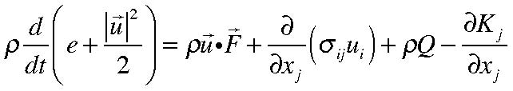
(10.1.1)
where e is the internal energy, F is the sum of all the body forces, including the centrifugal force, Q is the rate of heat addition by heat sources and K is the heat flux
vector which we saw could be written in terms of the temperature as
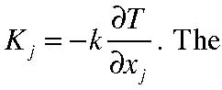
stress tensor is composed of a diagonal part we have associated with the pressure plus a frictional deviatoric part, i.e.
(10.1.2)
We suppose that the body force per unit mass can be written in terms of a force potential,
(10.1.3) and this is certainly true for the combined gravitational and centrifugal force that we identify with effective gravity. Note that the dot product of the body force with the velocity is
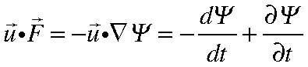
(10.1.4)
This allows us to rewrite (10.1.1),
✸ Once again we are indebted to “History of Hydraulics”, Hunter Rouse and Simon Ince,1957. Dover Publications , New York. pp 269.
Chapter 10 2 The third step in the above derivation uses the equation of mass conservation and we have allowed the potential Ψ to be time dependent, although it rarely is, to make a point below. Combining terms and using our definition of the dissipation function and the representation of the viscous forces in Chapter 6 e.g. see (6.114),
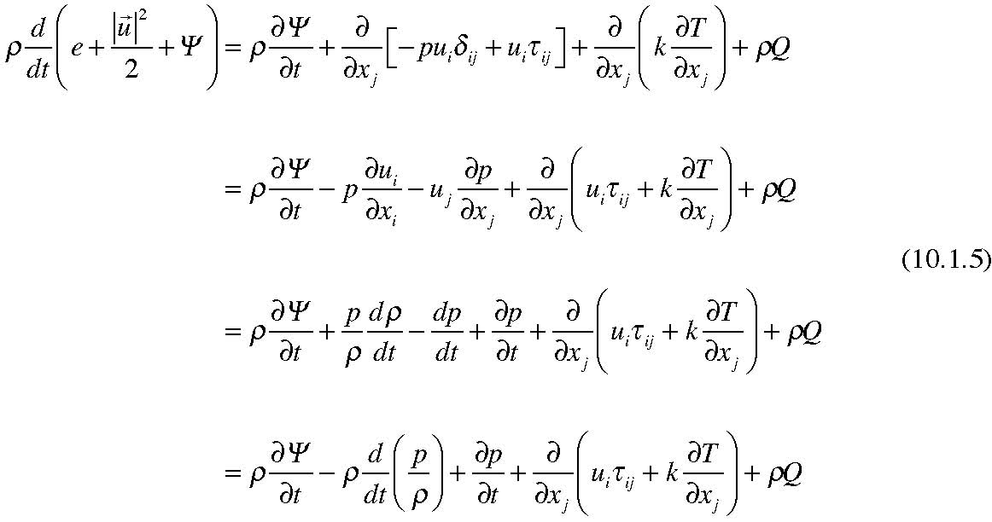
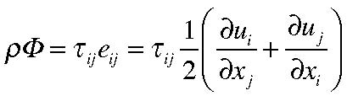
(10.1.6)
we obtain ,
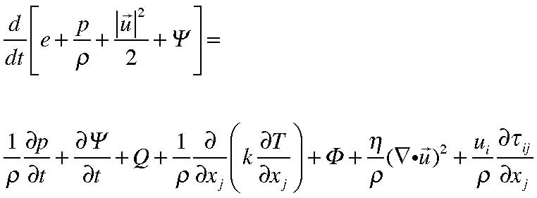
(10.1.7)
For the record, and because it will be useful, remember that the second law of thermodynamics yields for the entropy, (6.1.22)
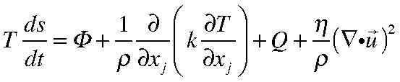
(10.1.8)
Note that in the absence of heat sources, heat diffusion and viscous effects, the right hand side of (10.1.7) would still not be zero if the potential and pressure were explicitly functions of time. This often seems puzzling to people so it is probably a good idea to take a moment to review a simple example to make the situation clearer. Let’s consider the one dimensional motion of a mass particle in a potential . You can think about the mass on a spring whose restoring force is given by –kx where x is the displacement. The equation of motion of the mass particle would be,
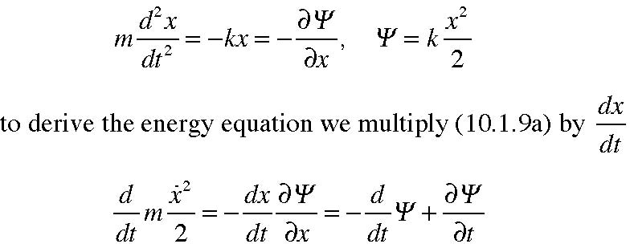
and obtain, (10.1.9 a, b)
(10.1.10)
or
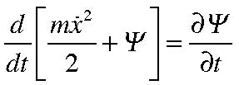
(10.1.11)
If the potential is only a function of the displacement , x, then it will be independent of time except insofar as it depends on x but if it is a function of time explicitly, the right hand side of (10.1.11) will be non zero and mechanical energy will not be conserved. This can occur, for example, if the spring constant is a function of time. In fact, if the spring constant increases whenever the particle is pulled towards the center of attraction and diminishes when the particle is moving away from the center, there will be a constant increase in the amplitude of a “free” oscillation. In fact, all little children recognize this intuitively; this is the basis for “pumping” a swing by judiciously increasing and decreasing the pendulum length with time. So, we should not be surprised if we lose a simple energy conservation statement if the potential is time dependent, although that is rarely an issue in our work. However, returning to (10.1.7) we see that the pressure, through its gradient, acts analogously to a force potential and therefore it is not surprising that on the right hand side of (10.1.7) the local time derivative of the pressure will lead to a time rate of change of the total energy.
If:
a) the flow is steady so that
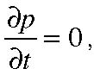
b) the flow is inviscid.
c) there are no heat sources (Q =0)
d) there is no heat conduction (k=0)
e) the forces are derivable from a potential that is time independent so
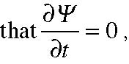
Then:
The quantity
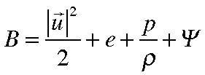
(10.1.12)
is conserved along streamlines which are trajectories for steady flow. Note that the ratio
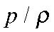 acts like a potential in (10.1.12). The function B is called the Bernoulli function. We defined the enthalpy in Chapter 6 (6.1.25) as
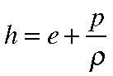
(10.1.13)
so that the Bernoulli function is
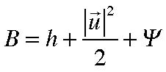
(10.1.14)
The same conditions that lead to the conservation of B along streamlines for steady flow also imply that the entropy is conserved , and for steady flow, is constant too along streamlines so both B and s are constant along streamlines.
Now for a general variation of entropy, the state equation (6.1.20) yields,
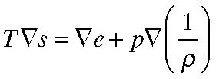
(10.1.15)
If we take the gradient of the Bernoulli function,
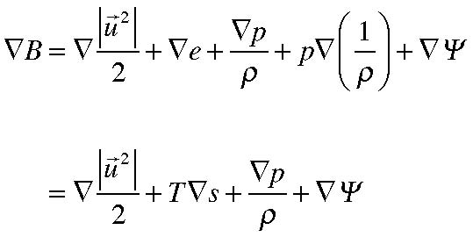
(10.1.16)
whereas the steady momentum equation in the absence of friction is,
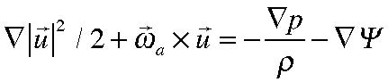
(10.1.17)
which when added to (10.1.16) yields an unexpected relation between the spatial variation of the entropy, the Bernoulli function and the absolute vorticity,
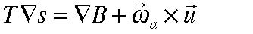 (Crocco’s theorem) (10.1.18) also note, that from (10.1.15)
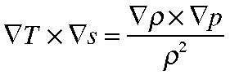
(10.1.19)
which relates the baroclinic production of vorticity to the misalignment of the temperature and entropy surfaces in space.
10.2 Special cases of Bernoulli’s theorem a) Barotropic flow
Consider the case of a barotropic fluid so that 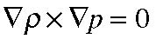 . This means that the density and pressure surfaces are aligned. Where one is constant the other is also constant or, that we can write the density in terms of the single variable p, so that . From (10.1.19) this also implies that T is a function only of s, so that,
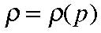
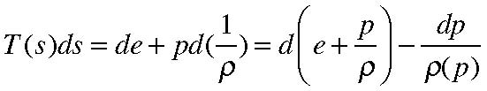
(10.2.1)
Let’s integrate (10.2.1) along a streamline,
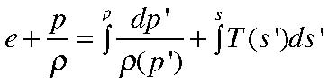
(10.2.2)
Since T is a function only of s the integral 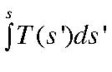 , which is second term on the right
hand side of (10.2.2), is a function only of s. But s is itself a constant along a streamline so that,
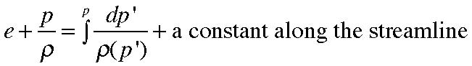
(10.2.3)
so that for the case of a barotropic fluid the Bernoulli theorem, (10.1.12) becomes,
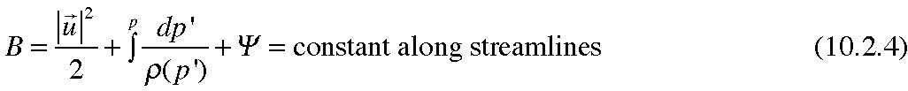
For the case in which the density is constant, this reduces to the more commonly known form of Bernoulli’s theorem,
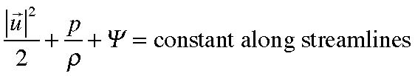
(10.2.5)
b) Shallow water model
Suppose now we consider the shallow water model of section (8.3).
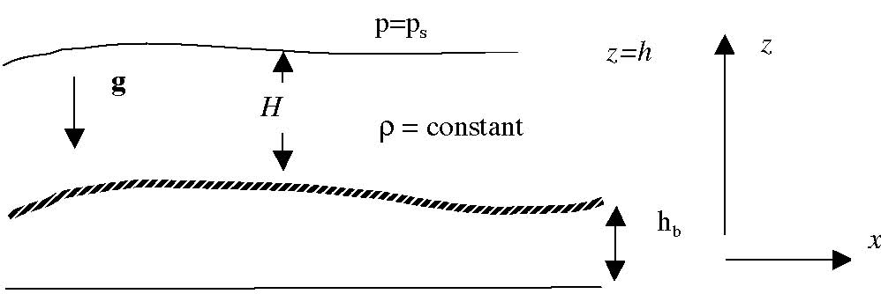
Figure 10.2.1 The shallow water model.
The principal dynamical simplification of such a model is that the vertical velocity is constrained by the geometry to be so small that the vertical acceleration term in the vertical equation o f motion is negligible and this allows the pressure to be calculated using the hydrostatic approximation as discussed in chapter 9. Thus
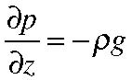
(10.2.6)
and for a fluid of constant density this can be integrated immediately,
(10.2.7)
To determine the “constant” C we apply the condition that the pressure match the atmospheric pressure ps(x,y,t) on the surface z=h(x,y,t)or
(10.2.8)
For steady flow the momentum equations in the horizontal direction are,
(10.2.9 a, b)
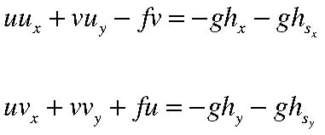
where we have defined
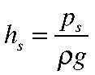
(10.2.10)
If we eliminate the pressure gradient terms in (10.2.9 a,b) by cross differentiating, we obtain,
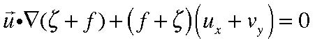
(10.2.11)
while the equation for mass conservation is ,
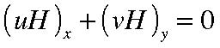
(10.2.13)
which when combined with (10.2.11) yields the conservation of potential vorticity in the form we discussed in section 8.3, namely, for steady flow,
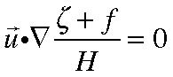
(10.2.14)
From (10.2.13) we can define a stream function for the horizontal transport,
(10.2.15)
or in vector form,
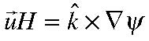
(10.2.16)
Since the potential vorticity 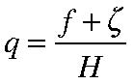 is constant along streamlines,
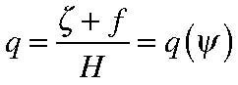
(10.2.17)
Applying the identity (7.7.1) to (10.2.9) shows that we can write the momentum equations for steady flow as,
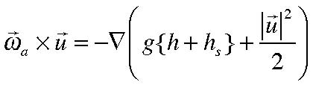
(10.2.18)
while the dot product of that equation with the velocity yields the
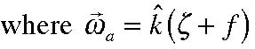
Bernoulli theorem for the shallow water model,
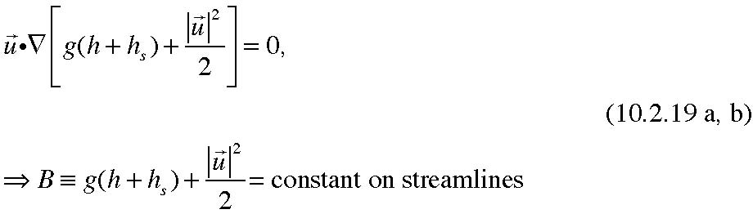
so that the momentum equation (10.2.18) is actually,
(10.2.20) But since the velocity is given by the streamfunction as in (10.2.16),
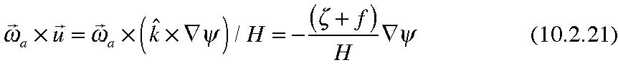
which means that the momentum equation is just,
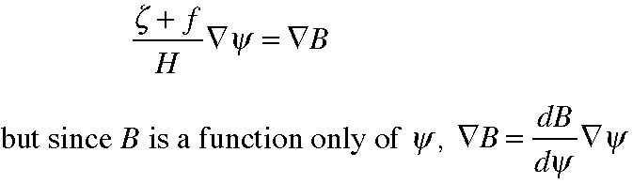
(10.2.22)
which with (10.2.22) yields a rather
remarkable connection between the potential vorticity and the Bernoulli function,
(10.2.23)
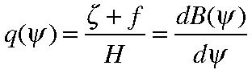
so that the potential vorticity is directly given by the variation of the Bernoulli function from streamline to streamline.
c) Irrotational motion
The permanent presence of the planetary vorticity means that , in principle, the fluid atmosphere and ocean always possess vorticity. Nevertheless, as the estimates of Chapters 7 and 9 show, the planetary rotation only becomes significant for motions on large length scales and long time scales. For motions whose time scale is short compared to a day, like the surface waves at the beach, the planetary vorticity is dynamically negligible. In such cases, we know from our discussion of the enstrophy, that in the absence of friction and baroclinicity a motion which at any instant , for example the instant at which motion is started, is free of vorticity it will remain free of vorticity.
◆
Such a state is termed irrotational. The Bernoulli theorem for such motions is extremely powerful. Thus, setting Ω =0, the condition for irrotationality is
(10.2.24)
That condition implies (and in fact, is necessary and sufficient) that the velocity is derivable from a potential, , the velocity potential , not to be confused with the gravitational potential, such that,
(10.2.25)
• In some texts, especially English, the curl operator is called rot standing for the rotation of the vector. The absence of the curl or rotation is a state that is irrotational.
It is important to note that it is only the spatial derivatives of that matter, an arbitrary function of time can always be added to the velocity potential without changing its physical content. The momentum equation (7.7.3) is, again ignoring friction,
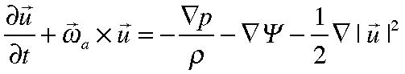
(10.2.26)
If
1) The fluid is irrotational so that ωa =0 ( and so (8.2.25) applies,
2) The fluid is barotropic so that
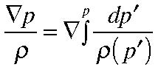
then,
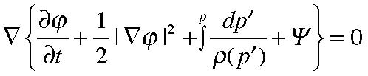
(10.2.27)
Since the gradient of the quantity in the curly brackets is zero, that quantity must be a function, at most, only of time, i.e.,
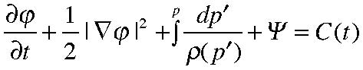
(10.2.28)
It is not hard to show that the function C(t) can be taken to be zero. Simply adding a function of time only to leaves the velocity unchanged so that
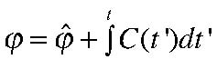
(10.2.29)
leaves the velocity unaltered but the equation (8.2.28) no longer contains the “constant” on the right hand side. Therefore, the Bernoulli equation for irrotational motion is,
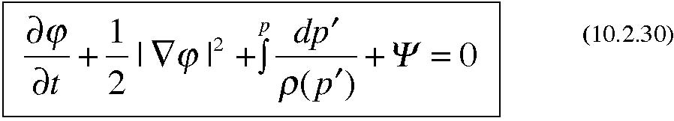
This form of the Bernoulli equation, which is valid only for irrotational flow is, however, not restricted to steady motions, as is the case for (10.2.4). We can, of course, apply it to steady irrotational motion. But since in this case 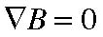 , it follows from (10.1.18) that a steady, irrotational flow must also have its entropy uniform in space.
10.3 Examples of irrotational, incompressible flows.
If the fluid is irrotational and incompressible so that,
(10.3.1 a, b) it follows, by substituting (10.3.1a) into (10.3.1 b) that,
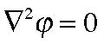
(10.3.2)
where in (10.3.2) we mean the full three dimensional Laplacian operator. It is important to note that this equation completely takes the place of the momentum equation. With both of the strong constraints of (10.3.1 a, b) operating, the flow is very strongly constrained to be given by the velocity potential which, in turn is a solution of Laplace’s equation (10.3.2) and so is a harmonic function.
In the 19th century these ideas were applied to several steady flow problems whose solutions were so distant from reality that fluid mechanics was threatened to become a purely scholastic activity with no connection to the natural world of physics. Let’s see why this happened. Steady flow past a cylinder.
Consider the steady flow past a cylinder of radius R and, neglecting viscosity as
being small and the fluid flow having started from rest, we imagine it is irrotational and
suppose it has a constant density as well. The situation is depicted in Figure 10.3.1. y r
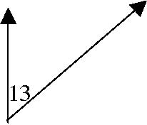
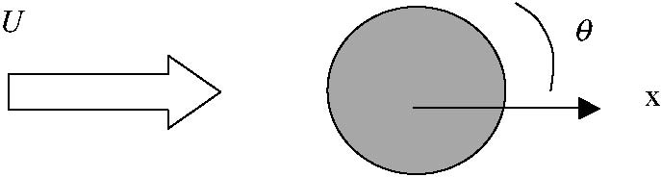
Figure 10.3.1 A uniform flow, U, impinges on a cylinder of radius R. The polar coordinate frame is shown.
The problem posed by the flow configuration in Figure 10.3.1, assuming that the motion is incompressible and irrotational, is to find a solution of Laplace’s equation that has zero radial flow on the surface of the cylinder and approaches the uniform, oncoming flow as r goes to infinity. The uniform flow has a velocity potential,
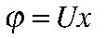 so that, in polar coordinates, the problem is,
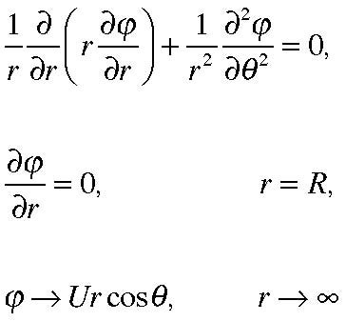
(10.3.3 a, b, c)
It is a simple matter to check that a the solution satisfying the equation and all the boundary conditions is,
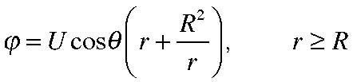
(10.3.4)
so that the velocity components are,
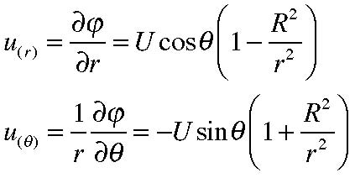
(10.3. 5 a, b)
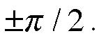
Recall that the azimuthal velocity is reckoned positive if it is anticlockwise. Note that the tangential velocity is a maximum at θ =
It is left as an exercise for the student to show from the velocity fields that the streamfunction for the flow is given by,
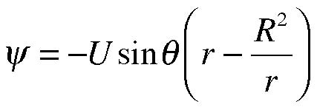
(10.3.6)♦
The streamlines of the flow✤ are shown in Figure 10.3.2
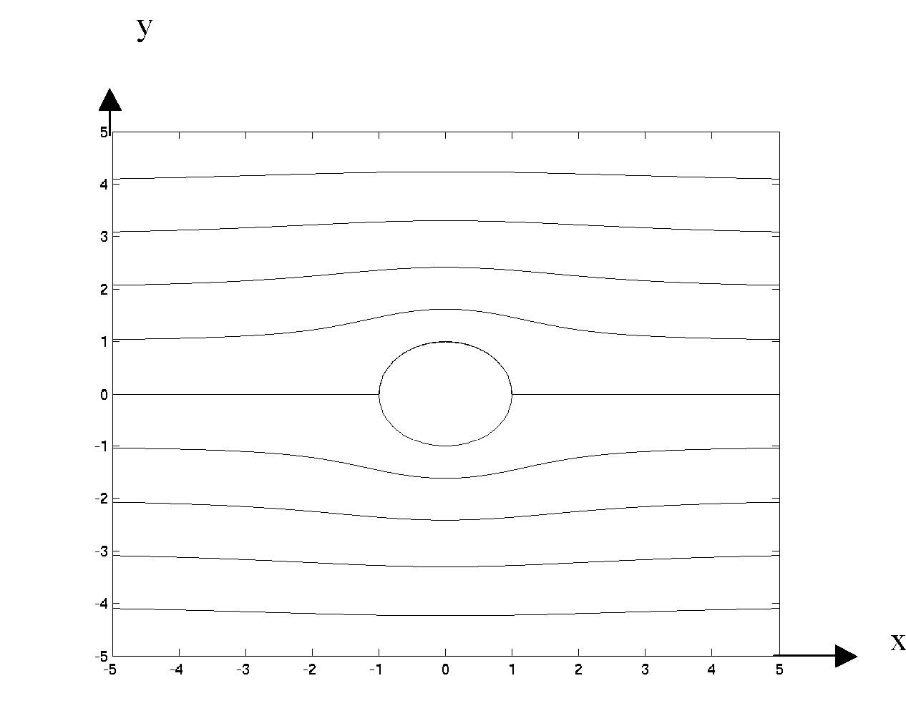
Figure 10.3.2 The streamlines of potential flow past a cylinder.
One notices immediately the artificial character of the flow, in particular the fore-aft complete symmetry. One never sees this is real life situations. When the flow approaches a blunt body like the cylinder the flow typically separates from the body leaving a
♦ 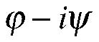The mathematically sophisticated student might notice that the constructproduces an analytic function of the complex variable z=x+iy.
✤ The solution is not unique. A constant circulation around the cylinder can be added for
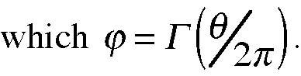
turbulent wake behind the cylinder as shown in Figure 10.3.3which is a reproduction of a figure from Prandtl and Tietjens, 1934 , Applied Hydro-and Aeromechanics, Dover pp311 (Dover edition1957).
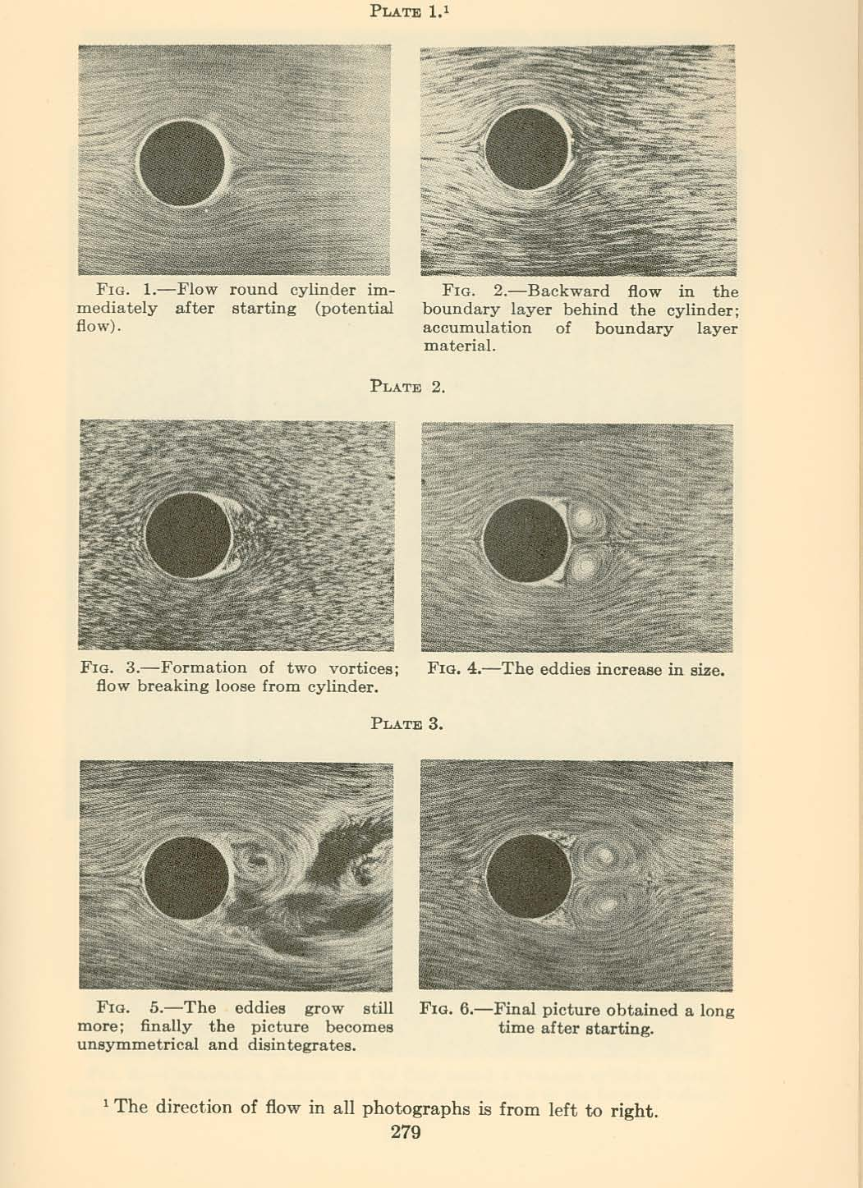
Figure 10.3. 3 Images from the experiments, first carried out in Prandtl’s laboratory in Göttingen in the 1930’s.
Chapter 10 17
The reason for the artificiality can be traced to the predicted pressure distribution on the surface of the cylinder. Using the Bernoulli equation we can obtain the pressure field from the velocity . Let the pressure at infinity be the uniform value 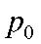 . We can ignore the role of the gravitational potential by imagining the cylinder oriented with its axis vertical so that the motion takes place in a plane of constant z. The total Bernoulli function, which is a constant, is then
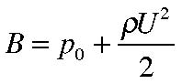
(10.3.7)
Elsewhere in the field of motion the pressure is obtained from
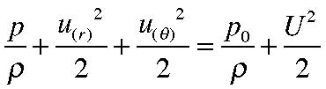
(10.3.8)
Consider the motion of the fluid element on the center line approaching the cylinder along y=0. On this line the component
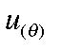 is zero so that the pressure is, from (10.3.8) and (10.3.5 a)
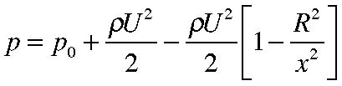
(10.3.9)
As the fluid approaches the cylinder on the line y=0 the velocity diminishes and, right at the cylinder on x=-R, y=0, the full velocity is zero and the pressure achieves its maximum value and is equal to B. As the fluid flows over the top (or bottom) of the cylinder it speeds up and achieves its maximum speed of 2U at θ = π/2 i.e. at x =0. y= R and so here the pressure has its minimum value. The pressure along the line y =0 and along the rim of the cylinder is shown in Figu
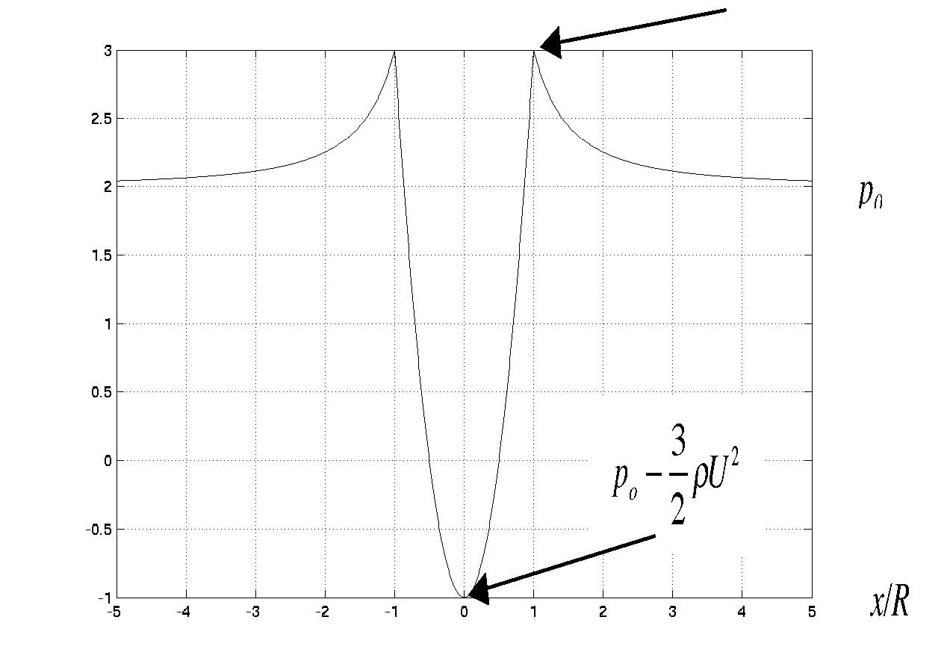
Figure 10.3.4 The pressure along y=0 and the rim of the cylinder.
The fluid reaches the stagnation point at θ=π and begins to accelerate as it begins it journey over the cylinder. It reaches its maximum velocity at the top (and bottom) of the cylinder and then begins to flow against the pressure gradient, between there and the rear stagnation point at θ=0. It is flowing in an adverse pressure gradient , i.e. into a region in which the pressure gradient is working against the motion but it has enough kinetic energy to allow it to reach the point at θ =0 with just enough velocity to make it. It has then completely exhausted its kinetic energy in climbing the pressure hill between θ = π/2 and θ =0. The pressure has acted as a potential field for the fluid motion and with the conservation of this potential and kinetic energy the fluid element is just able to traverse the rim of the cylinder.
Although we have assumed the friction is small, and this may be true almost everywhere, we know that for real fluids satisfying the no-slip condition, friction must be important in a narrow boundary layer near the solid surface of the cylinder. Even a small amount of friction, acting on fluid elements in the vicinity of the cylinder’s solid boundary , will dissipate some of the kinetic energy gained by the fluid element as it flows from the high pressure to low pressure region on the front of the cylinder and thus lack sufficient kinetic energy to negotiate the full pathway from the low pressure to high pressure portion of the path on the rear of the cylinder. See Figure 10.3.3. Those fluid elements that have been in contact with the cylinder long enough to feel the effect of friction will not be able to successfully complete the transit. Arriving at some point on the rear of the cylinder the adverse pressure gradient will push them back towards the oncoming fluid elements. A reverse flow will occur and the flow will separate from the boundary, at first as a strong eddy, leading eventually to a turbulent wake behind the cylinder. This failure of potential theory to adequately deal with the motion of bluff (i.e. non streamlined bodies) was a depressing failure of theoretical fluid mechanics that was not corrected until the combined theoretical and experimental work of Ludwig Prandtl (circa 1905) developed the ideas of boundary layer theory for non rotating flows. This allowed at least an explanation of the failure of potential flow but it was necessary to wait for the advent of high speed computing before direct calculations of the full flow evolution was possible theoretically.
A much more successful application of potential flow theory in the nineteenth century occurred in a problem of much more oceanographic interest in which the interaction with solid boundaries was not an essential feature and this was the development of a theoretical understanding of gravity waves, i.e. the dynamics of a fluid with a free surface under the action of gravity.
10.4 Irrotational gravity waves.
Consider the motion of an incompressible fluid of uniform density that consists of a layer of water of initially undisturbed depth D. For simplicity the bottom will be taken to
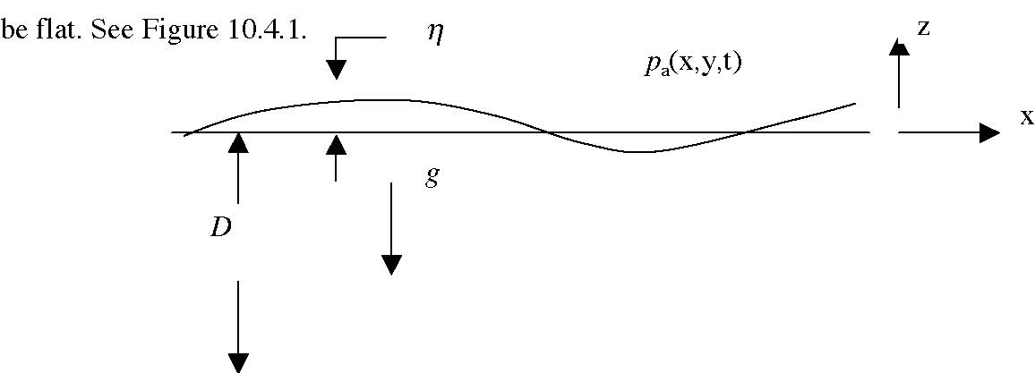
Figure 10.4.1 A layer of water of depth D subject to an atmospheric pressure forcing .
The fluid motion is of small enough scale so the earth’s rotation can be ignored and if viscosity can be neglected, motion starting from rest will remain irrotational. If the fluid, like water, can be idealized as incompressible, the velocity potential satisfies Laplace’s equation as shown in (10.3.1) and (10.3.2).
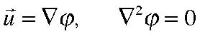
(10.4.1 a ,b)
The problem of gravity waves in water is especially interesting because it is a good example of a problem in which the physics is entirely contained in the boundary conditions. The governing equation (10.4.1 b) tells us nothing about the evolution of the wave field; for that we need to consider the boundary conditions. At the lower boundary the vertical velocity is zero, so,
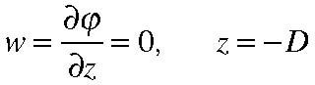
(10.4.2)
At the upper boundary, z=η there are two conditions:
1) The kinematic boundary condition: The position of the boundary is determined by the position of the fluid elements on the boundary. The boundary goes where they go. Thus, if the free surface is given by,
(10.4.3) taking the total derivative of each side of that equation,
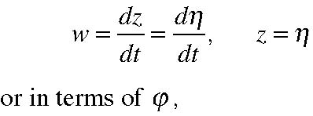
(10.4.4)
2) The dynamic boundary condition:
At the upper surface the pressure in the water has to match the pressure imposed by the atmosphere so that
(10.4.6)
or using the Bernoulli theorem for irrotational motion, (10.2.30), for a fluid of constant density and a gravitational potential
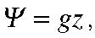
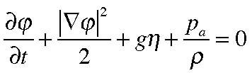
(10.4.7)
We will only consider the relatively easy problem of small amplitude motions when the wave amplitudes are small enough so that the nonlinear terms is the equations are negligible compared to the linear terms. When will that be so? Let’s suppose that the characteristic magnitude of the velocity of the fluid elements in the wave is characterized by a scale U. Suppose the period of the wave is measured by a scale T and the wavelength of the wave is of order L. Then
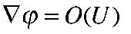 which implies that 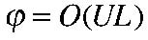 so the condition,
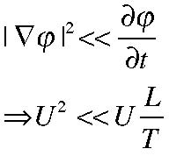
(10.4.8 a, b)
or,
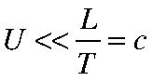
(10.4.9)
so that linearization is possible only if the velocity of fluid elements is small compared with the phase speed (the ratio of wavelength to period) of the wave. So, if we ignore terms that are quadratic in the amplitude of the wave, the boundary conditions become, at z = η,
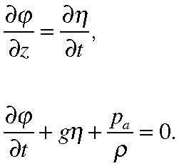
(10.4.10 a, b)
The most difficult aspect of the original problem is that the upper boundary condition is applied at the position of the free surface, z= η and this is one of the unknowns of the problem. Such free boundary problems are among the most difficult in mathematics. However, the linearization we have done also simplifies this aspect of the problem since we are essentially saying that the free surface does not depart significantly from its rest position. Thus, if we have a boundary condition in the general form,
(10.4.11)
we can expand the function F in a series about z=0,
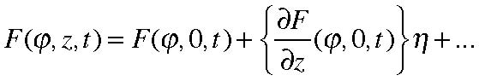
(10.4.12)
and since the function F is at least linear in the amplitude of the motion keeping linear terms only in the boundary condition reduces it to ,
(10.4.13) so that the boundary conditions on the upper surface, when linearized as in (10.4.10) can be (in fact must be for consistency) applied on the undisturbed free surface at z =0 and this is an enormous simplification. a) Forced waves
Suppose the atmospheric pressure field is given by,
(10.4.14)
so that it consists of a pressure wave moving across the water with wavenumber
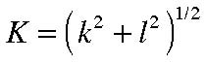
and phase speed c =ω/K. We can search for solutions to (10.4.1b) in the
form,
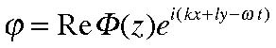
(10.4.15)
which when substituted into (10.4.1 b) yields an ordinary differential equation for Φ,
(10.4.16)
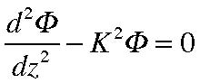
whose solution can be written,
(10.4.17)
and the application o f the boundary condition at z=-D implies that B=0. Note that to this point Laplace’s equation and the lower boundary condition have yielded only a constraint on the spatial structure of the motion but very little about its dynamics. For that we need to consider (10. 4. 10, a, b). Eliminating η between the equations yields the boundary condition in terms only of
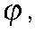
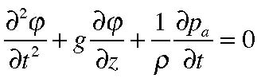
(10.4.18)
If the pressure field were time independent it would not force a nontrivial velocity potential. In that case the full solution would be =0 and η would hydrostatically
balance the applied pressure, i.e. 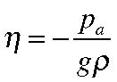 , the so-called inverted barometer. In our
case , though the pressure is a function of time and a non trivial wave solution is forced. Substituting (10.4.14), (10.4.15) and (10.4.17) into (10.4. 18) yields,
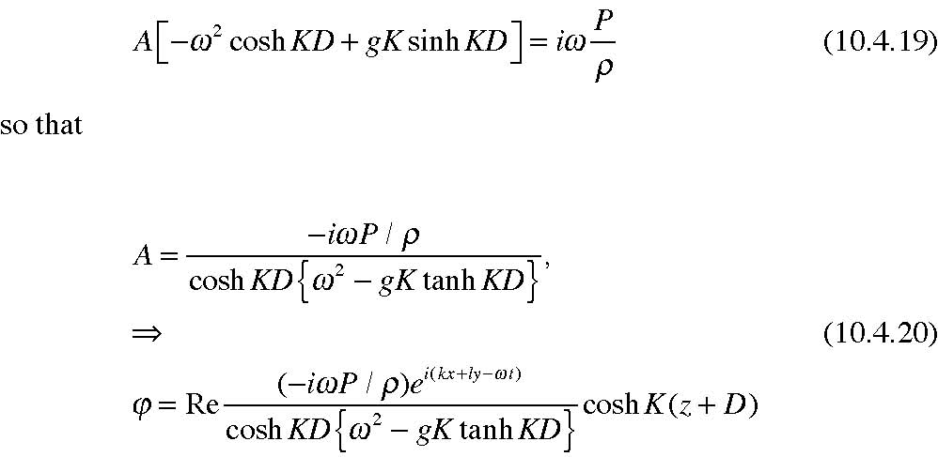
or ,
(10.4.21)
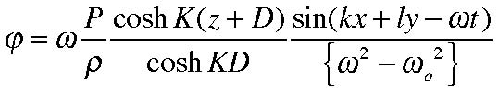
where we have defined the natural frequency,
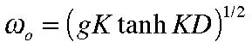
(10.4.22)
From either the condition (10.4.10 a or b) we can obtain the free surface height,
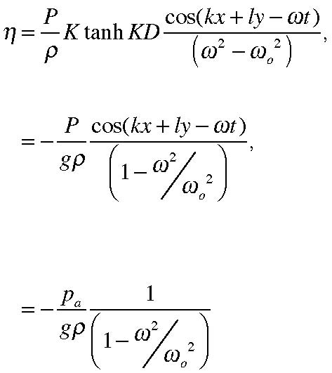
(10.4.23)
so if the frequency is much less than the natural frequency the free surface height responds statically, as the inverted barometer and is 1800 out of phase with the pressure. High pressure yields a depressed sea surface elevation. For frequencies that are very high with respect to the natural frequency the free surface elevation is in phase with the pressure so that high pressure on the surface yields a rise in sea level.
The natural frequency, (10.4. 22) is a function of the wavenumber, or wavelength. Let’s take a moment to review what we mean by the wavenumber. b) Free waves: For plane waves of the type (10.4.15) the phase θ, of the wave is the argument of the trigonometric function,
(10.4.24)
so that at any fixed time, the phase is constant on the lines kx+ly = const. as shown in Figure 10.4.2
y
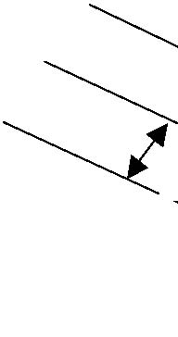 x
λ
Lines of constant phase (e.g. ridges) Figure 10.4.2 A plane wave showing lines of constant phase in the x, y plane. The phase increases most rapidly and linearly in the direction of its gradient and
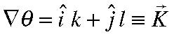
(10.4.25)
so that the wave vector is the maximum rate of increase (its magnitude) and gives the direction of that increase. In a distance X along the direction of the gradient , the phase increases by an amount
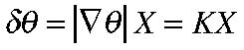
(10.4.26)
where K is the magnitude of the wave vector. The change in phase will be 2π i.e., the wave will repeat when δθ =2π. This defines the wavelength λ as
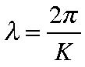
(10.4.27)
Similarly, the rate of decrease of the phase at a point is ,
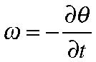
(10.4.28)
and the speed at which the phase of the wave moves in the direction of the wave vector is,
(10.4.29)
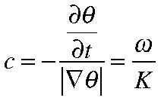
It is very important to note that the phase speed is not a vector velocity. The speed
(10.4.29) represents the rate at which phase lines move in the direction of K, that is, normal to themselves but this does not satisfy the rules of vector composition. For example, to calculate the rate at which a line of constant phase moves in the x direction for a fixed value of y,
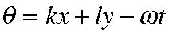
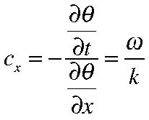
(10.4.30)
If the angle between the wave vector and the x axis is α , (10.4.30) yields,
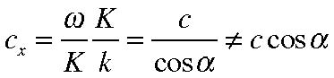
(10.4.31)
where the last term on the right hand side of (10.4.31) is what the speed in the x direction would be if the phase speed behaved according to the normal rules of vector composition. This is a hint that the speed of propagation of the phase lacks the mathematical behavior we associate with the propagation of entities that carry momentum and energy and you will see in 12.802 that those quantities are more closely related to the group velocity of the waves defined by, (for our two dimensional wave)
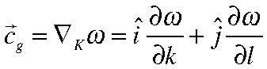
(10.4.32)
Figure 10.4.3 shows the frequency, phase speed and group velocity (in the direction of the wave vector) as a function of wavenumber of the free wave. That is, the wave corresponding to the natural frequency . From (10.4.23) this is the wave that can exist in the absence of forcing, i.e. it is the free mode of oscillation of the water. Note that for each K there are two solutions for the frequency,
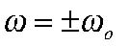 where the plus sign indicates the phase moving in the direction of the wave vector and the minus sign is for a wave moving in the opposite direction.
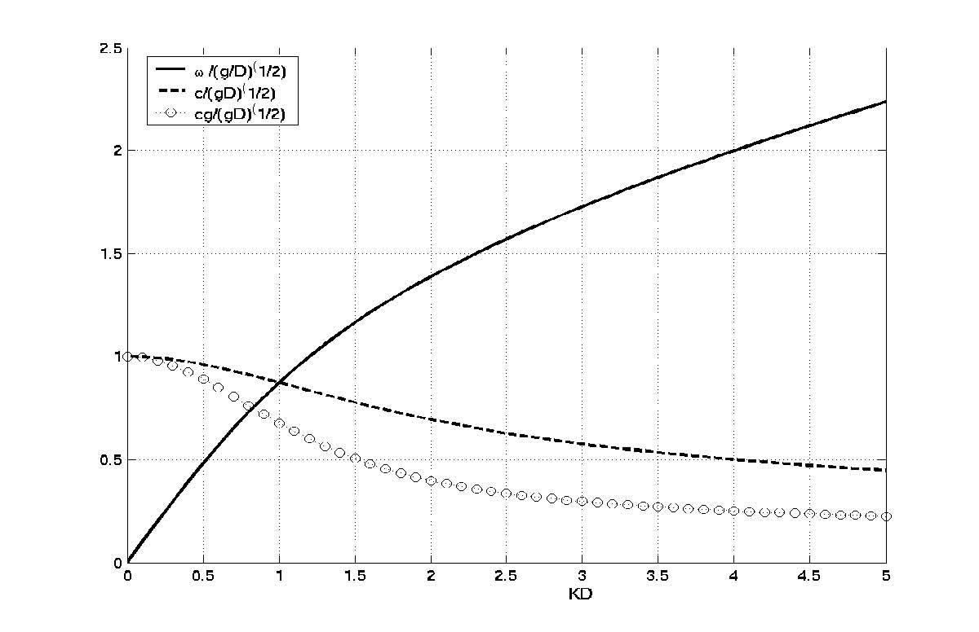
Figure 10.4.3 The frequency, phase speed and group velocity of surface gravity waves as a function of wavenumber (inverse wavelength)
Note that the phase speed of the wave is different for different wavenumbers; the waves are dispersive, a disturbance composed of a superposition of plane waves in a Fourier composition will therefore alter its shape as each component propagates at its own speed. Long waves, i.e. small KD propagate fastest and in the limit of waves that are very long compared to the depth , KD<<1, the phase speed becomes independent o f wavelength. For very long waves,
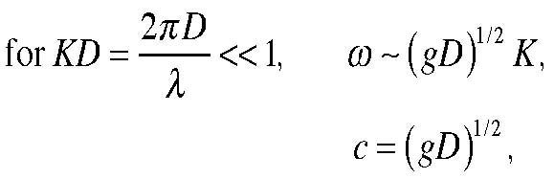
(10.4. 33 a,b)
so the phase speed is independent of wavelength and depends only on the water depth, while for very short waves,
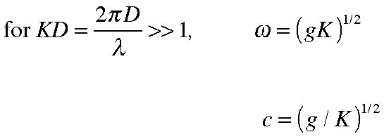
(10.4.34 a, b)
and the wave frequency and phase speed becomes independent o f the water depth.
The wave amplitude for the free wave (pa=0) is arbitrary in this linear theory and it is convenient to choose the x axis to lie in the direction of the wave vector so that the y wavenumber is zero. In that case we can write the solution as,
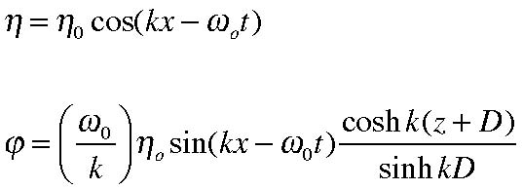
(10.4.35 a, b)
where (10.3. 35 b) is obtained from (10.4.10 a or b with pa =0. The velocities obtained from (10.4.35 b) are
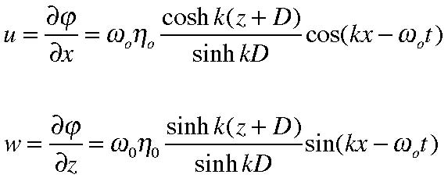
(10.4.36 a, b)
Since we have chosen the propagation direction to be the x axis the motion is two dimensional and so it is straight forward to construct the stream function for the motion since it is incompressible,
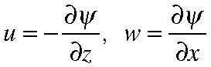
(10.4.37 a, b)
and it follows from (10.4.36 that,
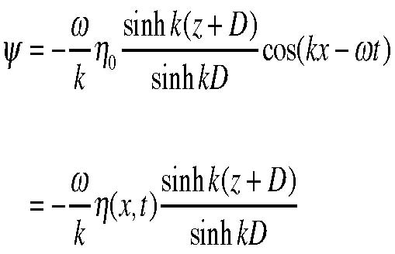
(10.4.38)
This is a good example of the streamlines not being particle trajectories. The streamlines, shown in Figure 10.4.4 give the direction of the instantaneous velocity field but since the motion is time dependent and the streamlines keep changing with time the fluid elements do not follow the streamline paths on their trajectories.
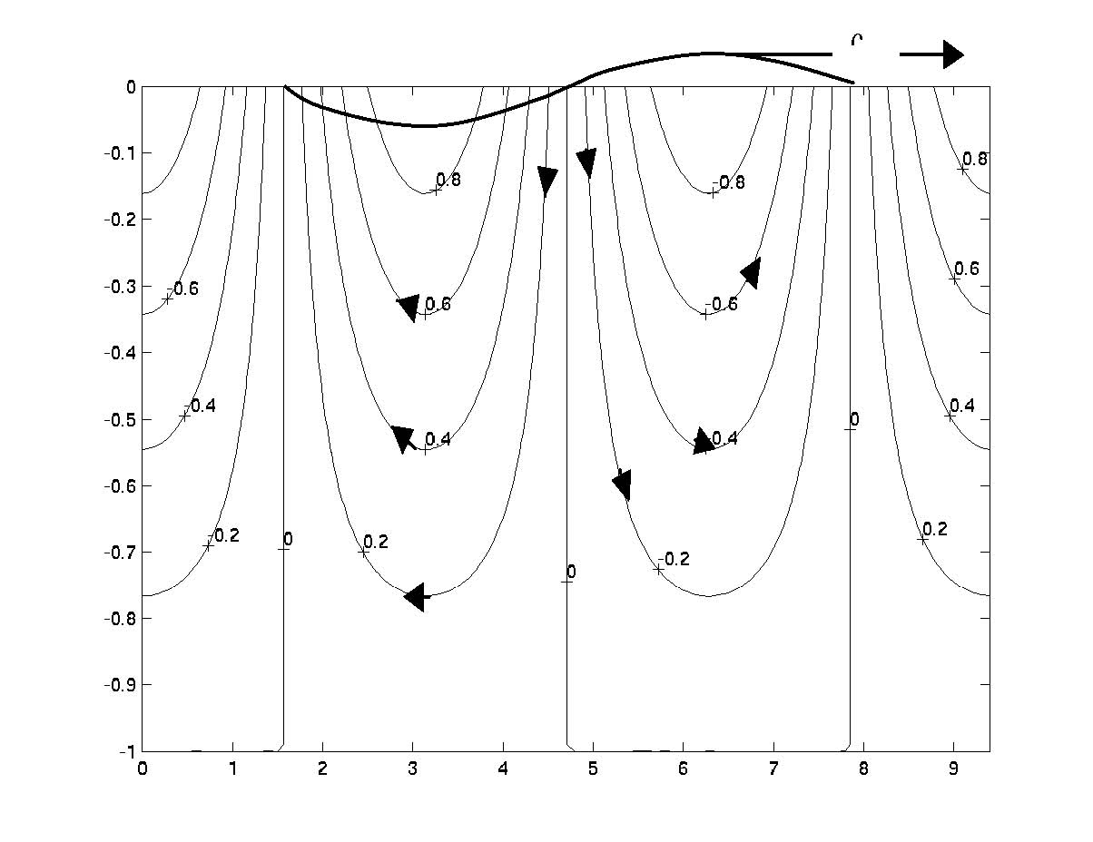
Figure 10.4.4 The instantaneous stream line pattern for a propagating gravity wave. In the figure kD=1. The (exaggerated) free surface has been drawn in by hand.
The fluid velocities can also be used to solve for the fluid trajectories.
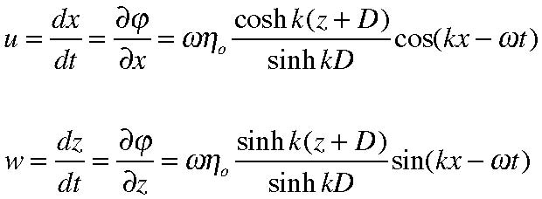
(10.4.39 a, b)
These are very non linear equations. However, for small displacements of each fluid element from its rest position , i.e. for small η0 we can write,
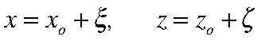
(10.4.40)
where the displacements, ξ and ζ are order η0 i.e. of order the amplitude of the motion. Thus keeping only linear terms in (10.4.39 a, b) yields the much simpler set,
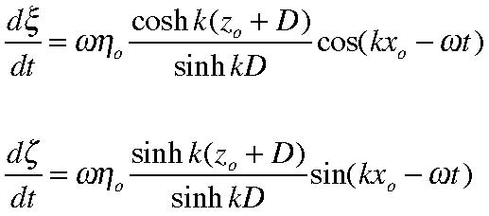
(10.4.41)
with solutions for the displacements,
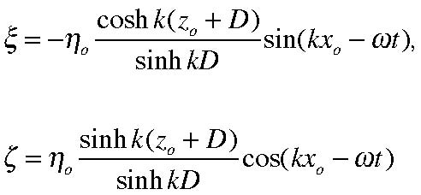
(10.4.42 a, b)
The fluid elements execute periodic orbits that are closed ellipses (in linear theory) since
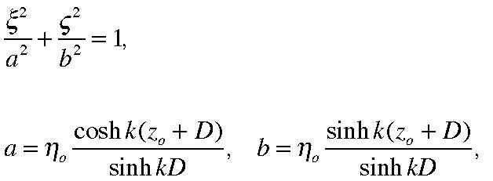
(10.4. 43 a, b, c)
The ellipses are functions of position in the water column. For fairly deep water the ellipses are nearly circular near the surface and become flat at the bottom where z0 =-D. The trajectories should be compared with the streamlines and the difference clearly noted. In particular you should check on the direction of motion the element makes around the ellipse as a trough and crest of the wave passes overhead and check whether that agrees with your experience at the beac c s you bathe in the waves.
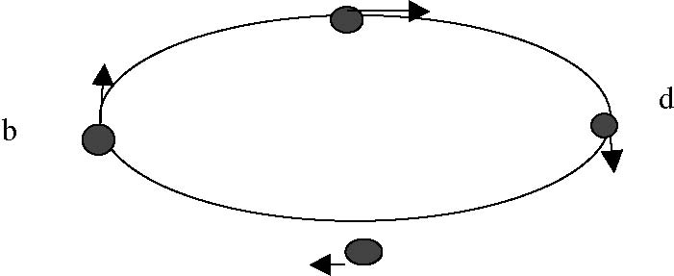
a
Figure 10.4.5 The orbit of a fluid element during the passage of a wave (to the right). a) under the trough. b) halfway between the trough and the arriving crest, c) at the crest. d) halfway between the crest and approaching trough.
10.5 Waves in the presence of a mean flow
To prepare for our discussion of internal waves and instability in Chapter 11 consider the slight modification of the above problem when we consider free gravity waves (the forced problem is also easy) in the presence of a mean, steady current oriented in the x direction. For simplicity we consider the waves propagating along the x axis. We can represent the mean flow by the potential
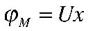 and the wave potential by so that the total potential will be,
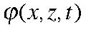
(10.5.1)
The wave potential satisfies Laplace’s equation as can be verified by inserting (10.5.1) into (10.4.1). The boundary condition on the wave potential at z=-D remains
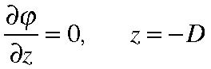
(10.5.2)
The Bernoulli condition at the upper surface is,
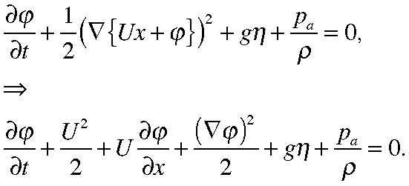
(10.5.3)
Again keeping only linear terms in the wave amplitude, the linearized upper boundary condition becomes,
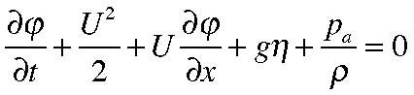
(10.5.4)
Note that the term U2/2 is a constant and could be eliminated by redefining the potential but this is not necessary. A similar linearization of the kinematic boundary condition,
(10.4.5) yields,
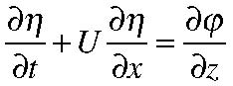
(10.5.5)
and as before, the boundary condition can be applied at z =0 for the linear problem. Solutions for free waves, (pa =0) can be found again in the form,
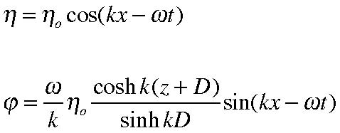
(10.5.6 a, b)
where now,
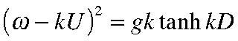
(10.5.7)
so that,
(10.5.8)
The frequency of the free wave is therefore the natural frequency 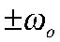 , sometimes called the intrinsic frequency, Doppler shifted by the amount kU. If the wave is propagating with the current the frequency is raised. If it is propagating against the
current the frequency is lowered and should
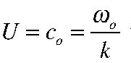 the wave propagating against
the current will be stationary.

