Chapter 7

Fundamental Theorems: Vorticity and Circulation

7.1 Vorticity and the equations of motion.

In principle, the equations of motion we have painstakingly derived in the first 6 chapters are sufficient unto themselves to solve any particular problem in fluid mechanics. All the information we need is really contained in the mass, momentum and thermodynamic equations. However, it is rare that we can exactly solve the equations for any real phenomenon of interest. So the question arises as to what general principles we can deduce about the dynamics of fluids that is robust and illuminating and that will give us insight, a priori about what to expect in particular cases and what relations must hold in any consistent approximation to the equations of motion.
Stated somewhat differently, given certain a priori constraints what are the general consequences? Usually the stronger the constraint the stronger the resulting consequence. For example, if we specify a priori that dissipation is not important we can prove an energy conservation theorem that will be generally true in the absence of dissipation for all flow configurations. It is important to bear in mind that all the results we can deduce come from the basic equations of motion, i.e. they are derived and not independent and hence any consistent approximation to the equations of motion must possess a corresponding principle.
In Geophysical Fluid Dynamics, especially the study of the atmosphere and the ocean we are particularly interested in the rotation of the fluid since every fluid element is already rotating with the planet. We noted in Chapter 3 that the vorticity (3.4.3)

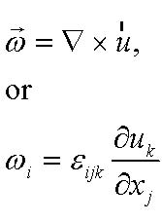 (7.1.1)
was twice the local rate of rotation of a fluid element. In a Cartesian coordinate frame,

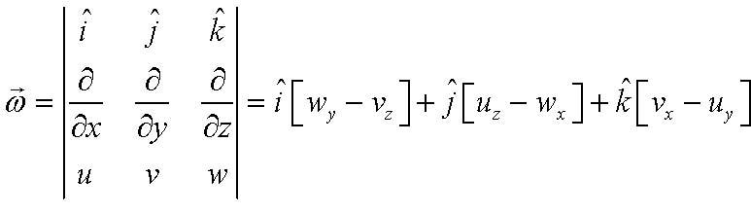 (7.1.2)
where subscripts denote differentiation.
It is important to distinguish between circular motion, i.e. the motion of a fluid particle in a circular orbit and the rotation of the element. The vorticity is defined as the local rotation or spin of the fluid element about an axis through the element. Figure 7.1.1 shows the distinction.

Figure 7.1.1 The fluid element moving from A to B on a circular path has no vorticity while the fluid element moving from C to D has vorticity.

It is important to keep in mind the distinction between vorticity and the curvature of streamlines.

A

B

C

D
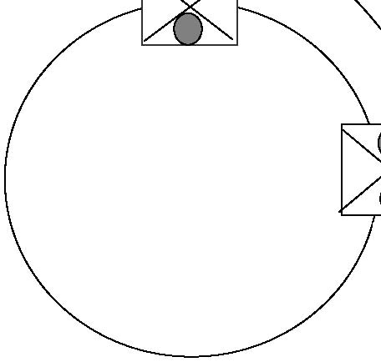
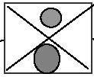
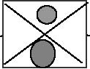
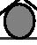
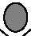
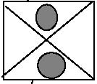
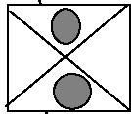
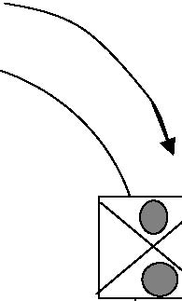
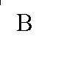
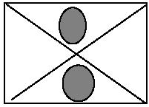
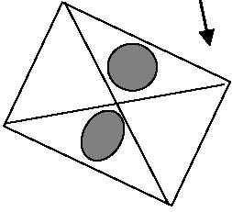

7.2 Vortex lines and tubes.

We define a vortex line in analogy to a streamline as a line in the fluid that at each point on the line the vorticity vector is tangent to the line, i.e. the vortex line at each point is parallel to the vorticity vector.

Figure 7.2.1 A vortex line

It is important to note that the strength of the vector vorticity is not constant along a vortex line in the same way that the velocity is not (necessarily) constant along a streamline.

A vortex tube is a cylindrical tube in space whose surface elements are composed of vortex lines passing through the same closed curve, C, as shown in Figure 7.2.2

vortex line

ω

ω
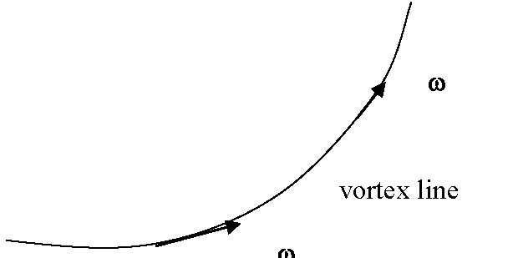
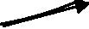
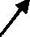

Figure 7.2.2 A vortex tube consisting of vortex lines each of which pass through the closed curve C.

Note that the vorticity vector ω does not have a component normal to the tube’s bounding surface by the method of construction. The vorticity vector always lies within the bounding surface.
The strength of a vortex tube, Γ, is defined by the product of the vorticity normal to the surface enclosed by the curve C,

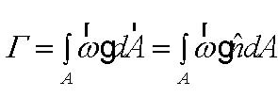 (7.2.1)
where the integral is over the surface girdled by the curve C as shown in Figure 7.2.3.

Figure 7.2.3 The vortex tube strength is the integral of the component of the vorticity normal to the surface bounded by the curve C over that surface.

C

vortex lines

n

ω

A

C
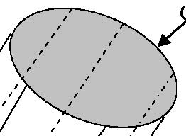
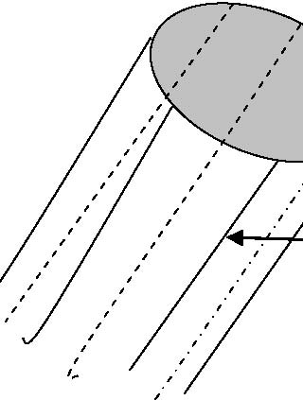
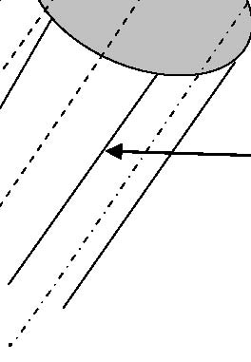
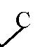
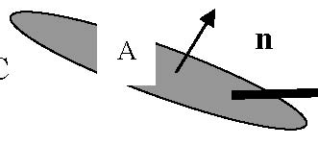
Thus the vortex tube strength is equal to the product of 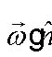 ( where is the normal to the surface A) integrated over the surface A which is the cross section of the tube. In some fluid mechanics literature the vortex tube strength is confusingly called the vortex flux but this is misleading because it does not refer to the advection of vorticity but only the integral in (7.2.1) in analogy with the mass flux through a stream tube.
An important fact (or theorem) that follows directly from the definition of a vortex tube is that the strength of a vortex tube is constant along the tube. Since 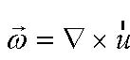 it follows trivially that
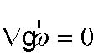 (7.2.2)
(In our tensor notation, 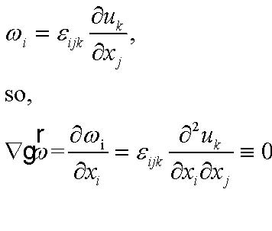 (7.2.3 a,b)

since the term on the right hand side of (7.2.3b) is the inner product of an antisymmetric tensor in the indices i, j, and a symmetric tensor in the same indices. If we integrate (7.2.2) over the area of the volume composed of the vortex tube and two arbitrary cross sections, as shown in Figure 7.2.4,

Figure 7.2.4 The volume composed of the surface of a vortex tube and two slices through the tube forming the areas A1 and A2.

A1

A2

n1

n2
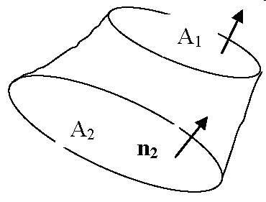
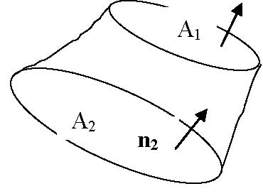
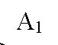
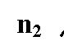
Note that in the figure the normal vector n2 is an inward facing normal to the volume. Integrating (7.2.2) over the volume

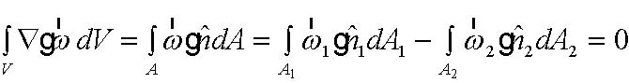 (7.2.4)
There is no component o f the vorticity normal to the rest of the volume’s surface since it is a vortex tube so the area integral in (7.2.4) is only over the areas of the slices across the tube. It follows directly that,

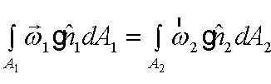 (7.2.5)
or since the areas chosen are arbitrary this means that the vortex tube strength, Γ, is constant along the tube. Note that this is a purely kinematic result. It depends only on the definition of the vorticity and its consequent non-divergence . It does not depend on the dynamics. An important implication of the result is that vortex lines, or tubes, cannot just end within the fluid. They must either close on themselves (like a smoke ring) or intersect a boundary.
In a rotating fluid,
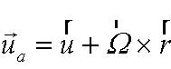 (7.2.6)
so that the vorticity associated with the velocity in an inertial frame is related to the velocity in a rotating frame by

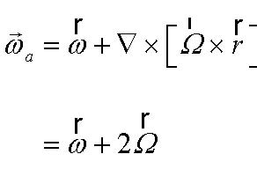 (7.2.7)

so the vorticity in the inertial frame is equal to the vorticity seen in the rotating frame (called the relative vorticity) plus the vorticity of the velocity due to the frame’s rotation which is just twice the rotation rate of the frame.
Similarly, the vortex tube strengths are related by,

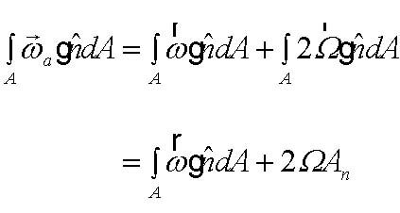 (7.2.8)

where An is the projection of A onto a plane perpendicular to 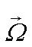 as shown in Figure 7.2.5.

Figure 7.2.5 The projection of the surface A onto the plane perpendicular to the rotation vector defines the area 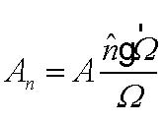 .
This shows that the contribution to the strength of a vortex tube of the planetary vorticity depends on the orientation of the tube with respect to the planetary rotation. The maximum contribution occurs when the tube is oriented parallel to the rotation vector. There is a zero contribution if the tube is perpendicular to Ω.

7.3 The circulation
The circulation of any vector field around a closed curve C in the fluid is defined as:

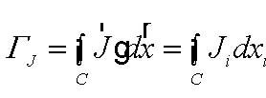 (7.3.1)
where the contour is taken in the counter-clockwise sense. The curve C need not lie in a plane and can be a complicated but continuous curve as illustrated in Figure 7.3.1

Ω

n

A

An
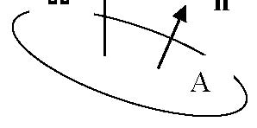
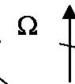
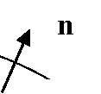
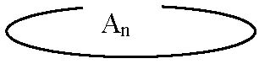

Figure 7.3.1 The contour C around which the component of J tangent to C is integrated.

The circulation involves the component of J tangent to the curve . If J is the velocity vector the resulting circulation is simply called the circulation and is denoted by Γ and is

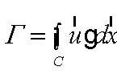 (7.3.2)
From Stokes theorem,

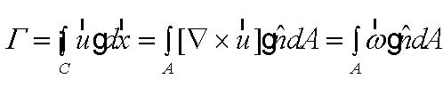 (7.3.3)
so that the circulation is just vortex tube strength for the tube enclosed by C.

Figure 7.3.2 the circulation around C gives the vortex strength of the vortex tube with cross sectional area A.

C

J

dx

C

ω

A
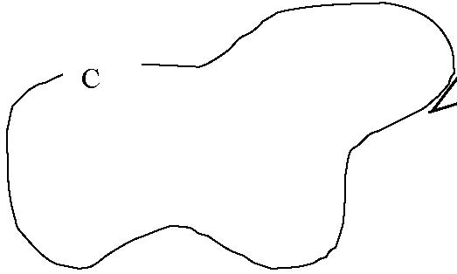
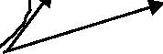
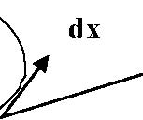
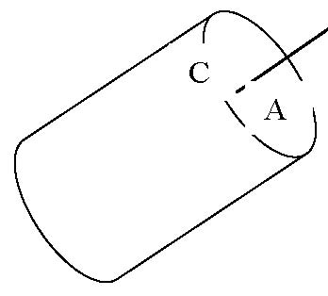
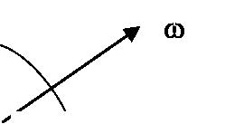

As we know from Stokes theorem, this relationship between the circulation and the area integral of the vorticity is only valid if the region enclosed by the contour C is simply connected. That is, the region must be such that we can shrink the contour to a point without leaving the region. Simply connected regions are bounded by contours that are called reducible. So, a region with a hole (like a bathtub drain) or an island (like Australia in the Pacific Ocean) is not simply connected and the contour is not reducible. Nevertheless, we can proceed by the following device. Consider the region with an non-fluid island whose bounding contour is CI. The original contour ,C, is then supplemented as shown in Figure 7.3.3 to form a new contour that does not have a hole.

Figure 7.3.3 . The augmented contour to deal with a region with an island in it.

The contour C has been augmented by a contour that travels to the island on the dashed line ca and then travels around the island on its bounding contour in a clockwise sense and then rejoins the outer contour along the path cb. We allow the two dashed segment to approach one another in the limit. The total contour integral is now,

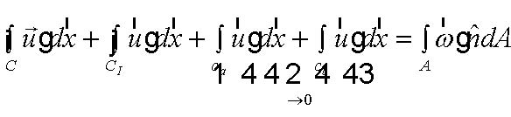 (7.3.4)

C

CI

c

cb
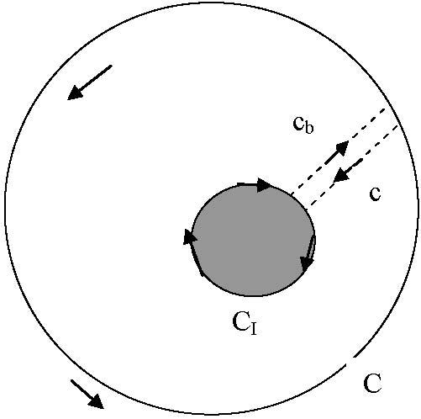
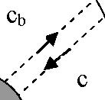
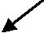
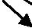
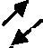
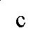
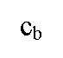
where the area integral on the right hand side of (7.3.4) is over the fluid area between the contours C and CI. The integrals on ca and cb cancel since they integrate the same velocity field but in opposite directions in the limit where the two segments approach each other. Thus, with attention to the direction of the contour integrals,

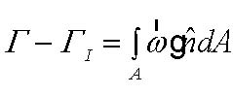 (7.3.5)
where Γ is the circulation on C and ΓI is the circulation (in the counterclockwise sense) around the island. Our general rule is then that the circulation on a contour is equal to the vortex strength of the region enclosed plus the circulation around all the holes enclosed by C.
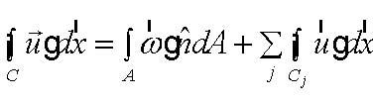 (7.3.6)

Of course, if the contour around the island could be shrunk to a point, and if the velocity remains finite, the contribution from the circulation around the hole would vanish and (7.3.6) would reduce to (7.3.3). These considerations are not just fussy mathematical arguments. In dealing with many problems we often find ourselves with “holes” in our domain either because of the presence of islands (like Australia) or the presence of regions where the dynamics requires different approximate equations than the ones we might be using rendering those regions inaccessible within our chosen dynamical framework and we might hope to replace the consequences of the generally more complex dynamics with some argument about the resulting circulation.
These considerations become important because of the central dynamical role of the circulation. Up to now we have only considered its kinematics but Kelvin’s theorem, below, makes is a central dynamical entity.

7.4 Kelvin’s Circulation Theorem

Consider a closed contour C that is drawn in the fluid and moves with the fluid so that the motion of the fluid elements on the contour determine its subsequent location and shape as shown in Figure 7.4.1.

Figure 7.4.1 The contour C and a fluid element A on the contour moving with the fluid velocity at that point.

Think of the contour as being composed of a “necklace” of fluid elements and the contour is moves with the necklace and is defined by the motion of the “pearls” on the necklace. We can then calculate the rate of change of the circulation on the contour,

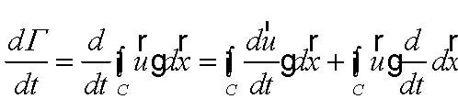 (7.4.1)
To calculate the last term we note that for the line element moving with the fluid,

Figure 7.4.2 The line element dx stretches and rotates depending on the velocity difference between its end points.
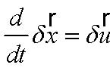 (7.4.2)
so that as the distance dx goes to zero, (7.4.1) can be written,

C

A

x

x+δx

u

u+ δu
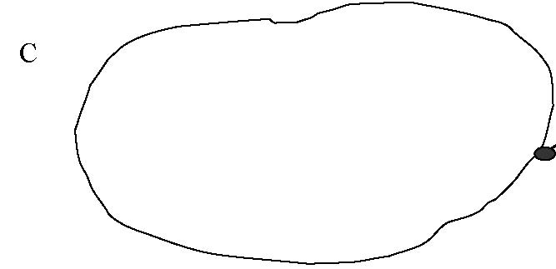
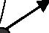
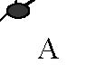
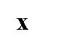
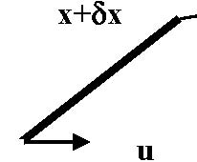
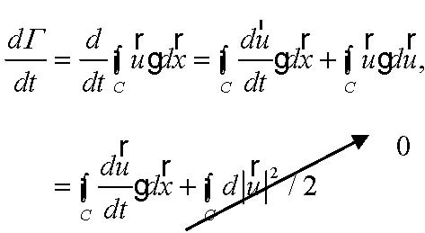 (7.4.3)
since the last term is the integral of a perfect differential around a closed path. Thus, (7.4.3) becomes,

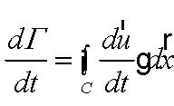
(7.4.4)
We have not specified which velocity we are using to define the circulation in (7.4.4). It is convenient for what follows to use the absolute velocity , i.e. the velocity seen in the inertial frame. Then,

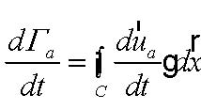 (7.4.5)

The momentum equation, (for simplicity let’s take the viscosity coefficients to be constants)

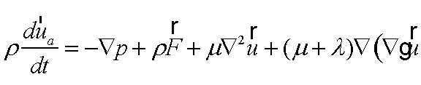 (7.4.6)
allows us to evaluate the right hand side of (7.4.5). First, we assume that the body force per unit mass, F , can be derived from a potential as in the case of gravity, so that,

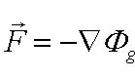 (7.4.7)
( we have put the label g on the potential to distinguish it from the dissipation function, 6.1.15). It follows from (7.4.7) that,

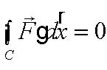 (7.4.8)

0
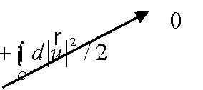
and hence (7.4.5) becomes,

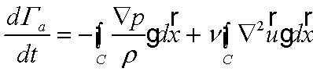 (7.4.9)

Since,

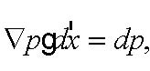 (7.4.10)
and

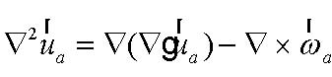 (7.4.11)

(this is easy to prove using the alternating tensor and using tensor notation), it follows that
(7.4.12)

The statement of Kelvin’s circulation theorem ,
If , for any circuit, C, moving with the fluid

a) 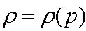 . That is, the density is a function only of pressure so that surfaces of constant density and pressure coincide ( a so-called barotropic fluid, the simplest example being a fluid of constant density) and this makes the integrand of the first term on the right hand side a perfect differential whose contour integral vanishes,
and
b) ν =0. That is, friction can be neglected,

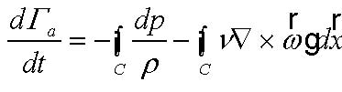
then,
The circulation is a conservative property. Note that the evaluation of the circulation Γa depends on knowledge of the position of the contour. Note too, that the conditions (a) and (b) need only be true on the contour.
Before discussing the consequences of the conservation of circulation let’s examine the terms on the right hand side of (7.4.12) that would be responsible for the production or destruction of circulation.
The first term is the baroclinic term
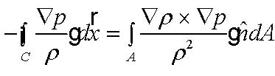 (7.4.13)
will be different from zero whenever the surface of density and pressure to no coincide. Consider Figure 7.4.3

Figure 7.4.3 The circuit C, the density and pressure gradient and an indication of the sense of the circulation induced by the baroclinic term (7.4.13)

If we think of the pressure gradient and its direction as being imposed by a gravity, just to make things intuitive, and if the density gradient is increasing to the left, it seems intuitive that the heavier fluid on the left would sink, the lighter fluid on the right would rise and the circulation would tend to increase as shown in the figure.
We emphasize this in the figure shown below,

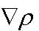

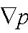

C

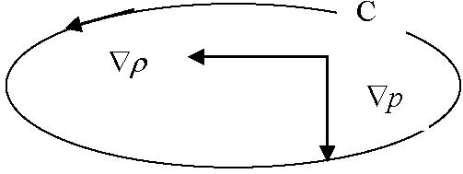
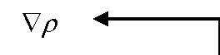
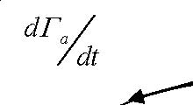

Figure 7.4. 4 The density and pressure surfaces. It should be clear that the tendency is for the density surfaces to slump to the horizontal producing circulation in the counter clockwise sense.

Another way of looking at the effect is to examine a fluid parcel whose center of gravity is displaced to the left by the presence of the density gradient.

Figure 7.4.5 The displaced center of gravity, the pressure gradient and the pressure force on the fluid element.

Taking torques around the center of gravity shows that the fluid will start to spin counter-clockwise producing positive circulation.

The second term on the right hands side of (7.4.12) represents the tendency of vorticity to diffuse through the fluid and so it can diffuse across the contour C without regard to the motion of the fluid. If the circulation measures the total vorticity contained within C the diffusion of vorticity, which we discussed in Section 5.3, permits the vorticity to diffuse across C. Indeed, using the identity (7.4.11) for the vorticity instead of the velocity,

p=const.

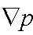

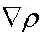

ρ =const.

cg

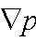

pressure force
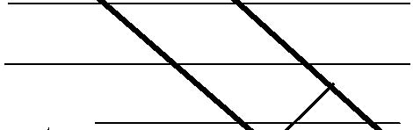
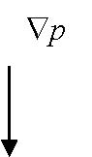
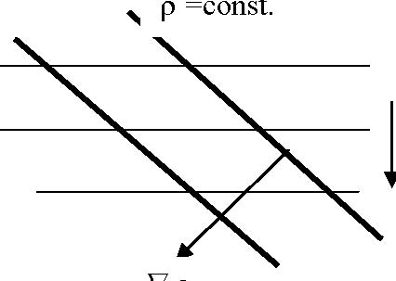
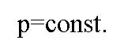
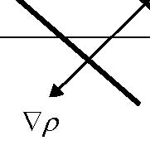
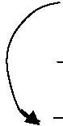
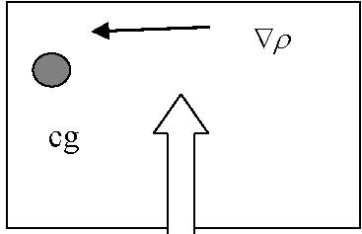
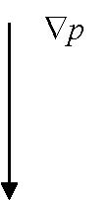
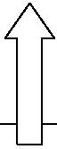

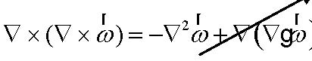 (7.4.14)

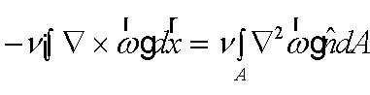 (7.4.15)

which emphasizes the diffusive character of the term. Note, however, that it is really the spatial variation of the vorticity on the contour that counts in (7.4.12)

For example, suppose the only component of the vorticity in the vicinity of an element of the contour is in the vertical direction, i.e. 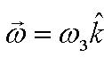 and suppose we consider an element of the contour parallel to the x axis so that 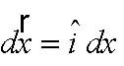 . Then the term, -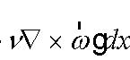 is just
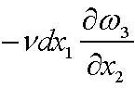 . Figure 7.4.6 demonstrates the diffusive effect.

Figure 7.4.6 The line element dx1 forms part of the contour C.

As shown there is a increase of ω3 in the x2 direction perpendicular to the element dx1. With our expectation of the nature of diffusion, i.e. that the property should diffuse down the gradient, we expect the vorticity to cross the line element and leave the domain encircled by C. This diffusive effect then lowers the circulation in the region enclosed by C even though no fluid crosses C (by definition).

0

x1

x2

x3

dx1

ω3
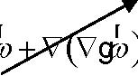
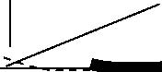
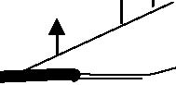
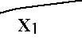
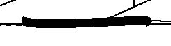
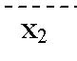

7.5 Kelvin’s theorem in a rotating frame.
To examine the form of Kelvin’s theorem for a rotating frame we need only recall the relation between the velocity as seen in an inertial frame and that seen in the rotating frame, namely,

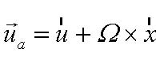 (7.5.1)
so that the circulations in each frame are related as,

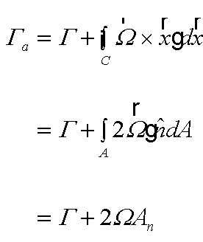 (7.5.2)
as in (7.2.8).
Since the circulation is a scalar the rates of change are the same in each frame so we can just substitute (7.5.2) into (7.4.12) to obtain for the circulation observed in a rotating frame,

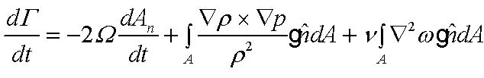 (7.5.3)
Consider the situation where viscosity can be neglected and where the fluid is barotropic. Then
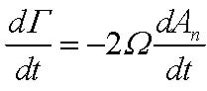 (7.5.4)
which just tells us that the total circulation is conserved. However, the implications are striking. As the projected area An changes the circulation in the rotating frame must change to compensate.
Example a. The Rossby wave
For example, suppose we have a flow in the atmosphere that we idealize as being two dimensional and horizontally non divergent. Then the horizontal area of any patch of fluid will be constant with time. If, though, the area slides on the surface of the sphere so that, moving northward, it is penetrated by more of the lines of vorticity associated with the Earth’s rotation, An will increase; see Figure 7.5.1.

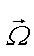

Figure 7.5.1 A zone of constant area A tangent to the sphere changes its projected area on the planetary vorticity by moving northward. The area is shown in the figure and is also shown in profile with the planetary vorticity piercing the area at an angle.

The projected area satisfies the relation,

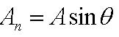 (7.5.5)
For a barotropic, inviscid fluid Kelvin’s theorem then becomes,

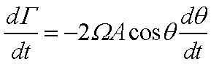 (7.5.6)

Now,

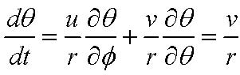 (7.5.7)

where r is the Earth’s radius. At the same time the left hand side of (7.5.6) is just

2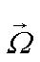

A

A

θ

n

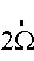
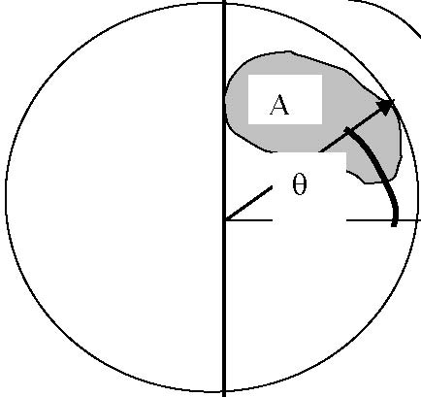
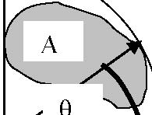
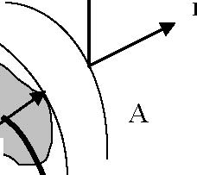
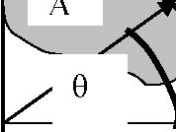
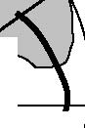
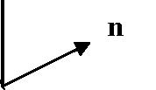
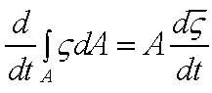 (7.5.8)

where is the mean value over the area A, of the vertical component of vorticity (normal to the Earth’s surface). If we consider infinitesimally small surface areas, that mean value will equal the value of the vorticity itself. Again, using the constancy of A this leads to the equation,

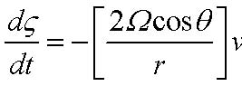 (7.5.9)

which is a differential statement of the vorticity induction effect. A fluid element moving northward will produce a decrease in the vorticity of the fluid (relative to the earth). If the vorticity is originally zero, northward motion will yield clockwise vorticity (clockwise circulation).
The vertical component of vorticity is,

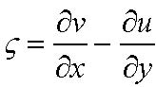 (7.5.10)
where x is a coordinate measuring distance eastward and y northward. We are using a locally Cartesian coordinate frame assuming that the scales of motion are large enough for Ω to be important but small enough to allow the geometrical convenience of the Cartesian system. Since the motion is two dimensional and nondivergent in our simple model, the velocities can be represented in terms of a streamfunction,

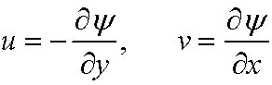 (7.5.11)

(check that this automatically satisfies the condition of zero horizontal divergence). The vorticity itself is,
(7.5.12) 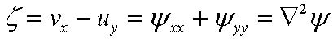
The differential statement of Kelvin’s theorem (7.5.6) becomes,

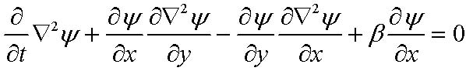 (7.5.13)
where we have defined the parameter,

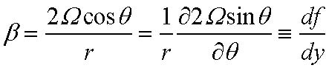 (7.5.14)
The local normal component of the Earth’s planetary vorticity, 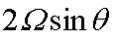 is conventionally denoted as f, the Coriolis parameter. It varies from a minimum at the south pole, passes through zero at the equator and reaches a maximum at the north pole. Its variation is important but relatively slow compared with the length scale over which atmospheric and oceanic motions vary and so it is possible to consider it nearly constant locally. Its variation with latitude, i.e. its northward gradient is given by β and the presence of this term in (7.5.13) is the so-called beta effect. The motion of fluid in the gradient of the planetary vorticity produces relative vorticity. This manifestation of the sphericity of the Earth in an otherwise flat, Cartesian geometry is the beta plane approximation. You will see a more rigorous and systematic justification in later courses (or see Chapter 3 of GFD) . This approximation was introduced in this heuristic manner by Rossby in his famous 1939 paper where he derived the vorticity wave that now bears his name.
Indeed, let’s follow his example and search for a plane wave solution of the nonlinear equation (7.5.13) in the form,

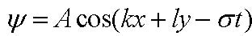 (7.5.15)
If this is substituted into (7.5.13) we note first that the nonlinear terms identically vanish. This is because, for a solution like (7.5.15) the relative vorticity
(7.5.16) 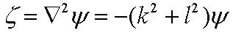

so that the nonlinear term, i.e. the advection of the vorticity of the fluid by its own motion, and which is the Jacobian of the streamfunction with the vorticity, is zero.
Thus, (7.5.13) yields,

(7.5.17)

The only non trivial solution to (7.5.17) gives the dispersion relation, that is, the relation between the frequency and the wavenumber, namely,

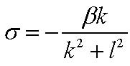 (7.5.18)

The frequency σ as a function of the x wavenumber k is plotted in Figure 7.5.2 and has several interesting and rather strange properties.

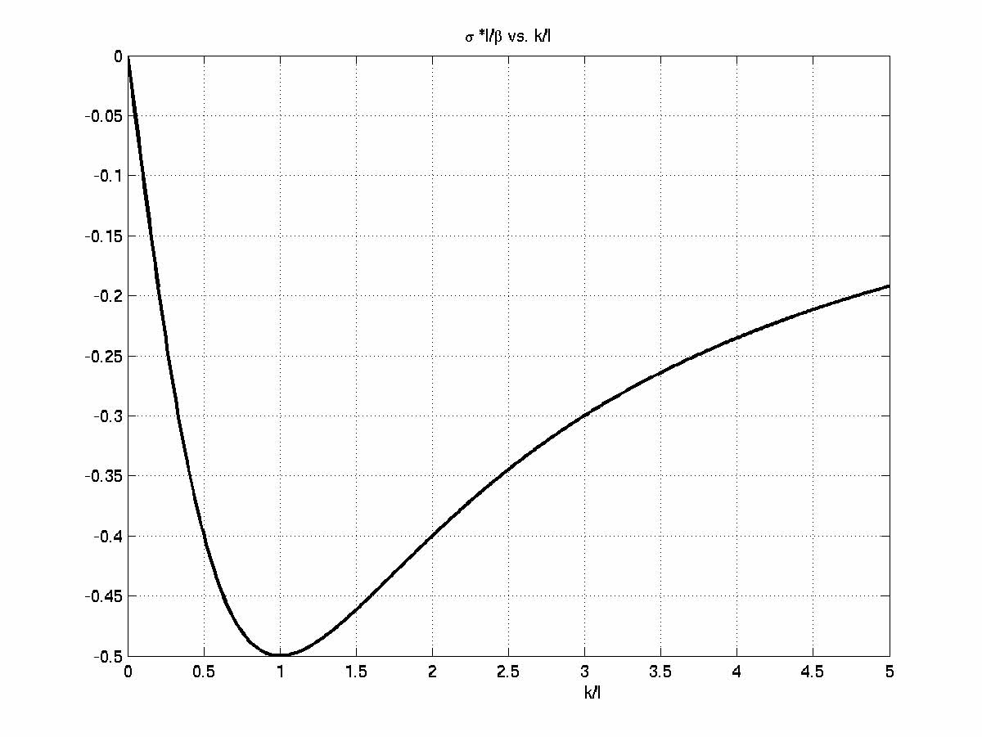
Figure 7.5.2 The frequency of the Rossby wave scaled with β/l plotted as a function of k/l.

The phase of the wave, (think about a particular crest ) is given by the argument of the trigonometric function in (7.5.15). The phase is
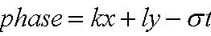 (7.5.19)
The rate at which a point of constant phase moves in the x direction is

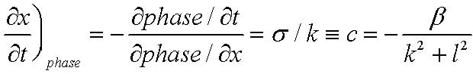 (7.5.20)
This phase speed in the x direction is always negative. That is, crests and troughs in the wave always move westward! As you will see in 12.802 the energy in the wave does not move at the phase speed but at a different speed, the group velocity, but this is beyond the point we will go now. Also, notice that there is a maximum (in terms of magnitude) Rossby wave frequency that depends on β and on the y wavenumber the latter of which will usually be set by the meridional extent of the domain.
Example b. The ocean circulation
We saw in chapter 5 that a wind stress acting on the surface of the ocean would produce a stress-driven transport in a frictional boundary layer, the Ekman layer, near the upper surface of the fluid and the divergence of that transport would yield a vertical velocity at the base of the boundary layer given by (5.2.6), namely,

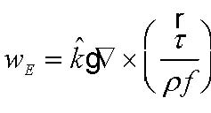 (7.5.21)
Suppose we consider an idealized model of the ocean circulation in which the fluid is considered to have constant density and a flat bottom. Then the fluid pumped down (or up) from the Ekman layer will force a compensating divergence of fluid below and an increase or decrease in the cross-sectional area of fluid columns beneath the frictional boundary layer as shown in Figure 7.5.3.

Figure 7.5.3 A fluid column in the ocean has a horizontal divergence due to Ekman pumping.

In this case a simple mass balance for the fluid column yields,

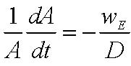 (7.5.22)

so that now (7.5.4) becomes,

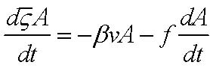 (7.5.23)

For the large scale circulation of the ocean, away from strong boundary currents like the Gulf Stream, the term on the left hand side is negligible. If U is a typical horizontal velocity and L is a typical horizontal length scale, then the left hand side can be estimated as,

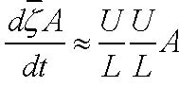 (7.5.24)

while the first term on the right hand side is of order 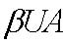 so that the ratio of the former to the latter is, 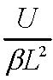 . If we use U= 5 cm/sec, L = 1,000 km and β =2 10-13cm-1sec-1 this ratio is 2.5 10-3, i.e. entirely negligible. Using (7.5.22) in (7.5.23) yields

Ekman layer

wE

D
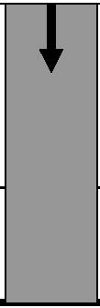
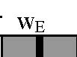
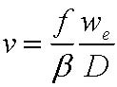 (7.5.25)

so that in the region of the subtropical gyre of the North Atlantic, for example, where the Ekman velocity is negative and of the order of 2 x10-4 cm/sec this yields a meridional velocity, taking D to be the thermocline depth of 1 km, of v = 1 cm/sec which is about right for a mid-ocean velocity when averaged over the thermocline. Note that this would yield a southward flow everywhere and unless we expect the oceans to drain, there must be a return flow in which the constraint (7.5.25), the Sverdrup relation, is broken. This can occur in narrow, swift boundary currents for which the left hand side of (7.5.24) is not negligible. We can estimate the width of such currents by asking for what value of L will the ratio U/βL2 be order unity. For U of order 5 cm/sec this yields a width of 50 km, i.e. just about the width of the Gulf Stream, the narrow boundary current that returns the flow that moves southward under the influence of the winds as described by (7.5.25)
Example c. The bathtub vortex.
Probably no aspect of Geophysical Fluid Dynamics is more fixed in the mind of the lay person than the “fact” that in the northern hemisphere water circulates counterclockwise as it goes down the bathtub drain and clockwise in the southern hemisphere. Let’s see if that is a reasonable conclusion to draw from our circulation arguments; then you can check it during your next shower or bath.
We consider a theoretician’s bathtub, one that is very large, circular and with the drain in the center.

Figure 7.5.4a A circular tub with a drain in the center. The contour C is a distance r from the center.

drain

C

r
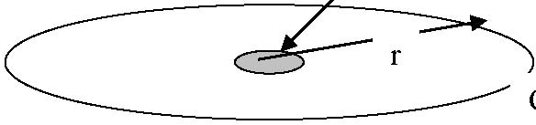
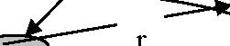
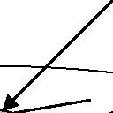
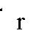

Figure 7.5.4b The layer of water in the tub has a depth d and it flows towards the drain.

Our simple model of the process will assume :
- 1) that the flow is 2-dimensional, i.e. independent of the azimuth around the drain.
- 2) The depth remains constant. (this is probably ok until the very end of the draining of the water).

Suppose a volume flux Q goes down the drain each instant and let u be the radial, outward velocity, then,

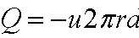 (7.5.26)
and is independent of r where we can think of r as the radius of the contour we will consider for Kelvin’s theorem. Thus,

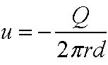 (7.5.27)
From the Lagrangian point of view 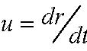 and so

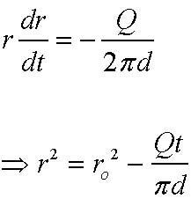 (7.5.28 a,b)
where r0 is the radius of the contour at t =0.

The circulation theorem, ignoring friction for now, is, (v is the azimuthal velocity)

d
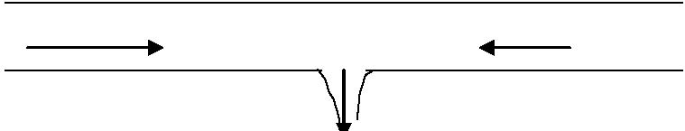

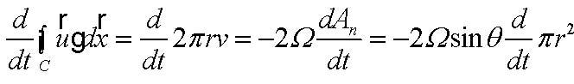 (7.5.29)

or, integrating in time,

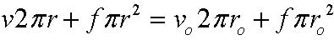 (7.5.30)
where the zero subscript denotes the value of the quantity on the contour when it was at radius r0. Note that , that is, the original velocity is a function of radius. Solving for the azimuthal velocity, 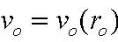

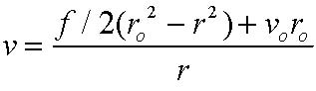 (7.5.31)
or using (7.5.28)

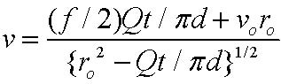 (7.5.32)
This is a completely Lagrangian description of the velocity. It is given in terms of the time t and the original position of the contour at r=r0. The Eulerian description is

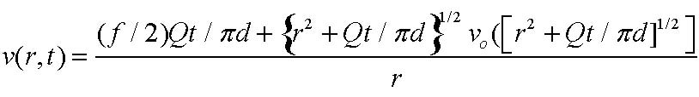 (7.5.33)

For large time, the contour C which started far from the drain, is about ready to disappear forever down the drain. Then, the radius of the contour is much smaller than its starting radius and the azimuthal velocity will be approximately given by (7.5.31) with , 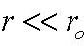

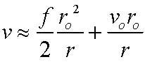 (7.5.34)
If the first term on the right hand side dominates then, certainly, the direction of the swirling flow as the water goes down the drain will depend on the sign of θ and be positive in the northern hemisphere and negative in the southern hemisphere. Let’s estimate the size of that term with respect to the second term which gives us a measure of how much velocity we have put into the tub by swishing around or even by just pulling the plug. The ratio of the first to second term is, 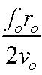 . Now in mid latitudes f is of the order of 10-4 sec-1. Suppose we have a rather sumptuous bathtub and let r0 be a meter . Then the initial velocity v0 would have to be less than 0.1 mm/sec to have the first term be even as large as the second term . I dare say most of us produce a greater disturbance in the tub ourselves so the expectation that we will know the hemisphere we are in by taking a bath is wildly unrealistic. However, very careful experiments have been done, requiring special care to have the fluid originally motionless and have the tub’s plug pulled without producing relative circulation and in these experiments the hemispheric effect can be observed.

7.6 Further consequences of Kelvin’s theorem: Frozen vortex lines.

Suppose, again, that we may neglect friction and that the baroclinic term is also zero. Then

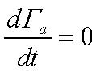 (7.6.1)
but, of course, Γ, the relative circulation will not be conserved. Note that (7.6.1) only requires that the baroclinic vector be zero in the surface containing the contour although here we have used the stronger condition that it vanish in the whole field of motion.
Now, consider a surface S which moves with the fluid and suppose that at t=0 it is composed of vortex lines as shown in Figure 7.6.1.

Figure 7.6.1 A surface S composed of vortex lines. The contour C lies in the surface.

On S we draw the contour C. At t=0 there are no vortex lines that penetrate the contour since they all lie on the surface. Hence, at t=0 the circulation Γa is zero. But if S, as defined, moves with the fluid and C moves with the fluid the circulation on C must remain zero since the circulation is conserved. Hence as S moves it remains composed of vortex lines.
Consider now two such surfaces that intersect. Each surface is composed of vortex lines and each surface remains composed of vortex lines. The intersection of the two surfaces clearly is a vortex line as seen in Figure 7.6.2.

S

C

ωa
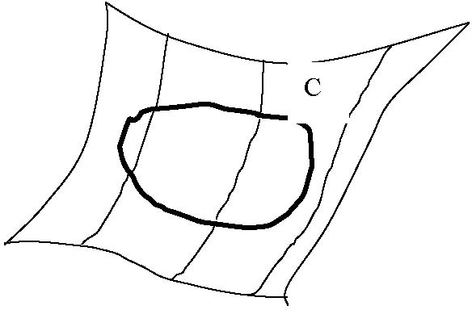
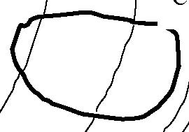
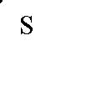
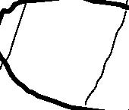
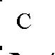
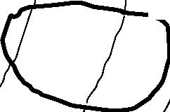
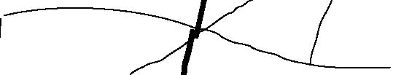
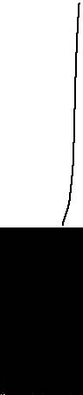
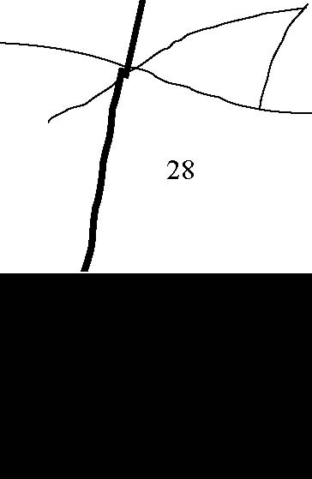
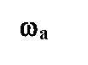
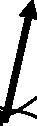

Figure 7.6.2 The intersection of two surfaces composed of vortex lines is a vortex line. If each surface moves with the fluid the intersection also must.

Since each surface moves with the fluid the intersection moves with the fluid and hence it follows that vortex lines move with the fluid if circulation is conserved. More precisely:

If 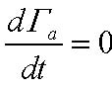 any line of material elements in the fluid that was once a vortex line remains a vortex line. Or, more arrestingly, vortex lines then move with the fluid as if they were frozen into the fluid.

The vortex line may become contorted but nevertheless it remains a vortex line. Note, this generally does not apply to the relative vortex lines.
A natural extension of the argument shows that it must also be true for vortex tubes, i.e. if circulation is conserved vortex tubes move with the fluid and from our kinematic argument the vortex tube strength remains fixed with time. As the fluid moves the tube may become stretched as shown in Figure 7.6.3.

C

ω1

ω2

C
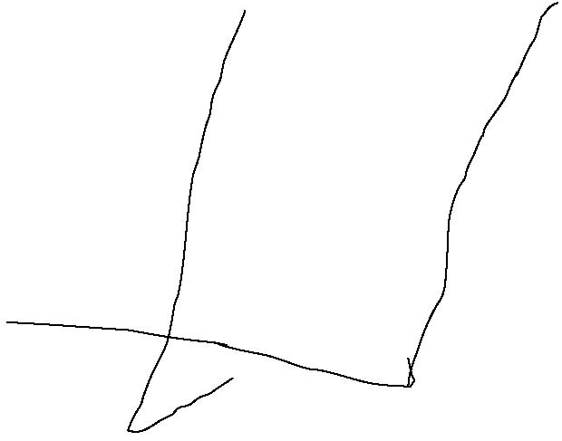
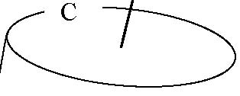
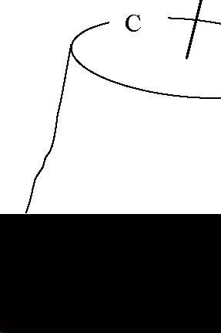
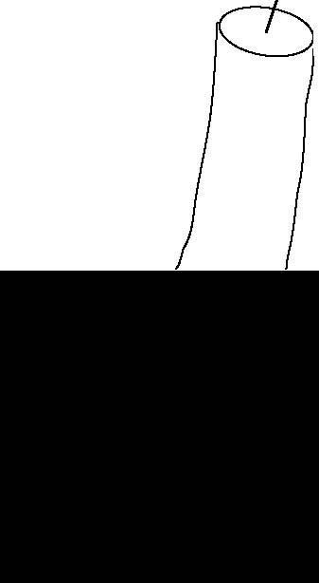
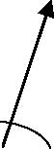
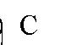

Figure 7.6.3 A vortex tube stretched by the fluid motion

If the column is stretched and its cross sectional area decreases (as would be the case if the fluid is nearly incompressible) the vorticity in the tube must increase to keep the vortex tube strength (or equivalently the circulation around C) fixed. Thus if 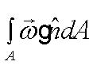 is fixed and the cross sectional area decreases the vorticity normal to the tube axis must increase. Hence, vortex tube stretching can increase the vorticity if circulation is conserved. In a rotating system 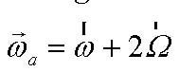 and we can imagine the following scenario. Suppose the tube stretches. If originally there is no relative vorticity (or a trivial amount) stretching of the tube will be stretching planetary vorticity filaments. Since the vorticity increases and the planetary vorticity is fixed (assuming constant Earth rotation rate) there must be an increase of relative vorticity. Hence the planetary vorticity is a possible source of relative vorticity that can be realized by stretching tubes in the presence of the planetary vorticity. For this reason large scale atmospheric and oceanic flows have currents that are full of vorticity that has come from vortex tube stretching in the presence of planetary vorticity.

7.7 The vorticity equation

withtime
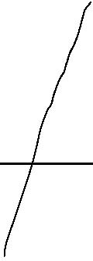
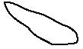

The vorticity is a vector. Kelvin’s theorem, or the general equation for the rate of change of circulation (7.5.3), gives us only a scalar equation. Hence much of the vectorial character of the vorticity dynamics is not revealed (this is why the result is so simple and elegant). To look into this further we will consider developing an equation for the vorticity. Again, we consider the case where the viscosity coefficients are constant. As a preliminary, we once again use our alternating tensors to prove the following identity,

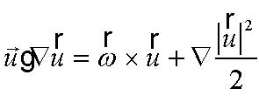 (7.7.1)
Consider the ith component

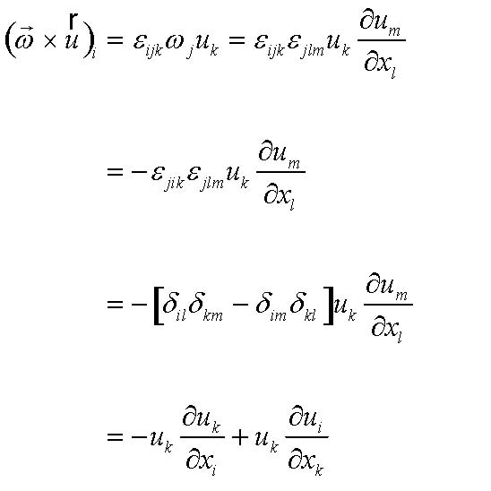 (7.7.2)
which when restoring vector notation yields (7.7.1).
Thus, the Navier-Stokes equations can be written,

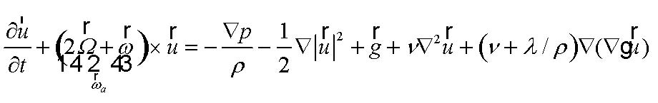 (7.7.3)

Note that a part of the acceleration term provides a gradient force, similar to the pressure gradient while another part alters the Coriolis acceleration so that it is proportional to the absolute vorticity. To obtain an equation for the vorticity we take the curl of the equations which yields,

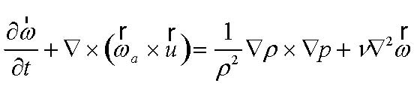 (7.7.4)
The second term on the left hand side is the curl of a cross product and, again, it is easiest to figure it out using our tensor notation and the simple rules following from the use of the alternating tensor, so, (using a superscript a to denote the absolute vorticity to avoid confusion with the coordinate indices),

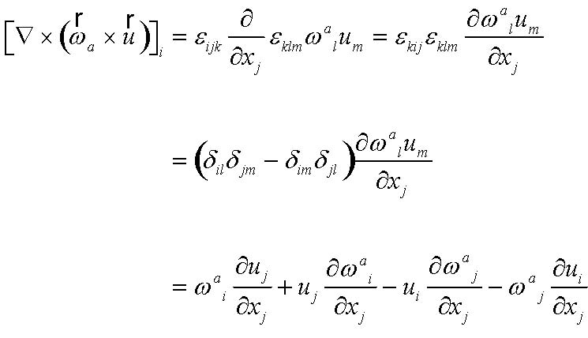 (7.7.5)
or, in vector notation and using the fact that the vorticity is always non-divergent, we obtain for (7.7.4)

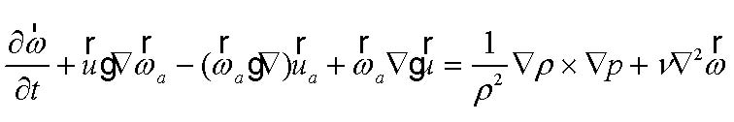 (7.7.6)
or noting that the planetary rotation is constant (the next step would be correct even if it were to be changing with time—that is left as an exercise for you),

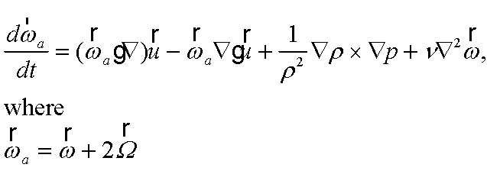 (7.7.7a,b)

The last two terms on the right hand side of the equation are already familiar to us from the discussion of the Kelvin’s circulation theorem. The new terms that require interpretation are the first two terms on the right hand side that contribute to the rate of change of the absolute vorticity 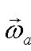. Those new terms, (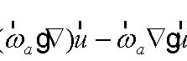 , can be thought about more simply if, at any arbitrary point we construct a coordinate frame whose z axis is tangent to the vortex line at a point, the origin of the frame, as shown in Figure 7.7.1 so that at the origin the vorticity vector is 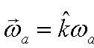 where 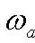 is the magnitude of the vector.

Figure 7.7.1 A vortex line, shown as the heavy line with an arrow, and the coordinate frame constructed so that at the origin the z axis is tangent to the vortex line.

Then the terms under consideration can be written in component form as

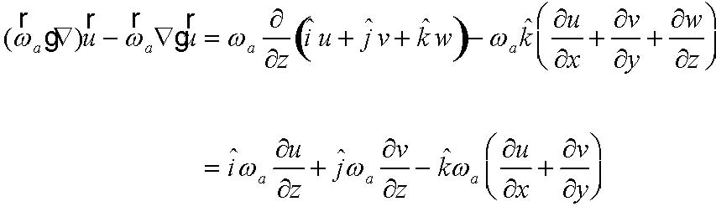 (7.7.8)
There are three components that contribute to the rate of change of the absolute vorticity.

1) In the x-direction ωa increases as the shear 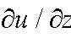 tips the vorticity vector in the x direction, just as if the vortex line moves with the fluid. In a infinitesimal interval Δt the change in the vorticity vector in the x direction from these terms alone would be, from (7.7.7)

x

y

z

ωa
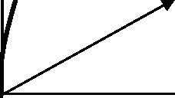
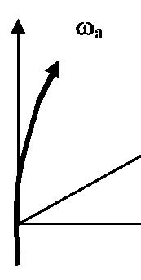
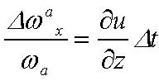 (7.7.9)

Note that a line element that moves with the fluid and which is originally parallel to the z axis would be tipped over so that, as shown in Figure 7.7.2,

Figure 7.7.2 A line element of length l is tilted by the shear and produces a displacement Δx parallel to the x axis.

Note that

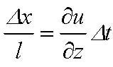 (7.7.10)
and comparing with (7.7.9) confirms that the production of vorticity parallel to the x axis can be interpreted as a simple tilting of the vorticity vector, originally parallel to the z axis, in the x direction by the shear. Obviously, the same occurs in the y direction as described by the second term on the right hand side of 7.7.8. Thus, the vortex change in the direction perpendicular to the vortex line is due to vortex line tilting by the shear in the direction perpendicular to the vortex line.
In the direction parallel to the vortex line, i.e. in the z direction, the rate of change of 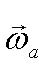 is given by,

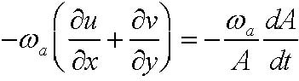 (7.7.11)

l

x

Δx

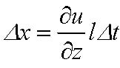
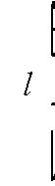
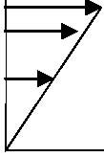
where A is the area perpendicular to the vortex line. A reduction of A will concentrate the vortex lines and increase the vorticity and this is the familiar effect of vortex tube stretching. If this effect were the only one operating, the vorticity equation in the z direction would simply be,

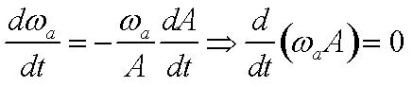 (7.7.12)
which we recognize from the circulation theorem.
Thus, following a fluid element:
The rate of change of absolute vorticity is due to:
- 1) vortex tube stretching
- 2) vortex tube tilting
- 3) baroclinic production of vorticity
- 4) viscous diffusion of vorticity.

7. 8 The enstrophy
Another useful measure of the intensity of the vorticity is the enstrophy. The absolute enstrophy is the defined as the square magnitude of the absolute vorticity vector,

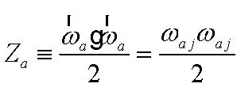 (7.8.1)
From the vorticity equation, (7.7.7) in component form,

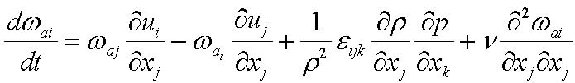 (7.8.2)
and taking the inner product with the vorticity, yields,

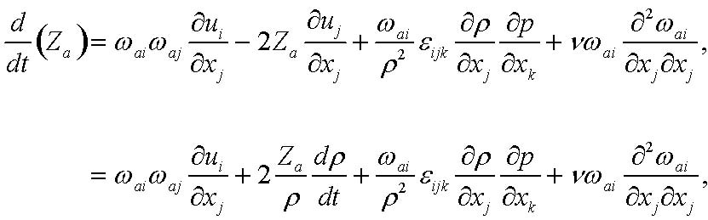 (7.8.3)
The second step in (7.8.3) uses the mass conservation equation. Multiplying the equation by 1 allows it to be rewritten, 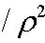

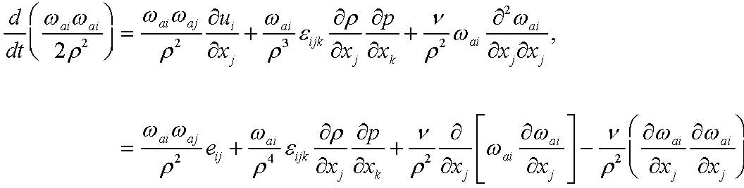 (7.8.4)
The appearance of the rate of strain tensor follows from the symmetry of the term 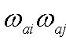 that allows the inner product of the first term on the right hand side to be written in terms of the symmetric part alone of the deformation tensor. Note that if the density were constant (or if we were considering only the change of Za due to friction) the effect of friction can be written as a divergence term whose integral represents a diffusive flux of enstrophy across the boundary and an negative definite term that represents the viscous dissipation of enstrophy. The most interesting term is really the first term, the production of enstrophy by the rate of strain in the fluid. To consider the term further, let’s evaluate it in the principal axis frame of eij i.e. the frame in which it is a diagonal tensor.

(7.8.5) 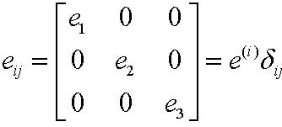
and let’s write the absolute vorticity vector as,
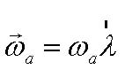 (7.8.6)

where λ is a unit vector in the direction of the vorticity. Then the inner product,

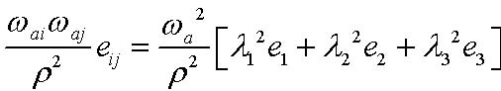 (7.8.7)

so that the enstrophy equation (7.9.4) becomes,

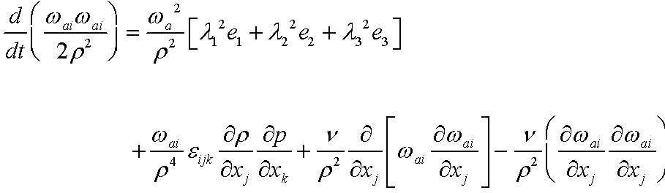 (7.8.8)

Note that if the vorticity has a component along a principal axis corresponding to extension (e) this will lead to an increase of enstrophy and that can balance the dissipation of enstrophy by friction. 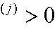
Suppose the motion is strictly two dimensional. For example, the velocity lies in the x , y plane and u and v are independent of z. The only component of vorticity is then in the z direction so that only λ3 is different from zero. But then e3 which is just is identically zero. It is also true that all the vortex tilting terms are zero, and so, if baroclinicity and friction are negligible the enstrophy for two dimensional motions would be conserved. 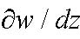
On the other hand for three dimensional motions, especially for turbulent motions, during intervals of time for which the vorticity is acted upon by the rate of strain tensor leading to extensions, the vorticity can become very intense and the vortex tilting mechanism can make the field of vorticity increasingly complex and entangled. So, we must expect a big difference between strictly or nearly two dimensional motion and three dimensional motion.
Suppose K is the largest rate of strain along the principal axes.

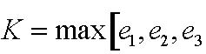 (7.8.9)
then ignoring friction and baroclinicity, (7.8.9) implies that,

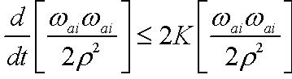 (7.8.10)
or,

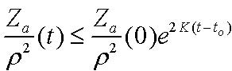 (7.8.11)
This implies that if the enstrophy (note the absolute enstrophy) is zero at some initial time it will remain zero in the absence of baroclinic and frictional effects. So, if the flow initially has no vorticity, i.e. if it is irrotational, it will remain so (this is sometimes called the persistence of irrotationality--- it sounds like a painting by Salvador Dali). Given the presence of the planetary vorticity, this is a situation that rarely arises for large scale flows. For small scale motions for which the planetary vorticity can be neglected it is, rather, a useful constraint to keep in mind as we shall later see.
Returning for a moment to (7.7.7), note that for two dimensional flows for which,

(7.8.12 a,b) 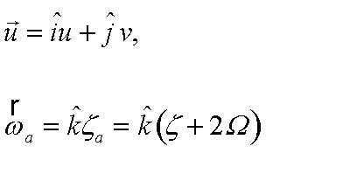
the vorticity equation becomes

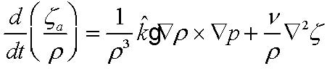 (7.8.13)
so that in the absence of baroclinicity and friction, for 2-dimensional flow, the ratio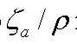 is conserved following the fluid motion. This is a rather special case of only marginal interest in meteorology and oceanography. However, in the next chapter we will generalize this result to three dimensional motions including baroclinic fluids.

