Chapter 6
Thermodynamics and the Equations of Motion
6.1 The first law of thermodynamics for a fluid and the equation of state.
We noted in chapter 4 that the full formulation of the equations of motion required additional information to deal with the state variables density and pressure and that we were one equation short of matching unknowns and equations. In both meteorology and oceanography the variation of density and hence buoyancy is critical in many phenomenon such cyclogenesis and the thermohaline circulation, to name only two. To close the system we will have to include the thermodynamics pertinent to the fluid motion. In this course we will examine a swift review of those basic facts from thermodynamics we will need to complete our dynamical formulation.
In actuality, thermodynamics is a misnomer. Classical thermodynamics deals with equilibrium states in which there are no variations of the material in space or time, hardly the situation of interest to us. However, we assume that we can subdivide the fluid into regions small enough to allow the continuum field approximation but large enough, and changing slowly enough so that locally thermodynamic equilibrium is established allowing a reasonable definition of thermodynamic state variables like pressure, density and pressure. We have already noted that for some quantities, like the pressure for molecules with more than translational degrees of freedom, the departures from thermodynamic equilibrium have to be considered. Generally, such considerations are of minor importance in the fluid mechanics of interest to us.
If the fluid is in thermodynamic equilibrium any thermodynamic variable for a pure substance, like pure water, can be written in terms of any two other thermodynamic variables✿, i.e.
(6.1.1) where the functional relationship in depends on the substance. Note that, as discussed before, (6.1.11) does not necessarily yield a pressure that is the average normal force on a fluid element. The classic example of an equation of state is the
perfect gas law;
(6.1.2) which is appropriate for dry air. The constant R is the gas constant and is a property of the material that must be specified. For air (from Batchelor)
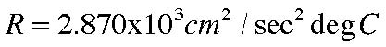
(6.1.3)
One of the central results of thermodynamics is the specification of another thermodynamic state variable e(ρ,T) which is the internal energy per unit mass and is, in fact, defined by a statement of the first law of thermodynamics.
Consider a fluid volume, V, of fixed mass (Figure 6.1.1)
dA Fi
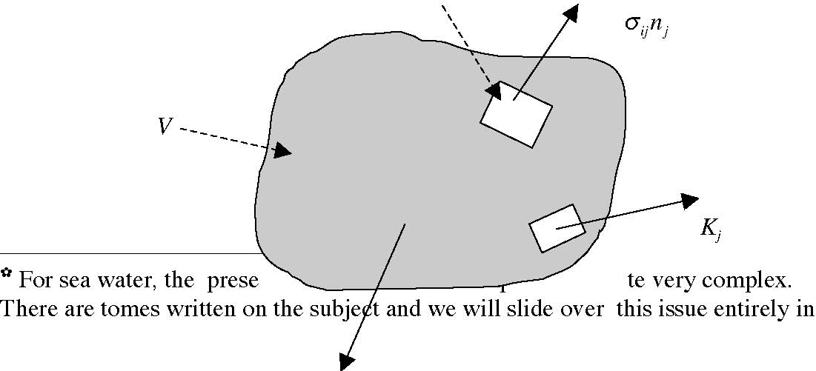
Figure 6.1.1 A fixed mass of fluid, of volume V, subject to body force F, a surface flux of heat (per unit surface area) out of the volume, K, and the surface force per unit area due to the surface stress tensor.
The first law of thermodynamics states that the rate of change of the total energy of the fixed mass of fluid in V, i.e. the rate of change of the sum of the kinetic energy and internal energy is equal to the rate of work done on the fluid mass plus the rate at which heat added to the fluid mass. That is,
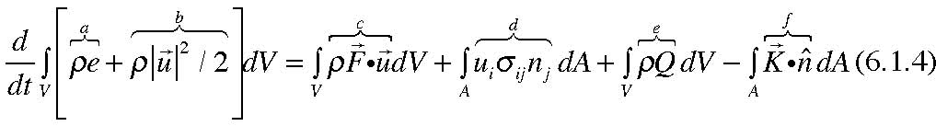
Let’s discuss each term :
- (a) The rate of change of internal energy.
- (b) The rate of change of kinetic energy.
- (c) The rate at which the body force does work. This is the scalar product of the body force with the fluid velocity.
- (d) The rate at which the surface force does work. This is the scalar product of the surface stress with the velocity at the surface (then integrated over the surface).
- (e) The rate at which heat per unit mass is added to the fluid. Here Q is the thermodynamic equivalent of the body force, i.e. the heat added per unit mass.
- (f)

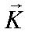 is the heat flux vector at the surface, i.e. the rate of heat flow per unit surface area out of the volume.
The terms (a) and (b) require little discussion. They are the internal and kinetic energies rates of change for the fixed mass enclosed in V. Note that term (b) is:
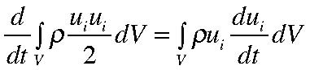
(6.1.5)
The principal point to make here is that (6.1.4) defines the internal energy as the term needed to balance the energy budget. What thermodynamic theory shows is that e is a state variable defined by pressure and temperature, for example, and independent of the process that has led to the state described by those variables.
Similarly, term (c) is the rate at which the body force does work. The work is the force multiplied by the distance moved in the direction of the force. The work per unit time is the force multiplied by the velocity in the direction of the force and then, of course, integrated over the mass of the body. Term (d) is the surface force at some element of surface enclosing V and is multiplied by the velocity at that point on the surface and then integrated over the surface. Using the divergence theorem,
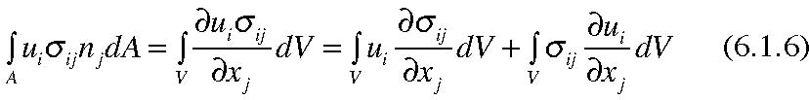
Term (e) represents the rate of heat addition by heat sources that are proportional to the volume of the fluid, for example, the release of latent heat in the atmosphere or geothermal heating in the ocean or penetrative solar radiation in the ocean and atmosphere. Finally the flux of heat out of the system in term (f) can also be written in terms of a volume integral,
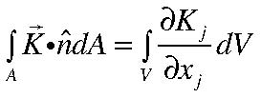
(6.1.7)
Now that all terms in the budget are written a volume integrals we can group them is a useful way as,
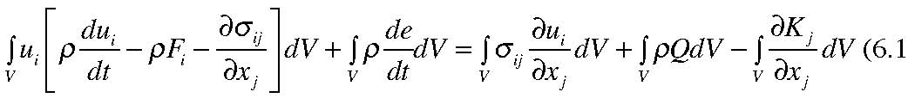
.8)
The first term on the left hand side has an integrand which is (nearly) the momentum equation if Fi contains all the body forces including the centrifugal force. It lacks only the Coriolis acceleration. However, since each term is dotted with the velocity one could easily add the Coriolis acceleration to the bracket without changing the result. Then it is clear that the whole first term adds to zero and is, in fact, just a statement of the budget of kinetic energy
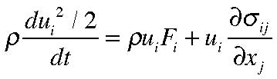
(6.1.9)
The remaining volume integral must then vanish and using, as before, the fact that the chosen volume is arbitrary means its integrand must vanish or,
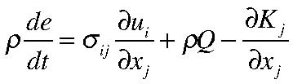
(6.1.10)
as the governing equation for the internal energy alone. Since the stress tensor is symmetric,
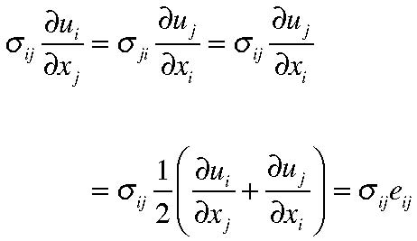
(6.1.11)
The first step in (6.1.11) is just a relabeled form with i and j interchanged. The second step uses the symmetry of the stress tensor and the last line rewrites the result in terms of the inner product of the stress tensor and the rate of strain tensor. Since, (3.7.15)
(6.1.12)
or with the relation ,
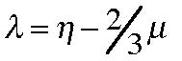 we have
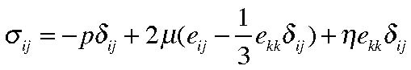
(6.1.13)
where the pressure is the thermodynamic pressure of the equation of state and η is the coefficient relating to the deviation of that pressure from the average normal stress on a fluid element. The scalar
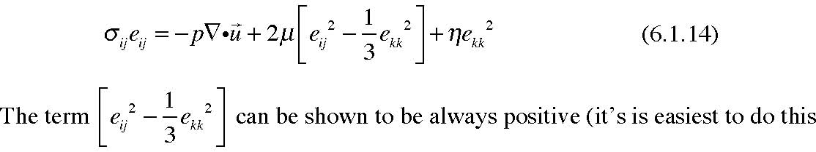
in a coordinate system where the rate of strain tensor is diagonalized). So this term always represents an increase of internal energy provided by the viscous dissipation of mechanical energy. Traditionally, this term is defined as the dissipation function, Φ , i.e. where,
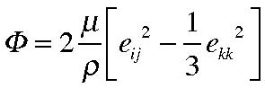
(6.1.15)
In much the same way that we approached the relation between the stress tensor and the velocity gradients, we assume that the heat flux vector depends linearly on the local value of the temperature gradient, or, in the general case
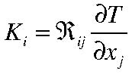
(6.1.16)
Again assuming that the medium is isotropic in terms of the relation between temperature gradient and heat flux, the tensor 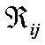 needs to be a second order isotropic tensor. The only such tensor is the kronecker delta so
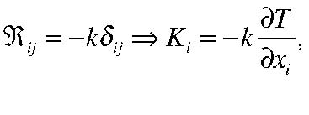
(6.1.17)
The minus sign in (6.1.17) expresses our knowledge that heat flows from hot to cold, i.e. down the temperature gradient, i.e.
(6.1.18)
where k is the coefficient of heat conduction. For dry air at 200 C, k= 2.54 103 grams /(cm sec3degC)
Putting these results together yields,
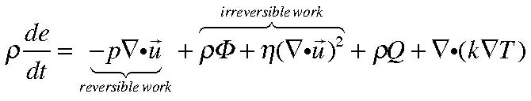
(6.1.19)
The pressure work term involves the product of the pressure and the rate of volume change; a convergence of velocity is a compression of the fluid element and so leads to an increase of internal energy but an expansion of the volume (a velocity divergence) can produce a compensating decrease of internal energy. On the other hand, the viscous terms represent an irreversible transformation of mechanical to internal energy. It is useful to separate the effects of the reversible from the
irreversible work by considering the entropy. The entropy per unit mass is a state variable we shall refer to as s and satisfies for any variation δ s
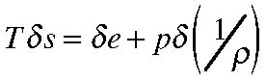
(6.1.20)
so that, for variations with time for a fluid element,
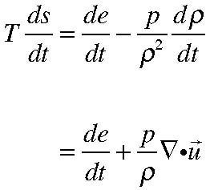
(6.1.21)
Substituting for de/dt into (6.1.19) leads to an equation for the entropy in terms of the heating and the irreversible work,
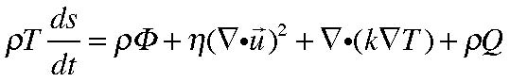
(6.1.22)
Since s is a thermodynamic variable we can write, that,
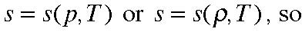
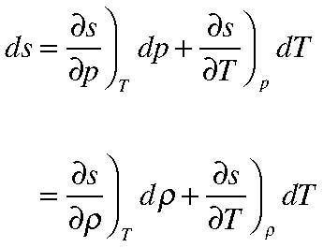
(6.1.23 a, b)
Similarly, we can write (6.1.20) in two forms,
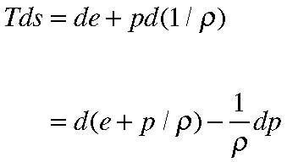
(6.1.24 a, b) and we define another state variable, the enthalpy , h, as
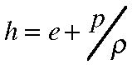
(6.1.25)
It follows from (6.1.23) and (6.1.24) that we can define,
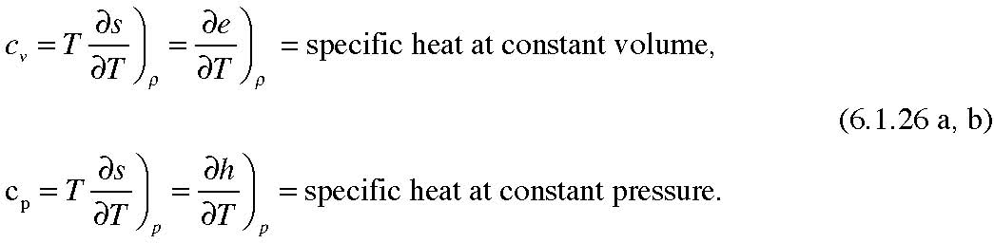
so that our dynamical equation for the entropy (6.1.22) becomes
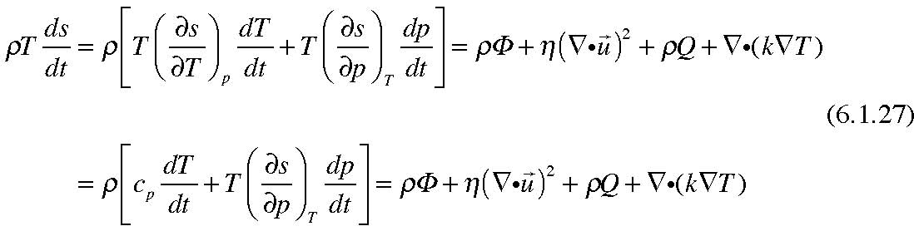
We are almost there. Our goal is to derive a governing equation for a variable like the temperature that we can use with the state equation (6.1.1) to close the formulation of the fluid equations of motion with the same number of equations as variables. We have to take one more intermediate step to identify the partial
derivative
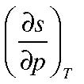 in terms of more familiar concepts. To do this we introduce yet
another thermodynamic state variable
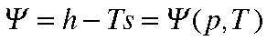
(6.1.28)
Therefore,
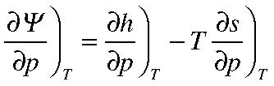
(6.1.29)
but from (6.1.24) and (6.1.25) for arbitrary variations,
(6.1.30)
we have,
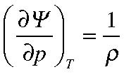
(6.1.30)
In the same way,
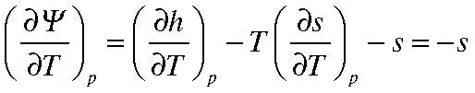
(6.1.31)
Keep in mind in using (6.1.24) that p is being kept constant in the derivatives in
(6.1.31)
Taking the cross derivatives of (6.1.30) and (6.1.31)
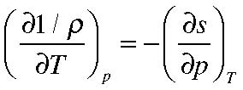
(6.1.32)
It is the term on the right hand side of (6.1.32) that we need for (6.1.27) and it is
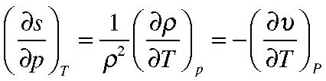
(6.1.33)
where is the specific volume i.e. 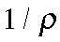 . The increase, at constant pressure of the specific volume is the coefficient of thermal expansion of the material, α is defined
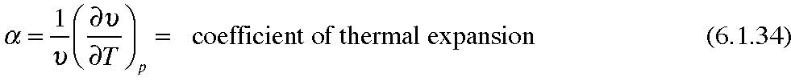
so that,
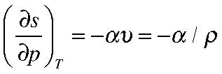
So that finally our governing thermodynamic equation is (6.1.27) rewritten :
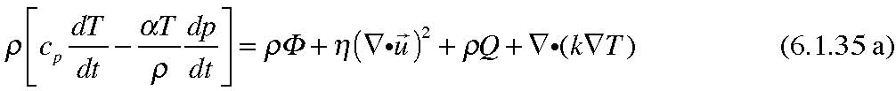
In analogy with the viscosity coefficient µ and the kinematic viscosity ν we divide the thermal diffusion coefficient k( dimensions mL/T3degC) by ρ cp to obtain κ the thermal diffusivity (dimensions L2/T, compare ν).
Our other equations are the state equation (6.1.1)
(6.1.35 b)
and the mass conservation equation, (2.1.11)
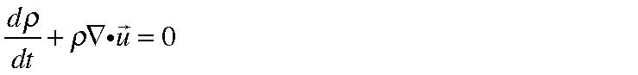 (6.1.35 c) and the momentum equation ( 4.1.13),
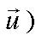
Our unknowns are
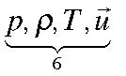 while we have 3 momentum equations, the
thermodynamic equation, the equation of state, and the mass conservation equation,
i.e. 6 equations for 6 unknowns, assuming that we can specify, in terms of these variables the thermodynamic functions
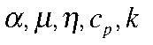 which we suppose is possible. (If we were to think of the coefficients η,κ,µ as turbulent mixing coefficients it is less clear that the system can be closed in terms of the variables p,ρ,T and
At this point we have derived a complete set of governing equations and the formulation of our dynamical system is formally complete. But, and this is a big but, our work is just beginning. Even if we specify the nature of the fluid; air, water, syrup or galactic gas the equations we have derived are capable of describing the motion whether it deals with acoustic waves, spiral arms in hurricanes, weather waves in the atmosphere or the meandering Gulf Stream in the ocean. This very richness in the basic equations is an impediment to solving any one of those examples since for some phenomenon of interest we have included more physics than we need, for example the compressibility of water is not needed to discuss the waves in your bathtub.
If the equations were simpler, especially if they were linear, it might be possible to nevertheless accept this unnecessary richness but both the momentum, thermodynamic and mass conservation equations are nonlinear because of the advective derivative so a frontal attack on the full equations , even with the most powerful modern computers is a hopeless approach. This is both the challenge and the attraction of fluid mechanics. Mathematics must be allied with physical intuition to make progress and in the remainder of the course we will approach this in a variety of ways. Before doing so we will discuss two specializations of the thermodynamics of special interest to us as meteorologists and oceanographers.
6.2 The perfect gas
The state equation (6.1.1) is appropriate for a gas like air for which R is 0.294 joule/gm deg C (1 joule =107 gm cm2/sec2). It follows that,
(6.2.1)
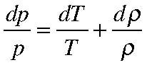
so that for processes which take place at constant pressure,
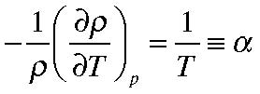
(6.2.2)
Thus, for a perfect gas, (6.1.35) becomes,
or,
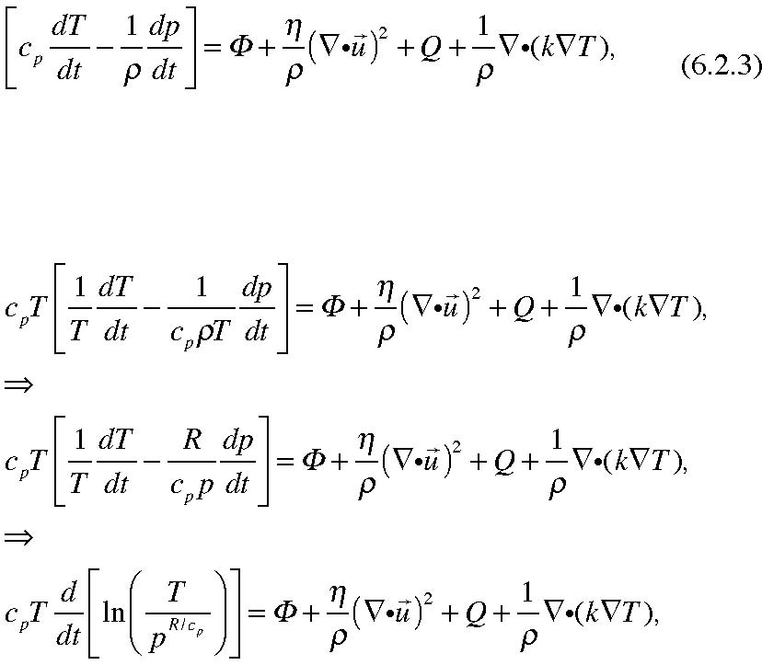
(6.2.4 a, b, c)
We define the potential temperature:
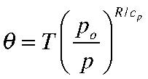
(6.2.5)
where p0 is an arbitrary constant. In atmospheric applications it is usually chosen to be a nominal surface pressure (1000 mb). Thus for a process at constant θ (whose
pertinence we shall shortly see) a decrease in pressure, for example the elevation of the fluid to higher altitude, corresponds to a reduction in T. Our thermodynamic equation can then be written as,
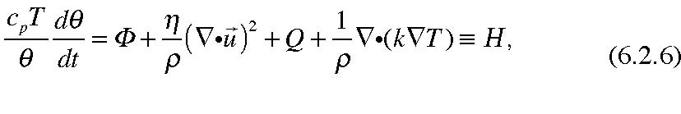
where H is the collection of the non-adiabatic contributions to the increase of entropy. If the motion of the gas is isentropic, i.e. if we can ignore thermal effects that add heat to the fluid element either by frictional dissipation, thermal conduction or internal heat sources, then the potential vorticity is a conserved quantity following the fluid motion since in general,
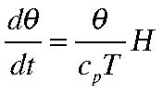
(6.2.7)
We can use (6.2.5) to express the gas law (6.1.1) in terms of the potential temperature. We use the thermodynamic relation
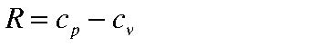 (6.2.8)
which follows from the fact that for a perfect gas the specific heats are constants so that,
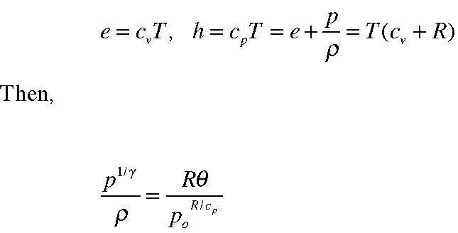
(6.2.9)
(6.2.10)
where
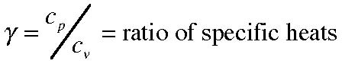
(6.2.11)
Thus for any process for which the potential temperature is constant,
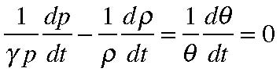
(6.2.12)
This relation is very important for adiabatic processes such as acoustic waves which are pressure signals that oscillate so rapidly that their dynamics is essentially isentropic✦ .
6.3 A liquid.
A liquid, like water is characterized by a large specific heat and a small expansion coefficient. In such a case the pressure term on the left hand side of (6.1.35a) is normally negligible. We can estimate its size with respect to the term involving the rate of change of temperature as, (using δp for the pressure variation
and δT for the temperature variation):
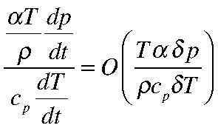
(6.3.1)
For water at room temperature α= 2.1 10-4 1/gr degC, cp is about 4.2 107 cm2/sec2 deg C. For water ρ is very near 1 gr/cm3. To estimate δp we suppose there is a rough balance between the horizontal pressure gradient and the Coriolis
acceleration. That is pretty sensible for large scale flows. That gives a
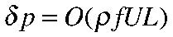 if L is the characteristic horizontal scale suitable for estimating derivatives and if U is a characteristic velocity. If the temperature is about 20O C (nearly 300O on the absolute Kelvin scale), with U =10cm/sec, and L =1,000 km,
and if the overall temperature variation is about 10 degrees C, the ratio in (6.3.1 ) is of the order of 10-5, e.g. very small indeed. Our thermodynamic equation then becomes, upon ignoring the pressure term,
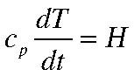
(6.3.2)
For simple liquids like pure water the equation of state can be approximated as✿ ,
(6.3.3)
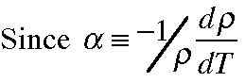
it follows that (6.3.2) can be written,
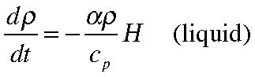
(6.3.4)
However, it is also generally true for a liquid that, as we discussed in Section 2.1
that for variations of the density such that 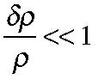 we can approximate the
continuity of mass with the statement that volume must be conserved, i.e. that,
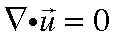 . (6.3.5) It is important to keep in mind that (6.3.5) does not mean that continuity equation
then implies that 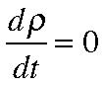 . Rather, that in the comparison of terms in that equation,
the rate of change of density is a negligible contributor to the mass budget. On the
other hand in the energy equation (6.3.4) one can only have
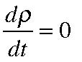 if the non
adiabatic term H is negligible. Thus, being able to demand requires an
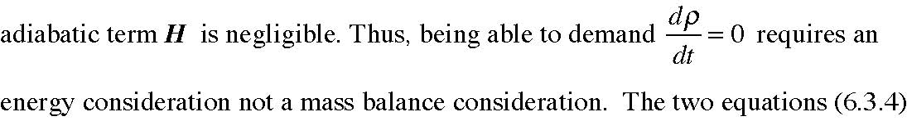
✸
This is on of the few scientific errors made by Newton who believed that acoustic waves wereisothermal rather than isentropic. It makes a big difference in the prediction of the speed of sound.
✿
This ignores the effect of pressure on the density which is not accurate for many oceanic applications for which there are large excursions vertically.
Chapter 6 16 and (6.3.5) are completely consistent. Indeed, it is an interesting calculation to estimate for the Ekman layer solution we have found, for example, what temperature rise we would anticipate in a fluid like water due to the frictional dissipation occurring within the Ekman layer. That estimate is left as an exercise for the student.

