Chapter 5
Frictional boundary layers
5.1 The Ekman layer problem over a solid surface
In this chapter we will take up the important question of the role of friction, especially in the case when the friction is relatively small (and we will have to find an objective measure of what we mean by small). As we noted in the last chapter, the no-slip boundary condition has to be satisfied no matter how small friction is but ignoring friction lowers the spatial order of the Navier Stokes equations and makes the satisfaction of the boundary condition impossible. What is the resolution of this fundamental perplexity?
At the same time, the examination of this basic fluid mechanical question allows us to investigate a physical phenomenon of great importance to both meteorology and oceanography, the frictional boundary layer in a rotating fluid, called the Ekman Layer. The historical background of this development is very interesting, partly because of the fascinating people involved. Ekman (1874-1954) was a student of the great Norwegian meteorologist, Vilhelm Bjerknes, (himself the father of Jacques Bjerknes who did so much to understand the nature of the Southern Oscillation). Vilhelm Bjerknes, who was the first to seriously attempt to formulate meteorology as a problem in fluid mechanics, was a student of his own father Christian Bjerknes, the physicist who in turn worked with Hertz who was the first to demonstrate the correctness of Maxwell’s formulation of electrodynamics. So, we are part of a joined sequence of scientists going back to the great days of classical physics.
Another intriguing figure in the story is the great Norwegian explorer/scientist Fridtjof Nansen. Trained as a botanist, a heroic arctic explorer, Nansen was a larger than life figure who played a leading role in Norway’s independence movement (from Sweden) and later, working under the auspices of the League of Nations was involved in many of the early 20th centuries most difficult human dramas. His biography is well worth reading. His relation to our study is more homely. He came to see V. Bjerknes to describe to him some unusual observations of ice-drift on one of Nansen’s expeditions on the Norwegian vessel , the Fram. Nansen noted that the ice drifted at an angle to the wind rather than directly downwind. He realized that it must be the earth’s rotation that was the cause and he asked Bjerknes if one of his students could look into the problem. Ekman was chosen, solved the problem for his doctoral thesis ( and indeed his solution was more general and elaborate that the one presented here and usually associated with his name.) This work was done in 1902, more than 100 years ago and is one of the very first boundary layer problems worked out in fluid mechanics and is essentially contemporary with the work of Prandtl who confronted a similar issue for nonrotating fluids.
Now, although we have not completed our formulation of the equations of fluid mechanics in the general case, we do have a complete set of equations for the case where the density can be considered a constant. This will give us a pretty good picture of the phenomenon of interest and we will return to the problem of the general formulation afterwards and be able to check how sensible our assumption of constant density is.
The problem to be discussed is the shown in Figure 5.1.1
zU
g
Ω
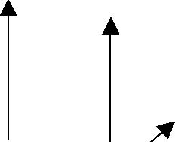y
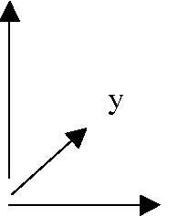 x
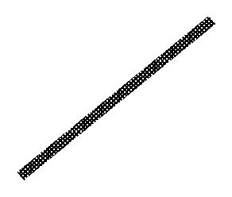
Figure 5.1.1 The fluid flows in the x direction with speed U far from a solid wall at z=0.
2
Far from a solid, horizontal plane which we idealize as having infinite extent, a uniform flow in the x direction has the magnitude U. What can we say about the structure of the resulting flow? We will use a Cartesian coordinate frame and use the notation (x,y,z) for (x1,x2, x3) and the associated components of velocity will be (u, v, w).
Since the density is constant the continuity equation is simply
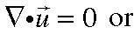
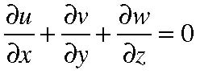
(5.1.1)
while the momentum equation for this incompressible fluid,
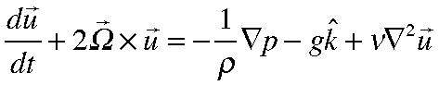
(5.1.2)
where k is a unit vector in the vertical direction, along the z axis and parallel to the rotation axis. The sum of the gravitational and centrifugal accelerations is written as g , the effective acceleration due to gravity and yields a force anti-parallel to the rotation. Recall that ν is the kinematic viscosity, µ/ρ. The three components of (5.1.2) are
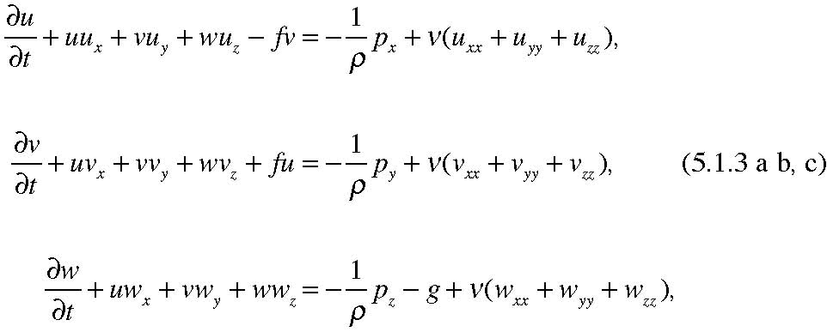
Here I have used the notation that subscripts denote partial differentiation and is the Coriolis parameter.
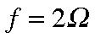
Let’s look for steady solutions so that the local time derivative is zero. Furthermore, since the velocity at infinity is independent of x and y, let’s look for solutions that are independent of x and y. That would imply, from (5.1.1) that 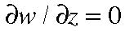 . But since w must vanish on the lower solid surface, w must be zero everywhere. So, with u and v independent of x and y and with w zero, (5.1.3) reduces to:
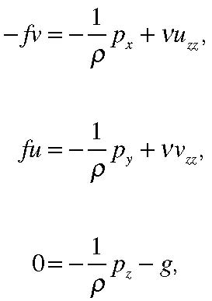
(5.1.4 a, b, c)
Note that these equations are linear, a very great simplification. Now we have to see whether we can find solutions satisfying the boundary conditions. One solution to the equations is a rather simple one,
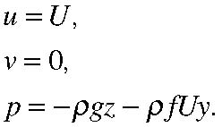
(5.1.5 a, b, c)
You can check that this satisfies the equations exactly. The flow is, everywhere, the constant velocity in the x direction, as at large z and the pressure field balances the hydrostatic force in the vertical and the Coriolis acceleration in the horizontal.
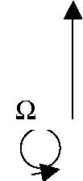
y
low pressure
U
x
high pressure
Figure 5.1.2 The balance between the pressure gradient and the Coriolis acceleration in the solution ((5.1.5).
The principal and inescapable problem with this solution is that it does not satisfy the no-slip boundary condition at z=0 where both u and v should be zero. The solution (5.1.5)
satisfies the equation, even with the viscous term, but the solution is wrong because it does not satisfy the boundary condition and it is wrong no matter how small µ might be. So, what is the relation between (5.1.5) , that we would naively imagine to be a good solution for small viscosity, and the correct solution that satisfies the boundary condition? Let us return to (5.1.4 a, b, c) and find solutions for the velocity components u and v that are functions of z. Note that the presence of rotation then implies that although the flow is in the x direction far from the wall, the frictional term in (5.1.4a) will force a flow in the y direction under the influence of rotation.
An x or y derivative of (5.1.4 c) shows immediately that
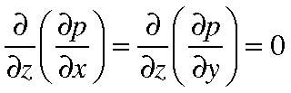
(5.1.6)
so that the horizontal pressure gradients are independent of z. As z• the horizontal pressure gradient balances the Coriolis acceleration of the uniform flow U, so,
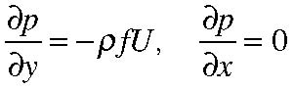
(5.1.7 a, b)
at infinity, and by (5.1.6) this is true everywhere in the flow, even down to the lower surface. Thus, (5.1.4 a, b) are just
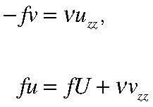
(5.1.8 a,b)
So that finally, we have two simple, ordinary differential equations for the velocity components u and v. If we eliminate u between the two equations by taking 2 z derivatives of the second equation, we obtain,
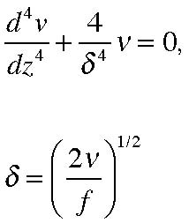
(5.1.9 a,b)
The quantity δ is the Ekman layer thickness and it depends on the kinematic viscosity and the rotation. For very small viscosity, or rapid rotation, the thickness becomes smaller and smaller.
The four independent solutions o f(5.1.9 a, b ) are:
while from (5.1.8b)
Our boundary condition as z→∞ is that (u,v)→(U,0). To satisfy this we clearly have to . At z =0, both u and v are zero. This determines the remaining constants,
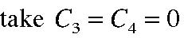
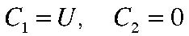
so that our final solution is,
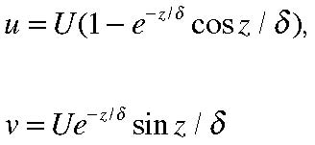
(5.1.11 a,b)
When z >>
u approaches U exponentially rapidly and v goes to zero. That is, outside a region of O( ) the solution approaches (5.1.5 a, b, c) which is the solution we would obtain completely ignoring friction. The effect of friction is limited to a region of O( ) near the solid boundary; this is the Ekman boundary layer. No matter how small the friction is, it is always important within this region. Indeed, the resolution of the perplexity of how a fluid with small friction still satisfies the no-slip condition is clear from the solution. As the friction gets smaller, the derivatives in z become larger at just the rate necessary to keep the second derivative terms in (5.1.4 a, b) of the same order as the Coriolis terms. In the limit of ν→0 there are two ways of examining the limiting form
of the solution. In one form we fix any value of z >0 and for sufficiently small νor equivalently, sufficiently small , we will be outside the boundary layer and in the region governed by the non viscous balances (in our case the balance between the Coriolis acceleration and the pressure gradient). However, there is another form of the limit in which we fix a value of z/ , i.e. we stay within the Ekman layer and as the friction gets smaller we are still within a region in which friction is an important term in the dynamical equations. So as the friction gets smaller the region in which friction is important gets smaller but there is always a region near the boundary in which the friction remains important to allow the flow to adjust to the no –slip condition at the boundary. Figure 5.1.3 shows the profiles of u and v as a function of z/δ. We see that the departure of the velocity from the value U in which the Coriolis acceleration balances the pressure gradient occurs only in a region of O(δ). As the viscosity decreases this scale decreases. For large z/δ the flow is along lines of constant pressure but as z decreases there is a flow, largely in the positive y direction in this case, so that near the wall there is flow down the pressure gradient, i.e. from high to low pressure. Since the pressure gradient is independent of z (5.1.7) as the velocity is reduced near the wall to satisfy the no slip condition, the Coriolis acceleration is no longer able to balance the pressure gradient and fluid begins to flow down the pressure gradient restrained increasingly by the friction as in a non rotating fluid. Figure 5.1.4 shows the direction of the velocity. This elegant figure is called the Ekman spiral and shows the turning of the velocity vector with height, as indicated on the plot. For very large heights the velocity, of course, is parallel to the x axis, i.e. perpendicular to the pressure gradient, while as z• 0 the velocity swings in the direction along the pressure force, down the pressure gradient until at z =0 the velocity makes a 450 angle with the direction of the flow at large z.
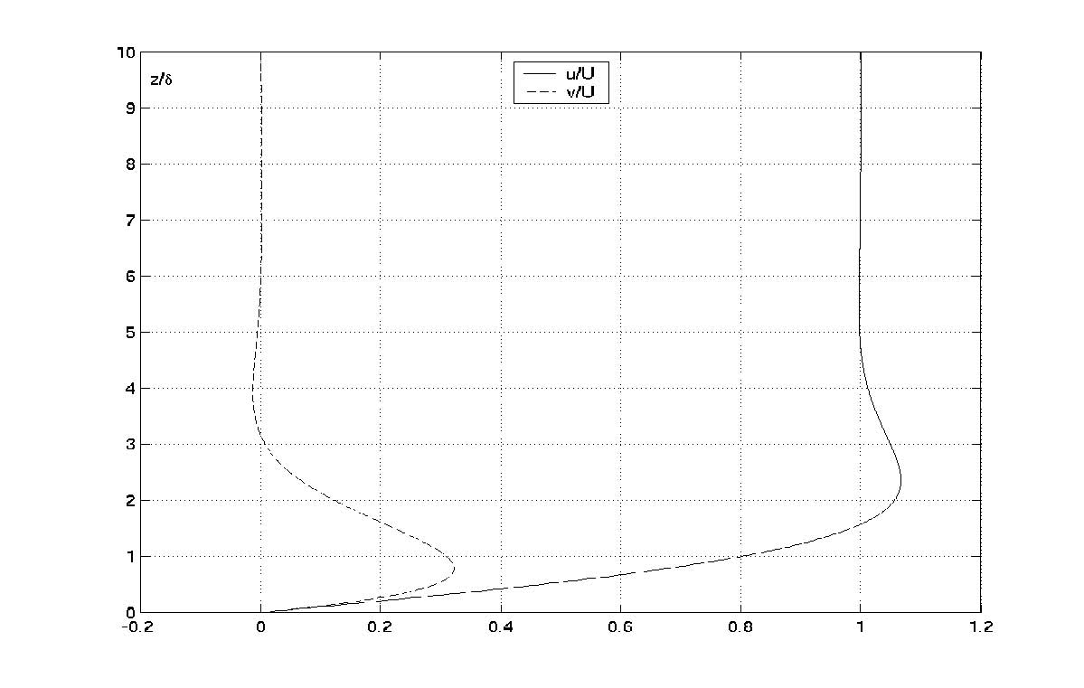
Figure 5.1.3 The profiles of u/U and v/U as a function of z/δ.
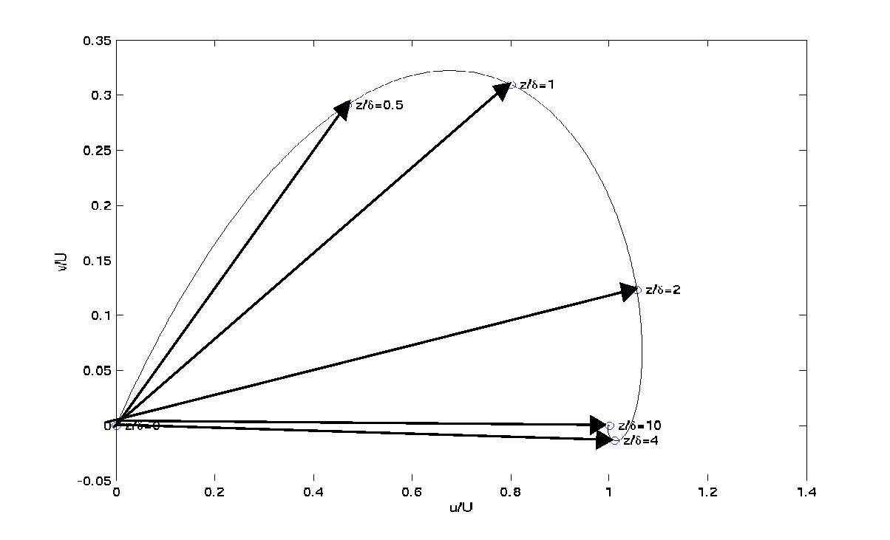
Figure 5.1.4 The hodograph of the Ekman solution in which v(z/δ) is plotted against u(z/δ).
From (5.1.11) the limits as z/δ goes to zero are
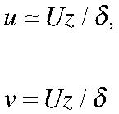
(5.1.12 a, b)
and notice that this angle is independent of the magnitude of the kinematic viscosity, ν. The total flow across the isobars is given by
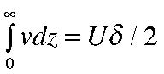
(5.1.13)
and is to the left of the geostrophic flow. (You should check the direction for the southern hemisphere where f is negative.
We can use this result to calculate frictional loss of energy since in the steady state problem we are discussing that loss is balanced by the work the pressure field does on the fluid to compensate for the frictional loss. The rate of work done (per unit horizontal area) is just the force (per unit area) times the velocity in the direction of the force, i.e.
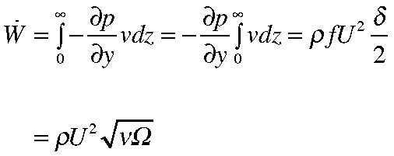
(5.1.14)
per unit horizontal area.
Now suppose we have a large cylindrical container filled with fluid whose circulatory velocity is of the order U. If the container has a depth D the kinetic energy per unit horizontal area would be,
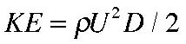
(5.1.15)
If that energy is not constantly replenished at a rate
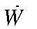 it will decay due to friction in a
time of the order t E
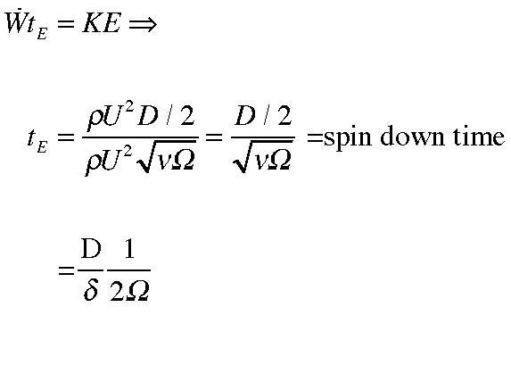
(5.1.16a, b, c)
If the Ekman layer thickness is a small fraction of the total depth of the fluid this decay time, the spin down time, is large compared to the rotation period of the system. When this is the case, we have a good measure,
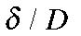 of how small friction is. If this parameter is small, friction is small , the decay time due to friction is long compared to a rotation rate. The measure that is more commonly used is the square of this ratio,
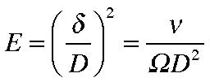
(5.1.17)
called the Ekman number and is one of the most important measures of friction in a rotating fluid. Let’s calculate the frictional stress on the lower boundary. The frictional stress on the boundary whose normal is n is,
(5.1.18) while the stress in the x (1) direction is,
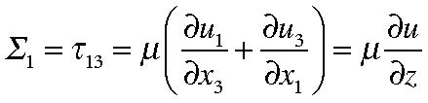
(5.1.19a)
since the component u3= w =0. Doing the same calculation for the y (2) direction,
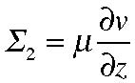
(5.1.19b) To calculate the stresses at the wall, i.e. at z =0, we can use (5.1.12) to obtain,
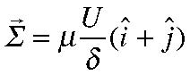
(5.1.20)
where i and j are unit vectors in the x and y directions respectively. The exerted on the fluid by its interaction with the wall, (here denoted by τ ) is just (5.1.20) in with a change of sign,
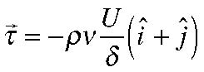
(5.1.21)
It is very illuminating to consider the total mass flux in the Ekman layer due to friction, that is, using (5.1.11),
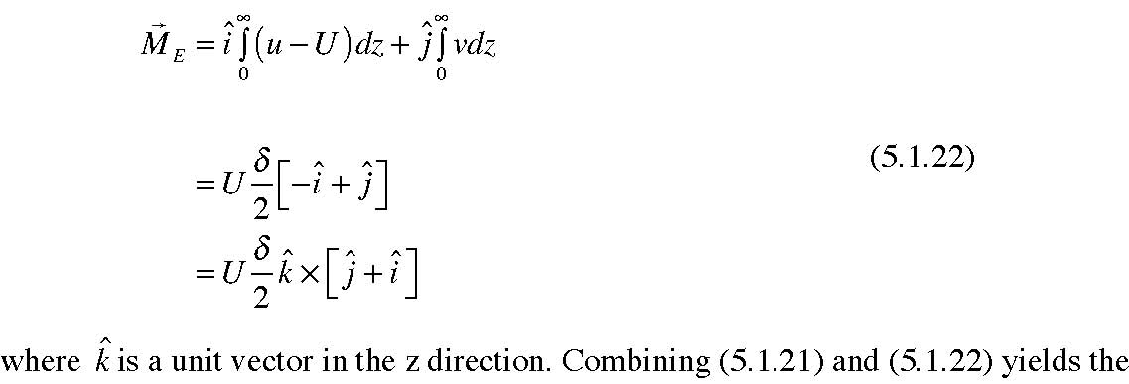
(5.1.22)
important result,
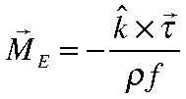
(5.1.23)
When f is positive, as it is in the northern hemisphere, for example, (5.1.23) states that the frictionally driven mass flux is to the right of the applied stress, see Figure 5.1.5 and is independent of the magnitude of the friction, i.e. it depends only on the overall stress on the fluid and not on the details of the distribution in z of the stress in the fluid. This follows directly from (5.1.8) which in vector form is,
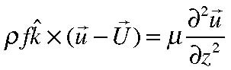
(5.1.24)
whose integration over z yields
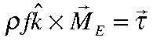
(5.1.25)
from which (5.1.23) follows directly. The only external, applied force on the fluid is the boundary stress τ and so the total Coriolis acceleration, integrated over depth (except for
the part balanced by the pressure gradient and which is subtracted out in (5.1.24)) is precisely proportional to the frictionally driven mass flux. This is why the total flux is independent of the particular value of ν.
τ
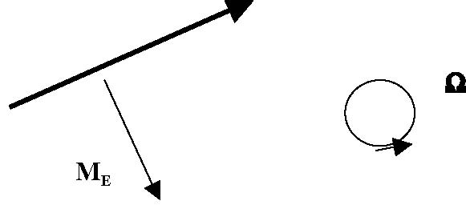
Figure 5.1.5. The relation between the applied stress on the fluid and the resulting Ekman mass flux (plan view).
We can take advantage of our exact solution of the Navier Stokes equation and apply it in situations where we would expect it to be a very good approximation.
For example, consider the flow over a lower solid boundary, as we have done, but allow the fluid far from the boundary to be a function of x and y, but on length scales in those directions that are much, much larger than the vertical scale of the Ekman layer. Thus at each x, y location the adjustment of the flow to the boundary will take place according to (5.1.11) but where now U is a function of x and y and its direction in the x,y plane also changes from location to location. We can still use the solution see the z derivatives in (5.1.3) will still be so much greater than the x and y derivatives so that
locally the balance (5.1.4) holds. It is useful to write the balance in the vector form
(5.1.24) whose solution, also in vector form is
The first term in (5.1.26) is the flow in the direction of the flow at infinity; this is along the lines of constant pressure (isobars). The second term in (5.1.26) is perpendicular to the isobars and down the pressure gradient. Consider a curved flow as shown in the figure,
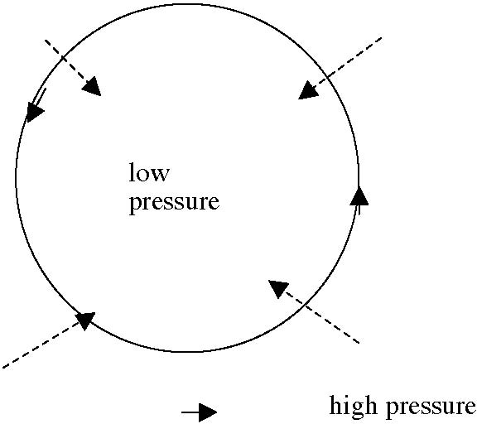
y
Figure 5.1.6 A circular cyclonic flow ( counter clockwise) showing the direction (dashed arrows) of the cross isobar flow. In the figure the isobars are coincident with the direction of the circular flow far from the solid surface.
The similar vector generalization of (5.1.13) yields for the cross isobar transport,
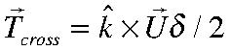
(5.1.27)
A vertical integral of the continuity equation between the lower surface and a position outside the boundary layer yields,
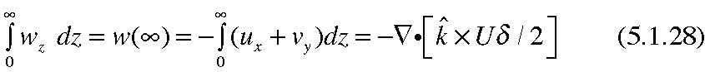
where the divergence in (5.1.28) is understood to be the 2-d horizontal divergence. This leads to the important result,
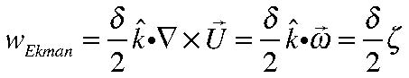
(5.1.29)
where ω is the vorticity of the flow above the boundary layer and wEkman is the vertical velocity sucked out of the Ekman layer by the overlying cyclonic, low pressure circulation, In (5.1.29) we have used ζ to denote the vertical component of the vorticity. The cross isobar flow driven down the pressure gradient flows towards the center of the cyclonic circulation in Figure 5.1.6 and has nowhere to go but up to conserve mass leading to (5.1.29). Thus, when a low pressure center passes over us we expect rising motion associated with the Low and the rising motion will generally lead to cloudy conditions as the moisture in the air condenses at higher altitudes where the air is colder. If ζ is negative, i.e. anticyclonic motion, the reverse occurs, the air motion subsides, drying the air out and usually fine weather is associated with the high pressure center.
5.2 Nansen’s problem
Let’s now look at the problem that Nansen brought to Bjerknes and that Ekman solved. We have an applied stress, generated by the wind, on the sea surface and we want to find the motion driven by the stress. Actually, we could use the results directly of the last section but for clarity we will reformulate the problem and it will be left to you to be explicit about the connection between the two solutions. The situation is shown in Figure 5.2.1
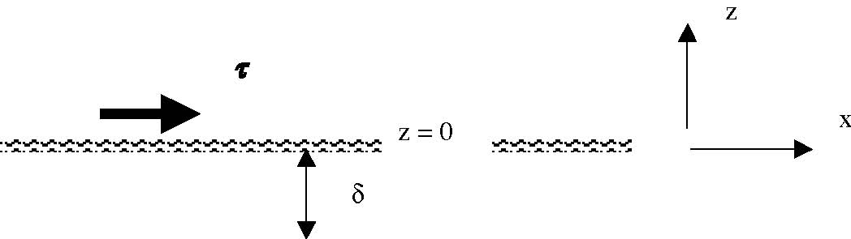
Figure 5.2.1 An applied stress, τ , acts on the surface of the water which occupies the infinite region z < 0. The direct action of friction is limited to a depth of O(δ).
The solution is the same as (5.1.10) except that for large negative z the velocities must go to zero. (There is no pressure gradient for large negative z although it could be added on later). Thus,
and
To satisfy finiteness of the velocity for large negative z (really large negative z/δ) we must take 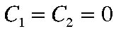 . At the sea surface, i.e. at z =0 the stress must be continuous or,
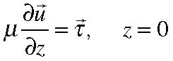
(5.2.2)
or when applied to each component, yields,
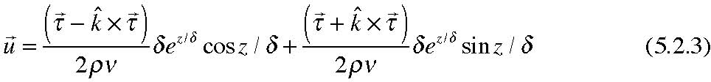
Note that at the sea surface, z=0, the velocity is,
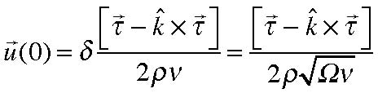
(5.2.4)
Note that the surface velocity is oriented 45O to the right (northern hemisphere) of the direction of the stress as shown in Figure 5.2.2
τ
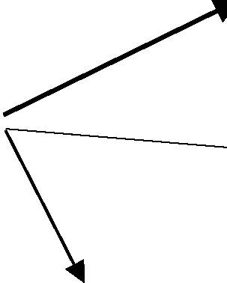u(o)
MEkman
Figure 5.2.2 The relationship between the surface stress, the resulting surface velocity and the total mass flux in the Ekman layer.
The vertical integral of the velocity in the Ekman layer now yields, for the stress driven transport,
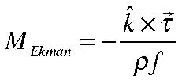
(5.2.5)
precisely as (5.1.23) predicts. There are a set of important oceanographic consequences that spring from (5.2.5).
First of all, note that (5.2.4) predicts that the surface velocity will be to the right of the wind (in the northern hemisphere) as Nansen had observed from ice motion in the Arctic. The model we have used here predicts a 450 angle but although the angle is independent of the size of µ it depends on µ being a constant. If we were to replace the microscopic viscosity with a turbulent viscosity that might vary in the z direction the angle made by the surface velocity would differ, usually becoming smaller. That it turns to the right is clearly a result of the Coriolis term, thought of as a force it produces a diversion of the flow to the right. Then each lamina of fluid stresses the fluid beneath and each such stratum moves a little bit further to the right resulting in the Ekman spiral of Figure 5.2. 3a.
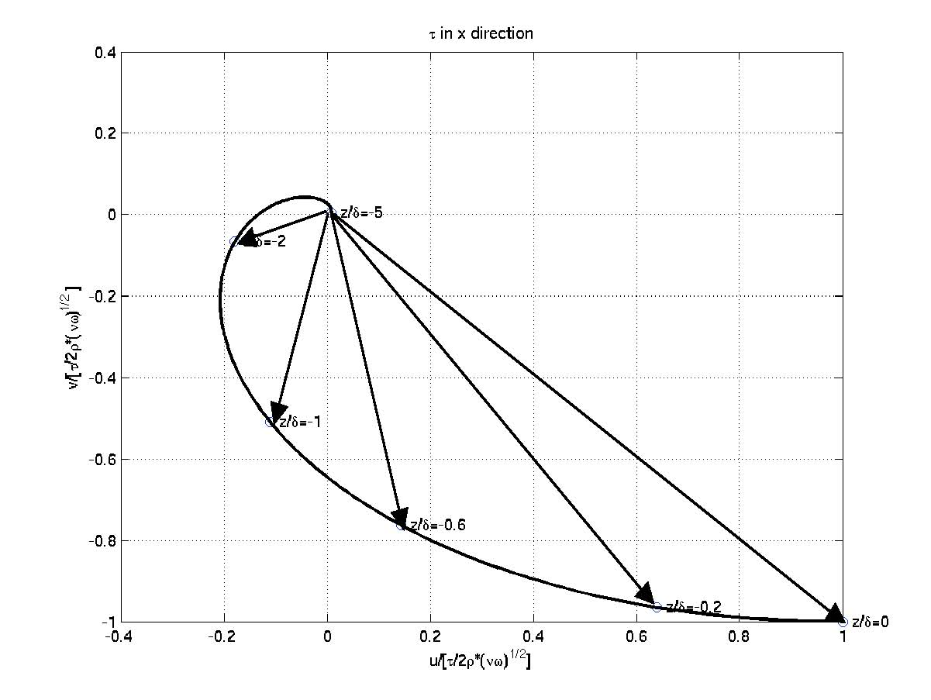
Figure 5.2.3 a The Ekman spiral below a stress in the x direction.
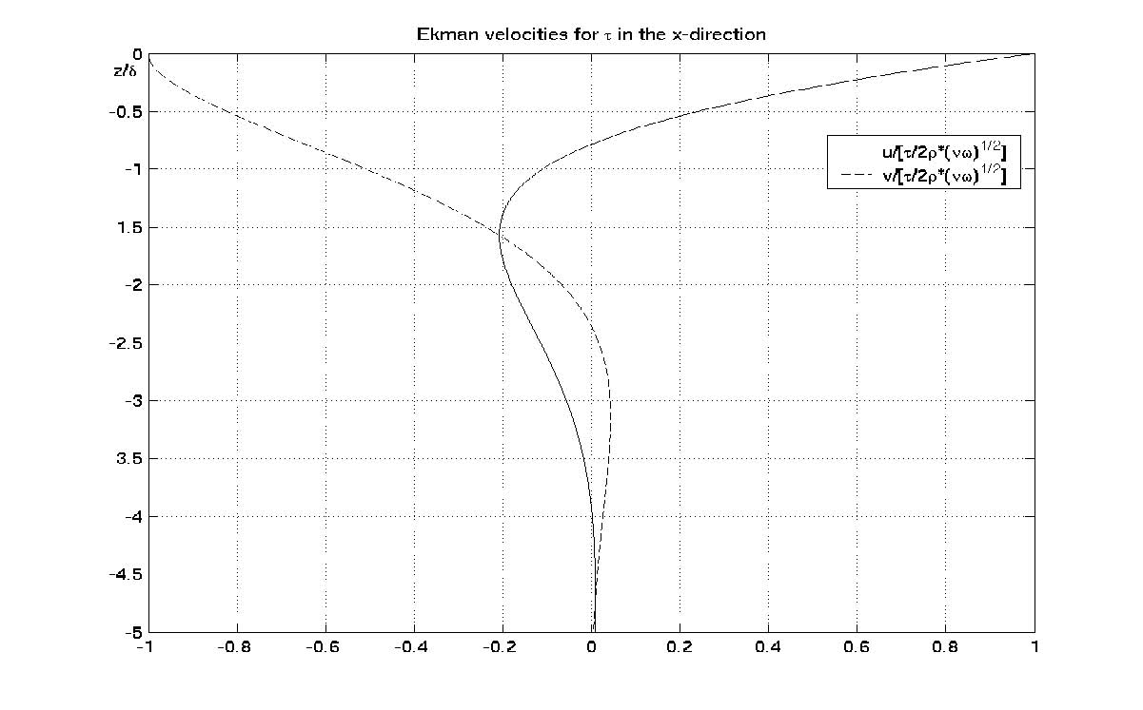
Figure 5.2.3b The profiles of the u (solid) and v (dashed) components of velocity produced by a stress in the x direction.
The more robust result that does not depend on the details of the size or structure of the coefficient of viscosity is the total mass flux in the stress-driven Ekman layer. It is always (in the northern hemisphere) perpendicular and to the right of the stress and has
the magnitude . One of the important consequences of this relation is the
phenomenon of coastal upwelling. When the wind blows parallel to the coast in a direction such that the fluid mass flux in the upper Ekman layer is blown off shore, the water that replenishes that mass is brought up from below the surface. See Figure 5.2.4. This upwelled water is normally cold and contains nutrients from great depth and is the reason that major fisheries are found along the coasts that have such upwelling favorable winds. For example, in the summers the strengthening of the Aleutian High Pressure system produces winds along the Oregon coast that blow to the south. The resulting wind stress drives the surface waters westward and cold water upwells along coast and is the region of rich salmon fisheries. It also, paradoxically makes the water along the coast colder in summer than in winter as anyone who has tried to swim from the lovely Oregon beaches in the summer will attest to.
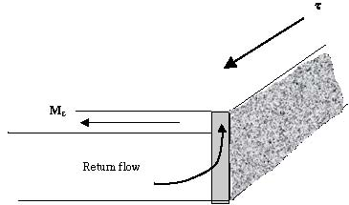
Figure 5.2.4 A schematic of an upwelling flow driven by a southward stress on the west coast of a continent.
For the open ocean the consequences are equally important. In the region of the subtropical gyres, i.e. between the equator and about 400 north and south, the wind system is as shown in Figure 5.2.5; winds from the west (westerlies) to the north, winds
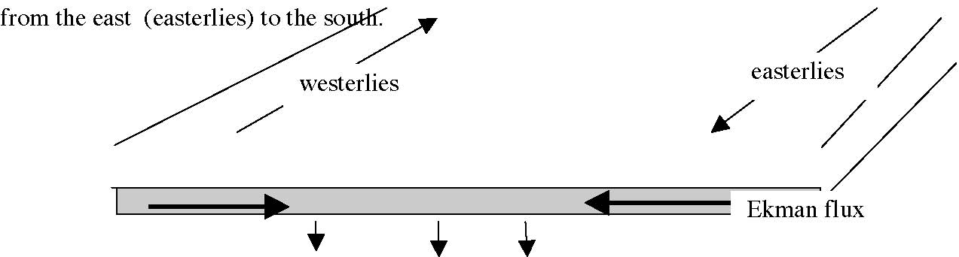
wE
Figure 5.2.5 The wind system in the region of the subtropical gyre produces a convergence of the Ekman flux and a downward vertical velocity wE that is responsible for driving the major oceanic gyres.
The convergence of he Ekman flux, (5.2.5) produces an Ekman vertical velocity at the base of the Ekman layer,
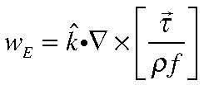
(5.2.6)
whose derivation is left to the student. Note that this vertical motion is independent of the viscosity coefficient. You will see next semester that this weak vertical velocity, typically of the order of (10-4 cm/sec) , is capable of generating the subtropical gyres and their intense boundary currents like the Gulf Stream whose speed is of the order of 100 cm/sec.
5.3 The impulsively started plate, boundary layer for a nonrotating fluid.
It is illuminating to contrast the role of friction in a nonrotating fluid with the results of previous two sections. Let’s consider essentially the same problem as shown in Figure
5.1.1 but now in the absence of rotation. The new problem is shown in Figure 5.3.1
y
U
Figure 5.3.1 A uniform flow in the x direction at t=0 must satisfy the no slip condition at y=0.
We now have a non rotating fluid, hence no Coriolis acceleration in the momentum equations. We start with a uniform flow parallel to a wall at y=0. Solutions can be found that are independent of x and z ( the coordinate out of the paper) but now we will not be able to find a solution that is independent of time. If we look for a solution such that
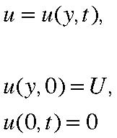
(5.3.1 a, b, c)
the continuity equation is again satisfied, all the nonlinear advective terms in the momentum equation vanish and the only non trivial remaining equation comes from the momentum equation in the x direction.
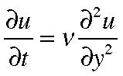
(5.3.2)
which is just the classical diffusion equation for u. Note that we have not included a pressure gradient in the x direction. Again, as (5.1.6) the pressure gradient must be a constant and we are assuming there is no gradient (and now none is needed) far from the wall and so the gradient is zero everywhere. The equation and the boundary conditions are invariant to the rescaling transformation
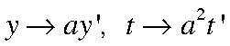
(5.3.3 a,b)
The invariance exists because the boundary conditions possess no geometrical scale against which distance in the problem can be measured. In that case (and that case alone) we are guaranteed that the solution of the partial differential equation (5.3.2) in two variables, has to be expressed as a function of the single variable,
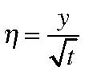
(5.3.4)
which is the similarity variable appropriate to the invariance (5.3.3 a,b). Using the relations,
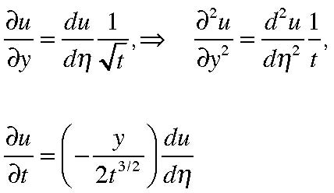
(5.3.5)
we obtain the ordinary differential equation
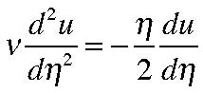
(5.3.6)
It is important to check at this point that the equation only contains coefficients that are functions of
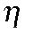 and not y and t separately. It is easy to integrate (5.3.6) to obtain,
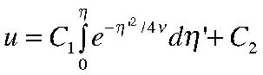
(5.3.7)
We now apply the boundary conditions and here, too, it is essential that they can be expressed in terms only of the similarity variable
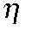 and not of y and t separately. The condition that u vanish on y =0 means that C2 =0. For y • ∞ u must equal U. Let
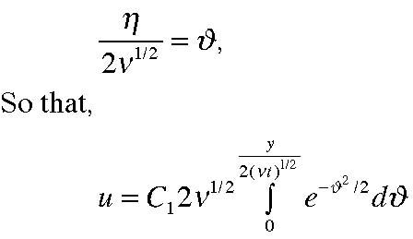
(5.3.8)
It follows that at infinity in y,
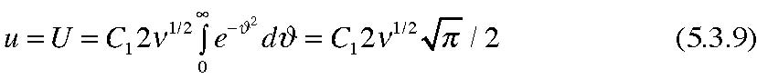
so that with the constant C1 now determined,
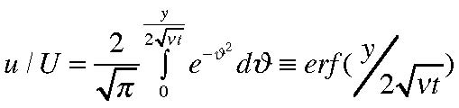
(5.3.10)
where erf(x) is the well-known error function defined by the integral in (5.3.1). The
solution for all time and for all y is given in terms of a single variable, 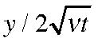 . For
large values of this variable the solution for u approaches U. Note this occurs either for large y or for small t. The profile of u versus y is the same for all t; it is only stretched by the factor
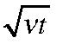 as time goes on. It is in this sense that the solution is self-similar. The profile of u/U is shown in Figure 5.3.2.
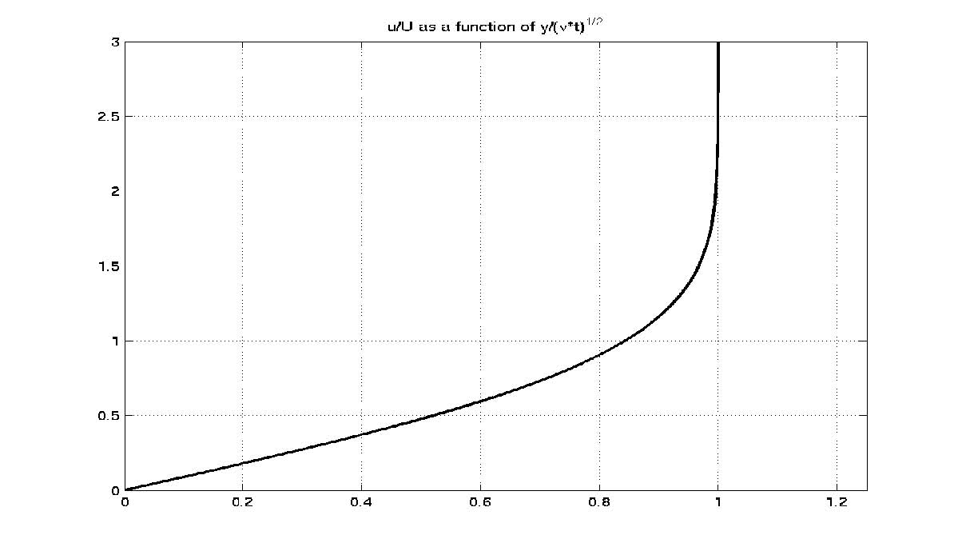
Figure 5.3.2 The solution u as a function of
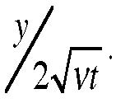
It is clear from the figure that the region of the flow affected by the no slip condition
applied at y=0 is something of the order of
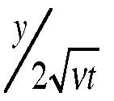 =2. For values of y less than this the
velocity is impeded by the friction and for very small values goes to zero. It follows directly therefore, that the region affected by friction grows in time at a rate such that
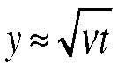
(5.3.11)
i.e. it increases parabolically with time. This is the usual behavior of a diffusion process.
The difference with the rotating case is very striking. In that case the region of frictional influence was limited to a scale
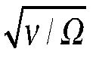 and did not change with time. We will have to examine later, when we have discussed vorticity dynamics more thoroughly the fundamental reason for this difference. But, notice the scaling similarity , instead of the running time variable t in (5.3.11) we substitute Ω-1 for the time.
We can calculate the frictional stress on the wall exerted on it by the fluid,
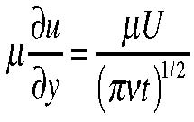
(5.3.12)
which is steadily decreasing with time as the shear in the velocity decreases. The vorticity in the fluid induced by the no slip condition has only a component in the z direction and is
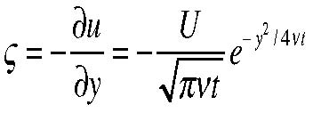
(5.3.13)
and this is not in complete similarity form. Figure 5.3.3 shows the vorticity at two times
such that 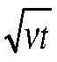 =0.5, and 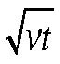 =4.
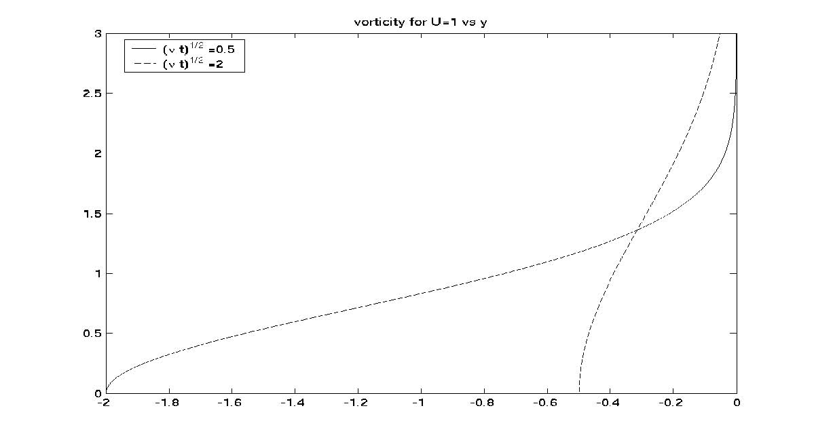
Figure 5.3. 3 The vorticity at two times as a function of y.
Note that the vorticity at any location diminishes with time but that the total vorticity in the flow
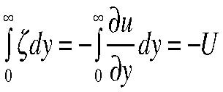
(5.3.14)
is fixed so that the friction diffuses the vorticity but does not reduce the total just like the diffusion of any passive substance.
Suppose now we have a fluid in a container of radius R and it is spinning with a certain angular speed ω. If the container is a long cylinder of length D whose bottom and top has an area πR2, and the area of the side wall is 2πRD. If D>>R we would imagine that the frictional interaction with the side wall would be dominant. How long would it take the fluid to come to rest? We can estimate that using the diffusion law and make the guess that the fluid motion would go to zero when
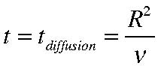
(5.3.15)
This is the characteristic diffusion time for a tracer (here momentum) to diffuse a distance
R. For water ν is O((10-2) cm2/sec at room temperature . For a coffee cup of radius of 4 cm, (about 1 1/2 inches) that yields a diffusion time of 1600 i.e. nearly half an hour. As you realize immediately the coffee swirling in your coffee cup comes to rest much more rapidly. Well, we have neglected the interaction with the bottom boundary layer in the cup. Although the cup as a whole is not rotating we could try to use the Ekman spin down time to estimate the adjustment time using the swirl angular velocity of the coffee for Ω. That spin down time is given by (5.1.16). The ratio
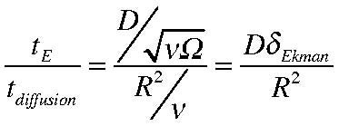
(5.3.16)
so that generally the Ekman spin down time will be much smaller than the diffusion time unless the container is so long and its aspect ratio D/R is so large that,
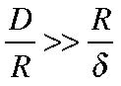
(5.3.17)
which is very unlikely. I will leave it to you to estimate the spin down time if Ω is about 6 sec-1 (corresponding to a rotation period of 1 second) and compare the result to the already calculated diffusion time if D is about 10 cm.
5.4 The Prandtl boundary layer
In the nineteenth century the application of fluid mechanics to practical problems, especially those involving the interaction of fluids and solid bodies, was frustrated by its inability to include the effects of friction for flows in which frictional effects are small almost everywhere but where, near the boundary of the solid the no slip condition imposes the need to include friction. Calculations of flows around solid bodies (like wings) were completely inaccurate, leading to absurd results like the so-called D’Alembert’s Paradox in which the object immersed in a stream of fluid lacked any drag. At about the same time (circa 1905) that Ekman was dealing with the problem of the frictional boundary layer in a rotating fluid, Ludwig Prandtl (1875-1953) introduced the idea of the frictional boundary layer in the field of nonrotating fluids. In this case, if we refer to (5.1.3), the absence of the Coriolis acceleration means that the frictional forces generated at the solid boundary must be balanced by the total derivative of the momentum. In Section 5.3 we saw that if the total derivative became the local derivative the resulting diffusion process would allow the effect of the boundary to eventually diffuse arbitrarily far into the fluid and no steady state is possible. On the other hand, if the situation is such that as the viscous effects are diffused into the fluid they are simultaneously advected downstream it is possible to achieve a balance between the steady, advective derivative and the frictional term. This leads to a complex nonlinear problem, much more challenging than the linear Ekman layer problem. We shall not discuss the problem in detail; you could consult Kundu’s book which has a good elementary discussion, or the more complete discussion in Batchelor’s book. In this section we will use a heuristic argument to predict the width of the viscous , steady boundary layer.
Consider the flow over a plate of finite length. Suppose as in Figure 5.4.1 the oncoming flow has the constant speed U.
y
U
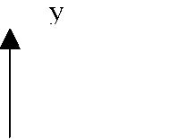26
Chapter 5
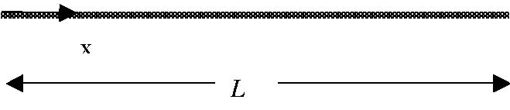
Figure 5.4.1 A uniform flow approaches a solid plate of length L.
We reason as follows: As the fluid in the approaching flow encounters the plate, the fluid right at the plate is arrested by the no slip condition. As the fluid proceeds down the plate that effect will diffuse into the fluid as the fluid continues to encounter the solid surface. We can therefore expect the region, δ, affected by viscous effects to grow like
(5.4.1)
where now t is the time the fluid has spent traveling along the plate. Roughly speaking we anticipate that this time will be of the O(x/U). This would lead to boundary layer thickness
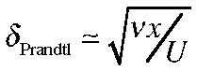
(5.4.2)
so that the boundary layer grows parabolically downstream as shown in the following schematic.
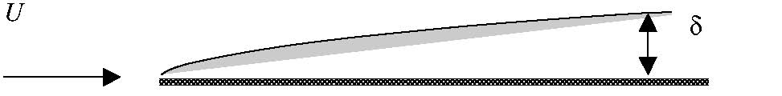
Figure 5.4.2 The area affected by friction over the flat plate.
This scale also can be deduced by a more systematic examination of the balance of terms in the steady nonlinear momentum equation in the x direction, i.e.
(5.4.3)
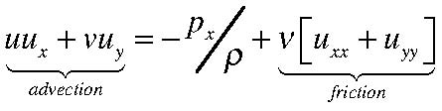
The order of magnitude of the term labeled “advection” is:
(5.4.4a)
where L is a characteristic down stream distance. In the frictional term, the largest
contributor, assuming the boundary layer scale is small compared to the body length,
will be the second derivative in the direction perpendicular to the plate so that
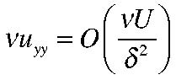
(5.4.5)
equating the two to ensure a momentum balance in the boundary layer yields the estimate
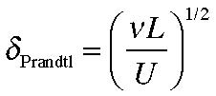
(5.4.6)
which is the same as (5.4.2) if we use L as a characteristic size for x. The ratio of the boundary layer width to the characteristic dimension of the plate is:
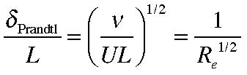
(5.4.7)
where Re is the Reynolds number
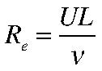
(5.4.8)
which is the natural measure of the ratio of inertia to viscous forces for a nonrotating fluid. When the Reynolds number is large (as it is for the atmosphere and ocean) viscous forces are small compared to inertial forces almost everywhere. For a nonrotating fluid the Reynolds number (named after the experimentalist Osborne Reynolds 1842-1912) plays a role similar to that of the Ekman number (5.1.17) for a rotating fluid.

