Chapter 2
The Continuum Equations
2.1 The conservation of mass
In solid mechanics and thermodynamics we keep track of a well defined fluid mass and this mass is usually trivially specified, as in the case of the planetary motion of the moon, for example. When we are dealing with a continuum it is not so easy to specify the mass of individual elements for which we want to write dynamical balances. So, first we have to see how to deal with the statement of mass conservation that would be implicit in describing the motion of a single solid body.
Consider a fixed, closed imaginary surface, A, drawn in our imagination in the fluid. It encloses a fixed volume, V, whose outward normal at each point on the surface is
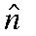 as shown in Figure 2.1.1
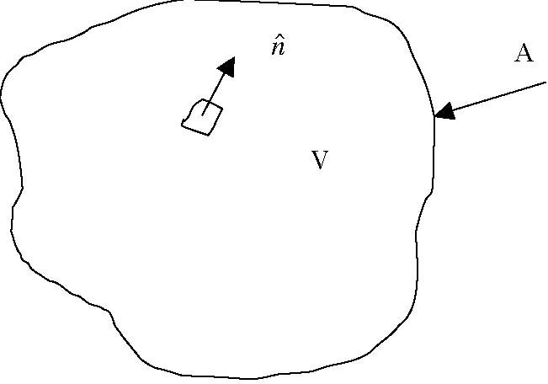
Figure 2.1.1 The control volume to describe the mass budget.
The surface of our imaginary volume is infinitely permeable. Fluid flows right through the surface with the fluid velocity at the surface. At each time, t, the mass enclosed in V by the surface A is
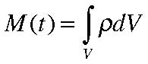
(2.1.1)
where ρ is the fluid density at and the integral is over the volume of V. Note that the density is generally a function of position within V, that is, The mass of fluid flowing out of V across its boundary, A, is
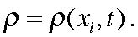
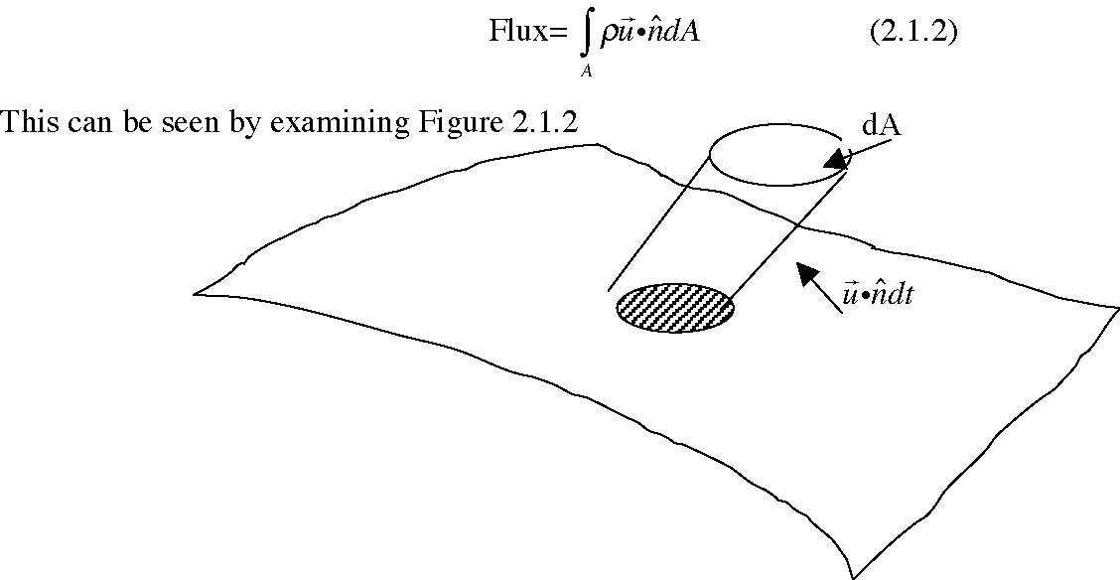
Figure 2.1.2 The pillbox crossing a surface element of A in a time dt
In each interval of time dt a small pillbox of mass whose cross sectional area is dA and whose height
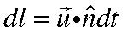 yields a volume
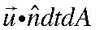 leaving the volume in that time. Therefore the rate at which fluid mass leaves the volume is given by (2.1.2). To conserve mass the rate of change of the mass in the fixed volume must be equal to the mass leaving (or entering). Thus,
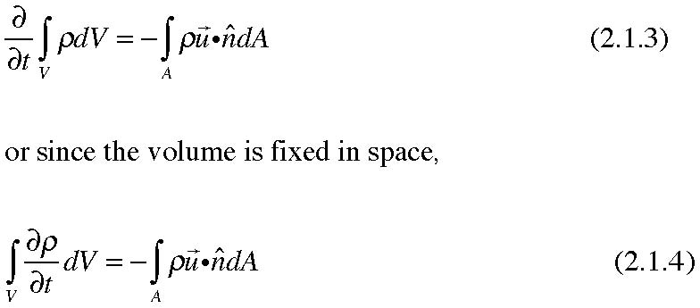
The divergence theorem states that for any well behaved vector field,
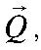
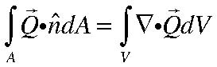
(2.1.5)
and so (2.1.4) can be written
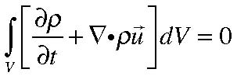
(2.1.6)
Now, the volume, V, we have used to keep track of the mass has been chosen arbitrarily. It could be any volume in the fluid. For (2.1.6) to always be true then, the integrand itself must vanish everywhere, since if there were a sub-domain in which it did not vanish we could choose V to correspond to that volume and obtain a violation of mass conservation. We therefore obtain the differential statement of mass conservation,
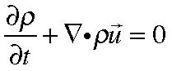
(2.1.7)
This equation which describes the condition of mass conservation is sometimes referred to as the continuity equation.
It might be useful to repeat the derivation in a more elementary but no less rigorous manner to emphasize the physical nature of the result. Consider an elementary cube with sides, dx, dy, and dz.
z
dz
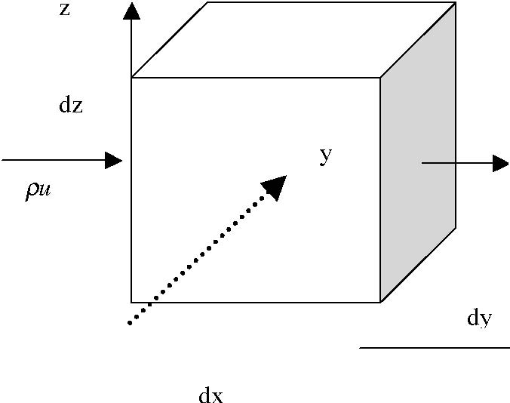
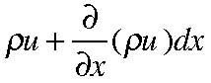
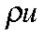
dy
x
Figure 2.1.3 An elemental cube used to budget mass. The net mass flux leaving the cube through the face perpendicular to the x axis with area dydz is :
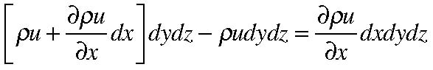
(2.1.8)
A similar calculation for the other four faces of the cube yields the net mass flux leaving the cube as:
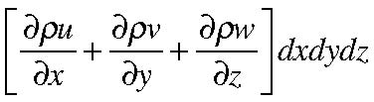
and this must be balanced by the decrease in the mass in the cube, or again (2.1.7)
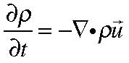
(2.1.7)
Indeed, this elementary derivation using an infinitesimal cube is nothing more than the basis of the proof of the divergence theorem in the first place and so is just as rigorous a derivation. Again, the physical statement is that at each point the local decrease of density compensates for the local divergence of the mass flux. If the divergence is negative we call it a convergence.
In our index notation the mass conservation equation can be written,
or, expanding the derivative,
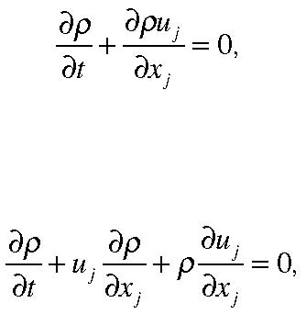
(2.1.9)
(2.1.10)
or in vector notation, using our formula for the total derivative,
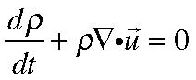
(2.1.11)
This is equivalent to (2.1.9), i.e. a statement of mass conservation but it can be given a slightly different interpretation. This equation describes the rate of change of density following a fluid particle and relates it to the local divergence of velocity. To understand this more deeply let’s return to Figure 2.1.2 and think about the volume , not as fixed in space and perfectly permeable but fixed to the fluid so that it deforms and stretches as the fluid composing its surface moves. At each point on the surface the outward movement of the fluid leads to a local volume increase so that the volume increase as a whole is simply,
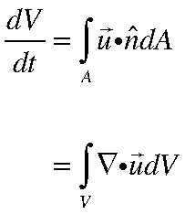
(2.1.12)
Now consider the limit as the volume under consideration gets very small in the limit as V→0.
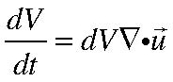
(2.1.13)
so that the mass conservation equation in the form (2.1.11) becomes,
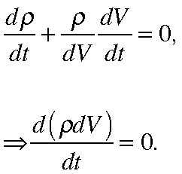
(2.1.14)
which states that the total mass in the moving volume consisting of the same fluid is conserved. As the volume of the fluid element increases (or decreases) the density must increase (or decrease) to compensate in order to conserved total mass.
Let’s estimate each of the terms in (2.1.11). If δρ is a characteristic value for the density variation or density anomaly and ρ is a characteristic value of the density itself, the term
(2.1.15) if U is a characteristic value of the velocity and its variation. On the other hand,
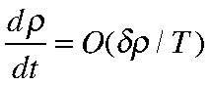
(2.1.16)
where T is the time scale over which the density anomaly changes. If, as in many oceanographic and atmospheric situations the time scale is the same as the advective time , L/U (this is the time it takes a disturbance to move a distance L moving with the fluid at a rate U) then,
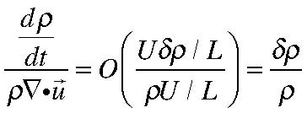
(2.1.17)
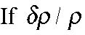
is small (it is of the order of one part in a thousand in the ocean) then the first term in (2.1.11) is utterly negligible compared to each of the three velocity terms in the divergence and so to conserve mass it is necessary, to O( 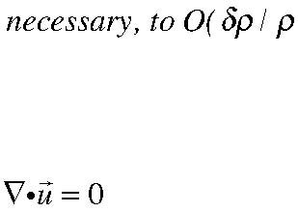) to conserve volume, or, as we see from (2.1.14) that
(2.1.18)
Our definition of an incompressible fluid is one that satisfies (2.1.18). In such cases the fluid needs to keep the volume of every fluid parcel constant although the volume will generally become very distorted by the motion. It is vitally important to realize that if
(2.1.18) is a valid approximation to the full conservation equation for mass, it does not
follow that 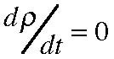. That it, (2.1.18) does not allow us to extract a second equation
constraining the density. You can’t get two equations from one equation. Keep in mind that the variation of density may not be zero, only that its variation is too small to be a player in the mass budget if
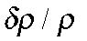 is small.
Even if
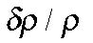is small, there are situations where (2.1.18) is not true. For example, if the time scale of the motion is not the advective time scale but , say, some period of oscillation that is very short compared to the advective scale, the local rate of change of density can be of the same order as the divergence. In that case the fluid will not act incompressible. Water flowing in a brook is very nearly incompressible in its dynamics yet when you click two rocks together underwater, the sound travels as an acoustic wave and that depends on the compressibility of the water and the high frequency of the generated sound wave. Incompressibility is therefore an approximation that for any fluid depends on the circumstances and must be determined by the nature of the dynamics being considered.
2.2 The streamfunction
In chapter 1 (see (1.7.12) ) we showed that the velocity field could be represented alternatively in terms of three scalars with
(2.2.1) If we substitute this representation in the continuity equation, (2.1.7) we obtain,
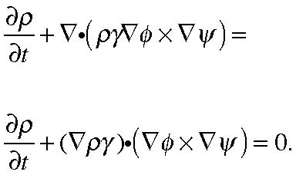
(2.2.2)
Consider the case when the flow is steady so that 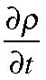 is identically zero. Then the
equation for mass conservation will be satisfied exactly if we choose the scalar
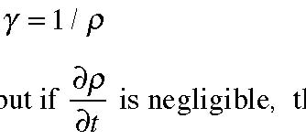 (2.2.3)
Note that even if the flow is not steady, but if is negligible, the result is still true. In
either case we then have the simpler representation of the velocity in terms of two arbitrary scalars, not three, i.e.
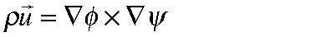 (2.2.4)
For a two dimensional flow, for example if z is constant for each fluid element, φ is just
z (plus an irrelevant constant) and the velocity field (or more precisely the mass flux) is
given in terms of the single scalar ψ,,
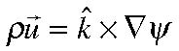
(2.2.5)
and the two velocity components u and v are ,
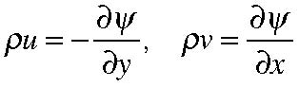
(2.2.6)
It follows from (2.2.5) that the two-dimensional velocity vector is always tangent to lines of constant ψ . The function ψ is called the streamfunction and its contours, at each
instant trace the streamlines for the flow (see Figure 2.2.1). Recall that if the flow is steady, or can be approximated as steady, these are also the trajectory of fluid elements, otherwise not.
ψ =ψ2
ψ=ψ1
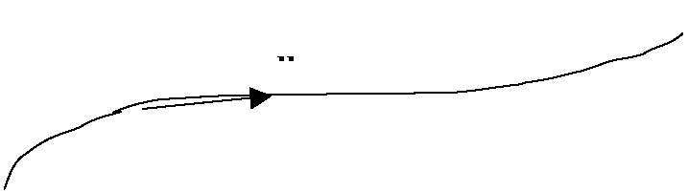
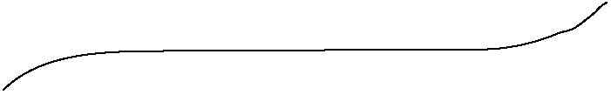
Figure 2.1.1. The two streamlines ψ1 and ψ2.
Of course the flow does not cross the streamlines and so the two contours shown in the figure act as a channel for the fluid. Let’s calculate the mass flux flowing through that channel. From (2.2.5) or (2.2.6) we can calculate the flux across any curve joining the two contours as shown in Figure (2.2.2)
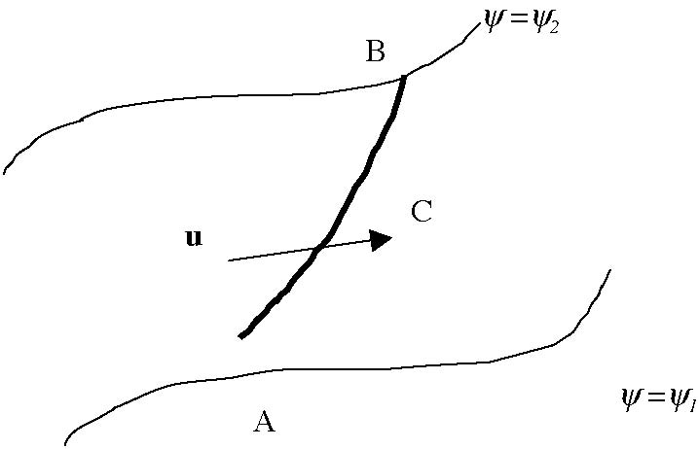
Figure 2.2.2 Calculating the flow across the line C between two streamlines
At each location along the line C we can represent the line by a series of infinitesimal steps with length dx and dy, as shown in the Figure 2.2.3 where the line C connects any two points A and B on each of the streamlines.
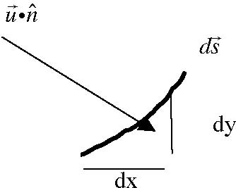
Figure 2.2.3 An element of the line C represented by two infinitesimal elements dx and dy.
The mass flux✱ across the element
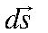 of C is the same as across the two infinitesimal elements dx and dy, namely,
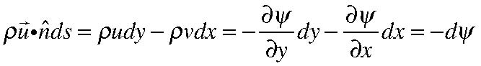
(2.2.7)
or integrating along C from one streamline to another yields
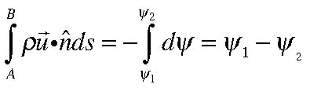
(2.2.8)
so that the mass flux between two streamlines depends only on the value of the streamfunction of those streamlines and is independent of the path used to calculate the flux. If the density can be considered constant, i.e. if its variation is slight as in the case of an incompressible fluid, the streamfunction ψ can be introduced for the velocity field itself since the condition for incompressibility for a two dimensional flow is just,
the line element tangent to C
(incompressible and 2-D) (2.2.9)
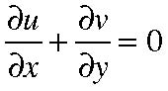
and the representation,
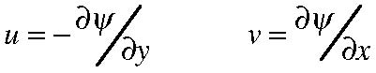
(2.2.10)
satisfies (2.2.9) exactly so that if is the volume flux that is given by the difference in the value of ψ from streamline to streamline in that case.
2.3 The momentum equation, Newton’s second law of motion.
In continuum mechanics we first of all suppose that the forces acting on each fluid element can be separated into two types.
1) There are long range forces that act directly on the mass of the fluid element. For example, gravity, or electro-magnetic forces (if the fluid is conducting), or from the d’Alembert point of view, accelerations. These forces are distributed over the volume of the fluid element. We usually specify the force in terms of a force per unit mass, F(x,t). Hence the total volume force on a fixed mass of fluid enclosed in a volume V is:
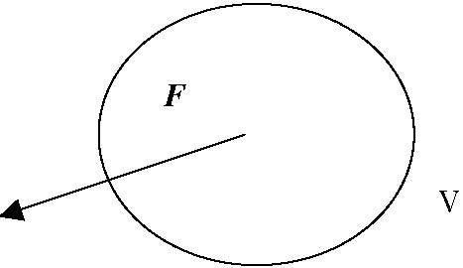
Figure 2.3.1 F is the body force per unit mass acting on the fluid element of volume V.
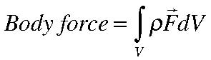
(2.3.1)
2) In addition, there are also short range forces, or surface forces, that act only on the surface of the fluid element (for example the pressure) and whose total force exerted
is proportional to the surface area of the fluid element. We denote the surface force per unit surface area as Σ. Note that Σ does not necessary have to be perpendicular to the surface.
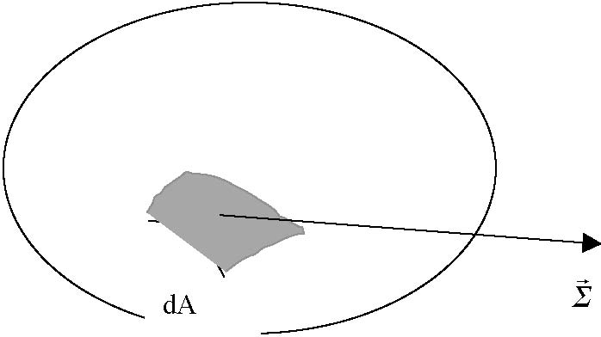
Figure 2.3.2 The surface force acting on an area element of the surface of the fluid particle.
Thus the total surface force on the fluid element is
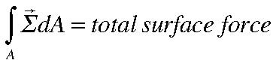
(2.3.2)
The surface force per unit area Σ is called the stress. It is a function of the orientation of the element al surface dA, i.e., of the direction in the fluid of the normal to the surface at each point. That is, in general,
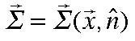
(2.3.3)
We will have to put considerable effort into finding a relationship between the state of the fluid and these surface stresses. Before doing so we should be clear about an
elementary definition of the stress. It is defined so that 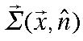 is the stress exerted by
the fluid that is on the side of the area into which the normal points on the fluid from which the normal points. By Newton’s law of action and reaction it follows that
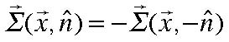
(2.3.4)
as shown in the figure below.
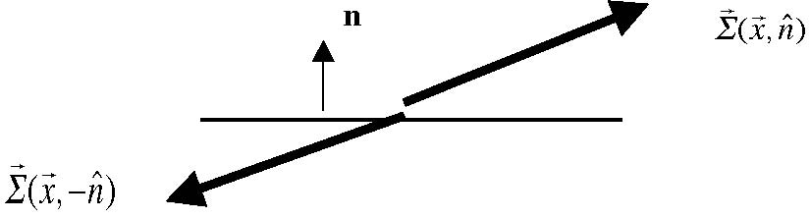
Figure 2.3.3 The stress and its reaction across the surface element.
Thus, if we consider volume with a fixed mass of fluid in an inertial system for to which Newton’s 2nd law of motion applies, we have,
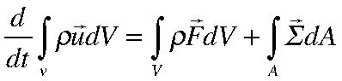
(2.3.5)
and the first question we must answer is whether the second term on the right hand side of (2.3.5 can be written as a volume integral so that we can extract, as we did for mass conservation, a differential statement for the momentum equation. This turns out to be a rather subtle issue and we are going to have to take a momentary diversion from our physical formulation of the equations of motion to discuss some fundamentals about vectors and their cousins, tensors.
2.4 Vectors, tensors and their transformations
Our goal is to discover what fundamental properties of the stress will allow us to rewrite the integral balance (2.3.5) as a differential balance, i.e. one for a infinitesimally small parcel of fluid. The key difficulty of preceding directly is that as the volume of that parcel becomes smaller and smaller it would appear that the surface term would dominate all the volume terms; the volume terms would go like l3 while the surface term should go like l2 and dominate in the limit l• 0. The fact that this cannot be the case will impose an important constraint on the basic structure of Σ. To begin with, though, we have to review some basic facts about vectors. There is a good discussion in Kundu’s book, also in the book by Batchelor. There are several excellent books that focus on vector and tensor theory appropriate for the fluid mechanics. I have always been fond of the book byAris (still available at online vendors) and the slim book by Harold Jeffreys (Cartesian Tensors, Cambridge Univ. Press) that is out of print but also available online.
Consider the position vector x as described in two orthogonal Cartesian frames with the same origin but one is rotated with respect to the other.
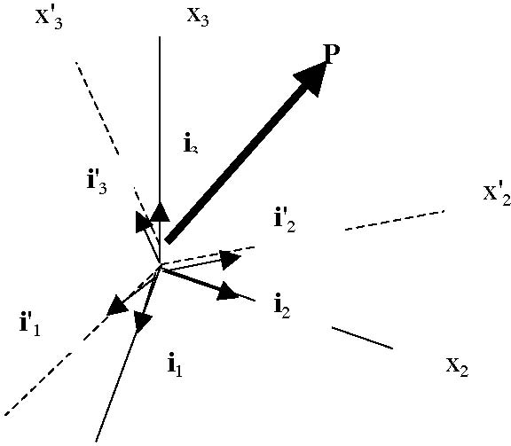
x'1
x1
Figure 2.4.1 The two Cartesian frames that serve to describe the same position vector x.
Consider the position vector x to the point P. The vector x is independent of the frame used to describe it but its coordinate description will be frame dependent. In the unprimed coordinate frame, that I will refer to as the “old frame” the vector can be described in terms of its coordinates along the three axes, each of which has a unit vector ij describing its direction in space.
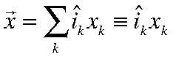
(2.4.1a)
where we have used our summation convention. Since the unit vectors are orthogonal, it follows that each component of the position vector can be found by taking the dot product with each of them,
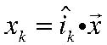
(2.4.1b)
We can also describe the same vector in the “new frame” i.e. , the primed axes. Although it is the same vector I will momentarily mark it with a prime to remind us which frame is being used to describe its coordinates, but keep in mind that x = x’.
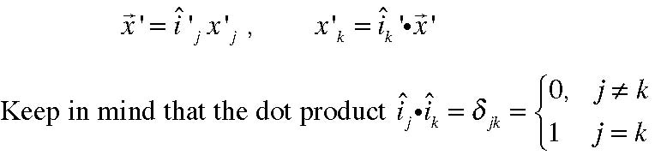
(2.4.2 a,b)
(2.4.3)
Next we want to make explicit the relation between the coordinates of the same position vector in the two frames. Since the vectors are the same,
(2.4.4)
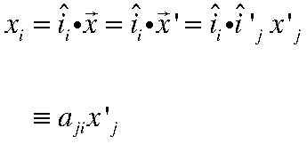
where the matrix aji is defined by the inner product of the jth unit vector of the new frame with the ith unit vector of the old frame. The aji are just the direction cosines between the two axes. Similarly,
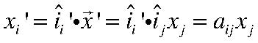
(2.4.5)
(Note: The above notation differs from that used in Kundu where he uses ajk as the direction cosines between the jth axis of the old frame and kth axis of the new frame). The transformation matrix ajk has the following important property. Since
(2.4.6)
for arbitrary position vectors , it follows that,
(2.4.7a)
while similarly,
(2.4.7b)
We define a vector as any quantity whose Cartesian coordinates transform by the same rule as the position vector, that is, the coordinates of the vector A in the new frame, A’i are related to the coordinates of the same vector in the old frame, Aj by the rule
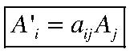
(2.4.8)
It is important to note that there are quantities that satisfy the usually described requirement to be a vector, i.e. having a magnitude and a direction, that do not satisfy the condition (2.4.8) and can not be considered as real vectors. The most important of these in fluid mechanics, especially in meteorology and oceanography, is the phase speed
of a wave. If its speed in the direction of the wave vector , k= {kj}, (i.e. in the direction perpendicular to the wave crest) is c, the components along the coordinate axes are
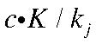 where K is the magnitude of k and this is not consistent with the phase speed being a vector.
The importance of the requirement (2.4.8) is that it preserves the invariance of properties that should not depend on the coordinate system, such as the length of the vector. Thus,
(2.4.9)
and similarly, the dot product of any two vectors is invariant, so that the dot product calculated in the two coordinate frames
(2.4.10) is the same. There is an important fact, called the quotient rule that helps us to identify a
quantity as a vector. The quotient rule states that: If q is a scalar (hence the same in all coordinate frames) and if u is an arbitrary vector and if
(2.4.11)
then v must be a vector. This follows from the following simple calculation of q in the two frames,
(2.4.12) or
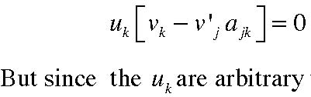
(2.4.13)
are arbitrary the quantity in the square bracket must vanish for each k demonstrating the v does, in fact, also transform as a vector.
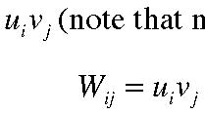
Suppose we take two vectors u and v and multiply their coordinates together, (note that no sum is implied), we then obtain a 3X3 matrix
(2.4.14) Since u and v are vectors , to transform the entries Wij from one frame to the other.
(2.4.15)
We define any square matrix Wij that transforms according to the rule (2.4.15) as a second order tensor and it need not be expressible as the product of two vectors. It need only satisfy the basic rule,
(2.4.16)
We are now in a position to discuss the nature of the surface stress and we will show it can be expressed in terms of a second order tensor σij.
2.5 The stress tensor.
Consider the tetrahedron shown in the Figure2.5.1. The outward normal from the slant face is n while the outward normals from the other three faces are (note the minus
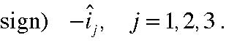
i3
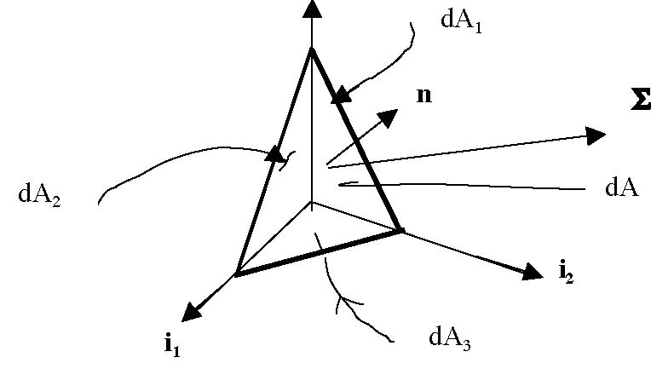
Figure 2.5.1 The tetrahedron used to calculate the force balance due to surface stresses.
The tetrahedron is small; each linear dimension is O(l) and we will be interested in the limit l→0. The total surface force on the tetrahedron, S, is
A little geometry and trigonometry shows that
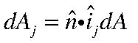 where dAj is the area of the
triangle perpendicular to the jth coordinate axis. At the same time we know that
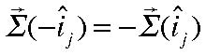
so that (2.5.1) becomes,
However, as l• 0 the size of the surface force is of order dA, i.e. of O(l2) while all the body forces are of O(l3) and so in the limit become negligible compared to the surface force. Thus, to lowest order, to preserve the force balance for each fluid element, S must vanish, i.e.
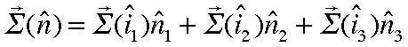
(2.5.3 a)
or, in component form
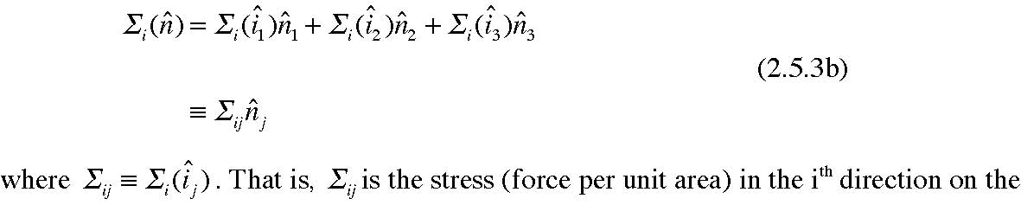
(2.5.3b)
face perpendicular to the jth axis. The result in (2.5.3) shows that we can write the stress on the surface with any orientation in terms of the quantities 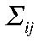 and the normal to that surface.
We usually use the notation,
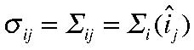
(2.5.4)
so that
(2.5.5)
where I have dropped the caret from the normal vector’s components. A helpful geometrical picture to keep in mind what the 9 components of σij refer to
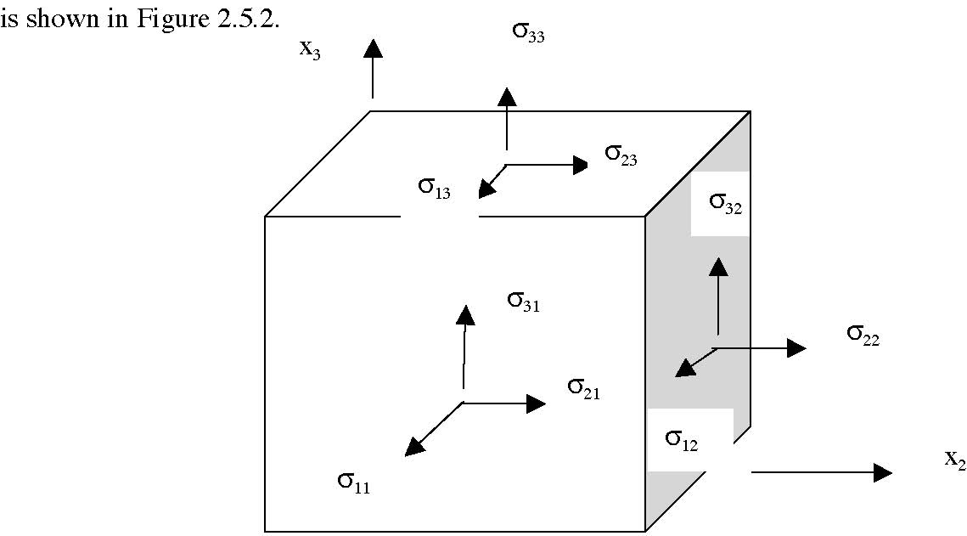
x1
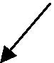
Figure 2.5.2 The defining figure for the elements of the stress tensor.
σij is the force per unit area in the ith direction on the face perpendicular to the jth axis.
Many texts take the relation (2.5.3) as a given but we see that it actually follows from the necessity of a force balance to lowest order i.e. at O(l2) in the limit l• 0.
Since 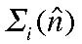 is a vector it follows from (2.5.5) and an application of the quotient rule that σij must be a second order tensor. This also follows directly since in the “new” frame we can write the surface force as
(2.5.6)
while we know that
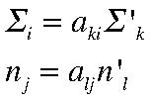
(2.5.7 a,b)
so that
or,
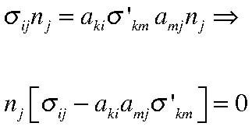
(2.5.9)
but since the normal vector can be arbitrary we must have
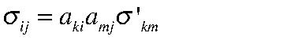 (2.5.10) which is the transformation rule for tensors.
2.6 An example
To get a feeling for the relationship between the elements of the stress tensor and the forces on fluid elements let’s consider a simple two dimensional example. Let’s consider the stress tensor
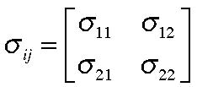
(2.6.1)
and consider the surface element in projected in the x-y plane as shown in Figure 2.6.1.
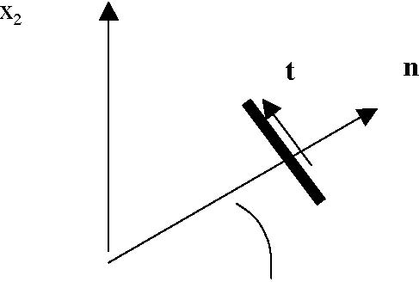
θ
Figure 2.6.1 The heavy line is a (2-d version) of a surface element whose normal is n and whose tangent vector is t. The normal vector makes an angle θ with the x1 axis.
The components of the vectors n and t are :
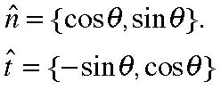
(2.6.2 a,b)
The stress Σ is
(2.6.3)
So, the stress in the direction of the normal is
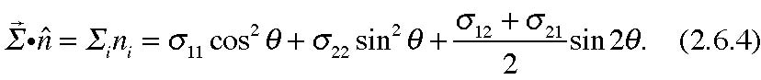
while the stress in the direction of the tangent vector t is,
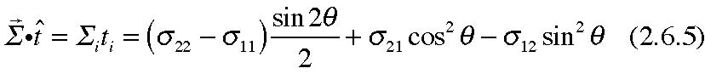
Consider the following special cases:
(2.6.6)
Then the normal stress is
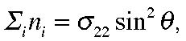
(2.6.7)
while the tangential stress is
(2.6.8)
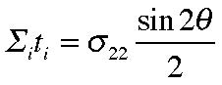
Therefore, for a material under tension , i.e. σ22 > 0 there will be a shear stress, parallel the plane of surface in Figure 2.6.1 that is a maximum when θ is 45O. Materials that are weak in shearing will tend to shear along this axis as you may have noticed with a piece
of chalk. At 45O the normal and shear stresses are equal and you can rationalize that by examining the force balance on the small triangle as shown in Figure 2.6.2.
σ22
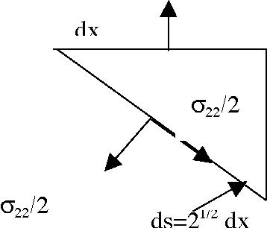
Figure 2.6.2 the force balance on a small wedge of material.
Of course, this force balance is just a special case of the force balance that let us arrive at the expression (2.6.3) in the first place.
Suppose, on the other hand that
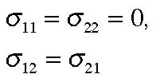
(2.6.9 a, b)
(We shall shortly see that (2.6.9 b) must be true. In this case the tangent component of the stress along the element at 45O is
(2.6.10)
so that there is no tangent stress component. Again note that the stress is a function of the orientation of the area under consideration as well as the magnitude of the elementary stresses σij.
A single example when this not the case is when the stress tensor is diagonal, so that
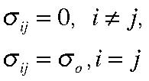
(2.6.11 a,b)
so that all off diagonal components are zero and the diagonal components are all the same. Looking at our expression for the normal and tangential stresses (2.6.4) and (2.6.5) we see that the normal stress would be the same, σO, for all angles, and the tangential stress would be always zero. This follows from the general transformation rule. Thus if
(2.6.12)
then in any rotated frame
the stress tensor remains diagonal and has only normal stresses in each rotated frame. On the other hand if the stresses are normal in one frame, but the normal stresses are not equal, in a rotated frame there will be tangential stresses as well as our example has shown. This becomes an important consideration when we will define the fluid pressure.
2.7 The momentum equation in differential form
We are now in a position to turn the statement of Newton’s second law of motion from the integral statement (2.3.5) to a more useful differential statement. We first must note the following important fact. If we consider any integral of the form,
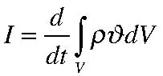
(2.7.1)
where 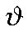 is any scalar (and so, for example, it could be a component of velocity) and where V is a volume enclosing a fixed mass of fluid. We can think of that volume as consisting of an infinite number of small, fixed mass volumes, each with a mass Since the mass of each is conserved following the fluid motion (2.1.14) it follows that the integral in (2.7.1) can be rewritten as
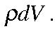
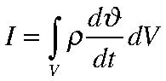
(2.7.2)
At the same time we will use our result on the representation of the surface stress to write the surface integral in (2.3.5) in terms of the stress tensor. Thus, for each velocity component we have,
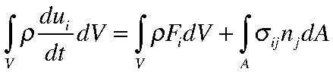
(2.7.3)
Although the second term on the right hand side looks like an area integral it can be written as a volume integral for the divergence of the vector (for each i ),
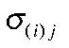 dotted with the normal vector 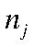 . This allows us to use the divergence theorem to write each term in the same volume integral ,
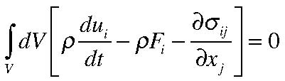
(2.7.4)
The fact that the surface integral of the stress is really a volume integral is a direct consequence of the earlier application of our force balance. That argument determined the structure of Σ in terms of the stress tensor σij so our ability to write (2.7.3) entirely as a volume integral is not a coincidence but rather a result of our basic physical formulation of the dynamics.
Now we use the usual argument about integral statements. The volume chosen in
(2.7.4) is entirely arbitrary so for the integral to vanish for an arbitrarily chosen V it must be true that the integrand vanishes so we obtain our fundamental result.
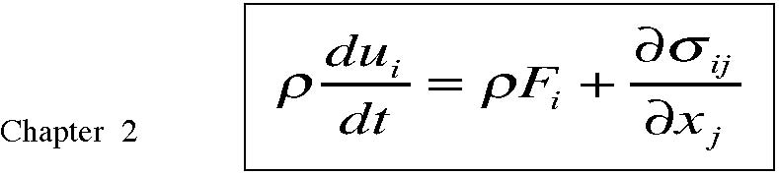
(2.7.5)
We should emphasize that this equation is valid for any continuum whether it is a fluid or a solid.
We could write (2.7.5) in more familiar vector form except for the last term. It is hard to squeeze what is a fundamentally tensorial quantity into vector clothing. It can be done by the use of what are called dyads but it adds little to and understanding of what the equation means.
Expanding the total derivative on the left hand side of (2.7.5) we have,
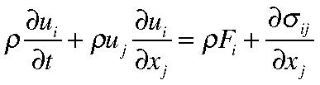
(2.7.6)
and when combined with the mass conservation equation (2.1.9) we obtain
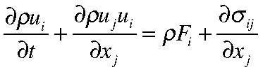
(2.7.7)
or equivalently,
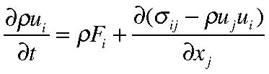
(2.7.8)
If (2.7.8) is integrated over a fixed , stationary and perfectly permeable volume, as in our derivation of the mass conservation equation , we obtain,
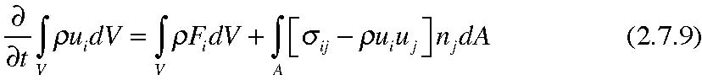
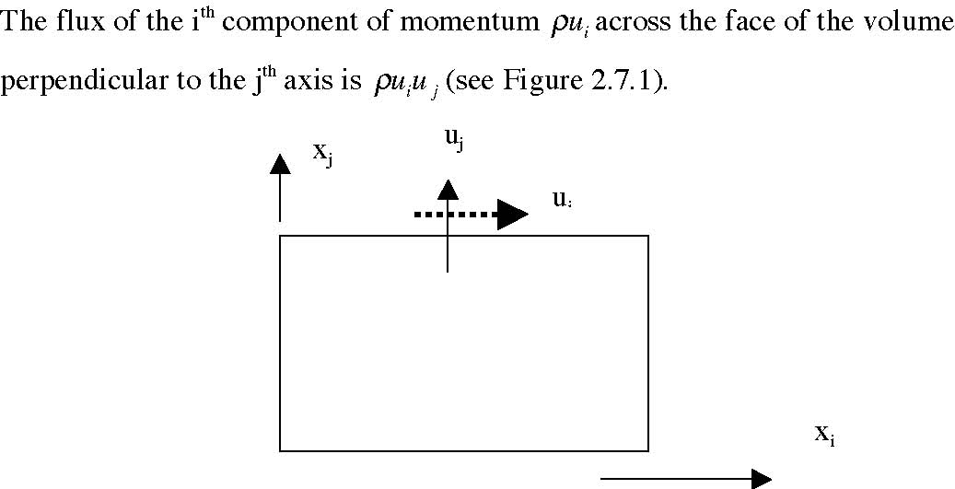
Figure 2.7.1 The velocity component uj carries a flux of momentum in the i direction across the face perpendicular to the jth axis equal to
By transferring the divergence of this momentum flux to the right hand side of the equation it appears as if it were equivalent to a stress acting on the fluid within the volume. A divergence of the momentum flux (more momentum leaving than entering) will reduce the momentum within the volume. This equivalence between the momentum flux and the stress tensor σij is fundamental. You may recall from kinetic theory of gases that the viscosity of a gas is due to just this kind of momentum flux on the molecular level. Here we see the macroscopic analogue. Indeed, when people try to find representations of the turbulent “stresses” which is nothing more than the momentum flux by motions on smaller space scales and faster time scales than we can hope to calculated directly, an appeal by analogy is often made to represent the turbulent stresses in terms of the large scale flow in the same way the molecular stresses are related to the macroscopic flow. Of course, at this stage we have done neither.
2.8 The symmetry of the stress tensor
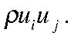
In principle, the stress tensor has nine independent components. We will show now that only 6 of these are independent because the off diagonal elements must satisfy a symmetry condition,
(2.8.1)
Before proving this result we need to establish some preliminary notation. Consider the cross product between two vectors A and B,
(2.8.2a) or in component form
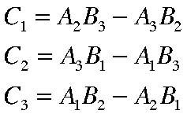
(2.8.2 b,c,d)
Notice the cyclic nature of the result (i.e. 1→2→3→1 …) to go from one component of the cross product to the next. This can be written in economical form using the so-called
alternating tensor , εijk
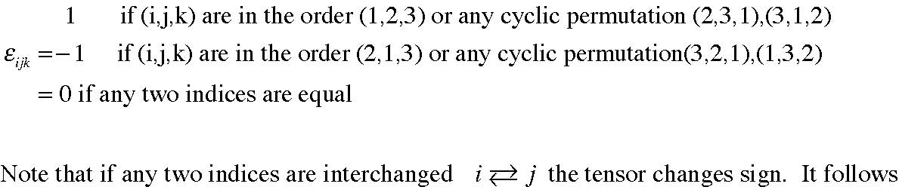
that the cross product of the vectors A and B can be written compactly as
(2.8.3)
For example, for C1 the only non zero terms on the right hand side from the sum over j and k are
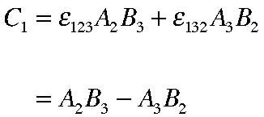
(2.8.4)
with the other components following cyclically. The alternating tensor is extremely useful and allows one, after a small effort at keeping its definition in mind, to no longer have to remember or look up all those vector identities that vector notation seems to hide.
A further identity of great utility that is easily memorized and completely eliminates the need to recall any vector identity is the identity for the inner product of two alternating tensors,
(2.8.5) (this can easily be remembered by noting that the first index of each alternating tensor forms the indices of the first delta function and the second index of each alternating tensor forms the indices of second delta while in the second product on the right hand
side these are reversed. Now let’s consider the torques on any fluid element around an arbitrary origin.
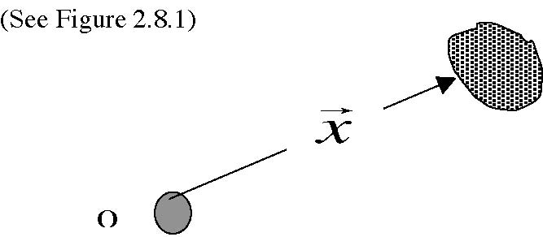
Figure 2.8.1 A fluid element of fixed mass, where is the distance vector from an
arbitrary origin.
The rate of change of the total angular momentum of the element around the origin is
given in terms of the torques on the element from the body forces and the surface force❀ ,
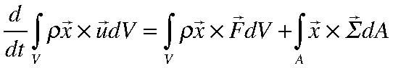
(2.8.6)
or using (2.7.1), (2.7.2) the term on the left hand side can be written,
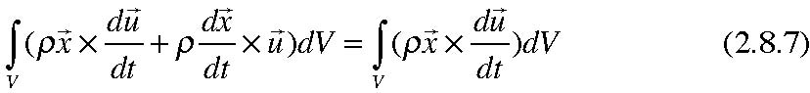
❀
This implicitly assumes that only the forces we have already considered can give rise to torques, i.e. thatthere are no other “intrinsic” sources of angular momentum.
since the second term on the left hand side is the cross product of the velocity with itself and so is identically zero. In component form then, (2.8.6) can be written
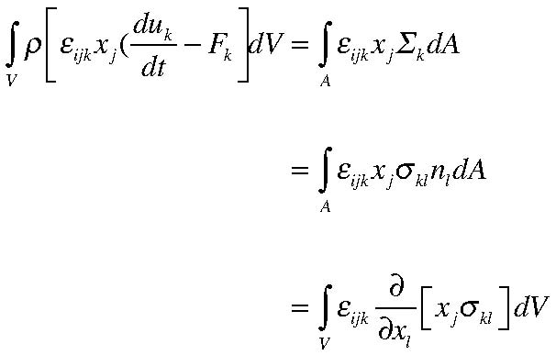
(2.8.8)
Note that since the coordinate axes are independent
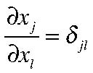
(2.8.9)
so that
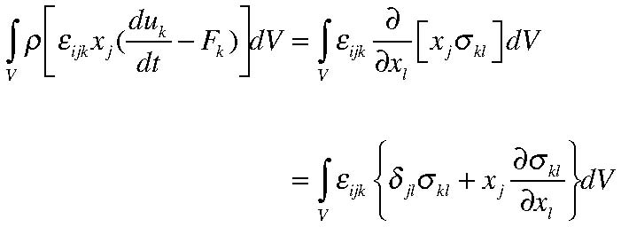
(2.8.10)
so that finally,
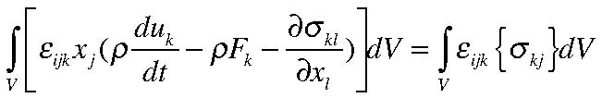
(2.8.11)
The left hand side of (2.8.11) is zero because the term in the bracket is just the momentum equation that is automatically zero. Again, since the volume of the fluid element that we have chosen is arbitrary, in order that the right hand side vanish the integrand must vanish, or,
(2.8.12)
Let’s examine this for i=1. The sum over j and k yields,
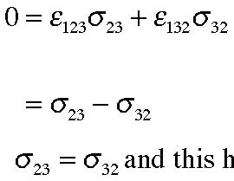
(2.8.13)
Therefore and this holds true for the other diagonal components of the stress tensor by a cyclic permutation of the indices. The stress tensor is symmetric and so has only six independent entries.
An elementary derivation o f the result follows by considering a cube of fluid and examining the torques around the center of gravity of the cube. Around the 3 axis we have (see Figure 2.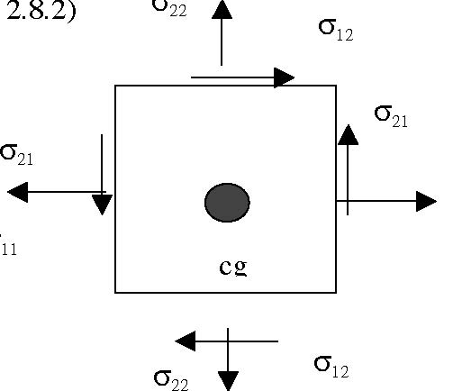8.2) σ22
σ12
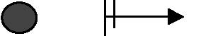σ11
σ11
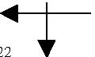
Figure 2.8.2 The calculation of the torque around the center of gravity of a fluid element.
Since the torque of the body forces (including the inertial acceleration) go through the center of gravity and since the variations of the stresses from one side of the cube to the other are of higher order in the cube distances dxi, the only way a torque balance can be achieved is if 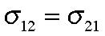 . (Note the change of direction of the stress from one face to the other and be sure you understand why .
Let’s count unknowns and equations: Unknowns:
ui, ρ,σij =(3+1+6)= 10 unknowns.
Equations:
(Mass conservation, momentum) = (1+3) =4 equations. So, clearly, we do not have enough to close our dynamical description. In particular, we need to discover more about the stress tensor. Indeed, up to now the equations we have derived apply equally well to steel as to any fluid. What is required is some description of the stress tensor that reflects the basic definition of a fluid and the properties of fluids, like water and air that are of principal interest to us.
Also, note that the diagonal elements of the stress tensor represent normal stresses, i.e. perpendicular to the surface of a fluid element and the off-diagonal elements represent tangent or shear stresses. In the next chapter we take up the constitutive relations for the stress tensor, i.e. the relation between the stress tensor and the state of the fluid flow.

