12. 800: Fluid Dynamics of the Atmosphere and Ocean
Chapter 1
The continuum hypothesis and kinematics
1.1 Introduction and syllabus.
This course is an introduction to fluid mechanics with special attention paid to concepts and applications that are important in oceanography and meteorology. Indeed, both meteorology and oceanography are notable for the fact that the explanation of fundamental phenomena requires a deep understanding of fluid mechanics. Phenomena like the Gulf Stream, coastal upwelling, the polar stratospheric vortex, the Jet Stream can all be approached as fundamental problems in fluid mechanics.
It is, as I hope to persuade you in this course, a beautiful subject dealing with compellingly beautiful physical phenomena. Even on the smallest scales accessible in everyday life there are lovely things to see and think about. Turn on the faucet in your sink and watch the roughly circular wave that surrounds the location where the water hits the sink and speeds outward, watch and wonder as the surf nearly always approach the beach head-on, see wave patterns in the clouds. Or, watch the smooth flow of water moving over a weir and wonder why it is so beautifully smooth. Why does each little pebble on the beach have a V-shaped pattern scoured in the sand behind it? Why is there weather instead of just tidal repetition? Why does a hurricane resemble a spiral galaxy? How can a tsunami move so fast? Why are there tornados, Dorothy, in Kansas but rarely in California? These are only a few questions that lead us to examine the dynamics of fluids. My own belief is that equipped with an understanding and sensitivity to the dynamics of fluids life can never be boring; there is always something fascinating to see and think about all around us.
A tentative syllabus (including more than we can probably get to) for the course might be as follows; 1) Formulation: a) Continuum hypothesis b) Kinematics, Eulerian and Lagrangian descriptions. (rates of change) c) Definitions of streamlines, tubes, trajectories.
2) a) Mass conservation. (For fixed control volume). Careful definition of
incompressibility and distinction with energy equation for ρ = constant.
b) Newton’s law
c) Cartesian tensors, transformations, quotient law for vectors and tensors,
diagonalization.
d) Tensor character of surface forces (derivation)
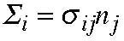
e) Momentum equation for a continuum.
f) Conservation of angular momentum, symmetry of stress tensor. Trace of stress tensor,
mechanical definition of pressure in terms of trace.
g) Stress, rate-of-strain tensor, isotropic fluids. Relation between mechanical and
thermodynamic pressure. Fluid viscosity, kinematic viscosity. Navier-Stokes equations.
f) Navier-Stokes equations in a rotating frame, centripetal and Coriolis accelerations.
g) Boundary conditions, kinematical and dynamical—surface tension.
3) Examples for a fluid of constant density.
a) Ekman layer, Ekman spiral, dissipation in boundary layer, spin-down time, Ekman
pumping. Ekman layer with applied wind-stress. Qualitative discussion of Prandtl
boundary layer.
b) The impulsively started flat plate. Diffusion of momentum.
4) Thermodynamics.
a)State equation, perfect gas, Internal energy.
b) First law of thermodynamics. Removal of mechanical contribution and equation for
internal energy. Dissipation function.
c) Dissipation due to difference between mechanical and thermodynamic pressure.
d) entropy, enthalpy, temperature equation for a perfect gas. Potential temperature.
Liquids.
e) temperature change in water for the impulsively started flat plate due to friction.
5) Fundamental theorems-Vorticity
a) Vorticity, definition, vortex lines, tubes, non-divergence. Vortex tube strength.
b) Circulation and relation to vorticity.
c) Kelvin’s theorem, interpretation. Friction, baroclinicity. Effect of rotation, Induction of
relative vorticity on the sphere. Rossby waves as an example.
d) Bathtub vortex.
e) Vortex lines frozen in fluid. Helmholtz theorem.
f) The vorticity equation, interpretation.
g) Enstrophy.
h) Ertel’s theorem of potential vorticity. Relation to Kelvin’s theorem. PV in a
homogeneous layer of fluid. The status function.
i) Thermal wind. Taylor-Proudman theorem. Geostrophy in atmospheric and oceanic
dynamics. Consequences.
j) Simple scaling arguments and heuristic derivation of quasi-geostrophic PV equation.
6. Fundamental Theorems. Bernoulli statements
a) Energy equation for time dependent dissipative motion.
b) Bernoulli theorem for steady inviscid flow. The Bernoulli function B.
c) Crocco’s theorem ( relation of grad B to entropy gradients and vorticity.)
d) Bernoulli’s theorem for a barotropic fluid.
e) Shallow water theory and the pv equation and Bernoulli equation. Relation between
gradB and potential vorticity and stream function.
f) Potential flow and the Bernoulli theorem.
APPLICATIONS AND EXAMPLES
g) Surface gravity waves as an example of (f)
h) Waves, trajectories, streamlines.
i) Two streams, internal waves with currents. Kelvin-Helmholtz instability. Richardson
number Miles-Howard theorem. Effect of surface tension. Physical interpretation of
instability.
j) Brief discussion of baroclinic instability. Wedge of instability, estimate of growth rates.
POSSIBLE SPECIAL TOPICS
i) Potential flow past a cylinder. Circulation, Lift (why airplanes fly).
ii) Vortex motion in 2-d. Point vortices. Hill vortex. Poincare theorems for continuous
distributions of vorticity. Modons. Effect of beta. Stern-Flierl theorem.
iii)Low Reynolds number flow. Down-welling in the mantle.
There are quite a number of excellent book on fluid mechanics. Styles vary and some people prefer one to another. There is no required text for the course and if you choose a text it should be clear from what we discuss in class what the appropriate readings might be that are helpful and I will generally leave reading assignments to you.
I list here a few books that I believe are useful.
1) Kundu, P.K. Fluid Mechanics. Academic Press 1990. pp 638.
2) Batchelor, G.K. Fluid Dynamics. Cambridge Univ. Press. 1967. pp 615 (This is
one of my favorites). 3) Aris, R. Vectors, Tensors and the basic equations of fluid mechanics. 1962. Prentice Hall. pp 286. 4) Cushman-Roisin, B. Introduction to Geophysical Fluid Dynamics. 1994.
Prentice-Hall. pp320 5) Gill, A.E., Atmospheric-Ocean Dynamics. 1982. Academic Press pp 662. 6) Pedlosky, J. Geophysical Fluid Dynamics 1987. Springer Verlag pp 710.
1.2 What is a fluid?
Naturally, one of the first issues to deal with is getting a clear understanding of what we mean by a fluid. It is surprisingly difficult to be rigorous about this but fortunately the materials we are mostly interested in, air and water, clearly fall under the definition of a fluid we will shortly give. However, in general it is sometimes unclear whether a material is always either a fluid or a solid.
A perfectly elastic solid is defined and recognized to be a material which suffers a proportionally small and reversible displacement when acted upon by a small force. If, for example, we take a cubic lump of steel and apply a force tangent to the surface of the cube as shown in the figure we observe a small displacement of the material.
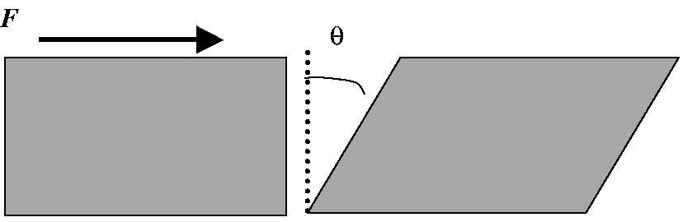
Figure 1.2.1 A small elastic cube subject to a force F suffers a small displacement with an angle θ.
If the solid is elastic the removal of the force will lead to a restoration of the original situation. For a fluid the same small tangential force will lead to an unbounded displacement. Instead, it is the rate of increase of θ that will be proportional to the force (or more precisely, the force per unit area to which it is applied. Hence, for a fluid such tangential forces lead to continuous deformations whose rate is proportional to the force. Thus a fluid can be defined as a material that can not remain motionless under the action of forces that leave its volume unchanged but otherwise act to deform it, as in the example above.
Some materials can act as elastic solids when they are forced on short time scales,
i.e. when they are sharply struck but deform in a manner like a liquid when the force operates over a long time, like silly putty. Or, a less “silly” example is the mantle of the Earth which supports elastic (seismic) waves on short time scales (seconds) but deforms like a fluid on very long time scales giving rise to mantle convection, sea-floor spreading and drifting continents. Air and water both act as fluids and one of the principal challenges for fluid dynamics is to obtain a useful mathematical representation of the relation between surface forces acting on pieces of fluid and the resulting deformations.
1.3 The continuum hypothesis
One of the pleasures of watching a moving fluid lies in the sinuous character of the motion. The continuity of the water in a cascade, the slow rise of the smoke from a burning cigarette (please don’t smoke) that turns more complex but remains continuous as it rises and the rippling of the sea surface under a light wind are all examples of the tapestry-like patterns of fluid motion. We intuitively think of the fluid involved as a continuum even though we are aware, intellectually, that the material is composed of atoms with large open spaces between them. Nevertheless, there are so many atoms on the scale of the motion that is of interest to us, from fractions of a centimeter to thousands of kilometers that an average over scales large compared to the inter atomic distances but small compared to the macroscopic scales of interest, allows us to establish a clear continuum with properties that vary continuously on the scales we use to measure. So, for example, if we consider a property like the temperature, T, we can define an averaging scale l, that is much larger than inter atomic or molecular distances but still small compared to the scale of our measuring instruments.
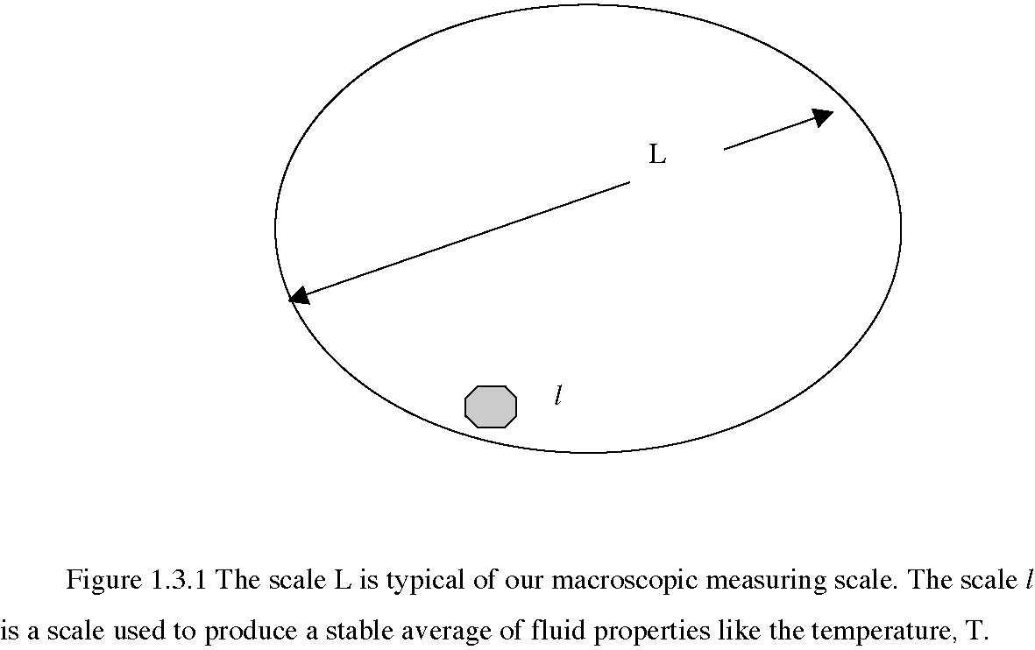
Batchelor points out that even on scales for l of order 10-3 cm, and a volume 10-9 cm3, such a tiny volume would contain on the order of 3 1010 air molecules in the atmosphere and this is more than enough to establish a thermodynamically stable definition of temperature or any other such property.
This allows us to consider fields like the temperature field as continuous functions of space and time, e.g. T=T(x, t) {here we introduce the bold face notation for vectors— sometimes we will use arrows over the variable instead}. Further, we will usually assume that such functions are differentiable to whatever order we feel is necessary. If there are discontinuities in our description of the fluid we consider them to be idealizations and simplifications of rapid variations in the continuum and such variations are to be thought of as occurring on scales much less than L but still large compared to the molecular scale.
An important consequence of this approach is that although it is a great simplification to ignore the atomic nature of matter and treat the fluid as a continuous medium, certain properties of the fluid like its viscosity, or thermal conductivity can not be predicted from within the theory but must be specified as given properties of the fluid. And, they can be complicated thermodynamic functions of temperature and pressure and that behavior must, as well, be specified external to the theory.
1.4 The fluid element.
We will often speak of a fluid element or particle. What we will mean is an arbitrary and arbitrarily small piece of the continuum that is a tagged piece of that fluid. Its volume is so small that its properties are uniform and it moves under the influence of the surrounding fluid. In principle, we mentally isolate it from its surroundings. Most Figure 1.4.1 The gray blob is a fluid element of fixed mass that deforms as it moves
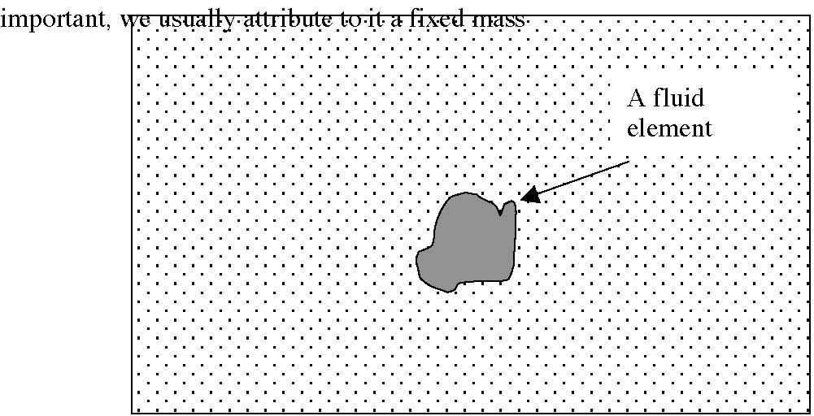
We introduce this notion primarily because Newton’s Law of motion is most easily written in terms of force balances on a “particle” of fixed mass although, as we shall see this is not necessary. It does allow us to consider the nature of many phenomena in an intuitive way if we can picture the dynamics of an isolated element. Like all simplifications it has to be used with care.
1.5 Kinematics
Before discussing the dynamics of fluids we must first consider and agree how to describe the fluid’s motion. This is the subject of kinematics. For a small solid object, like a stone, the description is usually quite simple. We just describe the trajectory, say of the center of mass as a function X =X(t) in three dimensions and relate the forces to the velocity and acceleration determined from our knowledge of X(t). In dealing with a fluid it is clearly not so simple. To paraphrase Gertrude Stein, there is no there there. We are clearly not interested in the center of gravity of the ocean, or not only in that, but in a description of the whole moving continuum, an infinitude of fluid elements. We have found two methods of description that are useful and illuminating. One is called the Eulerian method, the other is the Lagrangian method although both are probably due to Euler and later exploited by Lagrange.
1.5.a The Eulerian approach
The fluid extends over some three dimensional space and exists in time. Consider any property, P, for example the temperature. If x is the position vector with components {xj : j= 1,2,3)♦ then we can describe P as P(xi,t). This gives us P at each location and at each time without specifying which fluid element occupies that position at that time. In this description we do not keep track of individual fluid elements. This is a field description of the fluid and the absence of information about the identity of the occupier of a position may seem a loose way to proceed but it has many advantages, principle among them that it does not require us to keep track of the extra information about the
♦ the coordinates (x1,x2,x3) are equivalent to (x,y,z) individual fate of particular elements. A fixed current meter, or a fixed anemometer all measure in an Eulerian context.
1.5b The Lagrangian approach
As in particle mechanics, the Lagrangian approach keeps track of individual fluid elements as they move and describes the property P as a function of which particle it refers to and at each time. In this description each particle is given a name, i.e. a label, and this serves to identify the fluid particle at all subsequent times. A convenient label is the position xi that the particle had a some initial instant, t=tO. Suppose we call that position Xi so that Xi=xi at t=tO. Each fluid element then changes its position as it moves but its label X remains fixed.
1.5c The fluid trajectory
A simple way to define the trajectory of a fluid element is to specify
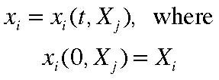
(1.5. 1 a,b)
This is the trajectory equation for a particular element. It tells us where, at time t, is the fluid element that initially (i.e. tO has been taken to be zero) was at position X. For all t> 0 there is an inverse to this relation,
(1.5.2)
which tells us which particle is at position xi at time t. So, we can equally well describe any property P in terms of the Lagrangian variables, P =P (X,t) and using (1.5.1) and
(1.5.2) we can go back and forth between the descriptions. Floats and radiosondes are essentially Lagrangian measuring tools.
In actual observational situations the description of any property field is usually incompletely sampled. There are only a finite number of floats that can be available, current meter arrays are sparsely distributed, etc, so it is often a challenge to go back and forth from one kinematic description to another.
1.6 Rates of change.
Consider a property P(xi, t) in the Eulerian description. Its rate of change with respect to time is central to the description of the fluid’s dynamics. We must keep in mind that there are several natural rates of change and they are all different. For example, when you are traveling on the way to Woods Hole from Boston you might detect a change in the weather, e.g. the temperature as you go along. You might detect that change not because the temperature is changing with time at each location but because the temperature is changing with distance and you are traveling in that temperature gradient. We need to distinguish between these rates of change. 1) A rate of change at a fixed point is:
the local time derivative =
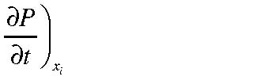 (1.6.1)
This yields the rate of change with time at a fixed point of the property P. We shall usually suppress the subscript xi as understood. You can think of this as the change in P as a series of fluid elements move through the point xi and so it is possible that this rate of change can be different from zero even if the property P is constant for each fluid element along its trajectory.
2) In general consider the rate of change of P for a moving observer (perhaps in a
convertible on Route 3). The observer moves with a velocity
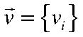
such that for the observer
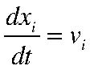
It is important to keep in mind that
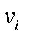 is not the fluid velocity. Thus, following the observer the total rate of change as seen by the observer is:
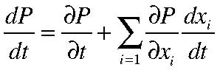
(1.6.2)
ASIDE: We now introduce the summation convention or sometimes it is called the Einstein summation convention. When we have a product sum as in (1.6.2) where an a dummy index (in this case i) is summed over we understand that the sum is implied over the index without explicitly writing the summation sign. Thus, for example, the inner product of vectors A and B can be written:
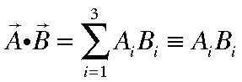
The rate of change of P given by (1.6.2) is then
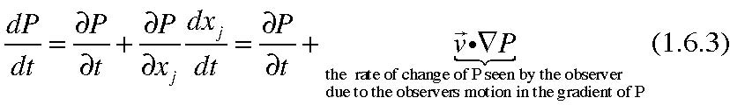
For example, a child on a slide whose elevation above the ground is h(x) will change
his/her height off the ground at a rate
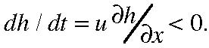
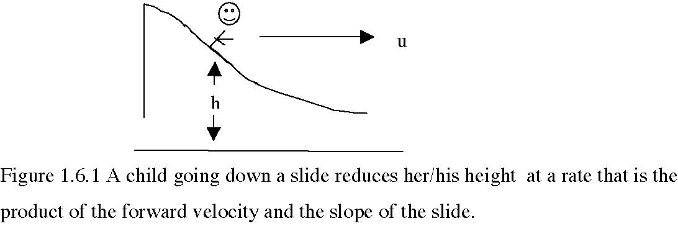
However, of particular interest is the rate of change of a property when the observer is the fluid itself, i.e. , the rate of change of a fluid property following a fluid element, or simply the rate of change of the property for the fluid element. In that case
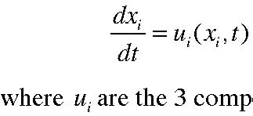
(1.6.4)
are the 3 components of the fluid velocity. (An integration in time of the above equation also yields the trajectory of the fluid elements.) Thus, for the fluid, the rate of change of a property P following each fluid element is:
(1.6.5)
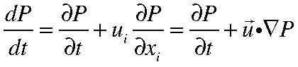
This derivative is the rate of change of P for the fluid particle that is occupying the position xi at time t. This Eulerian representation of the derivative is variously called the
total derivative or the material derivative and is also sometimes written as
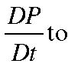
distinguish this derivative from that following a different observers rate of change. We will generally use the notation in (1.6.5). The total derivative consists of two parts. The first term on the right hand side of (1.6.5) is the local time derivative. The second term involving the motion of the fluid in the gradient of the property P is called the advective derivative and the total derivative is the sum of the local and advective parts.
The total derivative is central to fluid mechanics and please note that we need to know the fluid velocity as well as the space and time behavior of P to calculate the material derivative of P. If both P and ui are unknown the material derivative involves the product of two unknowns and the fundamental nonlinearity of fluid mechanics and all the phenomena, like turbulence, weather, eddies, chaos etc. follow from this simple fact.
Suppose that the property P is conserved for each fluid element so that its total derivative is zero. It follows that at each spatial location:
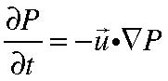
(1.6.6)
So, at a fixed location an observer would see a change in the property as a parade of fluid elements with different P pass that point. Think of a file of people of different heights, arranged in order of increasing height to the right. If the column moves to the right shorter and shorter people will occupy a given location and an observer will see constantly decreasing heights occupy the observation position even though each person maintains his/her total height (no beheadings allowed!)
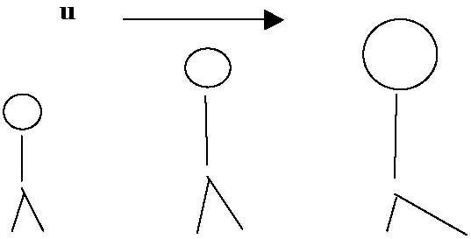
Observer grad (h) > 0 Figure 1.6.2 A file of people moving to the right. If the people are arranged with increasing height a fixed observer with see the height of people increasing at a fixed point. The height of each person is fixed.
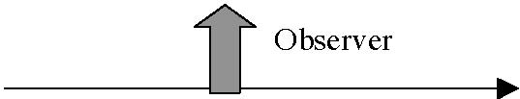
Suppose the property P is given by the relation:
(1.6.7) where ω is the frequency
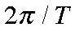 where T is the period and k is the wavenumber where λ is the wavelength. Suppose the velocity in the x direction is U. Then the total derivative of P is
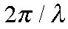
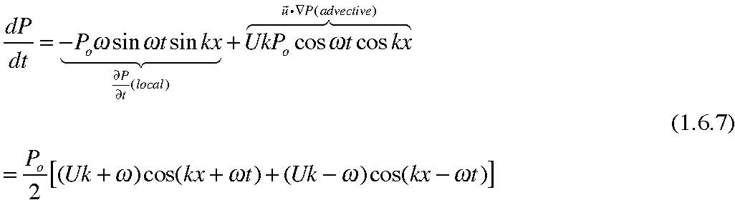
The ratio of the local part of the time derivative to the advective part is of the order
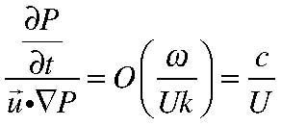
(1.6.8)
where c is the phase speed of the wave so the ratio measures the phase speed of the wave with respect to the speed of the fluid. If the ratio c/U is large, the advective derivative can be ignored to lowest order and the system will be linear. Note that if the Eulerian velocity field is given, the trajectory of each fluid element can be found integrating
(1.6.4) with
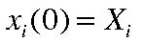 as initial condition. It is important to note that even for simple velocity fields (1.6.4) is usually very nonlinear, and if the motion is time dependent the resulting trajectories can be unexpectedly complex and even chaotic. In the Lagrangian framework the total derivative following a fluid particle is simply
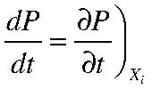
(1.6.9)
For simplicity suppose that U is a constant. Then the x-component of (1.6.4) yields,
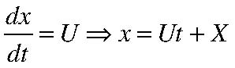
(1.6.10)
so that P in (1.6.7) can be written, with a few algebraic identities and using (1.6.10)
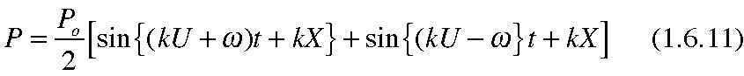
so that the total derivative (1.6.9) yields,
It is easy to see that the transformation (1.6.10) shows the equivalence of (1.6.7) and (1.6.12).
1.7 Streamlines
We define a streamline as a line in the fluid that is, at each instant, parallel to the velocity. If
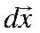 is a vector element along the streamline, this implies
(1.7.1) where λ is an arbitrary constant. In component form it follows that,
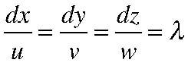
(1.7.2)
which can be thought of as two differential equations,
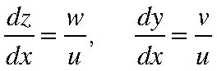
((1.7.3)
which with initial conditions yields a curve in space. This is the streamline.
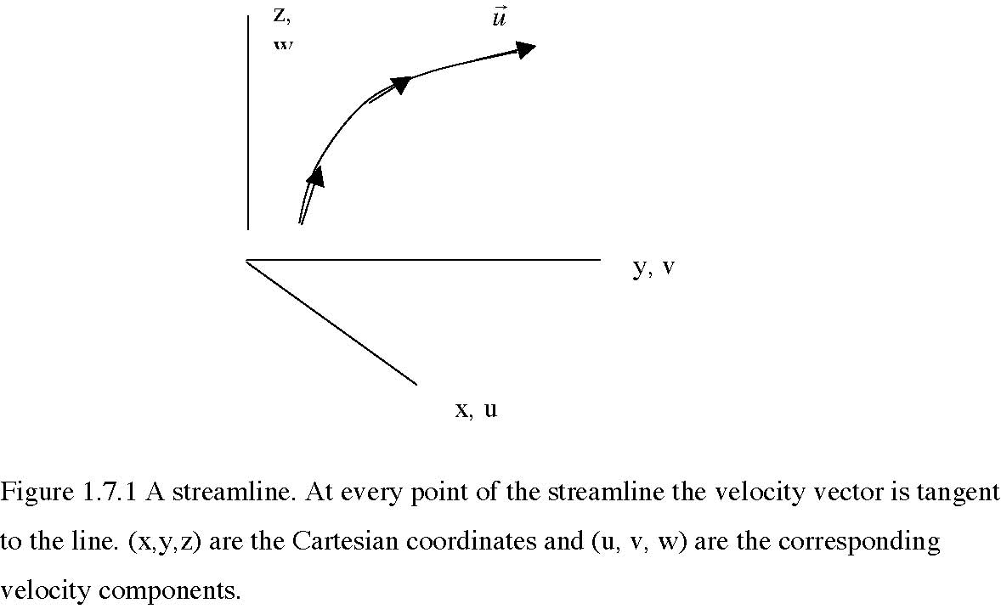
x, u
An equivalent representation can be used in which the arbitrary scalar λ is replaced by the differential parameter ds so that the condition (1.7.1) is written as 3 ordinary differential equations ,
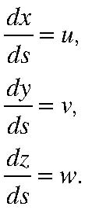
(1.7.4 a,b,c)
and so avoiding the apparent singularity that occurs where u is zero. s is simply a parameter along the streamline. Since the streamline is constructed at an arbitrary fixed time (and so will change its geometry if the velocity field is time dependent) it is frozen in place, like an imaginary highway for the flow, and gives the direction the fluid element on it would move if the velocity field were steady. So, we could interpret s as the time-like variable for the motion of the fluid along the streamline if the flow were steady. Of course, if the flow is not steady the streamlines constructed this way give a clear picture of the direction of the flow at this instant but do not give the trajectory or path of the fluid element on it. The highway, so to speak, can keep changing direction with time and so the path of the particle will diverge from the streamline.
For example, consider the two dimensional flow (w=0) for which,
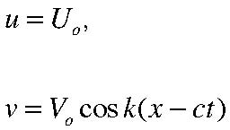
(1.7.5 a, b)
and for simplicity, Uo,Vo are constants. To find the fluid element trajectory we need to integrate the Lagrangian trajectory equations (1.6.4),
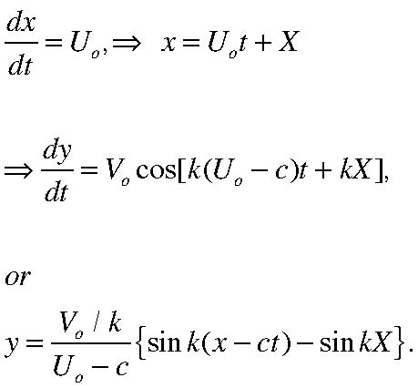
(1.7.6 a,b,c) Since t is related to x by (1.7.6 a) the path of the fluid element is:
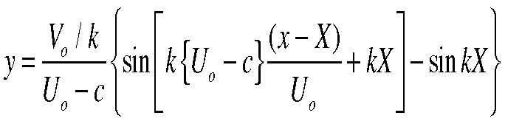
(1.7.7)
On the other hand the stream line passing through the point x=X, y=0 at t=0, is determined from the streamline equation,
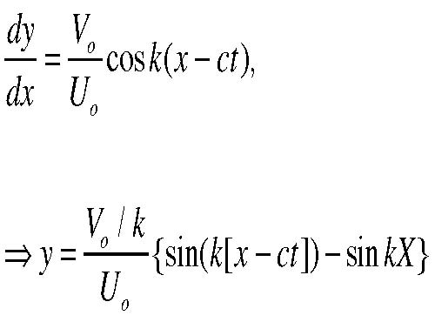
(1.7.8 a,b)
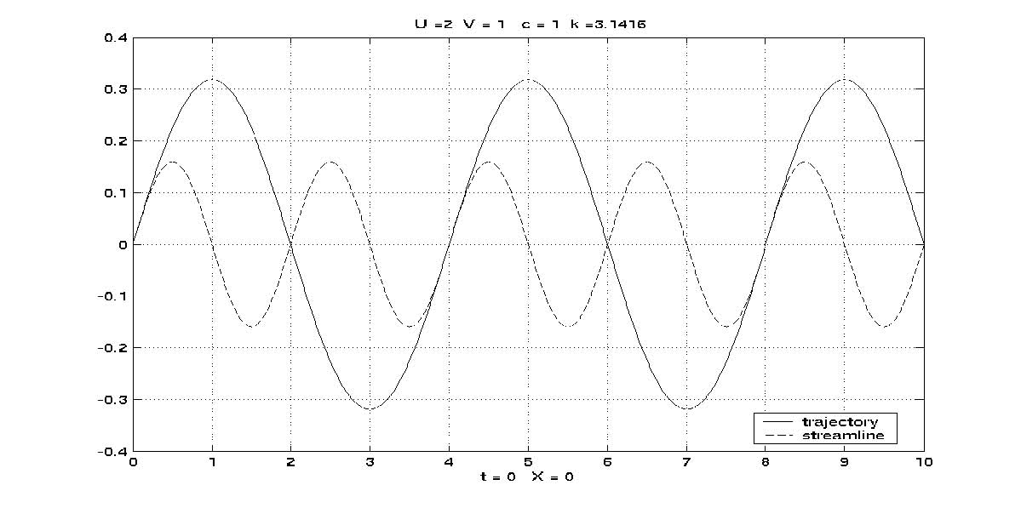
Figure (1.7.2) shows the trajectory for the particle that a t=0 is at x=X=0, y=0 as the solid line for Vo=1, Uo=2, and c =1 for k=π. The streamline at t=0 is shown passing through the same initial point. Note that the streamline , while giving the direction of the velocity all along the x axis at t=0 is not the subsequent path of the fluid element . The
wavelength of the trajectory and its amplitude are quite different. An extreme case is shown in Figure 1.7.3 when Uo-c is very small.
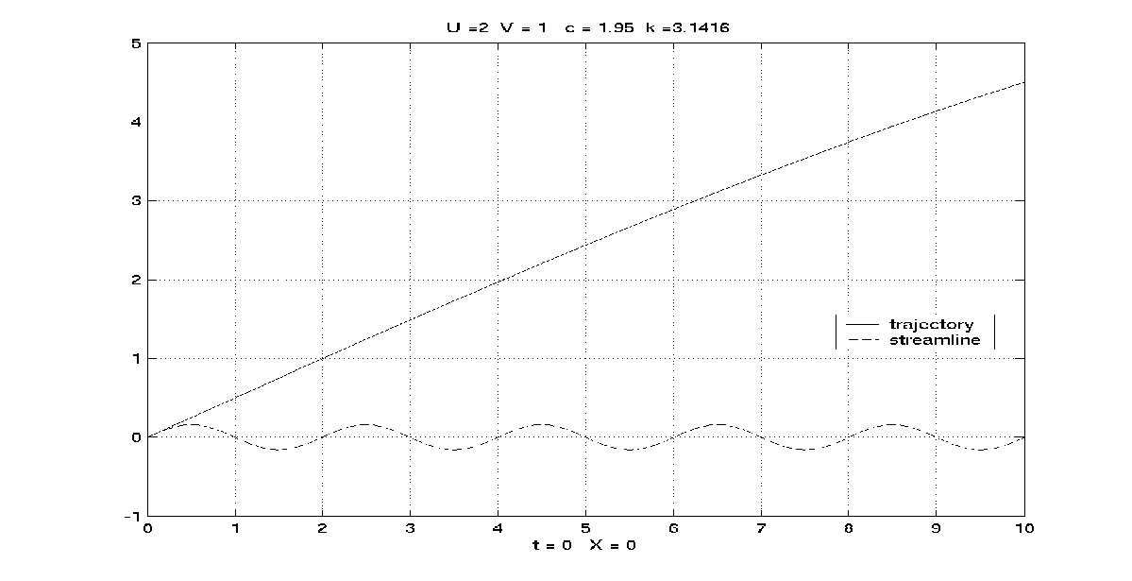
The departure of the trajectory from the streamline is dramatic. As c approaches Uo the fluid element, which moves in x with velocity Uo, remains fixed to the same phase of the wave, which moves with c, and so always sees the same value of v. This leads to an increasing divergence of the trajectory from the streamline. In fact, and it is left to you as an exercise, in the limit as c• Uo the trajectory is just a straight line whose slope, y/x, is just Vo/Uo. This has implications for the motion of individual air particles or water particles in the generally time dependent, turbulent atmosphere and oceans. Even very orderly streamlines, usually coincident with isobars, can mask significantly more extreme particle transports over greater distances than is evident from the streamline pattern.
Of course, if the flow is steady or nearly steady, the streamlines are a good image of the trajectories. Even when the flow is unsteady the streamlines accurately portray the direction of the motion at that instant over the whole flow field.
It is possible to construct a solution of (1.7.2) that consists of a surface composed of streamlines. Let’s call that surface ψ(x,y,z) =C (suppressing the dependence on t which is understood).
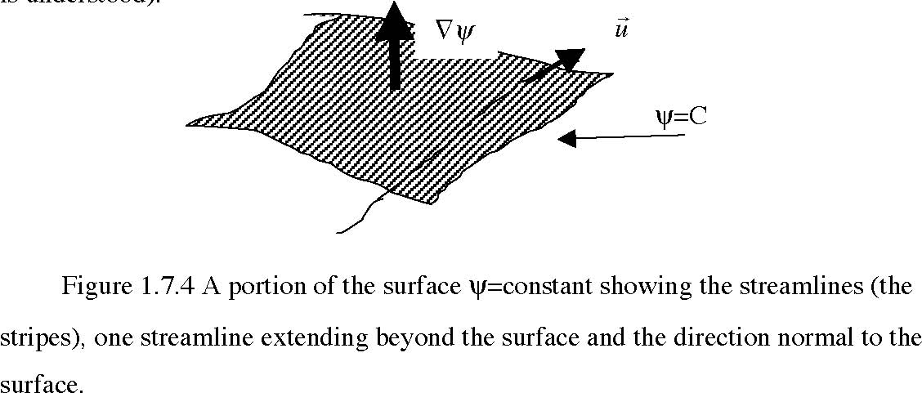
By definition of the surface,
(1.7.9) In fact, this is consistent with (1.7.1) and the condition that
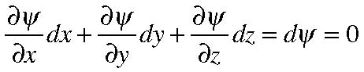
(1.7.10)
Note that if the flow is steady and so that the streamlines are also trajectories, (1.7.9) would be equivalent to the statement that the property ψ is conserved for each fluid element. Now, if we can construct one such surface composed of streamlines we can construct others. Consider a surface φ= D which is independent of ψ so that
(1.7.11)
The two surfaces intersect in a line that is necessarily a streamline since both (1.7.9) and
(1.7.11) must be simultaneously satisfied as shown in Figure 1.7.5.
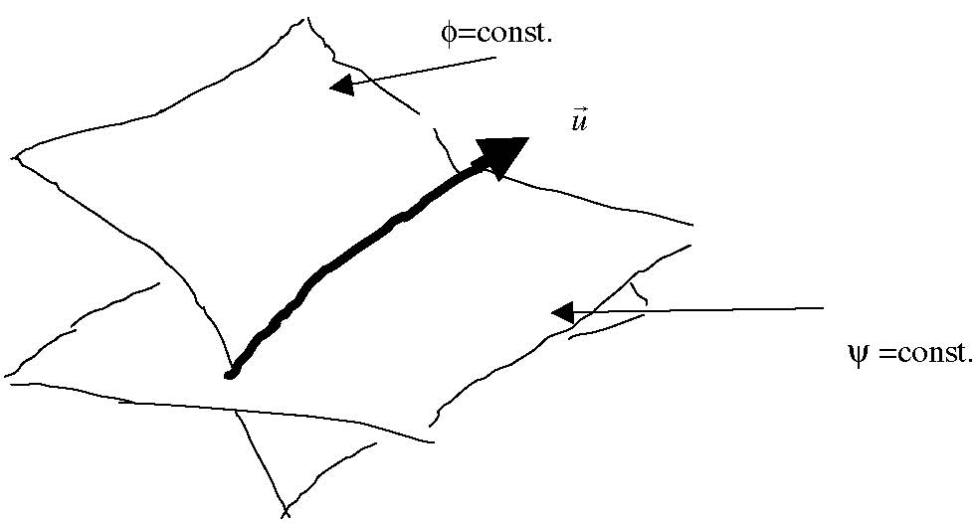
Figure 1.7.5 The intersection of the two surfaces ψ and φ. The intersection line, by construction is a streamline.
Since the velocity vector is perpendicular to both | it follows that the
velocity at any location can be represented as,
 | (1.7.12)

where, for now, γ is an arbitrary scalar function. At first sight this does not seem to be much of an advance since we have replaced as unknowns the three scalar components of velocity for the three unknown scalars γ,ψ and φ. But when we combine (1.7.12) with the statement of mass conservation , which follows in the next chapter, this representation becomes much more useful and when the motion is in two dimensions this representation reduces immediately to the common streamfunction you may have met before. If the motion is two dimensional, i.e. if say, w=0, then φ can be chosen to be z+zo , for zo arbitrary, in which case (1.7.12) becomes,
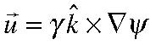
(1.7.13)
where
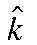 is a unit vector in the z direction.
1.8 The stream tube, streak lines
Consider a cylinder composed of all streamlines passing through a closed curve in space, as shown in Figure 1.8.1. The resulting surface is a tube whose walls are composed of streamlines. This is a stream tube and by definition no flow exits the tube
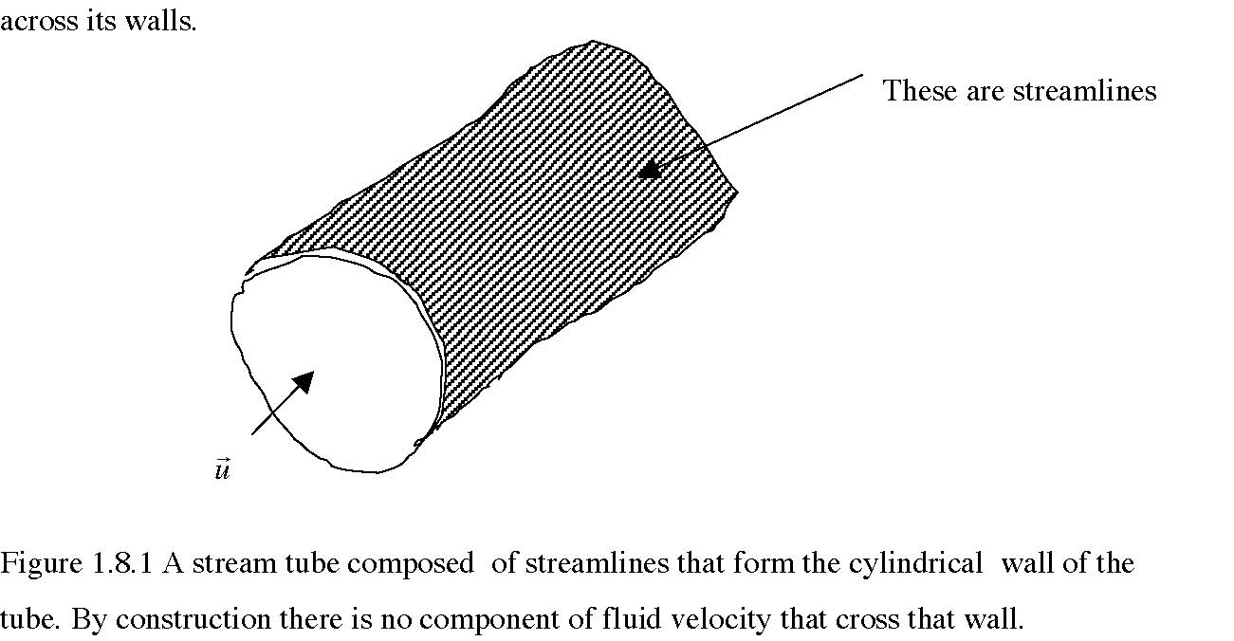
We have defined fluid trajectories and fluid streamlines and we have seen that when the flow is unsteady they are not the same. There is a third kinematic concept that is often used, the streakline. This is the line traced out in time by all the fluid particles that pass a particular point as a time goes on. It is left as an exercise for you to work out the streakline for the flow (1.7.5 a, b) that passes goes through the point x=0, y=0. The results can be quite surprising. For example, figure 1.8.2 shows the streamlines, trajectories and the streaklines for fluid emanating from x=0,y=0.
The streakline would be the line of dye released at the point (0,0) as observed at some later time downstream. From the figure it appears as if some kind of instability has occurred but looking at the generating velocity (1.7.5) that is clearly not the case. Can you explain it? It is a good test of your understanding of the kinematics we have discussed so far. Note that all the curves in figure (1.8.2) would coincide if c were zero.

