Cruise Prospectus
OSNAP "East" Cruise
R/V Neil Armstrong (July 18 - Aug. 9, 2022)

Description of Project: Nature and Objectives

The specific objectives of this cruise are as follows:

- To perform mooring operations along the OSNAP East line between the Iceland and Irminger basins, including servicing (recovery and redeployment) of 12 current meter moorings.
- To conduct standard CTD (Conductivity-Temperature-Depth) and Lowered ADCP (Acoustic Doppler Current Profiler) stations at approximately 42 sites along the same mooring line.
- To acquire continuous underway data (vessel-mounted ADCP data, meteorological data, and surface temperature and salinity data) along the cruise track, and to perform selected additional CTD stations along the cruise track.

This research is part of the U.S.-led Overturning in the Subpolar North Atlantic Program (OSNAP), an effort to determine the strength of the meridional overturning circulation and associated heat and freshwater fluxes in the subpolar North Atlantic. It is a collaborative program with scientists from several nations, including the U.K., the Netherlands, Germany, France, Canada, and China. Scientists from the U.S. and the Netherlands will participate in this cruise.

The moorings to be deployed on this cruise are listed in Table 1, and the planned CTD/LADCP stations are listed in Table 2. The mooring locations and planned CTD/LADCP stations are also shown in the attached maps (Figs. 1 and 2). The cruise will depart from, and return to, Reykjavik, Iceland. The order of operations and exact cruise track will depend on weather conditions and other considerations at the time of the cruise.

All of the moorings to be serviced or deployed are taut-wire subsurface moorings. Most of them have multiple instruments, including internally-recording current meters and temperature/salinity/pressure recorders. The CTD stations will include collection of salinity samples from Niskin bottles in order to calibrate the electronic conductivity sensors on the CTD package.

Table 1. Moorings to be serviced (recovered and deployed)

Name Latitude Longitude Depth(m)

U.S. Mooring positions in the Iceland Basin:
M1 58° 52.330' N 30° 31.765' W 1710
D1 58° 44.810' N 30° 07.040' W 1740
D2 58° 32.010' N 29° 27.580' W 2513
D3 58° 18.320' N 28° 49.060' W 2180
M2 58° 02.210' N 28° 01.130' W 2370
D4 58° 00.600' N 26° 58.120' W 2680
D5 58° 00.350' N 25° 40.560' W 2705

Dutch Mooring positions in the eastern Irminger Basin:
IC0 59˚ 13.02’ N 35˚ 07.51’ W 2930
IC1 59˚ 06.26’ N 33˚ 41.20’ W 2494
IC2 59˚ 01.29’ N 32˚ 43.56’ W 1873
IC3 58˚ 57.40’ N 31˚ 57.08’ W 1633
IC4 58˚ 53.38’ N 31˚ 17.90’ W 1471

Table 2. Proposed CTD/LADCP Stations

Sta. Latitude Longitude Depth (m)

1 57° 57.60' N 24° 29.35' W 2850
2 57° 57.60' N 25° 07.14' W 2800
3 57° 57.60' N 25° 44.94' W 2700
4 57° 57.60' N 26° 04.45' W 2700
5 57° 57.60' N 26° 22.74' W 2500
6 57° 57.60' N 26° 42.49' W 2600
7 57° 57.60' N 27° 00.62' W 2680
8 57° 58.04' N 27° 17.90' W 2680
9 57° 58.59' N 27° 33.97' W 2520
10 57° 59.25' N 27° 50.44' W 2520
11 57° 59.70' N 28° 04.41' W 2370
12 58° 05.04' N 28° 20.56' W 2500
13 58° 10.42' N 28° 36.96' W 2300
14 58° 15.70' N 28° 53.06' W 2175
15 58° 20.09' N 29° 05.51' W 2300
16 58° 24.67' N 29° 18.86' W 2100
17 58° 29.40' N 29° 32.10' W 2510
18 58° 33.42' N 29° 44.10' W 2000
19 58° 37.60' N 29° 56.87' W 1850
20 58° 42.03' N 30° 10.31' W 1740
21 58° 45.73' N 30° 22.08' W 1570
22 58° 49.85' N 30° 34.76' W 1710
23 58° 50.19' N 30° 48.27' W 1400
24 58° 50.52' N 31° 02.26' W 1480
25 58° 50.92' N 31° 15.99' W 1470
26 58° 52.31' N 31° 29.68' W 1500
27 58° 53.69' N 31° 43.38' W 1570
28 58° 55.09' N 31° 57.08' W 1670
29 58° 56.65' N 32° 12.52' W 1800
30 58° 58.21' N 32° 27.95' W 1900
31 58° 59.68' N 32° 42.28' W 2040
32 59° 01.34' N 32° 58.85' W 2080
33 59° 02.90' N 33° 14.31' W 2140
34 59° 04.48' N 33° 29.78' W 2260
35 59° 06.04' N 33° 45.26' W 2390
36 59° 07.70' N 34° 01.12' W 2450
37 59° 09.35' N 34° 17.65' W 2600
38 59° 11.00' N 34° 33.85' W 2680
39 59° 12.66' N 34° 50.04' W 2760
40 59° 14.62' N 35° 06.91' W 2860
41 59° 15.97' N 35° 22.43' W 2950
42 59° 17.63' N 35° 38.63' W 3000

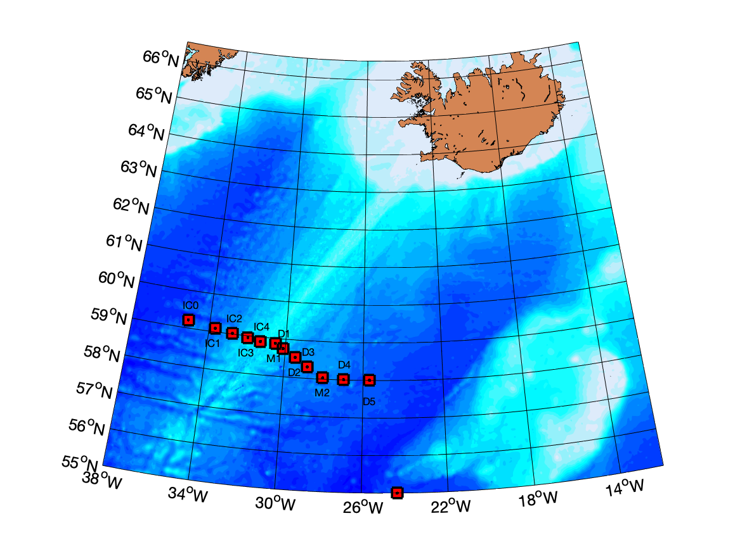
Figure 1. Mooring sites to be serviced (recovered and/or deployed) on the cruise.

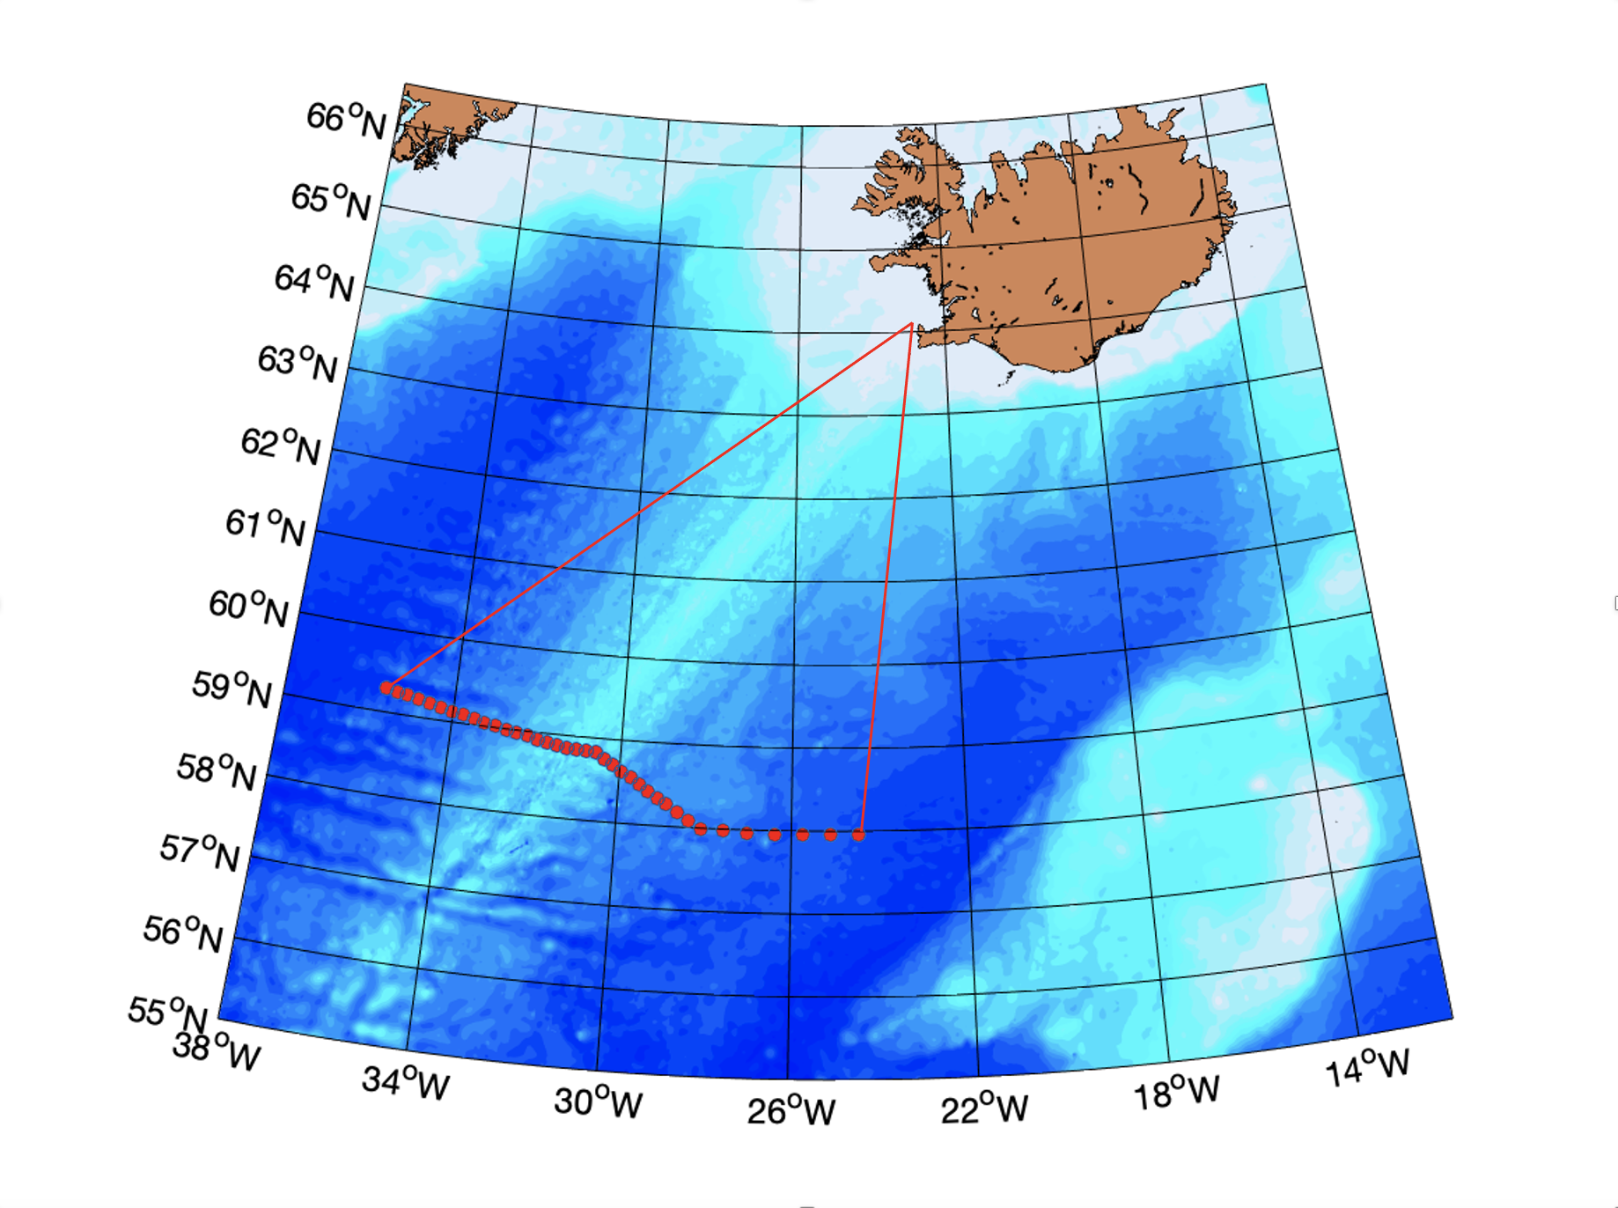
Figure 2. Planned CTD/LADCP stations to be performed during the cruise, and proposed cruise track to and from Reykjavik, Iceland.

