DRAFT Cruise Plan
Date Submitted: December 9, 2019

Platform: RV Armstrong

Project Title: ADEON: Atlantic Deepwater Ecosystem Observatory Network

Project Dates: January 11-14, 2020

Prepared by: ________________________ Dated: __________________
Dr. Jennifer Miksis-Olds
ADEON Lead PI
University of New Hampshire

Approved by: ________________________ Dated: __________________
WHOI Ship Ops
Title
Affiliation (Program or Lab)

Approved by: ________________________ Dated: __________________
Captain
Commanding Officer

I. Overview
A. ADEON Recovery Cruise – 11-14 January 2020
This expedition is a recover cruise for an unrecovered ADEON ocean bottom lander during the ADEON 4 Cruise aboard the R/V Armstrong in Oct-Nov 2019. The ocean bottom lander at the ADEON JAX site was not recovered. The acoustic release was able to communicate and was enabled for release, but the lander did not surface upon release. The lander was visible on the vessel sonar system to confirm location and presence. This project is a collaboration among three federal agencies: the Bureau of Ocean Energy Management (BOEM), NOAA, and the Office of Naval Research (ONR). Data gathered during this mission and future cruises for this project will help inform multiple management issues concerning this region. Details regarding daily operations and objectives can be found below.
B. Days at Sea (DAS)
Cruise is scheduled (11-14 Jan 2020) for 1 day of at sea operations.
C. Operating Area
The cruise will focus on retrieving and re-deploying the JAX lander at 30 º 29.6168 N / 80 º 00.1598 W.
D. Summary of Objectives
The goal of this expedition is to recover and deploy a bottom lander at the ADEON JAX site. Specific objectives include:
- Recover JAX lander with ROV upon arrival on site.
- Turnaround, and redeploy bottom lander at JAX site.
- Conduct CTD casts to collect sound speed profile and water column parameters.

E. Participating Institutions
1. University of New Hampshire
2. JASCO Applied Sciences
F. Personnel/Science Party: name, title, gender, affiliation, and nationality
 | Name (Last, First) | Title | Date Aboard | Date Disem. | Gen. | Affi. | Nat.
1 | Jennifer Miksis-Olds | Chief Scientist/Lead PI | 1/10/2019 | 1/15/2019 | F | UNH | USA
2 | Lawrence, Carmen | Landers |  |  | F | JASCO | USA
3 | TBD | ROV |  |  |  | Oceaneering
4 | TBD | ROV |  |  |  | Oceaneering
5 | TBD | ROV |  |  |  | Oceaneering

G. Administrative
1. Points of Contacts:
j.miksisolds@unh.edu {Chief Scientist}
j.miksisolds@unh.edu {Lead PI}

2. Diplomatic Clearances
None Required.

II. Operations
The Chief Scientist is responsible for ensuring the scientific staff are trained in planned operations and are knowledgeable of project objectives and priorities. The Commanding Officer is responsible for ensuring all operations conform to the ship’s accepted practices and procedures.
Key Changes and Points of Emphasis:
- Mission will Depart from Morehead City, NC and Return to Port Everglades, FL.

- There are no formal Mobilization days, as all items will be loaded at WHOI in Dec 2019.
- CTD rosette must be on board, calibrated, with new bottles mounted; sensors rated to at least 1000 m.

- Crane (probably ship’s) needed to load bottom lander, weight plate sets, and other items onto ship.

- Forklift needs to be on the dock and available for DEMOB
- DEMOB will start on 11 January 2020.

- Project Itinerary:

This expedition will travel to a single location for recovery and deployment of a bottom lander.

Dec 2019: MOB gear, personnel in Woods Hole, MA

11 Jan 2020 – Depart Morehead City, NC
12 Jan 2020 – Arrive at JAX site and conduct ROV ops, recover lander, CTD, turnaround lander.
13Jan 2020 – Deploy JAX lander
14 Jan 2020 – Return to Port Everglades, FL
15 Jan 2020 - DEMOB gear, personnel in Port Everglades, FL

- Staging and Destaging:
Ship’s personnel will be needed (e.g. Crane operator) to help load/offload scientific equipment during MOB/DEMOB.

C. Operations to be Conducted:
Operational Plans: The cruise consists of a single ocean bottom lander recovery with ROV ops, CTD cast, and re-deployment of the lander at the same location.
Scientific Computer System (SCS): We request standard SCS data collection for the cruise. This includes standard surface hydrographic measurements (temperature, salinity, fluorescence, etc).
D. Dive Plan
Dives are not planned for this project.

E. Applicable Restrictions

Bad weather conditions, high sea states, equipment failure, safety concerns, and unforeseen circumstances can preclude normal operations. The ship’s officers, chief scientist, and other personnel will assess and address any concerns or issues affecting normal operations.
III. Equipment
- Equipment and Capabilities provided by the ship (itemized)
CTD rosette with sufficient weight to conduct CTD casts down to 2000m
CTD sensors required: transmissometer, DO, temperature, conductivity, fluorescence, depth
EK80
Multibeam SONAR
Dynamic Positioning
Working winches
Working cranes

- Equipment and Capabilities provided by the scientists (itemized)
Bottom landers and weight plate sets. (see Appendix 1)

IV. Hazardous Materials - NONE
A.
V. Additional Projects
A. Supplementary (“Piggyback”) Projects
No Supplementary Projects are planned.

VIII. Appendices
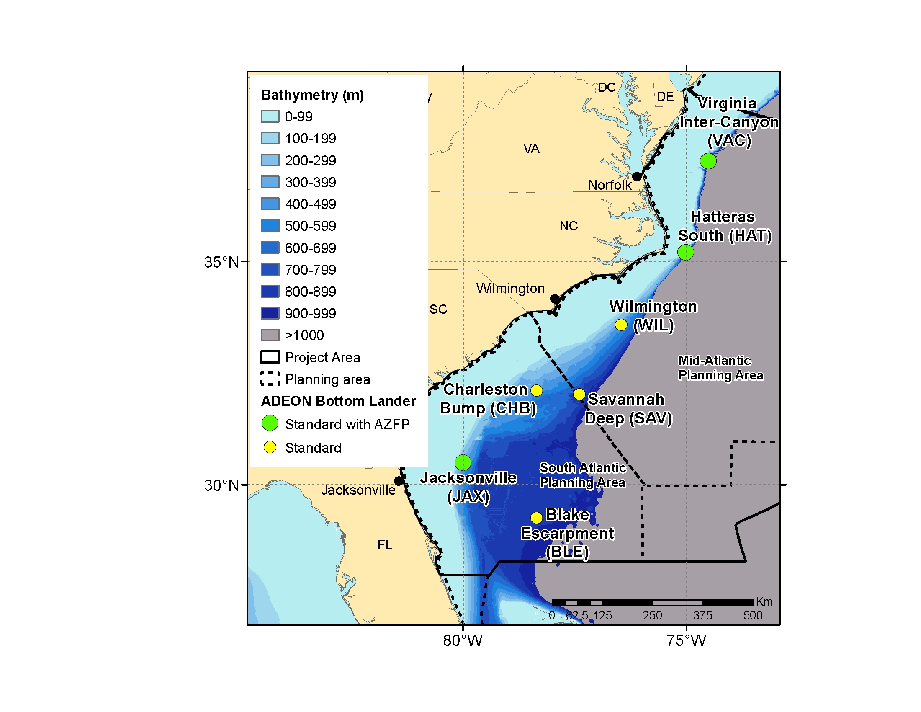
Figure 1. Map of ADEON site locations. Only the JAX site will be visited during the ADEON Recovery Cruise aboard the R/V Armstrong.

Appendix 1. Bottom-Lander Deployment and Recovery

The mooring has no cable (except for the winch used to lower it to the water surface), it is a freefall tetrahedral frame. It contains one component, with the anchor built into the structure. There will be 8 altogether, and I've attached a drawing, which contains the dimensions. Each mooring weighs ~ 550 kg and are subsurface with no surface impression.

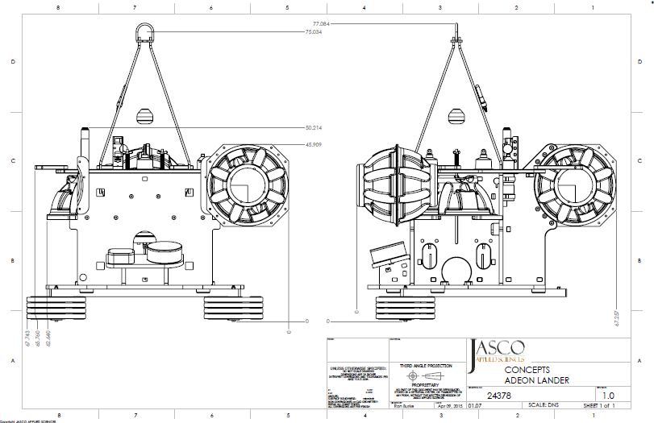
Figure A1.1. Schematic of bottom lander tetrahedral free-fall frame.

We will be supplying our own deck boxes to communicate with the acoustic releases.

The deployment procedure is as follows:

1. Vessel will approach the deployment position, down wind and current. Lander will be hung abaft the A-frame (complete mooring) via centerline winch. A-Frame will be used for over boarding the Lander, ~550kg with an on-load quick release (Sea Catch TR7 model). A slip-through tag line will be passed around the starboard side of the A-frame to control motion of lander during lifting.

2. Lander will be lowered below the water-line until the on-load release is just above the waterline. Vessel to drift into deployment position.

3. Ship is to maintain minimum speed to maintain position.
4. Once the vessel is in position, the tag line may be removed by the JASCO Lead. Once the tag line is retrieved, the order to release the on-load release and deploy the Lander via A-Frame will be given once all personnel are in position. All non-essential personal will be off the aft deck.

5. The order to ‘release’ will be given by the JASCO Lead.

6. Once the mooring is on bottom, JASCO to annotate logs, ship to mark plot.

7. Once the Lander is bottomed, a range check with the PortLF release will be done and position in logs will be annotated. Release is then disabled.

Retrieval Procedure (in consultation with ROV ops through Oceaneering:

TBD as discussion evolve with Oceaneering and lander condition is assessed.

