DRAFT Cruise Plan
Date Submitted: July 02, 2019

Platform: RV Armstrong

Project Title: ADEON: Atlantic Deepwater Ecosystem Observatory Network

Project Dates: October 20, 2019 to November 6, 2017

Prepared by: ________________________ Dated: __________________
Dr. Joseph D. Warren
Chief Scientist
Stony Brook University, 239 Montauk Hwy, Southampton, NY 11968

Approved by: ________________________ Dated: __________________
Dr. Jennifer Miksis-Olds
ADEON Lead PI
University of New Hampshire

Approved by: ________________________ Dated: __________________
WHOI Ship Ops
Title
Affiliation (Program or Lab)

Approved by: ________________________ Dated: __________________
Captain
Commanding Officer

I. Overview
A. ADEON Cruise #4, 20 October – 06 November, 2019
This expedition is the fourth of five cruises for this project focused on recovery, turnaround, and redeployment of bottom landers at seven sites along the outer continental shelf (OCS) of the United States east coast. In addition to the lander work, station sampling will occur at each location consisting of CTD profiles, net trawls for biological specimens, and a fine-scale, lawnmower pattern active acoustic survey using the hull-mounted echo sounder on the RV Armstrong. This project is a collaboration among three federal agencies: the Bureau of Ocean Energy Management (BOEM), NOAA, and the Office of Naval Research (ONR). Data gathered during this mission and future cruises for this project will help inform multiple management issues concerning this region. Details regarding daily operations and objectives can be found below.
B. Days at Sea (DAS)
Cruise is scheduled (20 Oct – 06 Nov) for 18 days of at sea operations.
C. Operating Area (see Figure 1)
The cruise will focus on activities at seven station locations along the eastern US continental slope, 37.5° N, -80°W to 29°N, -74.5°W (See Figure 1, Table 1).
D. Summary of Objectives
The goal of this expedition is to deploy bottom landers at seven sites and collect additional active acoustic survey, CTD profiles, net trawl/tow sampling at each site. In addition, transmission loss experiments will be conducted at four of the sites. After deploying all the bottom landers, we will return to the first site and recover and redeploy the lander at the same location. Specific objectives include:
- Recover, Turnaround, and redeploy bottom landers at seven site locations. (see Appendix 1)
- Conduct CTD casts to collect water column hydrography and water samples (down to 1000 m).
- Conduct net sampling for biological organisms using a mid-water trawl and vertical ring nets. (see Appendix 2)
- Collect echo sounder data using the EK80 system aboard the RV Armstrong during normal operations and during fine-scale (10 km x 10 km) lawnmower surveys at each study site.
- Calibration of EK80 echo sounders will occur if weather/sea conditions permit.

E. Participating Institutions
1. Stony Brook University
2. University of New Hampshire
3. JASCO Applied Sciences
4. TBD
F. Personnel/Science Party: name, title, gender, affiliation, and nationality
 | Name (Last, First) | Title | Date Aboard | Date Disem. | Gen. | Affi. | Nat.
1 | Warren, Joseph | Chief Scientist Acoustics/Nets |  |  | M | SBU | USA
2 | Blair, Hannah | Acoustics/Nets |  |  | F | SBU | USA
3 | Lucca, Brandyn | Acoustics/Nets |  |  | M | SBU | USA
4 | TBD | Nets |  |  | M | SBU | USA
5 | TBD | Nets |  |  | M | FAU | USA
6 | Miksis-Olds, Jennifer | Lead PI  AZFP/MMO |  |  | F | UNH | USA
7 | Kates Varghese, Hillary | MMO |  |  | F | UNH | USA
8 | TBD | MMO |  |  | M | Dalhousie | CA/USA
9 | Lawrence, Carmen | Landers |  |  | F | JASCO | USA
10

G. Administrative
1. Points of Contacts:
joe.warren@stonybrook.edu {Chief Scientist}
j.miksisolds@unh.edu {Lead PI}

2. Diplomatic Clearances
None Required.

II. Operations
The Chief Scientist is responsible for ensuring the scientific staff are trained in planned operations and are knowledgeable of project objectives and priorities. The Commanding Officer is responsible for ensuring all operations conform to the ship’s accepted practices and procedures.
Key Changes and Points of Emphasis:
- Science watches should be on a regular schedule, but may be adjusted depending on tasks.

- Mission will Depart from and Return to Woods Hole, MA.

- Mobilization begins on 17 October 2019.
- CTD rosette must be on board, calibrated, with new bottles mounted; sensors rated to at least 1000 m.

- Would like to use the Armstrong’s USBL (I believe) transponder on our IKMT trawls (attached to wire just above our net) for real time net depth monitoring.

- EK80 will require current calibration (if available)
- Crane (probably ship’s) needed to load bottom lander, weight plate sets, and other items onto ship.

- Forklift needs to be on the dock and available for MOB/DEMOB
- DEMOB will start on 07 November. We will have MUCH less gear/equipment to offload: no landers, mostly empty cases, with the only addition being net jars.

- Project Itinerary:

This expedition will travel to seven site locations for deployment of bottom landers and water column (CTD, net) sampling. Four of the sites will also have a transmission loss experiment occur. The vessel will return to the first station location and recover and redeploy the bottom lander before returning to port.

17-19 Oct: MOB gear, personnel in Woods Hole, MA

For estimated time line of cruise operations, see Appendix 3.
07-08 Dec: DEMOB gear, personnel in Woods Hole, MA (expect that DEMOB will be done in 1 day)

- Staging and Destaging:
Ship’s personnel will be needed (e.g. Crane operator) to help load/offload scientific equipment during MOB/DEMOB.

C. Operations to be Conducted:
Operational Plans: The cruise consists of a series of station operations (e.g. lander deployment, ctd profile, etc) that will occur at each station. As well as a few operations that will occur once (i.e. EK80 calibration). Detailed information about the non-standard different operations are contained in the Appendices to this cruise plan.
Scientific Computer System (SCS): We request standard SCS data collection for the cruise. This includes standard surface hydrographic measurements (temperature, salinity, fluorescence, etc).
EK80 Data Acquisition: The Simrad EK80 echo sounder, (18-, 38-, 70-, 120-, and 200-kHz with split-beam transducers) will acquire data continuously throughout the cruise, as long as its operation won’t interfere with other sensor data collection. The EK80 will be interfaced to the SCS to record bottom depth and vessel log values. The EK80 will be interfaced to the POSMV motion sensor. When operational, the EK80 will be synchronized with the Simrad ME70 multibeam (operating within the frequency band 70–120 kHz), and the ship’s ADCP. The EK80 is not synchronized with the other sounders and Doppler speed log on the vessel. To minimize acoustic and electrical interference, whenever possible we request deactivating other sounders on the vessel. The survey technicians will be responsible for EK80 and ME70 data acquisition and storage.
Further details on these additional operations are as follows:
1. Physical oceanographic parameters will be monitored through CTD casts, and the ship’s flow-through thermosalinograph and fluorometer instruments. Both of these systems (flow-through and CTD rosette-based) contain fluorescence sensors which will be used to provide information on horizontal and vertical variations in primary productivity. These data will be used to help reference and integrate the satellite measurements of primary productivity that are also being integrated into the ADEON data repository.
2. CTD casts will be conducted when at each site. The ship will supply SBE19+ and SBE911+, ECO Chlorophyll Fluorometer and Turbidity sensor (rated to at least 2000 m), and O2 sensor (rated to at least 2000 m). CTD rosette will also collect discrete water samples. The survey technician, with help from the science team, will be responsible for CTD operations. Some water samples may be filtered to ground-truth primary productivity estimates made from the fluorescence sensors on the CTD rosette and ship’s flow-through system.
4. Mid-water trawling will be conducted to sample deep-scattering layers identified in the EK80 data. The science team, with help from the survey tech and deck crew, will be responsible for trawling operations. (see Appendix 2)
D. Dive Plan
Dives are not planned for this project.

E. Applicable Restrictions

Bad weather conditions, high sea states, equipment failure, safety concerns, and unforeseen circumstances can preclude normal operations. The ship’s officers, chief scientist, and other personnel will assess and address any concerns or issues affecting normal operations.
III. Equipment
- Equipment and Capabilities provided by the ship (itemized)
CTD rosette with sufficient weight to conduct CTD casts down to 2000m
CTD sensors required: transmissometer, DO, temperature, conductivity, fluorescence, depth
EK80
Multibeam SONAR
ADCP
Dynamic Positioning
Oxygen sensor rated to at least 2000m
ECO Chlorophyll Fluorometer and Turbidity sensor rated to at least 2000m
USBL transponder (for attachment to trawl wire above our mid-water trawl)
Working winches
Working cranes
Freezers—80 and walk-in freezer
Seawater available on deck

- Equipment and Capabilities provided by the scientists (itemized)
Net tow systems.
Bottom landers and weight plate sets. (see Appendix 1)

IV. Hazardous Materials
A. Policy and Compliance
The Chief Scientist will include with their project instructions and provide to the CO of the respective ship 30 days before departure:
    - List of chemicals by name with anticipated quantity
    - List of spill response materials, including neutralizing agents, buffers, and absorbents
    - Chemical safety and spill response procedures, such as excerpts of the program’s Chemical Hygiene Plan or SOPs relevant for shipboard laboratories
    - For bulk quantities of chemicals in excess of 50 gallons total or in containers larger than 10 gallons each, notify ship’s Operations Officer regarding quantity, packaging and chemical to verify safe stowage is available as soon as chemical quantities are known.

B. Inventory
Common Name of Material | Qty | Notes | Trained Individual | Spill  control
Formalin | 10 liters | Stored in ship chem. locker | J. Warren | F
95% Ethyl Alcohol (ethanol) | 2 liter | Alkalinity, stored in ship chem. locker | J. Warren | E
Borate buffer (Borax) | 1 kg | Stored in ship chem. locker | J. Warren | NA - powder
C. Chemical safety and spill response procedures
F: Formalin/Formaldehyde
- Ventilate area of leak or spill. Remove all sources of ignition.
- Wear appropriate personal protective equipment.
- Isolate hazard area. Keep unnecessary and unprotected personnel from entering. Contain and recover liquid when possible.
- Use non-sparking tools and equipment. Collect liquid in an appropriate container or absorb with an inert material (e. g., vermiculite, dry sand, earth), and place in a chemical waste container.
- Do not use combustible materials, such as saw dust.

E: Ethanol
- Ventilate area of leak or spill. Remove all sources of ignition.
- Wear appropriate personal protective equipment.
- Stop the flow of material. Dike the spilled material.
- Carefully cover the area with spill absorbent material.
- Sweep up the residue using spark-proof tools and place the residue into a labeled, plastic, waste container (plastic pail with lid or double heavy duty plastic bags). Store for disposal as hazardous waste.
- Mop the affected area using detergent and water.

D. Radioactive Materials
No Radioactive Isotopes are planned for this project.
E. Inventory (itemized) of Radioactive Materials
Not applicable
V. Additional Projects
A. Supplementary (“Piggyback”) Projects
No Supplementary Projects are planned.

VIII. Appendices
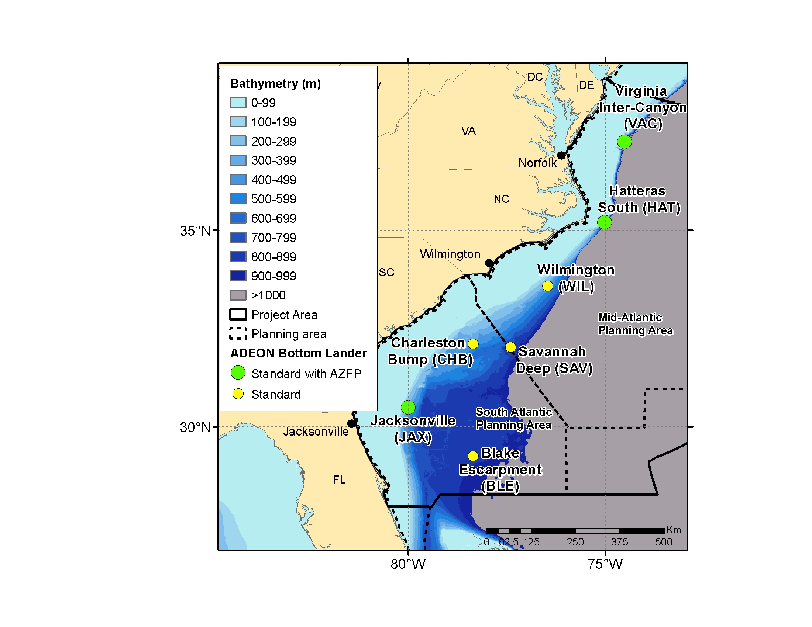
Figure 1. Map of ADEON site locations to be surveyed during the ADEON RV Armstrong cruise.

Table 1: Lander deployment locations, depth and estimated bottom locations from the EN 626 cruise. Station locations for AR040 cruise should be based on the “Estimated Location” column in this table.
Site | Deployment Location |  | Drop Date | Time (UTC) | Estimated Location |  | Depth (m)
Site | Latitude | Longitude | Drop Date | Time (UTC) | Latitude | Longitude | Depth (m)
BLE | 29°15.036’N | 078°21.064’W | 2018-11-06 | 14:08 | 29 15.0546 N | 078 21.0701 W | 868
JAX | 30°29.587’N | 080°00.177’W | 2018-11-07 | 17:52 | 30 29.6121 N | 080 00.1623 W | 317
CHB | 32°04.231’N | 078°22.424’W | 2018-11-04 | 16:04 | 32 04.2936 N | 078 22.2768 W | 401
SAV | 32°02.568’N | 077°20.885’W | 2018-11-08 | 23:04 | 32 02.6370 N | 077 20.8237 W | 790
WIL | 33°35.127’N | 076°27.034’W | 2018-11-10 | 15:19 | 33 35.2429 N | 076 26.9207 W | 460
HAT | 35°11.995’N | 075°01.187’W | 2018-11-11 | 15:15 | 35 12.0834 N | 075 01.0969 W | 291
VAC | 37°14.762’N | 074°30.872’W | 2018-11-12 | 16:54 | 37 14.7618 N | 074 30.8698 W | 212

Appendix 1. Bottom-Lander Deployment and Recovery

The mooring has no cable (except for the winch used to lower it to the water surface), it is a freefall tetrahedral frame. It contains one component, with the anchor built into the structure. There will be 8 altogether, and I've attached a drawing, which contains the dimensions. Each mooring weighs ~ 550 kg and are subsurface with no surface impression.

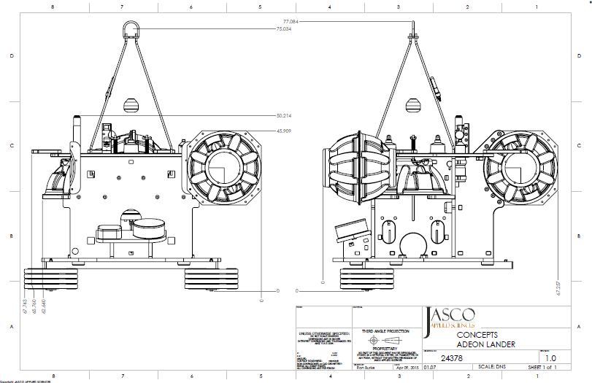
Figure A1.1. Schematic of bottom lander tetrahedral free-fall frame.

We will be supplying our own deck boxes to communicate with the acoustic releases.

The deployment procedure is as follows:

1. Vessel will approach the deployment position, down wind and current. Lander will be hung abaft the A-frame (complete mooring) via centerline winch. A-Frame will be used for over boarding the Lander, ~550kg with an on-load quick release (Sea Catch TR7 model). A slip-through tag line will be passed around the starboard side of the A-frame to control motion of lander during lifting.

2. Lander will be lowered below the water-line until the on-load release is just above the waterline. Vessel to drift into deployment position.

3. Ship is to maintain minimum speed to maintain position.
4. Once the vessel is in position, the tag line may be removed by the JASCO Lead. Once the tag line is retrieved, the order to release the on-load release and deploy the Lander via A-Frame will be given once all personnel are in position. All non-essential personal will be off the aft deck.

5. The order to ‘release’ will be given by the JASCO Lead.

6. Once the mooring is on bottom, JASCO to annotate logs, ship to mark plot.

7. Once the Lander is bottomed, a range check with the PortLF release will be done and position in logs will be annotated. Release is then disabled.

Retrieval Procedure:
  - Ship is to approach to an upwind position ~300m from the AEDON Lander waypoint and maintain position.
  - Transducer is lowered, ~15m below the waterline, ship de-clutched. Enable code is sent and JASCO technician establishes communication and range with PORT LF acoustic release. Once communication and position are established, release code is sent.
With FRC:
  - Once the ADEON buoy is on the surface the FRC crew deploys and both vessel and FRC begins steaming towards lander.
  - Crane operator lowers hook to the water line and FRC crew attaches crane hook to lift point of the lander. FRC crew clears area and crane operator begins lifting lander aboard.
Without FRC:
  - Once the ADEON buoy is on the surface vessel steams toward location. Crew prepares Kong boat hook attached to gaff with loop in line to attach to crane hook.
  - Once vessel reaches lander, crew member uses gaff to snap Kong boat hook onto the lift point of the lander and detaches Kong hook from gaff. Once gaff is free, the loop in the lift line on end of Kong hook is attached to the crane hook and the lander is lifted aboard and secured.
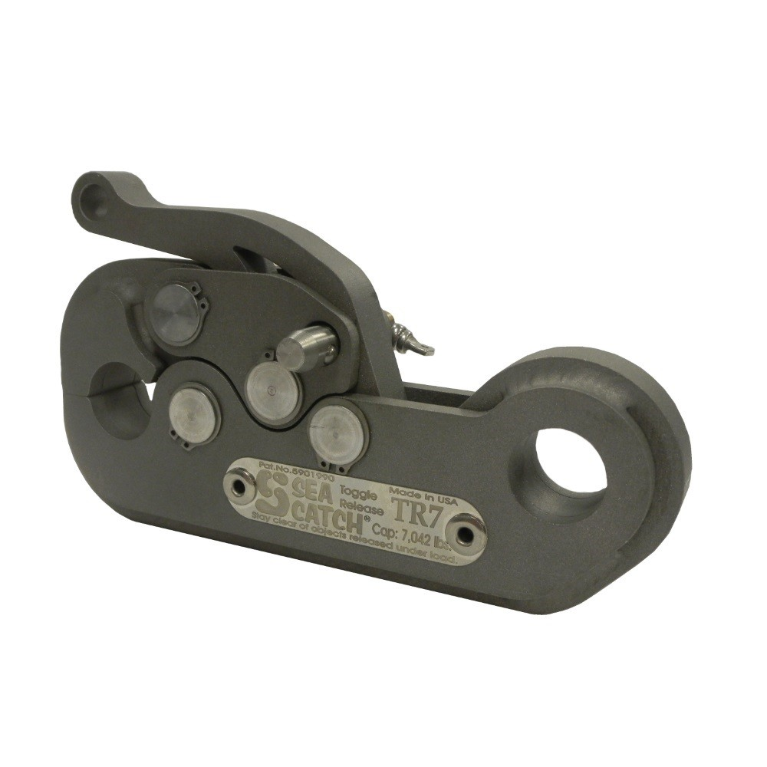
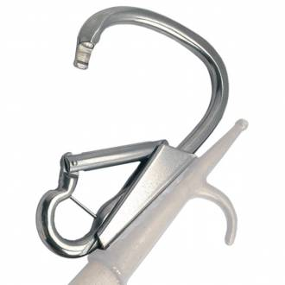
Sea Catch TR7 On-Load Quick Release (left) Kong Boat Hook (right)

Appendix 2. Net trawl operations
Mid-water Trawls: An Isaacs-Kidd Midwater Trawl (IKMT) and smaller ring nets will be used to collect midwater organisms for community analysis and to ground truth the acoustic data (Fig. A2.1).
The IKMT net is approximately 2 m wide by 3 m high (when fully extended) by 7 m in length. It consists of a horizontal spreader bar at the top and a weighted, depressor plate or v-fin at the bottom which are connected by a wire bridle that is collapsible. The net can be deployed from the stern or side of the vessel and has a single cod-end which is deployed/recovered by hand. Securing the weighted depressor v-fin is the primary launch and recovery consideration.
The IKMT is connected to a standard 9/16” trawl wire.
Multiple tows to specific depth-layers may conducted and would generally occur to depths ranging from 100 to 2000 m. In most cases the wire-out/net depth scope is ~1.7:1 to 2:1, so the maximum wire out needed is estimated to be 3000 m. Wire out/in speeds range from 10 to 30 meters per minute. Tows are conducted at vessel speeds of 2-4 kts and will take approximately 60-120 minutes depending on layer depth.
On our previous Armstrong cruise, the Armstrong’s USBL (I believe) transponder was attached to the trawl wire just above our net which allowed us to have real-time depth-monitoring while doing the tow which was INCREDIBLY useful. We’d like to use that again if possible.
Ring Nets: Vertical net casts will be made using a bongo-type net. These will be made with the ship stationary. Net mouth diameters will be ~60 cm or smaller and 5-7 m in length and can be deployed by hand via line or preferably by shackle attachment to a winch with a large weight (30+ lbs) attached below the net. Nets are lowered to a depth and then hauled back (typical downcast wire out speeds are 30 m/min and haul back speeds are 10-15 m /min). These can be done preferably from the side of the ship rather than the stern. If the ship has a clump weight (15 kg+), we would use that to keep the cable vertical during the net haul.
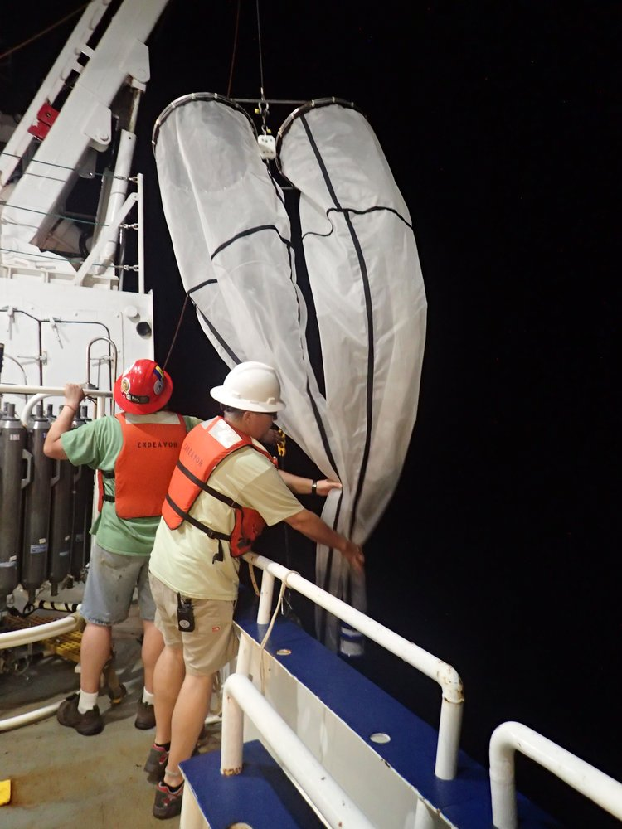
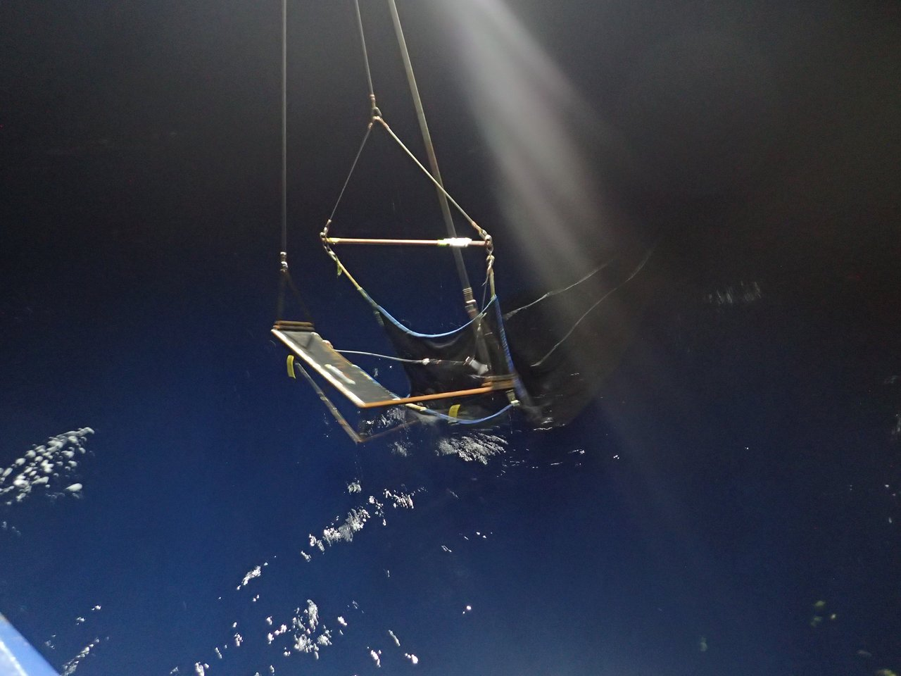
Figure A2.1 An IKMT net (left) and bongo-net ring nets (right) being deployed off the stern (left) and starboard side (right) during EN 615.

Appendix 3. Timeline of cruise operations.
ADEON Preliminary Cruise Plan (as of 2019.07.03) for Oct/Nov (AR040) RV ARMSTRONG

