Figure 1. NIOZ monocore will be suspended under the CTD rosette by a 10 m line. The monocore weighs about 33 lbs.

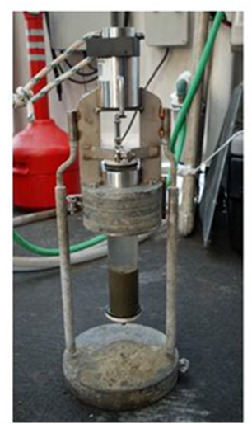

Appendix 2. Description of the monocore deployment procedures.

1. Attach line (scientist provided rope) with a bowline knot to the bottom of the CTD rosette and to the top of the monocore (See Appendix 2 Figure 1). Length of line will equate to the safe working distance between the bottom of the rosette and seafloor (e.g., 10 m), determined by ship operations.

2. Deploy CTD rosette over side of ship, and allow the monocore to hang below the rosette before lowering CTD to the seafloor. Remove black clip while the core is under tension; this is necessary so that the core can properly sink into the mud once the core has reached the seafloor.

3. When the rosette is approximately 50 m above bottom, lower winch speed to 30 m/min.

4. Lower CTD to 10 m above bottom or safe working distance used by the ship.

5. Raise the CTD rosette slowly, 30m/min until 50 m above bottom, then continue recovering the CTD at speed determined by ship operations.

6. Once the CTD is at the surface, recover the monocore.

7. Place black clip on top of monocore to ensure the core sample is secured.

8. Place monocore in stand (See Figure 1).

Figure Appendix 2.1 Monocore deployment schematic.

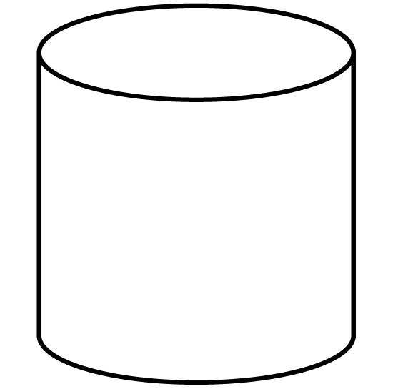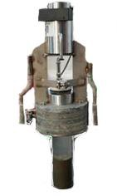

CTD

rosette

Line (scientist-supplied rope

–working load=250kg) Length=10 m or equivalent safe offbottom working distance established by ship operations

Bowline knot securing line

to rosette-with tie wrap securing loose end of knot

Black clip is removed before deployment while line (rope) is under tension

Bowline knot securing line to monocore-with tie wrap securing loose end of knot

