UNC Buoy Turn-around Operation Proposal
Tuesday, November 27, 2017

Recovering the UNC buoys for maintenance will be a challenging operation for the upcoming January 2018 cruise on the R/V Neil Armstrong. Here, we propose recovery of only the top half of the mooring, in the hope that doing so might simplify part of the operation, provided it is reviewed and approved by ship personnel.

A recovery and redeployment will be undertaken only if there appears to be a sufficiently long weather window to support the operations. We estimate that approximately 12 hours of relatively calm seas will be needed to complete the turn-around. Once redeployed we will also want to spend roughly 2 hours on site to ensure the buoys are functioning properly. If we don’t have a weather window of sufficient duration we prefer to leave the buoys deployed in their present condition.

The buoy has several elements that when deployed rise above the top safety ring of the buoy superstructure, specifically 2 anemometers, mounted on Delrin rods, and the lightning rod. Each of these elements is retractable, that is, they can be lowered into positions below the top safety ring. When the UNC group has done recoveries from smaller coastal vessels we have found it necessary to first put staff on the buoy using a small boat to lower the anemometers and lightning rods. This practice was a response to damage to the anemometers by small A-frames and/or the wire used to lift the buoys during recovery. From the R/V Armstrong it may be possible to recover the buoy without this step, though we want to carefully consider how this might be done.

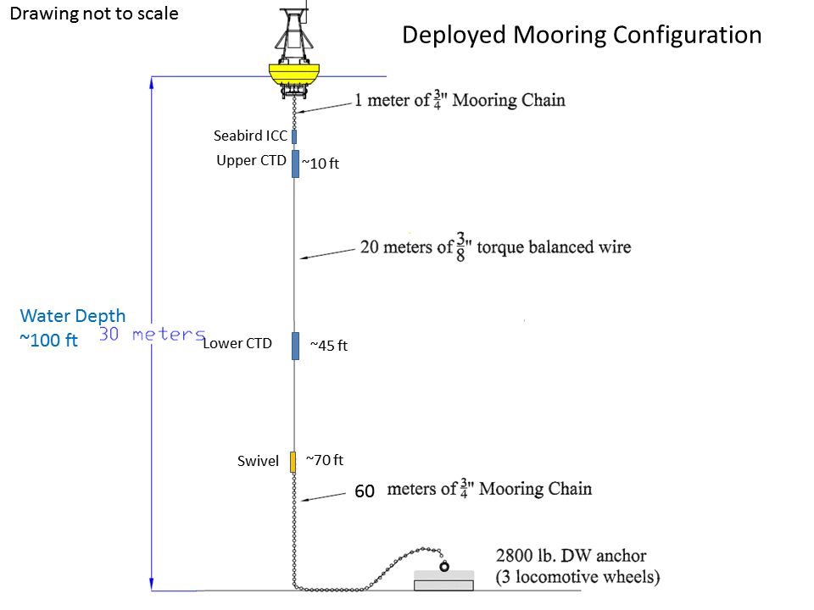

Figure 1. Schematic of the UNC buoy mooring as deployed showing components of the mooring system, lengths and depths. Drawing not to scale.

The proposal is to recover the buoys and mooring wire onto the vessel and separate the mooring to temporarily leave the mooring chain and anchor on station with a marker ball and line. This avoids having to recover the mooring chain and anchor. This will free the vessel from the buoy mooring to move off a safe distance or proceed to another station while preserving the chain and anchor. Once buoy maintenance is complete, the buoy and new mooring wire with refreshed sensors can be reattached to the anchor and chain, when the vessel is ready and in position to recover the marker. With this process, there are two distinct phases to the turn-around operation, recovery (Phase 1) and redeployment (Phase 2) of the buoy.

Phase 1. The proposed process to recover the buoys would be as follows. First, lift the buoy and secure the shackle between the 1m buoy chain and wire rope, then disconnect the short chain and buoy from the wire rope. Several options exist for lifting the buoy, including:

- After small boat operations lower sensitive instruments, the ship onboards the buoy through the A-frame. The buoy would be lifted from a single point on the superstructure close to the toroid. Would this require two blocks from the A-frame, one to the trawl winch (to pick up the buoy) and the second to the deck winch (to recover the mooring wire)?
- Leave the sensitive instruments deploy but attach to the buoy superstructure to control buoy motion prior to attaching to the lift point and recovering through the A-Frame. The buoy would be lifted from a single point on the superstructure close to the toroid. This too may require two blocks from the A-frame. Could a tugger be attached to the buoy superstructure, possibly with the line run through the aft scuppers, to pull the buoy over and provide control on its motion?
- Come alongside the buoy and lift it with the crane as a way to avoid possible collision of the buoy with the A-frame. The buoy could be lifted as above or using a 2-point bridle. It is not clear how best to separate the buoy from the rest of the mooring; there is a need to connect the top of the wire rope to the deck winch for recovery.

Regardless of which option (or some other) is used, while the buoy is suspended the inductive coupler will need to be removed (the ICC) from the top of the wire rope.

Next, pass the wire rope through the block to the deck winch and while winding, remove the sensors (2 CTDs). Two people are typically required for this operation, one to remove clamps, the other to hold parts. Finally, when the swivel is recovered, disconnect the mooring between the wire rope and chain at the shackle just below the swivel (Figure 1). The 60 m of chain allows enough scope to consider performing this operation because water depth is ~30 m.

After disconnecting, a large, visible poly ball (we suggest 1m diameter) and approximately 30 meters of appropriate rope can be connected to the free-end of the chain to temporarily mark its location (Figure 2). Use of a large float will allow the length of line to be roughly the same as the water depth to assure there is no loose line – essentially a tautline mooring. Assuming 30 m of chain weighs approximately 500 lbs, each meter of chain should weigh about 17 lbs.

Phase 2. The surface float will then be used to recover the mooring chain for redeploying the buoy. The details of this second phase still need to be discussed with the ship crew. But the process would roughly be the reverse of the recovery, except that the wire rope could be layed out on the deck, not wound on the winch, ready to go over the side once the mooring chain is reattached to the swivel. At issue is how best to control the payout of the wire rope as the buoy is redeployed. It may be best to lower the wire rope, with sensors, into the water, then deploy the buoy, and last release the connection to the top of the chain.

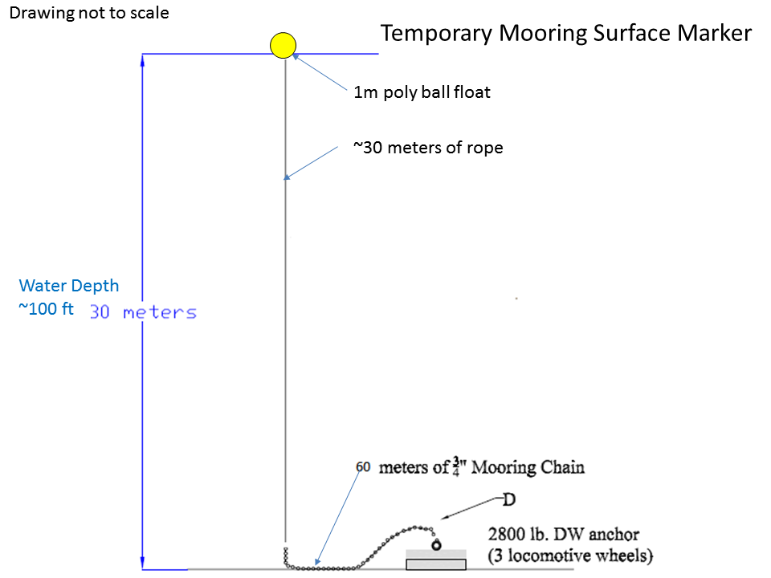

Figure 2. Schematic of temporary marker and rope attached to loose end of the mooring chain allowing ship to move off and then later recover the mooring for redeploying the buoy.

Besides being a little less work, this proposed method of buoy turn-around will preserve the buoy mooring hardware while allowing necessary maintenance of the buoy system and hardware. It is questionable whether the chain and anchor would survive recovery from the ocean floor because it may be buried in sediment or corroded; the chain has parted from the spindle on the anchor during past recoveries. We do not have spare mooring chain and anchor components.

And the issue of the sensitive instruments is repeated on the deployment – should we try to deploy with the instruments at full height, or raise them after deployment with small boat operations? We will have a much better sense of which approach is needed once we recover one of the buoys.

