NOC DWBC moorings

M1 [41.1118 W, 59.9030 N] at water depth = 2086 m
Instruments at:
Depth (m) 1959 1719 1479 1239 999 759 519 279 39
Type* A/C C/C C/C C C/C C C/C C C/C

(*Type: A/C = ADCP+CTD, C/C = CTD+CM, C = CTD,
where ADCP- 300 kHz ADCP, CM- Nortek current meter, CTD- microcat CTD)

M2 [40.6889 W, 59.8591 N] at water depth = 2434 m
Instruments at:
Depth (m) 2329 2114 1899 1684 1469
Type A/C C C/C C C

M3 [40.2765 W, 59.8148 N] at water depth = 2564 m
Instruments at:
Depth (m) 2460 2170 1880 1590 1300
Type A/C C C/C C C

M4 [38.5657 W, 59.6466 N] at water depth = 2989 m
Instruments at:
Depth (m) 2885 2545 2205 1865 1525
Type A/C C C/C C C/C

M5 [37.7992 W, 59.5771 N] at water depth = 3214 m
Instruments at:
Depth (m) 3033 2673 2313 1953 1593
Type A/C C C/C C C

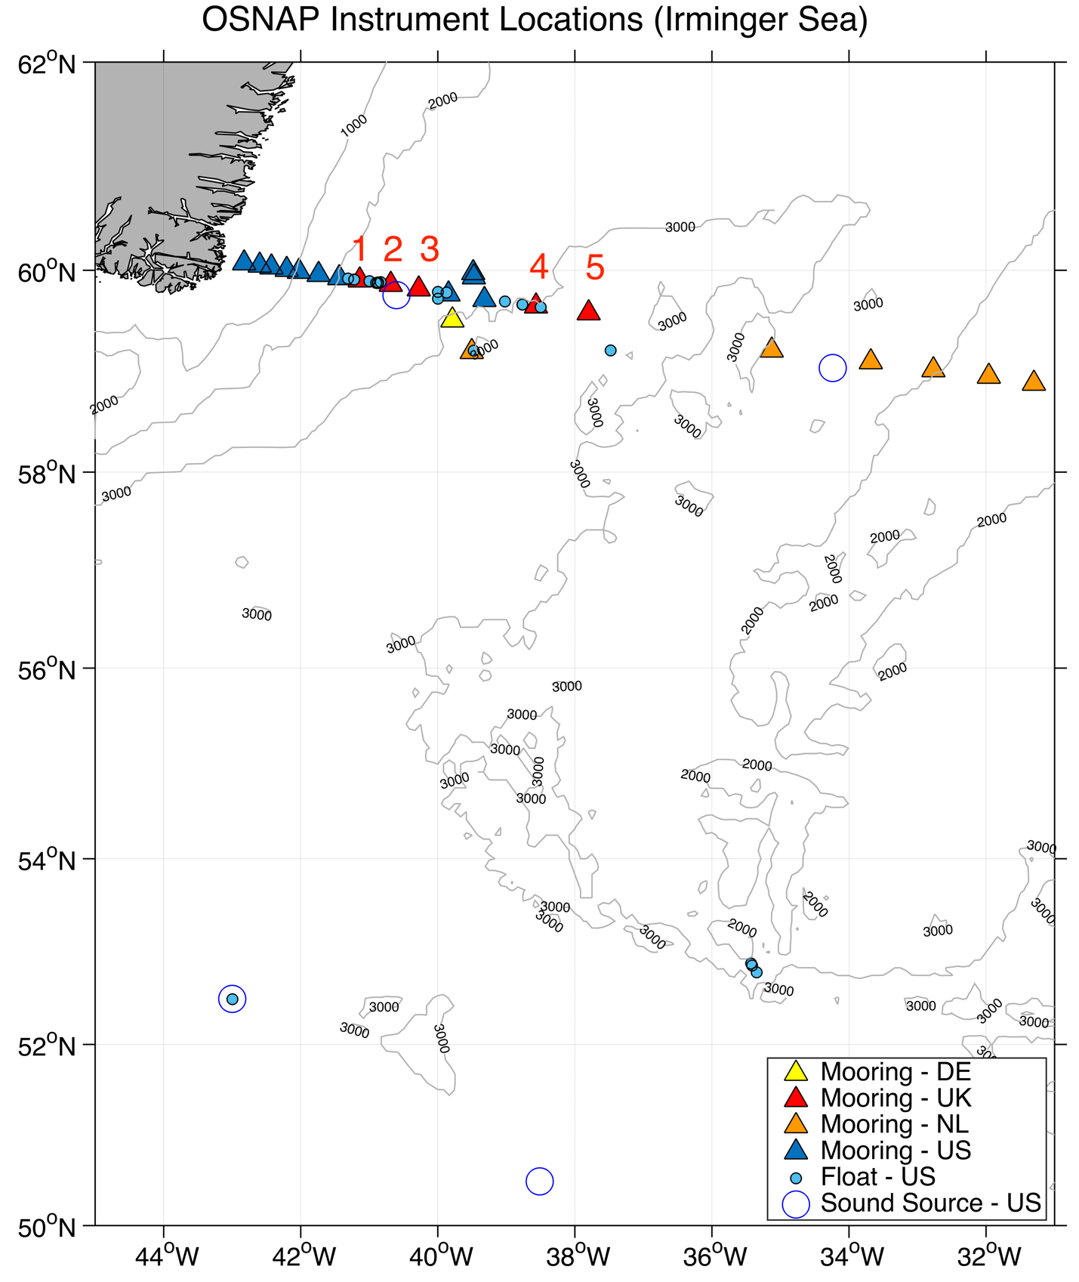

Figure 1. Location of five NOC moorings (NOC M1-M5; red triangles). Contours show the 1000-, 2000- and 3000m isobaths.

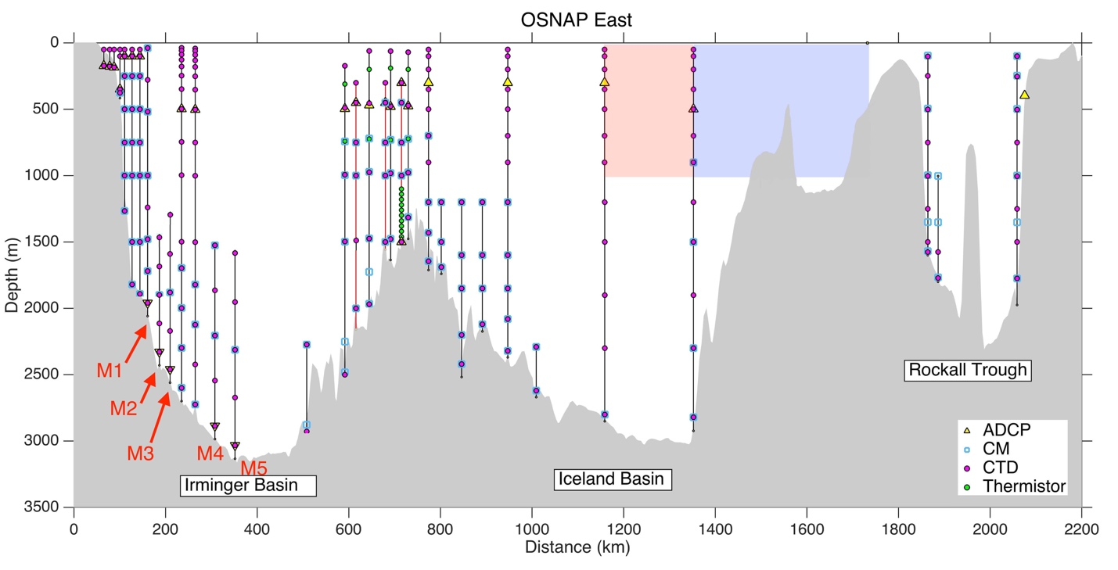

Figure 2. Instruments on the OSNAP moorings. Red labels indicate five NOC moorings.

