Cruise Plan
Coastal Pioneer SVC-III
R/V Armstrong Cruise AR1-07
31 Mar – 6 Apr 2016

Control Number: 3204-00506
Version: 0-02
Author: A. Plueddemann
Date: 03/23/2016
Approved:

Coastal and Global Scale Nodes
Ocean Observatories Initiative
Woods Hole Oceanographic Institution
Revision History
Version | Description | Originator | Release Date
0-01 | Draft for IPT Meeting | A. Plueddemann
0-02 | Revisions after IPT Meeting | A. Plueddemann

Table of Contents

Table of Contents ii
List of Figures iii
List of Tables iii
1.0 Introduction 1
1.1. Overview 1
1.2. Operating Area 1
2.0 Cruise Plan 1
2.1. Background 1
2.2. Staging and De-Staging 5
2.3. Cruise Operations and Objectives 5
2.3.1. Mooring Operations 6
2.3.2. Glider Operations 6
2.3.3. CTD casts 6
2.3.4. Sensor Performance Evaluation 6
2.3.5. Shipboard Underway Data 6
2.3.6. Small Boat Operations 6
2.4. Potential Restrictions 7
3.0 Appendices 7
Appendix A – Cruise Timeline 8
Appendix B – Selected Waypoints and Maps 9
Appendix C – Science Party 10

List of Figures
Figure 2-1 – Map of the Pioneer Array region 2
Figure 2-2 - Pioneer Array mooring site locations. 3
Figure 2-4 – Pioneer Array glider lines. 4
Figure 3-1 - Pioneer Central Surface Mooring (CNSM) 11
Figure 3-2 - Pioneer Central Inshore Profiler Mooring (PMCI) 12

List of Tables
Table 3-1 – Pioneer-SVC-III station list 9

Introduction

Overview
The Pioneer Array includes a network of moorings and autonomous robotic vehicles to monitor waters of the continental shelf and slope south of New England and, in particular, the shelfbreak front where nutrients and other properties are exchanged between the coast and the deep ocean. Data from the Pioneer Array will provide new insights into coastal ocean processes such as shelf/slope nutrient exchange, air-sea property exchange, carbon cycling, and ocean acidification that are important to the New England shelf and to continental shelf ecosystems around the world.
Infrastructure service cruises for the Pioneer Array of the National Science Foundation’s Ocean Observatories Initiative (OOI; http://www.oceanobservatories.org) are nominally scheduled twice per year (spring and fall). The sixth Pioneer infrastructure service cruise (Pioneer-6) will take place on the new WHOI ship R/V Neil Armstrong in May and June of 2016. In preparation for that work, the OOI team has been invited to participate in a series of Science Verification Cruises (SVC). This plan describes Pioneer-related work to be conducted on the third such cruise, SVC-III, planned to depart Norfolk, VA on 31 March 2016 and arrive at WHOI on 6 April.
The Pioneer SVC-III cruise has 5 Primary Objectives (see Section 2.3) that include recovery of a Coastal Surface Mooring (CSM), recovery of a Coastal Profiler Mooring (CPM), deployment of gliders, and CTD casts with water sampling at the deployment/recovery sites. The Pioneer SVC-III cruise also has Additional Objectives, including a CTD test cast, replacement of buoy tower instruments, and meteorological comparisons between ship and buoys.

Operating Area
The Pioneer operating area is the southern New England continental shelf and slope within a region bounded by approximately 39.0°-40.7° N and 69.9°-71.5° W (Error: Reference source not found). Pioneer SVC-III operations will be focused on the Pioneer Moored Array centered near 40.15°N, 70.83°W (Error: Reference source not found) and the glider lines (Figure 2-3). Mooring site locations and water depths are provided in Appendix A.

Cruise Plan

Background
A series of representative operations (CSM recovery, CPM recovery, glider deployments, CTDs) will be conducted in preparation for a major moored array infrastructure service cruise (Pioneer-6) aboard the Armstrong. The Central CSM (CP001CNSM-00004) was chosen for recovery based on its relative simplicity (no fuel cell) and the fact that the MFN is not fully instrumented (thus early recovery will have less impact on delivery of science data). The Central Inshore CPM (CP02PMCI-00004) was chosen for recovery because the wire-following profiler is no longer profiling and the ADCP has stopped transmitting.
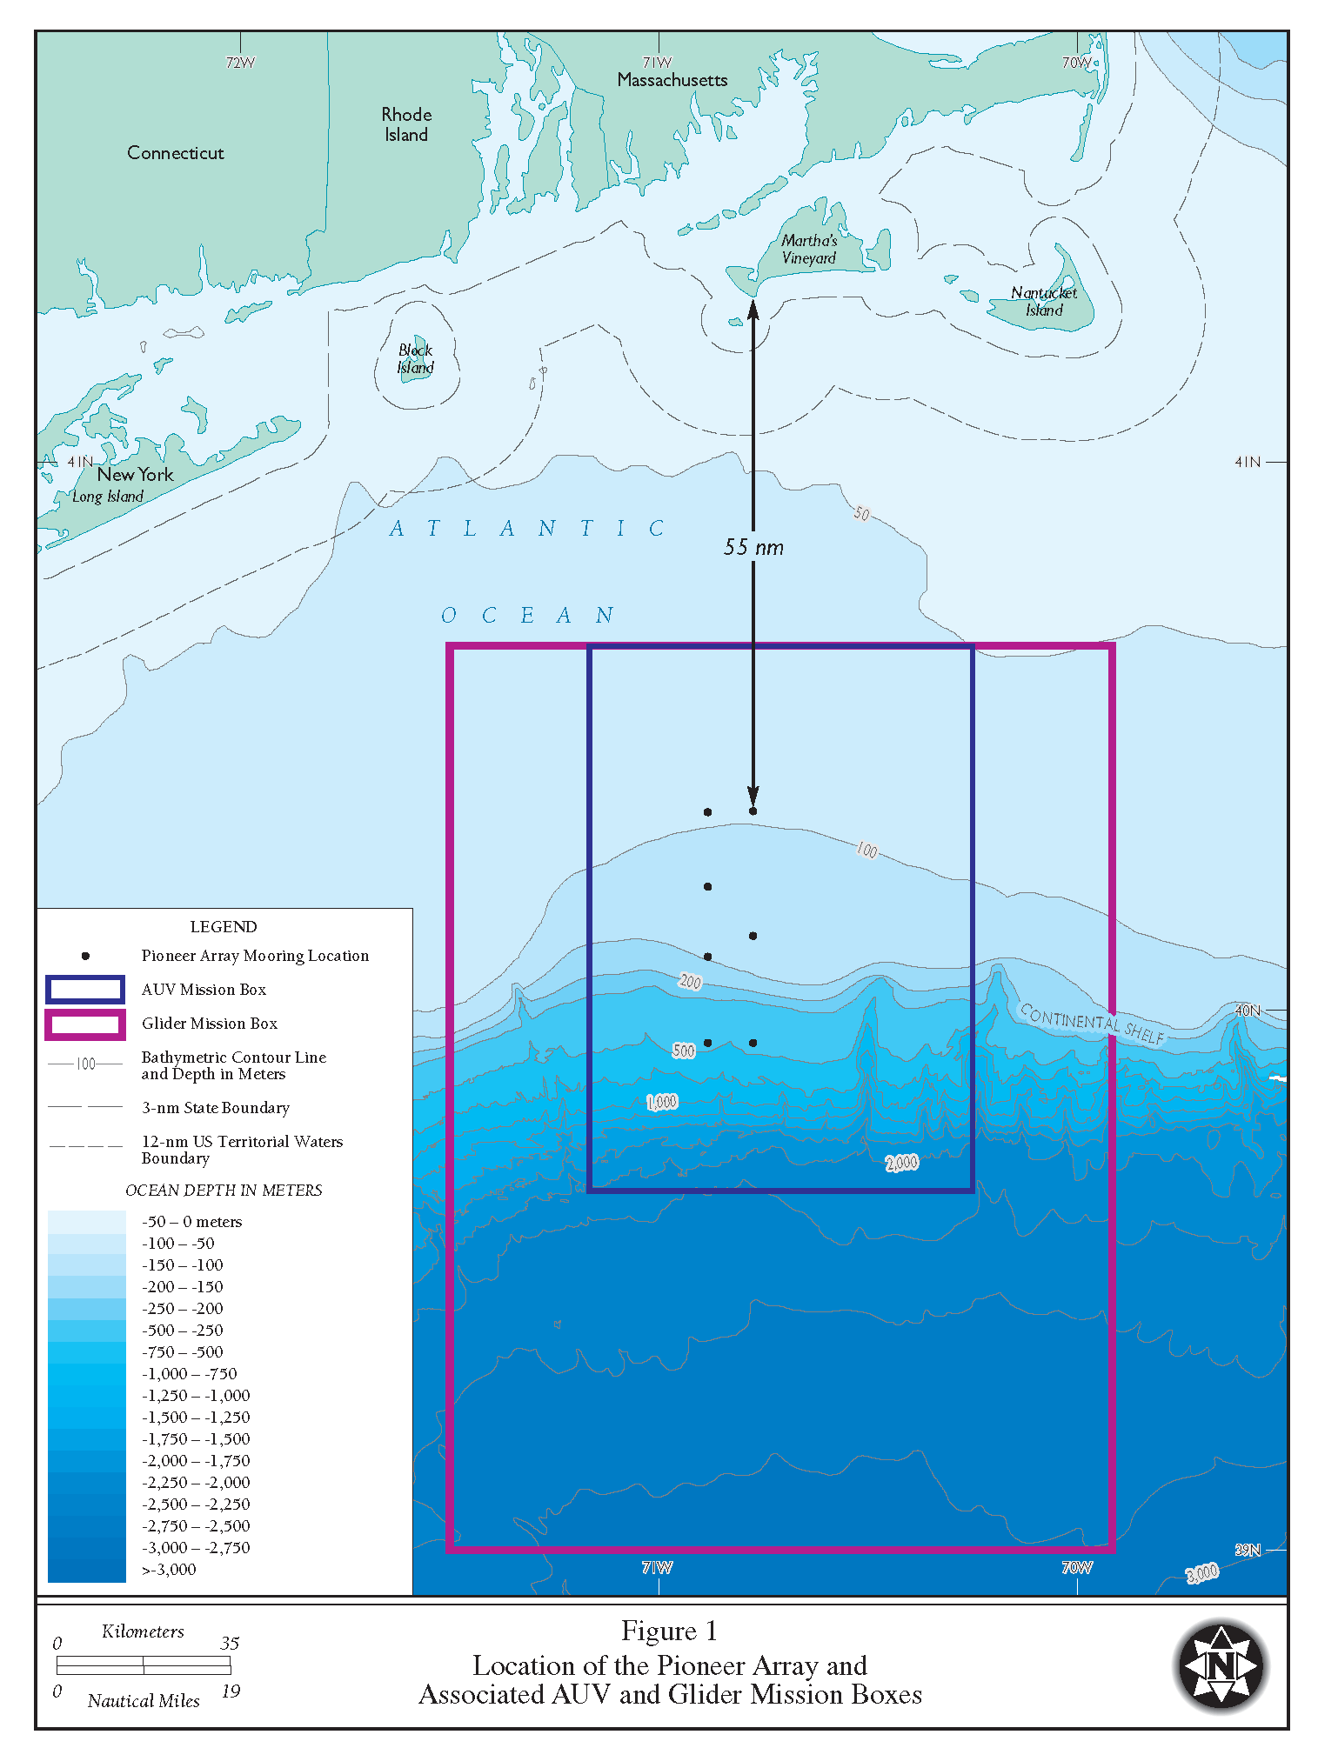

Figure 2-1 – Map of the Pioneer Array region
over the southern New England continental shelf and slope.
The seven sites of the moored array, the AUV operating region and the glider operating region are shown along with bathymetric contours.

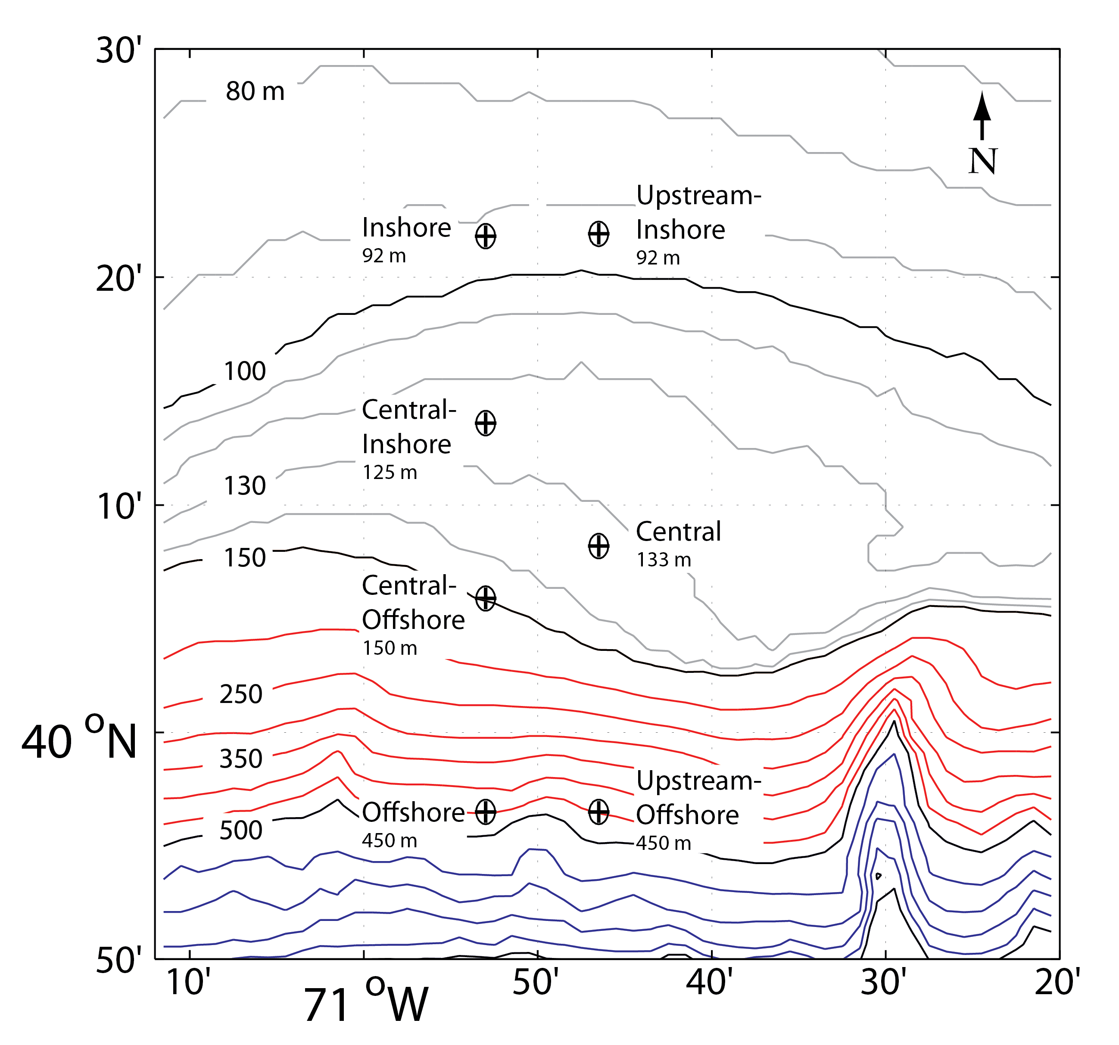
Figure 2-2 - Pioneer Array mooring site locations.
Site centers are marked by black "+" and encircled by approximate 0.5 nm radius buffer zones. Bathymetry is shown at 10 m (gray), 50 m (red) and 100 m (blue) intervals, respectively. Black contours are at 100 m, 150 m, 500 m and 1000 m.

Two glider deployments were chosen as a means of refurbishing the glider fleet since only two gliders are currently operating at the Pioneer site. Field verification of instrument performance requires that CTD casts with water samples be conducted in conjunction with all deployment and recovery activities.
The additional objectives were chosen to exercise the ship’s capabilities (e.g. small boat operations) while attending to previously identified infrastructure issues. For example, the Xeos GPS transmitters on two CPMs (CP04OSPM-00004, CP02PMCO-00005) are not functioning and should be replaced. A CTD test cast, done early in the cruise, will improve the likelihood of success for later casts.

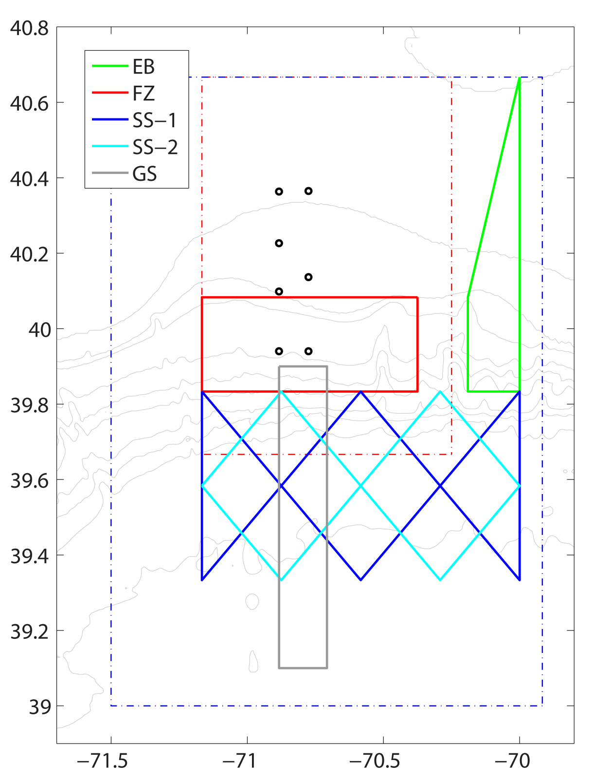
Figure 2-3 – Pioneer Array glider lines.
The Eastern Boundary (EB, green), Frontal Zone (FZ, red), Slope Sea (SS-1, blue; SS-2, cyan) and Gulf Stream (GS, gray) tracks are shown along with the Pioneer Array moorings (circles) and the glider and AUV operating areas (blue and red dashed lines, respectively).

Staging and De-Staging
Equipment will be shipped to Norfolk, VA on 25 March 2016. Staging and loading will be done at the Norfolk facility starting several days prior to departure. The ship’s crane will be suitable for loading most science gear. As part of the staging operation, it may be necessary to mount several antennas and run cables from these antennas to the main lab. Antenna mount locations and cable runs will be determined by consultation with the ship.
Destaging and offloading of scientific equipment will be initiated at WHOI upon termination of the cruse on 6 April. The ship’s crane will be suitable for offloading most science gear, supplemented by a commercial crane for containers/vans if necessary.

Cruise Operations and Objectives
The R/V Armstrong will depart from Norfolk and conduct a variety of operations, as agreed by the SVC-III co-PIs, including activities specific to the OOI Pioneer Array. Some non-OOI operations are mentioned for completeness (Appendix A), but this plan focuses on Pioneer Array activities. Operations at the Pioneer Array are expected to start on the 4th day of the cruise. The next 3 cruise days will include a combination of Pioneer Array activities, focusing on CSM recovery on the 4th day, CPM recovery and glider deployments on the 5th day, and additional objectives on the 6th day. CTDs with bottle samples will be done in conjunction with deployment and recovery operations.
The Primary Objectives (O1-O5) are listed below. Nominal dates for these activities are given in the cruise timeline provided in Appendix A. Site locations are listed in Appendix B.
O1. Recover the Central Coastal Surface Mooring (CP001CNSM-00004).
O2. Recover the Central Inshore Profiler Mooring (CP02PMCI-00004).
O3. Deploy a shallow (200 m engine) coastal glider on the EB line.
O4. Deploy a deep (1000 m engine) glider on the FZ line.
O5. Conduct CTD casts with water sampling at the deployment/recovery sites.
Additional activities are nominally scheduled in the cruise timeline (Appendix A), and will be fit in as time allows: Ship vs. buoy meteorological comparisons will typically be conducted from late evening, after mooring operations are completed, to early morning before the start of the next operation. Due to non-OOI overnight activities already scheduled, there may not be opportunities for ship vs. buoy comparisons.
The Additional objectives (A1-A4) are listed in rough priority order below, and will be completed as time and conditions permit.
A1. Conduct a CTD test cast with water samples
A2. Replace the Xeos GPS beacon on the OSPM buoy (CP04OSPM-00004).
A3. Replace the Xeos GPS beacon on the PMCO buoy (CP02PMCO-00005).
A4. Conduct ship vs. buoy meteorological comparisons at each CSM site.
A brief description of the anticipated operations associated with accomplishment of the cruise objectives follows:

Mooring Operations
Mooring deployments and recoveries will be done in stages using the ship’s crane and A-frame, plus winches and air tuggers supplied by the science party. Science party personnel will be familiar with mooring deployment and recovery, and will be capable of directing operations in cooperation with the ship’s crew. Additional science personnel will assist with mooring operations, met watches, and other observation and data collection activities.

Glider Operations
Glider deployments and recoveries will typically be done using the ship’s crane or A-frame, supplemented by air tuggers and handling equipment supplied by the science party. Science party personnel will be familiar with glider deployment and recovery, and will be capable of directing operations in cooperation with the ship’s crew during all phases of glider operations.

CTD casts
CTD casts will be conducted using the ship’s SeaBird 9-11 CTD sensors, 24 bottle rosette frame, and deck box. Sensors requested in addition to C,T,D are dissolved oxygen, chlorophyll fluorometer, transmissometer, and PAR. CTD operations will be supervised by shipboard SSSG technicians – the science party will supply line handlers and a lab operator. Water sampling and analysis will be handled by the science party.

Sensor Performance Evaluation
Sensor evaluation operations will be conducted with at each mooring deployment site and glider deployment site. The primary means of evaluation will be CTD casts obtained in near proximity (e.g. 0.25 nm) to the mooring or glider. For validation of meteorological and sea surface variables the ship may establish and hold a position, with bow into the wind, approximately 0.10 nm downwind of a buoy. This station will be held, and adjusted if necessary, while the science party evaluates data received from the buoy. During this period, the ships underway data will be continuously recorded. At a convenient time during the cruise, the ship may make a close approach to buoys to allow visual inspection, determination of the water line, and photographs.

Shipboard Underway Data
The ship’s meteorological system will be used to continuously monitor weather conditions while underway and for evaluation of buoy meteorology during the intercomparison period. The ship’s ADCP systems will be used to continuously measure the currents in the upper ocean while. Sea surface temperature and salinity will be recorded continuously, using the ship’s thermosalinograph.

Small Boat Operations
The use of a work boat may be necessary for servicing of instruments on the buoy towers (Additional Objectives A2 and A3) and may be requested for other operations such as glider recovery or attending to unforeseen problems that would require physical access to a buoy tower. Expected duration of use is approximately 0.5 to 1.5 hr. Work boat operations would be within 0.5-1.0 nm of the ship. It is recognized that such operations are weather dependent and would be conducted at the discretion of the ship.

Potential Restrictions
Small boat activities may be restricted by weather. In the case of a recovery operation, the ship will maneuver to the item to be retrieved and grappling lines and/or pick up poles will be used. Mooring activities may be restricted by severe weather or equipment failure. Severe weather would result in postponement until conditions eased. Failure of a given piece of Project equipment (e.g. winch, air tugger) can typically be compensated by use of an alternative approach. Failure of ship’s equipment (e.g. electrical or hydraulic system) would result in postponement of operations until the failure was addressed. Deployment and recovery activities may be restricted by the presence of multiple fixed objects (e.g. fishing gear) in the deployment area or along the deployment/recovery track. If possible, operations will be delayed until conditions are more favorable (e.g. change in prevailing wind direction allowing deployment approach along a different, unobstructed course).

Appendices
Appendix A – Cruise Timeline
Appendix B – Selected Waypoints and Maps
Appendix C – Science Party
Appendix D – Mooring Drawings

Appendix A – Cruise Timeline

Timeline

31 Mar Complete loading, depart Norfolk, transit
01 Apr Transit, CTD test cast, start non-OOI Multibeam survey
- CTD test cast with water samples (2 h)
02 Apr Complete non-OOI multibeam survey, transit to Pioneer site
03 Apr OOI mooring recovery and CTD cast. Non-OOI mooring deployment, glider recovery (evening) and Alvin Canyon acoustics (overnight)
- Prepare for recovery operations, bridge and deck (1 h)
- Recover CNSM Surface Mooring riser (3 h)
- CTD cast with samples and prep for anchor recovery (2 h)
- Recover CNSM anchor (2 h)
04 Apr OOI mooring recovery, CTD cast, and glider deployments. Non-OOI Alvin Canyon acoustic surveys (overnight)
- Prepare for recovery operations, bridge and deck (1 h)
- Recover PMCI Profiler Mooring riser (2 h)
- CTD cast at mooring site with samples (1 h)
- Recover PMCI anchor (2 h)
- Transit to glider deployment site (2 h)
- Glider deployment(s) (2 h)
- CTD cast at glider site with samples (1 h)
05 Apr OOI Xeos beacon replacement (OSPM, PMCO). Non-OOI Alvin canyon acoustics, mooring recoveries
- Replace Xeos beacon on OSPM buoy tower (3 h)
- Steam to PMCO (2 h)
- Replace Xeos beacon on PMCO buoy tower (3 h)
06 Apr Arrive WHOI approx. 10:00 AM

Appendix B – Selected Waypoints and Maps

Table 3-1 – Pioneer-SVC-III station list

Appendix C – Science Party
There will be 5 participants in the science party for SVC-III. An alphabetical list is given in the table below.
Participating Scientists
Name Gender Nationality Affiliation
- Basque, Christopher M USA WHOI
- Dunn, James M USA WHOI
- Haskins, Christina F USA WHOI
- Kemp, John M USA WHOI
- Wellwood, Dave M USA WHOI

Roles and responsibilities will be delegated among individuals and groups per the following major categories. These assignments are representative, and not intended to be limiting – all participants will assist with multiple aspects of the cruise effort as warranted.
- Overall cruise coordination and execution
  - John Kemp
- Cruise documentation, deployment records, platform and instrument metadata
  - Tina Haskins
- Logistics, deck operations, mooring hardware, mooring operations
  - John Kemp, Jim Dunn, Chris Basque
- Instrument configuration, preparation and pre-deployment checks
  - Tina Haskins (gliders)
- Hydrographic sampling, including physical sample preparation
  - Dave Wellwood, Tina Haskins
Appendix E – Mooring Drawings
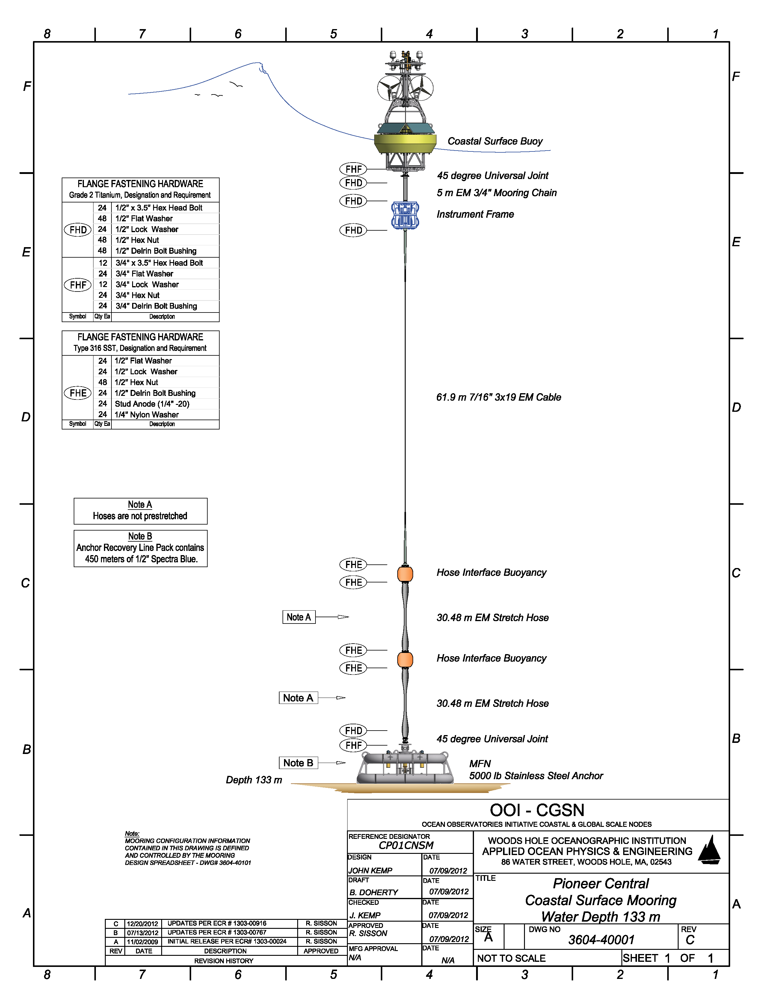
Figure 3-4 - Pioneer Central Surface Mooring (CNSM)
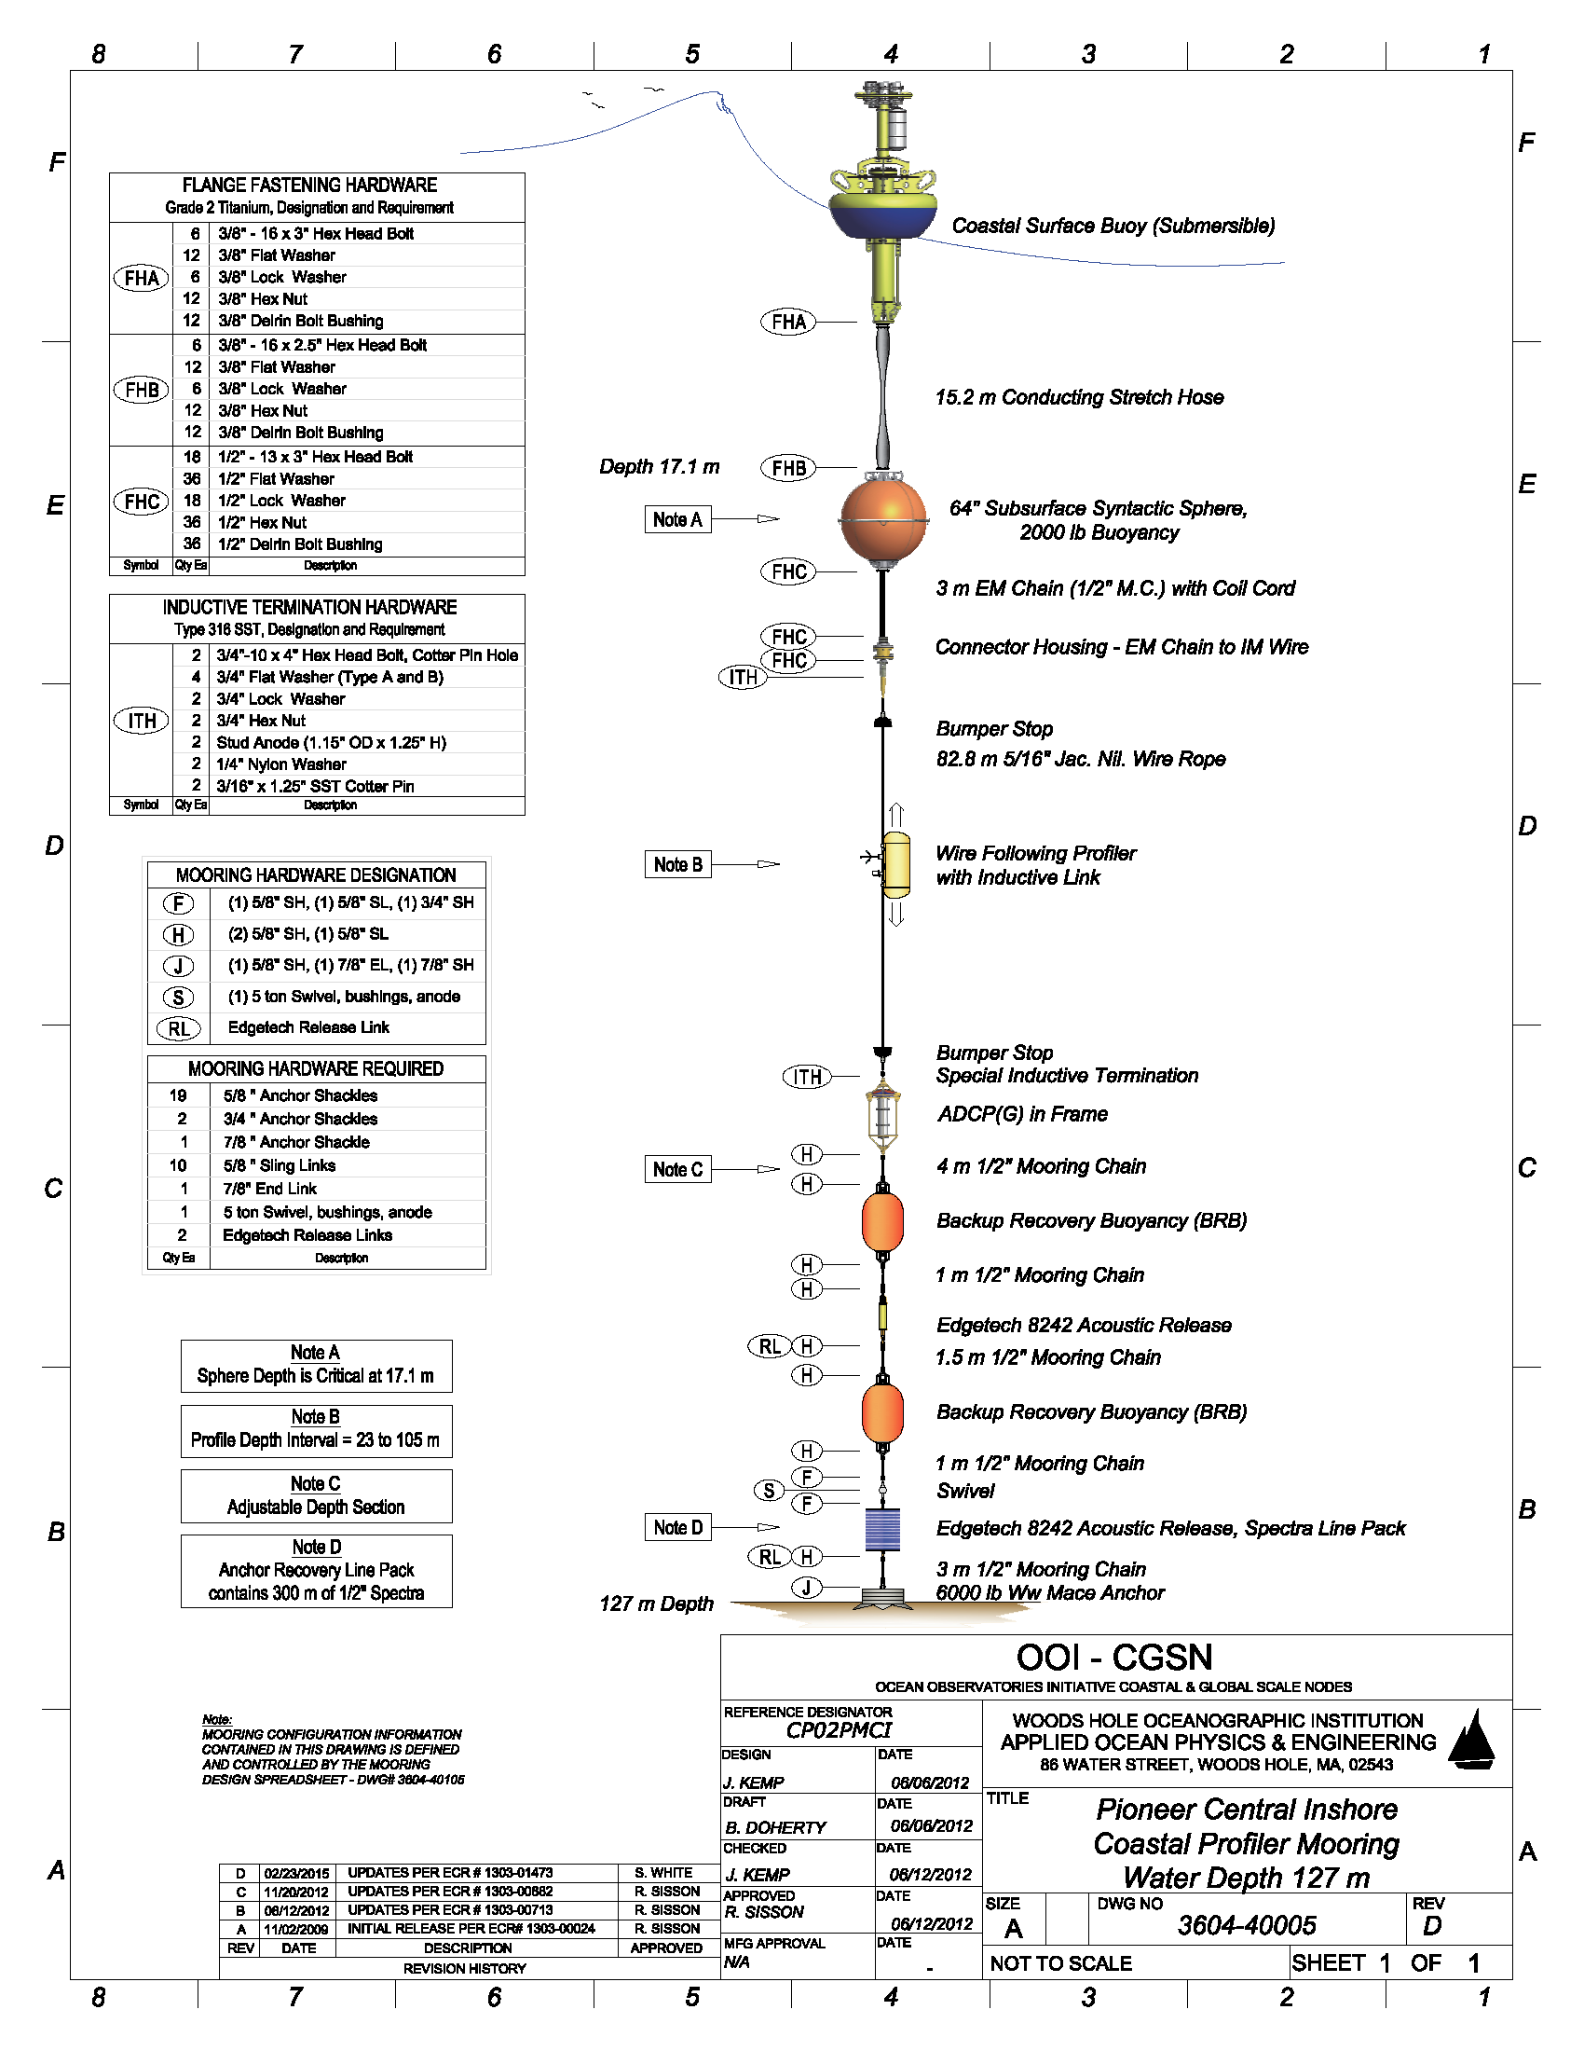
Figure 3-5 - Pioneer Central Inshore Profiler Mooring (PMCI)

