CGSN Site Characterization:
Argentine Basin

Control Number: 3206-00007
Version: 1-03
Date: February 28, 2011
Prepared by: S. White, M. Grosenbaugh, M. Lankhorst, H.-J. Kim, S.H. Nam, U. Send, D. Wickman, S. Morozova, R. Weller

Coastal and Global Scale Nodes
Ocean Observatories Initiative

Woods Hole Oceanographic Institution

Oregon State University

Scripps Institution of Oceanography

Revision History

Version | Description | Originator | ECR No. | Release Date
1-00 | Initial Release | S. White | 1303-00077 | June 2, 2010
1-01 | Add Current profile data (1.2.1), Lagrangian length scale data (1.2.5), Historical wind and wave data (1.3.1, 1.3.2), and Solar radiation data (1.3.4) | S. White | 1303-00112 | September 8, 2010
1-02 | Added Argo float velocity data | M. Lankhorst
1-03 | Update current data, editorial updates | M. Lankhorst  H.-J. Kim | 1303-00221 | February 28, 2011

Table of Contents

Scope 4
Overview 4
1. Site Survey 5
1.1. Bathymetry 5
1.1.1. Bathymetry Data 5
1.1.2. Bottom Type 6
1.2. Oceanographic Conditions 6
1.2.1. Currents 6
1.2.2. Mean Dynamic Ocean Surface Topography 12
1.2.3. Sea Surface Height Variability 14
1.2.4. Baroclinic Rossby Radius 14
1.2.5. Lagrangian Length Scale from Surface Drifters 15
1.3. Environmental Conditions 16
1.3.1. Historical Wind Data 16
1.3.2. Historical Wave Data 18
1.3.3. Weather Extremes 19
1.3.4. Solar Radiation 20
1.4. Commercial/Policy Factors 21
1.4.1. Shipping Lanes 21
1.4.2. Fishing Areas 22
1.4.3. Seafloor Cables 23
1.4.4. Other Moorings 23
1.4.5. Satellite altimetry tracks 23
2. Site Design 25
2.1. Site Components 25
2.2. Site Configuration 25
2.2.1. Moored Array 25
2.2.2. Glider Operations Area 27
3. References 28
Appendix A. Methodology for determining extreme events from KNMI data 29
Appendix B. Methodology for determining extreme events from GROW Hindcast data 33
Appendix C. Data sources 35

Argentine Basin Global Observatory Site Characterization

Scope
This report describes conditions in the atmosphere, in the ocean, and on the sea floor in the vicinity of the OOI Argentine Basin Array, and the infrastructure components and the proposed layout of the components at the site.

Overview
The selection of the sites of the global arrays was driven by the goal of establishing a few key stations in the data-sparse high latitudes that would provide sustained sampling at critical locations.
The Argentine Basin Global Observatory site is located at 42° S, 42° W east of Argentina. The water depth is nominally 5200 meters. The mooring array will consist of one Global Surface Mooring with standard-power and standard-bandwidth data transmission, one Global Hybrid Profiler Mooring, and two sub-surface Global Flanking Moorings. The moored array will be complemented by 3 ocean gliders.
The four moorings and the gliders give the array the capability to address the role of the mesoscale flow field in ocean dynamics. Mesoscale features such as eddies not only have enhanced horizontal transports associated with their flow, but they also can modulate and increase mixing in the water column and vertical exchange with the atmosphere. Because of the importance of the mesoscale context, the spacing of the moorings reflects the scale of mesoscale variability at this latitude as quantified by the Rossby radius and the siting of the array takes into account overpasses of satellites with altimeters which will provide complimentary observations of the mesoscale and larger scale flows in the region.
The Argentine Basin site was chosen for its strong atmospheric forcing, strong winds and waves. One consequence of the winter-time forcing is the modification of surface water and convection, which provides a mechanism for carbon dioxide absorbed into the surface layer to be carried into the interior. The Argentine Basin site is located in a region that is an ocean sink of carbon dioxide and has one of the higher inventories of anthropogenic carbon dioxide in the Southern Hemisphere (Sabine et al, 2004). This site can be contrasted with the other three global sites to examine sequestration of carbon dioxide and impacts of ocean acidification.
Remote sensing of ocean color and surface phosphate concentrations point the site being at the northern side of a region of high productivity and high nutrients, but there has been the suggestion that deposition of dust from the atmosphere at this site (Li et al, 2008) provides micro-nutrients.
Diverse satellite altimetry studies have pointed to the Argentine Basin site as characterized by strong mesoscale variability (e.g., Fu, 2007; Fu and Smith, 1996). The strong mesoscale variability together with high biological production may work together to support propagating bathymetric features known as “mud waves” that have been the study of a number of researchers in the Argentine Basin (e.g., Flood and Shor, 1988). It is also at a location where several water masses of the large-scale global thermohaline circulation transit through (Arhan et al., 1999, Roden, 1989), providing a site well-suited to monitor change and variability in these water masses and in the water column. The strong mesoscale variability of the site provides excellent opportunities for the study of the dynamics of these features and of their interaction with the mean flow and of their impact on regional biology and biogeochemistry.
Early discussions with UK Geotraces have pointed to their interest in the site in conjunction with planned sampling in the South Atlantic. Discussions with Argentine oceanographers also point to the potential for joint scientific studies of the region.

Site Survey

Bathymetry

Bathymetry Data

Bathymetry for the global sites was obtained from the Smith and Sandwell global database .

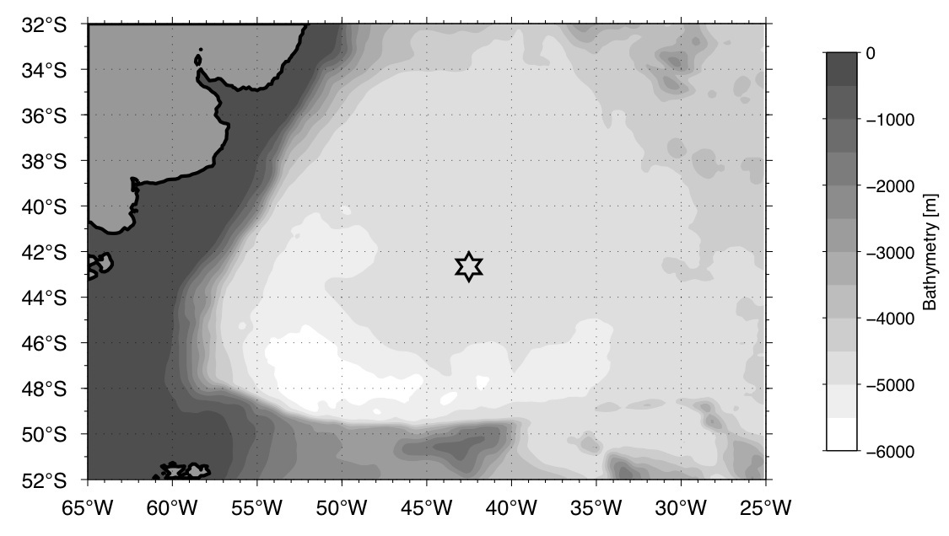

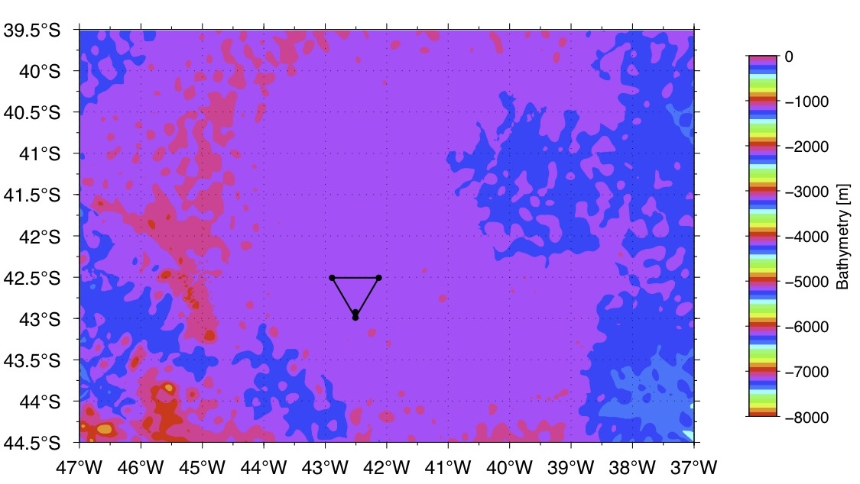

Figure 1. Smith & Sandwell Bathymetry for the Argentine Basin Global Array site. Top: Contours every 500 m. Bottom: Close-up with contours every 100 m.

Bottom Type

The sea bottom in the Argentine Basin is heavily sedimented with mud waves resulting from bottom currents (Flood and Shor, 1988). The Argentine Basin Array is located in the area of the North Flank Zapiola Drift where bottom currents run northwest. Mud wave spacing is on the order of 2 to 10 km, with wave heights averaging around 35 cm.

Oceanographic Conditions

Currents

1.2.1.1. In-Situ Data

Mooring Data:

A series of current meter moorings were deployed in the Argentine Basin from May 1987 to March 1988 as a part of the MUDWAVES project – Morphological and Dynamic Studies of Sediment Waves in the Argentine Basin (Harkema and Weatherly, 1989). The current meters consisted of Savonius rotors and vanes mounted at ~10 m above the seafloor. The closest site to the Argentine Basin Array location was Site 5 where two moorings were deployed at ~42°31’ S, 45° 7’ W and a water depth of 5045 m. Currents were measured with an average speed of ~11 cm/s in a westward direction (Table 1, and ). The predominantly westward current flow is supported by analysis of seafloor mud waves in this area by Flood and Shor (1988).

Table 1. Statistics from MUDWAVES current meters at 42°31’ S, 45°7’ W

 | Average Speed | Maximum Speed | Minimum Speed | Dominant Direction
Site 5T | 12 cm/s | 20 cm/s | 2 cm/s | West
Site 5S | 12 cm/s | 19 cm/s | 2 cm/s | West

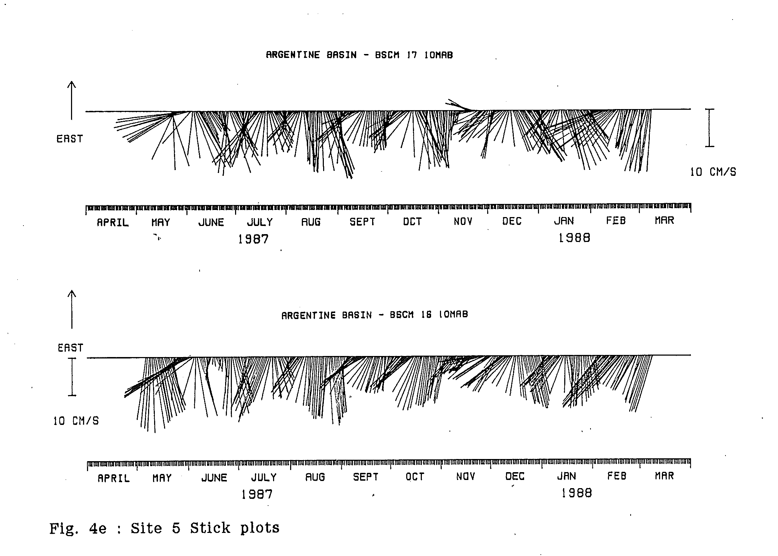

Figure 2. Stick plots of current meter data from MUDWAVES sites 5T (top) and 5S (bottom) (Harkema and Weatherly, 1989).

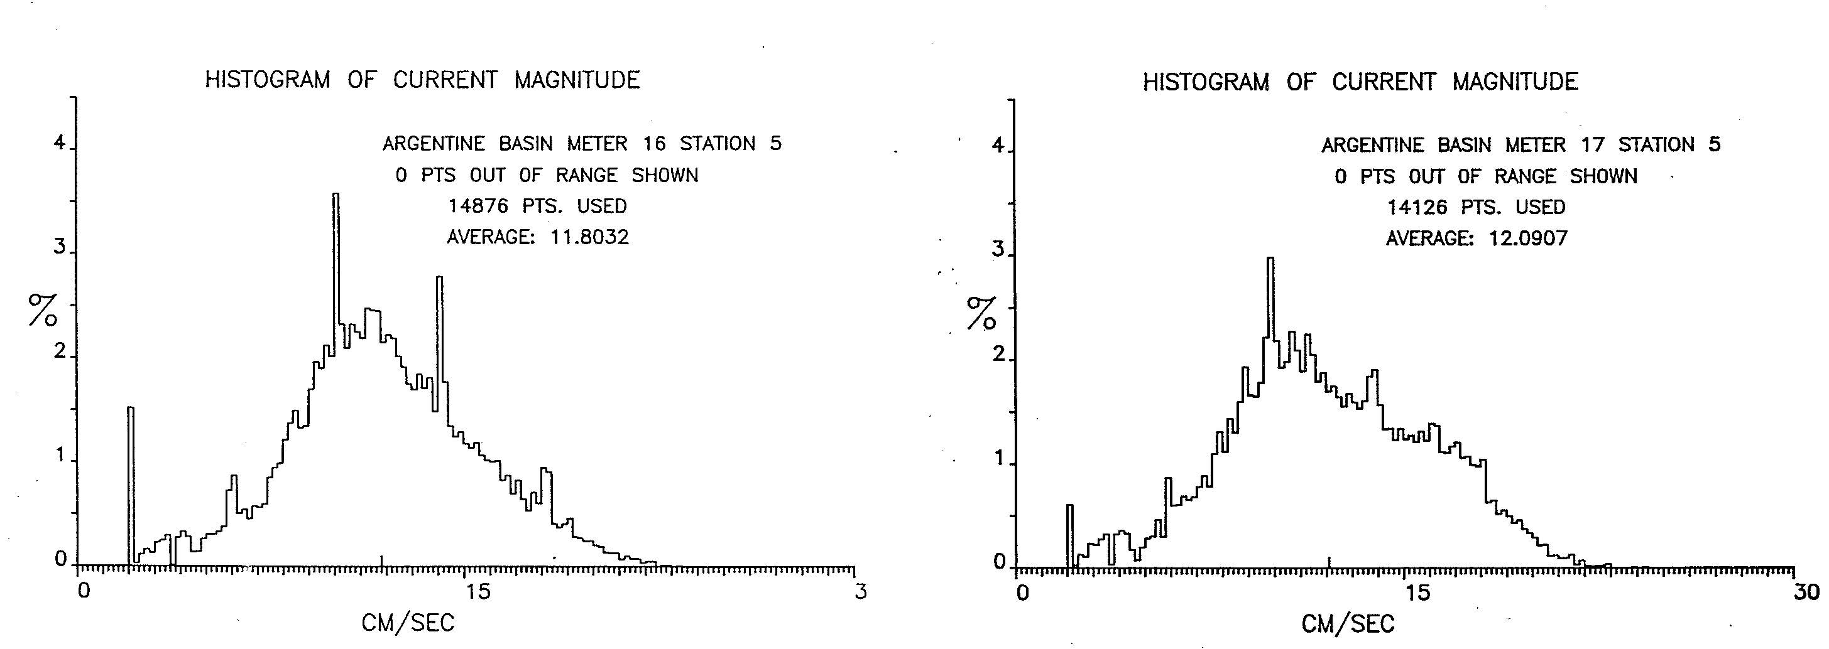

Figure 3. Histograms of current magnitude from MUDWAVES sites 5T (left) and 5X (right) (Harkema and Weatherly, 1989).

Surface Drifter Data:

The following are statistics derived from nearby surface drifter data. The data were obtained from http://www.aoml.noaa.gov/envids/gld/.

- Gaussian-weighted mean current vector: 9 cm/s (toward 97.6 deg.)
- Gaussian-weighted mean speed: 27 cm/s
- arithmetic mean current vector: 9 cm/s (toward 97.6 deg.)
- arithmetic mean speed: 27 cm/s
- std. dev. of east-west current: 21 cm/s
- std. dev. of north-south current: 21 cm/s
- std. dev. of current speed: 16 cm/s
- number of observations: 1669
- maximum current speed: 157 cm/s

Argo Float Data:

The subsurface current variability is characterized with Argo float data. Figure 5 shows statistics of temporal variability of subsurface currents. Each data point represents a ten-day average current derived from Argo float displacements over this time interval. Data are available at the Argo data centers (http://www.argo.ucsd.edu, ).

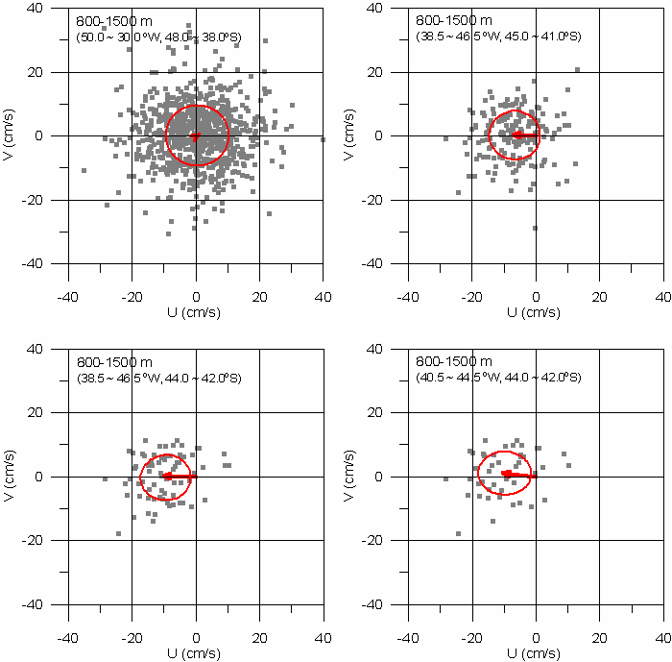

Figure 4. Scatter plot of horizontal currents derived from Argo floats in the vicinity of the OOI site. Different panels refer to different spatial extent around the OOI site. Mean and one standard deviation are marked with red arrows and ellipses, respectively.
The following table shows the statistics underlying the data of Figure 4.

(top left)  50.0 ~ 30.0 degW, 48.0 ~ 38.0 degS  mean u (cm/s) : 0.60897  mean v (cm/s) : 0.44033  u std. dev. (cm/s): 10.172  v std. dev. (cm/s): 9.5939 | (top right)  38.5 ~ 46.5 degW, 45.0 ~ 41.0 degS  mean u (cm/s) : -6.8352  mean v (cm/s) : 0.3452  u std. dev. (cm/s): 7.727  v std. dev. (cm/s): 7.7797
(bottom left)  38.5 ~ 46.5 degW, 44.0 ~ 42.0 degS  mean u (cm/s) : -9.9426  mean v (cm/s) : 0.31264  u std. dev. (cm/s): 7.6929  v std. dev. (cm/s): 6.9554 | (bottom right)  40.5 ~ 44.5 degW, 44.0 ~ 42.0 degS  mean u (cm/s) : -10.105  mean v (cm/s) : 1.1523  u std. dev. (cm/s): 8.6107  v std. dev. (cm/s): 7.1273

1.2.1.2. Reconstructed Current Profile

For the purpose of designing the OOI moorings, the following vertical current profiles were determined. Computational details are explained in the Appendix. There are three current profiles, meant to represent three scenarios:

- Background field. Represents a one-RMS statistic.
- Eddy event. Represents a two-RMS statistic.
- Extreme event. Represents a three-RMS statistic.

The table lists all three values, whereas the figure shows only the background field and the underlying equation.

Table 2. Reconstructed current profiles for three scenarios, i.e. background field, eddy event, extreme event.

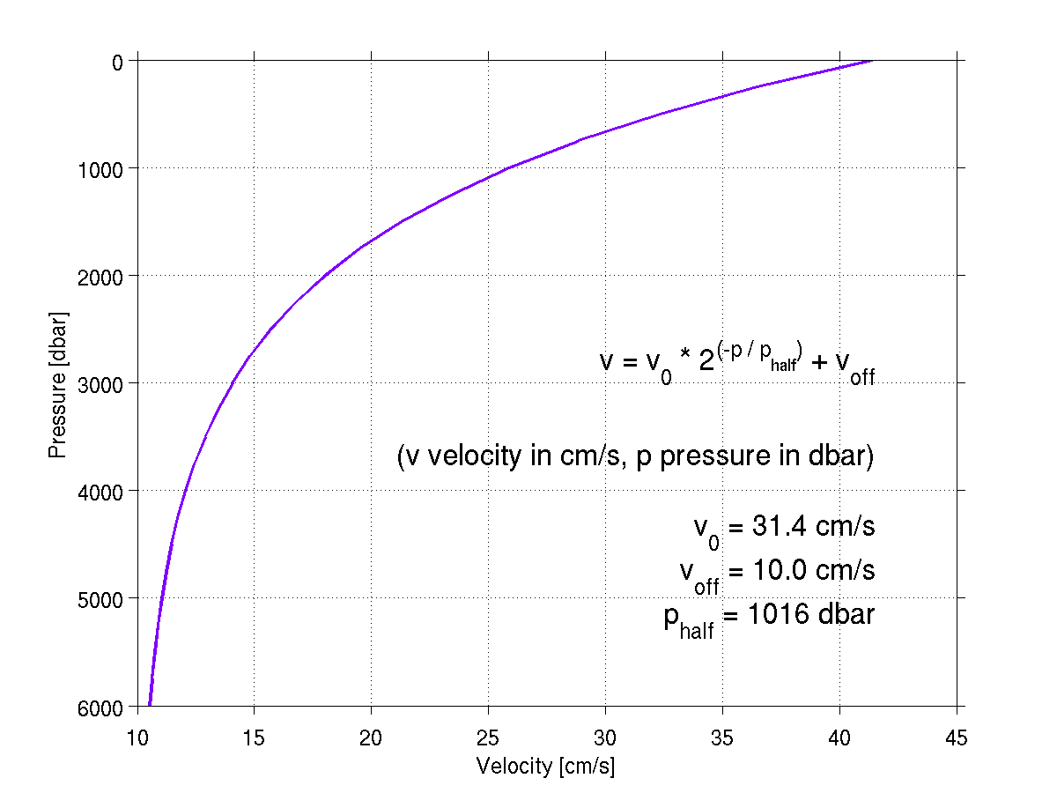
Figure 5. Background field of reconstructed current profile

Mean Dynamic Ocean Surface Topography

The “mean dynamic ocean topography” (MDOT) is that part of mean sea surface height that actually drives currents, as opposed e.g., to elevation because of the geoid. Assuming that these mean currents are geostrophic, one can interpret the MDOT as a stream function for the currents, such that the currents are parallel to lines of constant MDOT, and that current strength is inversely proportional to the spacing of these lines. Hence, Figure 6 shows the mean circulation. From the MDOT product, the mean geostrophic surface current amounts to 1.9 cm/s for the Argentine Basin.

The 1992-2002 mean ocean dynamic topography data has been obtained from Nikolai Maximenko (IPRC) and Peter Niiler (SIO).

The Rio5 MDOT was produced by CLS Space Oceanography Division and distributed by AVISO , with support from Cnes.

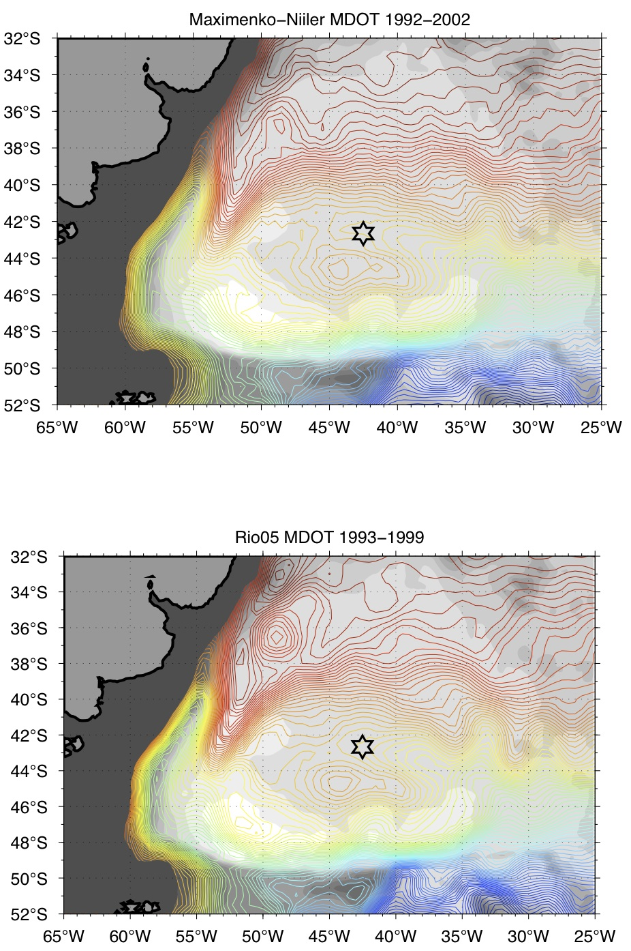

Figure 6. Comparing two different products for mean dynamic ocean topography at the Argentine Basin Global Array site (star symbol). Top: Product by Maximenko and Niiler (2005). Bottom: Product by Rio et al. (2005). Contours are 2 cm apart; gray shades show bathymetry every 500 m.

Sea Surface Height Variability

Variability of sea surface height (SSH) shows variability of the circulation. In Figure 7, it is computed as the standard deviation of SSH as measured by satellite altimetry, which makes it a proxy for Eulerian eddy kinetic energy (EKE). High values can be caused by passing eddies and meandering permanent currents, and are often (but not always) co-located with strong mean currents.

Altimeter products were produced by Ssalto/Duacs and distributed by AVISO , with support from Cnes.

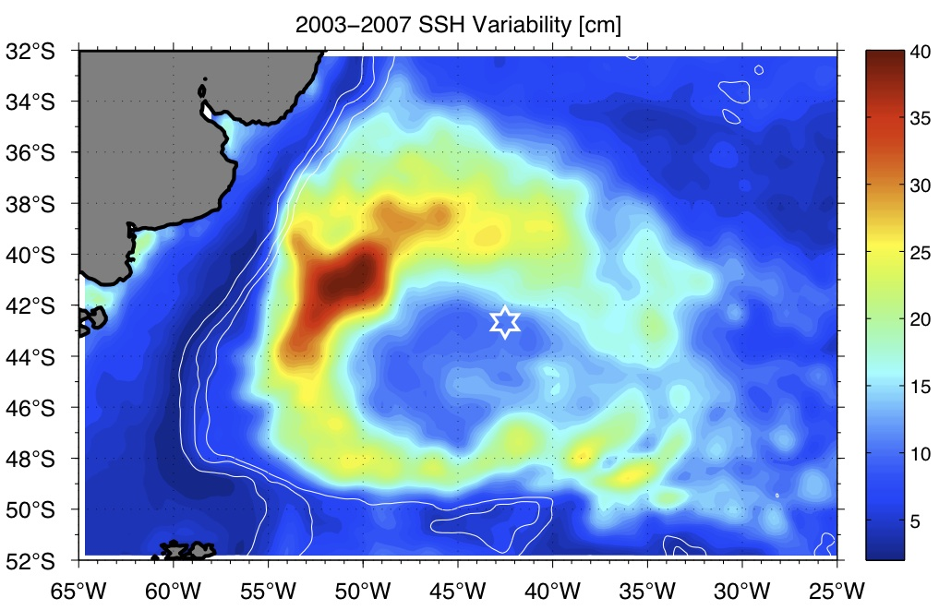

Figure 7. Variability of sea surface height from the AVISO global merged altimetry product, computed as standard deviation in cm. The star shows the Argentine Basin Global Array site. White lines show bathymetry at 3000, 2000, and 1000 m.

Baroclinic Rossby Radius

The baroclinic Rossby radius (Figure 8), or radius of deformation, is a property derived from stratification, i.e. from the density profile at a given location. It represents a (horizontal) distance. Theories of fluid instability (e.g., Eady theory) relate typical eddy sizes in the ocean to a multiple of this quantity.

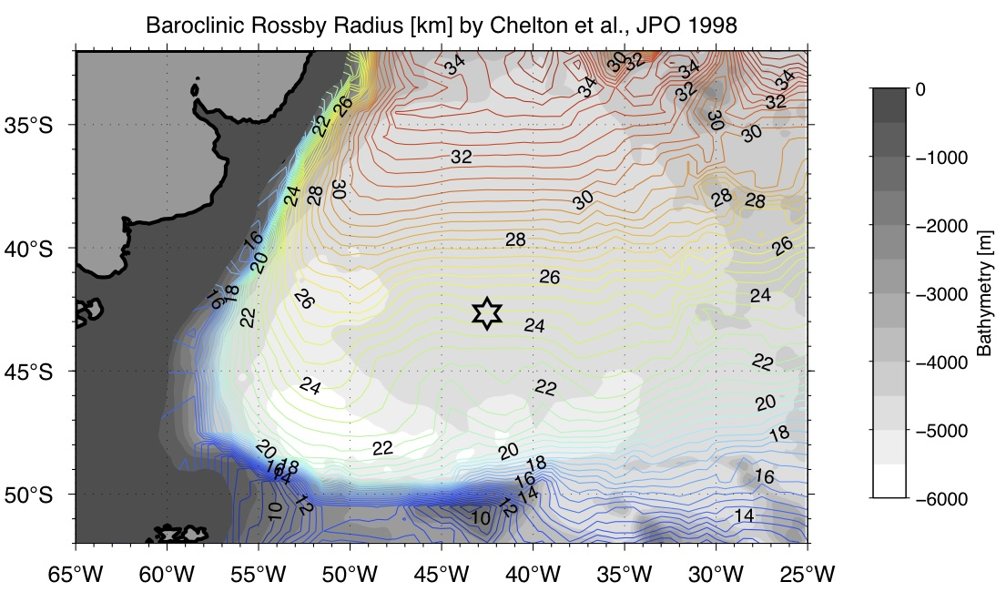

Figure 8. Rossby radius of deformation at the Argentine Basin Global Array site. Product by Chelton et al. (1998) . Gray shades show bathymetry every 500 m.

Lagrangian Length Scale from Surface Drifters
Figure 9 shows the Lagrangian length scale derived from surface drifter data. This is another measure of typical eddy sizes, and it amounts to circa 30 km at the OOI site in the Argentine Basin.

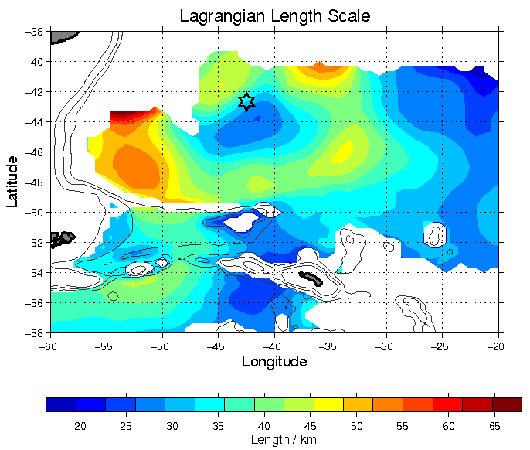
Figure 9. Lagrangian length scale computed from surface drifter data.

Environmental Conditions

Historical Wind Data

Scatterometer data from satellites was a source of wind speed and wind direction for the Argentine Basin Site. The Climatology of Global Ocean Winds (COGOW ) is an interactive map-based database of daily averaged wind data (Figure 10). Data are available at a spatial resolution of 0.5°of latitude/longitude, and daily temporal resolution. The data used here correspond to a 0.5° x 0.5° patch centered at 41.25°S 43.75° W. Each daily value represents an average of measurements made in the bracketing 3-day interval. Data are currently available for the period January 1999 – December 2004.

Another data source used to characterize the Argentine Basin site is GROW (Global Reanalysis of Ocean Waves ). This data is available at 3 hour resolution from 1970-2009. Data is available at 42.5° S, Long 42.5° W. Average wind speed is relatively constant throughout the year, although a slight seasonal trend is observed. During the winter months of May-October, the monthly wind speed average is around 19 knots; for the summer months of November-April, the average drops to 15 knots (Figure 11).

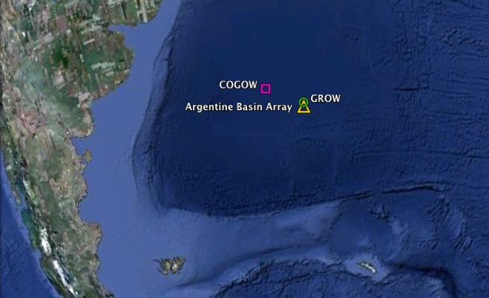

Figure 10. Locations of Argentine Basin Array (yellow triangle), COGOW site at 41.25°S 43.75° W (purple square), and GROW site 12215 (green circle). (Google Earth)

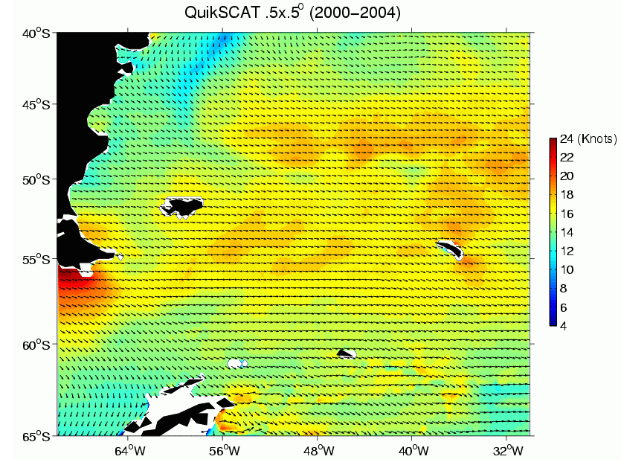

Figure 11. COGOW site at 41.25° S 43.75° W. Each arrow represents daily averaged wind data from 1999-2004. The purple marker represents the location of the Argentine Basin Global Array.

Figure 12. Monthly means, standard deviations, and extremes of hourly average wind speeds from GROW hindcast data.

From a QuikSCAT data product of three-day average wind values available at http://www.remss.com , the following are derived:

- Mean wind speed: 9.6 m/s
- Standard deviation of wind speed: 2.6 m/s

These QuikSCAT data are produced by Remote Sensing Systems and sponsored by the NASA Ocean Vector Winds Science Team.

Historical Wave Data

Records of wave height, direction, dominant period, and average period are available at a 3-hour resolution from GROW . Monthly means, standard deviations, and extremes of significant wave height (average height of the highest one-third of all waves) are shown in Figure 13. Mean significant wave height shows a distinct seasonal cycle, increasing from about 2 m in January to near 4 m in June. Significant wave height extremes are more variable ranging from 9 to 12 m throughout the year.

Storm peak data is also recorded and plotted in Figure 14. The threshold for significant wave height storm peaks is 8 m. There are storm peaks recorded for every month of the year, but for the summer months (Sep-Feb) there is an apparent decrease in storm peak activity.

Figure 13. Monthly means, standard deviations, and extremes of average significant weight height from GROW hindcast data.

Jun Jul Aug Sep Oct Nov Dec Jan Feb Mar Apr May

Figure 14. GROW Storm peak data for significant wave height.

Weather Extremes

The significant wave height and sustained wind for 10 year, 30 year and 100 year events is estimated from wave and wind records from the Koninklijk Netherlands Meteorological Institute ERA-40 Wave Atlas (www.knmi.nl/waveatlas ) (see Appendix A for details of the analysis). The wave and wind records were derived from a reanalysis of 45 years (1957-2002) of satellite wind observations collected by the European Center for Medium Range Weather Forecasts.

Table 3. Wind and wave extremes (KNMI Data)

 | Significant Wave Height (m) | Peak Period (s) | Wind Speed (m/s)
10 Year Return Period | 10.2 | 15.0 | 21.6
30 Year Return Period | 11.0 | 15.6 | 22.8
100 Year Return Period | 11.8 | 16.1 | 23.9

The significant wave height and sustained wind for 10 year, 30 year, and 100 year events are also estimated from wave and wind records from GROW hindcast data (, see Appendix B for details of the analysis). The wave and wind records were compiled from January 1970 – December 2009, representing 40 years of data. Peak period was calculated using a steepness parameter of 0.0571.

Table 4. Wind and wave extremes (GROW Hindcast Data)

 | Significant Wave Height (m) | Peak Period (s) | Wind Speed (m/s)
10 Year Return Period | 11.1 | 15.8 | 24.3
30 Year Return Period | 11.9 | 16.3 | 25.7
100 Year Return Period | 12.7 | 16.9 | 27.0

Solar Radiation

The Atmospheric Science Data Center at NASA Langley provides a number of satellite-derived data products relating to surface meteorology and solar energy. Data is available with a horizontal resolution of 1° in latitude and longitude. Table 4 shows monthly averages of solar radiation incident on a horizontal surface for the 22-year period July 1983-June 2005. Higher resolution daily data sets are also available.

Another Source is the PG&E solar radiation model based on the ASHRAE model (http://www.pge.com/mybusiness/edusafety/training/pec/toolbox/arch/calculators.shtml ). This model is widely used by the engineering and architectural communities (ASHRAE handbook: HVAC applications). Since this model only accounts for direct normal irradiance, the data was scaled down with a cloud cover factor by 30% to make it comparable to real data as well as the NASA satellite data (Figure 15). During the 12 month time scale, the two data sets overlap within 6%, a reasonable agreement (Table 5). The seasonal cycle of insolation is clearly seen, with maximum average near 270 W/m² and average minima near 56 W/m².

Table 5. Monthly Averaged Insolation on a Horizontal Surface (W/m²) at 42.73° S, 42.51° W.

 | Jan | Feb | Mar | Apr | May | Jun | Jul | Aug | Sep | Oct | Nov | Dec
NASA | 267.1 | 223.3 | 175.8 | 119.2 | 78.8 | 58.8 | 69.2 | 99.2 | 148.3 | 203.3 | 248.3 | 277.5
PG&E CLOUD | 260.3 | 224.2 | 170.1 | 114.1 | 74.6 | 56.5 | 63.2 | 93.5 | 143.1 | 198.9 | 246.0 | 269.9

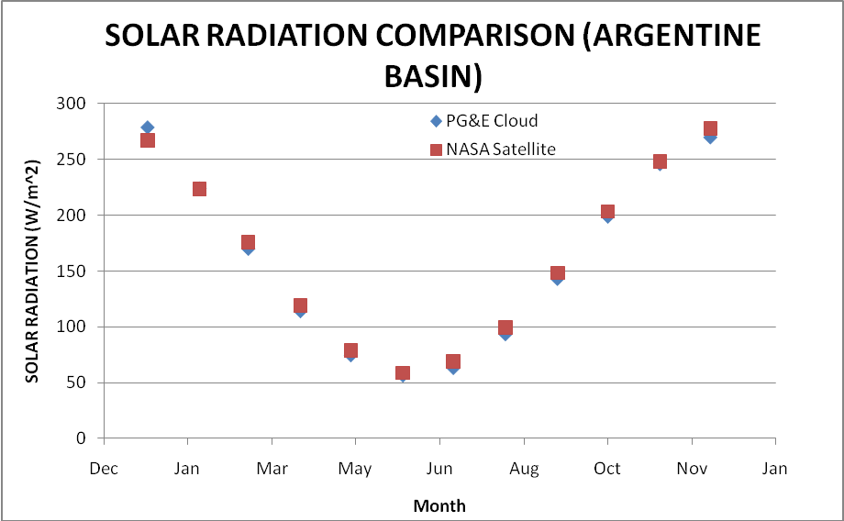

Figure 15. Solar Radiation Comparisons between the Atmospheric Science Data Center at NASA Langley satellite-derived data and the PG&E/ASHRAE model data reduced by 30% to compensate for Cloud Cover.

Histograms of average daily insolation taken from the PG&E model reduced by 30% to compensate for cloud cover for one year for 42°S, 42°W are shown by month in Figure 15. Winter months (Apr-Sep) show relatively compact distributions, with peak insolation values near 200-400 W/m². Distributions are qualitatively different in spring and summer (Nov-Feb), when long tails are seen on the low end of the distribution. Peaks in the spring and summer distributions occur at values between about 600-700 W/m².

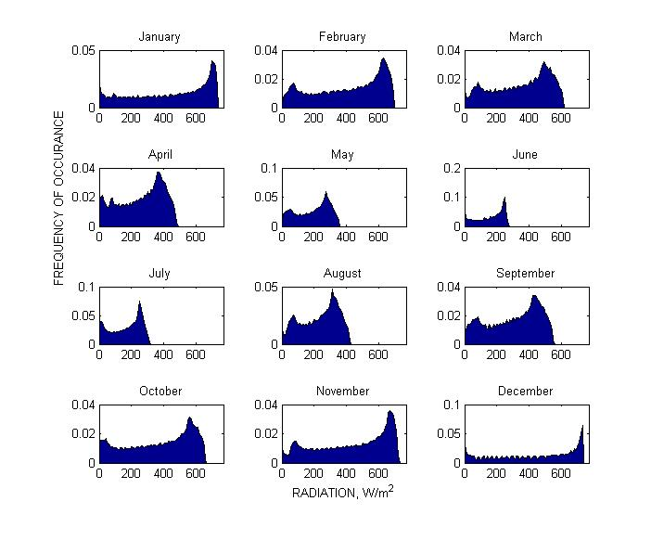
Figure 16. Monthly distributions of daily average insolation on a horizontal surface at 42°S, 42°W calculated from PG&E model data reduced by 30% to compensate for cloud cover.

Commercial/Policy Factors

Shipping Lanes

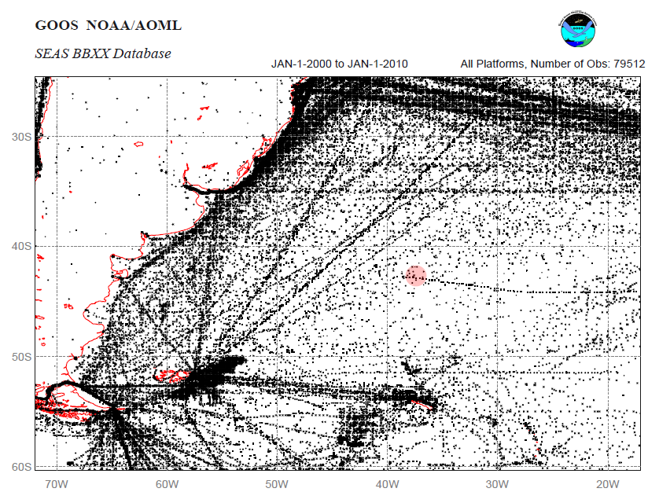

Figure 17. National Oceanic and Atmospheric Administration (NOAA) satellite data transmission locations from SOOP (Ship of Opportunity) vessels. Note: Transparent red circle at 42°S, 42°W indicates location of the Argentine Basin Array. Product courtesy of: NOAA BBXX, Joaquin A. Trinanes .

Figure 17 displays satellite acquired ship position for ships participating in the NOAA SOOP (Ship of Opportunity) data collection program. This data covers all transmission points from SOOP vessels over a 10 year period beginning 1 Jan 2000 and ending 1 Jan 2010. Vessel types participating include merchant vessels, fishing vessels, US Coast Guard and NOAA vessels. A “commercial shipping” dataset listing the number of large ships recorded, by satellite observation, in each 1-km² of the world ocean for a 12-month period starting in October 2004 available from the National Center for Ecological Analysis and Synthesis at UC Santa Barbara confirms the shipping traffic patterns displayed in Figure 17. Based on these two datasets, the Argentine Basin Global Observatory is outside the most frequently used shipping paths.

Fishing Areas

Fishing catches in the high seas of the southwest Atlantic ocean is dominated by Argentine Shortfin Squid. The countries predominantly fishing those grounds are South American (Brazil and Argentina) and Asian (Korea and Taiwan) (Sea Around Us project ).

Seafloor Cables

Figure 18.shows the global network of submarine telecommunications cables. The SAm-1 submarine telecommunications cable is owned by Telefonica International Wholesale Services (TIWS). The southern-most landfall of this cable system in the Atlantic Ocean is Las Toninas, Argentina. It is approximately 866 km northwest of the Argentine Basin Array (A. Gutiérrez, TWIS, personal communication).

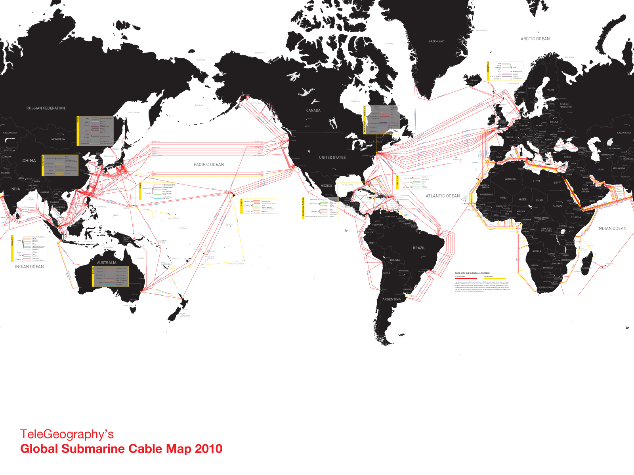
Figure 18. Global map of submarine telecommunication cables.

Other Moorings

At present no other moorings are known to be located in the Argentine Basin area.

Satellite altimetry tracks

The global OOI site locations were chosen to be co-located with crossing ground tracks of present satellite altimeters. As of 2010, this orbit is occupied by the Jason-2 satellite (previously Jason-1 and TOPEX/Poseidon). Figure 19 shows spatial SSH correlation to obtain an independent estimate of typical eddy sizes.

Along-track altimetry data were obtained from NASA’s Physical Oceanography Distributed Active Archive Center (PO.DAAC ).

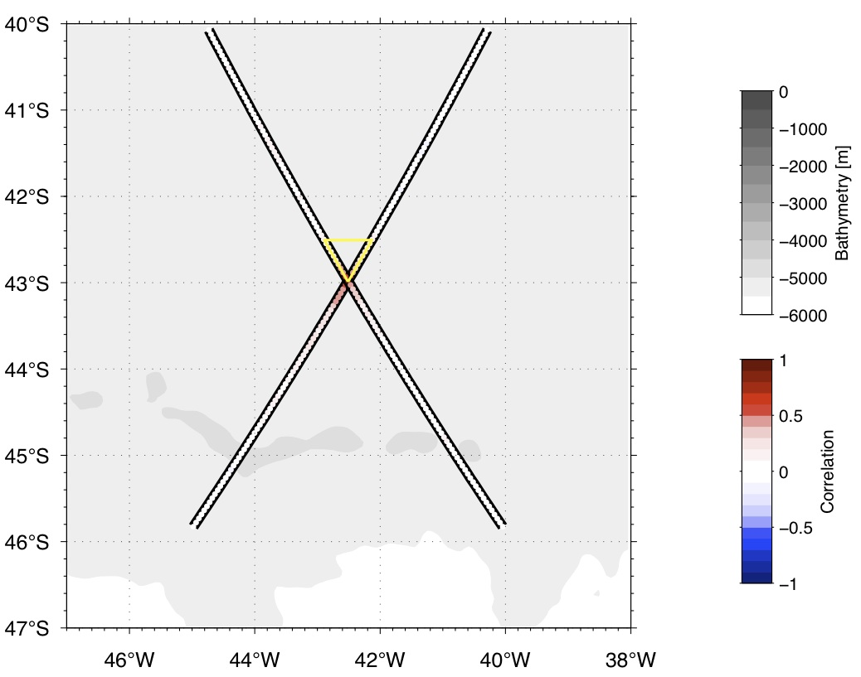

Figure 19. PRELIMINARY: Spatial correlation in along-track sea surface height anomaly as seen by satellite altimetry. Data are from the TOPEX/Poseidon satellite, cycles 12 through 364, in an along-track gridded product obtained from PO.DAAC (http://podaac.jpl.nasa.gov) and have been high-pass filtered at about 180 days to highlight the mesoscale eddy field.

Site Design

Site Components
The Argentine Basin Array consists of four moorings: a Surface Mooring, a Hybrid Profiler Mooring, and two Subsurface Flanking Moorings.

- The Surface Mooring is an inverse catenary mooring with a standard power Global Surface Buoy at the top and an anchor at the bottom. The watch circle of the Surface Mooring is 4.543 km and is calculated from the scope of the mooring (1.25 • depth) and the stretch of the nylon portions of the mooring line.
- The Hybrid Profiler Mooring consists of a taut subsurface mooring with a wire-following profiler, and a subsurface platform at ~230 m depth from which a surface-piercing profiler is deployed.
- The Flanking Moorings are taut subsurface moorings with a sub-surface float at ~30 m depth.

Site Configuration

Moored Array
The moored array will be configured as an equilateral triangle with one corner pointing poleward. The mooring locations described below are based primarily on Smith & Sandwell global bathymetry (general array location), Rossby radius (length of array sides), and satellite altimetry track lines (orientation of array). During the first deployment cruise, high-resolution multi-beam bathymetry surveys will be made of the deployment region. The actual mooring locations will be based on the results of that survey which may reveal the presence of seamounts or holes.

For the Argentine Basin Array, the Surface Mooring will be located at 42.9906° S, 42.5104° W. The Hybrid Profiler Mooring will be located 7.6 km due north from the Surface Mooring, and Flanking Moorings A and B will be located 62 km (PRELIMINARY) from the Surface Mooring due 330 and 30 degrees, respectively (Table 6, Figure 20). The appropriate spacing between the Surface Mooring and the Hybrid Profiler Mooring was calculated from the watch circles of both moorings (4.5 km and 10% of depth, respectively), plus an additional 50% to account for uncertainties in mooring placement (Figure 21).

The positions of the moored array are described by three parameters:
- Site Center. This is the central location for a site, from which the Site Radius is measured. The Site Center is listed in array location tables and plotted on maps. However, the mooring or moorings at the site may not be located at the Site Center. They will be located within the Site Radius.

- Site Radius. This is the region within which the mooring at each site will be located. A region, rather than an exact location, is necessary to allow for local-scale bathymetric features unresolved on available maps, uncertainties in “anchor-over” position, anchor fall-back during deployment, and the possibility that a replacement mooring may be deployed before the original mooring is recovered. The Site Radius is two times the nominal depth of the array.

- Mooring Separation. This is the distance between mooring anchor positions, described relative to the Surface Mooring position. The Hybrid Profiler Mooring is located as close to the Surface Mooring as possible (as described above). The Flanking Mooring separations, which can also be thought of as the length of the “sides” of the triangular array are based on the length-scale of mesoscale features in the region. Actual mooring positions and separations will only be known after deployment.

Table 6. PRELIMINARY Mooring Locations

 | Depth | Site Center |  | Site Radius | Mooring Separation
 | Depth | Latitude | Longitude | Site Radius | Mooring Separation
Surface Mooring  GA01SUMO | ~5200 m | 42.9906° S | 42.5104° W | 10.4 km
Hybrid Profiler Mooring  GA02HYPM | ~5200 m | 42.9222° S | 42.5104° W | 10.4 km | 7.6 km from Surface Mooring
Flanking Mooring A  GA03FLMA | ~5200 m | 42.5073° S | 42.8905° W | 10.4 km | 62 km from Surface Mooring
Flanking Mooring B  GA03FLMB | ~5200 m | 42.5073° S | 42.1303° W | 10.4 km | 62 km from Surface Mooring

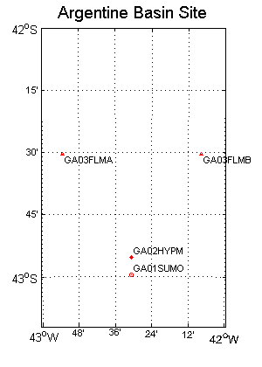
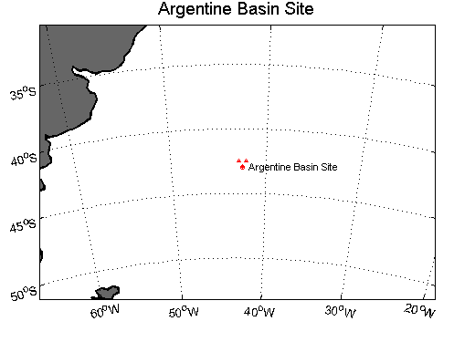
Figure 20. Location of the Argentine Basin Global Array

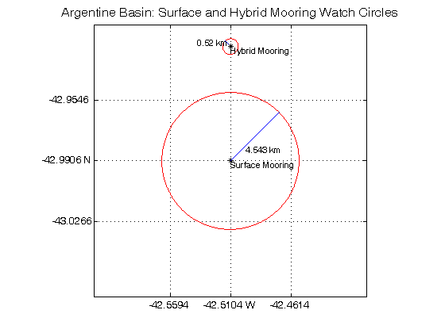
Figure 21. The spacing between the Surface Mooring and the Hybrid Profiler Mooring is 7.5945 km. This spacing takes into account the watch circles of both moorings (red circles), and other uncertainty factors such as deployed mooring location.

Glider Operations Area
Three open ocean gliders will operate in the vicinity of the moored array. The default mission plan of the gliders is to profile the water column from 1000 m depth to the surface in paths between the Surface Mooring and the Flanking Moorings. This will provide greater horizontal context to better resolve mesoscale features. The gliders will also provide adaptive sampling capabilities to respond to events in the area.

References

Arhan, M., K. Heywood, and B. King, 1999. The deep waters from the Southern Ocean at the entry to the Argentine Basin. Deep-Sea Res. II, 46, 475-499.

Chelton, D.B., R. A. deSzoeke, M. G. Schlax, K. El Naggar and N. Siwertz, 1998. Geographical variability of the first-baroclinic Rossby radius of deformation. J. Phys. Oceanogr., 28, 433-460.

Flood, R. D. and A. N. Shor, 1988. Mud waves in the Argentine Basin and their relationship to regional bottom circulation patterns. Deep-Sea Res., 35(6), 943-971.

Fu., L-L, 2007. Interaction of mesoscale variability with large-scale waves in the Argentine Basin. J. Phys. Oceanogr., 37, 787-793.

Fu, L-l and R. D. Smith, 1996. Global ocean circulation from satellite-altimetry and high-resolution computer simulation. Bull AMS, 77(11), 2625-2636.

Harkema, R., and G. L. Weatherly, 1989. A compilation of moored current meter data in the Argentine Basin April 25, 1987–March 14, 1988. Dept. of Oceanography, Florida State University, Report No. CMF-98-01, 64 pp.

Li, F., P. Ginoux, and V. Ramaswamt, 2008. Distribution, transport, and deposition of mineral dust in the Southern Ocean and Antarctica: Contribution of major sources. J. Geophys Res., 113, D10207.1-D10207.

Maximenko, N. A. and P. P. Niiler. Recent Advances in Marine Science and Technology
(Ed.: N. Saxena), chapter Hybrid decade-mean global sea level with mesoscale resolution.
PACON International, 2005.

Rio, M.-H. , P. Schaeffer, F. Hernandez, and J.-M. Lemoine. The estimation of the ocean Mean
Dynamic Topography through the combination of altimetric data, in-situ measurements
and GRACE geoid: From global to regional studies. In Proceedings of the GOCINA
international workshop, Luxembourg, 2005.

Roden, G. I., 1989. The vertical thermohaline structure in the Argentine Basin. J. Geophys. Res., 94, 877-896.

Sabine, C., L., N, Gruber, R.M Key, K. Lee, J. L. Bullister, R. Wannikopf, C. S. Wong, D. W. R. Wallace, B. Tillborook, F. J. Millero, T-H Peng, A. Kozyr, T. Ono, and A. F. Rios, 2004. The oceanic sink for anthropogenic CO2, Science, 5682, 367-371.

Appendix A. Methodology for determining extreme events from KNMI data

10, 30, and 100-Year Sea States

For Argentine Basin, we used the Koninklijk Netherlands Meteorological Institute ERA-40 Wave Atlas (www.knmi.nl/waveatlas). The data presented in the Wave Atlas was derived from a reanalysis of 45 years (1957-2002) of satellite wind observations collected by the European Center for Medium Range Weather Forecasts. The reanalysis wave height data is derived for the world’s oceans by using the historical wind data as input and calculating wave heights on a numerical grid. Corrections to the data are made using buoy and satellite-altimeter observations. Note that for the other deepwater OOI sites, we used time series data of significant wave height based on GROW reanalysis data. For the Argentine Basin site we do not have time series data. The most useful data presented at the KNMI web site is tabulated values of wave height versus wave period for 9o latitude × 9o longitude squares, one of which (36° – 45° S latitude and 36° – 45° W longitude which includes the Argentine Basis site (42° S, 42° W).
Plotted on a contour plot, the data looks like:

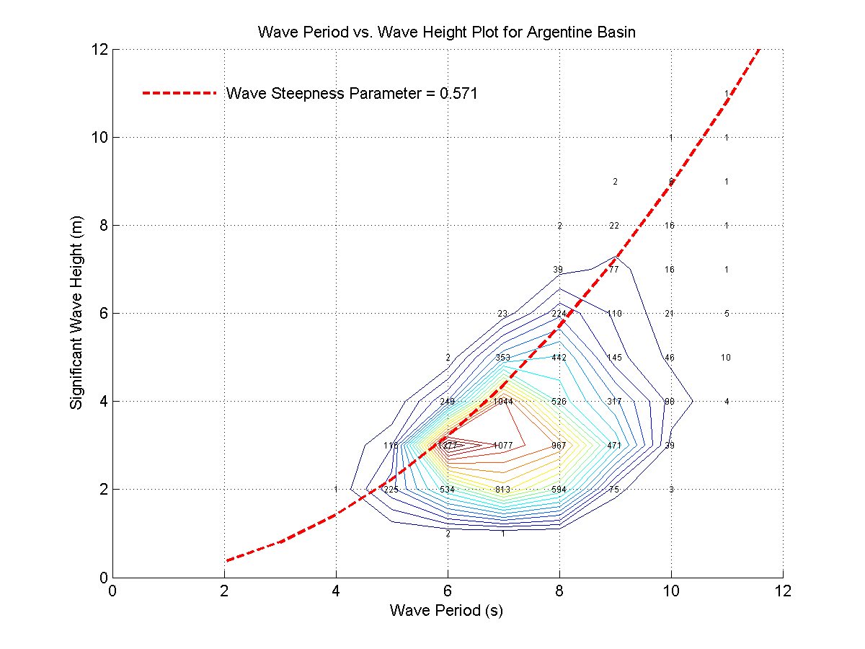

where the numbers represent events at the particular wave height and wave period per 10,000 total events. For example, there were 1044 events with significant wave height between 3-4 m (upperbound 4 m) and wave period of 6-7 s (upperbound 7s). The dashed red line is an eyeball fit that biases the high sea state data and represents a wave steepness 2πH_{s}/(gT_{m}²) = 0.0571. where H_{s} is significant wave height, T_{m} is the mean wave period, and g is gravity. We use this to calculate wave period for a given return sea state. Note that maximum theoretical wave steepness in 0.0667.

To determine significant wave height probability function, we first sum the rows to obtain a one-dimensional histogram of wave height. We divide the number of events per wave height bin by 10,000 to get the fraction of occurrence. Thus, the histogram represents the probability distribution for wave height over a 45-year period.

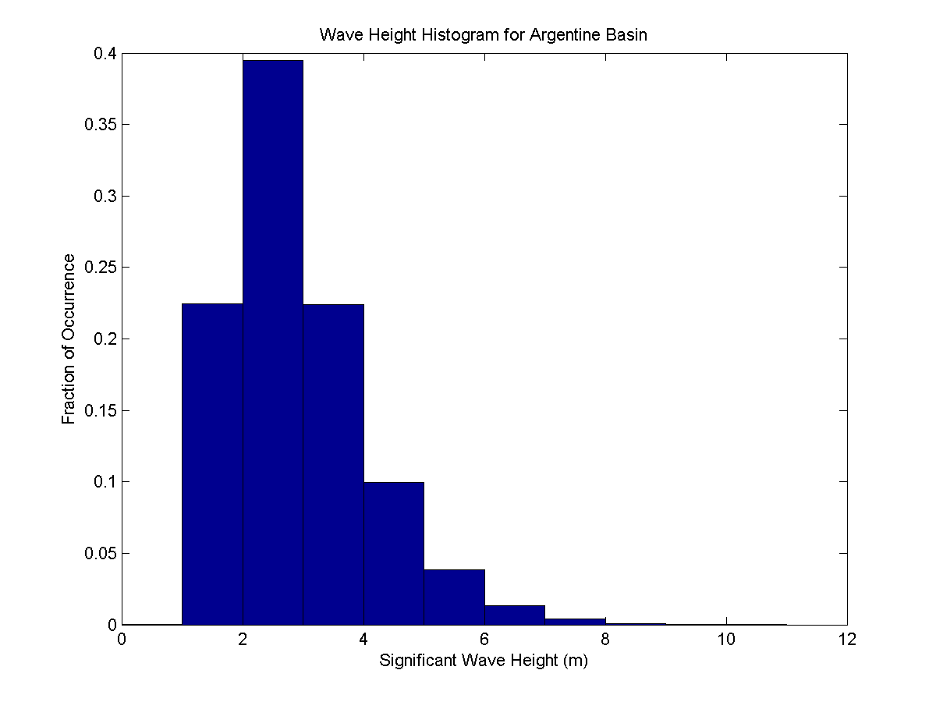

The data in the histogram is used to calculate a cumulative probability function, which gives the probability that the significant wave height H_{s} is less than a given threshold value H_{t}. This is written as Pr(H_{s} ≤ H_{t}), and a plot of this looks like:

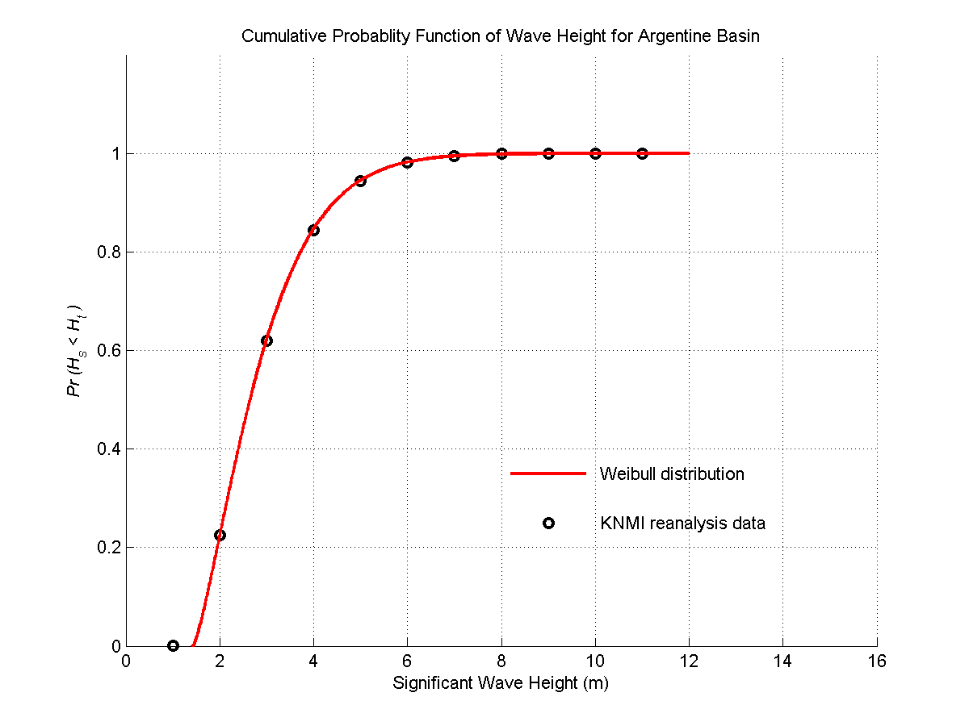

The red line represents a best fit of a three-parameter Weibull distribution and is given by the equation:

where the best-fit parameters are A = 1.43, B = 1.50, and C = 1.29. We determine the N-year return sea state H_{N} from the following equation:

for N = {10, 30, and 100 years). The value of d represents the duration of a typical storm. For this, we choose a value of d = 6 hours. This is based on applying this method to evaluate the return sea states for Station Papa. A value of d = 6 hours matched the previous results obtained using time series data from the NDBC Buoy 46001. Thus, H_{N} can then be calculated using:

where N is equal to 10, 30, or 100 years. The parameters A, B, C, and d are known and are given above. The peak period T_{p} follows from inverting the previous equation for the steepness parameter with T_{p} = 1.4T_{m}. Thus,

10, 30, and 100-Year Wind

The most useful wind data at the KNMI website are the monthly mean and monthly standard deviations. For Argentine Basin, we chose the windiest month (June) and determined the mean and standard deviation for the Argentine Basin site from the surface contour plots. These plots were constructed from 6-hourly time-series data (data point recorded every 6 hours) collected between 1971-2000. The 6-hourly time series data was not posted on the website.

For June, the mean wind speed is 9.4 m/s with a standard deviation of 3.6 m/s. We used these values to determine parameters B and C for a Weibull distribution. Parameter A is taken to be zero. Thus,

where W_{S} is the sustained wind and W_{t} is the threshold. The parameters B and C are determined from the following relations:

where Γ is the symbol for a gamma function. Once B and C are determined, we then calculated 10, 30, and 100-year wind events from

where N is equal to 10, 30, or 100 years. We use 30 days since the distribution corresponds only to the data for the month of June. The duration is d = 6 hours as before for wave height.

We applied this method to Station Papa using the KNMI data its windiest month December with mean 10.1 m/s and standard deviation of 4.0 m/s and were able to reproduce the previous results.

Appendix B. Methodology for determining extreme events from GROW Hindcast data

10, 30, and 100-Year Sea States

Historical records for significant wave heights come mostly from reanalysis of wind data collected by satellites. The wind data is used as input into numerical models that calculate significant wave height. Since winds are averaged over a fairly course grid, the significant wave heights typically underestimate short-term events as measured by surface buoys. The GROW data as delivered is usually corrected for this.

Extreme events (10, 30, and 100-year sea states) are estimated using Peak-Over-Threshold method. We catalogue the peaks above a given threshold (typically 0.5 to 0.75 of the maximum significant wave height of the given time record). The peaks we choose must be separated by at least 48 hours (this is our subjective criteria to insure independent storm events). If there are two peaks within a ±48-hour window, then we only retain the largest peak within the window. We calculate the cumulative probability distribution for the peaks above our threshold such that Pr(H_{s} ≤ H_{t}) = 0 where H_{s} is the significant wave height and H_{t} is the threshold and Pr(H_{s} ≤ H_{m}) = 1 – 1/(N+1) where H_{m} is the maximum peak and N is the total number of peaks above the threshold. Generalized Pareto Distributions are fitted to the measured distributions corresponding to different thresholds. Goodness of fit criteria that gives more weight to the higher sea states is applied to the different threshold distributions, and this is used to determine the parameters for the Generalized Pareto Distribution, which are then use in estimating 10, 30, and 100-year sea states. The input cumulative probability for a N-year sea state is given by 1-1/(N*m) where m is the average number of peaks per year above the given threshold. Peak period for the 10, 30, and 100 year sea states is determined from the curve 4πH_{s}/(gT_{p}²) = 0.0571. where H_{s} is significant wave height, T_{p} is the peak wave period, and g is gravity. We use this to calculate wave period for a given return sea state. Note that maximum theoretical wave steepness in 0.0667.

10, 30, and 100-Year Wind

Extreme wind events are determined in the same manner using Peak-Over-Threshold method. The wind data comes from satellite reanalysis studies and from surface buoy measurements.

Current Profiles

Consistently estimating typical current profiles for the four global-ocean OOI sites is made difficult by different levels of data availability/sparsity between the sites. To overcome this, current speed profiles were constructed for each site as vertically decaying exponentials plus an additional offset. The parameters to describe these functions are: the offset, the exponential decay depth, and the exponential initial value.
The offset was chosen to be 10 cm/s for all sites.
The vertical 50%-decay depth of the exponential was derived for each site individually. It stems from the shape of the first baroclinic mode of horizontal velocity, which in turn is based on temperature and salinity profiles in the “World Ocean Atlas” climatology. Values range approximately from 500m to 1200m.
The initial value of the exponential near the surface was chosen for each site individually, such that the velocity values would match those derived from an average of nearby surface drifter data and altimetry-derived surface currents, times a factor that makes these match near-surface ADCP values at the Irminger Sea site where such ADCP data exist.
The current speed values used for the ADCP, drifters, and altimeter were one-RMS values, which are thought of as representing the background field. Two stronger profiles were obtained by multiplying these with two and three, respectively interpreted as a typical eddy event and a multi-year repeat-cycle extreme event.

Appendix C. Data sources

Personal Contacts
Agustín Gutiérrez (agustin.gutierrez@telefonica.com)
Telefonica International Wholesale Services

