Cruise Plan
Coastal Pioneer 3 Deployment
Leg 2: R/V Knorr Cruise KN-224
10-16 December 2014

Control Number: 3204-00304
Version: 1-01
Author: A. Plueddemann
Date: November 21, 2014
Approved:

Coastal and Global Scale Nodes
Ocean Observatories Initiative
Woods Hole Oceanographic Institution
Oregon State University
Scripps Institution of Oceanography
Revision History
Version | Description | Originator | ECR No. | Release Date
0-01 | Draft | A. Plueddemann | N/A | 11/10/2014
0-02 | Draft | A. Plueddemann | N/A | 11/14/2014
1-00 | Initial release | P. Matthias | N/A | 11/15/2014
1-01 | Revised for Knorr | A. Plueddemann | N/A | 11/21/2014

Table of Contents

1.0 Introduction 1
1.1. Overview 1
1.2. Operating Area 1
2.0 Cruise Plan 1
2.1. Background 1
2.2. Staging and De-Staging 3
2.3. Cruise Operations and Objectives 4
2.3.1. Release Tests 5
2.3.2. Mooring Operations 5
2.3.3. Anchor Surveys 6
2.3.4. CTD casts 6
2.3.5. Sensor Performance Evaluation 6
2.3.6. Shipboard Underway Data 6
2.3.7. Small Boat Operations 7
2.4. Potential Restrictions 7
3.0 Appendices 7
Appendix A – Cruise Timeline 8
Appendix B – Selected Waypoints and Maps 11
Appendix C – Equipment Inventory and Deck Plan 12
Appendix D – Science Party 14
Appendix E – Mooring Drawings 15

List of Figures
Figure 2-1 – Map of the Pioneer Array region 2
Figure 2-2 – Pioneer Array mooring site locations. 3
Figure 3-1 – Deck Layout 12
Figure 3-2 – Pioneer Inshore Surface Mooring (ISSM). 15
Figure 3-3 – Pioneer Central Surface Mooring (CNSM). 16
Figure 3-4 – Pioneer Offshore Surface Mooring (OSSM). 17
Figure 3-5 – Pioneer Coastal Surface Piercing Profiler (CSPP). 18

List of Tables
Table 3-1 – Station List 11
Table 3-2 – Estimated Deckload 13

Introduction

Overview
This cruise represents the third major infrastructure deployment for the Pioneer Array of the National Science Foundation’s Ocean Observatories Initiative (OOI; http://www.oceanobservatories.org). The Pioneer Array includes a network of moorings and autonomous robotic vehicles to monitor waters of the continental shelf and slope south of New England and, in particular, the shelfbreak front where nutrients and other properties are exchanged between the coast and the deep ocean. Data from the Pioneer Array will provide new insights into coastal ocean processes such as shelf/slope nutrient exchange, air-sea property exchange, carbon cycling, and ocean acidification that are important to the New England shelf and to continental shelf ecosystems around the world.
The Pioneer 3, Leg 2 deployment cruise (Pioneer-3 L2) has eight primary objectives (see Sec. 2.3) that include the deployment of three Coastal Surface Moorings (CSMs), the deployment of two uncabled Coastal Surface Piercing Profiler (CSPP) moorings, recovery and refurbishment of the Upstream Inshore Profiler Mooring (PMUI), and CTD casts with water sampling at the mooring sites. The Pioneer-3 L2 cruise also has Additional objectives, including ship vs. buoy meteorological comparisons, and CTD/ADCP surveys in the vicinity of the Pioneer moored array.

Operating Area
The Pioneer operating area is the southern New England continental shelf and slope within a region bounded by approximately 39.0°- 40.7° N and 69.9° - 71.5° W (Fig. 1-1). Pioneer-3 operations will be focused on the Pioneer Moored Array centered near 40.15°N, 70.83°W (Fig. 1-2). Mooring site locations and water depths are provided in Appendix A.

Cruise Plan

Background
The Pioneer Array will be deployed in three phases, as described in the Pioneer Array Deployment Plan (CGSN 3101-00091: ECR 1303-01166). The deployment plan, and the instrument configurations on each platform, assume that Coastal Surface Moorings will be deployed for ~1 year and Coastal Profiler Moorings for ~6 months. The Pioneer Central Surface Mooring (CNSM) and the Upstream Inshore and Upstream Offshore Profiler Moorings (PMUI, PMUO) were deployed on the Pioneer-1 cruise. The surface mooring and two profiler moorings were recovered, and five profiler moorings were deployed (PMUI, PMUI, PMCI, PMCO and OSPM), on the Pioneer 2 cruise. Three gliders were deployed on Pioneer 2, occupying the EB, FZ and SS-1 lines. All gliders were recovered prior to the Pioneer 3 Leg 1 cruise. On the Pioneer-3 Leg 1 cruise, conducted in October 2014, the five Coastal Profiler Moorings were recovered, five replacement CPMs were deployed. Five gliders were deployed, occupying the EB, FZ, SS-1 and SS-2 lines.

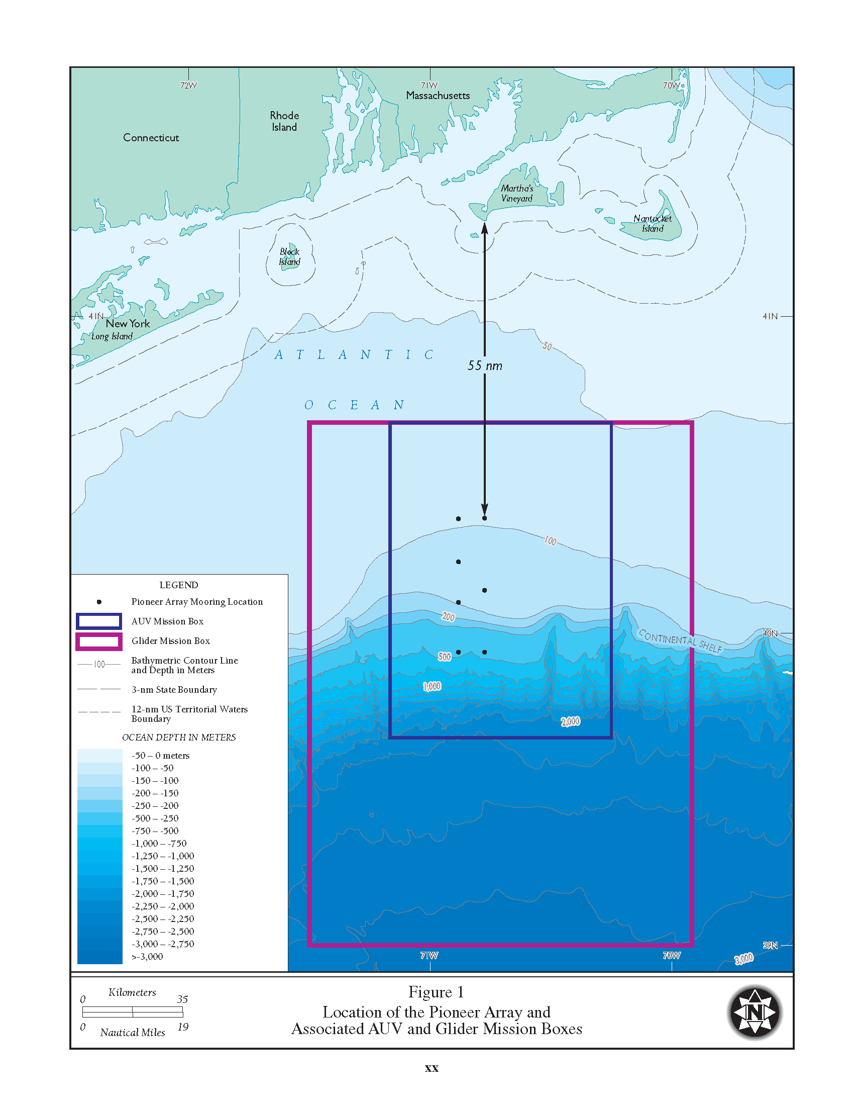

Figure 2-1 – Map of the Pioneer Array region
over the southern New England continental shelf and slope. The seven sites of the moored array, the AUV operating region and the glider operating region are shown along with bathymetric contours.
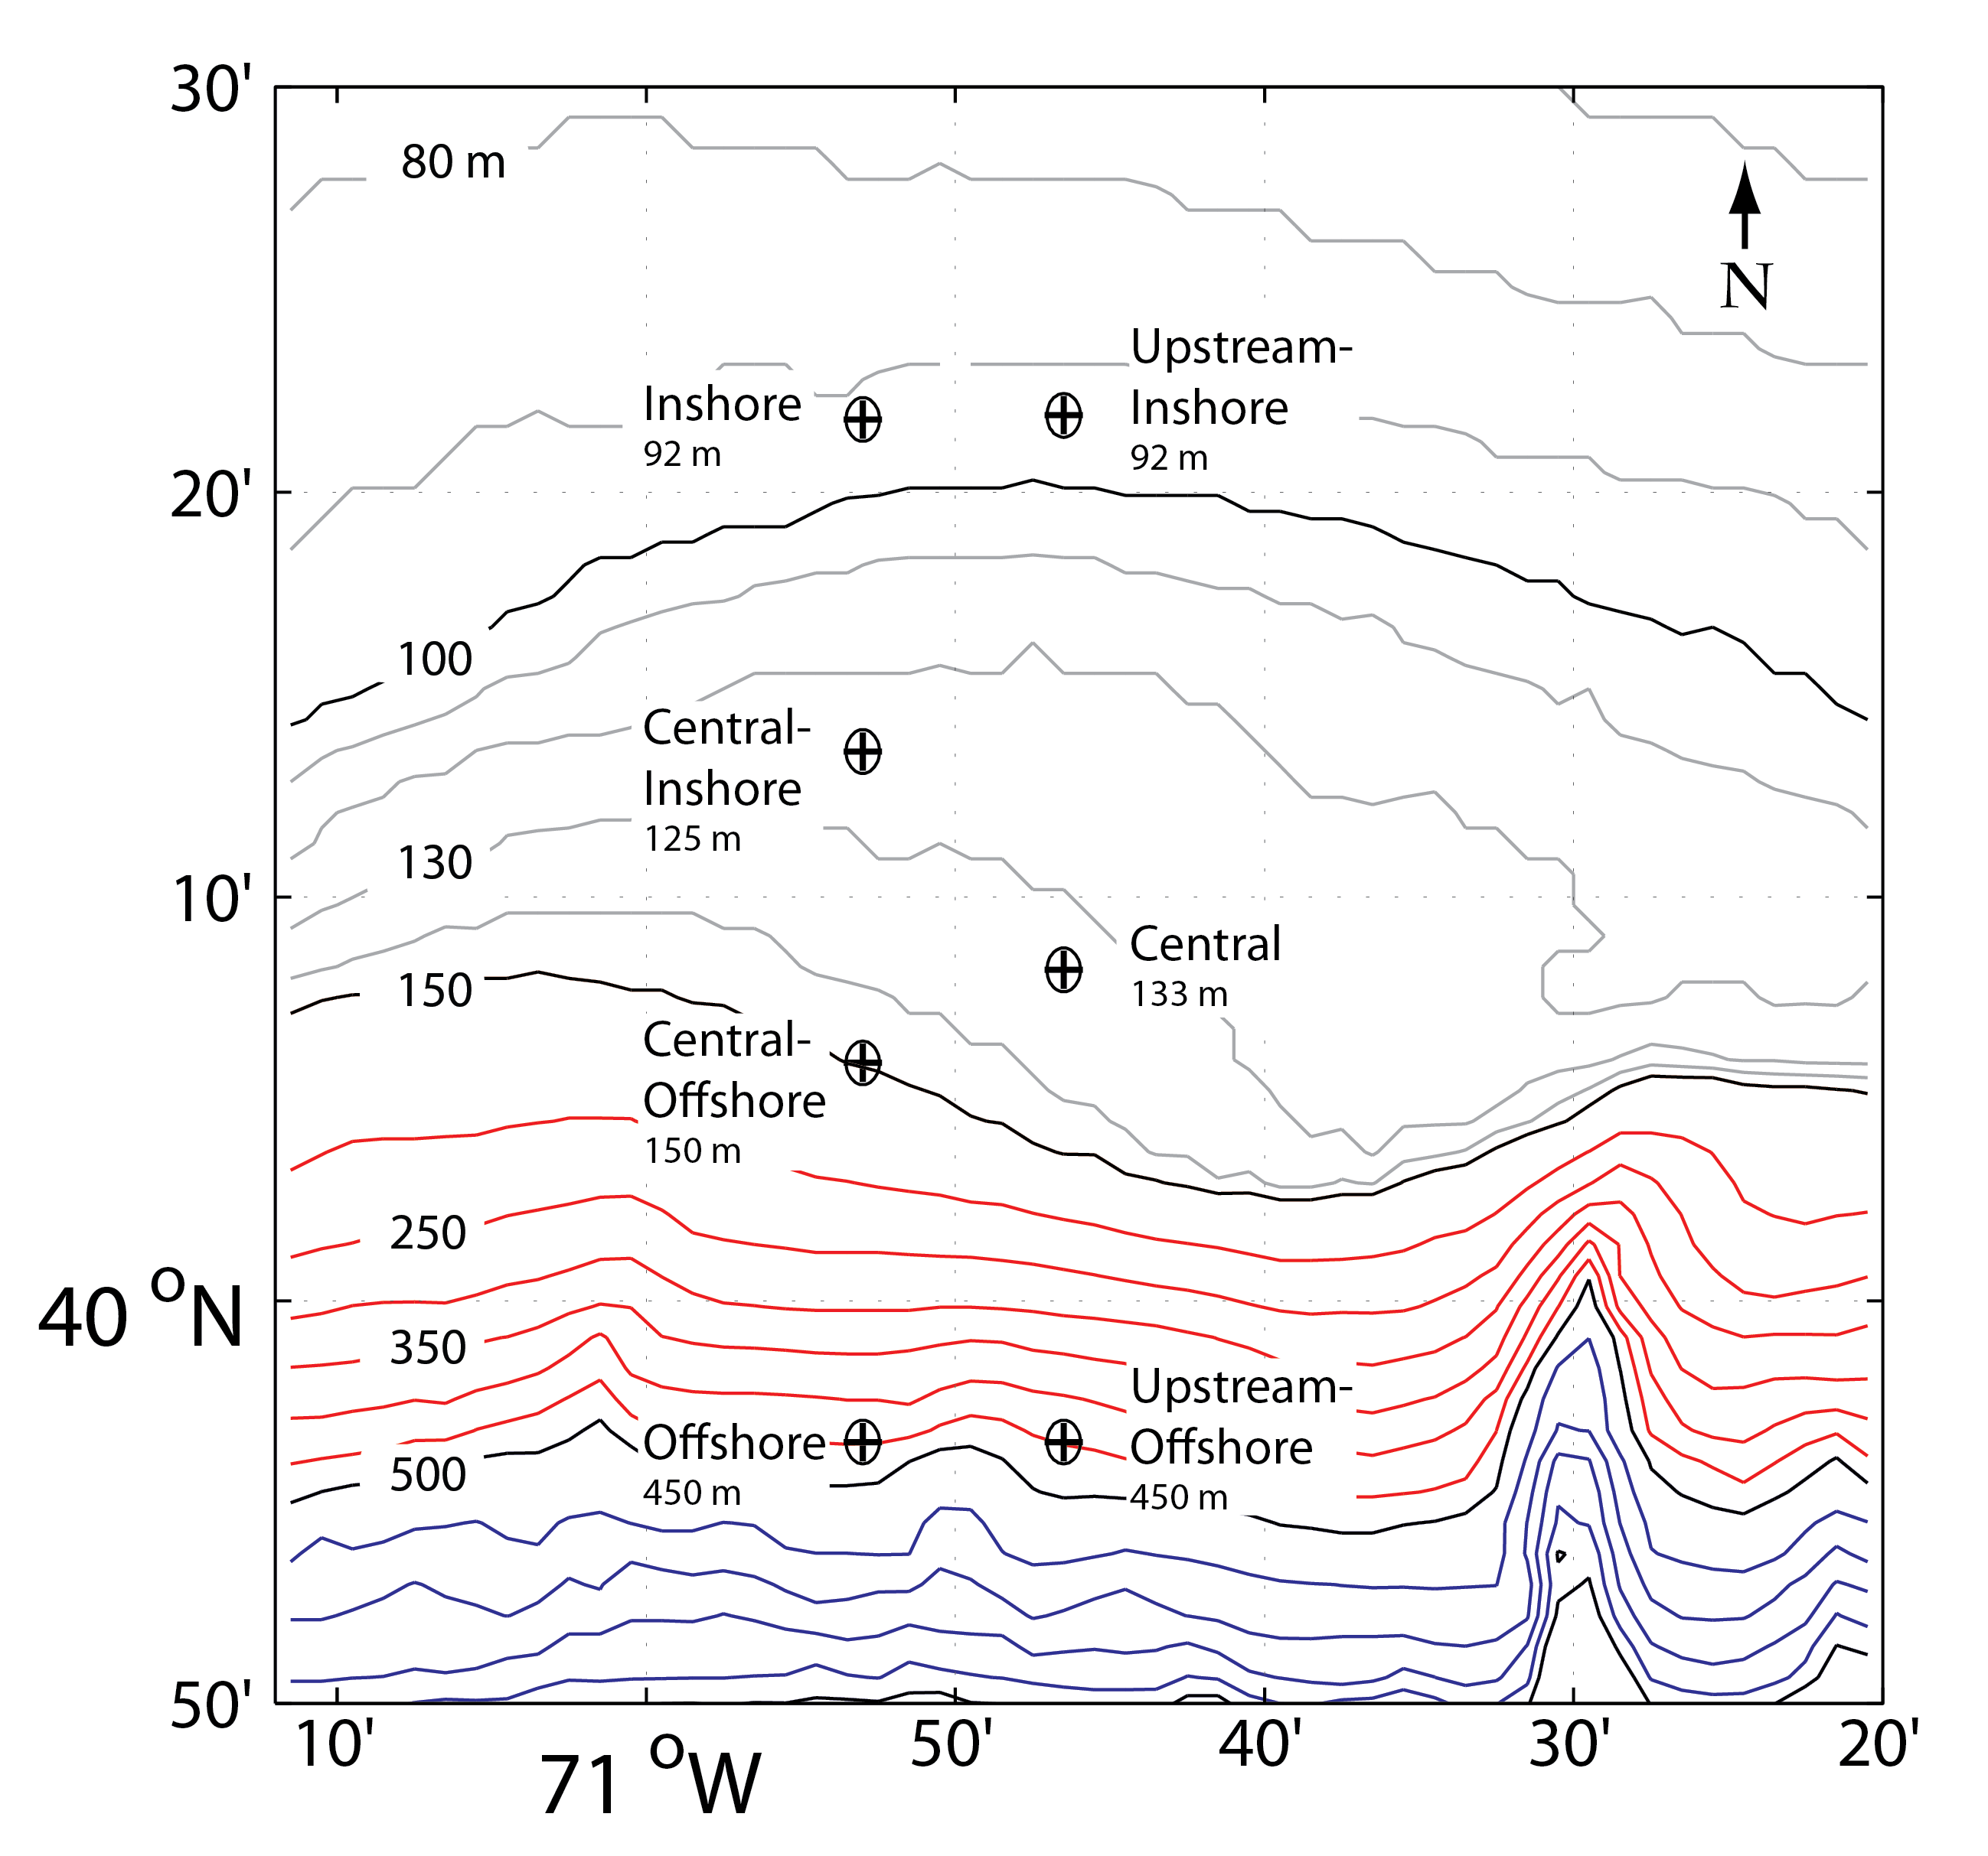
Figure 2-2 – Pioneer Array mooring site locations.
Site centers are marked by black "+" and encircled by approximate 0.5 nm radius buffer zones. Bathymetry is shown at 10 m (gray), 50 m (red) and 100 m (blue) intervals, respectively. Black contours are at 100 m, 150 m, 500 m and 1000 m.

Staging and De-Staging
Staging and loading will be done at the Woods Hole Oceanographic Institution (WHOI). Staging will begin on the WHOI dock during 6-7 December. Gear will be loaded aboard the R/V Knorr during 8-9 December. The ship’s crane will be suitable for loading all science gear. As part of the staging operation, it will be necessary to mount several antennas and run cables from these antennas to the main lab. Antenna mount locations and cable runs will be determined by consultation with the ship. A list of major equipment to be loaded and a deck plan showing the location of major deck components are provided in Appendix A.

Destaging and offloading of scientific equipment will be completed in Woods Hole upon termination of the cruse on 16 December, with the offloaded to be completed by 17 December. The ship’s crane will be suitable for offloading all science gear.

Cruise Operations and Objectives
The R/V Knorr will depart from Woods Hole on 10 December and transit to the Pioneer Offshore site where operations will commence. Days 2-4 of the cruise will be primarily dedicated to Coastal Surface Mooring (CSM) deployments. One of these (the Central Site mooring, CNSM) contains a methanol fuel in the surface buoy. Coastal Surface Piercing Profilers (CSPPs) will be deployed at the Inshore and Central sites adjacent to the CSMs. The fifth day will focus on Coastal Profiler Mooring (CPM) recovery and re-deployment. If all activities are complete, the sixth day will focus on a cross-shelf CTD survey. In the more likely event that bad weather or other difficulties preclude completion of the primary objectives, they will be completed on the sixth day. The ship will depart station on day 6 and arrive at WHOI on day 7. Other activities that need to be conducted in conjunction with the mooring deployments include anchor surveys and CTDs with bottle samples. A detailed timeline is provided in Appendix A.
Additional activities are nominally scheduled in the cruise timeline (Appendix A), and will be fit in as time allows: A glider recovery will be conducted at a convenient time when the ship is near the glider location. Ship vs. buoy meteorological comparisons will be conducted from late evening, after mooring operations are completed, to early morning before the start of the next operation. A variety of surveys may be conducted.
The primary Objectives (O1-O8) are listed below. Nominal times for these activities are given in the cruise timeline (Appendix A). Site locations are listed in Appendix B.
O1. Deploy the Offshore Coastal Surface Mooring (CP04OSSM-00001).
O2. Deploy the Central Coastal Surface Mooring (with fuel cell) (CP01CNSM-00002).
O3. Deploy the Inshore Coastal Surface Mooring (CP03ISSM-00001).
O4. Deploy the Central Surface Piercing Profiler Mooring (CP01CNSP-00001).
O5. Deploy the Inshore Surface Piercing Profiler Mooring (CP03ISSP-00001).
O6. Recover the Upstream Inshore Profiler Mooring (CP02PMUI-00003)
O7. Refurbish and redeploy the Profiler Mooring (CP02PMUI-00004).
O8. Conduct CTD casts with water sampling at the mooring sites.
There are also Additional objectives (A1-A4) that would be desirable to accomplish on the cruise. The Additional objectives are listed in rough priority order, and will be completed as time and conditions permit.
A1. Recover coastal glider SN 376, dedicated to the SS-1 line.
A2. Conduct ship vs. buoy meteorological comparisons at each CSM site.
A3. Conduct a CTD surveys (no bottle samples) in the vicinity of the moored array.
A4. Conduct shipboard ADCP and/or bathymetry surveys in the vicinity of the moored array.
The Chief Scientist (CS) will execute the cruise according to the direction of the Program Manager (PM) in order to accomplish, to the extent practicable, programmatic and scientific objectives as described above. The ship’s Master and the CS have discretion to alter the order of operations as well as determine that some operations cannot be accomplished safely or effectively, based on conditions encountered at sea. The CS and PM have discussed tasks and responsibilities for the cruise, have reviewed likely at-sea failure modes and actions, have reviewed guiding principles for at-sea decision making, and have established communication pathways for both routine reporting (e.g. email) and emergency contact (e.g. satellite telephone).
The CS and PM will communicate frequently (typically daily by email) during the cruise to exchange status information and to assess the potential impact of at-sea decisions driven by weather or technical issues. Significant modifications to the cruise objectives (e.g. inability to deploy/recover a platform) or changes to the cruise plan anticipated to have significant financial impacts (e.g. additional ship days) will be communicated to the PM at the earliest opportunity. Incidents involving injury or damaged/lost equipment will follow established Program protocols (UNOLS policies, OOI Incident Reporting Process). Anomalies, suspected failures and confirmed failures will be handled according to the OOI Equipment Notification and Escalation Process.

Release Tests
At a convenient time prior to deployment of the moorings, the science party will to perform release tests. The release tests involve lowering multiple acoustic releases, to one or more depths between 500 m and the surface and held there while being interrogated acoustically. The science party will bring an acoustic transceiver than can be lowered over the rail with a cable run to the main lab and connected to a transceiver controller. Alternatively, the controller can be connected directly to a 12 kHz hull transducer on the ship.

Mooring Operations
Mooring deployments and recoveries will be done in stages using the ship’s crane and winches supplied by the science party. Science party personnel will be familiar with mooring deployment and recovery, and will be capable of directing operations in cooperation with the ship’s crew. Additional science personnel will assist with mooring operations, met watches, and other observation and data collection activities.

Glider Operations
Glider deployments and recoveries will typically be done using air tuggers and handling equipment supplied by the science party. It is also possible to use the A-frame and/or the ship’s crane. Science party personnel will be familiar with glider deployment and recovery, and will be capable of directing operations in cooperation with the ship’s crew during all phases of glider operations.

Anchor Surveys
Once the anchor has settled on the bottom, the ship will occupy three stations 0.3 to 0.5 nm from the anchor drop point in a triangular pattern. At each station the slant range to the acoustic release will be determined. Ranging from three stations will allow the release position, and thus the mooring anchor position, to be determined by triangulation.

CTD casts
CTD casts will be conducted using the ship’s CTD sensors, 12 or 24 bottle rosette frame, and deck box. Sensors requested in addition to C,T, and D are dissolved oxygen, chlorophyll fluorometer, transmissometer, and PAR. An altimeter is desirable since cast depths will be within a few meters of the bottom. CTD operations will be supervised by shipboard technicians – the science party will supply line handlers and a lab operator. Water sampling and analysis will be handled by the science party.

Sensor Performance Evaluation
Sensor evaluation operations will be conducted with at each mooring deployment site and glider deployment site. The primary means of evaluation will be CTD casts obtained in near proximity (e.g. 0.25 nm) to the mooring or glider. For validation of meteorological and sea surface variables the ship may establish and hold a position, with bow into the wind, approximately 0.10 nm downwind of a buoy. This station will be held, and adjusted if necessary, while the science party evaluates data received from the buoy. During this period, the ships underway data will be continuously recorded. At a convenient time during the cruise, the ship may make a close approach to buoys to allow visual inspection, determination of the water line, and photographs.

Shipboard Underway Data
The ship’s meteorological system will be used to continuously monitor weather conditions while underway and for evaluation of buoy meteorology during the intercomparison period. The ship’s ADCP systems will be used to continuously measure the currents in the upper ocean while. Sea surface temperature and salinity will be recorded continuously, using the ship’s thermosalinograph.

Shipboard Multi-beam Bathymetry
Bathymetric surveys may be conducted within the Pioneer Array region (e.g. within the AUV Mission Box of Fig. 1-1). Nominal waypoints for each survey will be provided to the bridge and discussed with survey technicians. Cruising speed, leg length, and leg spacing can be adjusted as needed to ensure adequate data optimal system performance. The results of the bathymetry survey should be displayed immediately after completion for evaluation by the Chief Scientist.

Small Boat Operations
The use of a work boat may be requested, at the discretion of the ship, for glider recovery or attending to unforeseen problems that would require physical access to a buoy tower. Expected duration of use is approximately 0.5 to 1.5 hr. Work boat operations would be within 0.5-1.0 nm of the ship.

Potential Restrictions
Small boat activities may be restricted by weather. In the case of a recovery operation, the ship will maneuver to the item to be retrieved and grappling lines and/or pick up poles will be used. Mooring activities may be restricted by severe weather or equipment failure. Severe weather would result in postponement until conditions eased. Failure of a given piece of Project equipment (e.g. winch, air tugger) can typically be compensated by use of an alternative approach. Failure of ship’s equipment (e.g. electrical or hydraulic system) would result in postponement of operations until the failure was addressed. Deployment and recovery activities may be restricted by the presence of multiple fixed objects (e.g. fishing gear) in the deployment area or along the deployment/recovery track. If possible, operations will be delayed until conditions are more favorable (e.g. change in prevailing wind direction allowing deployment approach along a different, unobstructed course).

Appendices
Appendix A – Cruise Timeline
Appendix B – Selected Waypoints and Maps
Appendix C – Equipment Inventory and Deck Plan
Appendix D – Science Party
Appendix E – Mooring Drawings

Appendix A – Cruise Timeline

08 – 09 Dec Mobilization, LOSOS and WHOI pier
10 – 16 Dec Cruise dates
16 – 17 Dec Demob, WHOI pier and LOSOS

Timeline

10 Dec Depart WHOI
13:00 Depart Woods Hole (slack tide), steam to Offshore site (~10 h)

11 Dec Offshore site
07:00 – 08:00: Deck prep, ck weather, determine approach, steam line
08:00 – 10:00: Release tests, electronics prep, deck prep
10:00 – 15:00: Deploy surface mooring OSSM-00001
15:00 – 16:00: CTD with samples at Offshore site
16:00 – 17:00: Anchor survey, OSSM-00001
17:00 – 19:00: Recover glider
19:00 – 22:00: Monitor and evaluate OSSM function via telemetry
Overnight
Stand-off OSSM buoy for meteorological comparison
Transit to Inshore site to arrive 05:00

12 Dec Inshore Site
07:00 – 08:00: Deck prep, ck weather, determine approach, steam line
08:00 – 10:00: Release tests, electronics prep, deck prep
10:00 – 14:00: Deploy surface mooring ISSM-00001
14:00 – 16:00: Deploy surface piercing profiler ISSP-00001
16:00 – 17:00: CTD with samples at Inshore site
17:00 – 19:00: Anchor surveys, ISSM-00001, ISSP-00001
19:00 – 22:00: Monitor and evaluate ISSM, ISSP via telemetry
Overnight
Stand-off ISSM buoy for meteorological comparison
Transit to Central site to arrive 05:00

13 Dec Central site
07:00 – 08:00: Deck prep, ck weather, determine approach, steam line
08:00 – 10:00: Release tests, electronics prep, deck prep CNSM
10:00 – 14:00: Deploy surface mooring CNSM-00002
14:00 – 16:00: Deploy CNSP-00001
16:00 – 17:00: CTD with samples at Central site
17:00 – 19:00: Anchor surveys, CNSM-00002 and CNSP-00001
19:00 – 22:00: Monitor and evaluate CNSM, CNSP via telemetry
Overnight
Stand-off CNSM buoy for meteorological comparison
Transit to Upstream Inshore site to arrive 05:00

14 Dec Upstream Inshore site
06:00 – 07:00: Deck prep, ck weather, determine approach, steam line
07:00 – 08:00: Release tests, electronics prep, deck prep, PMUI
08:00 – 10:00: Recover PMUI-00003 mooring riser
10:00 – 11:00: CTD with samples
11:00 – 13:00: Steam to start point, prepare deck for deployment
13:00 – 16:00: Deploy PMUI-00004
16:00 – 18:00: Recover PMUI-00003 anchor and line pack
18:00 – 19:00: Anchor survey, PMUI-00004
Overnight
Transit to Upstream Offshore site

15 Dec Cross-Shelf CTD survey and/or Additional Activities*
08:00 – 09:00: CTD at UO
09:00 – 10:00: CTD at CS-4
10:00 – 11:00: CTD at CS-3
11:00 – 12:00: CTD at CN
12:00 – 13:00: CTD at CS-2
13:00 – 14:00: CTD at CS-1
14:00 – 15:00: CTD at UI
16:00: Depart station for WHOI
Overnight
Transit to WHOI

16 Dec Arrive WHOI (target is slack tide at ~11:00 AM)

* Additional activities may include:
Address problems detected by shore station
Complete unfinished anchor surveys
Cross-Shelf CTD survey, UI to UO (~8 h)
Steam cross-shelf AUV box (8 h @ 10 kt)
Steam mooring box (6 h @ 10 kt)

Appendix B – Selected Waypoints and Maps

Table 3-1 – Pioneer 3 Leg 2 station list

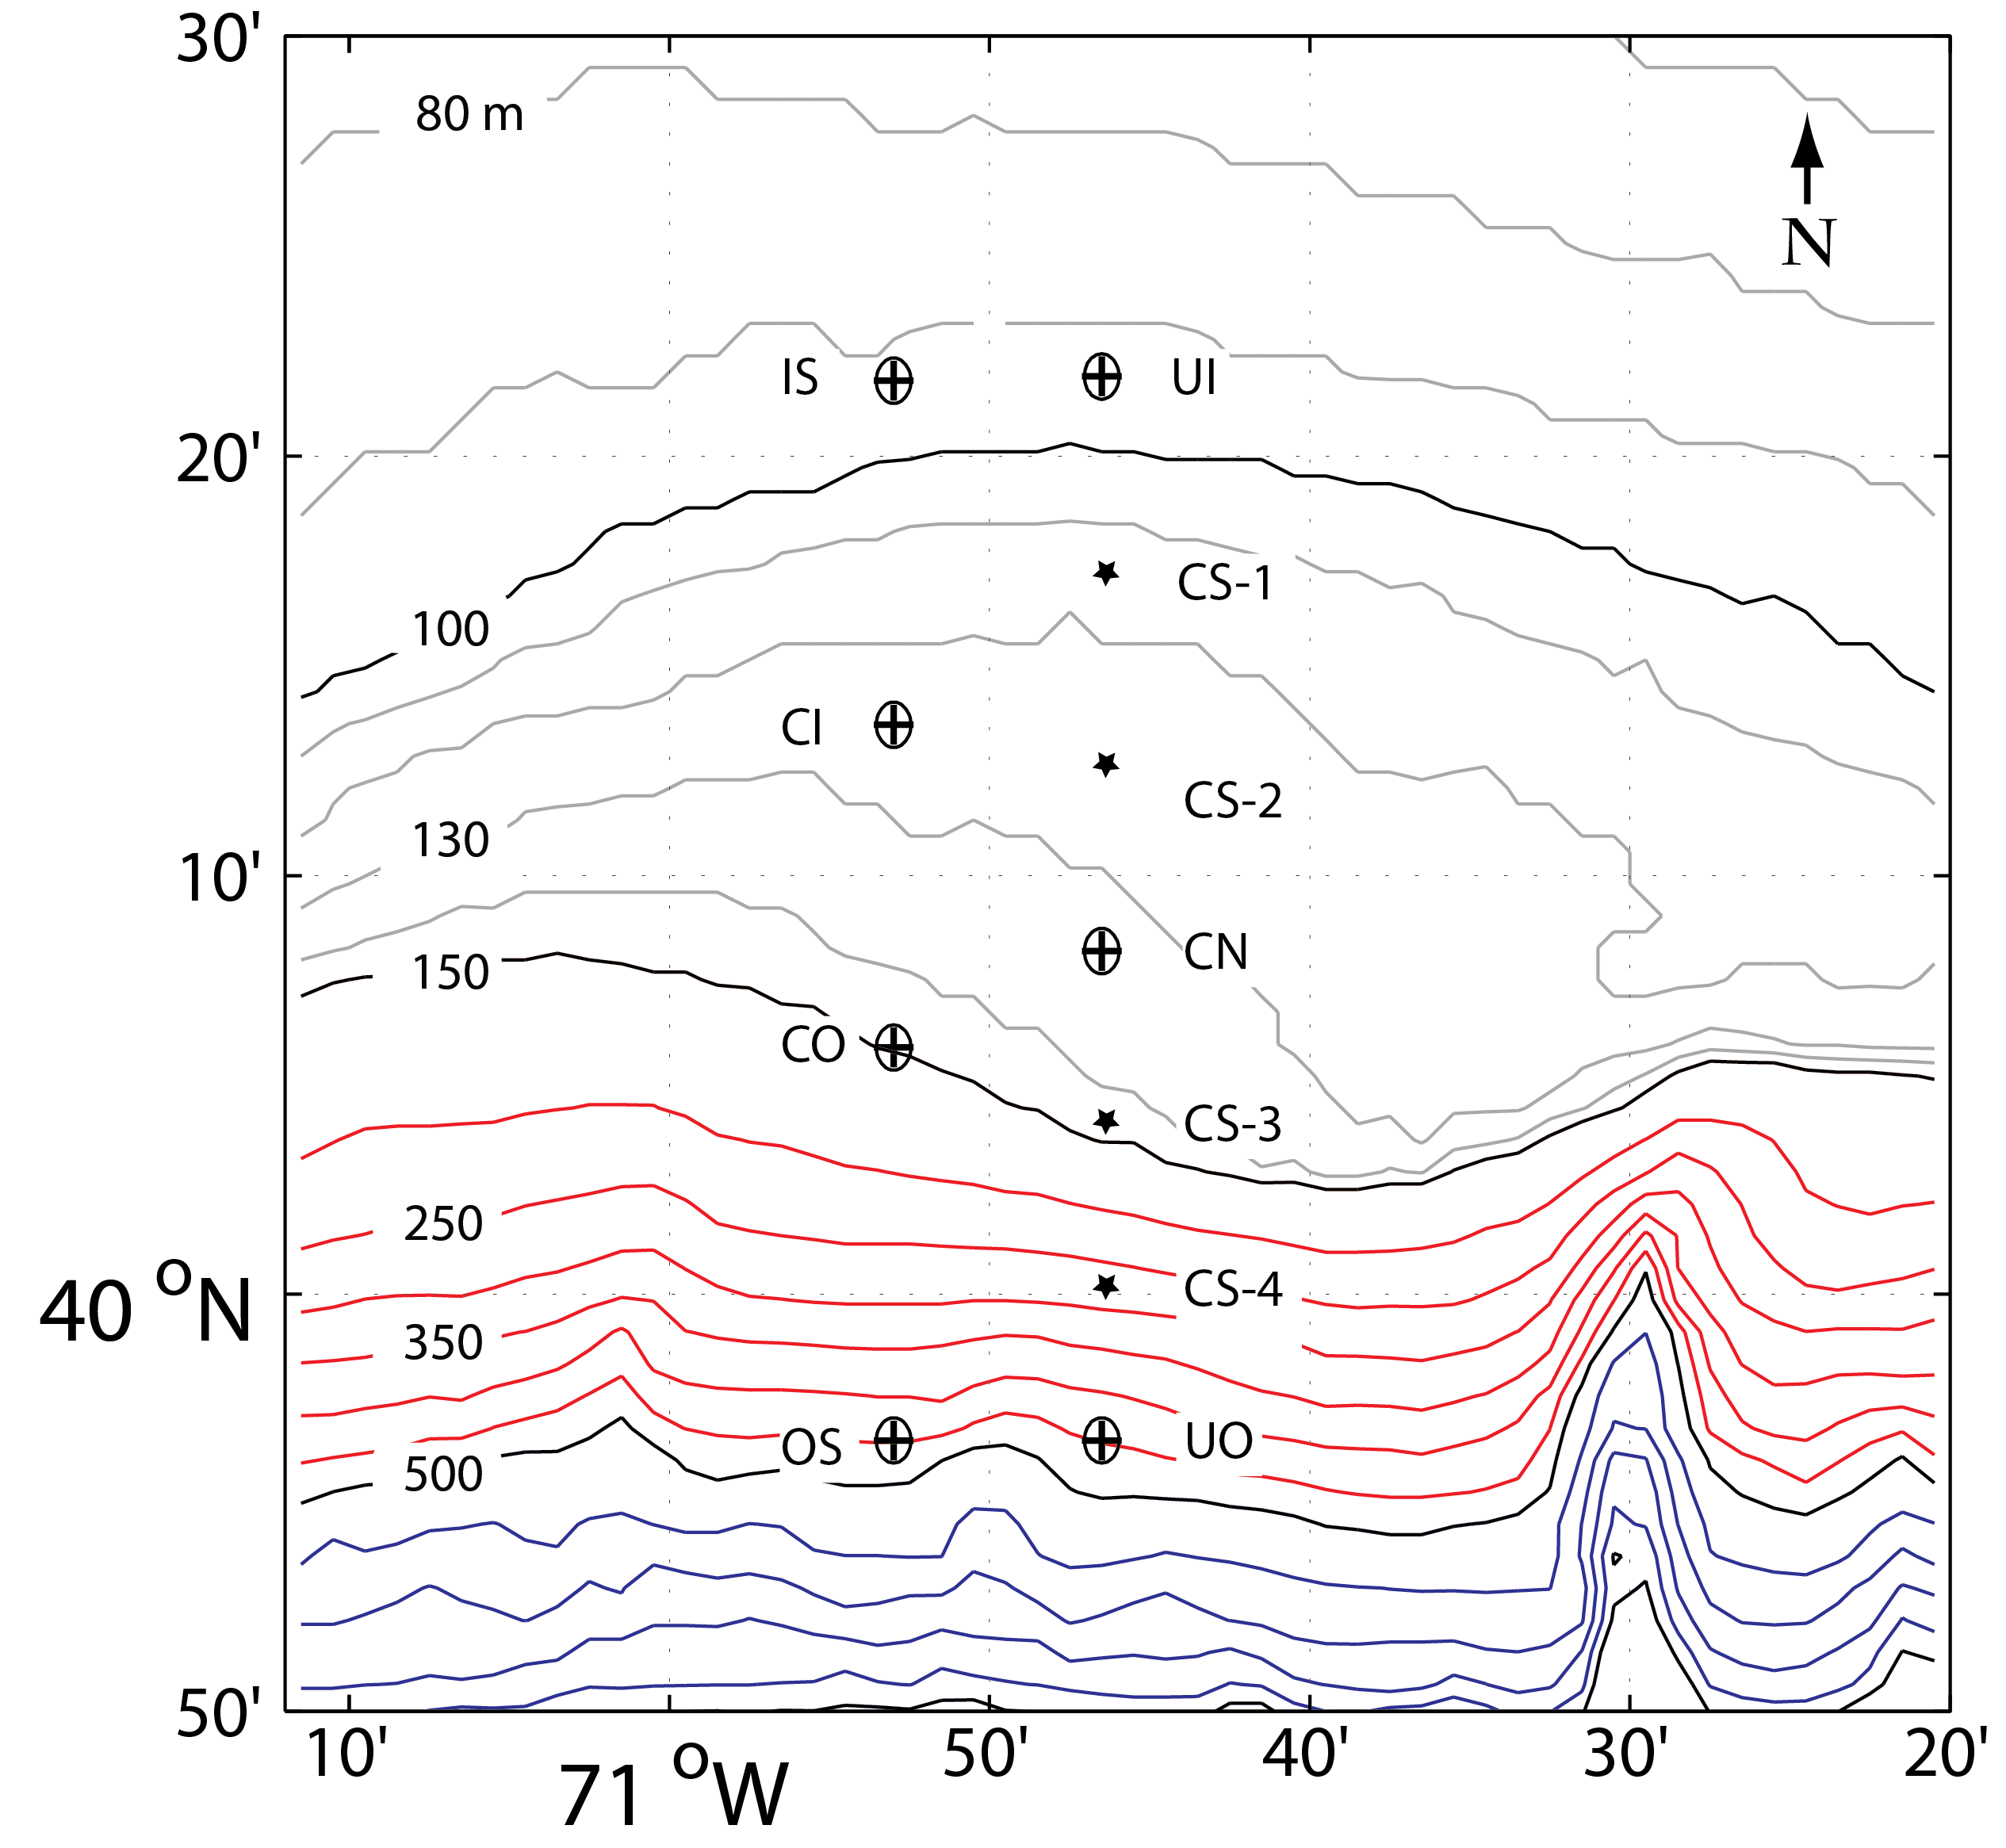

Figure 3-1 – Pioneer 3 Leg 2 station map showing the seven mooring sites (IS, CI, CN, CO, OS, UO, UI) and four cross-shelf CTD stations (CS 1-4) that, along with the eastern mooring line, make up the cross-shelf CTD survey line from UI to UO.

Appendix C – Equipment Inventory and Deck Plan

Figure 3-3 – R/V Knorr Deck Layout
Nominal deck layout for the major components associated with Pioneer-3 Leg 2 operations. Proposed locations of major deck elements are shown. Estimated weights of major deck components are also documented in a table.

Table 3-2 – Estimated Deckload

Appendix D – Science Party
There will be 12 participants in the science party, all affiliated with the Woods Hole Oceanographic Institution (WHOI). The Chief Scientist is Dr. Albert J. Plueddemann (WHOI). WHOI Shipboard Scientific Services Group (SSSG) participants will be Allison Heater and Tina Thomas. An alphabetical list is given in the table below.
Participating Scientists
Name Gender Nationality Affiliation
- Caporelli, Liz F USA WHOI
- Donohue, Meghan F USA WHOI
- Horn, Mark M USA WHOI
- Kelly, Brian M USA WHOI
- Kemp, John M USA WHOI
- Lumping, Chris M USA WHOI
- Lund, John M USA WHOI
- Murphy, Steve M USA WHOI
- Pietro, Jeff M USA WHOI
- Plueddemann, Al M USA WHOI/Chief Sci
- Wellwood, Dave M USA WHOI
- Wickman, Diana F USA WHOI

Roles and responsibilities will be delegated among individuals and groups per the following major categories. These assignments are representative, and not intended to be limiting – all participants will assist with multiple aspects of the cruise effort as warranted.
- Overall cruise coordination and execution
  - Al Plueddemann, John Kemp
- Cruise documentation, deployment records, platform and instrument metadata
  - Liz Caporelli, Mark Horn (CSPP), Brian Kelly (CSM)
- Logistics, deck operations, mooring hardware, mooring operations
  - John Kemp, Steve Murphy, Jeff Pietro, Meghan Donohue, Chris Lumping
- Mooring control, power and telemetry systems
  - Brian Kelly, John Lund (CSM), Diana Wickman, Mark Horn (CSPP)
- Instrument configuration, preparation and pre-deployment checks
  - Brian Kelly, John Lund (CSM), Diana Wickman, Mark Horn (CSPP)
- Platform configuration and mission plan
  - Brian Kelly, John Lund (CSM), Diana Wickman, Mark Horn (CSPP)
- Hydrographic sampling, including physical sample preparation
  - Dave Wellwood, Liz Caporelli
- Shipboard Scientific Services (CTD, ADCP, multibeam)
  - TBD, WHOI SSSG pool

Appendix E – Mooring Drawings

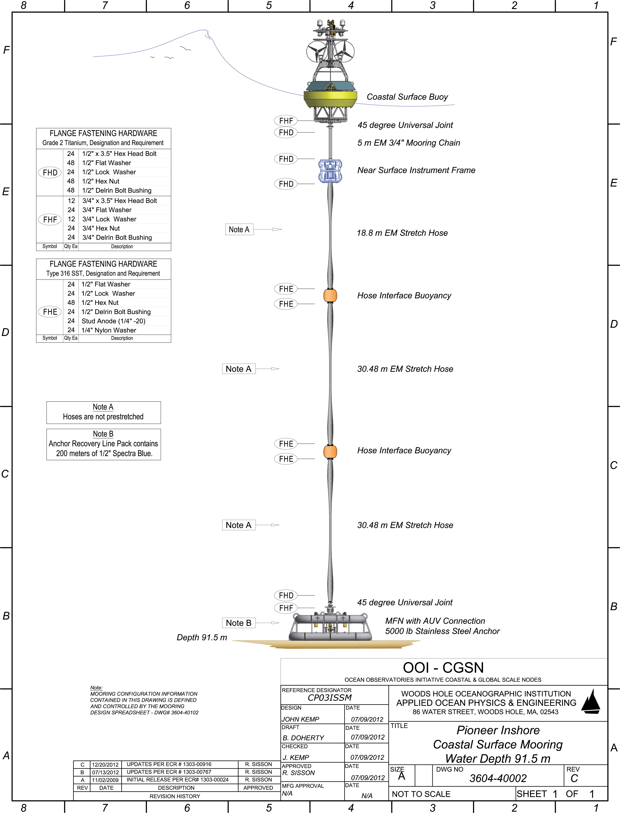
Figure 3-4 – Pioneer Inshore Surface Mooring (ISSM).

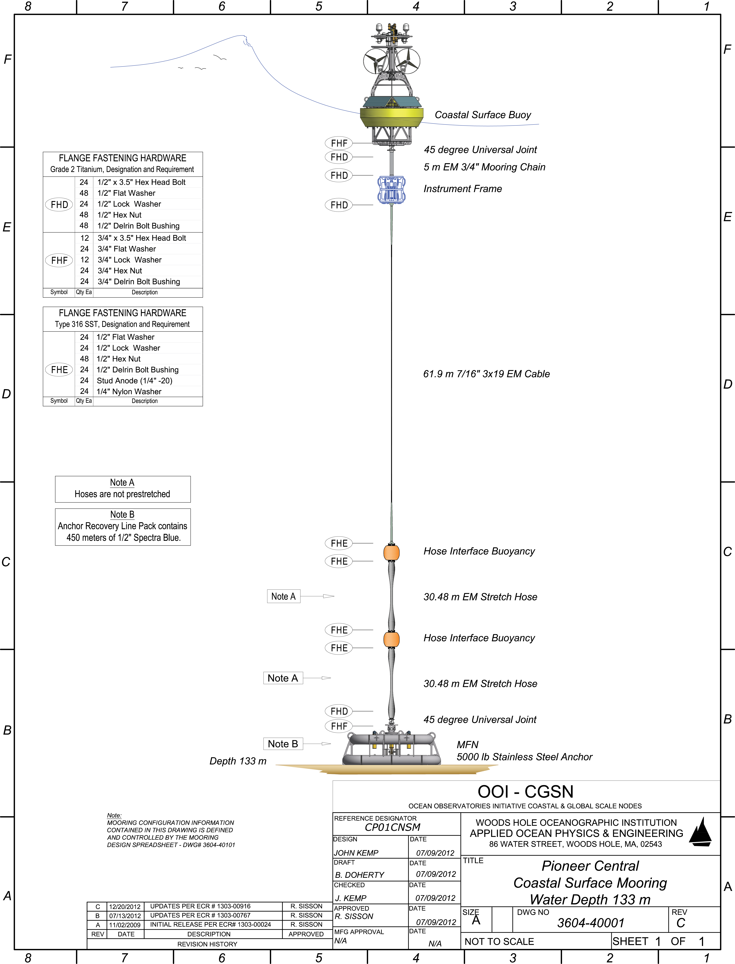
Figure 3-5 – Pioneer Central Surface Mooring (CNSM).

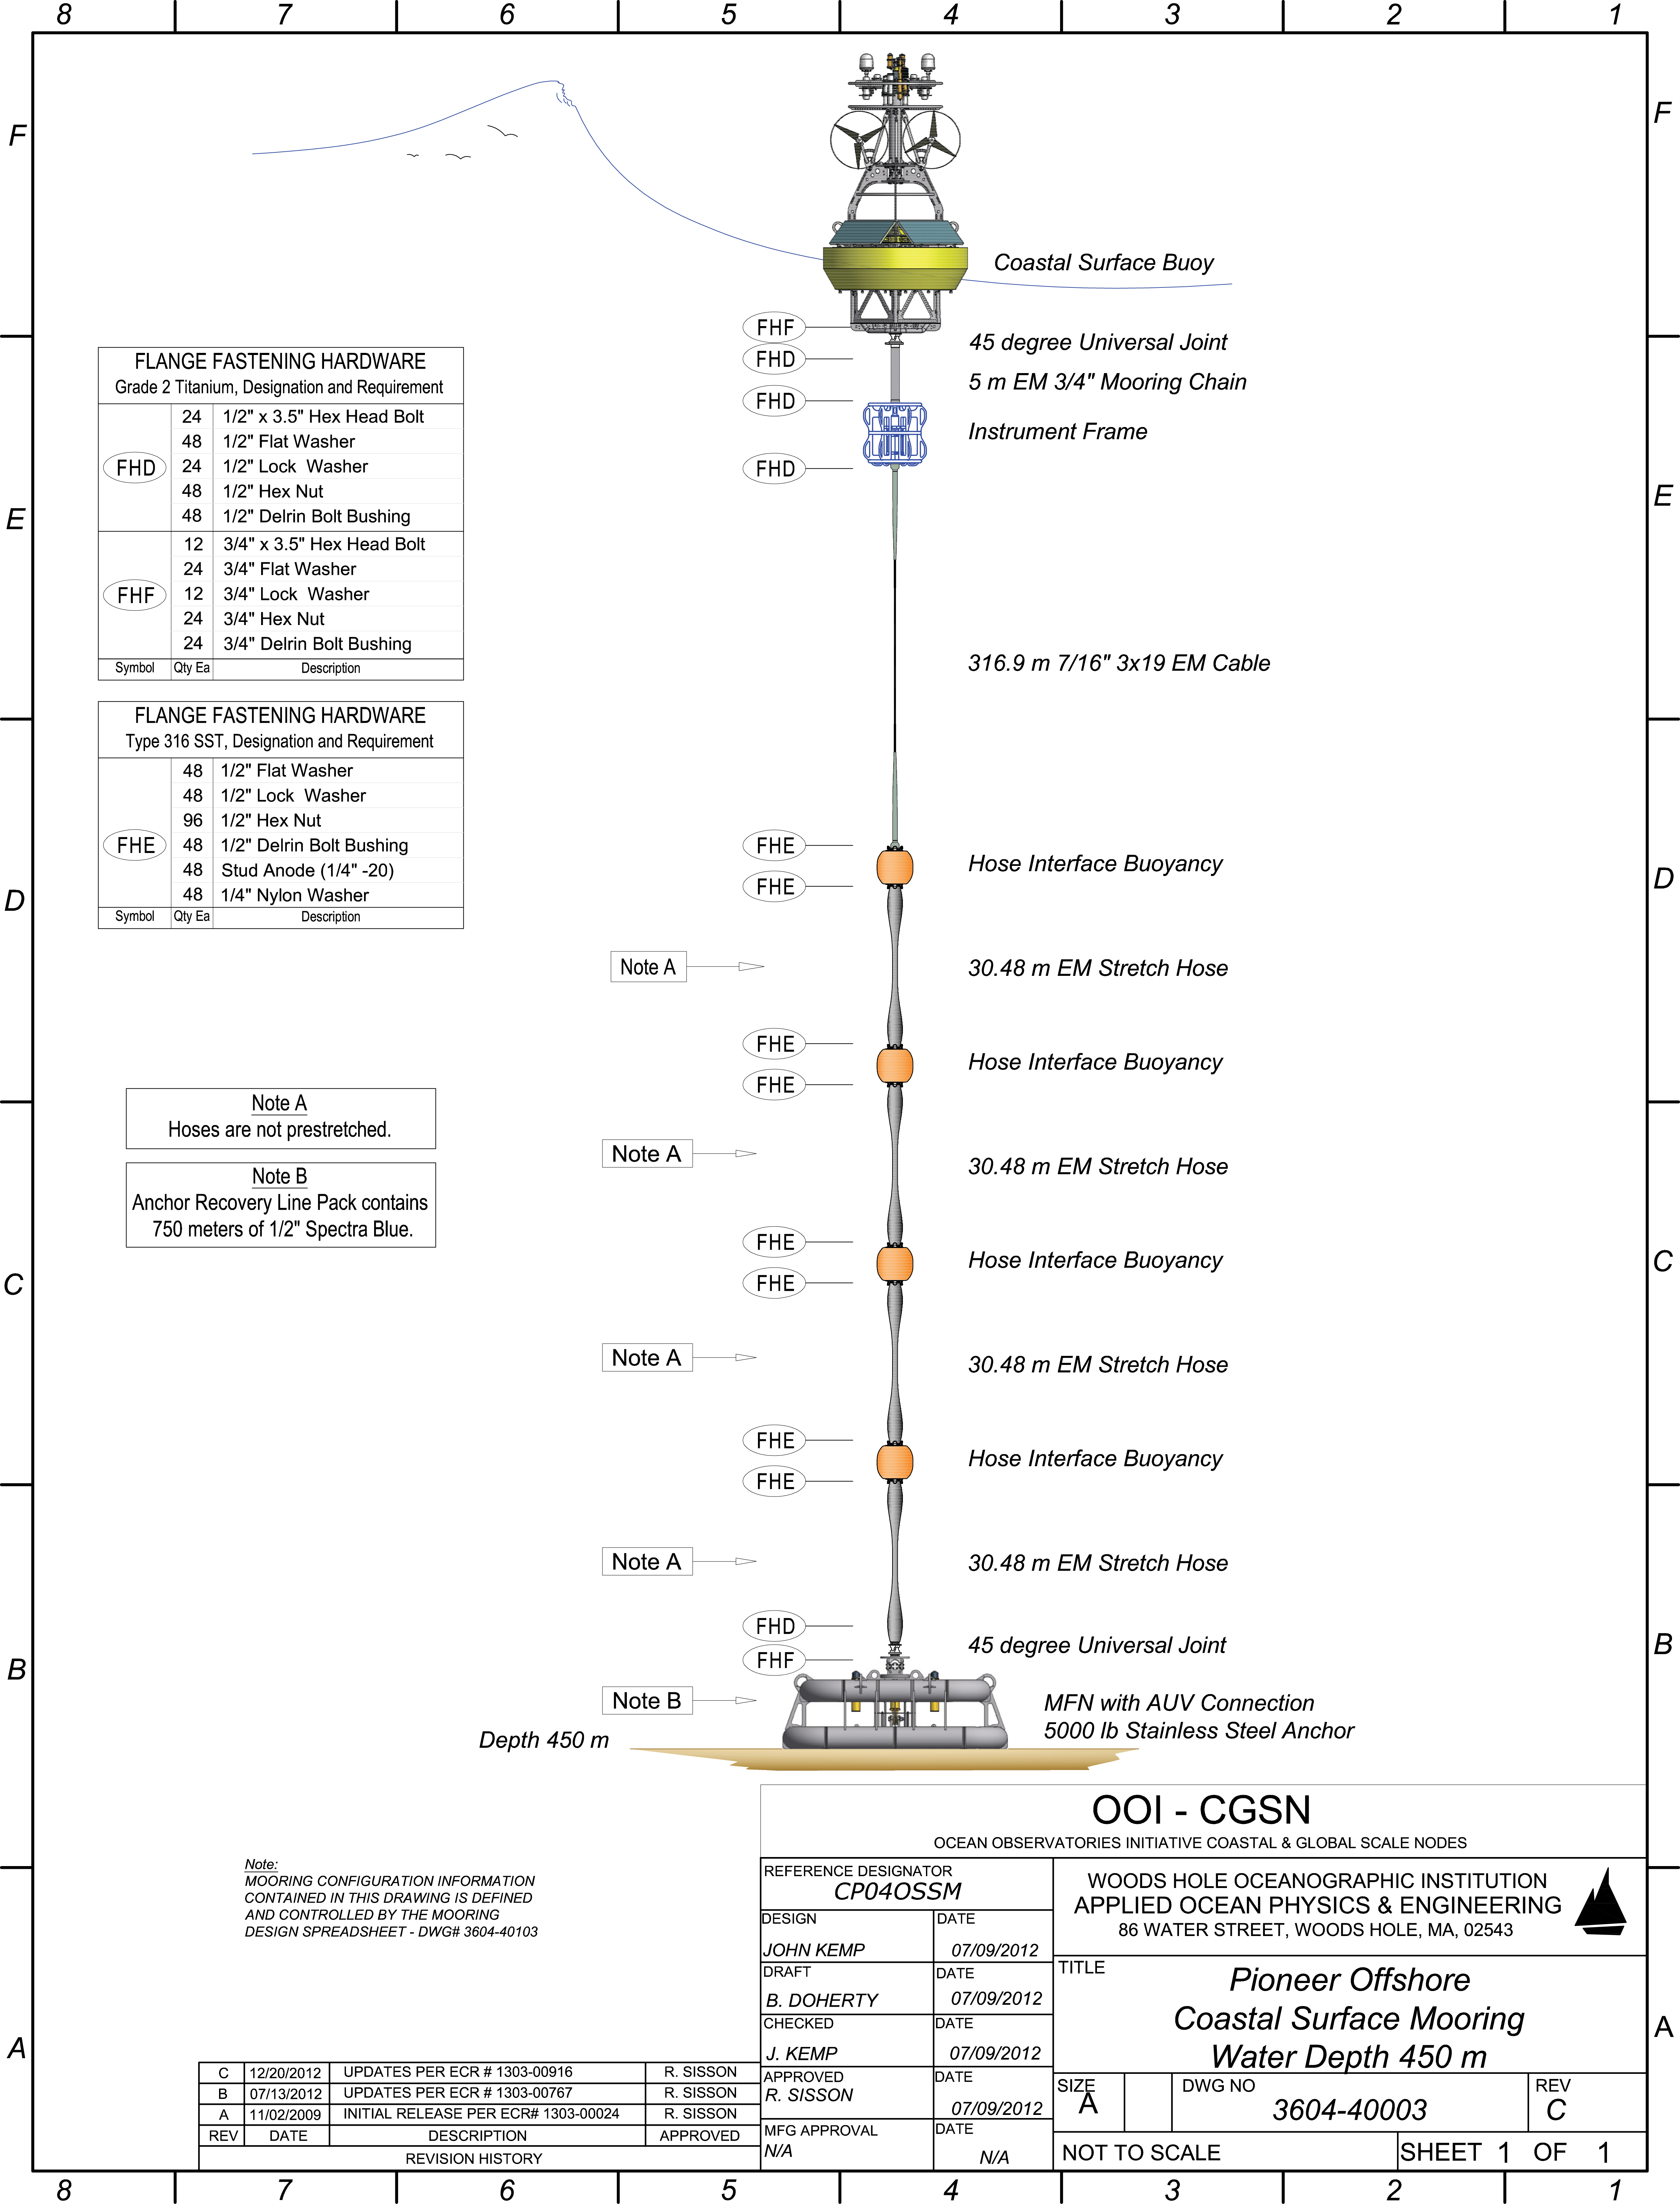
Figure 3-6 – Pioneer Offshore Surface Mooring (OSSM).

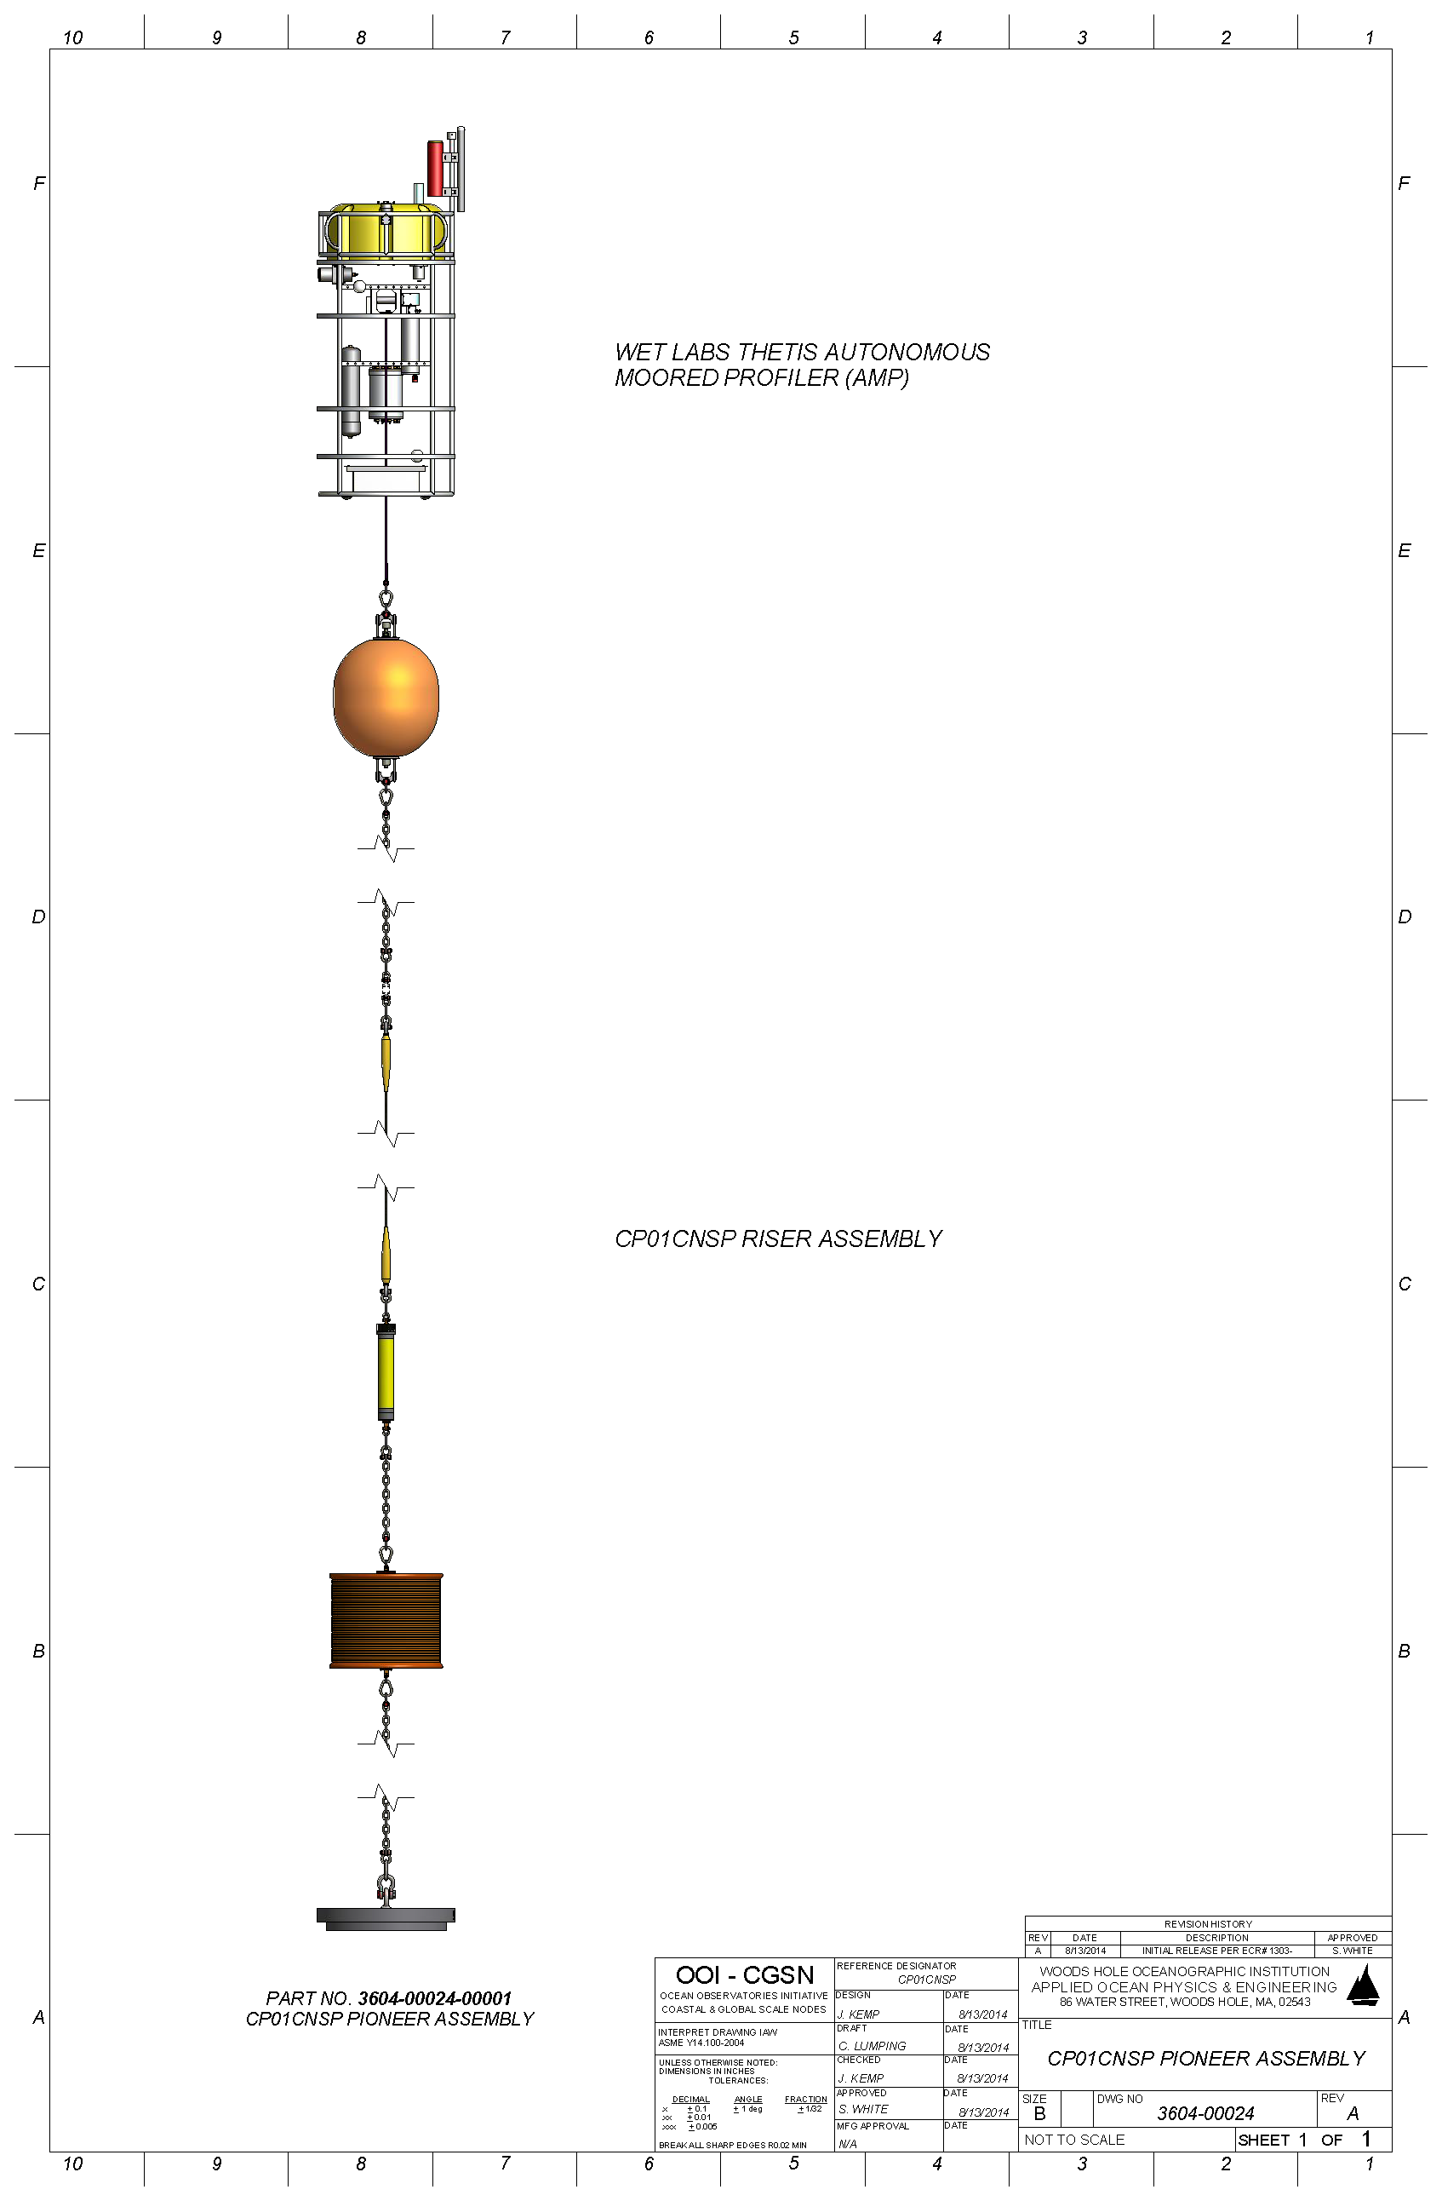
Figure 3-7 – Pioneer Coastal Surface Piercing Profiler (CSPP).
The Central CSPP is shown. Central and Inshore moorings differ only in the length of the riser.

