**Planned Installation Schedule for the Pioneer Array – November 2013 Update**

The Ocean Observatories Initiative will install scientific data buoys/moorings, autonomous underwater vehicles (AUV), and gliders for the Pioneer Array in the Atlantic Ocean in 2013 and 2014. The moorings will be maintained at these locations for approximately five years. The Pioneer Array will be installed and operated by Woods Hole Oceanographic Institution.

The Pioneer Array will provide observations of the physical, biological, and biochemical processes that occur on the highly dynamic Mid-Atlantic continental shelf. Woods Hole Oceanographic Institution will be installing and operating the array located along the continental shelf break, approximately 55 nautical miles south of Martha’s Vineyard, MA. Figure 1 shows the planned configuration of the 10 Pioneer Array moorings. Full installation of the array will take place in three phases during the late-2013 through 2014 period. Figure 1 shows the mooring site configurations with mooring types. Table 1 contains the mooring site details and phasing of the infrastructure deployments.

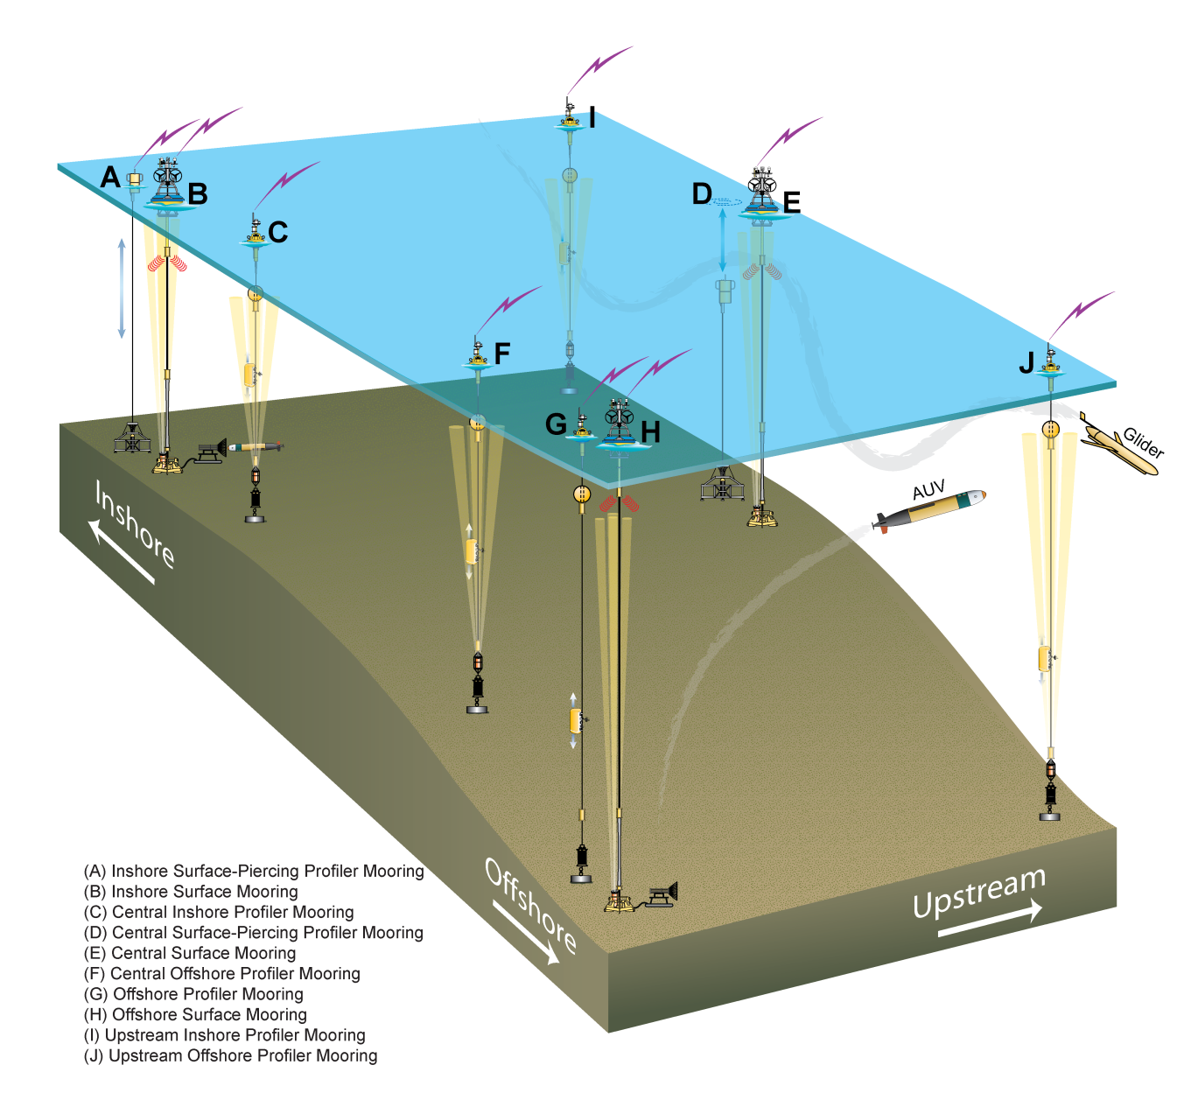

**Figure 1.** Configuration of the Pioneer Array moorings showing mooring types (A-J).

**Table 1.** OOI Pioneer Array Installation with descriptions of the mooring site locations, depths, moorings types, and planned installation times. Installations will be implemented in three phases; Phase I in 2013 and Phases II and III in 2014.

|  |  |  |  |  |  |
| --- | --- | --- | --- | --- | --- |
| **Site**  **Name** | **Site Center**  **Lat/Lon** | **Water Depth**  fathom (fm)  meters (m) | **Mooring Type**  (Letter designation refers to position in Figure 1) | **Install Year (Phase #)** | **Planned Installation Cruise Start Date\*** |
| Inshore | 40°21.8’N  70°53.0’W | 50 fm  (91.5 m) | **A** Surface-piercing profiler  **B** Surface mooring  AUV docking station (on B) | Fall 2014 (Phase III)  Fall 2014 (Phase III)  Fall 2014 (Phase III) | TBD  TBD  TBD |
| Central-Inshore | 40°13.6’N  70°53.0’W | 68 fm  (125 m) | **C** Profiler mooring | Spring 2014 (Phase II) | TBD |
| Central | 40°08.2’N  70°46.5’W | 73 fm  (133 m) | **D** Surface-piercing profiler  **E** Surface mooring | Fall 2014 (Phase III)  Fall 2013 (Phase I) | TBD  21 November 2013 |
| Central-Offshore | 40°05.9’N  70°53.0’W | 82 fm  (150 m) | **F** Profiler mooring | Spring 2014 (Phase II) | TBD |
| Offshore | 39°56.4’N  70°53.0’W | 246 fm  (450 m) | **G** Profiler mooring  **H** Surface mooring  AUV docking station (on H) | Spring 2014 (Phase II)  Fall 2014 (Phase III)  Fall 2014 (Phase III) | TBD  TBD  TBD |
| Upstream-Inshore | 40°21.9’N  70°46.5’W | 50 fm  (91.5 m) | **I** Profiler mooring | Fall 2013 (Phase I) | 21 November 2013 |
| Upstream-Offshore | 39°56.4’N  70°46.5’W | 246 fm  (450 m) | **J** Profiler mooring | Fall 2013 (Phase I) | 21 November 2013 |
| Glider mission area | N/A | varies | 6 gliders | Spring 2014 (Phase II) | TBD |
| AUV mission area | N/A | varies | 2 AUVs | Fall 2014 (Phase III) | TBD |

**\*** Cruise start dates are subject to change and not yet scheduled with exact dates beyond 2013.