

**Figure 1. Planned CTD/LADCP stations (shown in yellow dots).**

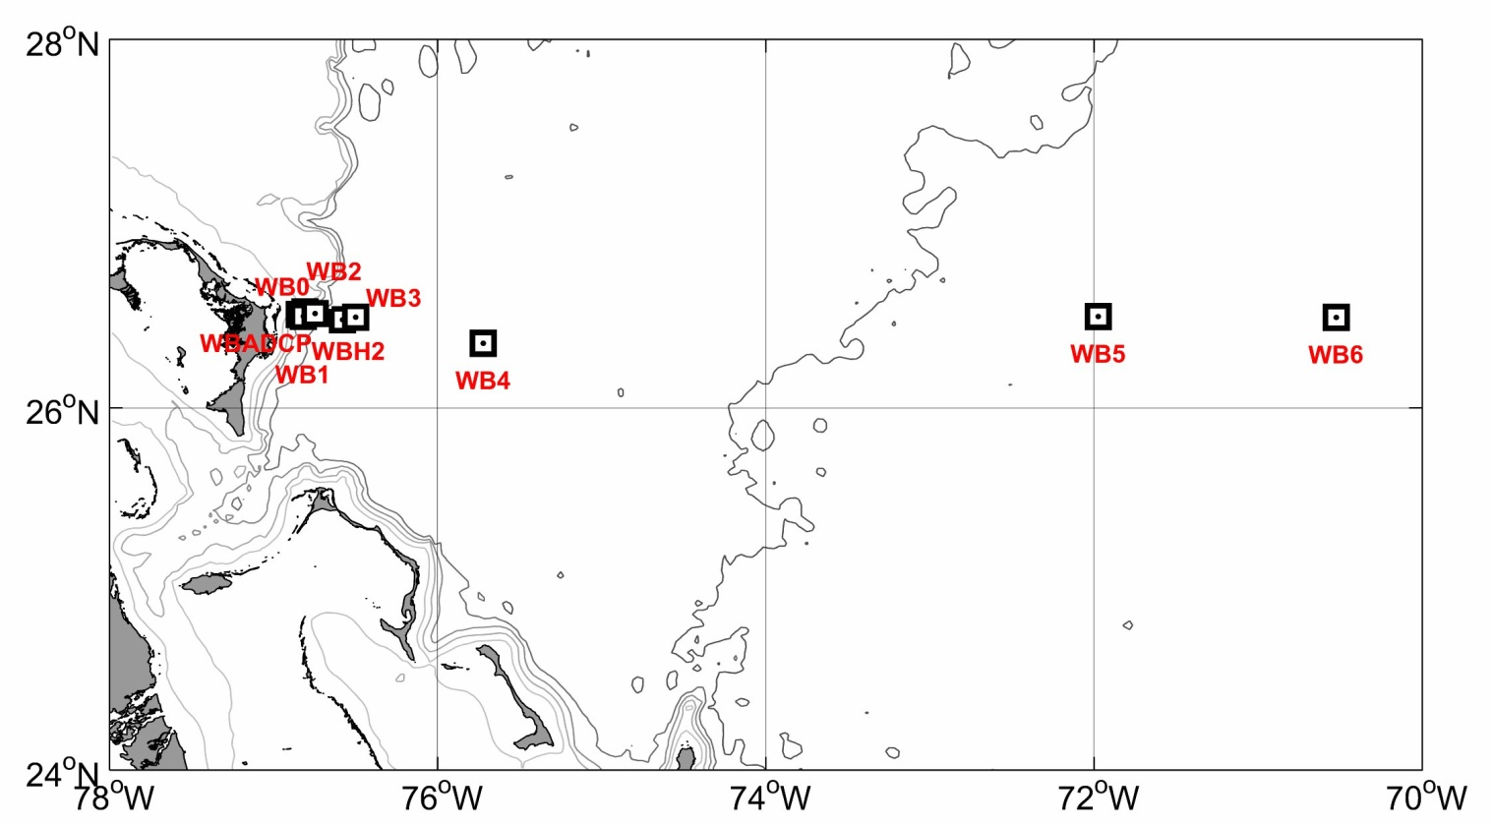

Figure 2. Current meter moorings to be recovered and deployed. Additional "bottom lander" moorings (not shown on map) will be recovered and deployed near mooring sites WBADCP, WB2, WB3, WB4, and WB5.

# List of planned CTD/LADCP stations

Station Latitude Longitude

|  |  |  |  |  |  |  |
| --- | --- | --- | --- | --- | --- | --- |
| 1 | 27 | 0.00 | N | 79 | 56.00 | W |
| 2 | 27 | 0.00 | N | 79 | 52.00 | W |
| 3 | 27 | 0.00 | N | 79 | 47.00 | W |
| 4 | 27 | 0.00 | N | 79 | 41.00 | W |
| 5 | 27 | 0.00 | N | 79 | 37.00 | W |
| 6 | 27 | 0.00 | N | 79 | 30.00 | W |
| 7 | 27 | 0.00 | N | 79 | 23.00 | W |
| 8 | 27 | 0.00 | N | 79 | 17.00 | W |
| 9 | 27 | 0.00 | N | 79 | 12.00 | W |
| 10 | 26 | 26.00 | N | 78 | 40.00 | W |
| 11 | 26 | 20.00 | N | 78 | 43.00 | W |
| 12 | 26 | 15.00 | N | 78 | 46.00 | W |
| 13 | 26 | 10.00 | N | 78 | 48.00 | W |
| 14 | 26 | 4.00 | N | 78 | 51.00 | W |
| 15 | 26 | 31.5 | N | 76 | 53 | W |
| 16 | 26 | 31.00 | N | 76 | 49.90 | W |
| 17 | 26 | 30.00 | N | 76 | 44.6 | W |
| 18 | 26 | 30.00 | N | 76 | 39.30 | W |
| 19 | 26 | 30.00 | N | 76 | 33.90 | W |
| 20 | 26 | 30.00 | N | 76 | 28.50 | W |
| 21 | 26 | 30.00 | N | 76 | 20.80 | W |
| 22 | 26 | 30.00 | N | 76 | 13.00 | W |
| 23 | 26 | 30.0 | N | 76 | 5.20 | W |
| 24 | 26 | 30.00 | N | 75 | 54.00 | W |
| 25 | 26 | 30.00 | N | 75 | 42.20 | W |
| 26 | 26 | 30 | N | 75 | 30 | W |
| 27 | 26 | 30 | N | 75 | 18 | W |
| 28 | 26 | 30 | N | 75 | 5 | W |
| 29 | 26 | 30 | N | 74 | 48 | W |
| 30 | 26 | 30 | N | 74 | 31 | W |
| 31 | 26 | 30 | N | 74 | 14 | W |
| 32 | 26 | 30 | N | 73 | 52 | W |
| 33 | 26 | 30.00 | N | 73 | 30.00 | W |
| 34 | 26 | 30.00 | N | 73 | 8.00 | W |
| 35 | 26 | 30.00 | N | 72 | 46.00 | W |
| 36 | 26 | 30.00 | N | 72 | 23.00 | W |
| 37 | 26 | 30.00 | N | 71 | 59.40 | W |
| 38 | 26 | 30.00 | N | 71 | 30.00 | W |
| 39 | 26 | 30.00 | N | 71 | 0.00 | W |
| 40 | 26 | 30.00 | N | 70 | 30.00 | W |
| 41 | 26 | 30.00 | N | 70 | 0.00 | W |
| 42 | 26 | 30.00 | N | 69 | 30.00 | W |

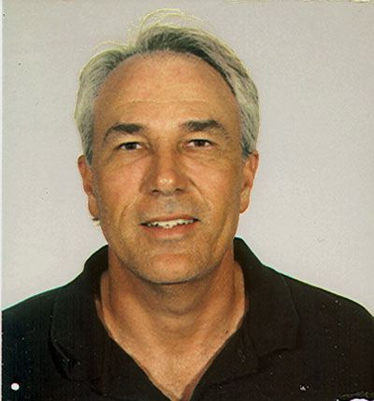

**BIOGRAPHICAL SKETCH**

_____________________________________________________________

**WILLIAM E. JOHNS**

Rosenstiel School of Marine and Atmospheric Science, University of Miami

4600 Rickenbacker Causeway, Miami, Florida 33149

**PERSONAL**

Citizenship: U.S.

Employment Status: Full-time

Current Academic Rank: Professor

Primary Department: Meteorology & Physical Oceanography

Office Telephone: (305) 421-4054

**RESEARCH INTERESTS**

Dynamics and Variability of Western Boundary Currents; Marginal Seas and Straits; Oceans Role in Climate.

**HIGHER EDUCATION**

B.S., 1978, Florida State University (Physics)

Ph.D., 1984, University of Rhode Island (Physical Oceanography)

**EXPERIENCE**

University of Rhode Island Graduate Res. Asst. 1978-1984

University of Miami, RSMAS/MPO Post-Doctoral Fellow 1985-l986

University of Miami, RSMAS/MPO Res Assistant Professor 1986-1987

University of Miami, RSMAS/MPO Assistant Professor 1987-1992

Associate Professor 1992-1999

Professor 1999-to present

Chairman, MPO 2004-2008

**PUBLICATIONS RELEVANT TO PROPOSED RESEARCH**

Garzoli, S. L., A. Ffield, W.E. Johns, and Q. Yao, 2004. North Brazil Current retroflection and transports. *J. Geophys. Res*. J. Geophys. Res., 109(**C1)**,C01013.

Mullison, J., H. Melling, H.P. Freitag, and W. Johns, 2004. Climate Variability Research Aided by Moored Current Profiles. *Sea Tech.,* **45**(2), 17-27, February.

Zhang, D., M.J. McPhaden, and W.E. Johns, 2003. Observational evidence for flow between the subtropical and tropical Atlantic: the Atlantic Subtropical Cells. *J. Phys. Oceanogr.,* **33,** 1783-1797.

Johns W.E., T.N. Lee, R. Beardsley, J. Candela and B. Castro, 1998. Annual Cycle and Variability of the North Brazil Current. J. Phys. Oceano., **28**(1), 103-128.

Lee, T.N., W.E. Johns, R.J. Zantopp, and E. Fillenbaum, 1996. Moored Observations of Volume Transport Variability in Western Boundary Currents of the Subtropical North Atlantic at 26.5° N. *J. Phys. Oceanogr.,* 26(6), 962-983.

Hogg, N.G. and W.E. Johns, 1995. Western Boundary Currents. Rev. of Geophys., Suppl. 1311-1334.

Johns, W.E., 1988. Near-surface current measurements in the Gulf Stream using an upward-looking acoustic Doppler current profiler, *J. Atmos. Oceanic Tech.*, **5,** 602-613.

**SELECTED FIVE OTHER SIGNIFICANT PUBLICTIONS**

Johns, W. E., T.L. Townsend, D. M. Fratantoni, and W. D. Wilson,2002, On the Atlantic Inflow to the Caribbean Sea. *Deep-Sea Res*., **49**, 211-243.

Johns, W.E., T.N. Lee, D. Zhang, R. Zantopp, C-T Liu and Y. Yang, 2001: The Kuroshio east of Taiwan: Moored transport observations from the WOCE PCM-1 Array. *J. Phys. Oceano*. **31**(4), 1031-1053.

Johns, W.E., T.J. Shay, J.M. Bane and D.R. Watts, 1995. Gulf Stream Structure, Transport, and Recirculation Near 68°W. J. Geophys. Res., **100**(C1), 817-838.

Johns, W.E., D. Fratantoni and R.J. Zantopp, 1993. Deep western boundary current variability off northeastern Brazil. Deep-Sea Res. **40**(2), 293-310.

Johns, W.E., T.N. Lee, F.A. Schott, R.J. Zantopp and R. Evans, 1990. The North Brazil Current Retroflection: Seasonal Structure and Eddy Variability, J. Geophys. Res., **95**(12), 22103-22120.

**NAMES OF GRADUATE STUDENTS ADVISED & POST DOCTORAL SCHOLARS** (last 5 years):

Murat Aydin, Ph.D. 1999 (mem.) Afonso Paiva, Ph.D. 1999 (mem.)

Jorina Waworuntu, Ph.D.,1999(mem.) DongXiao Zhang,Ph.D.,1999(co-adv.)

Ashwanth Srinivasan,Ph.D.,1999(mem.) Sarantis Sofianos,2000,Ph.D.(adv.)

Todd Spindler, Ph.D. 2001 (advisor) Lisa Greer, Ph.D., 2001 (member)

Bridgett O’Connor, Ph.D. 2001(mem.) Roy Watlington, Ph.D. (member)

**COLLABORATING SCIENTISTS OVER LAST 48 MONTHS**:

John Bane (UNC) Robert Evans (RSMAS)

Amy Bower (NRL) Nelson Hogg (WHOI)

Thomas Lee (RSMAS) Steve Murray (LSU)

Claes Rooth (RSMAS) Fritz Schott (IFM, Kiel)

Tamy Townsend(NRL) Randy Watts (URI)

Doug Wilson (NOAA/AOML) Bob Beardsley(WHOI)

Phil Richardson (WHOI) Dave Fratantoni (WHOI)

Lawrence Pratt(WHOI) Cho-Teng Liu (NTU-Taiwan)

Gustavo Goni (NOAA/AOML) Julio Candela (WHOI/CICESE)

**GRADUATE STUDENT ADVISOR**: D. R. Watts (URI)

**POSTDOCTORAL ADVISOR**: F. A. Schott (RSMAS and IFM, Kiel)