Cruise Prospectus
RAPID-MOCHA Western Boundary Cruise
R/V Knorr (Apr. 13 – May 4, 2011)

Description of Project: Nature and Objectives

The specific objectives of this cruise are as follows:

- To service 14 deep-sea moorings located off the eastern Bahamas along latitude 26.5°N.
- To recover data from 5 pressure-inverted echo sounder (PIES) sites by underwater acoustic telemetry.
- To conduct CTD (Conductivity-Temperature-Depth) and Lowered ADCP (Acoustic Doppler Current Profiler) sections across the Florida Current at 27ºN, Northwest Providence Channel, and along the 26.5ºN RAPID-MOCHA western boundary line east of Abaco, Bahamas.
- To perform several additional deep water CTD casts to calibrate moored instrumentation.

This research is part of the joint U.S./U.K. RAPID-MOCHA program, an effort to determine the strength of the meridional overturning circulation in the Atlantic and to monitor its variability as a possible indicator of future climate change. The program is jointly funded by the U.K. National Environmental Research Council (NERC) and the U.S. National Science Foundation (NSF).

The moorings to be recovered and redeployed on this cruise are listed in Tables 1 through 4. The mooring locations and planned CTD/LADCP stations (excluding Florida Straits) are shown in the attached maps (Figs. 1 and 2). Of the 14 moorings to be serviced, 9 are taut-wire subsurface moorings with multiple instruments, and 5 (denoted with “L” in the mooring site name) are short "bottom-lander" moorings containing only high-precision bottom pressure gauges. The precise schedule of the operations at each site is unknown at this time and will be dependent on weather conditions and other factors during the cruise. High-quality hydrographic measurements (CTD and water samples) will also be obtained at approximately 6 deep water stations (at locations near the moorings) to help calibrate the instruments to be deployed on the moorings and those recovered from the moorings.

Table 1. U.S. Moorings to be recovered
Mooring Site | Mooring Number | Latitude (ºN) | Longitude (ºW) | Depth (m) | Date of Deployment
WB0 | M390 | 26° 30.41' | 76° 50.45' | 1004 | 12/04/2009
WB3 | M391 | 26° 29.37' | 76° 30.02' | 4840 | 12/02/2009
WB5 | M392 | 26° 30.16' | 71° 58.70' | 5294 | 12/29/2009
WBL3 | M394 | 26° 29.42' | 76° 29.64' | 4843 | 12/02/2009
WBL5 | M393 | 26° 30.05' | 71° 59.20' | 5240 | 12/29/2009

Table 2. U.S. Moorings to be deployed
Mooring Site | Mooring Number | Latitude (ºN) | Longitude (ºW) | Depth (m)
WB0 |  | 26° 30.50' | 76° 50.50' | 1003
WB3 |  | 26° 30.00' | 76° 29.70' | 4840
WB5 |  | 26° 30.00' | 71° 58.50' | 5295
WBL3 |  | 26° 29.50' | 76° 29.60' | 4845
WBL5 |  | 26° 30.40' | 71° 58.90' | 5240

Table 3. U.K. Moorings to be recovered
Mooring Site | Mooring Number | Latitude (ºN) | Longitude (ºW) | Depth (m)
WBADCP |  | 26° 31.50' | 76° 48.48' | 609
WB1 |  | 26° 29.97' | 76° 49.12' | 1394
WB2 |  | 26° 30.87' | 76° 44.79' | 3796
WBH2 |  | 26° 28.86' | 76° 34.74' | 4824
WB4 |  | 26° 21.18' | 75° 43.32’ | 4713
WB6 |  | 26° 29.65' | 70° 31.40’ | 5491
WBAL2 |  | 26° 31.50' | 76° 52.56’ | 498
WB2L1 |  | 26° 30.38' | 76° 44.63’ | 3882
WB4L1 |  | 26° 21.26' | 75° 42.95’ | 4713

Table 4. U.K. Moorings to be deployed
Mooring Site | Mooring Number | Latitude (ºN) | Longitude (ºW) | Depth (m)
WBADCP |  | 26° 31.50' | 76° 48.48' | 609
WB1 |  | 26° 29.97' | 76° 49.12' | 1394
WB2 |  | 26° 30.87' | 76° 44.79' | 3796
WBH2 |  | 26° 28.86' | 76° 34.74' | 4824
WB4 |  | 26° 21.18' | 75° 43.32’ | 4713
WB6 |  | 26° 29.65' | 70° 31.40’ | 5491
WBAL2 |  | 26° 31.50' | 76° 52.56’ | 498
WB2L1 |  | 26° 30.38' | 76° 44.63’ | 3882
WB4L1 |  | 26° 21.26' | 75° 42.95’ | 4713

Table 5. Planned CTD/LADCP stations

Station Latitude Longitude
1 | 27 | 0.00 | N | 79 | 56.00 | W
2 | 27 | 0.00 | N | 79 | 52.00 | W
3 | 27 | 0.00 | N | 79 | 47.00 | W
4 | 27 | 0.00 | N | 79 | 41.00 | W
5 | 27 | 0.00 | N | 79 | 37.00 | W
6 | 27 | 0.00 | N | 79 | 30.00 | W
7 | 27 | 0.00 | N | 79 | 23.00 | W
8 | 27 | 0.00 | N | 79 | 17.00 | W
9 | 27 | 0.00 | N | 79 | 12.00 | W
10 | 26 | 26.00 | N | 78 | 40.00 | W
11 | 26 | 20.00 | N | 78 | 43.00 | W
12 | 26 | 15.00 | N | 78 | 46.00 | W
13 | 26 | 10.00 | N | 78 | 48.00 | W
14 | 26 | 4.00 | N | 78 | 51.00 | W
15 | 26 | 31.5 | N | 76 | 53 | W
16 | 26 | 31.00 | N | 76 | 49.90 | W
17 | 26 | 30.00 | N | 76 | 44.6 | W
18 | 26 | 30.00 | N | 76 | 39.30 | W
19 | 26 | 30.00 | N | 76 | 33.90 | W
20 | 26 | 30.00 | N | 76 | 28.50 | W
21 | 26 | 30.00 | N | 76 | 20.80 | W
22 | 26 | 30.00 | N | 76 | 13.00 | W
23 | 26 | 30.0 | N | 76 | 5.20 | W
24 | 26 | 30.00 | N | 75 | 54.00 | W
25 | 26 | 30.00 | N | 75 | 42.20 | W
26 | 26 | 30 | N | 75 | 30 | W
27 | 26 | 30 | N | 75 | 18 | W
28 | 26 | 30 | N | 75 | 5 | W
29 | 26 | 30 | N | 74 | 48 | W
30 | 26 | 30 | N | 74 | 31 | W
31 | 26 | 30 | N | 74 | 14 | W
32 | 26 | 30 | N | 73 | 52 | W
33 | 26 | 30.00 | N | 73 | 30.00 | W
34 | 26 | 30.00 | N | 73 | 8.00 | W
35 | 26 | 30.00 | N | 72 | 46.00 | W
36 | 26 | 30.00 | N | 72 | 23.00 | W
37 | 26 | 30.00 | N | 71 | 59.40 | W
38 | 26 | 30.00 | N | 71 | 30.00 | W
39 | 26 | 30.00 | N | 71 | 0.00 | W
40 | 26 | 30.00 | N | 70 | 30.00 | W
41 | 26 | 30.00 | N | 70 | 0.00 | W
42 | 26 | 30.00 | N | 69 | 30.00 | W

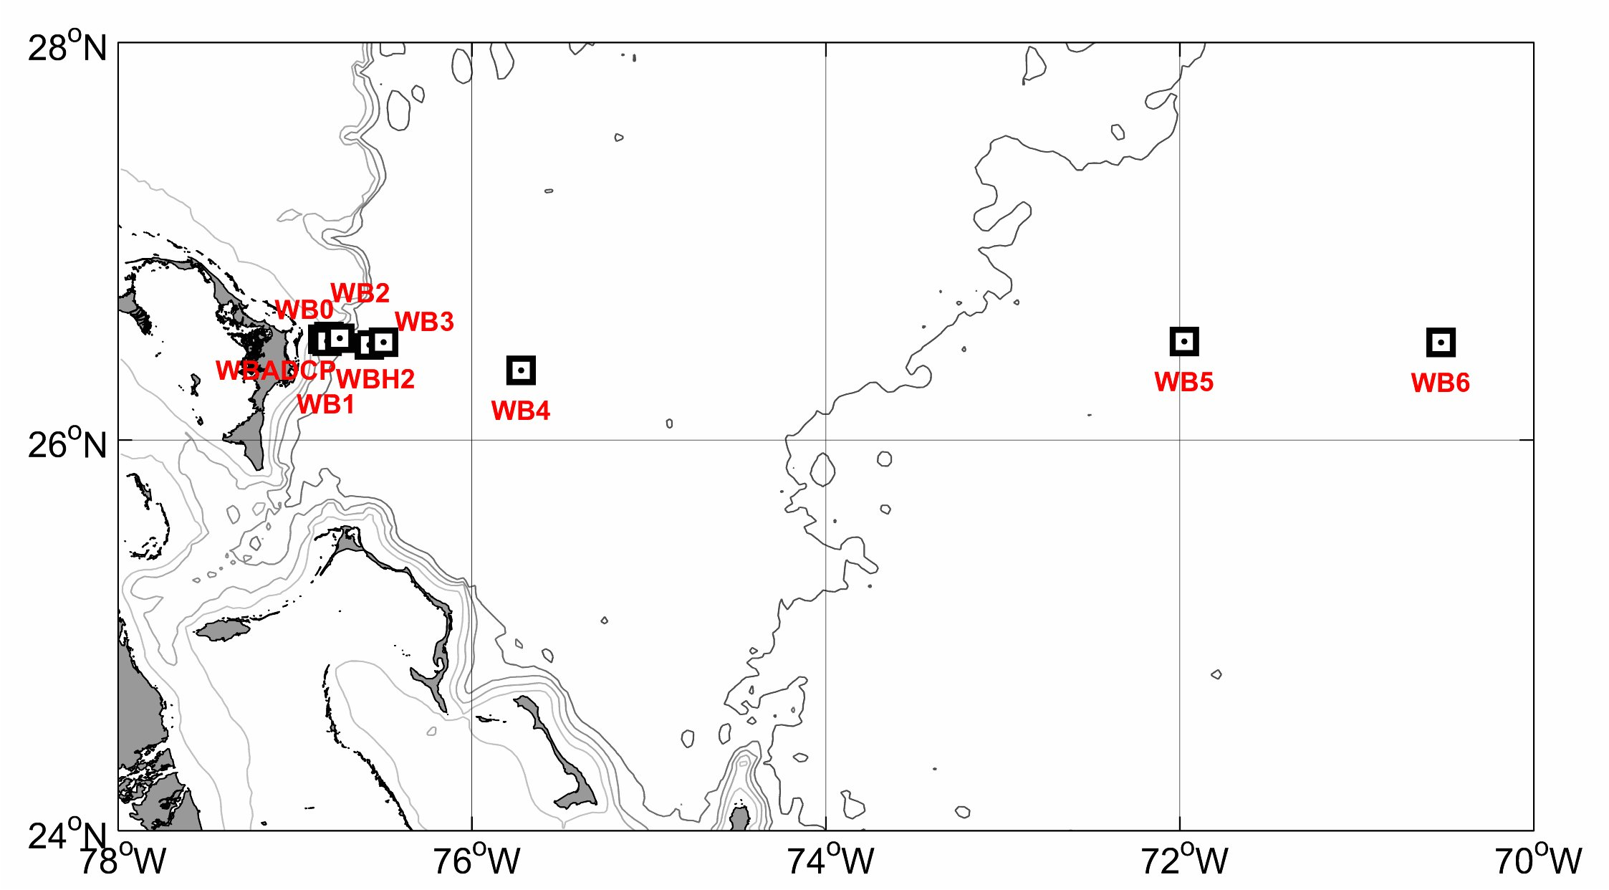

Figure 1. Current meter moorings to be recovered and deployed. Additional "bottom lander" moorings (not shown on map) will be recovered and deployed near mooring sites WBADCP, WB2, WB3, WB4, and WB5.

Figure 2. Planned CTD/LADCP stations (shown in yellow dots).

