Deep-ocean Assessment and Reporting of Tsunamis (DART®) System. The DART® system is a transportable, real-time, deep-ocean tsunami measurement system that provides early detection and real-time reporting of tsunamis in the open ocean. It consists of an anchored seafloor tsunameter, also referred to as a Bottom Pressure Recorder (BPR), and a companion moored surface buoy for real-time communication. An acoustic link transmits data from the BPR on the seafloor to the surface buoy. Redundant dual payloads housed in the surface buoy are equipped with Iridium satellite modems that provide two-way communications to shore side systems.

PICTORIAL OF DART BUOY SYSTEM:

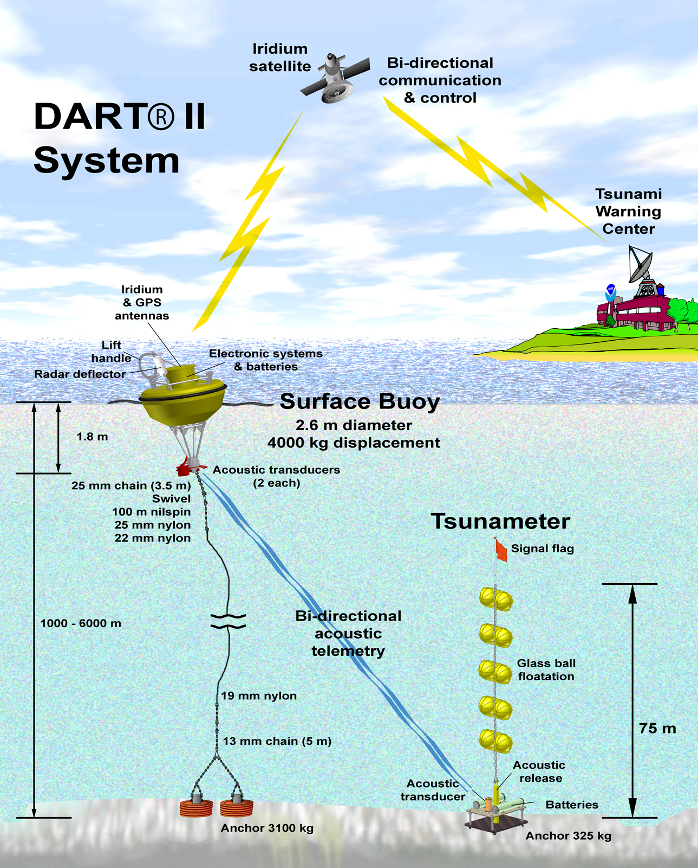

Buoy Characteristics.
DART buoy system - overall dimensions and weight.

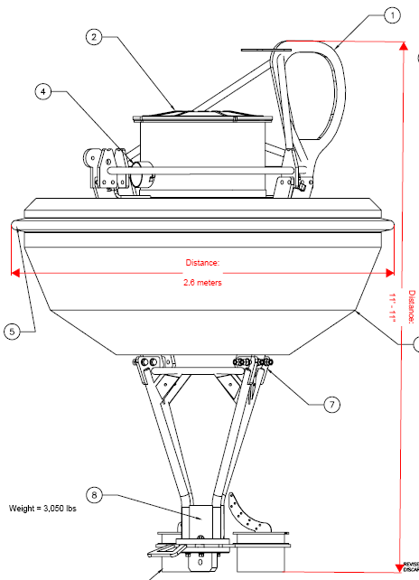

Buoy Characteristics.
DART buoy system – drawing with parts descriptions.

Bottom Pressure Recorder (BPR) Characteristics.
DART BPR system - overall dimensions and weight.

Bottom Pressure Recorder (BPR) Characteristics. (Sheet 1 of 2)
DART BPR System – drawing with parts descriptions.

Bottom Pressure Recorder (BPR) Characteristics. (Sheet 2 of 2)
DART BPR System – drawing with parts descriptions.

DART BUOY MOORING DIAGRAM: (Sheet 1 of 3)
DART Buoy Mooring System – drawing with parts descriptions.

DART BUOY MOORING DIAGRAM: (Sheet 2 of 3)
DART Buoy Mooring System – drawing with parts descriptions.

DART BUOY MOORING DIAGRAM: (Sheet 3 of 3)
DART Buoy Mooring System – drawing with parts descriptions.

DART BPR MOORING DIAGRAM: (Sheet 1 of 1)
DART BPR Mooring System – drawing with parts descriptions.

