PROCEDURE: NDBC-8113, REV-
DATE: 3/19/09

NDBC STANDARD PROCEDURE

FOR

DART II BUOY AND BOTTOM PRESSURE RECORDER DEPLOYMENT

__________________________________________________________
SYSTEMS ENGINEER DATE

__________________________________________________________
OBSERVING SYSTEMS BRANCH CHIEF DATE

__________________________________________________________
GOVERNMENT INSPECTOR DATE

_____________________________________________________________
DATA MANAGEMENT AND COMMUNICATIONS BRANCH CHIEF DATE

NATIONAL DATA BUOY CENTER
JOHN C. STENNIS SPACE CENTER
STENNIS SPACE CENTER, MISSISSIPPI 39529-6000

REVISIONS
REV | DESCRIPTION | DATE | APPROVED
- | INITIAL RELEASE. | 05/07/2007 | D. Maxwell
- | P08-0047 | 3/19/2009

ACRONYMS AND ABBREVIATIONS

BPR Bottom Pressure Recorder
DART Deep Ocean Assessment and Reporting of Tsunamis
NDBC National Data Buoy Center

- PURPOSE
This procedure provides instruction for deploying the DART II buoy and Bottom Pressure Recorder (BPR).

- APPLICATION
This procedure applies to all DART II buoy and Bottom Pressure Recorder (BPR) deployments. Consideration must be given to the fact that various ships are used in the DART fleet, and they are not necessarily the same. Field-fitting procedures are frequently employed when necessary.

- PREREQUISITES
None.

- DISCUSSION
The National Data Buoy Center (NDBC) is responsible for the establishment and maintenance of the Deep Ocean Assessment and Reporting of Tsunamis (DART) buoy project. This step-by-step instruction displays how to deploy DART II buoys and BPRs. This guide can be used for multiple deployments on a single cruise.

- EQUIPMENT REQUIRED
- DART II Buoy
- Buoy Mooring with Anchor
- Bottom Pressure Recorder (BPR) Unit
- BPR Mooring
- Acoustic Release Mechanism
- Personal Protective Equipment
- Laptop HyperTerminal
- AM Transducer

- SAFETY
Standard ship practices must be followed. Personnel performing deployments must be familiar with ship’s safety rules and practices. All persons must know their responsibilities on board the vessel.

- INSTRUCTIONS
  - Site Preparation Prerequisite
    - Prior to arriving on site for deployment, the lead electrical technician, shall record the buoy hull number and all items with control numbers.
    - While in transit, a call shall be placed to the DAC (011-228-688-3716) to report which buoy, BPR, and electronics will be deployed at a particular station. During this call, an estimated time for deployment shall also be reported.

    - Ensure, via the DAC, that the buoy and BPR are in Test Mode.
    - The lead electrical technician will then ensure that the buoy and BPR are powered on, programmed, and ready for deployment.
    - When powering the BPR, the deployment mode switch shall be pressed to the on (down) position.
    - Finally, the deployment team including the appropriate team’s crew shall meet to discuss a plan of action for the upcoming deployment. At this time a deck lead will be determined.

  - Buoy Deployment Preparation
    - Upon arriving at the designated area for deployment, a survey of the ocean floor will be conducted. This will be done to determine the depth and the layout of the bottom.
    - Following the bottom survey, a mooring calculation will be performed by the lead mechanical technician. This is done to determine the total length of mooring nylon line that will be used. The calculation is as follows:
Total distance of line multiplied by .985 (slope) – length of Nilspin or Fishbite rope. The mooring calculates to a distance slightly less that the actual depth of the water at that particular location.
    - The deployment team will now begin the deployment preparation and set up process. Position and secure the buoy directly beneath the block on the A-frame.
    - The upper mooring chain shall now be attached to the buoy.
    - A reel stand will be set up to the side of the ship’s capstan creating approximately a 90º angle of the reel stand, capstan and ship’s A-frame.
    - The Nilspin wire rope will then be wrapped around the ship’s capstan and fake out excess line on deck for buoy deployment.
    - The Nilspin wire rope will then be attached to the upper mooring chain and placed through an open block attached to the ship.
    - A lifting sling or ¾” eye-spliced piece of nylon will be attached to the teacup handle on the buoy’s mast. This will be used to lift the buoy
    - Attach the release mechanism (buoy quick release) to the sling on the teacup handle.
    - Attach the ship’s A-Frame lifting line to the release mechanism with tension.
    - Tag lines shall now be placed in two places on buoy mast and rigged to allow easy removal when buoy is set in the water.
CAUTION: At this time everyone performing buoy operations shall know their responsibilities for the deployment.

  - Buoy Deployment Operations

NOTE: The deck lead will give all commands during buoy operations. He must be listened to at all times.

    - The deck lead will give the command to the A-Frame operator to begin slowly lifting the buoy over the back or side of the ship.
WARNING: Tag lines must be kept tight at all times during the deployment of the buoy to ensure everyone’s safety.

    - Once the buoy has been lowered into the water, all tag lines will be removed and buoy is to be released.
    - The ship will begin to move away from the buoy.
    - When the buoy is in a position behind the ship, line will begin to pay out. The capstan will be used to feed the line. The ship shall slowly steam ahead at the appropriate speed and direction.
    - After the Nilspin wire rope has completely deployed, the upper mooring nylon spool will be attached. This is done by wrapping the wire rope around the capstan several times and stopping the capstan as necessary.
    - Attach the nylon line to the wire rope (can be fishbite or Nilspin rope) using a 7/8” shackle connected to the Nilspin end and a 1” safety anchor shackle connected to the upper nylon line. This wire rope was previously wrapped around the ship’s capstan in step 7.2.6, and must be done again to tighten the excess wire rope on deck.
    - Begin to feed out the upper mooring nylon line.
    - Following the upper mooring nylon line are the ¾” NEV spools. These spools are connected using 5/8” safety anchor shackles. The number of these spools used depends upon the water depth and the number to be spooled will have been determined before the deployment.
    - Following the deployment of the NEV spools, will be the EV spool. The length of line needed, which was previously determined, will be cut and an eye splice done.
Note: NEV means “not marked every 50m”. EV means “marked every 50m”. This nomenclature was inherited from PMEL mooring procedures.

    - Remove the mooring line from the open or fair lead to the ship. Tie mooring line off to the ship for towing buoy.
    - Attach the anchor to the crane.
    - Attach tag lines around each anchor for support.
    - Use the crane and tag lines to move anchor into position for deployment. This will be done off the stern of the ship.
    - Remove the anchor from the crane.
    - Attach the release mechanism to the sling link of chain on the anchors.
    - Attach the A-Frame line to the release mechanism.
    - Once the ship has arrived at the determined drop location, mooring line being towed must have tension taken off so EV eye splice can be attached to anchor chain.
    - Lower the anchor into the water using the A-frame.
    - As the anchors are being lowered, the rope on the release mechanism shall be tied off to a cleat on the deck of the ship.
    - Upon further lowering, the weight of the anchors will trip the release mechanism.
    - Allow one hour for the mooring to settle.

  - Bottom Pressure Recorder Deployment Preparation
    - Move the platform into position for deployment underneath the block of the A-frame.

    - Remove the mooring floats from their cage and place them in a line on the deck of the ship with the top float closest to the stern.
    - Attach the top float to the second float using the 10 meter piece of yalex rope. This is done using ½” safety anchor shackles.
    - Attach all remaining floats using the ¾”, 3 meter pieces of nylon rope. Paired floats will have ½”, 1 meter long pieces of chain attached with u-bolts. See Drawing 1.
    - Assemble the BPR mooring in accordance with NDBC Drawing No. D090001

    - .
    - The tag lines shall still be attached to the BPR anchor and rigged for easy removal after the BPR is outboard of the ship.
    - The lead technician and the captain shall predetermine the desired coordinates. The ship shall now position itself slightly down current from buoy and slow steam to allow floats to be played out back of ship.
    - The goal is to place the BPR unit as close to the buoy anchors as possible.

  - Bottom Pressure Recorder Deployment Operations
    - When the ship is in position for the drop, the deck lead will give the A-Frame operator the command to begin lifting the unit.
    - Once the unit is lifted approximately 5” off the deck, the lead will give the A-frame operator the command to lower the A-frame away from the ship causing the unit to move out past the stern.
    - Once the unit is a safe distance away from the ship, the lead will give the A-Frame operator the command to begin lowering the unit.
    - As the unit is being lowered, the release mechanism rope shall be tied off to a cleat on the deck of the ship. The weight of the unit will trip the release.

  - Post-Deployment Operations (Field Technicians, DART Supervisor, DAC and IT)
    - Immediately after the release of the BPR, the lead Field Technician shall contact the DART Supervisor or DAC at Stennis Space Center to inform them of the deployment. (011-228-688-3593 or 011-228-688-3716)
    - The DART Supervisor, Field Technician, or DAC will monitor the “deployment mode” data being received from the station. In addition, the output of the BPR Tilt Sensor will be monitored to determine BPR orientation on the ocean floor. If either the horizontal X or Y angles with the ocean floor exceed 10 degrees, the BPR shall be recovered and redeployed.
    - Prior to receiving the first six hours of the hourly data block, a “get engineering data” command shall be issued by the DAC. This command can be given any time after the deployment. This is the first test to ensure functionality of the system.
    - The DART Supervisor or DAC can release the deployment team from site following the first transmitted block of six hour data. The hourly data block is the second test to ensure functionality.
    - After a 36-48 hour monitoring period by the DART Supervisor and the DAC, following the unit settling back into normal hour data logging mode, the system can be taken out of Test Mode and be released to the NDBC website as operational.
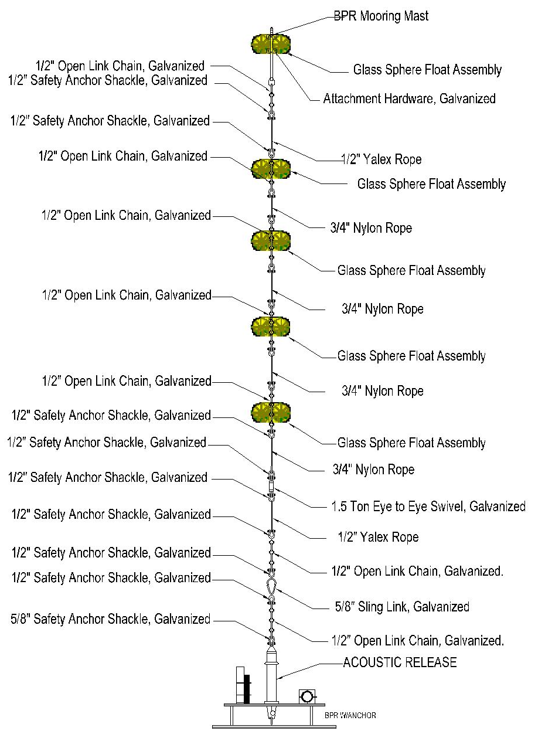

Drawing 1, Current DART BPR Mooring

8.0 DATASHEET

