CalNex 2010 onboard Atlantis
14 May – 8 June 2010
Chief Scientist/Principal Investigator: Trish Quinn

Cruise Description and Objectives:

CalNex 2010 is a combined air quality/climate project that will take place in the coastal region of California. Sampling will be coordinated with ground-based stations located in California and multiple aircraft. Sampling aboard Atlantis will take place continuously with the following goals:

- To characterize onshore and offshore sources of boundary layer gases and aerosols
- To characterize transformation processes (day and night time chemistry) that affect the levels of aerosols and ozone in the boundary layer of the study region
- To characterize the chemical, physical, and optical properties of aerosols and their direct radiative effect
- To characterize aerosol-cloud interactions in the study region

Schedule and sampling plan:

The CalNex 2010 project will depart San Diego on May 14 and will spend approximately 13 days working in the southern California coastal region. This work will include:

- Sampling emissions outside of and within San Diego, Los Angeles, Long Beach, and Port Hueneme harbors.
- Sampling marine vessel emissions outside of and within harbors, near shipping lanes, and in low and high-S fuel zones.
- Characterizing night time chemical processing of air masses during offshore flow in regions near but downwind of Santa Monica and San Pedro.
- Characterizing marine air masses during periods of onshore flow upwind of Santa Monica, Los Angeles, and San Pedro.
- Characterizing aerosol-cloud interactions during periods of pollution outflow coincident with stratus clouds in regions near the coast and up to 100 nm offshore.

There will be a mid-cruise stop for personnel exchange and pick up of liquid N2 dewars. The exact date and place is TBD but most likely will be on or around May 28 in the Long Beach vicinity.

Between approximately May 29 and June 7, the CalNex 2010 project will spend 10 days working off the northern California coast and in San Francisco Bay. This work will include:

- Characterizing aerosol-cloud interactions near the coast and up to 100 nm offshore between Los Angeles and Monterey.
- Sampling marine air masses during onshore flow upwind of San Francisco Bay.
- Sampling emissions within San Francisco Bay (marine vessel, Port of Oakland, oil refineries, urban and industrial) for approximately 2 days.
- Sampling sources and chemical processing of air masses during a transit up and down the Deep Water Channel to West Sacramento and while in the turning basin at West Sacramento. This work is expected to be carried out once and take 2 to 3 days.

All CalNex equipment will be offloaded in San Francisco between June 8 and 10.

Measurements:

Air samples will be collected using equipment mounted on the forward part of the O2 deck. An aerosol sampling mast mounted on the AeroPhys van will extend 8 m above the deck. A tower for gas sampling will be mounted forward of the VOCs van.

Ship and scientific personnel must be constantly aware of potential sample contamination. Work activities and smoking forward of the main stack must be secured during sampling operations. The scientists on watch must be notified of any change in ship course or speed that will move the relative wind abaft the ship’s beam or if anyone needs access to the bow.

Radiosondes will be launched approximately 4 times per day at 0500, 1100, 1700, and 2300 UTC.

Seawater will be sampled continuously from the uncontaminated seawater system outlet in the ROV hangar.

The measurements to be made of aerosol and gas phase species are listed below.
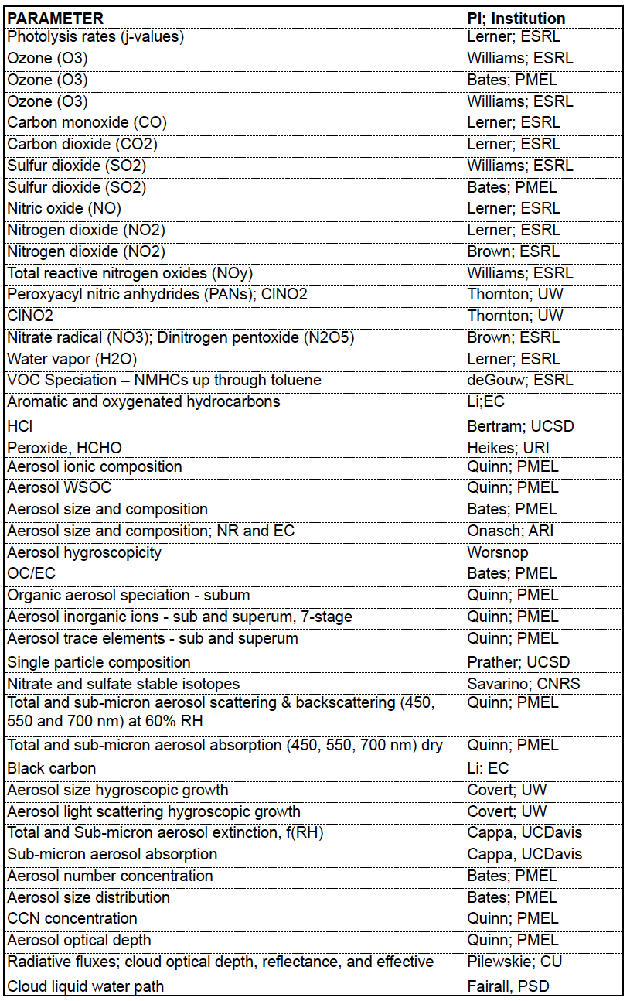
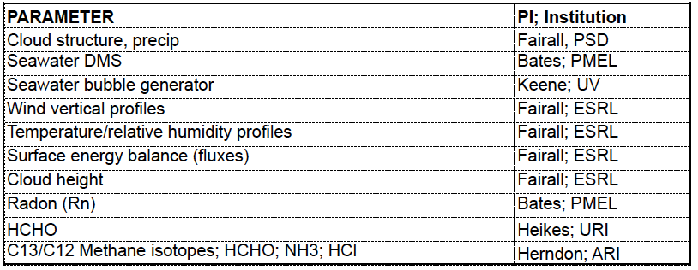

Layout of Vans: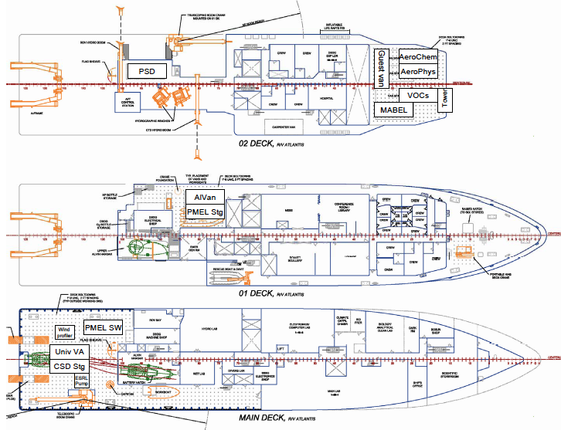

Placement of gas tanks and liquid N2 dewars:

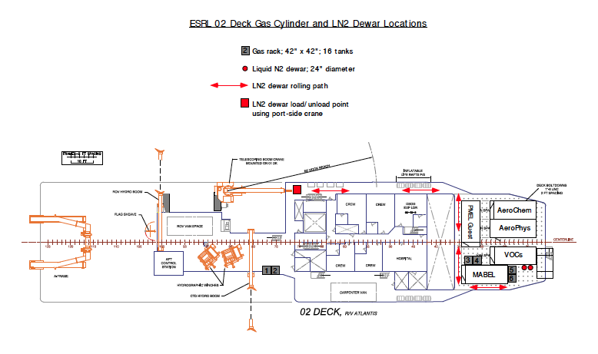

Requirements for Science Vans

Portable Science Vans 02 Level:

  - PMEL 1 (AeroChem Van)
wt 15,000 lbs
size 8' x 20'
power 70 amp 480 v three phase
location outboard port side 02 level, sampling line connected to AeroPhys Van
Needs phone connection.

  - PMEL 2 (AeroPhys Van)
wt 17,000 lbs
size 8' x 20'
power 70 amp 480 v three phase
location inboard port side 02 level, sampling mast mounted on roof
Needs phone connection, dry compressed air (120 psi, 4 CFM).

  - PMEL 3 (Guest Van)
wt 15,000 lbs
size 8' x 20'
power Power from PMEL 1
location port side 02 level aft of PMEL 1 and 2,
sampling line connected to PMEL 2

  - ESRL 1 (MABEL)
wt 15,000 lbs
size 8' x 20’
power 70 amp 480 v three phase
location outboard starboard side, 02 level, inlets and grated decking mounted on roof
Needs phone connection

  - ESRL 2 (VOCs)
wt 15,000 lbs
size 8' x 20’
power From ESRL 1 van
location inboard starboard side, 02 level, inlets mounted on roof
Needs phone connection

  - PSD Cloud radar van
wt 17,000 lbs
size 8’ x 20’
power 70 amp 480 v three phase
location O2 deck aft
Needs phone and Ethernet connection

Portable Science Vans 01 Level:

  - PMEL Alvan
wt 12,000 lbs
size 8' x 20'
power 30 amps 480 v three phase
location outboard, port side, 01 level
Needs freshwater line, Ethernet connection and phone.

  - PMEL spare parts/storage van
wt 12,000 lbs
size 8' x 20'
power none
location inboard port side, 01 level

Portable Science Vans Fantail:

  - ESRL 3 (pump van)
wt 7,200 lbs
size 8' x 8’
power none
location fantail

  - PMEL SW van
Wt 12,000
Size 8’ x 16’
Power 70 amp 480 v three phase
Location fantail
Needs freshwater & seawater lines, dry compressed air (120 psi, 4 CFM), phone connection

  - CSD Stg, spare parts/storage van
wt 12,000 lbs
size 8' x 20'
power none
location Fantail

  - Univ VA
wt 15,000 lbs
size 8' x 20'
power 30 amp 240 V
location Fantail
Needs seawater and freshwater lines, dry compressed air.

