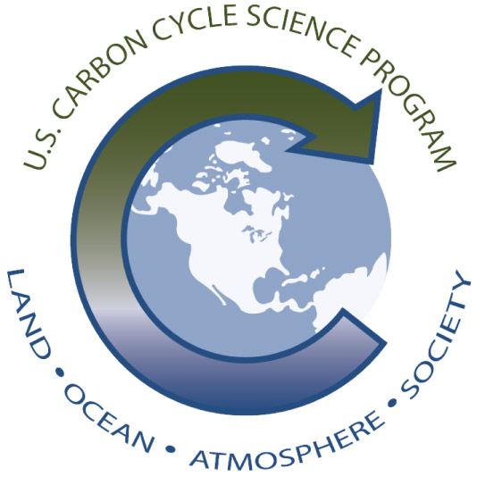 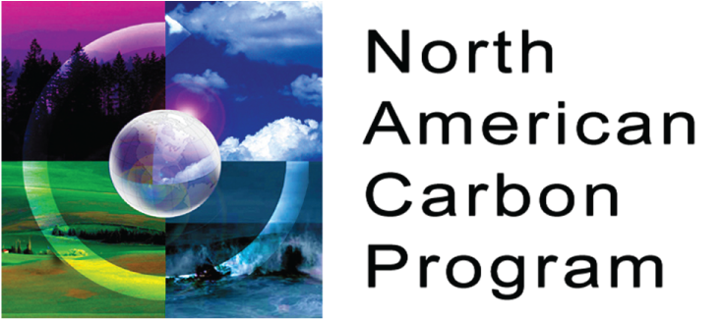 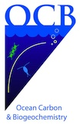

Coastal CARbon Synthesis (CCARS) Community Workshop

*Woods Hole Oceanographic Institution, Clark 507*

*August 19-21, 2014*

**WORKSHOP AGENDA**

**Tuesday August 19, 2014**

07:30 Continental Breakfast, hang posters (Clark 5)

08:30 Welcome and Introduction (Paula Coble, USF)

**PLENARY 1. Carbon Fluxes in North American Coastal Systems: Key Processes**

**Chairs:** *Marjy Friedrichs (VIMS), Simone Alin (NOAA/PMEL)*

**Terrestrial fluxes** (45 min. talk, 15 mins. for questions)

9:00 Lateral transfers of carbon from terrestrial watersheds to the oceans: Rivers and groundwater (Richard Alexander (USGS), Beth Boyer (PSU), Joe Needoba (OHSU), Ted Stets (USGS), Richard Smith (USGS))

10:00 Break

**Tidal wetland fluxes** (45 min. talk, 15 mins. for questions)

10:30 Tidal wetland fluxes overview (Chuck Hopkinson, Univ. Georgia) - primary production and CO2 uptake, burial, lateral fluxes, etc.

**Estuarine and shelf water fluxes** (30 min. talk with 10 mins. for questions)

11:30 Lateral fluxes: Shelf-open ocean exchange (Marjy Friedrichs (VIMS), Penny Vlahos (UConn))

12:10 Lunch

13:30 Coastal primary production in North America (Steve Lohrenz, UMassD)

14:10 Coastal Net Ecosystem Production (NEP) in North America (Michael Kemp, UMCES)

14:50 Air-sea fluxes (Wei-Jun Cai, UDel)

15:30 Break

15:50 Burial and sediment-water exchange (Miguel Goñi, OSU)

16:30 Group Q&A and discussion

17:00-19:00 Poster session and welcome reception (Clark 5)

**Wednesday August 20, 2014**

07:30 Continental Breakfast, hang posters (Clark 5)

**PLENARY II. Regional Coastal Carbon Budgets: Existing Gaps and Potential New Approaches**

**Chairs:** *Ray Najjar (PSU), Paula Coble (USF)*

**Structure:** 15-minute talks to demonstrate synthesis work and updated budgets from each region, key accomplishments and remaining gaps/holes with 5 minutes for questions

08:30 East coast (Ray Najjar (PSU), Marjy Friedrichs (VIMS))

08:50 West coast (Simone Alin, NOAA/PMEL)

09:10 Gulf of Mexico (Paula Coble, USF)

09:30 Arctic (Jeremy Mathis (NOAA/PMEL), Jessica Cross (NOAA/PMEL))

09:50 Great Lakes (Galen McKinley, Univ. Wisconsin)

10:10 Break

**10:30-12:30 BREAKOUT 1. Coastal Fluxes and Processes**

***Goal:*** *Based on current regional budgets and associated gaps in understanding, identify highest-priority process studies for advancing our understanding of the coastal carbon budget*

Groups (self-assigned)

* Air-sea exchange (Lead: J. Mathis)
* Terrestrial inputs (Lead: P. Coble)
* Estuarine and tidal wetland fluxes (Lead: M. Herrmann)
* Biological transformations (Lead: S. Lohrenz)
* Carbon loss terms: Burial and cross-shelf exchange (Leads: M. Friedrichs, S. Alin)

12:30 Lunch

14:00 Breakout 1 reports to plenary

**15:00-17:00 BREAKOUT 2. Coastal Observations**

***Goal:*** *Based on current status of regional budgets, identify highest priority observations (by region) for coastal processes and fluxes discussed in Breakout 1*

Groups (self-assigned)

* East coast (Lead: R. Najjar)
* West coast (Lead: S. Alin)
* Gulf of Mexico (Lead: P. Coble)
* Arctic (Lead: J. Mathis)
* Great Lakes (Lead: G. McKinley)

15:45 15-minute break during Breakout 2

17:00 Poster session (Clark 5)

18:00 Workshop Dinner

**Thursday August 21, 2014**

07:30 Continental Breakfast (Clark 5)

08:30 Breakout 2 reports to plenary

**09:30-11:30 BREAKOUT 3. Scaling Up: Integration of Observations and Models in Coastal Systems**

**(Same regional groups and leaders as Breakout 2)**

***Goal:*** *Recommend highest priorities for model development and integrated data and modeling approaches across different time and space scales*

Potential discussion points

* Working across terrestrial-coastal ocean interface
* Estuarine and tidal wetland processes
* Coastal ocean processes
* Working across coastal-open ocean interface

10:30 15-minute break during Breakout 3

11:30 Breakout 3 reports to plenary

12:15 Lunch

13:30 **GROUP DISCUSSION** - Science plan, strategize about near-term research and field priorities and existing funding opportunities

15:00 Workshop adjourn and steering group meets to discuss science plan and writing assignments