Climate States, Freshwater, & Heat Content

Summary of Posters

- Sea ice retreat ➔ Ocean freshwater change
- Ocean heat and stratification changes ➔ Sea ice retreat
- External forcings (rivers, atmospheric fluxes) ➔ Sea ice and ocean freshwater & heat content

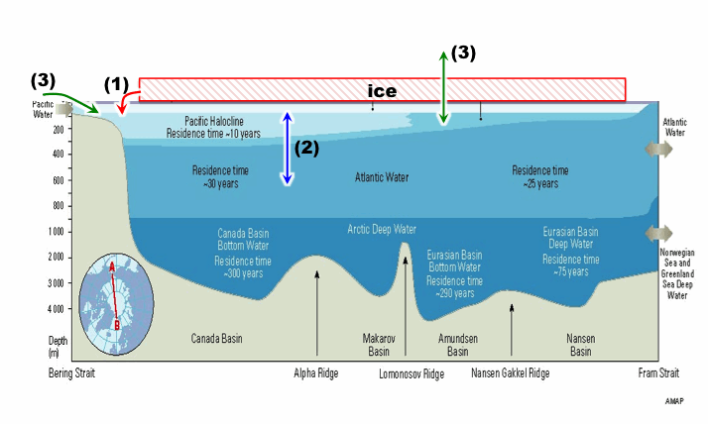

Some questions:

- The Arctic Ocean is changing! OK, but how large are these T, S, u changes, relative to historical (pre-ice retreat) variability?
  - Observations: E.G., compare model output not just with PHC mean, but with EWG variance
- Pan-Arctic flux study:
  - Sheldon Bacon discusses his idea for the 4 straits study heat & FW fluxes, for pan-Arctic. Then: (i) tease out diff’s in terms, and (ii) regional balances (hmmm… there’ll be problems with no obs on “internal” straits.) Wielsaw suggests we include the coupled models…. This addresses a common FAMOS reviewer complaint! (ie lack of feedback to coupled community)
- Google hangout: flux discussion group…

- Where does water in outflows originate and how does this vary interannually? IE linking the “fluxes in straits” group with the “ocean circulation” group
  - Observations: Can compare with ocean chemistry observations

- What is the role of sexy new (or newly recognized) processes?
  - Submesoscale processes in the mixed layer
  - Deeper mixing by IGWs, tides, etc
  - Surface waves
    - interaction with sea ice
    - coastal erosion

-- Who is including these in large-scale models? What will it take to do so?

- Fluxes through straits:
  - Local vs. remote forcing?
  - Use of simple models for understanding (a la Mike Spall’s poster)

- Momentum fluxes:
  - We suggest an observational process study to do the air/ice/ocean transfer eg on a floe… hmmm maybe AOFBs?

- Studies of properties (T, S, v) and fluxes at individual straits: model vs. obs study a la Bering St. chapter:
  - model subsampling at mooring locations
  - allow model vs. obs diff’s in position of features by comparing via water mass features

- We are interested in paleo (with varying levels of enthusiasm).

