M/V Alucia & M/V Umbra 2015 Cruise Planning Document

To Whom It May Concern:
This document contains information for the Principal Investigator and Chief Scientist planning their research cruise. There are many items to attend to and WHOI will be here to help you at any and every point in the process. Alucia and Umbra are unique vessels with unique capabilities and challenges; they are unlike any UNOLS vessel in configuration and purpose.

The following are ‘must have’ items to conduct your cruise. Detailed information about each is below.
- Cruise planning questionnaire (submit as soon as possible)
- Pre-cruise meeting (held with WHOI once the cruise is approved)
- Timeline of field activities (this is a day-by-day plan of your cruise including mobilization)
- Research clearance for the nation(s) who territorial waters you will be working in.
- Personnel list (Alucia has accommodations for a science party of 9; Umbra has accommodations for a science party of 11).

- Cruise Planning Questionnaire
This document that can be found here:
http://www.whoi.edu/fileserver.do?id=212224&pt=2&p=166309
and can be downloaded as a PDF and faxed or emailed to:
Philip Sacks – Mission Coordination
psacks@whoi.edu
Office: 508-289-4931
Mobile: 508-560-4787
Fax: 508-457-2185

The Cruise Planning Questionnaire allows us to begin planning for your mission and bring the most appropriate departments and professionals at both WHOI and aboard the Alucia and/or Umbra into the planning process.

- Pre-Cruise Meeting

This meeting, often the first of many, brings the Chief Scientist and key personnel to the table with the marine and scientific professionals from WHOI. This is key to developing the logistics and a mission plan that is safe and feasible.
This meeting can be conducted in person at Woods Hole Oceanographic Institution or via teleconference. It should be set up as soon as possible with:
Philip Sacks – Mission Coordination
psacks@whoi.edu
Office: 508-289-4931
Mobile: 508-560-4787

- Timeline

The timeline is a planning schedule for the intended operations on a day-by-day basis. It can be submitted in any format and should show all operations planned/proposed, duration per day, crew support required and how many days on mission they will be conducted.

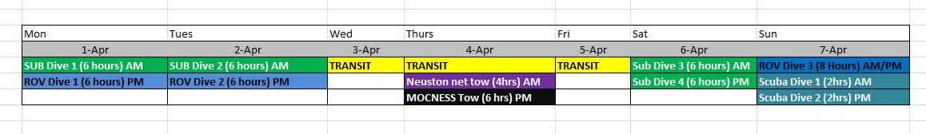
Example:

This will allow your science party, WHOI and personnel from Alucia and/or Umbra to evaluate the workload and, if necessary, edit the plan to ensure both the ship(s) and the crew(s) are not overburdened or underutilized.
- Research Clearances
Research Clearances are necessary for operation within any country’s Economic Exclusive Zone (EEZ). The EEZ of any nation extends 200 nautical miles seaward from the nation’s coast. Often the EEZ is extended due to small islands. It is imperative to be aware of the location of any proposed sampling in reference to the nearest nation’s EEZ. Currently, all research clearances are handled by:
Eric Benway
ebenway@whoi.edu
508-289-3770

- Personnel List

Alucia has 9 berths and Umbra has 11 berths for the science party. This includes any additional technicians, sub pilots or videographers. The principle submersible pilot and the Dive Safety Officer are not included in this number. Personnel can be a limiting factor in some operations, for instance operation of a single submarine would require 3 to 4 additional individuals as crew which reduces the total number of available bunks. Please note that both the crews of the Alucia and the Umbra stand a full and regular watch schedule and should not be relied upon for labor during scientific operations, though they can and will lend a hand as time permits.

Welcome to the M/V Alucia and M/V Umbra’s 2015-2016 cruise season. We at Woods Hole Oceanographic Institution look forward to aiding you in a safe and successful research cruise.

Kind Regards,
WHOI Marine Operations

Roles & Responsibilities: Alucia Science Cruise Planning

Theo Moniz
Project Manager
tmoniz@whoi.edu

Phil Sacks
Mission Coordinator
psacks@whoi.edu

Anthony Tarantino
Submersible Operations
atarantino@whoi.edu

Ed O’Brien
Diving Operations
edobrien@whoi.edu

Bill Lange
Advanced Imaging and Visualization Laboratory (AVIL)
wlange@whoi.edu

