
Woods Hole Oceanographic Institution
Dr. Laurence P. Madin, Executive Vice President and Director of Research

May 18, 2010

TO: Scientific Staff, Technical Staff & Postdocs
FROM: | Larry Madin | 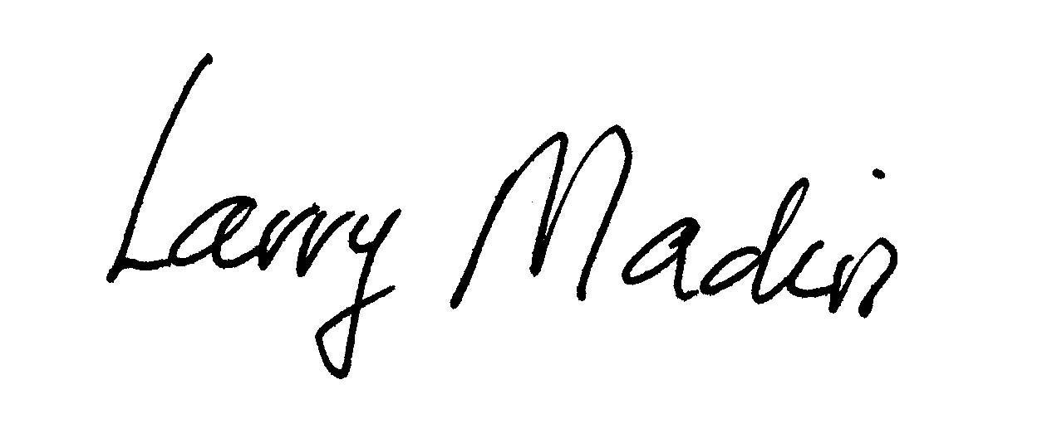
SUBJECT: Timely Technical Reporting

The late submission of technical reports for awarded projects continues to be a problem for the Institution. I hope that by raising awareness and understanding of the issue we can improve our record.

Institution & Investigator Responsibility
Research awards from external agencies typically have terms and conditions which include an expectation of financial and technical reporting. By accepting an award the Institution assumes overall responsibility and risk for ensuring compliance with the terms and conditions, but it’s the Principal Investigators who are responsible for conceiving, funding and carrying out their research programs. Therefore, while the Institution has systems in place to provide award support and financial reporting, it is ultimately the responsibility of the Principal Investigator to provide required technical information to the sponsor, including reports from subcontracts. Additionally, both sponsors and the Department administration must be informed when there are problems hindering a project or its timely completion.

Consequences
For the last several years, WHOI has been working to improve its record of timely submission of annual and final technical reports. With the advent of electronic submission and tracking systems, there is increased ability by agencies to monitor compliance. Potential consequences for non-compliance extend beyond the individual project and include:
- Awards to the PI may be delayed or canceled by the agency.
- Awards for collaborators may be delayed or canceled by the agency.
- WHOI may not get paid or payment may be delayed – Most awards are paid on a cost-reimbursement basis which means WHOI advances money to the project and then invoices the sponsor for payment. Until payment is received we carry the debt. Failure to receive technical reports is often the reason given by sponsors for withholding payment of invoices.
- Loss of expanded authorities on current and future awards – Expanded authorities allow Grant & Contract Services staff to approve some actions such as budget revisions and no-cost extensions. Without expanded authorities, all such requests would require prior sponsor approval in writing which could significantly delay work on the project.
- WHOI might be tagged as high-risk – This designation usually involves much more oversight and on-going monitoring by the sponsor. It indicates that the sponsor has serious concerns about the PI’s and WHOI’s ability to manage projects. Other non-federal government sponsors may even choose to give their money to a lower-risk organization.
- If non-compliance becomes a persistent problem, WHOI may be debarred from receiving Federal awards.

Given the potential consequences to colleagues and the Institution, it is conceivable that an investigator’s record of timely reporting could be taken into consideration during annual performance review.

I urge you to be very serious about meeting reporting deadlines, and make them a priority. New Institution procedures (attached) have been developed to help with this and will be implemented next month. Also, keep in mind that the department administrators are on-hand to provide assistance with reporting. Their help in reviewing reports prior to submission and familiarity with the idiosyncrasies of the various electronic systems used could be invaluable in smoothing the process for you.

Thank you for your consideration and cooperation in improving WHOI’s track-record in this area.

LPM:an

Cc: J. Umschlag, M. Murphy, M. Ferreira, J. Reilly, M. Wray, M. Schumacher, L. Flick, F. Hampshire, W. Huntington, P. Daly, J. Uttaro, C. Reid & GCS Staff, L. Murphy (Asst. Controller)

