Processes controlling retention of spring-spawned Atlantic cod (Gadus morhua) in the western Gulf of Maine and their relationship to an index of recruitment success

James H. Churchill^{1,*}, Jeffrey Runge² and Changsheng Chen³

¹Department of Physical Oceanography
Woods Hole Oceanographic Institution
Woods Hole, MA 02543 USA

²School of Marine Sciences
University of Maine
Gulf of Maine Research Institute
350 Commercial Street
Portland, ME 04101 USA

³Department of Fisheries Oceanography
School for Marine Science and Technology
University of Massachusetts Dartmouth
706 South Rodney French Blvd,
New Bedford, MA 02744 USA

*Correspondence. e-mail: jchurchill@whoi.edu; phone: 508-289-2807; FAX: 508-457-2181

Running title: Retention of spring-spawned cod in the Gulf of Maine
ABSTRACT

Atlantic cod, Gadus morhua, harvested in US waters are presently managed as a Gulf of Maine stock and a stock comprising Georges Bank and southern New England populations. Over the past 2½ decades, success of age-1 recruitment to the Gulf of Maine stock has varied by more than an order of magnitude. To investigate the hypothesis that this variation is related to variation in the transport of larval cod to nursery areas, we carried out model simulations of the movement of planktonic eggs and larvae spawned within the western Gulf of Maine during spring spawning events of 1995-2005. Results indicate that the retention of spring-spawned cod, and their transport to areas suitable for early stage juvenile development, is strongly dependent on local wind conditions. Larval cod retention is favored during times of downwelling favorable winds and is least likely during times of upwelling favorable winds, during which buoyant eggs and early stage larvae tend to be advected offshore to the Western Maine Coastal Current and subsequently carried out of the Gulf of Maine. Model results also indicate that diel vertical migration of later stage larvae enhances the likelihood of retention within the western Gulf of Maine. Consistent with model results is a strong correlation between age-1 recruitment success to the Gulf of Maine cod stock and the mean northward wind velocity measured in Massachusetts Bay during May. Based on these findings, we propose a wind index for strong recruitment success of age-1 cod to the Gulf of Maine stock.

Key words: Atlantic cod, Gulf of Maine, recruitment success, larval transport

INTRODUCTION
The harvest of Atlantic cod (Gadus morhua) in the Gulf of Maine, one of the two management units for Atlantic cod in U.S. waters, is an important part of the regional commercial fishing economy. In 2004, approximately 3.8 x 10³ mt of Atlantic cod were taken from the Gulf of Maine, only slightly less than the 4.6 x 10³ mt cod harvest from Georges Bank and southern New England (O’Brien et al., 2006; Mayo and Col, 2006). However the yearly cod harvest from the Gulf of Maine has declined considerably since its peak of 17.8 mt in 1991, prompting concern about the future commercial viability of Gulf of Maine cod stock.
In forming management decisions aimed at rebuilding or maintaining a regional fish stock, it is important to understand what controls recruitment to the year-1 population. As in many other species, recruitment into the Gulf of Maine cod stock process is highly variable. Since it was first tabulated by the U.S. National Marine Fisheries Service (NMFS) in 1982, the ratio of the number of year-1 recruits to the previous year’s spawning stock biomass (referred to as recruitment success) has fluctuated by more than a factor of 25 (Fig. 1).
Undoubtedly, this variation in recruitment success is due of a number of factors, including food availability for larval stages and predation mortality. We examine here variability in advective transport of larval cod from spawning areas to nursery areas, identified by Hjort in his second hypothesis as an important influence on recruitment success (Sinclair et al.,1985). According to this hypothesis, recruitment success depends in part on the extent to which larvae are transported to regions suitable for juvenile development. For Gulf of Maine cod, interannual variations in Gulf of Maine currents transporting larvae to suitable benthic juvenile habitat could play an important role in the large variation in recruitment success.
Thanks largely to studies carried out in the last decade, a good deal is now known about the migration and spawning patterns of Gulf of Maine cod stock, which is presently concentrated in the western Gulf areas of Ipswich and Massachusetts Bay and Stellwagen Bank (Fig. 2). In particular, evidence is accumulating that this western Gulf of Maine cod stock may be largely sustained through self-recruitment and have limited communication, via fish migration, with other regional cod stocks.
Movements of cod within the western Gulf of Maine were recently examined by Howell et al. (2008) using the data from a fish tagging and recapture study. They found that recoveries of fish tagged in the western Gulf of Maine were mostly (>73 %) within 30 km of their point of release, and only a small proportion (3 %) were > 100 km from their release point. Based on these and other recapture statistics, Howell et al. characterized the western Gulf of Maine cod population as “sedentary resident”. This characterization is consistent with the data of a larger-scale fish tagging program reported by Tallack et al. (2009), which showed little movement of cod out of the inshore waters of the western Gulf of Maine.
Spawning by the western Gulf of Maine cod stock is largely confined to winter and spring spawning events (Hoffman et al., 2006; 2007; Huret et al., 2007; Howell et al., 2008, Kovach et al. submitted). Spring spawning is concentrated in the area of Ipswich Bay and near Cape Ann (Fig. 3) and extends over April through June, with peak activity tending to occur in May. Winter spawning typically extends from November through February and is broadly distributed over the western Gulf (Hoffman et al., 2006; 2007). Howell et al. (2008) analysis of tagged fish recapture locations suggests that the spring-spawning Gulf of Maine cod may exhibit a natal homing behavior, returning to the Ipswich Bay area each spring for spawning.
The developing eggs and larvae from these spawning events are pelagic and subject to drift in currents for 2-4 months before late stage larvae metamorphose into juveniles and settle onto bottom habitats (Lough, 2004). In the western Gulf of Maine, larval drift may be strongly influenced by the Western Maine Coastal Current (WMCC), which flows to the south-southeast off the Massachusetts coast (Vermusch et al., 1979; Lynch et al., 1997; Pettigrew et al., 1998, 2005; Churchill et al., 2005; Manning et al., 2009). The WMCC is part of the Gulf of Maine Coastal Current, although the coastal designation of both currents is somewhat misleading, as neither is bound to the coast. In many observations, the maximum flow of the Gulf of Maine Coastal Current appears a considerable distance from the coast, often centered near the 100 m isobath (Churchill et al., 2005; Keafer et al., 2005; Pettigrew et al., 2005).
The bottom habitat in the western Gulf of Maine suitable for early stage settlement of juvenile cod may be inferred from the distribution of age-0 cod (Huret et al., 2007). Based on 22 years of data from trawl surveys off the Massachusetts coast, Howe et al. (2002) found that newly settled cod tend to be concentrated within distinct depth zones. Data from spring surveys show age-0 cod predominantly within near-shore waters with depths shallower than 30 m. Juvenile cod found in the autumn surveys appear over a somewhat deeper swath, but are nonetheless largely confined to depths of less than 60 m. Howe et al. (2002) concluded that the near-shore region of Massachusetts and Ipswich Bay constitute a critical habitat for newly settled cod.
Recent analysis of drifter observations by Manning et al. (2009) reveals that the WMCC tends to bypass the Juvenile cod habitat in Ipswich and Massachusetts Bay. Their compilation of drifter tracks which passed through the western Gulf of Maine clearly shows the WMCC in the form of a relatively strong flow directed to the southeast with a magnitude of order 15 cm s⁻¹. The mean isobath over which these drifters passed, taken as an indicator of the mean core of the current by Manning et al, is 67 m.
In exploring how Hjort's second hypothesis may apply to Gulf of Maine cod, we focus on the fate of cod eggs/larvae released in the spring spawning event. This event was chosen because it is concentrated in a distinct area. As will be shown later, the spring spawning event occurs at a time when the water column is vertically stratified, allowing us to specify the depth of cod eggs and early stage larvae. This event is of particular interest in light of recent analysis of genetic markers showing genetic differentiation between the spring spawning cod captured in Ipswich Bay and spawning cod captured in other areas of the northeast US coast (Wirgin et al. 2007; Kovach et al. submitted).
Our work is aimed at understanding how variations in western Gulf of Maine circulation impacts the extent to which larvae spawned in Ipswich Bay during spring are retained within the western Gulf of Maine and successfully delivered to areas suitable for early-stage juvenile development. A practical goal is to identify a readily determined index of recruitment success to the western Gulf of Maine cod stock. Perhaps more importantly, we view our study as an initial step in understanding how this cod stock is maintained and how it interacts with other regional cod stocks.
Our approach is to simulate the movement of developing cod eggs/larvae spawned in Ipswich Bay using an 11-yr series of high resolution velocity fields derived from a hydrodynamic model of Georges Bank and the Gulf of Maine. We examine how the transport and ultimate fate of cod larvae are impacted by wind-driven circulation, the large-scale regional flow and larval behavior.

METHODS
Our work follows an earlier study of larval cod transport in the western Gulf of Maine by Huret et al. (2007). Using velocity fields from a hydrographic model, Huret et al. tracked particles from identified spawning areas and used the results to derive estimates of transport success to areas suitable for settlement and early stage juvenile cod development. The analysis was confined to simulations of a single year, 1995. Here we extend that analysis to multiple years and investigate the effect of vertical migration of larvae. In the subsections below, we describe the model used for generating the velocity fields and the method for tracking particles, representing cod eggs and larvae, within these fields.

Generation of velocity fields
We used velocity fields spanning the period of 1995-2005 as generated by the "first generation" Finite Volume Coastal Ocean Model of the Gulf of Maine and Georges Bank (GoM/GB FVCOM). Developed by the Marine Ecosystems Dynamics Modeling group at the University of Massachusetts Dartmouth, this is an unstructured grid, free-surface, fully 3-dimensional primitive equation model that solves the governing equations through computation of fluxes between triangular control volumes of an unstructured grid (Chen et al., 2003, 2006, 2007). The model grid encompasses the Gulf of Maine and Georges Bank, as well as the Scotian Shelf and the New York Bight. It extends offshore to roughly the 3000-m isobath. Within the Gulf of Maine, the horizontal grid resolution is 2-10 km in the basins and 0.5-2 km in coastal regions. In the vertical, the grid is divided into 30 equally spaced sigma layers, giving a 1-m resolution at 30-m depth.
Forcing of the model at the lateral boundary is applied in the form of tidal elevations, imposed at the open boundary, and freshwater influx from all major rivers in the model domain. Forcing at the surface is derived from the fifth generation mesoscale meteorological model (MM5) run at 10-km resolution (Chen et al., 2005). The surface forcing terms include atmospheric heat fluxes, precipitation/evaporation and wind stress. At the upstream boundary, the time-varying influx of Scotian shelf and slope water is imposed. During model execution, satellite-derived sea surface temperature fields are assimilated to adjust the modeled surface temperature.

Particle tracking
The larval tracking simulations were done in the “off-line” mode using hourly-averaged velocity fields generated by GoM/GB FVCOM. Larval movement in the horizontal plane was assumed to be passive. The larval trajectories were determined by integrating model velocities, linearly interpolated in space and time, using an explicit fourth order Runge-Kutta scheme with a 120 s time step.
In specifying the vertical position of eggs and larvae released into the model flow field, it was assumed that the early life history of cod, from spawning to settlement, consisted of a buoyant egg/larval stage followed by a larval stage capable of vertical migration at a body length of 6-9 mm (Lough and Potter, 1993).
A critical parameter in the simulation is the depth at which cod eggs are assumed to reside. This was specified based on the expected vertical density distribution in the Gulf of Maine during late spring and early summer and the expected density of cod eggs and early stage larvae. In examining the density structure in the western Gulf of Maine during spring, we drew from three data sources: a set of 163 conductivity temperature and depth (CTD) profiles acquired over 7 cruises carried out as part of a Massachusetts Water Resource Authority study during May-June of 2000 and 2001 (Anderson et al., 2002), a series of 87 CTD profiles acquired during May and June as part of the NMFS survey cruises conducted from 1978 to 2007, and CTD data acquired from Dec. 1989 through Nov. 2002 from a mooring deployed in western Massachusetts Bay (Anderson et al., 2007). These data indicate strong and persistent vertical density stratification in the Ipswich and Massachusetts Bay region throughout May and June. In the majority of CTD profiles from this period, the surface to bottom density difference exceeds 1.5 kg m⁻³, and is due to a combination of vertical temperature and salinity stratification (Fig. 4). The surface density seen in most profiles is in the range of 1023-1025 kg m⁻³. Occasionally lower surface densities are seen near the coast and are associated with a thin (typically <5 m) low salinity plume, presumably due to local river discharge.
To our knowledge, there have been no measurements of the density of cod eggs and larvae spawned in the western Gulf of Maine. In a relevant study on the density of eggs and early stage larvae spawned by cod captured over Newfoundland Shelf and Grand Banks, Anderson and de Young (1994) found that egg density varies considerably depending on spawning stock and the properties of the water in which spawning occurs. Most applicable to cod eggs spawned in Ipswich Bay were their measurements of the density of eggs spawned by cod captured over the inner Newfoundland Shelf and held in tanks containing inshore surface water. Notably, the density declined with egg age, and mean densities for all ages were in the 1020-1023 kg m⁻³ range. Based on this result and the measured density distributions in western Gulf of Maine during May and June, we have assumed that eggs spawned in Ipswich Bay during spring are predominately situated in the near-surface layer subject to direct wind forcing.
Duration of the egg stage and early larval stages (until swimming capability) is highly temperature dependent (Page and Frank, 1989; Otterlei et al., 1999; Folkvord, 2005, and references contained therein). Using a function relating egg stage duration to ambient temperature (Page and Frank 1989) and expected near-surface springtime temperatures in the western Gulf of Maine, we determined that eggs spawned in Ipswich Bay during spring hatch in roughly 10 days. Based on analysis of larval growth rates presented by Bolz and Lough (1988) and Otterlei et al. (2005), we further determined that cod larvae spawned in Ipswich Bay during spring should become swimming capable 10-30 days after hatching. Once swimming capable, larval cod exhibit a tendency for diel vertical migration, occupying deeper water during daylight hours and residing near the surface at night (Bailey, 1975; Lough and Potter, 1993; Lough et al., 1996).
Based the above information and analyses, we represented the vertical position of developing eggs and larvae as a relatively simple function (Fig. 5). In the buoyant stage, cod eggs and early-stage larvae were assumed to maintain a constant depth of 2.5 m to ensure that they would reside in the near-surface layer subject to direct wind forcing (i.e. predominately above the seasonal pycnocline). Because the duration of the passive buoyant stage may vary depending on a number of factors, we conducted transport simulations with the duration of the constant depth stage set to several different values. The results shown here were determined with the constant depth stage set to 21 d, a conservatively low estimate of the age to attain swimming capability. As detailed below, we also carried out transport simulations in which the developing eggs and larvae remained buoyant, maintaining a depth of 2.5 m, from spawning to settlement. The diel vertical migration was confined between two specified levels: a near surface level of 2.5 occupied during dark hours and a deep level occupied during daylight hours. We show results for two deep levels: 20 and 40 m. At bottom depths shallower than the specified deep level, the maximum decent was set to 1 m above the sea floor. Initiation of upward and downward migration were set to coincide with sunset and sunrise, respectively, and migration time was set to 4 h. Similar functions have been used to describe the vertical migration behavior of cod in other modeling studies (Werner et al., 1993; Vikebø et al., 2005, 2007)

Transport Success
Transport success was defined as the likelihood that larvae will be over areas suitable for juvenile settlement during an age when they are settlement capable. Our method for estimating this quantity was identical to that employed by Huret et al. (2007). As a first step, ensembles of particles, representing spawned cod eggs, were released into the model flow field. The particles were evenly distributed over the region designated by Huret et al. (2007) as the Ipswich Bay spawning area (Fig. 3). Ensembles were set out at intervals of three days. This is shorter than the 8-30 day range of decorrelation times of currents within the western Gulf of Maine that we have computed from available current meter data. Each particle was tracked for 60-days, taken as the maximum age to larval settlement. The minimum age of settlement capability was set to 45 days. The transport success for a particular spawning period was then taken as the average fraction of time (expressed as a percentage) that the simulated egg/larval tracks initiated during this period were over areas suitable for settlement during the last 15 days of their 60 day drift. Based on the juvenile cod distributions reviewed above, the area suitable for larval settlement was taken as regions shallower than either 30- or 60-m. Here we show only those results derived by assuming a 30-m maximum depth for the settlement suitable region. Results determined assuming that the settlement region extended to 60-m were not significantly different.
We computed transport success to three separate settlement regions in the western Gulf of Maine (Fig. 3): (1) a northern region off the Maine and New Hampshire coasts and north of the Ipswich Bay spawning area, (2) the Ipswich Bay region, encompassing the Ipswich Bay spawning area, and (3) the Massachusetts Bay region.

RESULTS
Model-generated flow in the Western Gulf of Maine
Before considering the results of the larval tracking simulations, it is useful to examine flows generated by the model in the near-absence of wind forcing. These are illustrated by the averaged modeled surface currents of May 1995 (Fig. 6), a time when the magnitude of the mean wind velocity measured at the NOAA/National Data Buoy Center (NDBC) buoy 44013 (Fig. 3) was less than 0.25 m s⁻¹. Similar to the drifter results of Manning et al. (2009), these mean currents show that the Western Maine Coastal Current takes the form of a strong flow directed westward along the Maine coast and southward along the outer arm of Cape Cod. Importantly, this current bypasses two of the regions of interest: the spawning area of Ipswich Bay the shallow areas of Massachusetts Bay where cod tend to settle. A focus of our analysis will be the extent to which the combination the WMCC and wind-driven flow impacts the retention of Ipswich Bay-spawned cod in the western Gulf of Maine.

Transport success for eggs/larvae maintaining a constant depth
In presenting the transport success results, our intention is to demonstrate the effect that wind forcing has on the year-to-year variation in larval retention in the western Gulf of Maine and to quantify how vertical migration behavior impacts larval retention. For this reason, we first present the results of transport simulations in which the developing eggs and larvae are maintained a constant depth of 2.5 m until settlement. We then consider how the introduction of vertical migration affects cod movement and transport success.
Consistent with the mean southward flow in the western Gulf of Maine (Fig. 6), yearly averaged values of transport success of eggs/larvae fixed at 2.5 m to region 1 are negligible, never > 0.15 %, indicating little transmission of spawned cod from Ipswich Bay to the north (Fig. 7). Yearly averages values of transport success to region 2, encompassing Ipswich Bay, are modest, with a maximum of 5 % in 2001, indicating a relatively little local retention of larvae within Ipswich Bay. However, significant retention of larvae is indicated for region 3, Massachusetts Bay. Yearly-averaged transport success to region 3 is in excess of 10 % for 7 of the 11 simulation years. Hereafter, we consider only transport success to regions 2 and 3, the regions of Ipswich and Massachusetts Bay, ignoring the negligible transport to the north.
To determine if transport success may vary with date of spawning, we averaged the transport success values for each release date (e.g. May 1, 4, 7 …) over all 11 years of the transport simulations. The results show a nearly monotonic decline in transport success with advancing date of release, from a high of 25-30 % for release dates in early May to a low of 2-5 % for release dates in late June (Fig. 8a). Given this trend, we found it useful to separately consider transport success for May and June releases. Not surprisingly, for most years, the transport success for those particles released in May is significantly greater than the transport success of the particles set out in June (Fig. 9). The only exception is 1999, a year with low (<1.5 %) transport success for both May and June releases.
For both May and June releases, the yearly-averaged transport success series show considerable year-to-year variation. The analysis to follow is directed at the hypothesis that this variation, and the decline in transport success with release date (Fig. 8a), are largely due to the combination of wind-driven upwelling/downwelling circulation and the Western Maine Coastal Current. More specifically, we hypothesized that the likelihood that buoyant eggs/larvae released from Ipswich Bay spawning area be retained in the western Gulf of Maine may be relatively low during a time of predominately upwelling circulation, and may be relatively high during a period when the circulation is predominately downwelling. The reasoning is that upwelling circulation will tend to carry buoyant particles offshore to the Western Maine Coastal Current, which will in turn transport the particles out of the Gulf of Maine. By contrast, a downwelling circulation will tend to move buoyant particles onshore and away of the influence of the Western Maine Coastal Current.
In considering the possible impact of winds on upwelling/downwelling circulation, it is often convenient to view the influence of across-shore and alongshore winds separately. In the western Gulf of Maine, the across-shore axis is roughly oriented east-west. An eastward wind will tend to accelerate the surface water offshore and thus be upwelling favorable. By the same logic, a westward wind will be downwelling favorable. If north-south direction is taken as the alongshore axis, a northward wind would be considered upwelling favorable as this would generate, through the Coriolis effect, a cross-shore flow to the east. Conversely, a southward wind would be downwelling favorable.
The tendency for downwelling winds to favor retention of buoyant particles in the western Gulf of Maine is illustrated here by the positions (at 15 day intervals) of particles released from the Ipswich Bay spawning area on 1 May 2003 (Fig. 10). Their release was followed by a period of predominately downwelling favorable winds, as indicated by the wind record from NDBC buoy 44013 (Fig. 3). Over the first 15 days after release, winds were predominately westward, resulting in a downwelling circulation that kept the buoyant particles within the nearshore zone (Fig. 10a). Over the subsequent 15 days, winds were southward (also downwelling favorable) and the majority of particles were contained within Massachusetts Bay (Fig. 10b). Mean winds were close to zero for the next 15 days (Fig. 10c) and were directed to the WNW (downwelling favorable) over the final 15 days of the 60-day simulation (Fig. 10d). The result of this predominately downwelling favorable wind history is that the majority of the particles were confined to the Massachusetts Bay region over the last 15 days of their 60-day drift (the time when the developing cod are considered settlement capable). The transport success of these particles to the Massachusetts Bay region was 78 %.
The tendency for upwelling wind to favor the export of buoyant particles from the western Gulf of Maine is illustrated by the positions of particles released on 13 May 1999 (Fig. 11). The persistent upwelling circulation following their release carried the majority of particles offshore to the Western Maine Coastal Current. The result was low particle retention in the western Gulf of Maine as reflected by low transport success (<0.4 %) to all regions.
To explore how the decline in transport success with release date (Fig. 8a) may be related to the local wind forcing, we averaged the winds from buoy 44013 over 21-day intervals following each release date. As demonstrated later, the first 21 days of a particle’s drift appears to be crucial in determining whether it is ultimately retained in the western Gulf of Maine. For each release date, the average extended over all 11 years of the simulations (1995-2005). These averages become progressively more upwelling favorable with advancing starting date (Fig. 8b). Averages for starting dates in early May are weakly downwelling favorable, whereas averages for starting dates in late June are strongly upwelling favorable. Plotting these averaged winds against the corresponding averages in transport success (matching release date with starting date of the wind average), clearly shows that transport success tends to decline as the wind over the first 21 day of egg/larval drift becomes more upwelling favorable (Fig. 8c). This trend is particularly strong for the comparison of transport success with averaged northward (alongshore) wind. The inference is that the decline in transport success with advancing release date during the spring spawning period is principally due to a shift in the wind pattern in the western Gulf of Maine, with winds becoming progressively more upwelling favorable (favoring export of particles out of the western Gulf of Maine) going from early May through June.
To investigate how the year-to-year variation in transport success may be related to wind forcing, we computed averaged winds for each May and June of the 1995-2005 simulation period. Averages of the east and north wind components for May tend to co-vary with regard to being upwelling or downwelling favorable. The average winds of June are all strongly upwelling favorable, consistent with the 21-d wind averages discussed above (Fig. 8b). Plotting transport success against the northward (alongshore) monthly averaged wind speed (Fig. 12) reveals a tendency for the highest transport successes to be associated with downwelling favorable winds. Notably, the highest yearly-averaged transport success for May releases occur for those years when the mean alongshore wind of May is directed to the south (downwelling favorable) with a magnitude of greater than 0.5 m/s (1998, 2003 and 2005).

The effect of vertical migration
The analysis reviewed thus far indicates that the tendency for buoyant eggs/larval spawned in Ipswich Bay during spring to be retained in the western Gulf of Maine is strongly tied to the upwelling/downwelling character of the local wind. The question remains as to how vertical migration in the larval stage may influence larval transport and retention in the western Gulf. To address this, we carried out transport simulations with diel vertical migration imposed at a specified age after spawning (Fig. 5). As noted in Methods, sets of simulations were carried out with different ages of migration capability and differing maximum depth of migration. As illustrated by the representative results shown here (Fig. 13), the introduction of vertical migration did not significantly alter the year-to-year variation in transport success.
For nearly all years, transport success is marginally enhanced by the introduction of vertical migration, indicating that diel migration improves the likelihood of larval cod retention in the western Gulf of Maine during spring. Our examination of the larval tracks and the circulation fields indicates that this is a consequence of the manner in which the migration exposes the larvae to the cross-shore flow associated with upwelling/downwelling circulation. To understand the phenomenon, consider a particle, representing a developing cod larvae, which is at the end of its buoyant stage (when it becomes capable of migration) and is contained within the western Gulf of Maine. If this particle remains buoyant and is exposed to a lengthy period of upwelling circulation, it will likely be carried offshore to the Western Maine Coastal Current and subsequently exported out of the Gulf of Maine. However, if the particle executes vertical migration over a lengthy upwelling period, it will during the course of each day alternate between the offshore flow in the upper layer and the onshore flow in the lower layer and likely be spared offshore transport to the Western Maine Coastal Current.
The close comparison between the transport patterns determined from simulations with and without vertical migrations (Fig. 13) further suggests that transport in the initial buoyant egg-early larval stage may be critical in determining the ultimate settlement fate of cod spawned in Ipswich Bay.

Downwelling winds in May: an Index of Recruitment Success
Our analysis strongly indicates that the extent to which buoyant cod eggs/larvae spawned in Ipswich Bay during spring are retained in the western Gulf of Maine, and transported to areas suitable for juvenile development, is tied to the dominant local wind direction during May. Retention is largest in those years when the winds during May are predominately downwelling favorable. In applying this result for fisheries management, it is clearly of interest to determine the extent to which recruitment success of cod are related to our estimates of transport success and to the mean winds during May.
A priori, a close comparison between recruitment success and transport success may not be expected. Our calculation of transport success does not include the winter spawning event, nor does it account for factors influencing larval survival, including predation and food supply. Nevertheless, cod recruitment to the Gulf of Maine appears to be weakly related to our estimates of transport success (Fig. 14). Most significant is that the three highest values of recruitment success of our analysis period (1995-2005) occur during those years (1998, 2003 and 2005) when the estimates of transport success are highest and mean wind of May (as recorded at buoy 44013) is most downwelling favorable (Figs. 9, 12 and 15). This leads to the hypothesis that unusually strong recruitment success of Gulf of Maine cod may be largely due to high retention of spring-spawned larvae and occur during those years when May winds are predominately downwelling favorable.
A comparison of recruitment success with the mean northward wind component measured at buoy 44013 during May is consistent with this hypothesis (Fig. 15). The correlation shows a tendency for the highest recruitment success to occur during years when the May wind is strongly downwelling favorable. For the 20 years with both 44013 wind measurements and recruitment success estimates, the years with the highest recruitment success estimates are also the years when the mean north-south wind measured at buoy 44013 during May is most downwelling favorable. For each of these years the mean north-south wind is southward (downwelling favorable) with a magnitude of greater than 0.4 m/s (Fig. 15). The tentative conclusion is that the mean wind of May may be used as an index of unusually high age-1 cod recruitment to the Gulf of Maine.

DISCUSSION
Our analysis indicates that a significant fraction of the cod larvae spawned in the Ipswich Bay is likely to be retained in the western Gulf of Maine. It is thus possible that the western Gulf of Maine cod population, described by Howell et al (2008) as sedentary-resident, is largely sustained through self-recruitment. Also indicated by our analysis is that the retention of spring-spawned larvae in the western Gulf is strongly tied to the local wind, with downwelling winds favoring retention. This is due to the tendency of upwelling circulation to transport buoyant eggs and larvae offshore to the Western Maine Coastal Current.
The relative simplicity of our model and limited scope of our investigation leave a number of issues regarding the recruitment of cod to western Gulf of Maine unresolved. One is the manner in which early-stage cod survival is impacted by food availability, growth rate and predation. Also unresolved is the fate of larvae exported from the western Gulf of Maine. Do these larvae significantly contribute to other cod populations, such as those over Georges Bank and Nantucket Shoals (Fig. 2)? Recent analysis of genetic markers by Wirgin et al. (2007) and Kovach et al. (submitted) suggests that the extent to which cod spawned in the Gulf of Maine are incorporated into remote cod stocks may be different for the spring and winter spawning events. Their results show that spawning-condition cod found in Ipswich Bay during spring are genetically distinct from other regional cod stocks, whereas spawning-condition cod found in the western Gulf of Maine in winter are genetically similar to cod of other regions, particularly in Nantucket Shoals and the eastern New York Bight.
We have not reported on our simulations of the transport of winter-spawned cod spawned in the winter event primarily because of uncertainty in the vertical location of the buoyant eggs and early stage larvae. The water column is vertically mixed during the winter spawning event, making it difficult to ascribe a depth range over which cod eggs are likely to be found. Nevertheless, it is of interest to note that our preliminary simulations have indicated buoyant cod spawned during the winter event have a very low likelihood of retention within the western Gulf of Maine. Predominately upwelling favorable wind conditions prevail throughout the winter spawning event, and a sizeable fraction of winter event spawning occurs close to the path of the Western Maine Coastal Current (Hoffman et al., 2006, 2007). Combining this tentative result with the findings of Wirgin et al. (2007) and Kovach et al. (submitted) leads to the hypothesis that the winter and spring spawning events in the western Gulf of Maine may serve somewhat different functions in sustaining the cod stocks off the northeast US coast. The spring spawning event may principally sustain the local "northern" cod stock in the western Gulf of Maine, whereas the winter spawning may be more important in supplying recruits to other regional cod stocks.
Another unresolved issue of interest is the manner in which local circulation may affect egg/larval transport and recruitment of cod to other coastal areas in the Gulf of Maine. The Massachusetts Bay region is the largest coastal area onshore of the normal path of the Gulf of Maine Coastal Current (Pettigrew et al., 2005). It may thus constitute a zone more favorable to the retention of locally spawned larvae than other areas along Gulf of Maine coast. This may be partly the reason why a concentrated population of sedentary-resident cod is found in Massachusetts and Ipswich Bays, while cod populations elsewhere in the Gulf of Maine have become decimated (Ames, 2004).
Addressing these and related issues will require more sophisticated modeling, for example to account for variations in egg and larval growth and predation, as well as more detailed observations on cod spawning behavior, migration patterns and juvenile habitat distribution. Given the importance of cod to the northeast Atlantic ecosystem and to the fishing economy of the northeast US, further modeling and observational investigation of cod recruitment dynamics is in our view warranted.

ACKNOWLEDGEMENTS
We are grateful to Ralph Mayo and Loretta O’Brien for supplying the data used to generate Fig. 1 and for informative discussions on fisheries oceanography. We thank numerous other individuals with whom we conferred throughout the course of this project, notably Geoff Cowles, Bill Hoffman, Hunt Howell, Martin Huret, Adrienne Kovach, Trond Kristiansen, Greg Lough, James Manning and Shelly Tallack. For his assistance in accessing the hydrodynamic modeling data and dealing with the numerous technical issues that arose, we are particularly grateful to Dave Stube. This work was funded through an NSF Coupled Natural and Human Systems award (0709527) and an award from the NOAA Fisheries and the Environment (FATE) program.

REFERENCES

Ames, E. (2004) Atlantic cod stock structure in the Gulf of Maine. Fish. Res. 29:10–28.

Anderson, D.M., Keafer, B.A., Churchill, J.H. and Loder, T.C. (2002) Post-outfall surveys of toxic Alexandrium fundyense populations in Massachusetts Bay, 2001. Boston: Massachusetts Water Resources Authority. Report ENQUAD 2002-08:36pp.

Anderson, J. T. and de Young, B. (1994). Stage-dependent density of cod eggs and larvae (Gadus morhua L.) in Newfoundland waters. ICES Mar. Sci, Symp. 198:654-665.

Bailey, R.S. (1975) Observations on diel behaviour patterns of North Sea gadoids in the pelagic phase. J. U.K. Mar. Biol. Assoc. 58:62-67.

Bigelow, H.B. (1927) Physical oceanography of the Gulf of Maine. Fish. Bull. 40:511–1027.

Bolz, G.R. and Lough, R.G. (1988) Growth through the first six months of Atlantic cod, Gadus morhua, and haddock, Melanogrammus aeglefinus, based on daily otolith increments. Fish. Bull. 81:827-836.

Brooks, D.A. (1985) The vernal circulation in the Gulf of Maine. J. Geophys. Res. 90:4687– 705.

Chen C., Beardsley, R., Hu S., Xu, Q. and Lin, H. (2005) Using MM5 to hindcast the ocean surface forcing fields over the Gulf of Maine and Georges Bank region. J. Atmos. Ocean Technol. 22:131–145.

Chen, C., Beardsley, R.C. and Cowles G. (2006). An unstructured grid, finite-volume coastal ocean model (FVCOM) system. Special Issue entitled “Advance in Computational Oceanography”, Oceanography 19:78-89.

Chen, C., Huang, H., Beardsley, R.C., Liu, H., Xu, Q. and Cowles, G. (2007). A finite-volume numerical approach for coastal ocean circulation studies: comparisons with finite difference models. J. Geophys. Res. 112:C03018, doi:10.1029/2006JC003485.

Chen, C., Liu, H. and Beardsley, R.C. (2003). An unstructured, finite-volume, three-dimensional, primitive equation ocean model: application to coastal ocean and estuaries. J. Atmos. Oceanic Tech. 20:159-186.

Churchill, J.H., Pettigrew, N.R. and Signell, R.P. (2005). Structure and variability of the Western Maine Coastal Current. Deep-Sea Res. II 52:2392-2410.

Folkvord, A. (2005) Comparison of size-at-age of larval Atlantic cod (Gadus morhua) from different populations based on size- and temperature-dependent growth models. Can. J. Fish. Aquat. Sci. 62:1037-1052.

Hoffman, W.S., Salerno, D.J., Correia, S.J. and Pierce, D.E. (2006). Implementing the industry-based survey for Gulf of Maine cod pilot study. Final Report for Contract EA133F-03-CN-0010 to NOAA Northeast Cooperative Research Partners Program, NOAA Fisheries Service Northeast Regional Office, Gloucester MA:37pp.

Hoffman, W.S., Correia, S.J. and Pierce, D.E. (2007). Implementing the industry-based survey for Gulf of Maine cod pilot study. Final Report for Contract EA133F-03-CN-0109 to NOAA Northeast Cooperative Research Partners Program, NOAA Fisheries Service Northeast Regional Office, Gloucester MA: 45pp.

Howe, A., Correia, S., Currier, T., King, J. and Johnston, R. (2002). Spatial distribution of ages 0 and 1 Atlantic cod (Gadus morhua) off the eastern Massachusetts coast, 1978–1999, relative to ‘Habitat Area of Special Concern’. Technical Report TR12, Massachusetts Division of Marine Fisheries, Pocasset, MA:35pp.

Howell, W.H., Morin, M., Rennels, N. and Goethel, D. (2008) Residency of adult Atlantic cod (Gadus morhua) in the western Gulf of Maine. Fish. Res. 91:123-132.

Hunt, J.J., Stobo, W.T. and Almeida, F. (1999) Movement of Atlantic cod, Gadus morhua, tagged in the Gulf of Maine area. Fish. Bull. 97:842-860.

Huret, M., Runge, J.A., Chen, C., Cowles, G., Xu, Q. and Pringle, J.M. (2007). Dispersal modeling of fish early life stages: sensitivity with application to Atlantic cod in the western Gulf of Maine. Mar. Ecol. Prog. Ser. 347:261-274.
Kovach, A.I., T.S. Breton, D.L. Berlinsky, L. Maceda, and I.Wirgin. Submitted. Fine-scale spatial and temporal genetic structure of Atlantic cod in U.S. coastal waters. Mar. Ecol.Prog. Ser., submitted.
Lough, R.G. (2004). Essential fish habitat source document: Atlantic cod, Gadus morhua, life history and habitat characteristics, NOAA Tech Memo NMFS-NE-190:94pp.

Lough, R.G., Caldarone, E.M., Rotunno, T.K., Broughton, E.A., Burns, B.B. and Buckley, L.J. (1996). Vertical distribution of cod and haddock eggs and larvae, feeding and conditions in stratified and mixed waters on southern Georges Bank, 1992. Deep-Sea Res. II 43:1875-1904.

Lough, R.G and Potter, D.C. (1993). Vertical distribution patterns and diel migrations of larval and juvenile haddock Melanogrammus aeglefinus and Atlantic cod Gadus morhua on Georges Bank. Fish. Bull. 91:281-303.

Lynch, D.R., Holbrook, M.J. and Naimie, C.E. (1997) The Maine coastal current: spring climatological circulation. Cont. Shelf Res. 17:605–634.

Manning J.P, McGillicuddy, D.J., Pettigrew, N.R., Churchill, J.H. and Incze, L.S. (2009). Drifter Observations of the Gulf of Maine Coastal Current. Cont. Shelf Res. 29:835-845.
Mayo, R.K. and Col, L.A. (2006). The 2005 assessment of the Gulf of Maine Atlantic cod stock. Northeast Fisheries Science Center Reference Document 06-02:109pp.

O’Brien L., Shepherd, N. and Col, L. (2006). Assessment of the Georges Bank Atlantic Cod Stock for 2005. Northeast Fisheries Science center Reference Document 06-10:148pp.

Otterlei, E., Nyhammer, G., Folkvord, A. and Stefansson, S.O. (1999). Temperature- and size-dependent growth of larval and early juvenile Atlantic cod (Gadus morhua): a comparative study of Norwegian coastal cod and northeast Arctic cod. Can. J. Fish. Aquat. Sci. 56: 2099-2111.

Page, F.H. and Frank, K.F. (1989). Spawning time and egg stage duration in Northwest Atlantic Haddock (Melanogrammus aeglefinus) stocks with emphasis on Georges and Browns Bank. Can. J. Fish. Aquat. Sci. 46:68-81.

Pettigrew, N.R., Townsend, D.W., Xue, H., Wallinga, J.P., Brickley, P.J. and Hetland, R.D. (1998). Observations of the Eastern Maine Coastal Current and its offshore extensions in 1994. J. Geophys. Res. 103:30,623–30,639.

Pettigrew, N.R., Churchill, J.H., Janzen, C.D., Mangum, L.J., Signell, R.P., Thomas, A.C., Townsend, D.W., Wallinga, J.P. and Xue, H. (2005) The kinimatics and hydrographic structure of the Gulf of Maine Coastal Current. Deep-Sea Res. II 52:2369-2391.

Sinclair, M., Tremblay, M.J., and Bernal, P. (1985) El Nino events and variability in a Pacific mackerel (Scomber japonicus) survival index: Support for Hjort's second hypothesis. Can. J. Fish. Aquat. Sci. 42:602-608.

Tallack, S. (2009) Proceedings from a workshop to identify future research priorities for cod tagging in the Gulf of Maine, 12 February, 2009. US Department of Commerce Northeast Fish Science Center Ref. Doc. 09-09:76pp.

Vermersch, J.A., Beardsley, R.C. and Brown, W.S. (1979). Winter circulation in the western Gulf of Maine: Part 2. Current and pressure observations. J. Phys. Oceanogr. 9:768–784.

Vikebø, F., Jørgensen, C., Kristiansen, T. and Fiksen, Ø. (2007). Drift, growth and survival of larval Northeast Atlantic cod with simple rules of behaviour. Mar. Ecol. Prog. Ser. 347:207–219.

Vikebø F., Sundby, S., Ådlandsvik, B. and Fiksen, Ø. (2005). The combined effect of transport and temperature on distribution and growth of larvae and pelagic juveniles of Arcto-Norwegian cod. ICES J. Mar. Sci. 62:1375–1386

Werner, F.E., Page, F.H., Lynch, D.R., Loder, J.W., Lough, R.G., Perry, R.I., Greenberg, D.A. and Sinclair, M.M. (1993). Influences of mean advection and simple behavior on the distribution of cod and haddock early life stages on Georges Bank. Fish. Oceanogr. 2:43-64.

Wirgin I., Kovach, A., Maceda, L., Roy, N.K., Waldman, J. and Berlinsky, D. (2007) Stock identification of Atlantic cod in U.S. waters using microsatellite and single nucleotide polymorphism DNA analyses. Trans. of Am. Fish. Soc. 136:375-391.

FIGURE CAPTIONS
Figure 1. Estimates of recruitment success of the Gulf of Maine cod stock determined from the analysis of trawl survey data by the US National Marine Fisheries Service (Mayo and O’Brien, 2006). Recruitment success (or survival ratio) is defined at the ratio of spawning stock biomass (SSB, in kg) for a given year to the age-1 recruits (R, in numbers of individuals) of the subsequent year. Points appear at the year of the SSB estimate.

Figure 2. The distribution of cod in the Gulf of Maine/Georges Bank region as determined from US National Marine Fisheries Service (NMFS) trawl data from 2000-2004. The circles show the number of fish per 30 minute tow, whereas the gray x’s indicate locations where less than 2 cod were taken in a tow. The dashed line marks the boundary of the area enclosing Gulf of Maine cod stock as defined by the NMFS. Roughly 90 % of the total number of cod taken from this area during the 2000-2004 NMFS surveys was captured in the western Gulf of Maine (west of 70ºW).

Figure 3. The western Gulf of Maine. The region shaded red is our representation of the Ipswich Bay spawning area from which particles, representing developing cod eggs and larvae, were released into a modeled flow field. Transport success of larval transport to the three regions enclosed by the dotted lines was computed from the simulated particle tracks. Also shown is the location of NOAA meteorological buoy 44013 (triangle) at which wind measurements used in our study were recorded.

Figure 4. Fields of temperature, salinity and density (sigma-T) representative of water properties seen in the western Gulf of Maine during May and June. The fields were derived from data acquired on 30 May 2002 at stations (indicated by the “V”s at the top of each panel) orientated along a line extending through Massachusetts Bay, roughly intercepting the location of buoy 44013 as shown in Fig. 3.

Figure 5. Sample function describing the vertical position of developing eggs and larvae as a function of age. In this example, it is assumed that the eggs and early-stage larvae are buoyant and reside at 2.5-m depth for the first 21 days after spawning, and then execute diel vertical migration for the remainder of their pelagic stage.

Figure 6. Means of model generated surface currents for May 1995. These currents approximate mean flows not driven by the local wind stress, as the mean wind of this period, measured at buoy 44013 (Fig. 3), was < 0.25 m/s in magnitude. The area shaded yellow is the modeled region of egg release in Ipswich Bay.

Figure 7. Mean transport success to regions 1, 2 and 3 for fixed depth (at 2.5 m) particles released from the Ipswich Bay spawning area (Fig. 3).

Figure 8. (a) Transport success, averaged over 1995-2005, as a function of release date.
(b) 21-day averages of wind velocities from 1995-2005 plotted as a function of the starting date of each average. Note that with advancing release date, the transport success tends to decline while the average wind experienced during the early-stage egg-larval drift becomes more upwelling favorable. This trend is clearly seen in (c), a plot of transport success against 21-day wind average.

Figure 9. Averaged values of transport success to regions 2 and 3 (Fig. 3) for fixed depth (at 2.5 m) particles released in May and June.

Figure 10. Tracks of fixed depth (at 2.5 m) particles released from the Ipswich Bay spawning area (shaded red) on 1 May 2003. Tracks are shown in 15-day increments with the mean wind measured at NOAA buoy 44013 (Fig. 3) during each increment also shown (magnitude of the first increment’s mean wind is shown in (a)). The numbers in (d) are the values of transport success to each of the target sub-regions of the western Gulf of Maine. During the first 30 days of the simulation, the winds are highly downwelling favorable resulting in significant particle retention in the western Gulf of Maine and high values of transport success.

Figure 11. Same as Fig. 10, except showing the tracks of particles released on 13 May 1999, at the beginning of a period with predominately upwelling favorable winds. The upwelling transport carries the buoyant particles offshore to the western Maine Coastal Current, which transports the majority of particles out of the Gulf of Maine.

Figure 12. Averaged transport success for May and June releases against monthly mean northward wind of May and June measured at NOAA buoy 44013 (Fig. 3).

Figure 13. Comparison of transport success determined from simulations of fixed depth particles (solid line) and of particles executing vertical migration after 21 days (Fig. 5). Migration limits were between 2.5 and 20 m (dashed line) and between 2.5 and 40 m (dotted line).

Figure 14. A comparison of age-1 recruitment success to the Gulf of Maine cod stock with estimates of transport success of May releases, computed assuming constant depth through the larval phase. Note that the three highest estimates of transport success correspond with the three highest estimates of recruitment success.

Figure 15. A comparison of cod recruitment success to the Gulf of Maine with the mean northward wind measured at NOAA buoy 44013 during May. Note that the five highest recruitment success estimates are for those years with the May wind is most downwelling favorable.
FIGURES

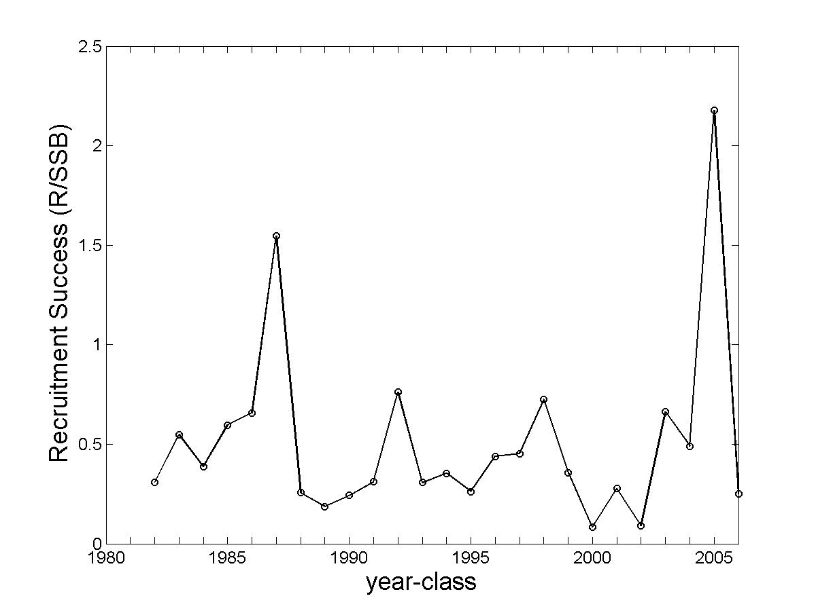

Figure 1. Estimates of recruitment success of the Gulf of Maine cod determined from the analysis of trawl survey data by the US National Marine Fisheries Service (Mayo and O’Brien, 2006). Recruitment success (or survival ratio) is defined at the ratio of spawning stock biomass (SSB, in kg) for a given year to the age-1 recruits (R, in numbers of individuals) of the subsequent year. Points appear at the year of the SSB estimate.

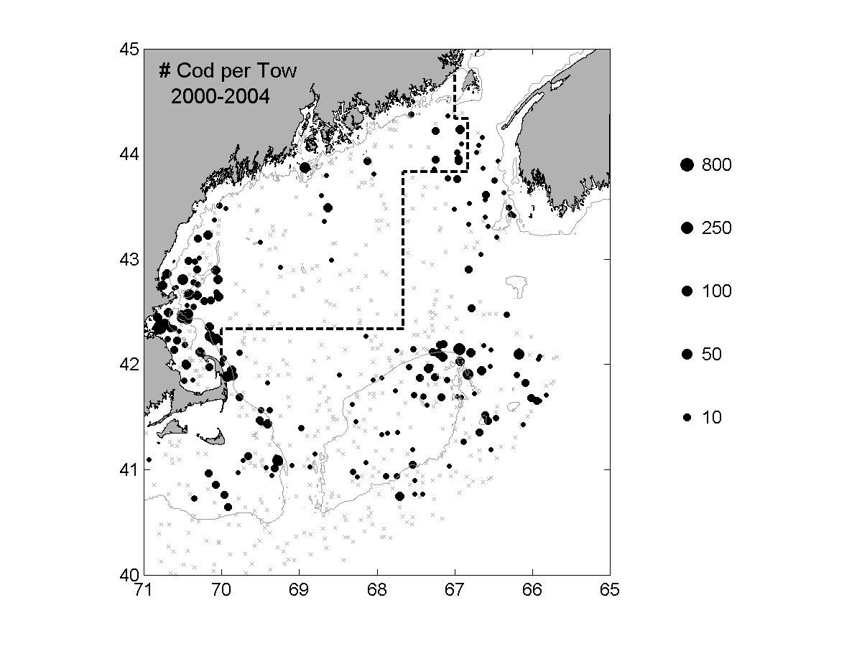

Figure 2. The distribution of cod in the Gulf of Maine/Georges Bank region as determined from US National Marine Fisheries Service (NMFS) trawl data from 2000-2004. The circles show the number of fish per 30 minute tow, whereas the gray x’s indicate locations where less than 2 cod were taken in a tow. The dashed line marks the boundary of the area enclosing Gulf of Maine cod stock as defined by the NMFS. Roughly 90 % of the total number of cod taken from this area during the 2000-2004 NMFS surveys was captured in the western Gulf of Maine (west of 70ºW).

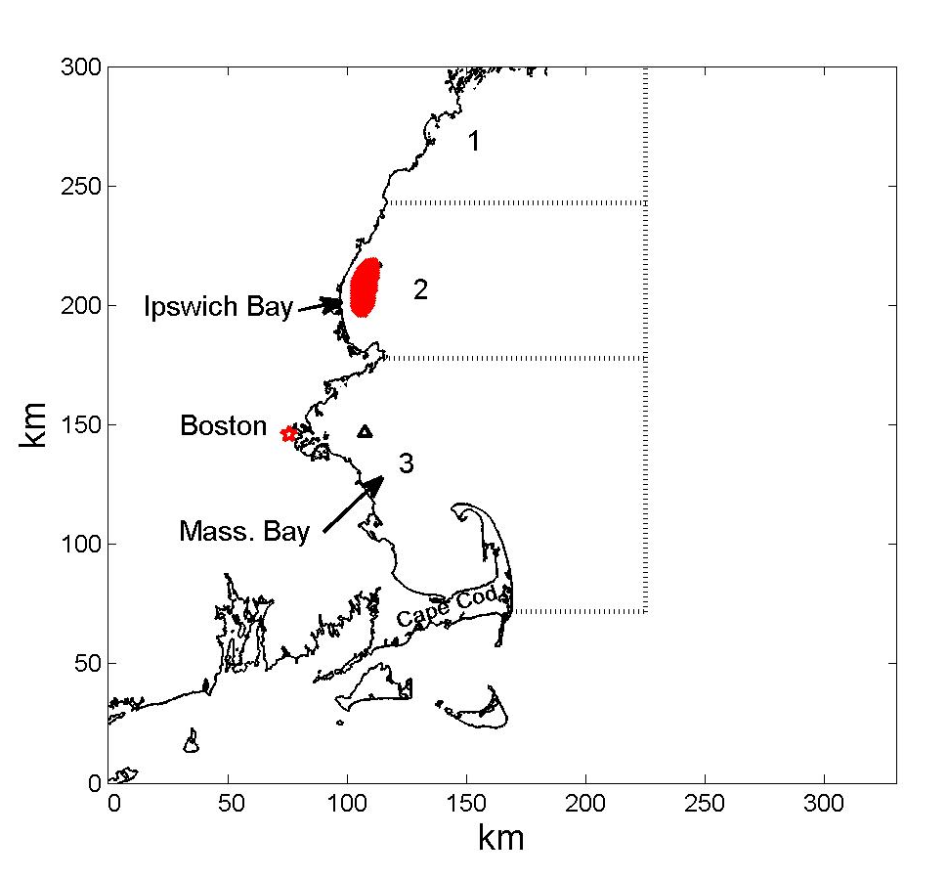

Figure 3. The western Gulf of Maine. The region shaded red is our representation of the Ipswich Bay spawning area from which particles, representing developing cod eggs and larvae, were released into a modeled flow field. Transport success of larval transport to the three regions enclosed by the dotted lines was computed from the simulated particle tracks. Also shown is the location of NOAA meteorological buoy 44013 (triangle) at which wind measurements used in our study were recorded.

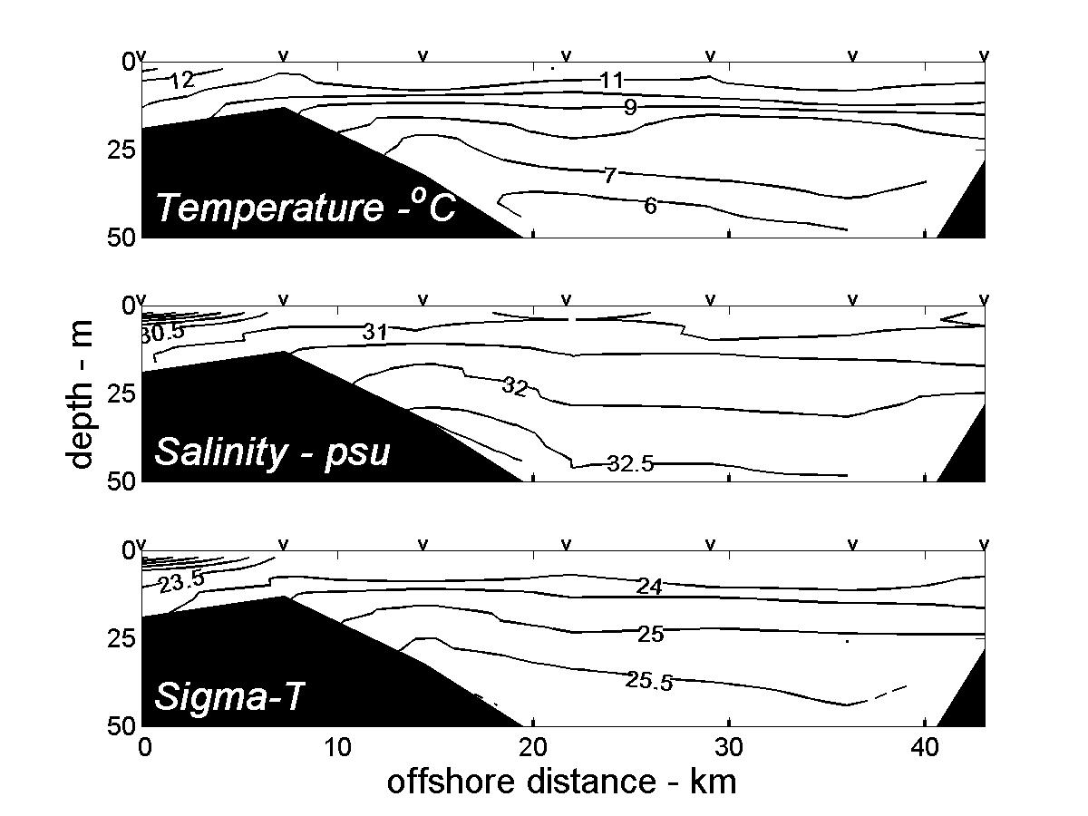

Figure 4. Fields of temperature, salinity and density (sigma-T) representative of water properties seen in the western Gulf of Maine during May and June. The fields were derived from data acquired on 30 May 2002 at stations (indicated by the “V”s at the top of each panel) orientated along a line extending through Massachusetts Bay, roughly intercepting the location of buoy 44013 as shown in Fig. 3.

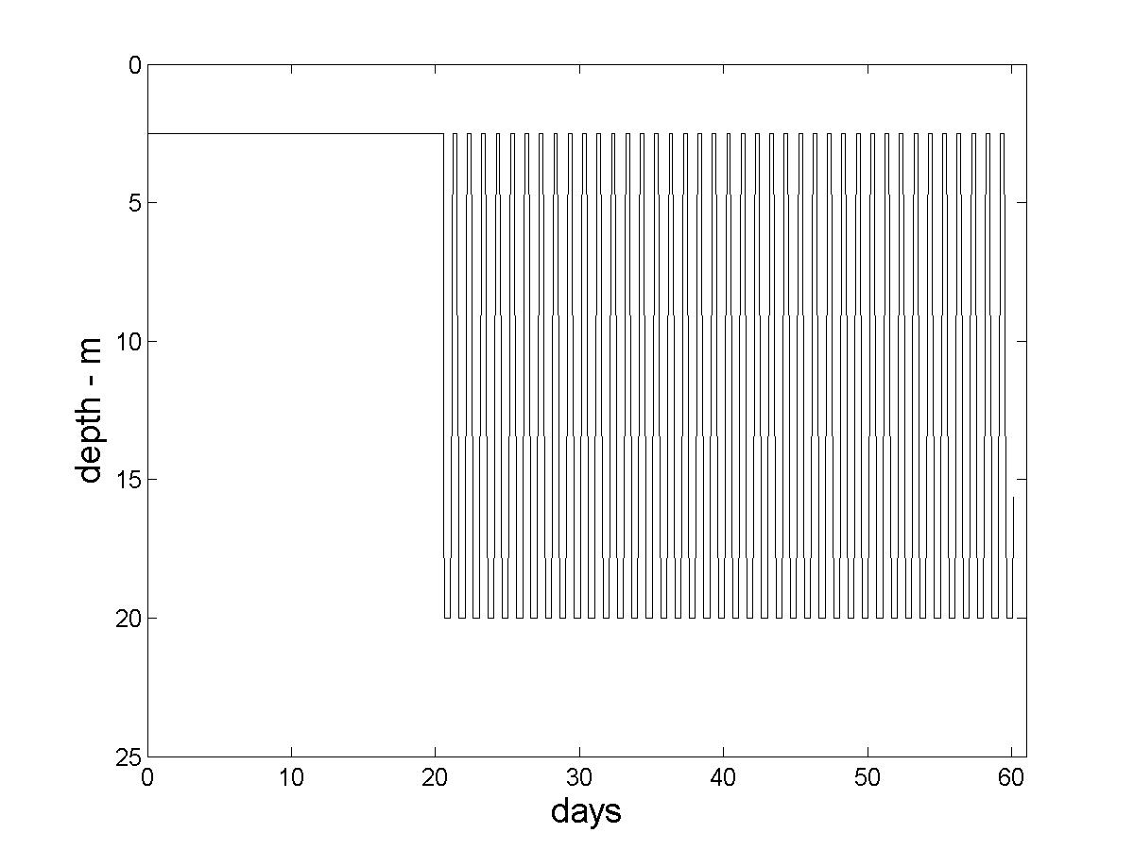

Figure 5. Sample function describing the vertical position of developing eggs and larvae as a function of age. In this example, it is assumed that the eggs and early-stage larvae are buoyant and reside at 2.5-m depth for the first 21 days after spawning, and then execute diel vertical migration for the remainder of their pelagic stage.

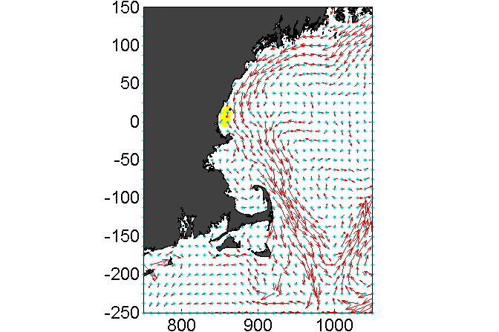

Figure 6. Mean of model generated surface currents for May 1995. These currents approximate mean flows not driven by the local wind stress, as the mean wind of this period, measured at buoy 44013 (Fig. 3), was < 0.25 m/s in magnitude. The area shaded yellow is the modeled region of egg release in Ipswich Bay.

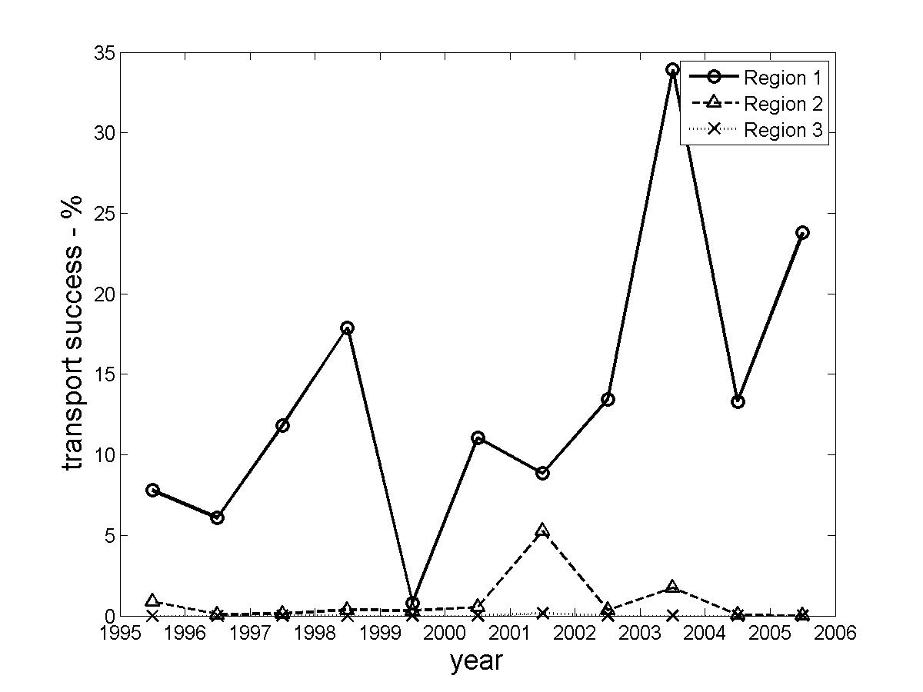

Figure 7. Mean transport success to regions 1, 2 and 3 for fixed depth (at 2.5 m) particles released from the Ipswich Bay spawning area (Fig 3).

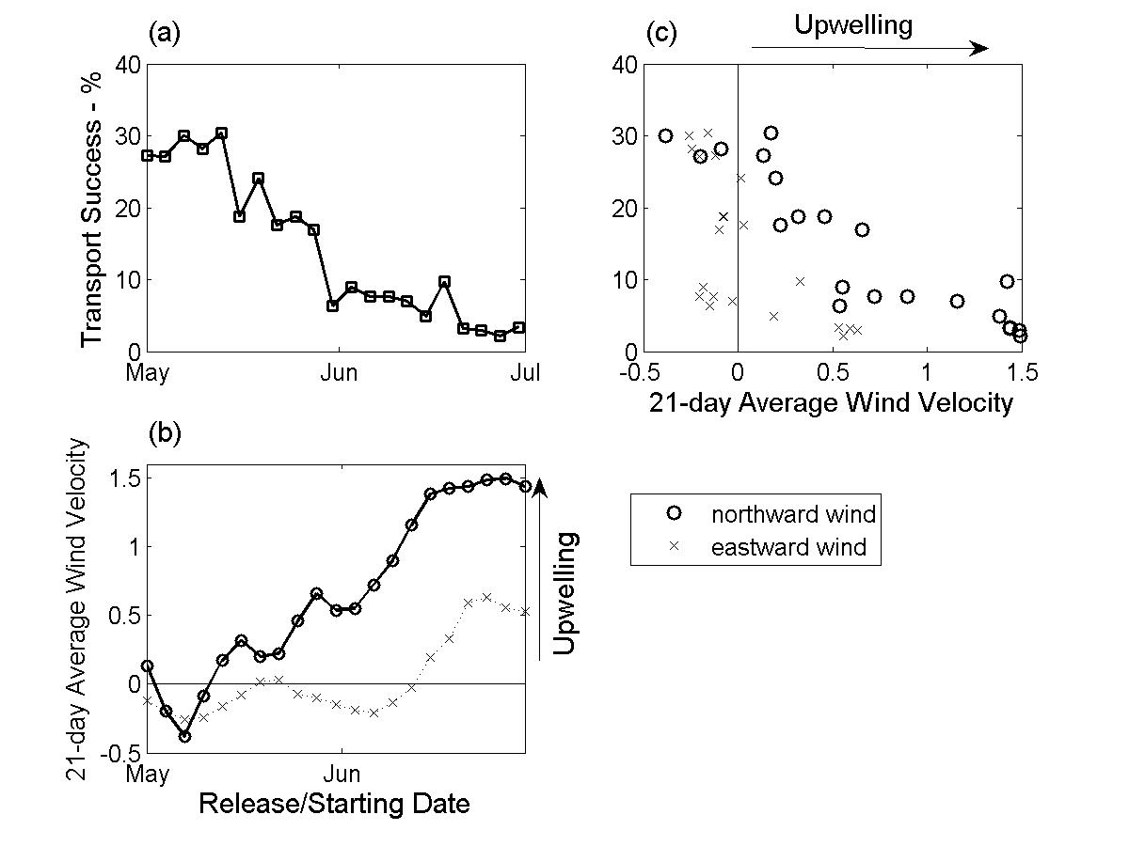

Figure 8. (a) Transport success, averaged over 1995-2005, as a function of release date.
(b) 21-day averages of wind velocities from 1995-2005 plotted as a function of the starting date of each average. Note that with advancing release date, the transport success tends to decline while the average wind experienced during the early-stage egg-larval drift becomes more upwelling favorable. This trend is clearly seen in (c), a plot of transport success against 21-day wind average.

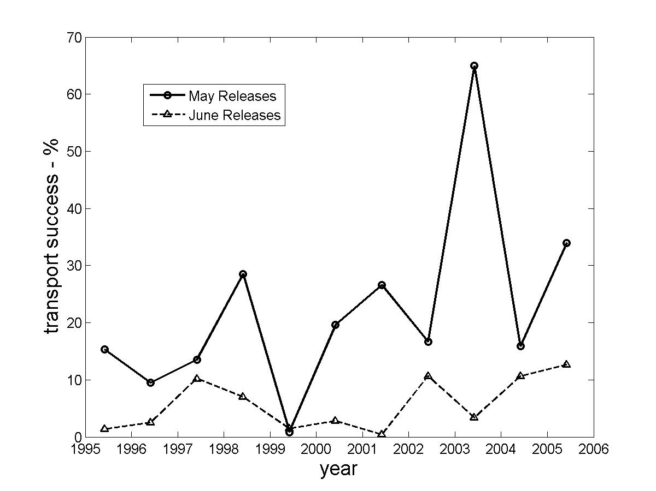

Figure 9. Averaged values of transport success to regions 2 and 3 (Fig. 3) for fixed depth (at 2.5 m) particles released in May and June.

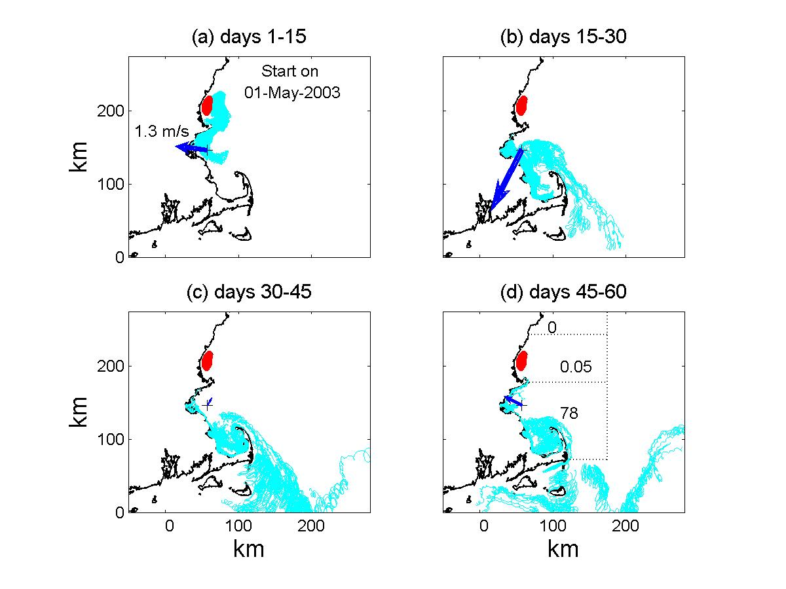

Figure 10. Tracks of fixed depth (at 2.5 m) particles released from the Ipswich Bay spawning area (shaded red) on 1 May 2003. Tracks are shown in 15-day increments with the mean wind measured at NOAA buoy 44013 (Fig. 3) during each increment also shown (magnitude of the first increment’s mean wind is shown in (a)). The numbers in (d) are the values of transport success to each of the target sub-regions of the western Gulf of Maine. During the first 30 days of the simulation, the winds are highly downwelling favorable resulting in significant particle retention in the western Gulf of Maine and high values of transport success.

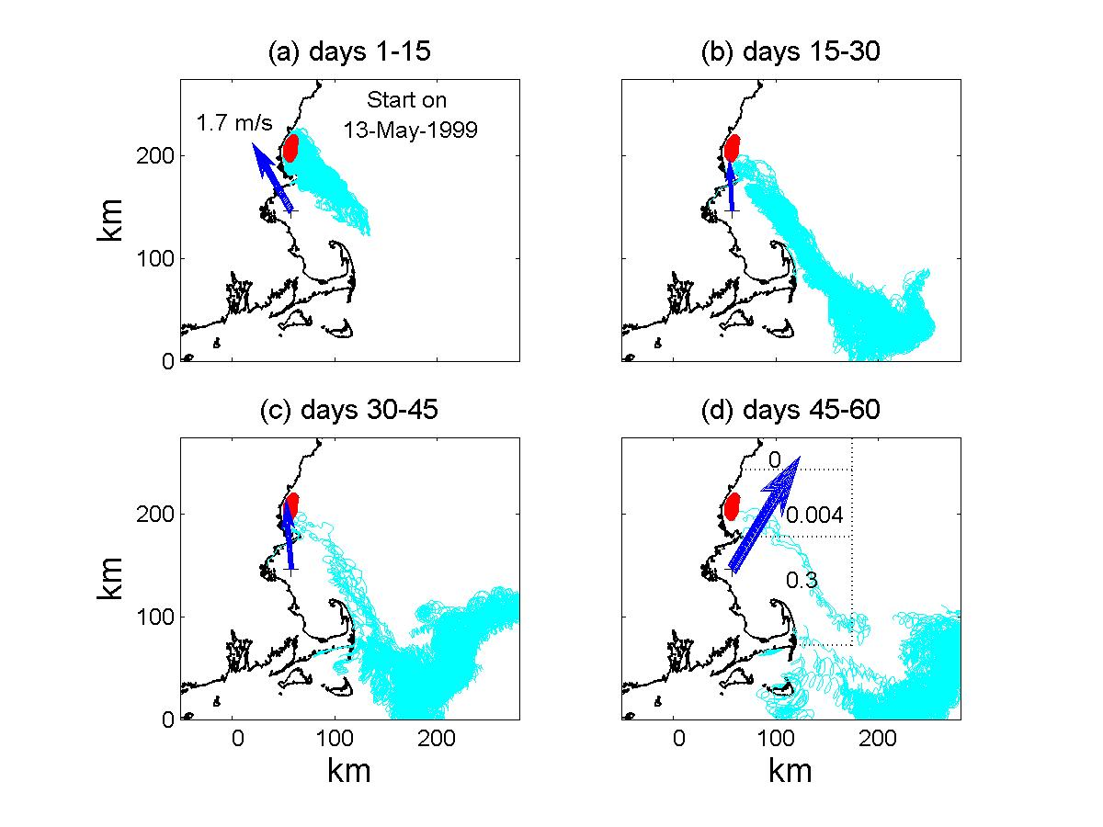

Figure 11. Same as Fig. 10, except showing the tracks of particles released on 13 May 1999, at the beginning of a period with predominately upwelling favorable winds. The upwelling transport carries the buoyant particles offshore to the western Maine Coastal Current, which transports the majority of particles out of the Gulf of Maine.

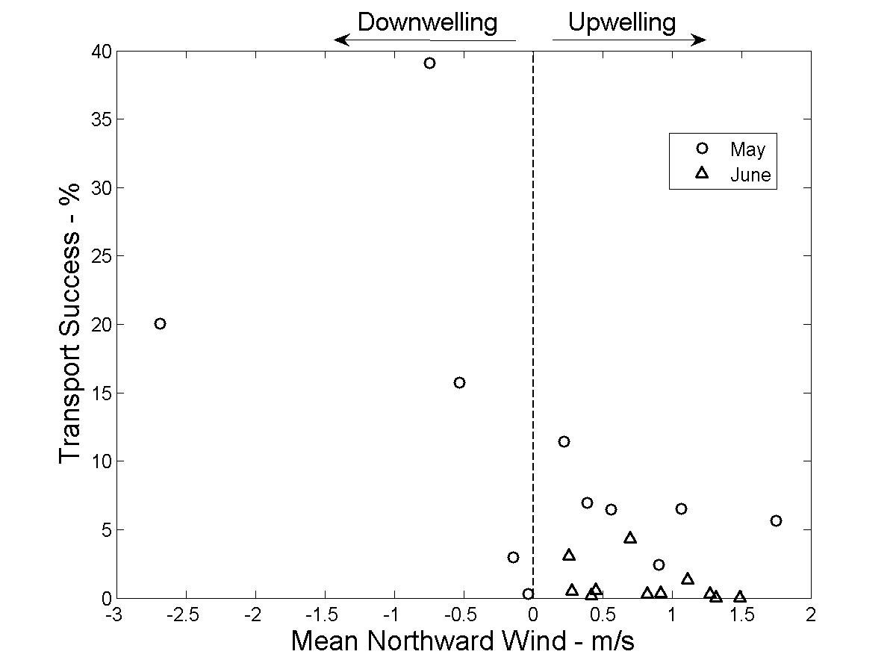

Figure 12. Averaged transport success for May and June releases against monthly mean northward wind of May and June measured at NOAA buoy 44013 (Fig. 3).

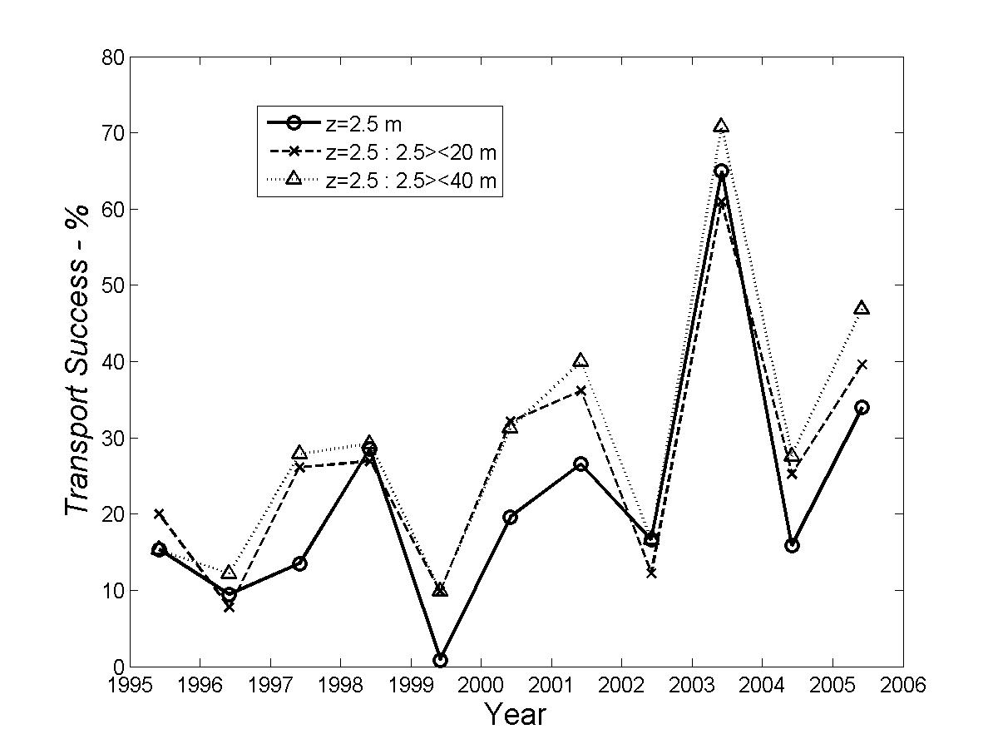

Figure 13. Comparison of transport success determined from simulations of fixed depth particles (solid line) and of particles executing vertical migration after 21 days (Fig. 5). Migration limits were between 2.5 and 20 m (dashed line) and between 2.5 and 40 m (dotted line).

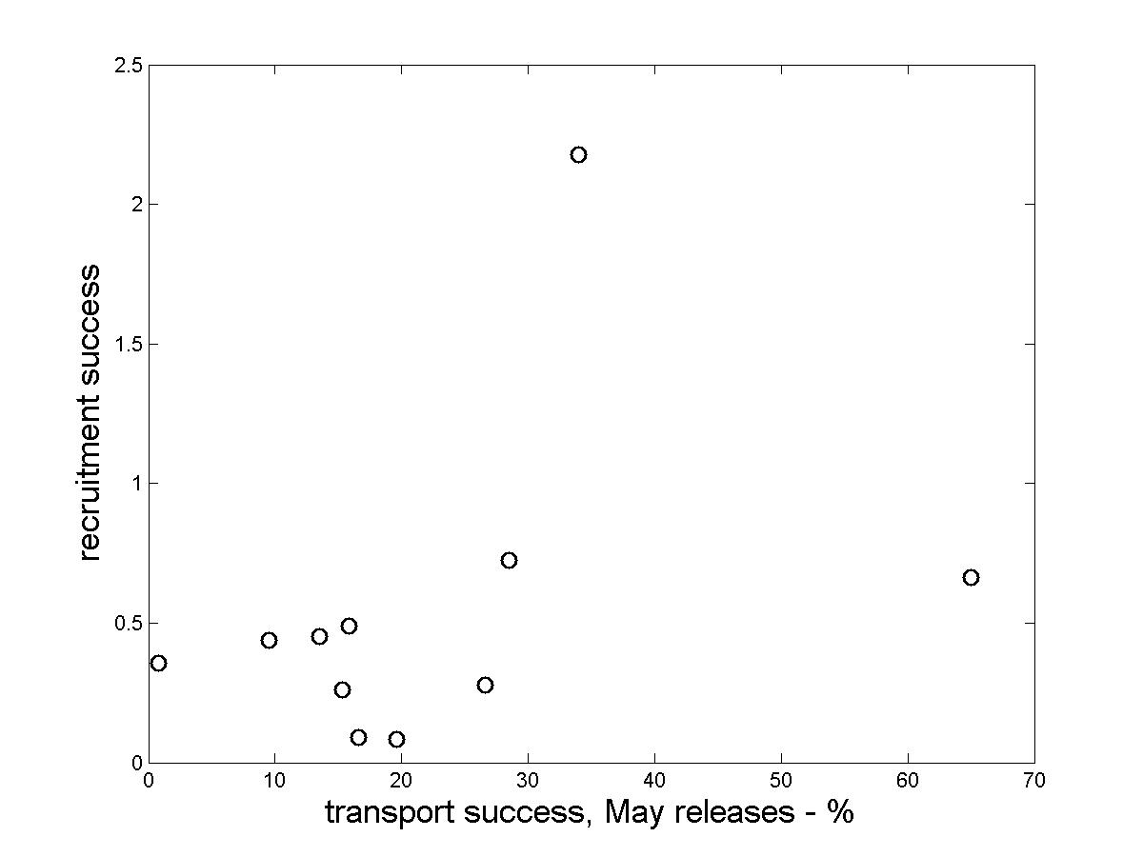

Figure 14. A comparison of age-1 recruitment success to the Gulf of Maine cod stock with estimates of transport success of May releases, computed assuming constant depth through the larval phase. Note that the three highest estimates of transport success correspond with the three highest estimates of recruitment success.
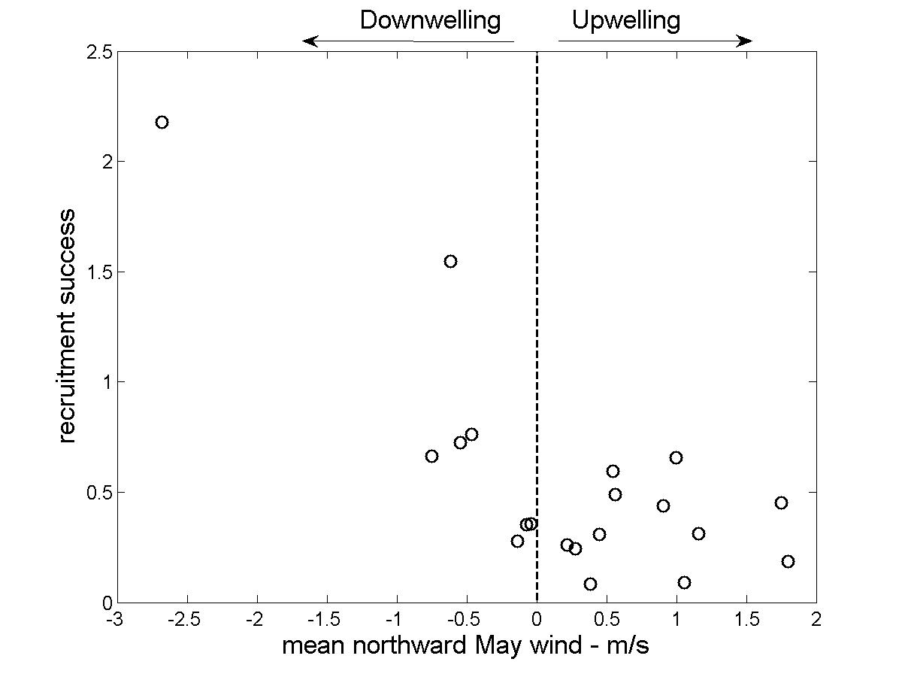

Figure 15. A comparison of cod recruitment success to the Gulf of Maine with the mean northward wind measured at buoy 44013 (Fig. 3) during May. Note that the five highest recruitment success estimates are for those years with the May wind is most downwelling favorable.

