Cape Hatteras Continental Margin Dynamics:
Analysis of Physical, Chemical and Geological Conditions

Cruise Plan (16-27 March 2016)
RV Neil Armstrong

CRUISE NUMBER AR1-06

BEGINNING DATE March 16, 2016 ENDING DATE March 27, 2016

PORT OF ORIGIN Charleston, SC PORT OF TERMINATION Norfolk, Va

Scientific Party
ECU Group
Reide Corbett Professor, Chief Sci. East Carolina Univ. & UNC CSI corbettd@ecu.edu, 252-475-5428
J.P. Walsh Assoc. Professor East Carolina Univ. & UNC CSI walshj@ecu.edu, 252-475-5429
Sid Mitra Assoc. Professor East Carolina University mitras@ecu.edu
Mike Muglia Res. Scientist UNC Chapel Hill & UNC CSI muglia@csi.northcarolina.edu
Erin Field Asst. Professor East Carolina University fielde14@ecu.edu
Beau Benfield MS student East Carolina Univ
Ian Conery PhD student East Carolina Univ
Keith Garmire technician UNC CSI
Ryan Gibbons MS student East Carolina Univ
John McCord Outreach Specialist UNC CSI
Trip Taylor technician UNC CSI
Caroline Webb MS student East Carolina Univ

USGS/WHOI Group
Dan Lizarralde Assoc Sci., Co-Chief WHOI danl@whoi.edu, 508-289-2942
Danforth Scientist USGS
Baldwin Scientist USGS
Eimer PhD Student WHOI
Tominaga Asst. Professor Texas A&M

Coastal margins are critical regions of the Earth where continents and oceans interact, and they are measurably changing in response to societal impacts and natural variability. Approximately 40% of the global population lives within 100 km of the shore, and because of property values, resources and tourism, the economic significance of margins is enormous. The Cape Hatteras continental margin is a critical region of the western North Atlantic Ocean where numerous rivers and estuaries connect to sea through barrier islands and the Gulf Stream sweeps along the margin carrying water, solutes and sediments into the seaward (Fig. 1). To better understand the physical functioning of these and other critical land-ocean transition zones, we are .We intend to use the vessel to collect additional data off the NE North Carolina coast, more specifically the Cape Hatteras continental margin (Fig. 2) with three primary foci: 1) seafloor mapping and targeted coring near the shelf edge, 2) sediment and carbon transport and accumulation (evaluating a leaky estuary); and 2) Gulf Stream dynamics, energy resources and ecological implications. J.P. Walsh and Reide Corbett will act as Co-Chief Scientists for the ECU-related objectives of the cruise and provide the critical feedback on vessel operations requested. Based on our previous experience and planned activities for this cruise, we will be able to provide a thorough review on a diversity of operations.
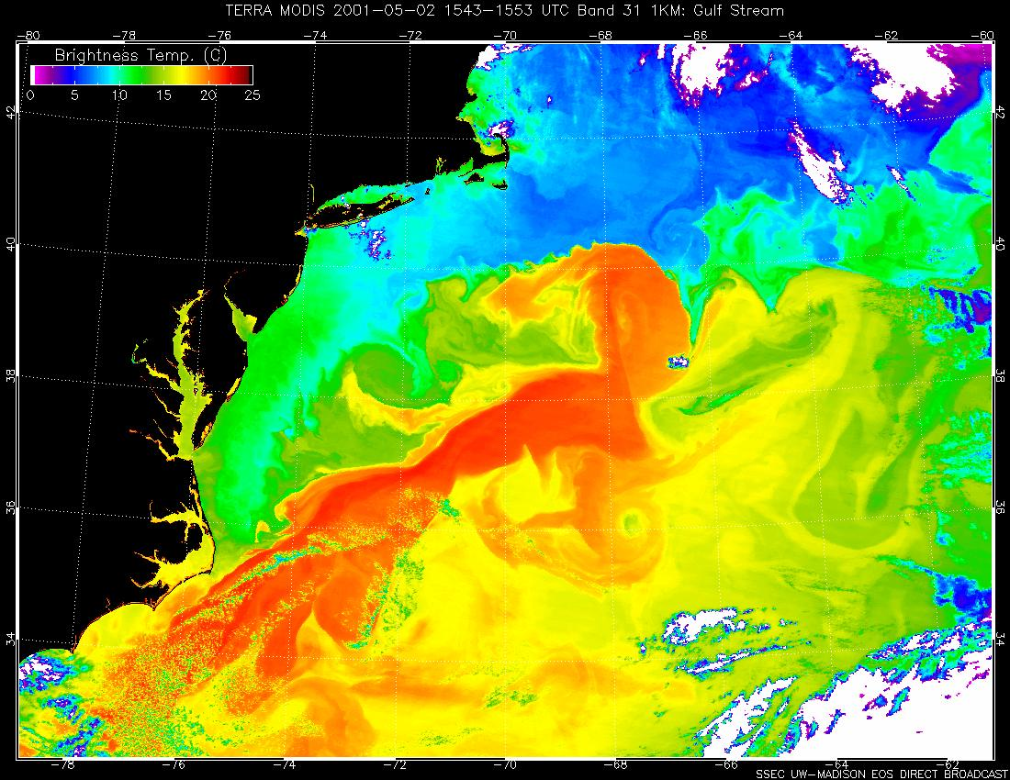
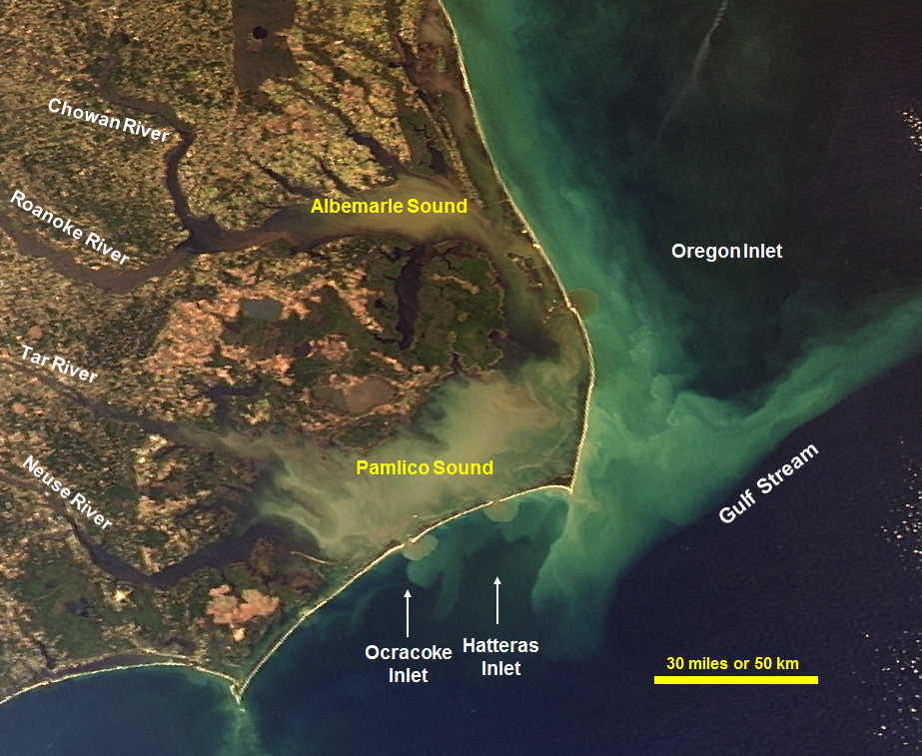
Figure 1: Sea-surface temperature of the western North Atlantic Ocean based on MODIS imagery (Top) and visible satellite image of eastern NC (Bottom). Note the confluence of water masses near Cape Hatteras and offshore sediment flow.
This cruise is an interdisciplinary effort, linking physical, chemical, and geological oceanographers interested in land/ocean interactions on varying spatial and temporal scales. In particular, we are interested in the role of the Gulf Stream as a link between land-derived material and deep sea cycling and deposition and as a renewable resource with the environmental implications for harnessing such a resource. The scientists listed are actively involved in research in the proposed study area. The cruise will provide an opportunity to expand the region of study beyond the shelf edge and offers a unique opportunity for a “shake-down” cruise using multiple types of instrumentation and interacting effectively with scientist from multiple disciplines on a single cruise.

Specific Objectives:
- Seafloor Mapping and Targeted Coring of Cape Hatteras Continental Margin (Fig. 2) (3 days)
- Collect multibeam within areas of interest (2 priority areas, Fig. 3 inset, pink box) to evaluate bottom geomorphology along shelf-slope transition.
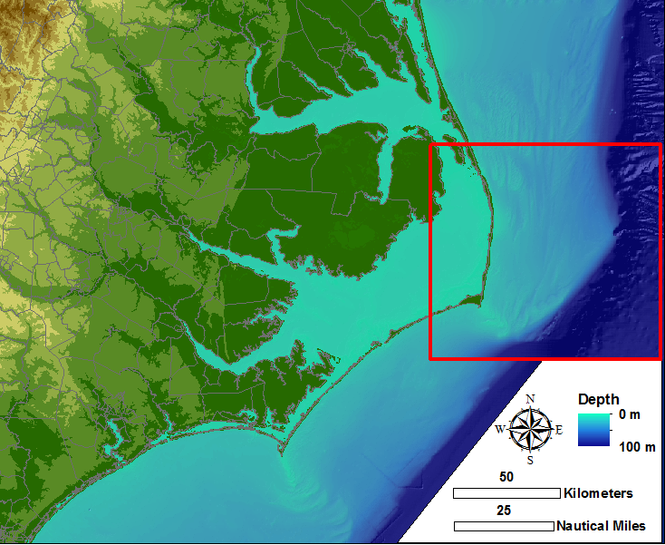
Fig. 2: NC coast and ocean with Cape Hatteras continental margin highlighted in red.
- Core (box and kasten) sites based on initial multibeam interpretation.
Shipboard equipment ideally needed:
- Multibeam
- Knudsen
- Coring device (box and kasten)
- Space to set up portable-digital X-radiographic system
- Refrigerator space for sediment samples

2. Sediment and Carbon Transport and Accumulation (2 days)
- Collect water exported from Pamlico Sound from Oregon Inlet starting at max ebb.
- Collect water (surface and bottom) and sediment on an approximate across-shelf transect beginning at a point adjacent to Oregon Inlet (Fig. 3 inset, yellow cross-shelf line).
- Analyze water and sediment along transect across the shelf, through the Gulf Stream.
- Collect air using a high volume air sampler as time permits.
Targeted Analyses: Particulate organic carbon, particulate black carbon in water column, sediments, and in aerosols. Bulk dissolved organic carbon and trace organic compounds in water column including oxygenated PAHs.
Shipboard equipment ideally needed:
- 20L Nisken bottles in rosette array
- MET package
- Coring device
- Wet lab for filtration
- DDI water (with UV oxidation lamp)
- 110 v power requirement in bow area
- Wet lab counter space
- Areas to secure high pressure gas tanks
- Refrigerator and freezer space for samples

3. Gulf Stream Dynamics (2 days)
a) Resolve the shelf break jet on north/south leg via alongshore transect with ADCPs. A transect along the 200m isobath from 36° 30' to an approximate cross stream transect beginning at: 35°10'35.47"N, 75°10'8.41"W (~100m isobath). Running all three ADCPs along this leg is optimal; otherwise the 150 kHz ADCP would be preferred (Fig 3, orange line).
b) Evaluate the Gulf Stream marine hydrokinetic energy resource and inform future transect plans with our own 75 kHz ADCP via cross-shore transect. From 35°10'35.47", 75°10'8.41"W , we would turn cross-shelf and cross-stream and proceed to 35° 5'35.78"N, 75° 0'16.79"W, and beyond that to 34°49'59.61"N, 74°36'7.57"W (~35 nautical miles from the beginning of the cross stream transect), continuing along that same line until Gulf Stream currents are at least less than 1 m/s. Along this cross isobath leg, the 38 kHz ADCP measurements are of primary interest. CTD casts along the route as often as practical are requested, with deeper CTD casts offshore being the most valuable (Fig 3 orange line and diamonds).
c) Cores and multibeam at specific sites to evaluate benthic habitat and character (Fig 3 orange diamonds):
35°10'35.47" N 75°10'8.41" W
35° 5'35.78" N 75° 0'16.79" W
34°49'59.61" N 74°36'7.57" W
- Measurements of interest in addition to those from the ADCPs, CTD casts, and cores include any from radiometers (UV, IR, etc.), at least hourly met observations (wind speed/direction, temperature, and humidity, cloud cover), and sea surface temperatures.

Shipboard equipment ideally needed:
- CTD
- Coring device.
- Multibeam
- Knudsen
- ADCP
- MET package

Fig. 3: Site Map – Includes priority areas for both ECU and USGS/WHOI groups

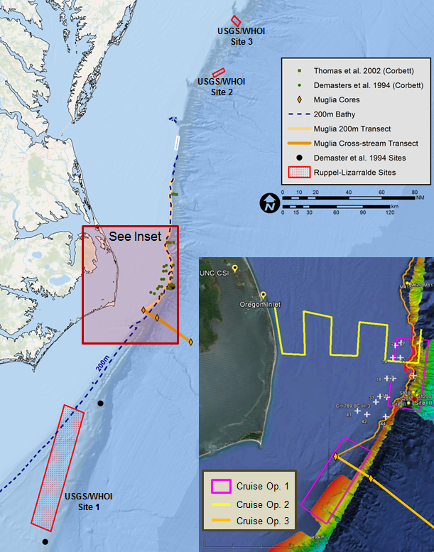
*Note: all activities, sampling locations, and the above schedule depend on underway findings. Sites, schedules, and operations will likely change throughout the cruise.

Schedule

14 March (Mon) Arrive Charleston, meet at Port at ~1600
Verify equipment arrival; coordinate with ship personnel to load gear in afternoon.
Group sleeps on ship?? May need to book hotel.

15 March (Tues) Begin unpacking, testing and setting up in research labs
Work with Research Techs to provide safest location for X-radiography system.

16 March (Wed) Ship leaves port @ 0600 (approx.., tide dependent), steams for USGS/WHOI Site 1 (~180 miles or ~16 hour steam). Arrive on site approximately 2200. Begin survey (see WHOI/USGS science plan)

17 March (Thurs) 12 hour survey at USGS/WHOI Site 1;
steam at 8 knots for better survey to ECU Cruise Op. 3b - Cross-stream transect (~60 miles or ~8 hour steam); arrive approximately 2000.

STILL WORKING ON THIS

26 March (Mon) At approximately 0800, all scientific operations will need to stop to begin our steam to Norfolk (~180 miles or ~16 hour steam). Complete shipboard analyses and start packing gear.

27 March (Tues) Arrive Port; begin unloading gear. If time allows, we will depart for home.

*Note: all activities, sampling locations, and the above schedule depend on underway findings. Sites, schedules, and operations will likely change throughout the cruise.
ACTIVITIES

(A) Sample OPS Log (Corbett) – Record OPS # anytime something goes over the side (CTD, Water Samples, Grab sample, etc.). Will use ships computer, back up nightly.

(B) Continuous flow-through system and met data collection; periodic sample collections for calibration

(C) Multibeam/Knudsen surveys (Walsh)

(D) Water column structure (CTD) and samples at all cross shelf stations (Obj. 2) (Mitra)

(E) ~40 Coring stations, Box core and Kasten core (Corbett)

(F) Shipboard ADCP (Muglia)

(G) Hope to update Research Blog (Corbett – need to talk to ship prior)

