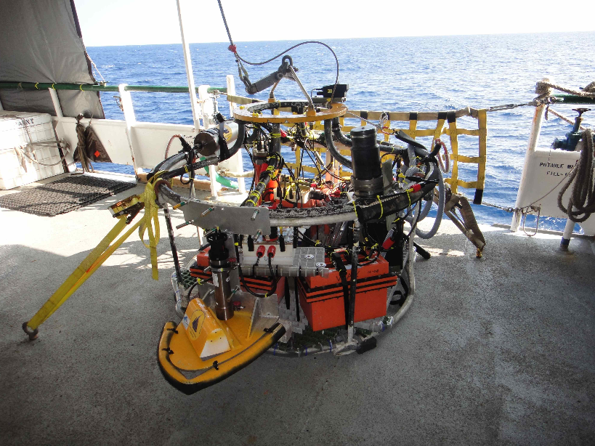
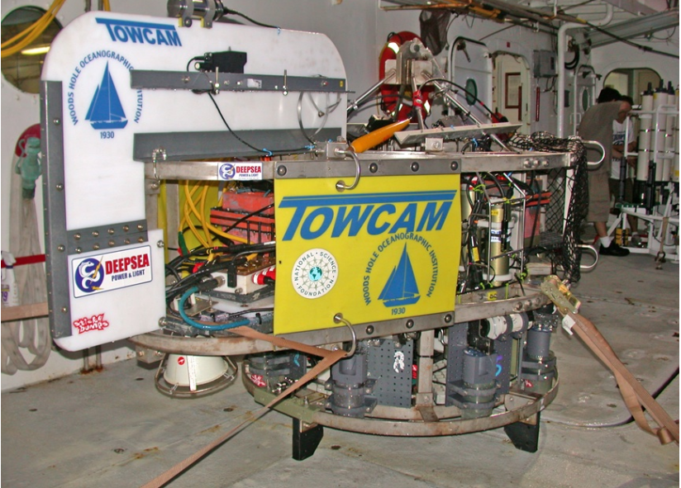
-------- Original Message --------
Subject: | Request to load TowCam and supplies on Knorr in January 2013 for Smith et al. MAR 16N cruise, and requests re: info/testing of CTD winch/wire
Date: | Mon, 10 Dec 2012 07:58:28 -0500
From: | Dan Fornari <dfornari@whoi.edu>
To: | Chad Smith <csmith@whoi.edu>, Smith Deb <dsmith@whoi.edu>, Hans Maureen Schouten & <hschouten@whoi.edu>, "hdick@whoi.edu Dick" <hdick@whoi.edu>
CC: | Fornari Dan <dfornari@whoi.edu>, David Fisichella <dfisichella@whoi.edu>, Swartz Marshall <mswartz@whoi.edu>

Hi Chad - I am requesting that the WHOI-MISO TowCam system to be used on the Smith/Schouten/Dick cruise next Spring be pre-loaded onto the Knorr in order to avoid excessive wear/tear on the equipment and to reduce shipping and mobilization costs.

The frame can be secured outside on an upper deck with a tarp over it. The camera electronics and equipment consists of boxes of gear - probably about 1.5 palettes in total volume, that can be tucked away in the hold or stored under benches, etc, and 6 non-spillable deep-sea batteries compensated in mineral oil (non-hazmat) - they too can be stored in the hold or under a bench in one of the labs.

The photos below show the 2 types of TowCam frames that may be deployed depending on upcoming discussions with the PIs regarding the onboard sampling capability for TowCam. The first photo shows the frame that is about 11ft long and 5ft tall and 5ft wide. The second photo shows a modified TowCam frame that uses a 5 ft diameter CTD rosette frame as the basic structure; it is about 40" tall to the bail. It also has 'wings' on either end (where the strobes attach) that stick out another 1.5 ft, but those are removable so I could un bolt them if needed for space during storage. Only one of these frames would be used. I should know this week which one after I talk with Debbie/Hans/Henry.

TowCam is towed off the 0.322" 3-conductor CTD wire. I would like the CTD wire on Knorr to be Megger tested from the wet end through the full reel on the drum and through the slip rings so that we can be sure the conductors and slip rings are in good condition as the real-time 'data link' system will be used to transmit real time imagery up the CTD cable. I can send you specs for the Megger testing, although Mike Gagne and Marshall are both very familiar with the measurements that need to be made. We need access to all 3 conductors, separately, and the armor. If you could also let me know how much wire is on the CTD winch and its condition and when last used. Lastly in this regards - because we 'fly' the TowCam about 5 m above the seafloor during the Tows, the TowCam engineer will be operating the CTD winch so we need to have winch controls in the lab. Please confirm that these are available and have been recently tested. I have cc'ed Marshall Swartz and Dave Fisichella on this so they are in the loop.

Please let me know when the gear needs to be staged at the WHOI dock and who I should contact about the details. I can provide a customs manifest for all the equipment so it can be cleared through US customs prior to departing WHOI in mid-January.

Thanks in advance for your help with this. If you have questions please don't hesitate to email or call (my cell is 508-566-6558).

Best Regards,
Dan

