RV OCEANUS Cruise 477
Cyst Map Cruise in the Gulf of Maine
October 24 – November 4, 2011
U.S. Geological Survey Hydraulically Damped Sediment Corer
Core recovery
Sediment cores (~1 m in length) will be obtained using the U.S. Geological Survey hydraulically-damped sediment corer at 5-10 of the WHOI cyst sampling stations. The USGS sampler can be deployed: (1) through the aft A-frame using the trawl winch, (2) over the starboard side picking with the crane and transferring load to a hydrographic winch, or (3) over the starboard side using the crane, trawl winch wire, and boom crutch. Best strategy to be determined in consultation with Oceanus crew (most likely (1) or (2) for ease of transferring between WHOI Craib and USGS samplers and simplicity of operation). Weight of the corer is approximately 1200 pounds. Two cores will be taken at each sample site.
Sample processing in the laboratory
The cores will be processed in the laboratory using the University of Maryland Gust Erosion Microcosm system (UGEMS). This system applies a series of known stresses to the surface of the core. Processing of the two cores from each station takes about 4 hours.

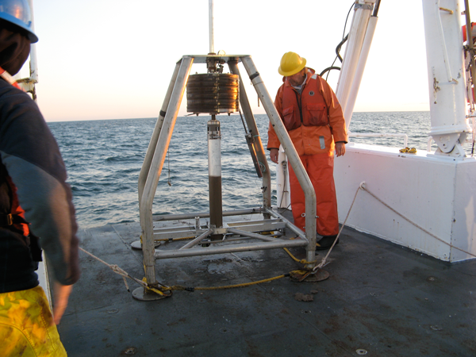
USGS sediment corer on deck with sample in core tube.

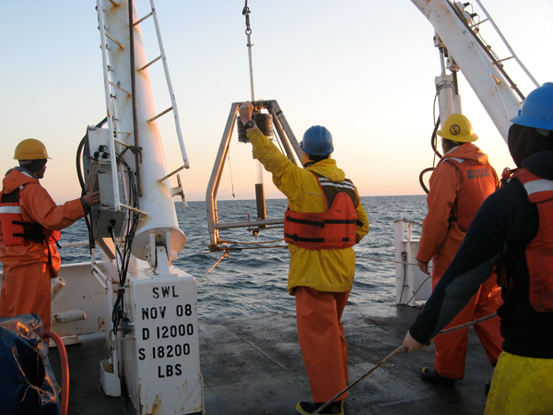
USGS sediment corer being recovered through A-frame on RV Endeavor.

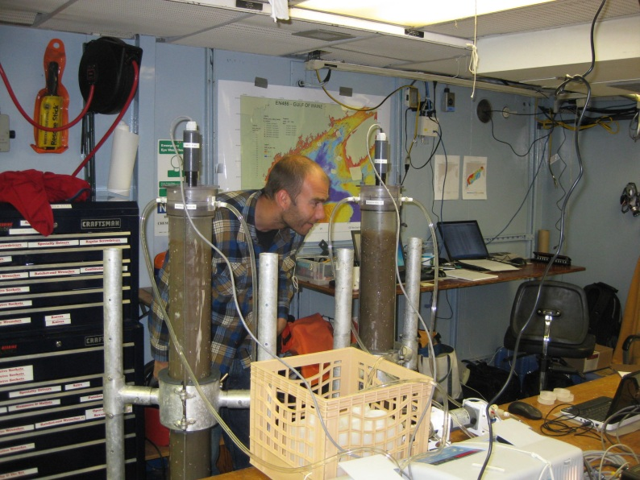
Setup of GEMS erosion system in ships laboratory. Motorized heads are fitted to the cores which apply a series of known stresses to the sediment surface. The eroded sediment is captured and weighed.

Bradford Butman (bbutman@usgs.gov; 508-457-2212)
9/1/2011

