Project Title: High-resolution 3D mapping of plankton, marine snow, and associated environmental variables in the Gulf of Mexico using the Video Plankton Recorder

Project PI: Cabell Davis (Biology)

Background:
The overall NRDA plankton-sampling plan includes surveys of plankton and particles in the shelf and slope seas of the Gulf of Mexico. Vertically integrated plankton net hauls through the upper water column of the Gulf of Mexico from of Texas to Florida have been conducted over the past 25 years, providing a strong historical baseline of data (NMFS/NOAA SEAMAP program). The overall NRDA plankton-sampling plan takes advantage of this historical data set and is augmenting the sampling plan with vertically stratified sampling and optical imaging of fragile plankton and marine snow. The station spacing of the SEAMAP and NRDA sampling grids is extensive, but is sparse compared with the high-resolution sampling capabilities of new optical imaging systems and the high-resolution data needed for initializing and validating coupled biological-physical numerical models of the pelagic ecosystem and how it is potentially impacted by the oil spill.

A series of cruises in the fall of 2010 (aboard Walton Smith and HOS Davis) used the digital-autonomous video plankton recorder (DAVPR) to sample fragile plankton and marine snow in the deeper slope sea from the surface to near bottom. Comparative studies between plankton imaging systems and traditional net-based sampling techniques have been carried out by various investigators (i.e. Broughton and Lough, 2006) and paired MOCNESS-DAVPR sampling was conducted during January 2011 in joint ship operations aboard the Arctic and Nick Skansi. These two types of sampling systems have been found to be comparable in quantifying hardy plankton that can withstand net sampling. Fragile organisms and particles such as small gelatinous organisms (including many larvae) and marine snow are easily identified and quantified using imaging systems, whereas these delicate groups are destroyed or damaged beyond recognition in net samples.

In addition to sampling both robust and fragile plankton and particles, the second generation Video Plankton Recorder (VPRII) (Figure 1) is able to rapidly survey plankton with very high horizontal and vertical spatial resolution, i.e., at the same resolution as the physical and environmental variables (CTD, fluorescence, PAR, turbidity, dissolved oxygen). This sampling allows direct comparison of plankton and their environment over scales from centimeters to 1000s of kilometers (Davis et al., 1992; Davis and McGillicuddy, 2006). The equivalent along-track spacing of VPRII towyo profiles (towing at 10 knots) is 250-750m when sampling to depths of 50-150m, respectively.

Proposed Research:
The primary objective of the proposed March/April 2011 R/V Oceanus plankton imaging sampling cruise is to collect high-resolution data on plankton and marine snow together with environmental variables using the VPRII. A high-speed survey of the shelf and slope waters of the northern Gulf of Mexico will be conducted, with the transect lines running through the standard SEAMAP stations and extending beyond them into the slope sea (Figure 2). The occurrence, abundance, biomass, and vertical distribution of plankton and marine snow, together with ocean temperature, salinity, chlorophyll fluorescence, PAR, and turbidity in the Gulf of Mexico will be quantified in real time. This sampling will allow direct comparison of data from traditional samplers used in the SEAMAP surveys and the current NRDA MOCNESS surveys with optical imaging of the VPRII. The VPRII sampling will extend the spatial resolution of the present sampling and will allow quantification of fragile plankton and marine snow. It will also allow comparison between deeper DAVPR optical-based sampling in the slope region with net-based sampling of shelf and slope regions. The proposed Oceanus cruise is part of the over-arching plan to conduct sampling in each season, utilizing several sampling methods (e.g. MOCNESS, bongo net, neuston net, and imaging systems). The duration of the program with respect to the number of years is to be determined. Because plankton are transported over wide areas, and populations are connected across the northern Gulf of Mexico, sampling plans need to be broad in geographic scope.

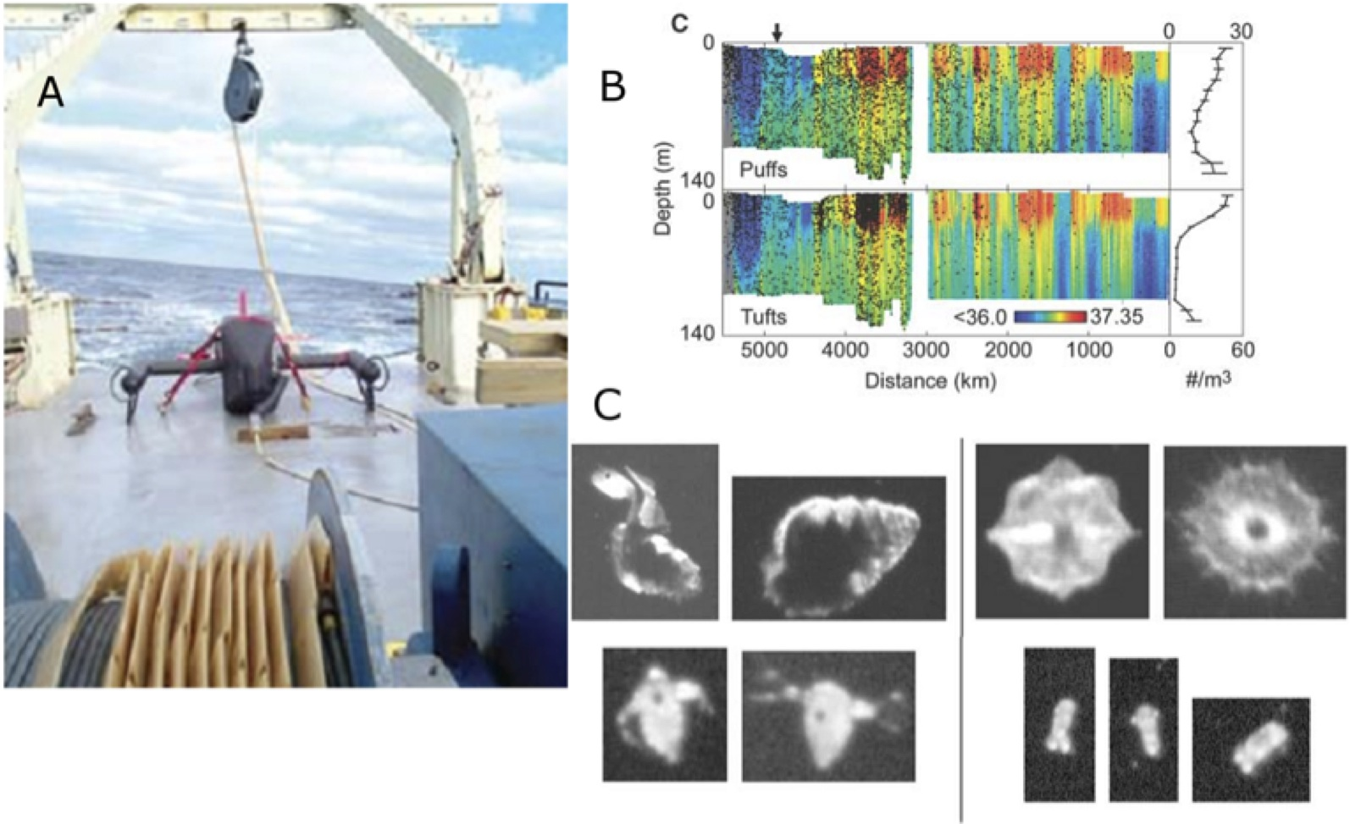
Figure 1. (Left) VPRII on deck of R/V Oceanus with winch and fairing on cable. (Right, Top) High-resolution data from transatlantic VPRII survey showing plankton distributions (Trichodesmium tuft and puff colonies, black dots) plotted on salinity. (Right, Bottom) example images from the VPRII camera showing pteropods, acantharians, cladocera, and rotifers.
Instrumentation – The Video Plankton Recorder (VPR) is an underwater video microscope that images plankton and particles and collects data on hydrography and environmental variables. The VPR is the original electronic optical plankton imaging system, developed at WHOI (Davis et al., 1992a,b). There are now over 60 scientific publications based on data collected by this system. The VPRII (Figure 1) (Davis et al., 2005) is a high-resolution, in situ, digital imaging system mounted on a fast (10-knot) towfish that undulates automatically between the surface and 150m and steers to starboard when surfacing to avoid the ship wake. The VPRII was carefully designed to avoid disturbing the imaged volume prior to sampling it, minimizing avoidance by zooplankton and destruction of delicate plankton and marine snow. The VPRII automatically identifies, in real time, plankton and particles (including fragile plankton and marine snow) in the size range of 50 microns to cm (with present lens setting), and has been used for high resolution mapping of abundance and biomass of plankton taxa across ocean basins and in regional seas (Davis et al. 2005; Davis and McGillicuddy, 2006; Hu and Davis, 2006). The number of plankton counted by the VPRII far exceeds that of traditional net surveys (Davis et al., 2005). The VPRII sensors include the plankton camera, CTD, fluorometer, OBS, PAR, and dissolved oxygen.

Proposed survey – We propose to a conduct rapid broad-scale high-resolution 3D VPRII survey of the upper 150m of the water column for plankton, marine snow, and environmental variables, covering the entire shelf and slope sea of the northern Gulf of Mexico (Figure 2). The VPRII 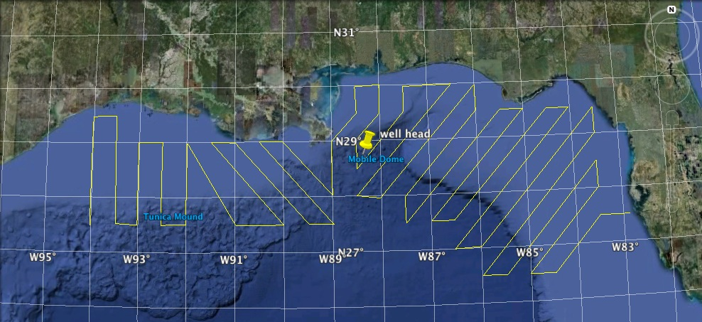
Figure 2. Proposed VPRII survey of the northern Gulf of Mexico, with the transect lines running through the SEAMAP stations as well as extending further offshore into the slope sea.
samples to 150m as configured and will cover the entire water column of the shelf ecosystem and upper layer of the slope sea, regions (horizontally and vertically) with the highest biological productivity, plankton abundance and biomass. The survey will have unprecedented resolution for sampling plankton taxa and marine snow and will be the first time an optical imaging survey has coincided with the station grid of a major plankton survey program (SEAMAP).

We will process the VPRII images in real time, obtaining real-time underway maps of plankton abundance and environmental variables. These data will be subsequently compared with historical and contemporary data from the NRDA and SEAMAP plankton sampling programs. These data will be made available for further analyses and incorporation into computer models of the pelagic ecosystem.

We will also bring our DAVPR and Seabird SBE911plus CTD systems for deep sampling of the plankton, marine snow and environmental variables. Time permitting, we will conduct joint sampling with other research vessels doing plankton net sampling with MOCNESS and other systems. We will also include and Aquatracka fluorometer, and acoustic backscatter system (ABS), and a holographic camera (Holocam) system on the DAVPR/CTD package as was done on the winter (January) 2011 DAVPR cruise. This will allow for winter/spring comparisons to be made.

Cruise schedule:

Table 1. Proposed schedule for R/V Oceanus VPR cruise
2/26-2/28/2011 | Setup and test sampling systems on R/V Oceanus
3/1/2011 | R/V Oceanus departs WHOI
3/7/2011 | R/V Oceanus Arrives Tampa, FL
3/8/2011 | Final mobilization on Oceanus Tampa, FL
3/9/2011 | R/V Oceanus Departs Tampa, FL
3/19/2011 | R/V Oceanus Arrives Panama City, FL
3/19/2011 | Personnel exchange
3/20/2011 | R/V Oceanus Departs Panama City, FL
4/8/2011 | R/V Oceanus Arrives Galveston, TX
4/10/2011 | R/V Oceanus Departs Galveston, TX
4/18/2011 | R/V Oceanus arives WHOI

WHOI Budget Information:
The Woods Hole Oceanographic Institution (WHOI) is a non-profit [501c(3)] research and education organization subject to the cost principles of OMB Circular A-122. WHOI Principal Investigators are responsible for conceiving, funding and carrying out their research programs. Many of them also constitute the educational faculty of the Institution. Senior Personnel are expected to raise 12 months of support for themselves and their staff by writing proposals and obtaining sponsored research grants and contracts from a variety of sources. Those who participate in WHOI's academic programs receive an average of only 2 months of Institution support per calendar year, and participation in teaching and advising is neither required nor universal. NSF has confirmed to WHOI that salary support beyond 2 months per year can be justifiable for these Principal Investigators.
WHOI calculates overhead rates (both Laboratory Costs and General & Administrative Costs) as a percent of total direct salaries and benefits, as allowed by OMB Circular A-122. Direct salaries exclude overtime-premium pay. A proposed labor month is equal to 152 hours or 1824 hours annually versus 2080 hours (40 hours/week for 52 weeks). The difference is for vacations, holidays, sick time, and other paid absences, which are included in the Paid Absences calculation. WHOI cannot "waive" or reduce overhead rates on any sponsored research project due to the structure of our negotiated rate agreement with ONR. When a program sets limits on overhead, WHOI must use Institution unrestricted funds to pay the unfunded portion of the overhead costs.
The rates included in the proposal are negotiated with ONR or they are estimates. When estimated rates are finalized, costs will be in accordance with the rate agreement.

Budget Justification:
Salaries:
Cabell Davis (Senior Scientist) requests 2 months support as Chief Scientist on the cruise and co-developer of the VPR. He has extensive experience using this instrument in a wide range of ocean environments. He will provide oversight of equipment preparation and mobilization, personnel organization, science and operational aspects of survey mission including deployment, operation, and retrieval of the VPRII, DAVPR, and Holocam. He will train personnel on how to operate the instrument, and on the collection, processing, and storage of data.

Phil Alatalo (Research Associate) requests 1.5 months support to participate in this cruise to assist with operation/launch/recovery and data acquisition and processing. He has participated in numerous VPR cruises over the past decade and is an expert plankton biologist and oceanographer.

Fredrik Thwaites (VPRII Engineer) requests 1.5 months support to participate in this cruise as the lead VPRII engineer. He developed and built the engineering design for the fast-tow body and control systems for the VPRII.

Research Assistant II (TBA) – 1.5 months support is requested for an additional Research Assistant to participate in the cruise to help with operation/launch/recovery, and data acquisition and processing.

Travel costs:
Airfare is requested for the science/operations personnel to travel between Woods Hole, Tampa, Panama City and Galveston. Travel support is requested for ground transportation, excess baggage fees, and for lodging and meals.

Supplies:
Funds are needed to purchase three 1-TB hard drives for data storage and backup. Funds are also needed for assorted hardware and tools for VPRII maintenance and use. We also request support for assorted office and shipboard supplies, copying and communications.

Rental equipment:
We request funds to rent the DAVPR from Seascan Inc. which will be used to make deep tows at selected stations for comparison with other sampling in the region.

Vessel charter costs:
We request 49 days of R/V Oceanus time, which includes transits to/from the Gulf of Mexico, as well as 33 days for the survey grid plus weather days. A shipboard Marine Technician and VPRII Technician are required for this cruise including setup and maintenance, mobilization, operations, and demobilization costs. These two shipboard technicians also will stand watches with the scientific party during operation of the sampling gear. The 24/7 operations will require three 8-hour watches.

Shipping costs:
Funds are required for express shipment of two VPRII servos from Galveston to WHOI so that they can be serviced rapidly in preparation for the next VPRII Oceanus cruise (Departs WHOI on April 23, 2011). Funds also are needed for shipment of DAVPR from WHOI to Tampa and back from Galveston to WHOI.

References:
Broughton EA, Lough RG. 2006. A direct comparison of MOCNESS and Video Plankton Recorder zooplankton abundance estimates: Possible applications for augmenting net sampling with video systems. Deep Sea Research Part II: Topical Studies in Oceanography, 53, 2789–2807.
Davis, C. S., S. M. Gallager, and A. R. Solow. 1992a. Microaggregations of oceanic plankton observed by towed video microscopy. Science, 257, 230–232.
Davis, C. S., S. M. Gallager, M. S. Berman, L. R. Haury, and J. R. Strickler. 1992b. The Video Plankton Recorder (VPR): Design and initial results. Arch. Hydrobiol. Beih., 36, 67–81.
Davis, C. S., F. Thwaites, S. M. Gallager, and Q. Hu. 2005. A three-axis fast-tow digital Video Plankton Recorder for rapid surveys of plankton taxa and hydrography. Limnol. Oceanogr.: Methods, 3, 59–74.
Davis, C. S. and D. J. McGillicuddy. 2006. Transatlantic abundance of the N2-fixing colonial cyanobacterium Trichodesmium, Science, 312, 1517 – 1520.
Hu, Q. and C. S. Davis. 2006. Accurate automatic quantification of taxa-specific plankton abundance using dual classification with correction. Mar. Ecol. Prog. Ser., 306, 51-61.

See list of VPR publications at: ftp://ftp.whoi.edu/pub/users/cdavis/vprpapers/vpr_papers_lista.pdf

