BARBADOS SEEP SITES
LOCATIONS | El Pilar | Orenoque A | Orenoque B | Authorities
Latitude | 11 14N | 10 19.6N | 10 18.5N | Olu-LeRoy et al. 2007  Olu et al. 1996  (parens depth = He data)
Longitude | 59 22W | 58 53.5W | 58 37.5W
Depth | 1200 m (1496 m) | 1690 m (1844 m) | 2080-1950 m (2086 m)

DISTANCES | Bridgetown | El Pilar | Orenoque A | Orenoque B
El Pilar | 110 nm/200 km
Orenoque A |  | 61 nmi/112 km
Orenoque B |  |  | 16 nmi/29 km
Bridgetown |  |  |  | 175 nmi/322 km

Cruise Dates: 17-20 May Science welcome on board 2 nights before departure and night of arrival.

Schedule (second draft)
17 May 0900 depart Bridgetown to El Pilar (11h @10 kts average)
2000 on station 14 h; MOCNESS alpha then MOORING alpha deployment
18 May 1000 depart El Pilar to Orenoque A (6h @10 kts average)
1600 on station 14 h; MOCNESS beta then MOORING beta deployment
19 May 0400 depart Orenoque A to Orenoque B (2h @10 kts average)
0600 on station 14 h; MOCNESS kappa then MOORING kappa deployment
19 May 2000 depart Orenoque B to Bridgetown (18 h @10 kts average)
20 May 1400 arrive Bridgetown
posted Oceanus cruising speed is 11 kts

14+4 (van) berthing
01 Van Dover
02 Young
03 Maslakova
04 He
05 Eggleston
06 He TBD
07 Eggleston TBD
04 Plouviez
05 Lynne Butler MOCNESS tech
06 Barbados Observer
07 Young/Maskalova TBD
08 Young/Maskalova TBD
09 Young/Maskalova TBD
10 Young/Maskalova TBD
11 Young/Maskalova TBD
12 Van Dover TBD
13 Laura Brothers (mapping)
14-18 TBD

Sibuet, M.; Olu-Le Roy, K. (2003). Cold seep communities on continental margins: structure and quantitative distribution relative to geological and fluid venting patterns, in: Wefer, G. et al. (Ed.) (2002). Ocean margin systems. pp. 235-251

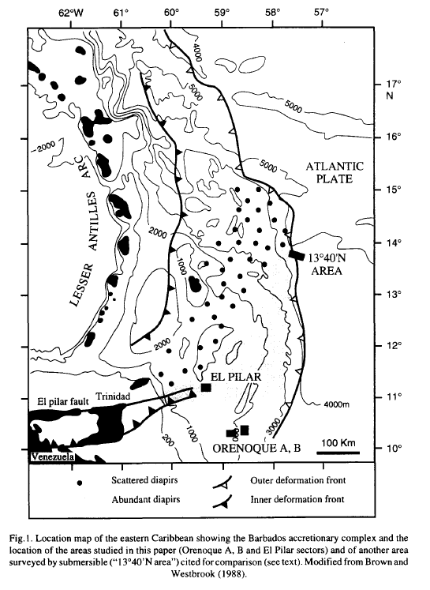

Olu et al. 1996
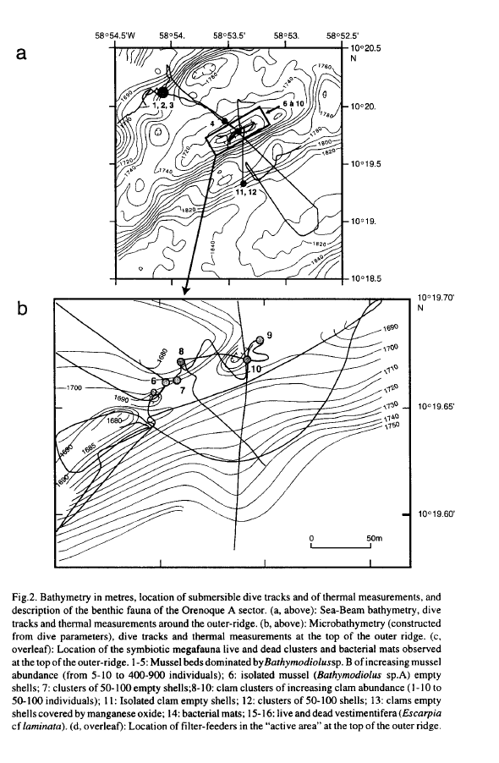

Olu et al. 1996
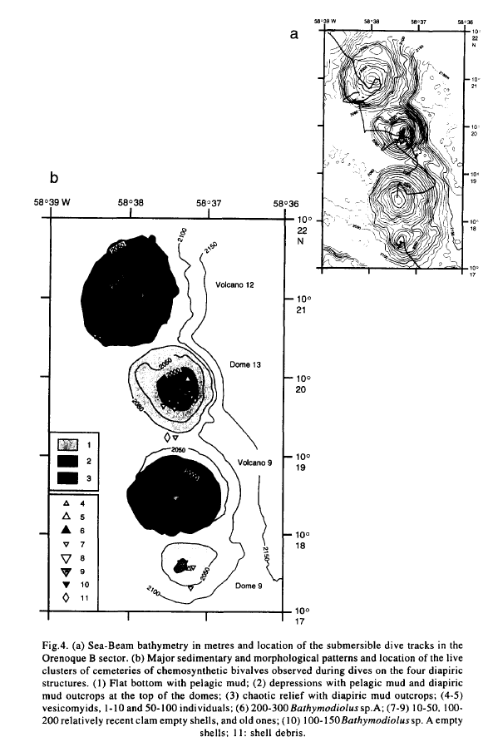

Olu et al. 1996
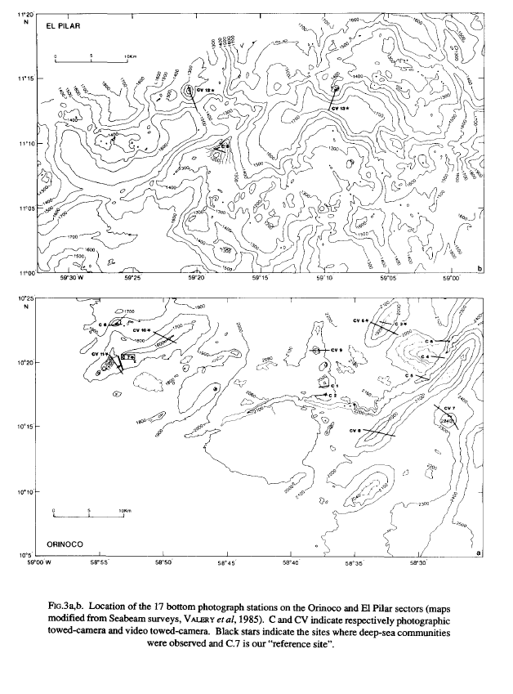Jollivet et al 1990
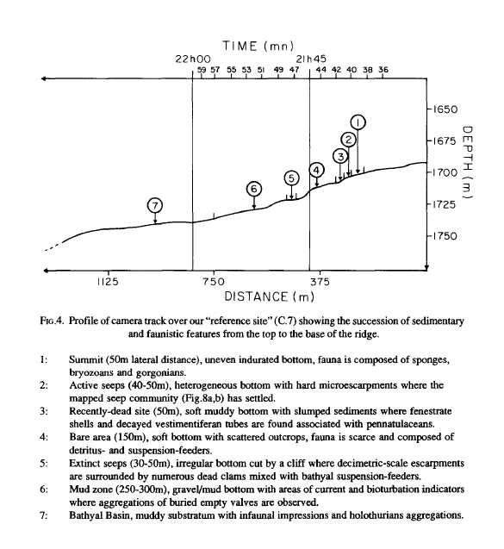
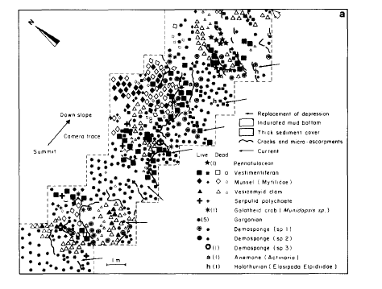
Jollivet 1990 (Orinoco transect)

