Setting up the Softphone For Windows

Softphone can be accessed from anywhere there is an Internet connection.
But the users must have a VPN or a RAS account.

There are several different softphones that are available and that will work with our VoIP system.
One of the most reliable ones (and free) is Xlite from www.xten.com.
To use this softphone download it from
http://www.xten.com/index.php?menu=download and install it using the default options below.

Headsets for PC use with X-Lite Softphone and for voicemail .wav files.
Radio Shack
Lightweight Stereo Multimedia Head set, 33-1187 at $19.95
Description:
Omnidirectional boom mic easily adjust to various positions
Swiveling earcups for the best fit
8-footcord with two gold-plated 1/8" plugs
To use this softphone download it from:
http://www.xten.com/index.php?menu=download

Install Instructions for Windows
Install Xlite (3.0 – build 29712) using the default options.
When you start your Xlite phone for the first time the SIP Accounts configuration window comes up.
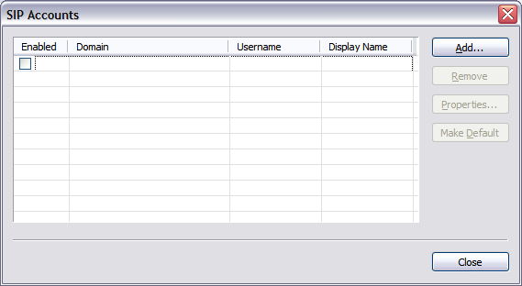
Click Add…
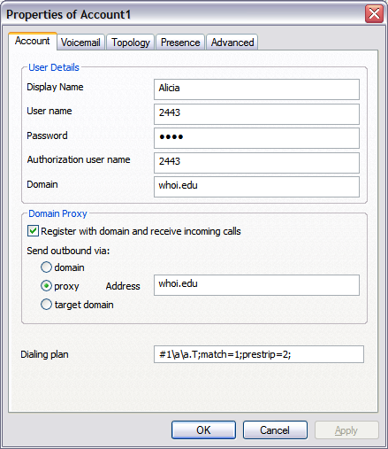
The info that needs to be entered for WHOI is:
Account Tab: User Details
Display name: your choice
User name: your sip phone number
Password: your sip phone number
Authorization user name: your sip phone number
Domain: whoi.edu
Account Tab: Domain Proxy
Check: ◻ Register with domain and receive incoming calls
Select: Set outbound via: ○ proxy Address: whoi.edu
The rest of fields - defaults are OK
Setting up the Softphone for MAC or Linux

Softphone can be accessed from anywhere there is an Internet connection.
But the users must have a VPN RAS account

There are several different Softphone that are available and that will work with our VoIP system.
One of the most reliable ones (and free) is Xlite from www.xten.com.
To use this softphone download it from
http://www.xten.com/index.php?menu=download (Mac, or Linux) and install it using the default options below.

To start configuring, click on the Menu icon next to the Green telephone icon on the main Xlite display. Then go to "System settings" and then "SIP Proxy". The info that needs to be entered for WHOI is:
Enabled: Yes
Display name: your choice
Username: your sip phone number
Authorization name: your sip phone number
Password: your sip phone number
Domain / Realm: whoi.edu
SIP Proxy: whoi.edu
Outbound proxy: whoi.edu
Rest of fields - defaults are OK

If you are setting up the Softphone on your home computer, you will need to set the following:

Go back to the "System Setting" and then to "Network" and set:
Primary STUN server: paulrevere.whoi.edu (optional - helps when behind NAT such as at home)
Secondary STUN server: xten.net (optional)
Primary DNS server: dns1.whoi.edu
Secondary DNS server: dns2.whoi.edu (optional - could use Adelphia or someone else here if you want)
Rest of fields - defaults are OK

Headsets for PC use with X-Lite Softphone and for voicemail .wav files.
Radio Shack
Lightweight Stereo Multimedia Head set, 33-1187 at $19.95
Description:
Omnidirectional boom mic easily adjust to various positions
Swiveling earcups for the best fit
8-footcord with two gold-plated 1/8" plugs

