Snom
Telephone
Guide

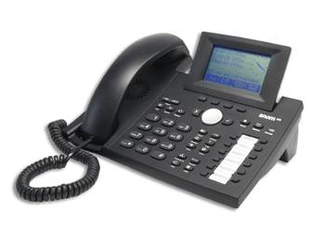

Contents

Introduction………………………………………………………………..…1
VoIP Mail Guide…………………………………………………………..…3
Snom 360 Dialing Reference…………………………………………...….5
Using your Snom phone………………………………………………...….7
Accessing the Web Interface………………………………………..……..9
Setting up Softphone for MAC or Linux……………………………..…..12
Headset use for voicemail.wav……………………………………..……12
FAQ’s…………………………………………………………………........13

Quick Snom Guide for phone --- Cut and tape to your phone......18

Introduction
For an in depth look at the new WHOI telephone system, please look at our web pages at: http://www.whoi.edu/sites/voip
New VoIP Telephone/Voicemail System
WHOI is installing a new phone and voicemail system to replace its current 18 year old Nortel system. The new system will have most of the same features as the current system as well as several new ones. The most fundamental change is that the new system is based upon networking technologies instead of dedicated wires connecting a phone to a centralized phone switch. So you will be able to use the new phone system from the new telephone handsets that we are deploying, and also from anywhere that you can get an Internet connection. Although we are currently focusing upon replacing the voice communications services provided by the Nortel system, over time we will extend the new system to support video, text messaging, shared documents, and other forms of person-to-person communications. For example, it will be possible for a WHOI person traveling in Europe to dial someone's four digit WHOI extension and have the person answering it be traveling in Asia. With the right software, they could then discuss and edit a paper, share a PowerPoint presentation, or exchange video by using small cameras. All this would happen without interaction with the traditional phone companies and without incurring charges (other than perhaps local Internet access costs.)

The new phone system uses mostly standard computer hardware and open source software. It has been setup as a pair of redundant servers with one located on the Quissett campus and the other in the Village. Both systems have connections to Verizon for outside access.
The primary components of the new phone system are:
1. SIP servers - these arrange for calls from one Internet device (such as one of the new phones or a software phone application running on a computer) and another.
2. Asterisk servers - these provided connections between the Internet based phones and traditional phone systems, including our Nortel system, Verizon, and our long distance carriers.
3. The voicemail system - this is running on the Asterisk servers and is quite similar to the current Meridian voicemail system. One major new feature is that it can send your voicemail messages to your Email, so you listen to them anywhere you can access Email.
4. IP telephones - We are currently deploying desktop handsets made by Snom. These are multi-line, speaker phones with a web interface that you can use to track calls and configure several options. We also have a couple of Polycom conference phones and have experimented with several other IP phones, including one that uses the wireless network. One of the advantages of an Internet standards-based system is that we are not confined to a single vendor’s phones.
5. Softphones - this is software which runs on our computer and acts as a fully functioning phone. There are many different softphones available to choose from. We are currently recommending one call X-Lite from Xten because it is reliable, runs on Windows, MacOS, and Linux and is free.
1
The new system runs on Linux, BSD (Unix) amd MacOSX and provides all of the features you would expect from a PBX and more. The system does voice over IP in many protocols, and can interoperate with almost all standards-based telephony equipment using relatively inexpensive hardware.
All the occupants in the MRF and Watson (BGC), the two new buildings on Quissett Campus, are on the new telephone and voice mail system. We are staring the migration for the remaining buildings.
The new phones will be plugged into the network drop where your printer or your desktop computer is currently plugged in. Your printer or computer will be plugged into the PC port on your new IP phone. All phones will be powered over the Ethernet port from the network closet. All network closets have UPS’s and ar on the emergency generator. The IP phones strip off the power before it goes out to the PC port on the phone. NetGear switches can also be run off the PC port on the IP phone.
2
WHOI VoIP Voice Mail Guide

Asterisk PBX 1.0 Voice Mail

2006-06-06

How to use the new voice mail system with your
SNOM 360 SIP Phone

Introduction

∙ WHOI’s new Voice over IP (VoIP) telephone system comes with a new voice mail system. Everyone who has a VoIP phone gets their voice mail on this new system.
∙ The new voice mail system is similar to the old one, but has a different menu layout and some new features. This guide describes the features of the new system.
∙ Probably the most useful part of this guide is the Menu Reference on the back. This is the complete layout of the menus you will use to check your voice mail, record greetings, and so forth.

Sending Voice Mail

∙ When you call a VoIP extension and the phone is busy, or the person is away and does not answer, you can leave voice mail for them. When you’re done recording the message, you can hang up, press the # key.
∙ You can also forward voice mail to other WHOI VoIP users, or compose and send a voice mail from within the system. There is not yet a facility to send global voice mail, or to create distribution lists, but one will be added soon.
∙ A voice mail account can hold only ninety-nine messages total. After this limit is reached, callers will not be able to leave any more messages.

Log In Information

∙ Access voice mail: dial 3000 or 508-289-3000.
∙ Your mailbox number is the same as your extension number.
∙ Your default password is the same as you extension. Please change it.

Recording Greetings

∙ You can record three different greetings for your voice mailbox: the unavailable, busy and temporary greeting. You can also record your name.
∙ The unavailable greeting is played when someone calls you and you do not answer the phone. The busy greeting is not an option at this time. The temporary greeting overrides the unavailable greeting and must be deleted; there is no auto delete with a date and time stamp. Once your temporary greeting is deleted your unavailable greeting will be restored.
∙ If you do not record one of these messages, callers will hear a prerecorded message using your name recording. If you do no record your name, they will hear a prerecorded message with your extension number.

Email Notification

∙ When someone leaves you a voice mail, you will receive an email message notifying you of the message. This message will include the phone number of the sender, the length of the message, and an attachment containing the message as a sound file. However, reading this email does not clear the voice mail from your new voice mail messages.
∙ If you do not want to get email notifications for voice mail, contact the Telecom at telecom@whoi.edu to let us know. You can also choose to receive the notification without the sound file.
3
Voicemail Tips

∙ Different SIP phones interact with voice mail differently. To check your voice mail on your SNOM phone, press the button on the top right marked “Retrieve”.
∙ When you have unheard messages an amber light will blink on your phone. A steady light indicates a missed call, to turn off light and clear display press the button.
∙ Your SNOM phone has a Do Not Disturb (DND) setting. You can turn it on or off by pressing the button at the bottom marked “DND”. When DND is on, all incoming calls will be diverted to voice mail. Your phone will not ring if DND is on. It will instruct the caller’s phone to connect directly to your voice mail. Make sure to turn DND off when you want to receive calls.
∙ You can also divert a single incoming call to voice mail by pressing the “Deny” button, while the phone is ringing.
∙ To skip a greeting and leave a message, press the # key and begin talking immediately as the tone is instantaneous.

Compatibility

∙ From your SIP phone, you can place calls to people on the old WHOI phone system (Meridian), and leave voice mail for them. Meridian users can also call SIP users and leave them voice mail.
∙ However, the two voice mail systems are separate. You cannot forward a voice mail message from one to the other. Also, SIP and Meridian extensions cannot be on the same voice mail distribution list.

VoIP Glossary

distribution list - a “mailing list” for voice mail. Used to send single voice mail message to many people at once.
do not disturb (DND) - a setting on some phones that diverts all incoming calls to your voice mail. When you have DND set, your phone does not ring.
message waiting indicator (MWI) - the light on your phone that indicates you have new (unheard) voice mail.
reorder - a signal that your call could not be completed. If you call a non-WHOI SIP address that does not exist, you may get a reorder message on your phone.
Session Initiation Protocol (SIP) - an Inter-net standard for VoIP phones. Allows phone calls, video conferencing, and other applications to go over the Internet.
SIP address - an “email address” for a SIP phone or user. SIP users on the Internet can reach any WHOI user by their email address, or by their extension - such as sip:3100@whoi.edu.
SNOM phone - the brand of VoIP hard phone that WHOI has deployed.
Voice over IP (VoIP) - carrying phone calls over the Internet or LAN, instead of over dedicated phone lines.
VoIP hard phone - a telephone that plugs in-to the Ethernet instead of a phone line. Your SNOM phone is a VoIP hard phone that uses SIP.
VoIP soft phone - a program that runs on your computer, and that works like a phone. WHOI is using the X-Lite soft phone for most users.
4
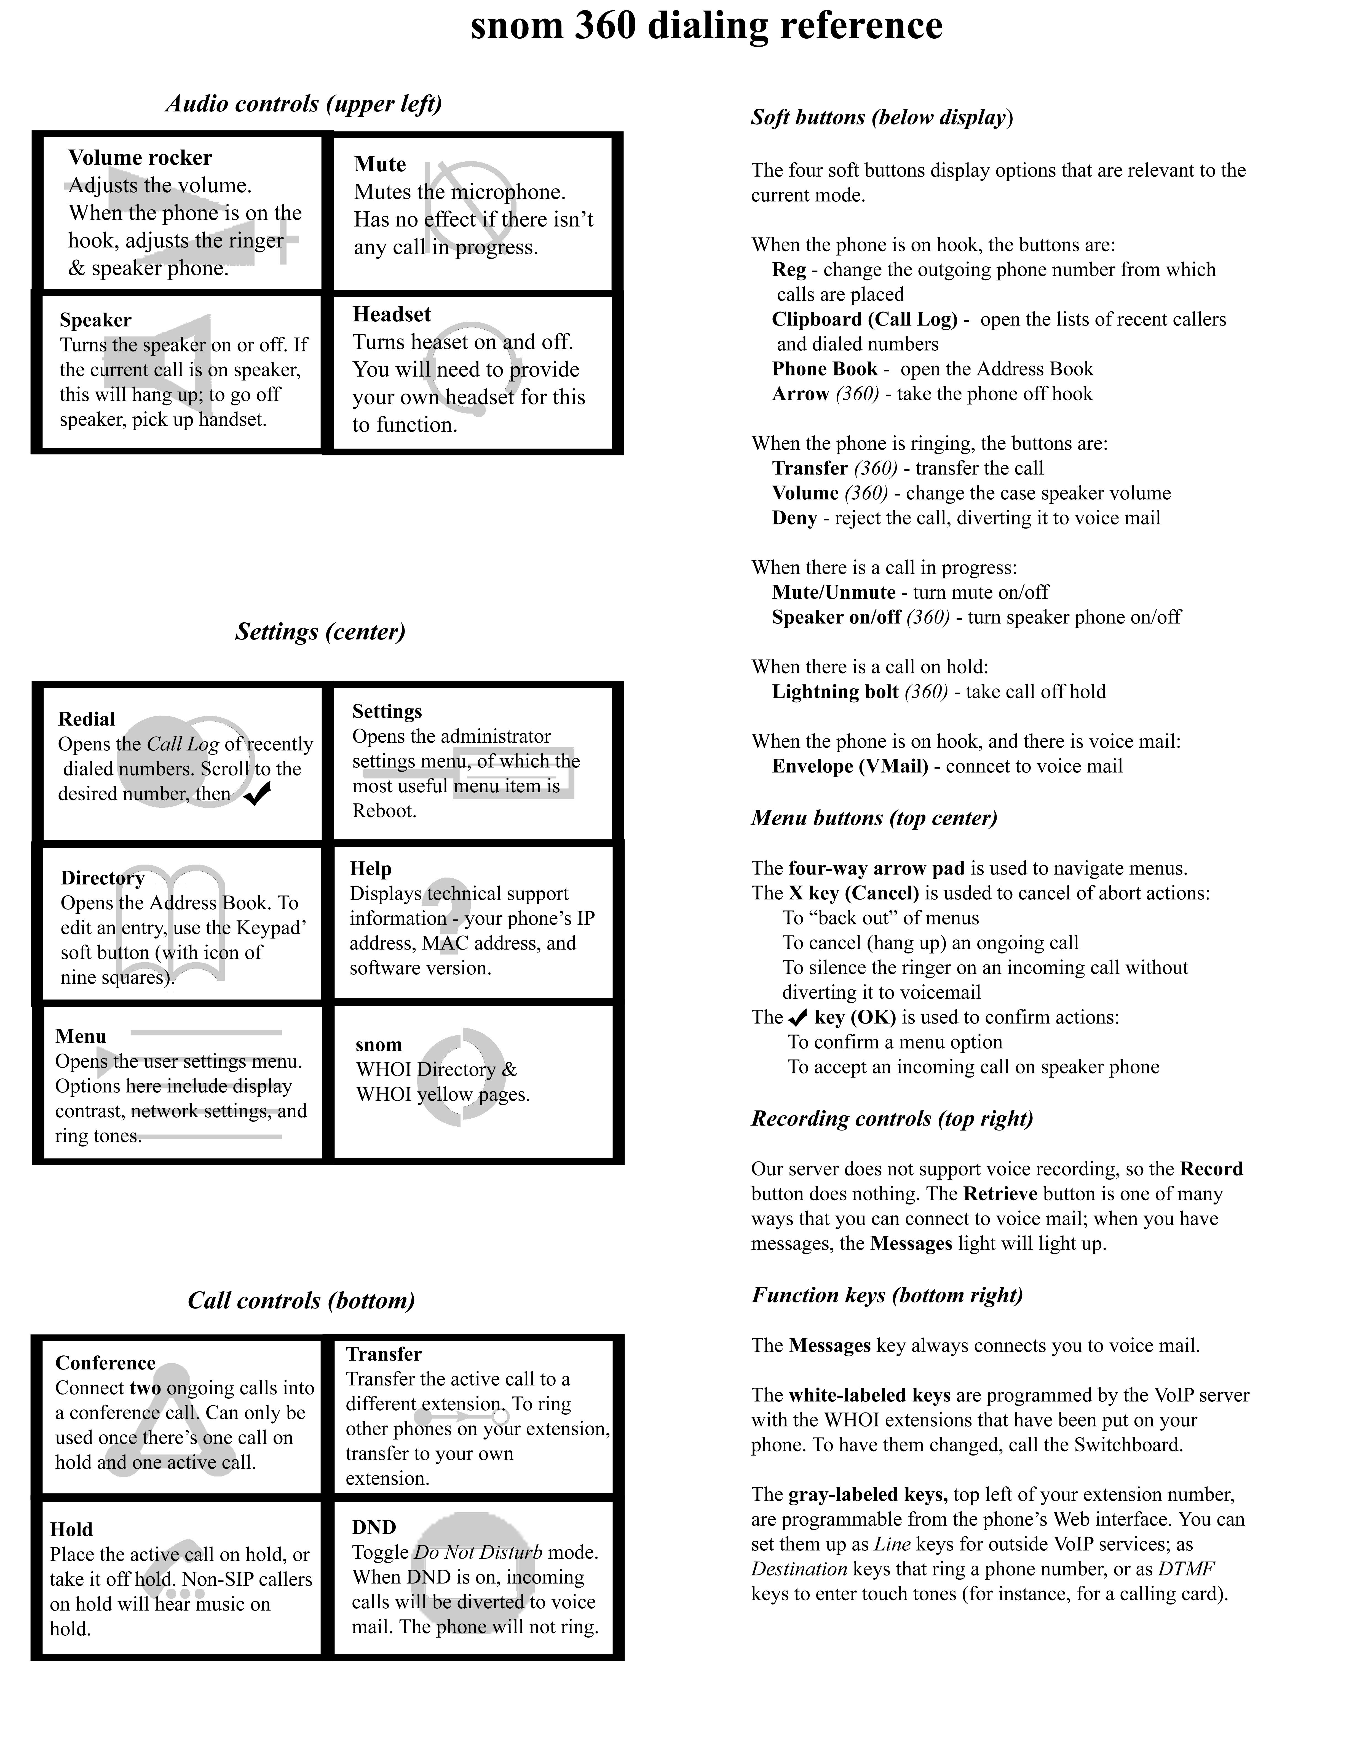

5
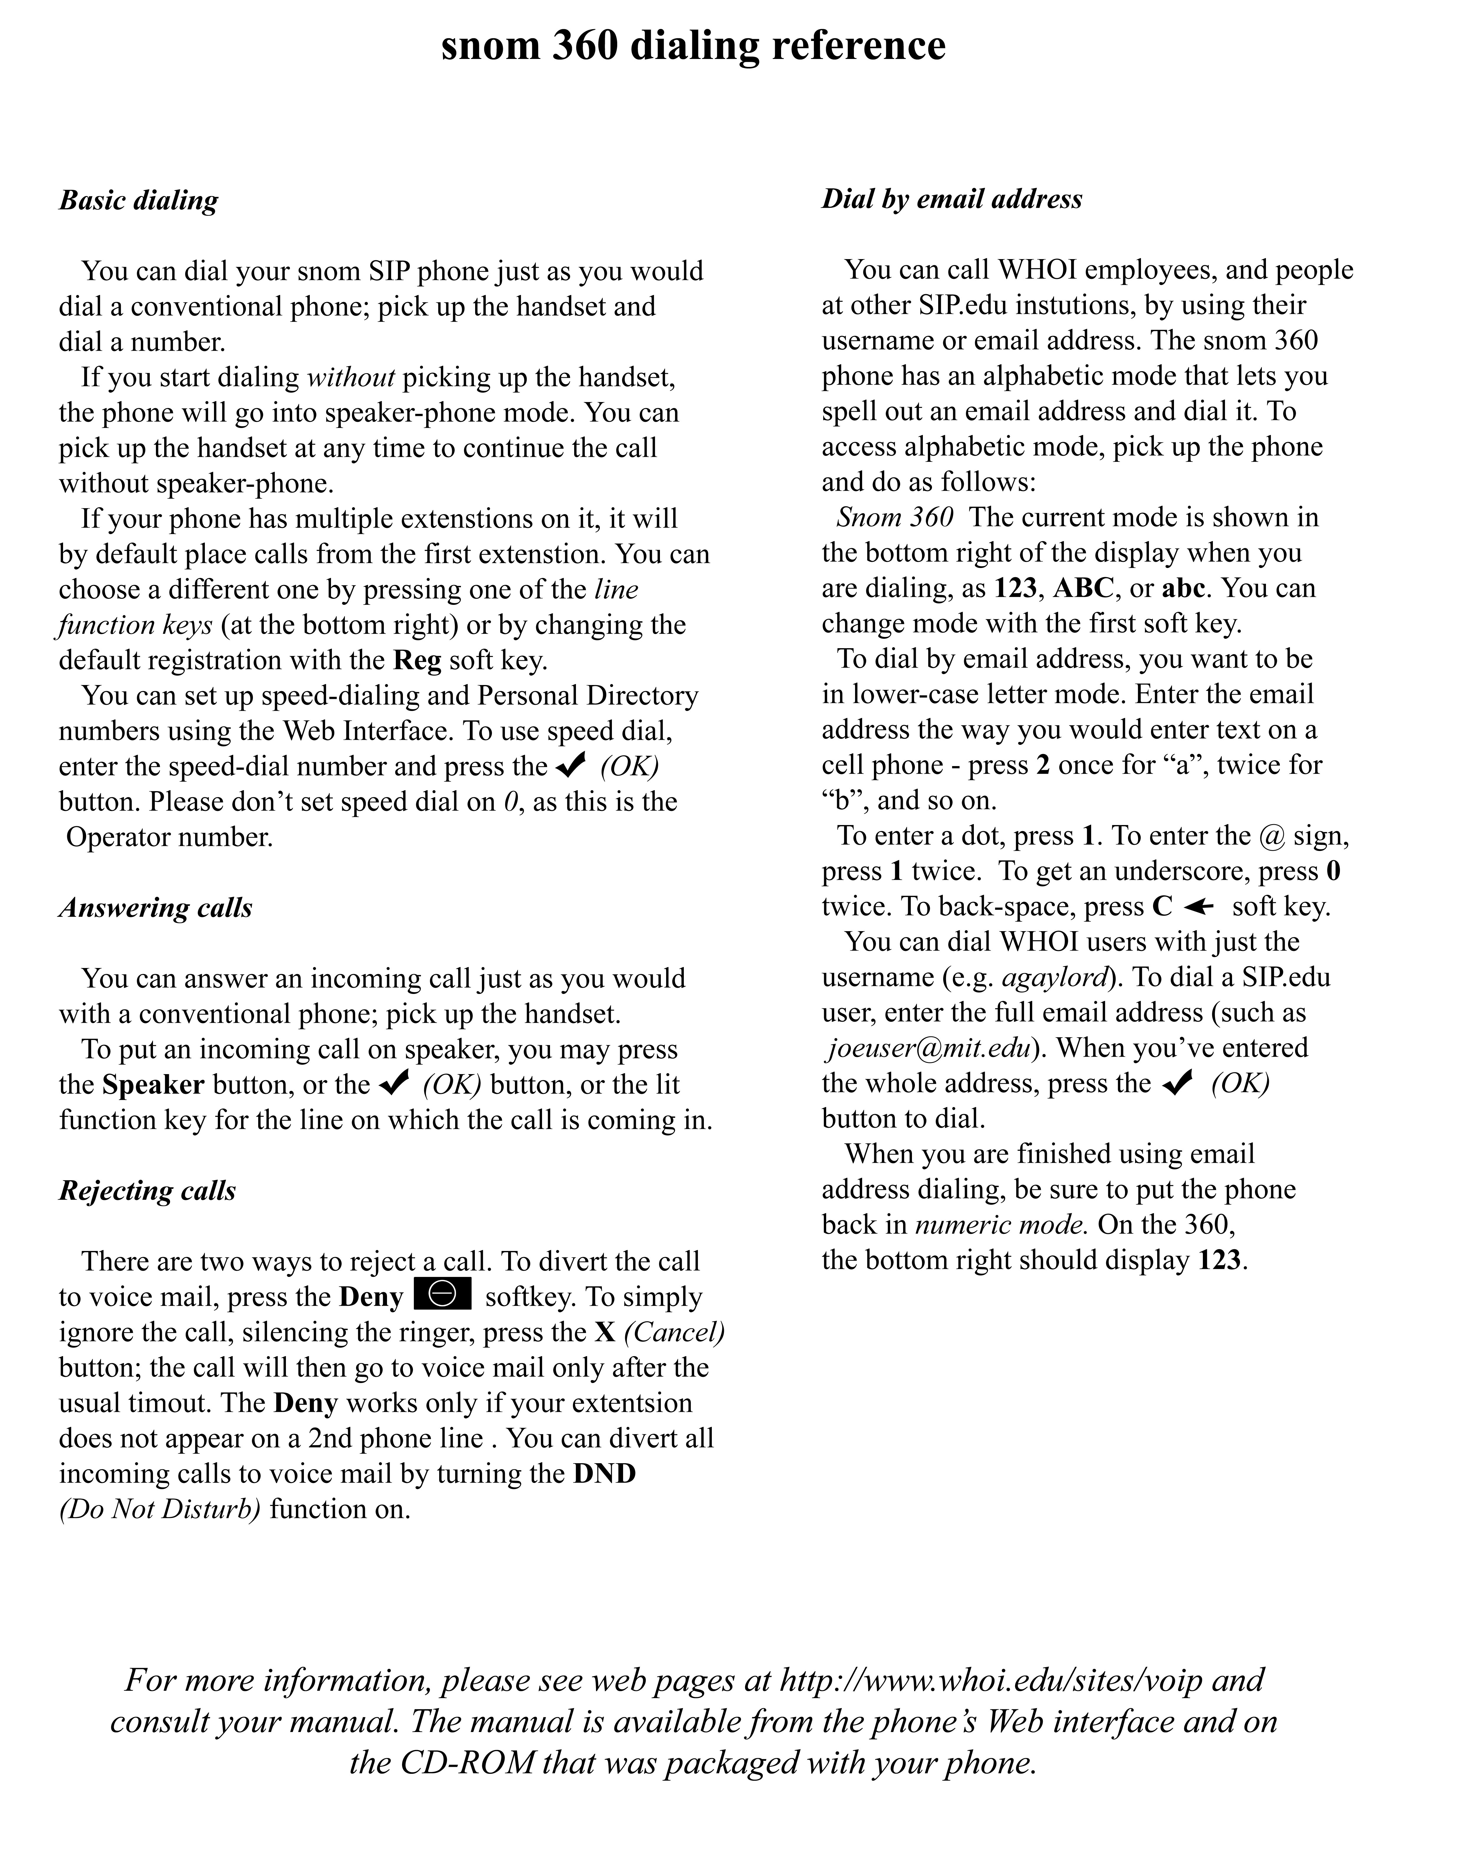
6
Using your phone
New features
Meet Me Conference
Voicemail in your email that can be played from a sound file on you computer
Web phone interface
Softphone for PC and laptops that can be accessed from anywhere there is an Internet connection and the users have a VPN or RAS account.
Call Logs (missed, received and dialed calls)
Different rings for each extension on telephones with multiple lines

Phone Features not available at this time:
Call forward
Call Park
Intercom

Dialing features
Dial plan is the same as on the Nortel System
XXXX 4-digit dial remains the same.
9-(508)-XXX -XXXX
9-1-(XXX)-XXX-XXXX billing code
88-3-XXXX and push the Check button
After dialing an international number you must push the Check key.

Dial a call:
1. Pick up the handset and key in the number you are calling or
2. Push the speaker button to get a dial tone and key in the number you are calling.

Answer a call:
1. Pick up the handset and speak or
2. Push the speaker button and speak.

Redial a call:
Push the redial button, the display will show a list of the most recently dialed numbers, select the number to redial from the list using the up and down arrow keys and push the check (OK) button.

Put a call on Hold or take off Hold:
Press the Hold button.

Set up a conference call - can only be used to connect three phones (the Nortel would allow up to 6), for more than three use “Meet Me”
1. When two phones are active, put one on hold by pressing the conference button.
2. Dial the third party.
3. When the third party answers, press the conference button again to connect all three parties.

MeetMe Conference feature (Try it!)
This system has a MeetMe Conference feature you can also access from your Nortel phone or callers can call directly.
Dial extension 3192 (508-289-3192) from either phone system (Nortel or Asterisk)
MeetMe facility supports an arbitrarily large number of conference calls.
Use your two digit department number followed by your extension number as a conference number and send it to your attendees along with the MeetMe number 508-289-3192 or ext 3192 for internal attendees.
7
When attendees dial the MeetMe number 508-289-3192 (3192 for internal attendees) they will be requested to enter a number for the conference they want to attend. They will enter the department and extension number that you have previously given them.

Transfer a call
During a call, press the transfer key to put the party on hold, and then dial the number to which the call is to be transferred. Press the Check key and the transfer is completed.

Retrieve voicemail
When the Message light is blinking, you have a Voicemail message. To listen to it press the Retrieve button, push the Messages line or dial 3000. Enter your extension number and password and press 1 for new mail.

View missed calls/call history
Press the second soft key (button located just below the phone list icon on the display)

Locate phone IP and MAC address, and software RLS version
Press the Help? Key

Reboot/reset phone
Press the Settings button, and then select Reboot or Reset Values

Autodial
Function keys can be assigned a number to autodial using the Web Interface. Go to the Web Interface, select Function Keys, change the drop down to Destination, enter the number and save. To dial, press the appropriate function key. Other selections on the drop down list are not functional at this time.

8
Accessing the Web Interface
You must have Adobe Reader installed on your computer to open the Web Interface. If you do not have it go to Adobe.com, click on the icon that says “Get Adobe Reader”, and download it. It’s free.
To access your web page first locate your IP address. Use the last four digits of the phone’s MAC address for the password. When you get to the page, save it with a bookmark.

• Push the ? Help button
• Bring up a browser and type in the IP address of your phone in the address bar.
• At the login prompt use the last four digits of the MAC address for both your user name and password
The Web Interface is the easiest way to enter names and numbers into your Address Book.
• From the left hand column, select Address Book.
• In the center section, fill in data in the Add or Edit Entry section.
• All numbers must be entered without spaces, dashes. You will have to add 9 to outside numbers and 91 to long distance numbers.
• You can also set a contact type and outgoing identity
• When all the information you want has been entered, click the Add/Edit button
• After you have clicked the Add button, you will see the person’s name in your address book by pressing the third softkey on your phone.

The Web Interface is the only way to enter speed dial numbers.
• From the left hand column, select Speed Dial.
• You may use up to 31 numbers plus # and *.
• All numbers must be entered without spaces, dashes. You will have to add 9 to outside numbers and 91 to long distance numbers.
• Click in the next available block or select any one you want.
• You cannot enter a name so you need to keep a list of Speed dial numbers you assign.
• To use Speed Dial, lift the handset or push the speaker button, push the Speed Dial number and push the Check button.

Setting up the Softphone

There are several different Softphone that are available and that will work with our VoIP system. One of the most reliable ones (and free) is Xlite from www.xten.com. To use this softphone download it from
http://www.xten.com/index.php?menu=download ( Windows, Mac, or Linux) and install it using the default options.

To start configuring, click on the Menu icon next to the Green telephone icon on the main Xlite display. Then go to "System settings" and then "SIP Proxy". The info that needs to be entered for WHOI is:

Enabled: Yes
Display name: your choice
Username: your sip phone number
Authorization name: your sip phone number
Password: your sip phone number
Domain / Realm: whoi.edu
SIP Proxy: whoi.edu
Outbound proxy: whoi.edu
Rest of fields - defaults are OK

9
If you are setting up the Softphone on your home computer, you will need to set the following:

Go back to the "System Setting" and then to "Network" and set:
Primary STUN server: paulrevere.whoi.edu (optional - helps when behind NAT such as at home)
Secondary STUN server: xten.net (optional)
Primary DNS server: dns1.whoi.edu
Secondary DNS server: dns2.whoi.edu (optional - could use Adelphia or someone else here if you want)
Rest of fields - defaults are OK

Softphone can be accessed from anywhere there is an Internet connection and the users have a VPN or RAS account.
We are currently using a Radio Shack Multimedia Headset, which seems to work fine.

Setting up the Softphone

There are several different softphones that are available and that will work with our VoIP system. One of the most reliable ones (and free) is Xlite from www.xten.com. To use this softphone download it from:

http://www.xten.com/index.php?menu=download (Windows, Mac or Linux)

Install Instructions
Install Xlite (3.0 – build 29712) using the default options.
When you start your Xlite phone for the first time the SIP Accounts configuration window comes up.
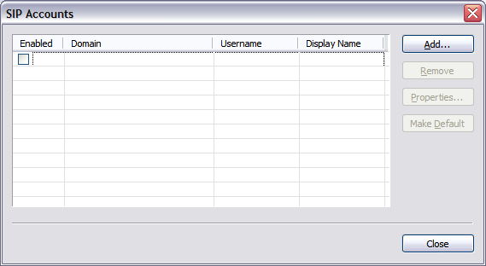
Click Add…
10
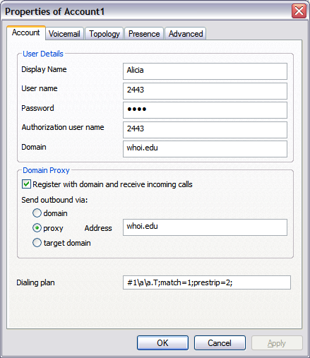
The info that needs to be entered for WHOI is:
Account Tab: User Details
Display name: your choice
User name: your sip phone number
Password: your sip phone number
Authorization user name: your sip phone number
Domain: whoi.edu
Account Tab: Domain Proxy
Check: ◻ Register with domain and receive incoming calls
Select: Set outbound via: ○ proxy Address: whoi.edu
The rest of fields - defaults are OK
11
Setting up the Softphone for MAC or Linux

Softphone can be accessed from anywhere there is an Internet connection .

But the users must have a VPN RAS account.

There are several different Softphone that are available and that will work with our VoIP system. One of the most reliable ones (and free) is Xlite from www.xten.com.

To use this softphone download it from:

http://www.xten.com/index.php?menu=download (Mac, or Linux) and install it using the default options below.

To start configuring, click on the Menu icon next to the Green telephone icon on the main Xlite display. Then go to “System settings” and the “SIP Proxy”. The info that needs to be entered for WHOI is:

Enabled: Yes
Display name: your choice
User name: your sip phone number
Authorization name: your sip phone number
Password: your sip phone number
Domain / Realm: whoi.edu
SIP Proxy: whoi.edu
Outbound proxy: whoi.edu
Rest of fields - defaults are OK

If you are setting up the Softphone on your home computer, you will need the following:

Go back to the “System settings” and then to “Network” and set:

Primary STUN server: paulrevere.whoi.edu (optional - helps when behind NAT such as at home)
Secondary STUN server: xten.net (optional)
Primary DNS server: dns1.whoi.edu
Secondary DNS server: dns2.whoi.edu (optional - could use Adelphia or someone else here if you want)
Rest of fields - defaults are OK

Headsets for PC use with X-Lite Softphone and for voicemail.wav files

Radio Shack:
Lightweight Stero Multimedia Head set, 33-1187 at $19.95

Description:
Omni-directional boom mic easily adjusts to various positions
Swiveling earcups for the best fit
8-foot cord with two gold-plated 1/8” plugs
12
FAQ’s
September 6, 2006

Where can I find an overview of VoIP online?
For an in depth look at the new WHOI telephone system, please look at our web pages at:
http://www.whoi.edu/sites/voip

Telephone

Why does my phone only dial letters?
Pick up phone, select button under the 123 or abc on the telephone display and push it until ABC is selected. (The other options are for dialing in name and ip address)

My Telephone has no dial tone – Reboot phone
Reboot the phone, push settings key, use arrows up or down until you find the reboot option, press the check button, the phone reboots in 10-15 seconds. Or unplug the network cable.

I can not make an International call, why?
After you dial in the number push the Check key to complete the call.

Why can we no longer dial MIT with the 88X-XXXX?
To complete a call to MIT you must push the Check Key after you have entered the number.
How many parties can I have using the conference feature?
Only three, yourself and two other parties.
How can I make a conference call?
There are two options
1. Three party conference
if the phone is connected with two calls, one on hold and one active, you can connect all three phones in a conference by pressing the conference button or the key under the display icon
2. MeetMe Conference feature Can also be used from a Nortel phone.
Assign a 6-digit conference number.
Please use your two-digit department number plus your four-digit telephone extension number. Send the conference ID number to your attendees along with the MeetMe number 508-289-3192 or ext 3192 for internal attendees. When attendees dial the MeetMe number 508-289-3192 they will be requested to enter a conference ID number for the conference they want to attend.

How do I change the ring tone?
Select the menu button, arrow down to “Line”. Select Line option by pressing the check mark, arrow down to the “Ring Tone”, press the check mark, select the line for which you wish to change the ring tone, use the up/down arrows to play the different rings, press the check mark to select desired ring, press the X button twice to exit out of the menu options. There is also the selection for silence for users with multiple lines on their phone.
When someone calls me, my phone does not ring.
Look at the display and make sure that DND is not active.
How do I answer a 2nd call when on a call, without losing either call?
Put the first call on Hold and answer the second one.
13
Why does my phone ring 10-11 rings before it goes to voicemail?
The ip phone ring cycle is shorter than other phones; the caller only hears the standard 4-5 rings. To send a call immediately to voicemail and stop the ringing, press the X button.
How can my coworker pick up his line and get the call that I just answered on my phone on his extension number? When I place the call on hold it does not light the line on his phone. The call is now yours; you must transfer it back to his phone.
Push transfer key and dial his extension number, push the check mark to complete the transfer back to his phone.
Can you tell by the ring if the caller is internal or external? No But all users now have a display phone that will show you the calling ID if it is available.
My phone does not have a release button, how do I disconnect a call without hanging up? The X button replaces the release button.
What is my phone IP and MAC address? Push the ? (Help) button to the right of the number 6 on the phones dial pad, it will display the software version number, the IP address and the MAC address of the phone.
How can I access my web phone interface?
To access your web page first locate your ip address and the last four digits of the phones MAC address for the password
· Push the ? Help button, this will give you the ip and MAC address.
· Bring up a browser and type in the ip address of your phone.
· At the login prompt use the last four digits of the MAC address for both your user name and password.
· See all the features you can change via your web phone
· Scroll down to the end of the page on the left for the Snom 360 manual; you will need Acrobat to open it.
What can be done via my web phone interface?
Set up speed dial numbers
Set of address book; allows you to select caller and dial from PC or phone.
The 9 or 91 must be in the dial sequence, no spaces or - dashes for speed dial and address book numbers.
What headsets will work with the new ip phones? Any types will work. There are several listed on my web pages at http://www.whoi.edu/sites/voip under Phone Accessories.
Voicemail
How do I access my voicemail from another phone?
Dial extension 3000. From out side WHOI dial 508-289-3000
What is my voicemail password?
The default password is the same as your extension number, please change it.
Why are callers still hearing the standard voicemail canned greeting when I have recorded my unavailable greeting?
Log in and delete your temporary greeting even is you did not make one. One could have pressed this option but not made a greeting. By selecting this option and not recording a greeting the canned greeting is played, as this greeting takes precedence over your unavailable greeting.
How can I skip the greeting and leave a message?
Press the # key and start talking immediately (there is a short tone but it is often not heard, so start talking as soon as you hit the # key).
14
How can I skip the voicemail header and advance to the message?
Press the 1, the header (name, ext, #, date and time of the call) will be skipped and the message plays immediately.
How can I skip forward or backward through voicemail messages?
Pressing the * will rewind backwards by 3 seconds and # will skip forward 3 seconds. Multiple presses will jump you multiple times. Warning if you jump ahead to many times you may get disconnect, as the # is also a command for hang-up.
How do you get a call to be answered by voice mail before 10-12 rings?
(The ip ring cycle is shorter so you hear 10-12 rings but the caller only hears 4-5 rings)
Press the X button to silence the phone while it is ringing and send the call directly to voicemail.
How do I delete my temporary greeting?
Log on to your voicemail box
Press "0" for Mailbox Options.
Press "4" to select temporary greeting.
Press "2" to select erase temporary greeting

I have a message waiting light but there is no message to play?
The caller has hung up without leaving a message, use 7 to delete the header and 6 to go to the next message.
Can I use the Broadcast Message Feature? (Send the same message to a Distribution List of multiply users)?
Not available at this time.
Is there an Express Message 6600 feature on the new VoIP voicemail?
Yes, there is a VoIP feature similar to Meridian Mail Express Messaging (Compose and send a message without ringing the user’s phone, but can only be used to send to users on the new VoIP system). You must first log in to your mailbox and can only send to one user at a time.
Log into your mailbox
At the menu greeting press 3 for advance options
Follow the prompts
Press 5, at the “press 5 to leave a message" prompt”
At the extension prompt - Dial in the ext. number you want to send the message to
At the prompt, "Please leave a message at the tone when done hang up or press # key to stay logged in to your mailbox"
Record your message at the tone and follow the prompts to hang up or select another feature.
How to access old messages without listening to new messages, exiting and re-entering messages feature?
Log on to Voice Mail by pushing the Messages line or dialing 3000.
Press your extension number and password.
Press 2 to change folders.
Press 1 for the old messages folder.
Press1 to play old messages
Press 7 to delete
Press 6 to advance to next message
Press the # key to log off
How do I access old messages after listening to new messages without exiting
and logging back on?
Log on to Voice Mail by pushing the Messages line or dialing 3000.
Enter your extension number and password.
Press 1 for new messages.
At any time while Listen to new messages you can change folders by pressing 2.
Press 2 to change folders
Press 1 for old messages
Press 1 again for old messages
Press 6 to go to next message
Press 7 to delete message
To advance and delete old messages with out listening to them rapidly
Press 76,76, and keep pressing 76 until you get to the end.
Press the # key to log off
I understand that the voicemail system is limited to 99 messages per mailbox. What happens when that limit is reached?
Once the limit of 99 voicemail messages stored for your mailbox is reached, a caller reaching your voicemail will hear a message indicating that the mailbox is full and cannot store any new messages. The caller will be unable to leave a message for you.
Which voicemail greeting is played if I have activated DND (do not disturb)?
The message you recorded for the unavailable greeting is played to the caller reaching your phone with DND active.
Which voicemail greeting is played if I press the X key when my phone is ringing?
The message you recorded for the unavailable greeting is played to the caller if you press the X key while the phone is ringing.
15

Why do my voicemail messages get cut off when I use the playback of messages via Email?
The problem that some people have reported with voicemail messages seemingly being prematurely truncated is occurring during the playback of messages sent via the Email notification. This is happening at the local computer playing the message and is not a problem with the new voicemail system or in the delivery of the message over the Email system. Some older computers may have hardware limitations that make it difficult to playback the message, but in most cases the problem is in the software configured to play the sound file.
The message file sent to you via Email is a copy of the voicemail message sound file that is stored on the voicemail system. If it plays correctly on your phone, then your computer will play correctly on your computer unless the sound playback program being used is causing problems. You can listen to the message as it is stored on the voicemail system from any phone, not just VoIP phones. Just call into the system at 508-289-3000 and enter your extension # voicemail password #
There are many different applications on most people's computers that may try to playback the voicemail sound file, a .WAV sent as an attachment in the Email message. Some programs don't work as well as others and some may also cutoff the playback when they try prompting you to do an upgrade. Your Email client will try to invoke one of these depending upon how it and/or the operating is configured.
For Windows users, the best application to use for playing the voicemail messages is Windows Media Player version 10 (version 9 will work, I'm not 100% certain about earlier versions). If another application is being used, I suggest changing over to Windows Media Player and give detailed instructions for doing this at the end of this message. If you are using a different application and never experience any playback problems you can leave it as is if you prefer.
For Mac users if you are running MacOS X and the standard Email client you should be OK.
If you are having problems with the playback of voicemail messages and this document does not help, please send a response of voip-operators@whoi.edu with as much specific information as you so we can further diagnose the problem.
16

What are some of the delivery options for Voicemail?
1. Voicemail via your telephone and in your email.
The default option is delivery in both locations, and must be deleted in both locations as they are stored on two different servers.
2. Voice Mail via your telephone only.
3. Voice Mail via Email only. If this option is chosen you can no longer retrieve voicemail messages via the telephone.
Misc FAQ’s
Will my phone work if the Internet is down? Yes, except in some rare outages, it will depend on which part of the Internet is down:
1. WHOI has redundant servers and multiple paths. If parts of the internal network (within WHOI) are having a problem no phone on that portion will work. Example Redfield 1st floor switch may be down, so Redfield 1sts floor phones will not work.
2. If the outage is external from our ISP provider YES you will have phone service. All of our telephone calls go out via Verizon T-1 lines, not over our ISP with the exception of MIT calls using the access code 88+3+XXXX.
Where can I find my phones user manual? Go to the web interface for our phone and click on Manual in the left column.
How can I access my web phone interface?
To access your web page first locate your ip address and the last four digits of the phones MAC address for the password
· Push the ? Help button, this will give you the ip and MAC address.
· Bring up a browser and type in the ip address of your phone.
· At the login prompt use the last four digits of the MAC address for both your user name and password.
· See all the features you can change via your web phone
· Scroll down to the end of the page on the left for the Snom 360 manual; you will need Acrobat to open it.
What will happen to all the FAX machines? They will remain as is for now. Once we bring on line the analog channel bank all the FAX lines will be moved over. The change will be transparent to the users.
Will my phone work is there is no power? Yes, all the network ports used for phones will have power over Ethernet. All the network closets have UPS’s that have been resized to last several hours and in the major buildings that have generators the closet have been put on the generators.
17

Voice Mail Menu Reference

Dial 3000 or press the Voice Mail or Retrieve Key
on your phone to check your voice mail.

NOTE: To skip greeting & leave message: Press # key

Main Menu:
1 Check Messages
Message Menu
1 - Skip ahead during header
2 - Return to beginning of current message
3 - Advanced options
4 - Go to previous message
5 - Repeat message
6 - Go to next message
7 - Delete/undelete message
8 - Forward message
9 - Save message

2 Change Folders
Folders (when saving messages)
0 - New messages
1 - Old messages
2 - Work
3 - Family
4 - Friends

3 Advanced Options
Remember these cannot be used if the other
user/caller is still on the Meridian Mail System
1 - Send a reply (by voice mail)
2 - Call the current message sender
3 - Play the current message envelope
5 - Compose and send a message

0 Mailbox Options
1 - Record “unavailable” greeting
2 - Record “busy” greeting
3 - Record your name
4 - Record a “temporary greeting”
(over-rides both unavailable and busy)
5 - Change your password

18

