ANTARCTIC SUPPORT AND RESEARCH VESSELS
AGULHAS
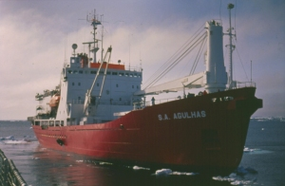
The "Agulhas" is the Antarctic Support vessel operated by the Republic of South Africa. She is equiped to work in heavy pack ice and is used for supply to bases in the various sub-Antarctic islands as well as to the SANAE Base on the Antarctic Continent itself

AKADEMIK FEDOROV"
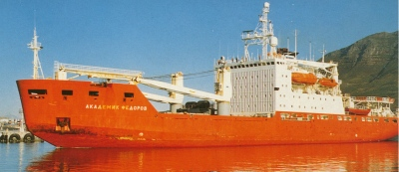
The Russian "AkademikFederov" was built in Rauma Repola, Finland in 1987 as an ice strengthened vessel. she is a sister ship to "Michael Somov". She has 12 laboratories on board and has a heli-pad on her aft deck. The photo above shows her at Cape Town in South Africa

ALMIRANTE IRIZAR
The "Almirante Irizar" is the main Argentine Antarctic support vessel. She is a fully equipped icebreaker with the highest possible +1A1 icebreaking classification. She carries a crew of 135 plus 45 additional passengers and has space for 2 Sea King SH-3D or similar helicopters.  She was built in Finland in 1978 and since then the Almirante Irizar has worked every year in the Antarctic supplying scientific research stations and also being employed as a floating laboratory or carrying out search and rescue missions. | 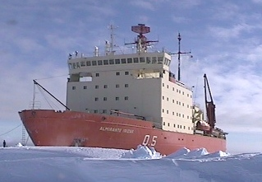

ALMIRANTE OSCAR VIEL
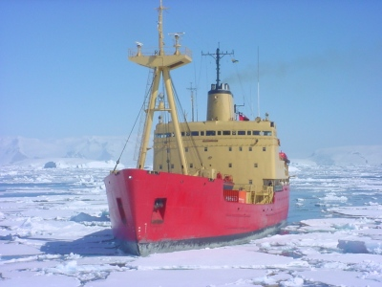
The "Almirante Oscar Viel" is the main Chilean Antarctic supply vessel. It has a strengthened hull enabling it to push through thin pack ice as shown in the photo above. It has a pennant number "AP-46" and is often identified this way as its full name of "Almirante Oscar Viel Rompehielos" is rather long. "Rompehielos" means Icebreaker.

AMERICAN TERN
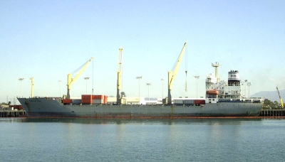
For the 2002-2003 season the "American Tern" took on the role of the main American Antarctic supply vessel, replacing the long serving "Green Wave" which was proving both unreliable and too small. The "American Tern" was built in Germany 1990 to Finnish Ice class 1A specifications and has a 50% greater carrying capacity than "Green Wave". The vessel is operated by American Automar which has a contract with the American Military Sealife Command which provides the cargo capacity for the US Antarctic Program. This contract which extends until 2010 also employs the vessel on a supply route to Thule in Greenland. The photo above shows the vessel loading cargo at Port Hueneme before her inaugural Antarctic voyage
ARCHANGELGRACHT
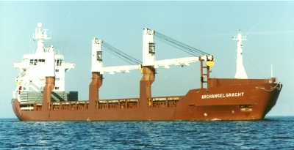
"Archangelgracht" is a Container ship operated by the Dutch shipping company Spliethoff as part of their world wide fleet of "gracht" vessels. The name "gracht"meaning "canal" in Dutch."Archangelgracht" was built in 1990 and has a cubic capacity of 525,000 cbft. The vessel has 3 cranes capable of lifting 40 metric tons each. The vessel has a A-1 ice strengthened hull mainly used for Baltic Sea work. In February, 2001 she was contracted by the United States National Science Foundation to act as their second Antarctic supply vessel of the season taking containerised and other cargo from Lyttelton to McMurdo Sound and returning to Lyttelton
ARCTIC SUNRISE
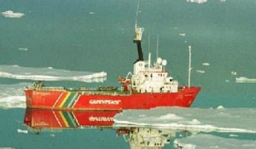
The "Arctic Sunrise" shown above is a former seismic research vessel based in Amsterdam which operates world-wide on enviromental protests. It is a 1A1 Class Icebreaker originally built in 1975 as the Polar Bjorn. In 1998 it visited New Zealand for a refit and then was sent to Antarctic waters in search of illegal Toothfish pirate fishing vessels suspected to be operating in waters south of Australia.

ARY RONGEL
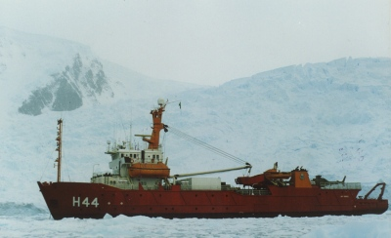
The "Ary Rongel" is the vessel used by the Brazil Antarctic Programme as their main support vessel. It is shown above in thick ice near the Brazilian Antarctic Base of Commandante Ferraz on King George Island.

AURORA AUSTRALIS
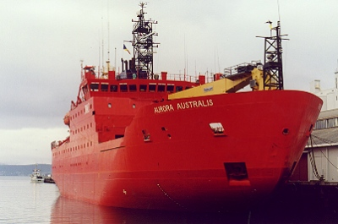 | This vessel shown at left is the main Australian Government's Antarctic supply/research ship.  It has good icebreaking capabilities, extensive research labs, a helicopter deck and confortable crew and expedition facilities. It was launched in 1989 and is operated by P & O Polar Australia Pty Ltd.

AUSTRAL LEADER
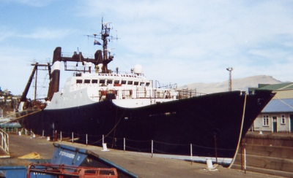
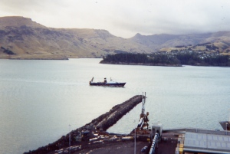  "Austral leader"arriving in Lyttelton | The "Austral Leader" is a 85 metre long steel hulled fishing vessel owned by Austral Fisheries Pty Ltd and is registered at Fremantle in Western Australia. She was built in 1967 at Bordeaux in France and was previously named "Groenland" (1978), "Southern Leader" (1981) and "Harvest Leader" (1991). Between 1997 and 2000 she was the only vessel licensed by the Australian Fisheries Management Authority to fish for Patagonian Toothfish in the waters surrounding Macquarie Island.
BRAVEHEART
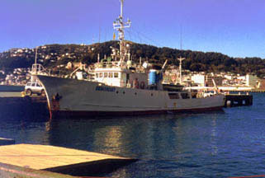
The "Braveheart" is a ex Japanese research vessel operated by the Stoney Creek Shipping Company of Palmerston North in New Zealand. She was refitted for this special voyage to Campbell Island where she acted as mother ship to an International Expedition of Dxer's in January 1999. The picture above shows the "Braveheart" in Wellington Harbour prior to departure.
BREMEN
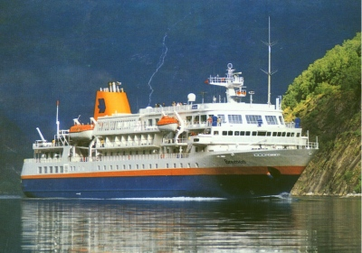
The "Bremen" is a specially built ice-strengthened eco-cruise ship which makes regular tours from South America to the Falklands and other South Atlantic islands as well as to the Antarctic Peninsula. She was launched in 1990 as the "Frontier Spirit" but renamed in the mid 1990's when she was purchased by a German company. She has a helicopter pad on her top deck and carries several zodiacs for landing tourists at remote locations

CALEDONIAN STAR
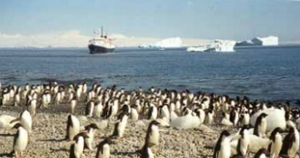
The above photo shows the 3,132 ton tourist cruise vessel "Caledonian Star" off the penguin rookery at Gouldin Island on the Antarctic Peninsula. The "Caledonian Star" was operated by Lindblad Special Expeditions who specialise in Antarctic Tourist cruises. She was built in 1966 and had previous names of "Marburg" and "North Star". In 2002 she was renamed "Endeavour" but was still operated by Lindblad Expeditions
H.M.S. DUMBARTON CASTLE"
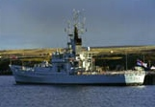
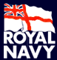 | The "Dumbarton Castle" is a Royal Navy Patrol ship permanently based at the Falkland Islands. She is a Castle Class patrol vessel and is shown above alongside at east Cove in the Falkland Islands

H.M.S. ENDURANCE"
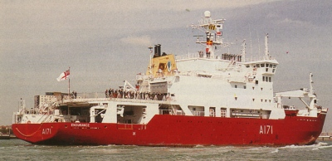
The "Endurance" is the British Royal Navy ice strengthened vessel which operates in the South Atlantic and around the Antarctic Peninsula regions protecting England's interests in the area. Duties include the re-supply and support of British troops stationed throughout the area as well as fishery protection. It replaced an earlier "Endurance" which was decomissioned on 17 October, 1991 after 35 years of Polar service. The current "Endurance" was originally the Norwegian "Polar Circle" which was renamed "Endurance" in honour of its pre-decessor
ERNEST SHACKLETON"
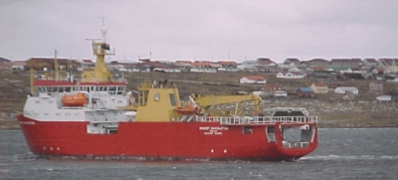
The "Ernest Shackleton" was built in 1995 for the Norwegian Rieber Shipping Company of Bergen and was named "Polar Queen". She is a 80 meter ice strengthened vessel specially designed for polar research work. She served both in the Arctic and Antarctic before in 1999 being renamed "Ernest Shackleton" and being chartered on a long term bareboat charter to the British Government. She was registered with the Falkland Islands Government on the 30th September, 1999. The view above shows her arriving at Port Stanley on the 12th of January 2000 after returning from a relief voyage to Halley Antarctic Base.

FARLEY MOWAT
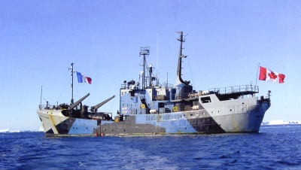
The "Farley Mowat" is the flagship of the Sea Shepherd Conservation Society which was founded in 1977 by Canadian Paul Watson and which takes its role of Marine Protection and Education from the United Nations World Charter for Nature. Paul Watson who had been one of the original founders of Greenpeace in 1972 left that organisation in 1977 to found the Sea Shepherd Organisation.The vessel was added to the fleet in February 2002 but as this name was already used by another vessel the decision was made to name it after the noted Canadian environmental writer Farley Mowat who is a patron of the Society. The vessel was used in the 2002-03 anti-whaling campaign | 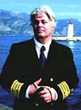  Captain Paul Watson
GREEN WAVE
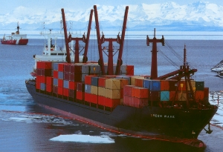
The MV "Green Wave" is a cargo vessel which has for many years acted as the main US Operation Deep Freeze logistics and supply vessel. Most seasons she carries cargo from the USA to McMurdo Sound via Lyttelton completing one round trip and sometimes a second trip from Lyttelton south. The photo above shows her approaching the ice wharf in McMurdo Sound

GUS W. DARNELL
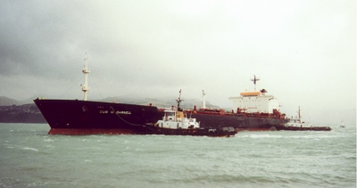
The "Gus W Darnell" is a Military Sea Transportation Service oil tanker and was the annual supply tanker chosen for the McMurdo fuel run for January 2002.
She arrived in McMurdo on the 23rd of January, 2002 and after discharging fuel departed for Lyttelton where she is shown above arriving in the early hours of 6th February, 2002 to discharge fuel and take on supplies.
HAKUREI MARU
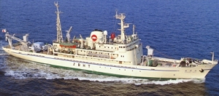
The "Hakurei Maru" was commissioned in 1974 by a group of Japanese companies who formed the Metal Mining Agency of Japan . They were interested in exploiting possible mineral wealth on the Ocean floors around the world. The "Hakurei Maru" takes floor bed samples by a variety of trawling and drilling means and has extensive analysing laboratories on board. She is ice-strengthened for work in Polar regions.
In January 1999 she called into Fremantle, Western Australia prior to working in the Great Southern and Antarctic Oceans south of Australia

HESPERIDES
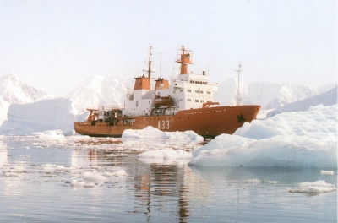
The "Hesperides" is Spain's main Antarctic support vessel. She was built in Spain at the Cartagena Shipyards and delivered in April, 1991. She has 9 officers, 46 other crew and can carry 30 scientists. She has an endurance of 90 days.
HUMBOLDT
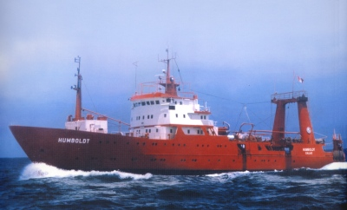
The "Humboldt" is the Antarctic supply vessel operated by Peru in support of its Antarctic base"Machu Picchu" situated on King George Island in the South Shetland Islands off the Antarctic Peninsula.
The "Humboldt" was built in 1979 and has an ice re-inforced hull. She has a 100 person capacity and is currently captained by Commander Gustavo Otarola. her home port is Callao, near Lima.

HUMBOLDT
The "Humboldt" is the Antarctic supply vessel operated by Peru in support of its Antarctic base"Machu Picchu" situated on King George Island in the South Shetland Islands off the Antarctic Peninsula.
The "Humboldt" was built in 1979 and has an ice re-inforced hull. She has a 100 person capacity and is currently captained by Commander Gustavo Otarola. her home port is Callao, near Lima.
JAMES CLARK ROSS"
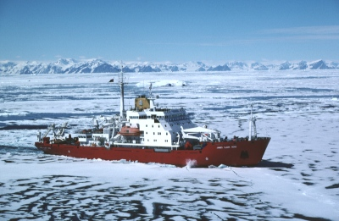
The "James Clark Ross" is the main British Antarctic Survey vessel responsible for re-supply and support of the various British Antarctic Bases in the South Atlantic and the Antarctic. It is designated as a Royal Research ship.

JASTARNIA BOR
Poland operates an active programme of Antarctic sciences based at their "Henryk Arctowski" Base on King George Island near the Antarctic Peninsula. Their supply vessel is the large "Jastarnia Bor". For the 1995-97 period it transported the 20th Polish Antarctic Expedition to the Antarctic.
JI DI.
The "Ji Di" is an oceanographic ship built in 1971 for the North China Sea Branch of the State Ocean Administration.  It is 152 metres longwith a 20 metre beam and a 20,000 nautical mile range. | 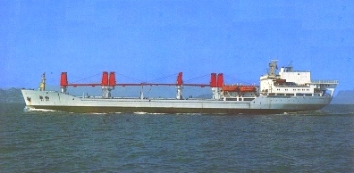

On the 30th of October, 1989 "Ji Di" departed Qingdao Port to commence the first Chinese Expedition (Chinare VI) of one ship to two Antarctic Bases. Under Captain Wei Wenliang the vessel first called at Zhongshan Station and then Changcheng Station (Now called Great Wall Station) before returning to Qingdao on the 10th of April, 1990. Wan Guoming was the leader of the Expedition
JOIDES RESOLUTION
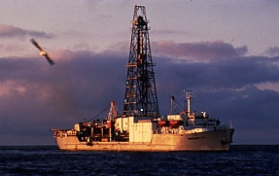
The "JOIDES Resolution" is an American drillship named after Captain James Cook's "Resolution". The "JOIDES" is an acronym for Joint Oceanographic Institutions for Deep Earth Sampling. In 1998 the "JOIDES Resolution" visited New Zealand after a series of 7 holes drilled off the Chatham Island Rise and further south to research the world's largest cold deep current known as the Pacific Deep Western boundary Current. Her single New Zealand port of call was Wellington
KAPITAN KHLEBNIKOV
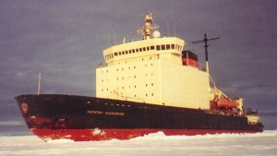
The photo above shows the "Kapitan Khlebnikov" in fast ice near the Amery Ice Shelf.
The "Kapitan Khlebnikov" is a Russian Icebreaker based in Vladivostok which also now operates tourist cruises in the Antarctic (as well as the arctic) for a variety of western companies.
KRASIN
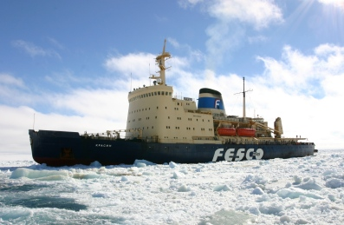
The "Krasin" is a A1 Class Finnish built icebreaker operated by the Russian company FESCO (Far Eastern Shipping Company) and based in Vladivostok in Siberia. It was built in 1976 and is 442 feet long and can break ice up to 6 feet thick. Becuase of extreme ice build up in McMurdo Sound over the past winter season caused by the giant B15A iceberg and the availability of only a single US Coast Guard icebreaker, the "Polar Star", it was decided by the American Deep Freeze authorities to hire the "Krasin" for the 2004-05 McMurdo "break-in". "Krasin" to act as support ship to oil rig operations in the Sea of.
The "Krasin" departed Vladivostok on December 21st, 2004 and arrived at the Ross Sea ice edge exactly one month later on January 21st, 2005.
LA CURIEUSE
The "Curieuse" is a research ship based at Port aux Francais, the main Port in the Kerguelen Islands in the French Southern and Antarctic Territories is engaged in maritime scientific work mainly relating to the foodchain in Antarctic waters.
LAS PALMAS
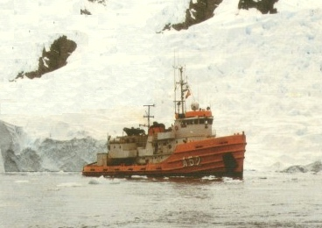
The "Las Palmas" is a spanish Antarctic support vessel built in 1978 in Satander, Spain. It has again been used in recent season supporting Spanish and the Bulgarian Antarctic Programmes
L'ASTROLABE
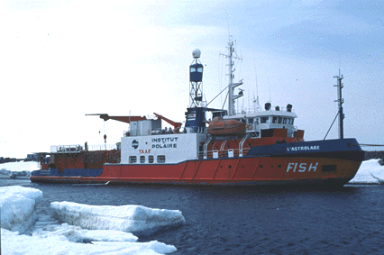
The "L'Astrolabe" is the main French Southern and Antarctic Territories support vessel. It is based at Hobart in Tasmania and sails each summer to the various French Bases both on the Antarctic Continent and in the Southern Indian Ocean
LAURENCE M. GOULD
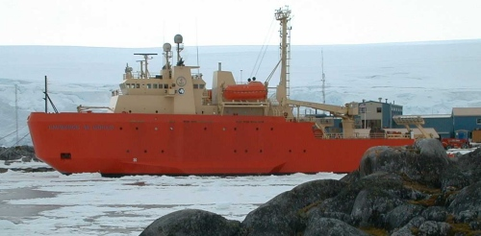
The "Laurence M. Gould" is named in honour of Laurence Mckinley Gould the polar explorer and geologist who was second in command during Admiral Richard E. Byrd's first Antarctic expedition during 1929-1930.
The vessel is a sister ship to the "Nathaniel B. Palmer". It was launched in 1998 and has ice-breaking capability while preforming mainly a research and supply role. The photo above shows the "Laurence M. Gould" off the US Palmer Antarctic Station.
LAWRENCE H. GIANELLA
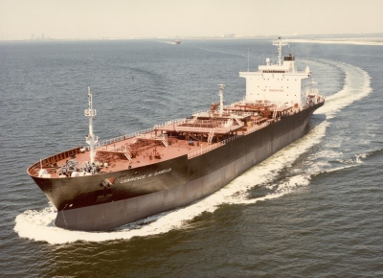
The "Lawrence H. Gianella" is a United States Military Sealift Command tanker which has been used as the tanker for McMurdo fuel supply a number of times. Her previous visit to McMurdo was in January 1999
LAUTARO
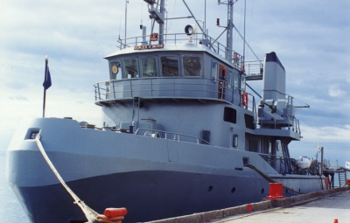
The "Lautaro" is a Chilean Navy vessel which acts as supply vessel for the various Chilean Antarctic Bases. It has pennant number "ATF 67" by which it is often known.
H.M.S. LEEDS CASTLE"
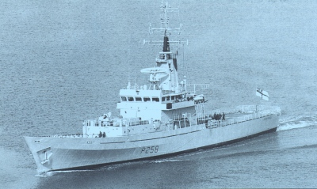
The "Leeds Castle" (P258) is a Royal Navy Castle Class patrol vessel designed for long distance maritime patroling. It is equipped with a helicopter

LEUCOTON"
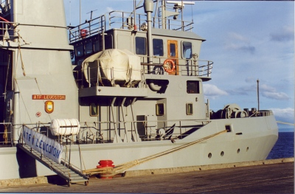
The "Leucoton" is a Chilean Navy vessel which operates in Southern Chile. It is shown above berthed in Punta Arenas prior to departure for the Antarctic.
MAGDALENA OLDENDORFF
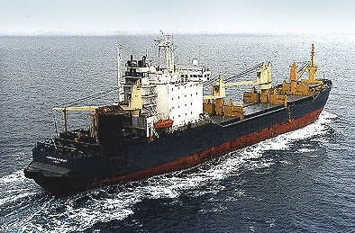
The "Magdalena Oldendorff" was built in 1983 as a ARCTIC-21 Ice Class multi-purpose Ro/Ro vessel. She is one of a large fleet operated by her German owners.
In late 2000 it was announced that "Magdalena Oldendorff" would be the support vessel for the 20th Indian Antarctic Expedition. She left Capetown on the 31st December, 2000 bound for the Antarctic continent taking the Indian Expedition led by the Geologist Marvin D'Souza.

MARION DUFRESNE'
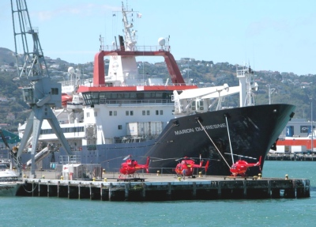 | Marion Dufresne was commissioned in 1995 to carry out global oceanographic research and to re-supply the French Austral islands of Crozet, Kerguelen, Amsterdam and Saint-Paul.  It is one of the world’s largest scientific vessels, measuring 120 m in length and with a dead weight of 4,900 tons. She is shown at left berthed in Wellington on January 30th, 2006.

It carries a wide range of advanced oceanographic, geophysical and geological equipment. Among its arsenal of research tools are two that place this vessel at the forefront of global marine research: its giant piston corer ‘Calypso,’ capable of recovering deep-sea sediment cores 60 meters long and weighing up to 10 tons; and its multi-beam sonar mapper, which produces high-resolution images of the seafloor. She carries 3 helicopters and can carry 110 passengers
MELVILLE
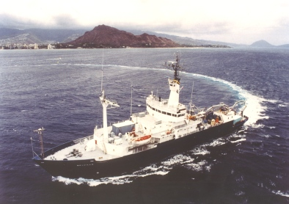
The "Melville" is a US research vessel operated by the Scripps Institution of Oceanography and used for deep sea oceanographic work. It was built in 1969 and is 85 metres long and is based in San Diego. She is shown above off Honolulu during a photo shoot
H.M.A.S. MELVILLE
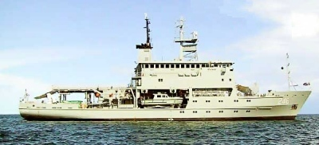
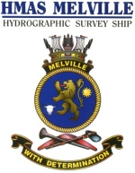 | The "Melville" is one of the Australian Navy's two Leeuwin Class Hydrographic Service ships both commissioned on the 25th of May, 2000.  They are usually based at Darwin or Cairns but their responsibility extends throughout Australia's territorial waters. They carry 46 officers and crew, a large launch and can carry a helicopter.
NATHANIEL B. PALMER
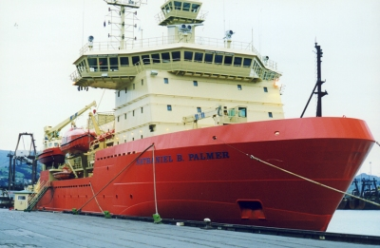
The above view shows the "Nathaniel B. Palmer" berthed at Lyttelton in October 1998. The "Nathaniel B. Palmer" is a modern (Built 1991) American Icebreaker and research ship operated for the National Science Foundation by Antarctic Support Associates. In 1998 It completed with distinction a mid-winter expedition to the McMurdo Sound area in the Ross Dependency spending several months making surveys of ice thickness, water temperatures etc while operating in perpetual darkness
OGS EXPLORA
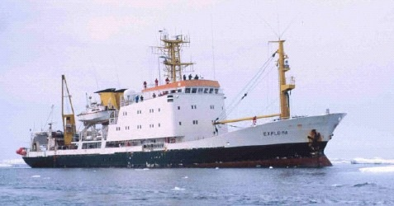
The OGS "Explora" was constructed at Elmsfleth in Germany in 1973. She measures 1,400 tons. In 1988 she was acquired by the Italian National Oceanographic Institute and based in Trieste. Her role was as a Polar and Oceanographic research vessel with a special emphasis of the Antarctic. Between 2003 and 2005 she underwent an extensive modernisation acquiring more modern ocean bed scanning equipment. In the 2005-06 Season she undertook an extensive cruise to the Ross Sea engaged in mapping the ocean bed and also other sampling programmes.
ONNURI"
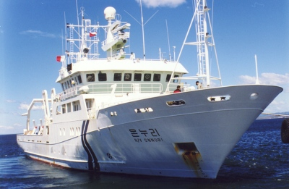
The "Onnuri" is a South Korean Research and Antarctic supply vessel built in 1991 at Bergen in Norway. She has a sister ship called the "Eardo". Both have compliments of 15 crew and 17 scientists. Both are operated by the Korean Ocean Research and Development Institute known as KORDI. the picture above shows the "Onnuri" berthed at Punta Arenas in December 1999 prior to her departure to the South Korean Antarctic Base, "King Sejong" on King George Island.
OUTENIQUA"
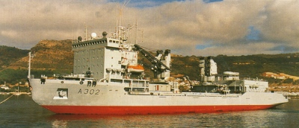
The "Outeniqua" is a South African Navy logistics ship which in recent years has operated as the main logistics ship for South Africa. It is based in Cape Town Naval Base.For the 1997-98 Summer season both the "Outeniqua"and the supply ship "Agulhas" arrived at the main SANAE Base from Cape Town to commence the rebuilding of the main South African Antarctia base.
PAARDEBERG
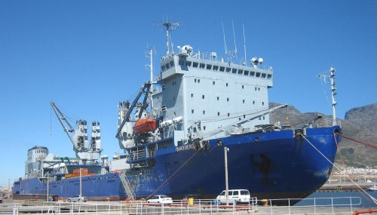
The "Paardeberg" is a ice strengthened (Ice class A2) multi-purpose auxillary replenishment vessel which was built in the Ukraine in 1991. She is flagged at Kingston in St. Vincent but owned by an Israeli company which bases her at Capetown in South Africa. She was previously the South African Navy vessel "Outeniqua". The view above shows her berthed at Capetown in March 2006.

PAUL BUCK
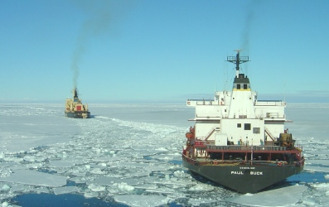
The "Paul Buck" is a United States Military Sealift Command tanker which has been used as the tanker for McMurdo fuel supply a number of times. She is shown above being escorted into McMurdo Sound by the chartered icebreaker "Krasin" on January 21st, 2005. Ross Island can be seen in the distance.
POLAR BIRD
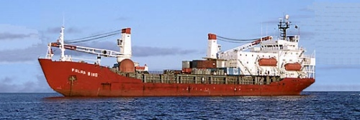
The "Polar Bird" is an Antarctic supply vessel which has been chartered by a variety of countries. It is ice-strengthened. In 1998 it was chartered by the Australian Antarctic Research Expedition as a temporary replacement for the out of service "Aurora Australis

POLAR DUKE"
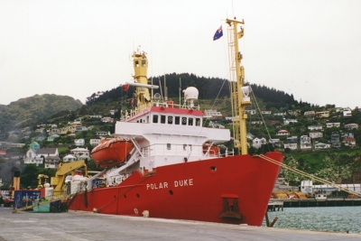
The "Polar Duke" is an ice strengthened vessel owned by Polar Ships A/S of Norway which specialises in providing specialist charter vessels. The "Polar Duke" was built in 1983 and since then has visited the Antarctic many times. To read an interesting story about the vessel and to see a nice selection of photos taken during her 1999-2000 Antarctic expedition to Northern Victoria
POLAR QUEEN
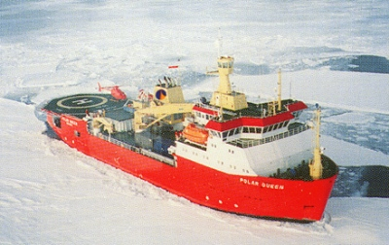
The "Polar Queen" is a Norwegian owned ice strengthened vessel built in 1995 for Rieber Shipping of Bergen. The vessel has been chartered several times for Australian Antarctic Base re-supply voyages.In early 1999 with the unavailability of the "Aurora Australis" due to breakdown, the "Polar Queen" was again chartered to carry out urgent Base re-supply. The following season the vessel was renamed "Ernest Shackleton" and bareboat chartered to the British Antarctic Survey for a 10 year period.
POLAR SEA
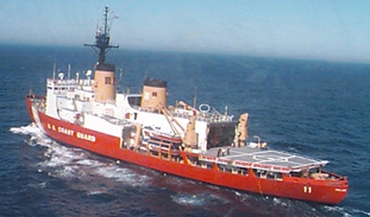
The "Polar Sea" (WAGB-11) is one of two United States Coast Guard Icebreakers stationed in the Pacific which alternatively provide the Ice Breaking support to the American "Operation Deep Freeze" program based largely in McMurdo Sound area of the Ross Dependency. Her sister ship is the "Polar Star".
For the 1998-99 Austral summer season, the "Polar Sea" spent 7 weeks in Antarctic waters visiting McMurdo Base only rarely.
POLAR STAR
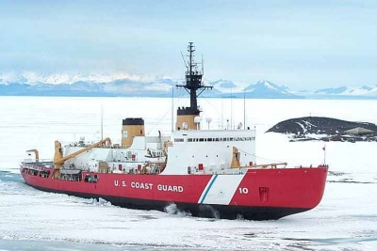
The "Polar Star" (WAGB-10) is one of two United States Coast Guard Polar Class Icebreakers which provide the ice breaking support for the American "Operation Deep Freeze" program based largely in the McMurdo Sound area of the Ross Dependency. Her sister ship is the "Polar Star". Both are equipped with a Helicopter. The picture above shows "Polar Star" at McMurdo with Scotts Hut to the right and the trans-Antarctic mountains in the far distance.
POLAR STAR
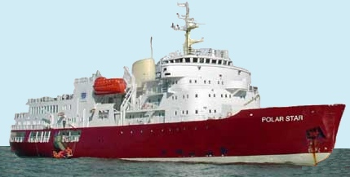
The "Polar Star" was built in Finland in 1969 as the Swedish A1 Class icebreaker "Njord". She was modernised in 1988 and served as a working icebreaker in the Baltic until April 2000 when she was purchased by Tourist company Karlsen and renamed "Polar Star". She can carry 98 passengers in 46 cabins. She is specially equipped for expeditions cruising in polar waters with a fleet of 10 Zodiacs. Recently a 11 day expedition to the South Shetlands and the Antarctic Peninsula.
POLARSTERN
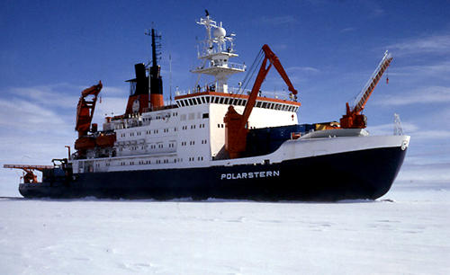
The "Polarstern" is the main German Antarctic support vessel. It is a fully ice-strenthened icebreaker class vessel operated by the Alfred-Wegener Institute. Each year during the Austral summer it resupplies the German Neumayer Antarctic Base station as well as the Filchner Ice shelf station. In association with the South African SANAE it also helps in the resupply of the South African Bases
RAINBOW WARRIOR (11)
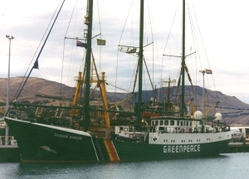
The "Rainbow Warrior" is the new flagship of the world-wide Greenpeace Environmental Organisation. It replaces the previous "Rainbow Warrior" which was sunk in Auckland Harbour by French Secret Service (DGSE) Agents in 1985. The current "Rainbow Warrior" continues the same role of environmental protest ship. The above view shows "Rainbow Warrior" in the inner Lyttelton Harbour on 31st March 1998
RICHARD G. MATTHIESEN"
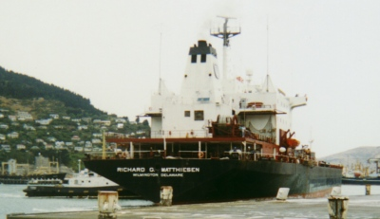
For the 1999-2000 Austral summer season the United States Antarctic Programme used the Military Sealift Command common user tanker "Richard G. Matthiesen" for its supply run to McMurdo Sound.
The vessel is 39,624 tons displacement and was particularly suited to this task as it has a double hull and is also ice strengthened. It was built in 1985 and has hull number T-AOT

ROGER REVELLE
The "Roger Revelle" is an American Oceangraphic vessel operated by the Scripps Institution of Oceanography. It was built in 1996 and normally operates in the North Pacific based from San Diego.  At the end of 1997 it commenced a series of Oceanographic cruises from Lyttelton south to the Antarctic | 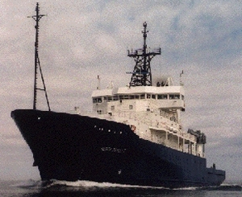
SEA SURVEYOR
The motor vessel "Sea Surveyor" in January 1999 left the Southland Port of Bluff carrying a wildlife recovery party from the Rare Breeds Conservation Society. The aim of the Expedition was to recover from the remote sub-Antarctic Islands both live animals and genetic samples of others to enable to survival of the gene pool of the long isolated Auckland Island wild pigs prior to the Department of Conservation eradication programme intended to return the Islands to their natural state
SHIRASE
The Shirase is the main Japanese Antarctic Suport vessel. It is a powerfull icebreaker commissioned in 1983.  It carries a post office on board and normally makes one single long voyage each season from Japan via Fremantle to the Japanese Antarctic Bases of Syowa (established 1957), Mizuho (est. 1970) and Asuka (est. 1985). It then returns to Japan via Sydney after a round trip of around 6 months. Mail from the Japanese Bases and posted on board "Shirase" itself is usually carried all the way back to Japan before on forwarding via the Japanese and international mail systems. A limited amount of Paquebot mail is posted at either Fremantle or Sydney. | 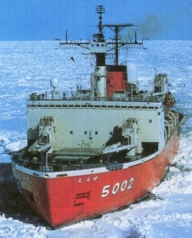

SHONAN MARU No 1 and No 2.
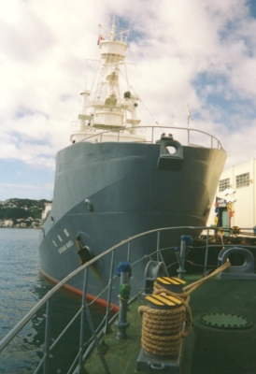  Shonan Maru No 1 | 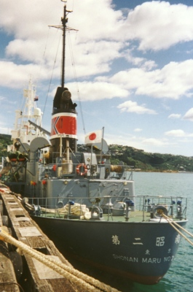  Shonan Maru No 2

These two former Japanese whaling ships were chartered by the International Whaling Commission (IWC) at the end of 2000 for a two-year whale research programme in the Southern and Antarctic Oceans.
SIR HUBERT WILKINS
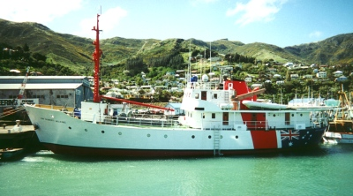
The "Sir Hubert Wilkins" is a ice-strengthened (Ice class IA) former state launch of Finland. It was purchased in 2000 by the Australian based company "Ocean Frontiers" owned by Antarctic veterans Don and Margie McIntyre, is based in Hobart and operates from there to the Antarctic mainland in the Australian Antarctic Territory and the Ross Dependency providing logistic support for private and government sponsored Antarctic expeditions
SONNE
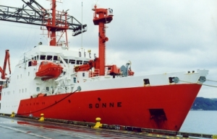
The "Sonne" is a German Oceanagraphic Research Vessel based in Bremen. she is equipped to sample the Ocean bed by drilling and recently has also carried her own submersible.In 1998 as part of the United Nations International Year of the Ocean she voyaged to the South West Pacific where she undertook drilling and other sedimentary sampling around New Zealand, in the Great Southern Basin and on the Chatham Islands rise, prior to arriving in Wellington on the 15th October 1999. The picture above shows her tied up alongside her berth in Wellington
SOUTHERN CHAMPION
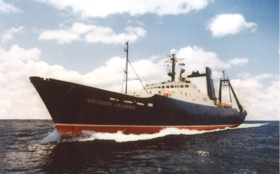
The "Southern Champion" is a modern 2,203 ton fishing vessel owned by Austral Fisheries Pty. Ltd of Fremantle. She commenced fishing in the Southern Ocean around Heard Island late in 2000 using the West Australian Port of Albany as her base.Because of delays to the Australian Antarctic division chartered vessel "Polar Bird" which had been trapped in Antarctic pack ice it was decided instead to use the "Southern Champion" to transport back AAT scientific personnel from Heard Island. The vessel arrived at Heard Island on the 11th February and promptly uploaded a limited number of AAT personnel and transported them to Albany arriving in the early hours of the 20th of February, 2001.
SOUTHERN SUPPORTER
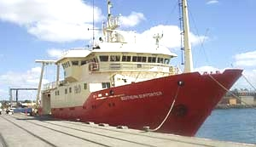
The P&O operated vessel "Southern Supporter" is usually under charter to the Australian Customs Department and operates as a fisheries Patrol vessel in the seas around Heard and McDonald Islands watching out for Patagonian toothfish pirate fishing vessels. She has in recent seasons undertaken two widely reported long chases of such vessels both of which were eventually arrested and escorted to Australia. In December 2003 the "Southern Supporter" was chartered by the Australian Antarctic Division to transport expeditioners to and from Heard Island from Fremantle in Western Australia.The ship was built at Vigo, Spain in 1993. The hull which was originally designed for deep sea trawling has an Ice Class 1A rating. Fitted with three cargo holds, the ship can reach a maximum speed of 12 knots in full loaded condition. She is fitted out with state of the art safety and navigational equipment, high standard passenger/crew accommodation and related scientific & technical facilities, workshops and spaces. She also has a helideck
SOUTHERN SURVEYOR
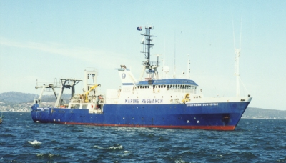
The "Southern Surveyor" is a marine Research vessel operated by the Australian Government CSIRO organisation. It is based at Hobart and engaged in mainly marine research in Southern waters. In 1998-99 it was called on to replace the "Aurora Australis" for a number of maritime roles in Antarctic Waters

SPIRIT OF ENDERBY
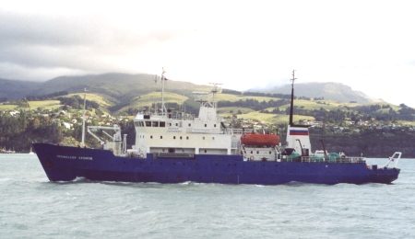
The "Spirit of Enderby" is a sister ship to the "Akademik Shokalskiy" which Heritage Expeditions of Christchurch had operated for 10 seasons up to the end of the 2003-04 season. Her registered name is "Professor Khromov". She was built in 1984 and refurbished in Lyttelton in 2004 before commencing tourist work. She carries 48 passengers and is equipped with several naiads, all terrain vehicles and for Antarctic work also carries a helicopter.
TANGAROA
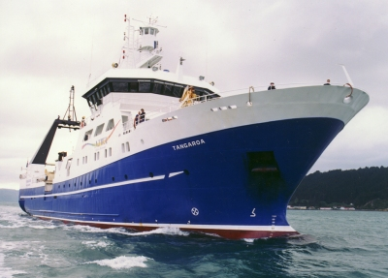
The "Tangaroa" is an Oceangraphic and fisheries Research vessel operated by the New Zealand Institute of Water and Air (N.I.W.A.) and is based in Wellington. In 1998 she was involved in New Zealand's contribution to OCEAN'98, the United Nations "International Year of the Ocean".

H.M.N.Z.S. TE KAHA
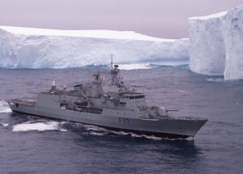
This February 1999 view shows the New Zealand Anzac class frigate "Te Kaha" patrolling amongst Antarctic Icebergs while looking for Illegal Patagonian toothfish pirate fishing ships. She has also acted as a replenishment and personnel transport ship to a variety of sub-Antarctic i
VANGUARDIA
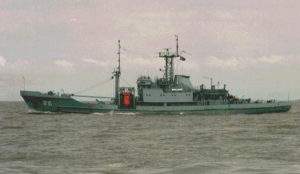
The "Vanguardia" is the regular supply ship used by the Uruguayan Antarctic Institute for the resupply of its Antarctic Base "Artigas".
She was built in 1976 and purchased by Armada (Navy) Uruguay on the 18th December 1991. She is 72 metres long.

VASILIY GOLOVNIN"
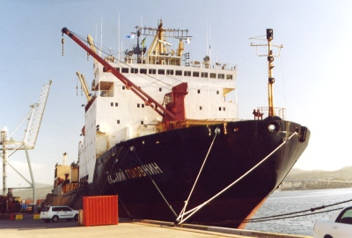
The "Vasiliy Golovnin" is a Vitus Bering Class Icebreaking ship operated by the Far-Eastern Shipping Company of Vladivostok. She was built in the Ukraine in 1988 and is a sister ship to the "Xue Long" operated by the Chinese Antarctic Programme. She can carry in her holds the equivalent of 305 standard containers and has 5 deck cranes, a stern ramp and an aft helideck and hanger. For the 2003-04 season she was chartered by the Australian Antarctic Division to undertake their voyage 5 which was described as a Continental resupply trip to Casy, Davis and Mawson Bases. This was her inaugural Antarctic voyage
XUE LONG
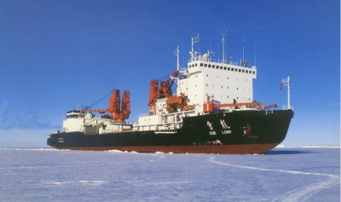
The "Xue Long" was previously known as the "Snow Dragon". The vessel is the main Chinese Antarctic support vessel. It is based at Shanghai and provides Icebreaking capabilities to the Chinese when re-supplying their two main Antarctic bases. To see covers from these bases click on either Great Wall Station or Zhong Shan Station. It is currently the biggest vessel regularly engaged in Antarctic work
YUZHMORGEOLOGIYA"
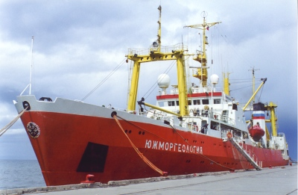
This vessel with the long strange sounding name is a Russian ice strengthened cargo supply and research vessel which is under charter by the American NOAA to provide logistic support to the Copacabana field camp on King George Island as well as a number of other American scientific projects in the Antarctic Peninsula area. The name of the vessel translates to something like "South Sea Geology".

